9/10/2024
Portfolio & Reflective Piece
Psychology for work

Contents
Reflective Written Summary 2
Reference List 4
Evidence 5
Staff Stress & Emotional Wellbeing Policy for Swansea Bay Health Board 5
Meetings minutes 21
Managers guide to interviews, appointments and pre-employment checks. 22
Risk Assessment 33

Reflective Written Summary

When I first found out that we had to take part in work experience I was overjoyed with being able to learn about working in a professional environment. It was going to give me an insight into the way workplaces are run and how the staff work out day-to-day issues. To reflect on my experience, I will be using the Gibb’s Reflective Cycle (Gibbs, 1988). This was created to look back at an experience and see what went well and what could have been better. The reflective cycle has 6 stages which are description, feelings, evaluation, analysis, conclusion, action plan. This is to ensure that people can learn from experience and do it better next time. There is another reflective cycles which is ‘The integrated reflective cycle’ (Bassot, 2013) this was taken from the Gibb’s Reflective Cycle but it only has 4 stages and is a simpler way of reflecting on an experience.
The aim of this part of the module was to gain hands on experience in the world of work. I decided to do my work placement In the IT department in Swansea Bay Health Board. I decided to go there as my mum is one of the heads of department there and she was able to help me achieve my goal in gaining experience in a workplace. The whole department was present as I went in on a Tuesday this is due to them all going to the office on this day as they are still doing integrated work from COVID. I thoroughly enjoyed this as I was able to see how a workplace ran instead of just teams’ meetings. I enjoyed working here and gained a lot of experience. I took part in management meetings where they discussed upcoming projects which needed to be done to improve the needs of the service users. I analysed and started to create an easy guide to how the recruitment process works so that the staff can quickly look at it and know what step they must do next in the recruitment process.
I was feeling nervous when I first went as I didn’t know what to expect but as soon as I went and was introduced to everyone and started to get to know the team, I started to get into the rhythm of what needed doing. I felt as if I could get into the work that I was told to do once I had settled in. I feel proud of myself for completing this, I faced my anxiety and went in confident and did my best to hide how anxious I was as some people may have been put off by this. I feel as if I succeed in what I set out to do and now I will be more confident and positive next time I go into a scenario like this.
To evaluate the experience, I felt as if I gained the experience needed. The good parts were that I learnt how the recruiting processes work and how they select the right candidate for a job. I was a bit put off as on this day it was the only day people from this workplace saw each other in person so there was a lot of socialising rather than work being done. It is understandable but I don’t feel as if I got the full experience, I could have got if it was a normal working day. For some people It could have been some of their only contact other than on teams’ meetings. I think another downfall to this was because I was with my mum, I couldn’t be fully myself and adjust into the environment.
I threw myself into the experience and tried to get as much work done as I could to ensure that I could come away from there and have an insight into the recruitment processes and the way that meetings are conducted in a professional setting. I spoke to many different people in the department that did different jobs and was able to identify what roles everyone did and how they all fitted together. I enjoy hands on work and learn better when putting things into practice so I excelled when I could take part in the work rather than just listen to what everyone does as I then had a deeper understanding.
To conclude, I have deepened my understanding in many aspects in relation to work. I have now got an understanding of how its like working after COVID which is a huge realisation of how much it really has affected workplaces and the people that work in them. I have got a better insight into the way people conduct themselves in a workplace which will be useful for when looking for a job in the future. I learnt the way the different levels of management go through the recruitment process for different types of roles which will give me an opportunity to excel in job interviews and when apply for jobs as I will know what sort of things that management look for in general. I realised from this that I need to develop my communication skills as I could of probably got more out of it if I had expressed more of what I wanted to do rather then going along with what I thought I should be doing. I’m going to read up on ways to communicate effectively in a workplace. If I were to do it again I would set myself goals to achieve during the time I was there so I had a certain subject to focus on therefore I would feel more of an achievement. I would keep my work that I completed to ensure I look back at it for reference in the future.

Reference List

Bassot, B. (2013). The Reflective Journal. Basingstoke: Palgrave
Gibbs, G. (1988). Learning by Doing: A guide to teaching and learning methods. Oxford : Oxford Polytechnic.

Evidence

Staff Stress & Emotional Wellbeing Policy for Swansea Bay Health Board
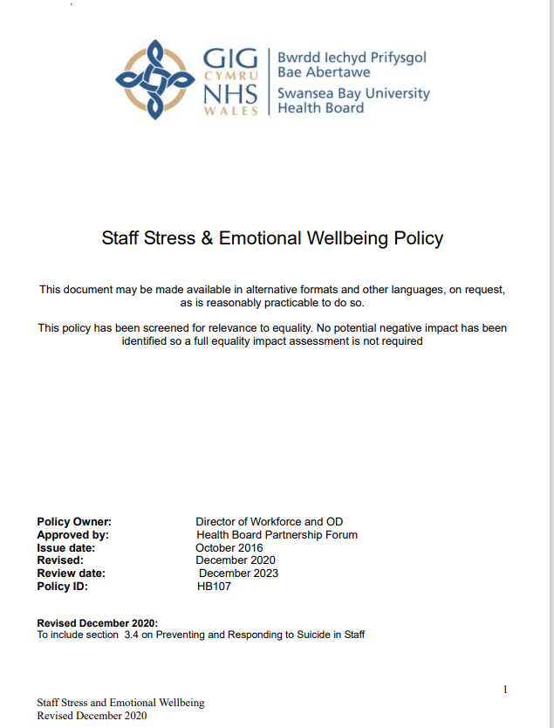
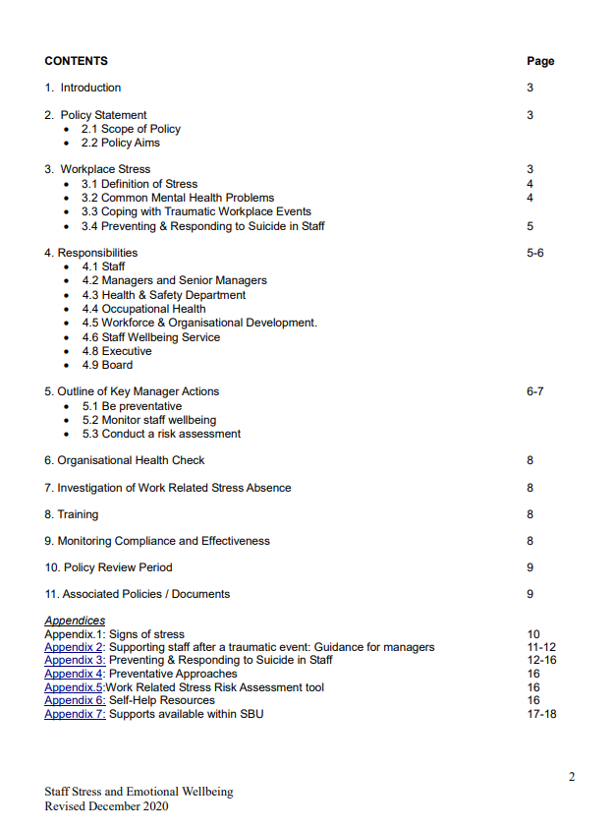
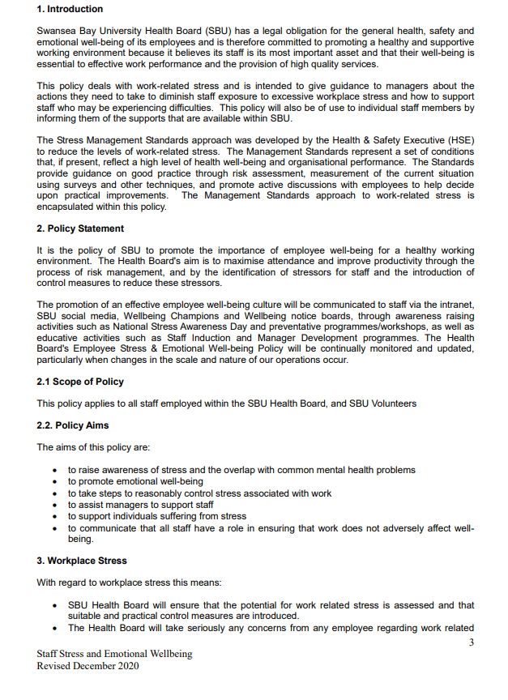
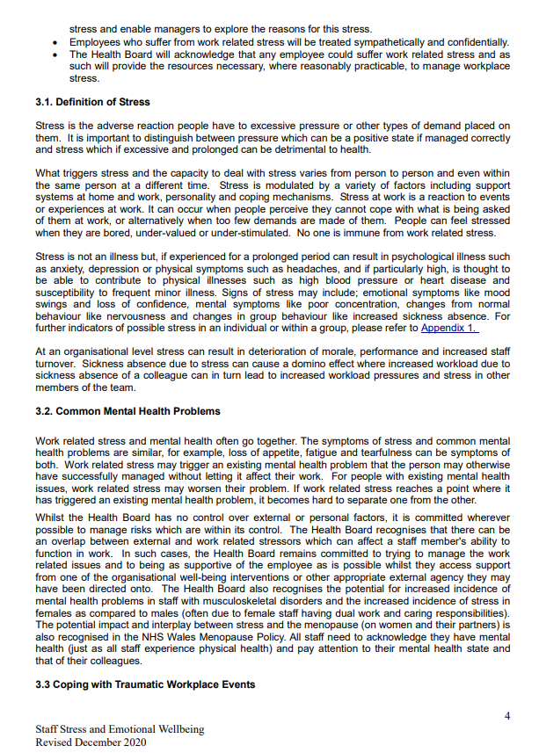
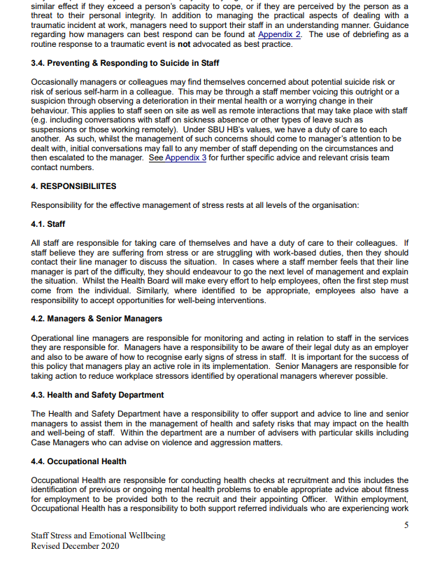
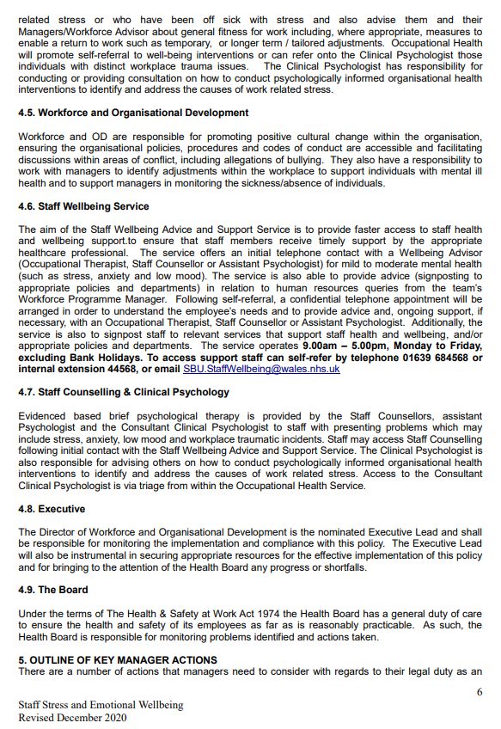
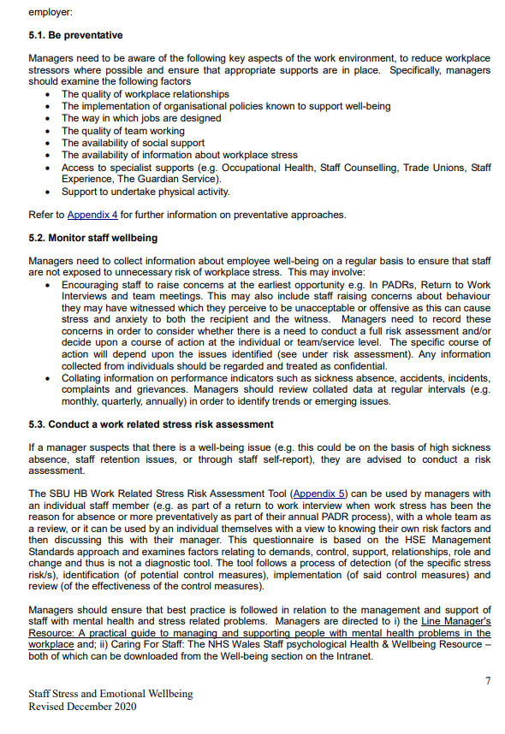
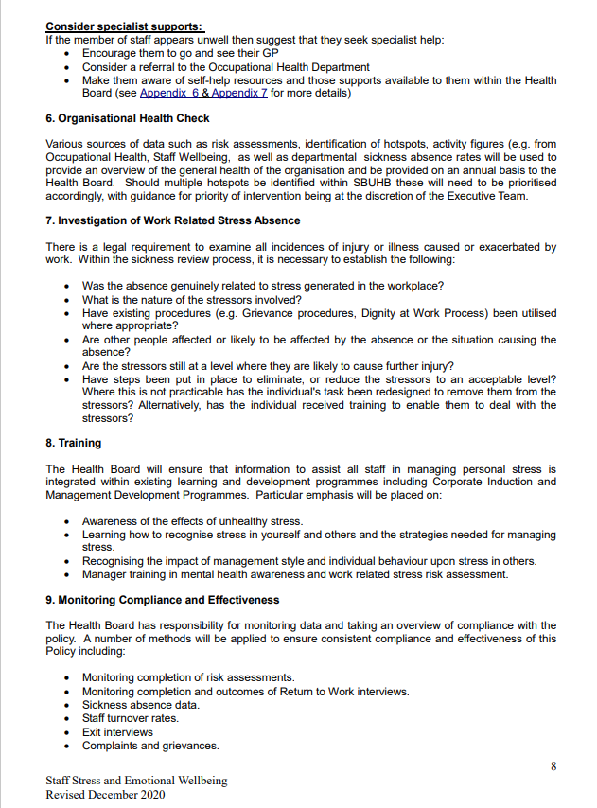
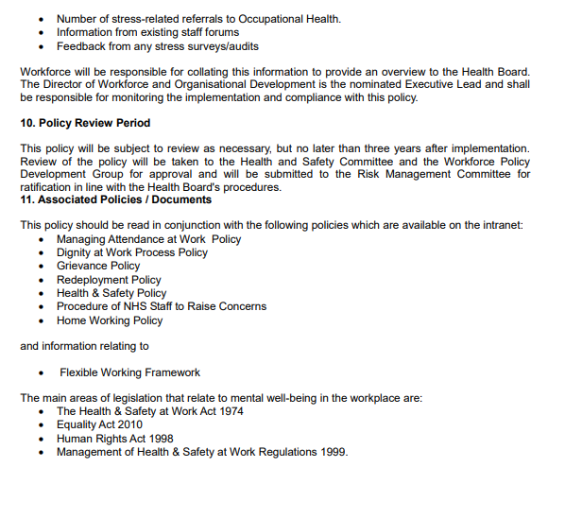
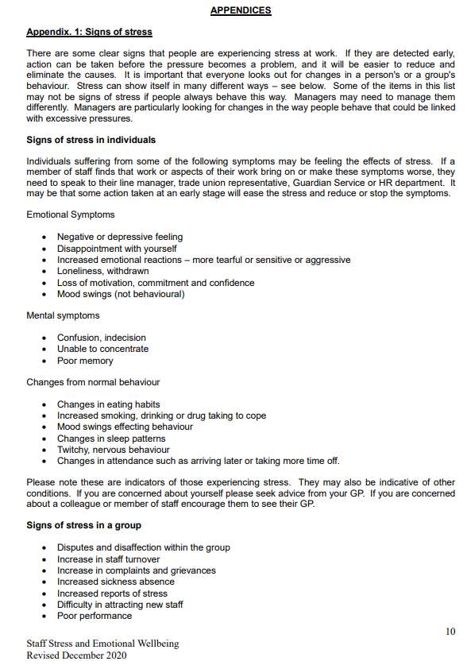
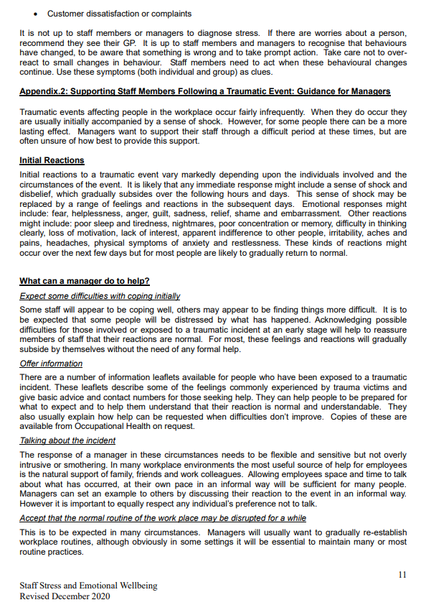
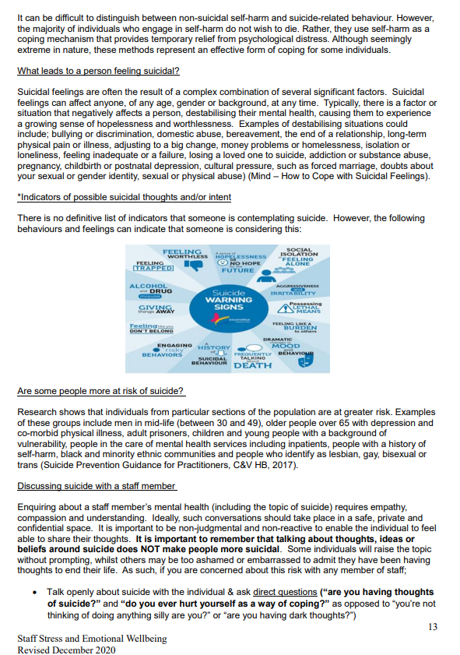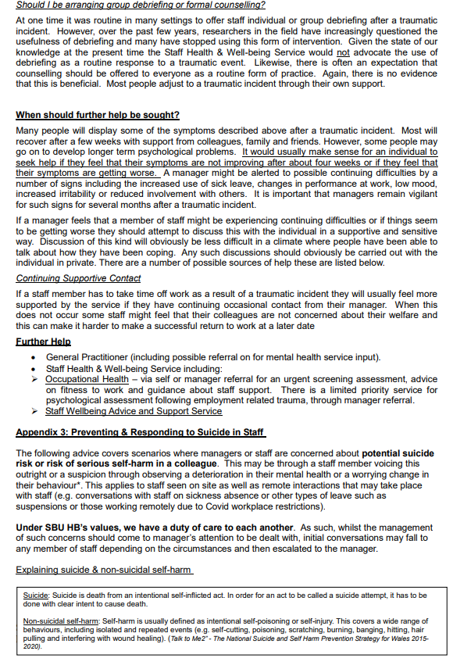
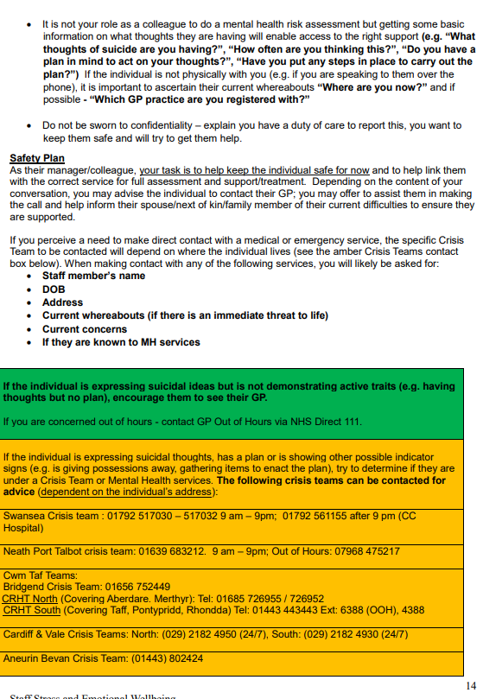
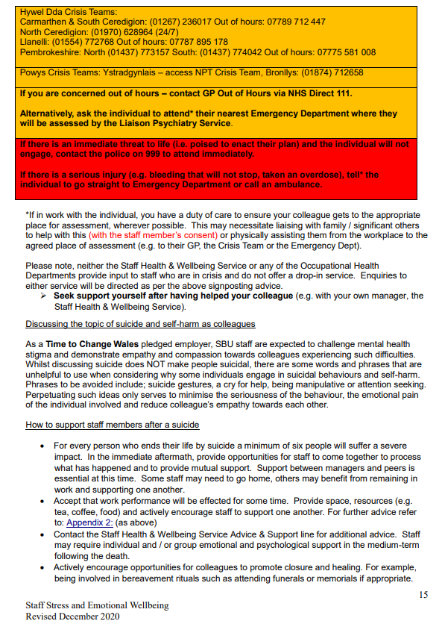
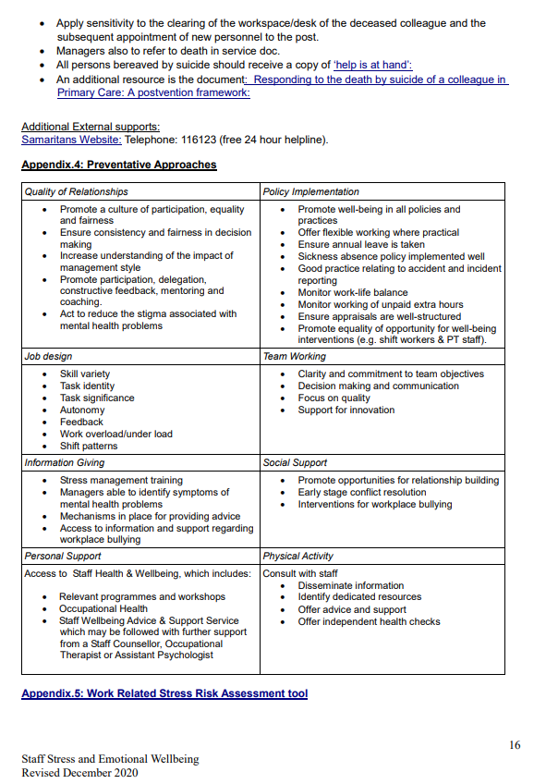

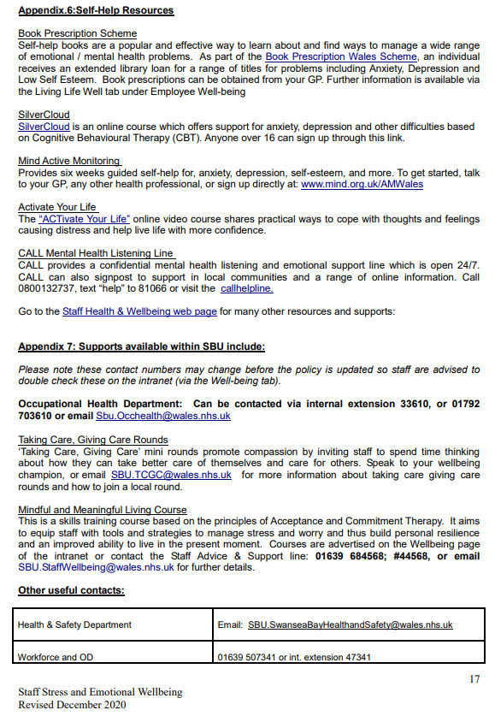
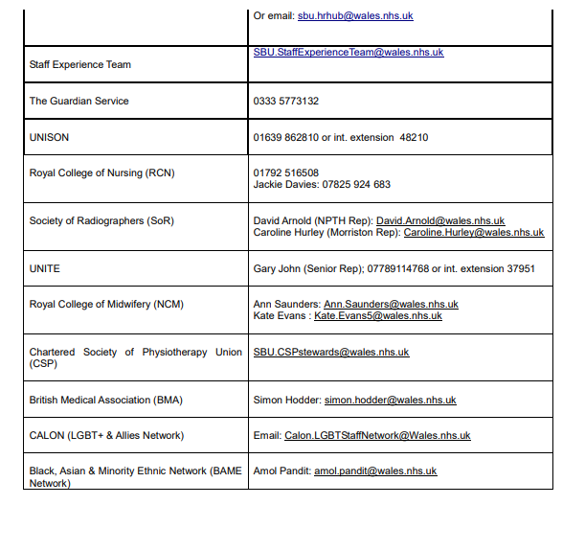

Meetings minutes
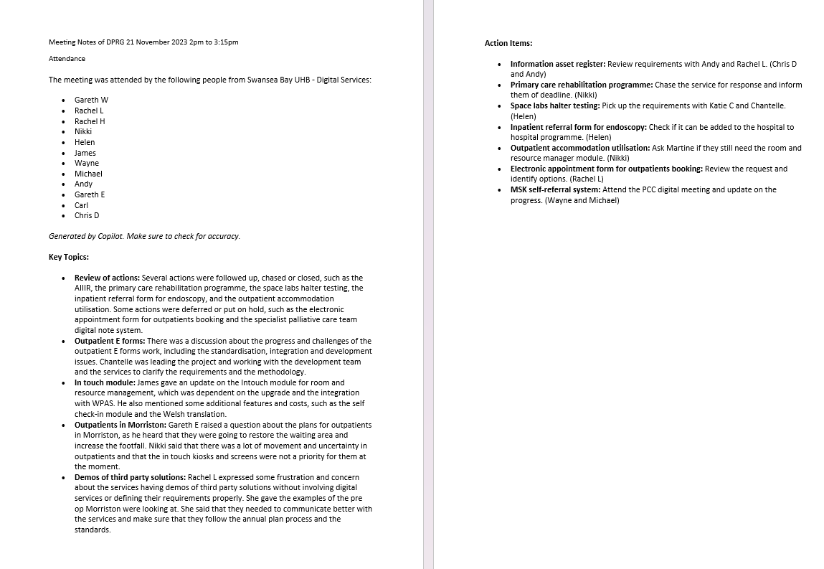

Managers guide to interviews, appointments and pre-employment checks.

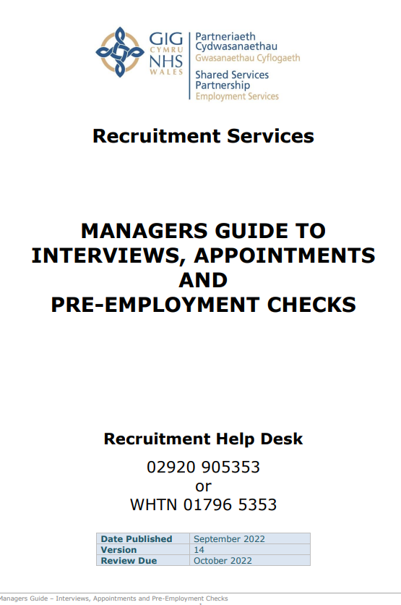
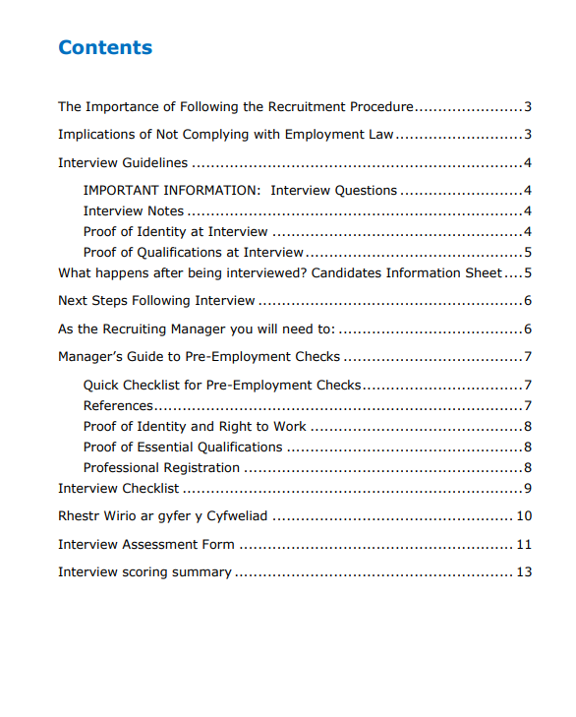
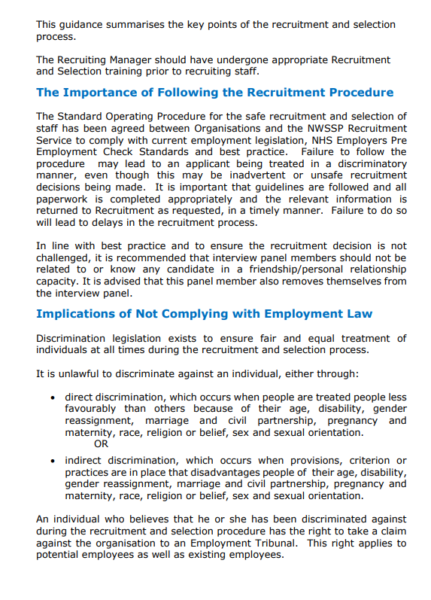
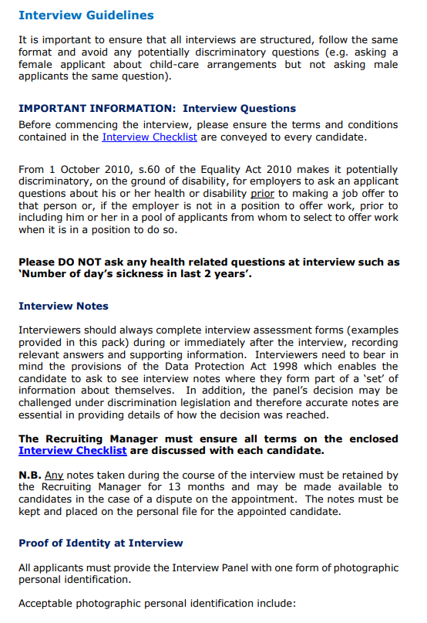
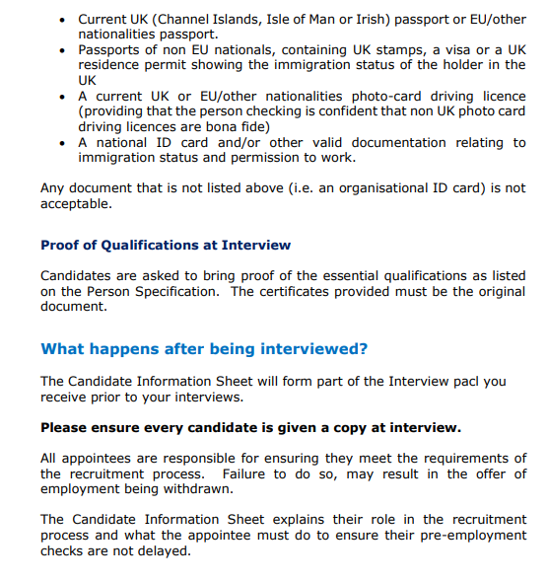
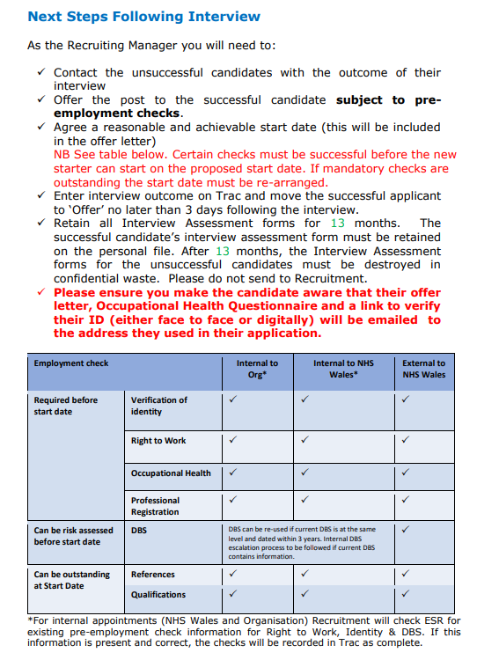
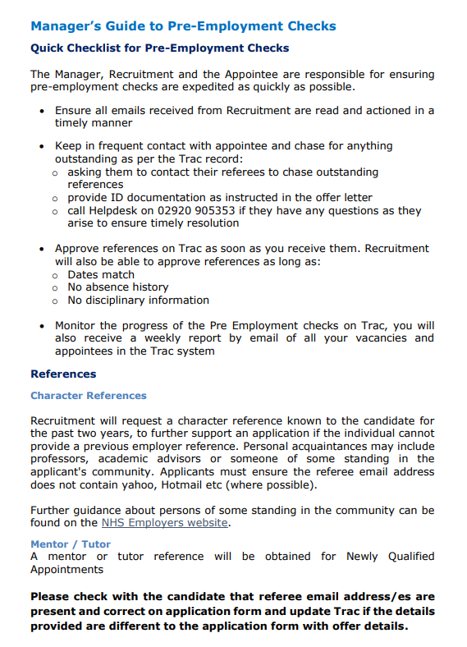
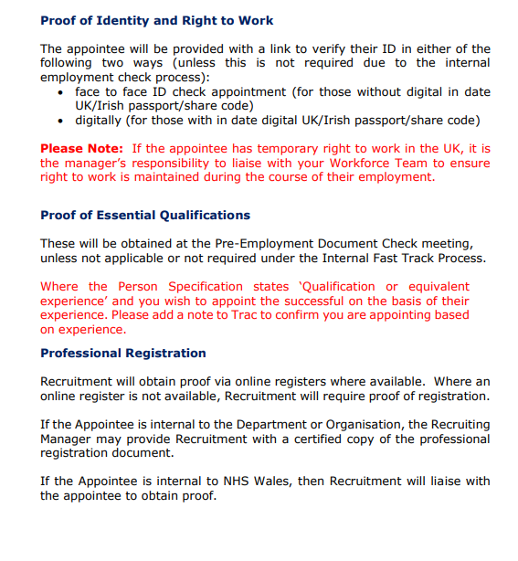
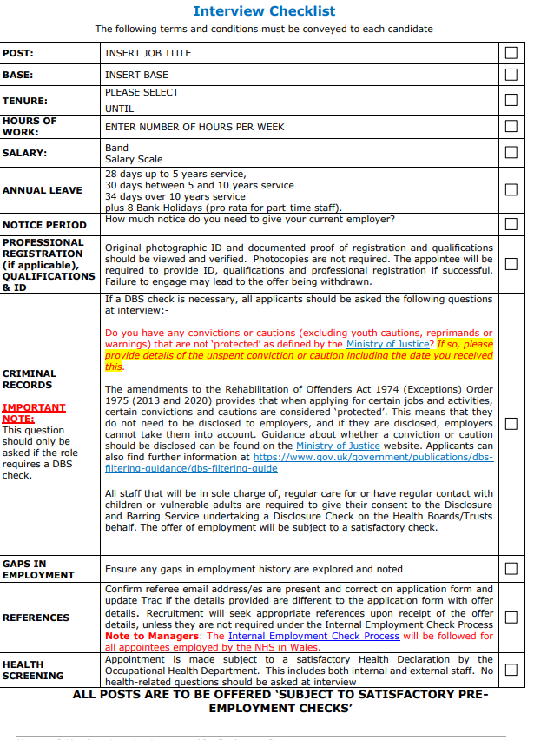
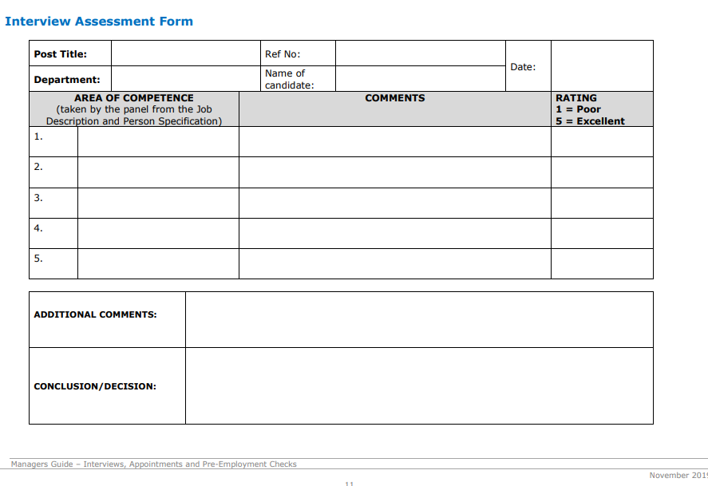
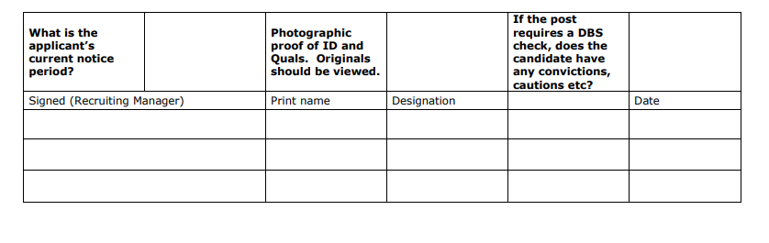
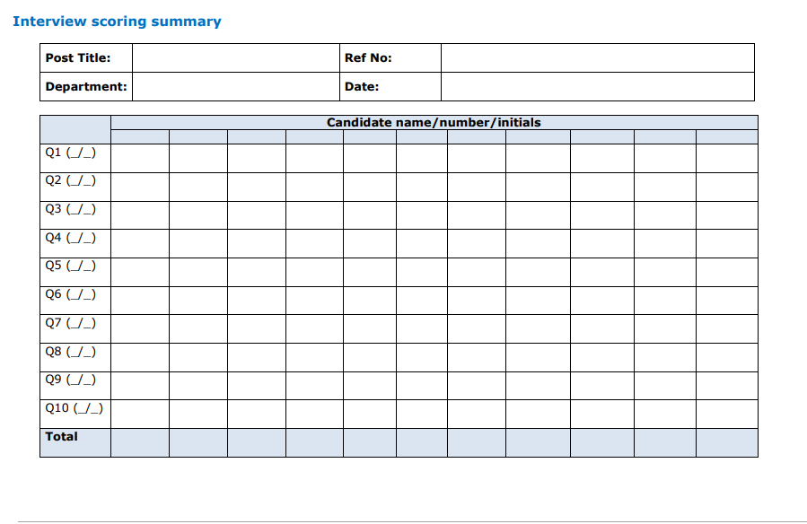

Risk Assessment



