Assessment 2
Intercultural competence report
Vasile Asmarandei
2212713
Foreign Languages & Cultural Awareness BMIH5003
Lisa Bassler
01/03/2024
1094 words

Executive Summary :

This report builds a comparison between England and China based on GLOBE Project study, is an internal document elaborated by Associate General Manager of Diversity Hotel and Spa from London, occasioned by future opening of a subsidiary in China, analysing for England and China similarities and differences in context of cultural intelligence and sensitivity, concluded in most important recommendations for General Manager who is preparing for the trip, to understand better how the business could expand in a country with a different culture, which aspects are relevant about culture and leadership, with a focus on key cultural differences.

Table of contents

1 Introduction 4
2 Key Concepts in Intercultural Competence 4
3 The Global Marketplace 4
4 GLOBE Project 4
5 Case Study: England 5
6 Case Study: China 6
7 Cultural Analysis: England vs. China 7
8 Impact on Business and Leadership 7
9 Conclusion 8
10 Recommendations 9
References 10
Appendix 12

1. Introduction:
Intercultural competence involves the skill to proficiently interact and communicate in diverse cultural contexts.. In today's globalized world, where diverse cultures intersect, intercultural competence is crucial. It enables individuals and organizations to understand, appreciate, and adapt to cultural differences, stimulating successful communication and collaboration. A heightened cultural understanding promotes empathy, minimizes misunderstandings, and enhances relationships in the global marketplace (Rudd, 2015). In essence, intercultural competence is a key skill set for cooperation, innovation, and sustainable partnerships in an interconnected world, where cross-cultural interactions are integral to professional and personal success.
2. Key Concepts in Intercultural Competence
Intercultural competence involves the ability to effectively interact with individuals from diverse cultures. Key concepts include cultural awareness, communication sensitivity, and adaptability. Cultural empathy, a fundamental aspect, entails understanding others' perspectives without judgment (Bakir, 2017). These concepts and frameworks collectively aid in assessing and enhancing intercultural competence, fostering successful global interactions.
3. The Global Marketplace
The global marketplace is characterized by interconnected economies, rapid technological advancements, and diverse consumer bases. While offering expansive opportunities, it presents challenges such as regulatory complexities and geopolitical uncertainties. Various cultural norms have a substantial influence on various aspects of business, including interactions, negotiations, and partnerships. These differences shape communication styles, decision-making processes, and approaches to building relationships (Bakir, 2017). Misinterpretations can arise due to varying perceptions of time, hierarchy, and communication norms. Successful global enterprises recognize the importance of cultural intelligence, adapting strategies to align with local customs. Effectively navigating cultural nuances fosters trust, mitigates misunderstandings, and establishes fruitful, enduring partnerships in the dynamic and complex global business landscape.
4 GLOBE Project
The GLOBE Project is a renowned study / initiative that statistically interpretate cross-cultural leadership and organizational particularities in many countries. Launched in 1991, it involves scholars from various countries and aims to enhance understanding of cultural influences on leadership behaviors. GLOBE identified six global leader behavior dimensions. This extensive project provides valuable insights into cultural variations, assisting businesses and policymakers in navigating diverse global contexts and promoting effective leadership across different cultural settings (House, 2004).
The GLOBE (Global Leadership and Organizational Behavior Effectiveness) Project in 2004 expanded its study to encompass 61 countries, investigating leadership behaviors and organizational practices. This research identified nine cultural dimensions: Power Distance, Uncertainty Avoidance, Societal Collectivism, In-Group Collectivism, Gender Egalitarianism, Assertiveness, Future Orientation, Performance Orientation, and humane orientation (House, 2004). By examining these dimensions, the GLOBE Project offers a comprehensive understanding of cultural influences on leadership, aiding global organizations in fostering effective cross-cultural collaboration and leadership practices. The extensive scope of the study, covering diverse nations, contributes to its significance as a valuable resource for navigating international business and management.
5. Case Study: England
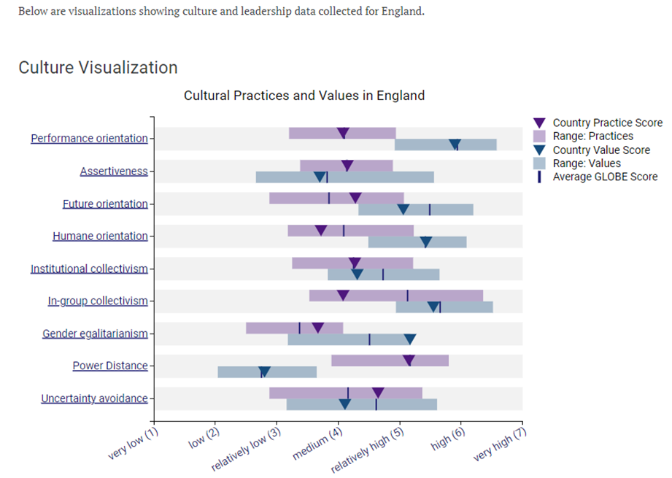
(GLOBE Project, 2004)
England exhibits a predominantly individualistic cultural orientation, emphasizing personal autonomy and self-expression. Communication styles tend to be direct, with an appreciation for clarity and open dialogue. In terms of leadership preferences, a democratic and participative approach is often valued. Key customs and traditions include the respect for the monarchy and the observance of traditional events like Wimbledon and afternoon tea. Politeness and the use of humour, often with a touch of self-deprecation, are integral behaviors. While English culture shares some global norms, such as the recognition of individual rights, its nuanced approach to social interactions and the significance placed on historical traditions distinguish it. Understanding these cultural dimensions is crucial for successful cross-cultural engagements and effective leadership within an English context.
6. Case Study: China
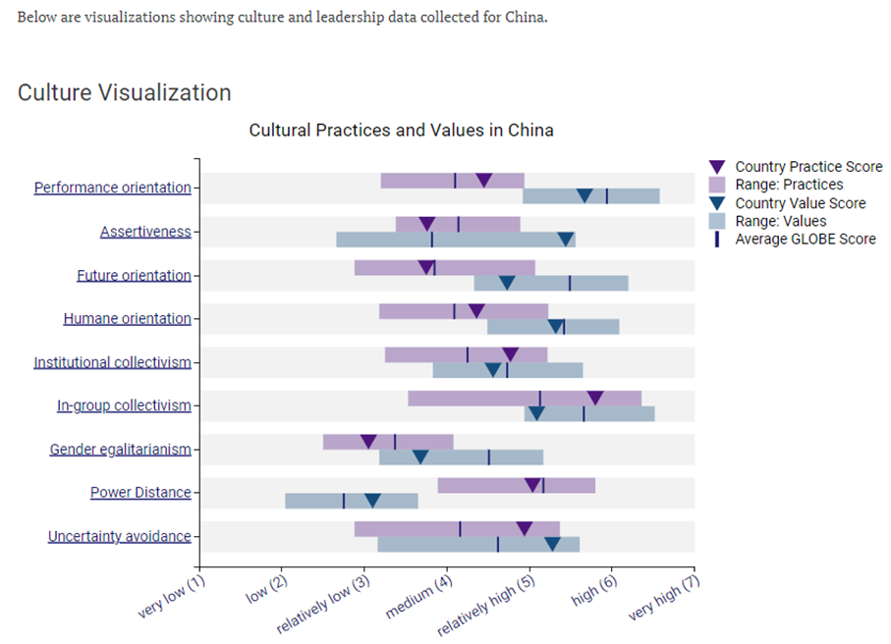
(GLOBE Project, 2004)
China epitomizes a collectivist culture, prioritizing group harmony and familial ties over individual pursuits. Communication in China is often implicit and context-dependent, emphasizing the importance of non-verbal cues and indirect expression. Traditional leadership expectations include a preference for hierarchical structures and a paternalistic leadership style, where leaders are seen as mentors (Yihong, 2009). Confucian values of filial piety, respect for elders, and harmony underpin many customs and traditions. The celebration of the Chinese New Year, reverence for ancestors, and the significance of the red colour symbolize good fortune (Huang, 2021). Face-saving is crucial in Chinese interactions, influencing behaviors like modesty and indirect disagreement. Understanding these cultural dimensions is pivotal for effective cross-cultural communication, establishing strong relationships, and navigating leadership roles within a Chinese cultural context.
7. Cultural Analysis: England vs. China
England and China showcase distinct cultural characteristics, reflecting their diverse histories and societal norms. Communication styles in England lean towards directness and clarity, while China places greater emphasis on indirect communication and non-verbal cues. Work ethics in England often prioritize individual initiative, whereas China emphasizes group cohesion and dedication to collective goals (House, 2004). Business practices in England are often characterized by flexibility, while China may value structured processes and long-term relationships. Social customs in England revolve around politeness and a certain degree of informality, whereas Chinese social customs are deeply rooted in traditions like guanxi (relationship-building) and face-saving (House, 2013). Comparing Chinese cultural traits with those of England underlines the importance of recognizing diverse global perspectives for effective cross-cultural collaboration. From GLOBE Project data, several cultural dimensions are quite similar, few are different. One significant contrast lies in Individualism vs. Collectivism; England leans towards individualism, prioritizing personal autonomy, while China emphasizes collectivism, valuing group cohesion (House, 2004). Additionally, in Uncertainty Avoidance, England exhibits a preference for flexibility and adaptability, whereas China tends towards higher uncertainty avoidance, favouring rules and structured situations. Assertiveness is another divergent dimension, with England displaying a more assertive communication style compared to the more reserved and indirect communication often found in China. These differences (GLOBE project, 2004) underscore the importance of nuanced cultural understanding in fostering effective cross-cultural interactions.
8. Impact on Business and Leadership (Wang, 2012)
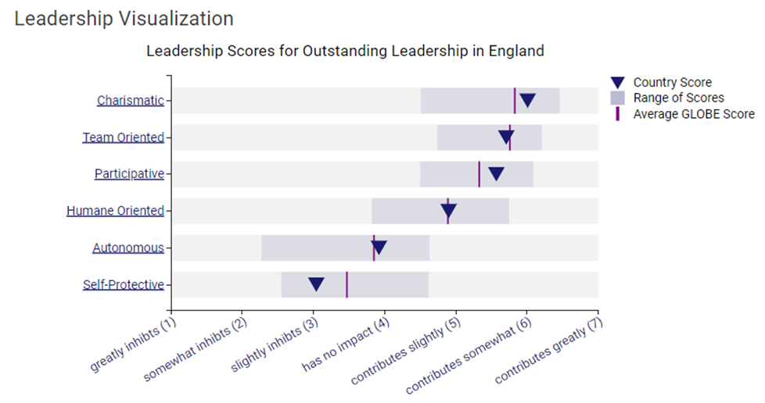
(GLOBE Project, 2004)
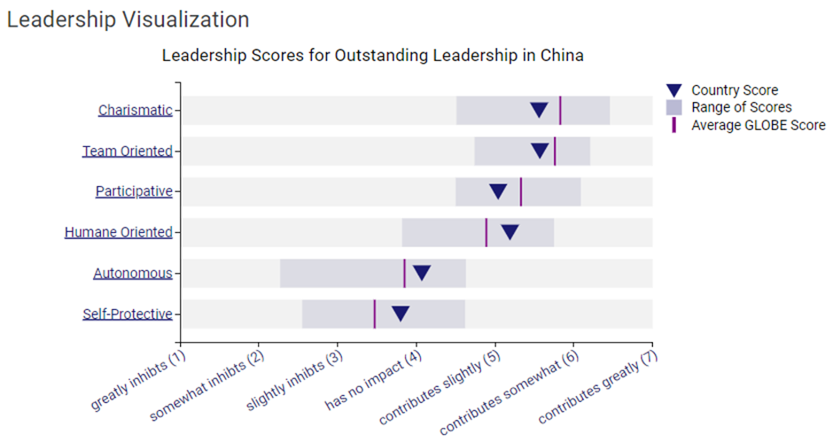
(GLOBE Project, 2004)
Cultural differences significantly shape business dynamics in England and China. In England, individualistic values drive entrepreneurial initiatives, with decision-making often decentralized (House, 2013). Leadership styles prioritize collaboration and open communication. Conversely, in China, collectivism influences collaborative business practices, and hierarchical structures guide decision-making. Leaders often embody a paternalistic role, emphasizing mentorship and group harmony (Wang, 2012) . Intercultural competence is pivotal, enabling leaders to navigate nuanced communication styles, diverse work ethics, and varying approaches to decision-making. Leaders fostering intercultural competence facilitate effective collaboration, build trust, and adapt strategies for success in both the British and Chinese business landscapes, underscoring the role of cultural sensitivity in achieving organizational effectiveness and sustainable leadership.
9. Conclusion
In conclusion, the analysis reveals distinctive cultural aspects in England and China, impacting communication styles, work ethics, and business practices. Recognizing these differences is imperative for successful cross-cultural engagements. Intercultural competence emerges as a linchpin for effective leadership and organizational success (Grobelna, 2015). Navigating the intricacies of the global marketplace necessitates not only an understanding of cultural nuances but also the ability to adapt and appreciate diverse perspectives. Leaders and organizations equipped with intercultural competence can forge meaningful connections, foster collaboration, and thrive in an interconnected world, reinforcing its pivotal role in achieving success amidst the complexities of the ever-evolving global landscape.
10. Recommendations
Key recommendations focusing on cultural intelligence and sensitivity for delegated hotel staff in the business (Diversity Hotel & Spa) context of expansion in China:
- Cross-Cultural Training: provide comprehensive cross-cultural training to all hotel personnel, especially those in customer-facing roles. Understanding the cultural nuances of Chinese guests, such as communication styles, preferences, and expectations, is crucial for delivering exceptional service. Training should cover topics like greetings, gift-giving customs, and dining etiquette (Hsu, 2016).
- Adaptation of Service Standards: tailor service standards to align with Chinese cultural norms and expectations. Chinese guests may have different expectations regarding service, such as a preference for a more personalized and attentive approach. Training staff to adapt their service style to accommodate cultural preferences can enhance guest satisfaction (Grobelna, 2015).
- Language and Communication: Invest in language training for hotel personnel, including front-desk staff, concierge, and restaurant teams. Language is a critical aspect of communication. While English proficiency is valuable, having some staff members fluent in Mandarin can greatly improve the guest experience. This also demonstrates a commitment to understanding and accommodating Chinese guests.
- Cultural Sensitivity in Marketing and Promotion: Tailor marketing materials and promotional activities to resonate with Chinese cultural values and aesthetics. Cultural sensitivity in branding and promotional efforts can attract Chinese clientele.
- Cultural Awareness Training for Leadership: Ensure that leadership, including the general manager, undergoes cultural awareness training. Leadership sets the tone for the entire organization. A culturally aware leadership team will be better equipped to foster a workplace environment that values diversity and understands the importance of cultural intelligence in business operations (Bakir, 2017).
Implementing these recommendations will help the hotel personnel in the new subsidiary navigate cultural differences effectively, providing a positive and culturally sensitive experience for Chinese guests. Regular feedback mechanisms and continuous learning initiatives can further enhance cultural intelligence over time

REFERENCE LIST

Bakir, A., et al. (2017) “Cross-cultural issues in tourism and hospitality. ”Tourism and Hospitality Research 17.3: 245-248. (https://journals.sagepub.com/doi/full/10.1177/1467358416653868)
Grobelna, A. (2015) “Intercultural challenges facing the hospitality industry. Implications for education and hospitality management”. Journal of Intercultural Management 7.3, 101-117. ( available at https://www.ceeol.com/search/article-detail?id=798971 )
House, R. et al. (2004). Culture, leadership, and organizations: The GLOBE study of 62 societies. Sage publications.
House, R. et al. (2013). Strategic leadership across cultures: GLOBE study of CEO leadership behavior and effectiveness in 24 countries. Sage Publications.
Hsu, C. HC, and Songshan S.H. (2016) “Reconfiguring Chinese cultural values and their tourism implications”. Tourism Management 54: 230-242. (Available at: https://www.sciencedirect.com/science/article/abs/pii/S0261517715300467)
Huang, S., Wen, J., (2021) “Developing and validating a Chinese cultural value scale in tourism”, Tourism Management, Volume 86, 2021,104327,ISSN 0261-5177, https://doi.org/10.1016/j.tourman.2021.104327. (Available at: https://www.sciencedirect.com/science/article/pii/S0261517721000467)
Rudd, D., and Mills, R. (2015) “Communication, Climate and Culture in the Hospitality Industry”. American Journal of Management 15.4. ( Available at: http://digitalcommons.www.na-businesspress.com/AJM/RuddD_Web15_4_.pdf )
Tabari, S., Jonathan AJ W., and Hadyn I. (2016) “Conceptualising the impact of culture and language upon hospitality service management”. Worldwide hospitality and tourism themes 8.1: 12-28. ( available at: https://www.emerald.com/insight/ content/doi/10.1108/WHATT-10-2015-0037/full/html)
Wang, H., Waldman, D. A., & Zhang, H. (2012). “Strategic leadership across cultures: Current findings and future research directions”. Journal of world business, 47(4), 571-580.
Yihong, G., Joseph, L. B., & Jane, O. (2009). “Sociocultural contexts and English in China: Retaining and reforming the cultural habitus”. China and English: Globalisation and the dilemmas of identity, 6, 56.
GLOBE project (2004) Visualizations of 2004 study / China / Culture Visualization and Leadership Visualization available at : https://globeproject.com/results/countries/CHN?menu=country#country
GLOBE project (2004) Visualizations of 2004 study / England / Culture Visualization and Leadership Visualization available at:
https://globeproject.com/results/countries/GBR?menu=country#country

Appendix
Findings – extra Globe Project
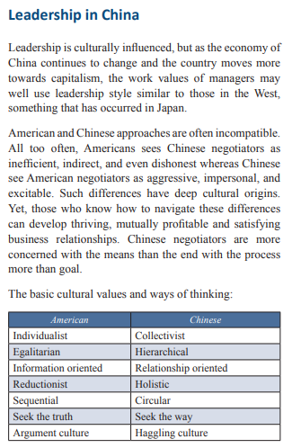
(Garg, 2018)
Garg, S. (2018) “Strategy and Leadership Practices Across Cultures World Wide,” International Journal on Leadership, 6(2), pp. 35-.
“insights into leadership from [.] 20 countries and regions around the world, including socio-cultural analysis from experts in China, Brazil, Ethiopia ”(Western, 2018)
Western, S. and Garcia, E.-J. (eds) (2018) Global leadership perspectives : insights and analysis. Los Angeles: SAGE.
“to become aware of cultural differences, how to recognize when cultural differences pose a leadership challenge, and how to adapt your communication” (Prince, 2000)
Prince, D.W. and Hoppe, M.H. (2000) Communicating across cultures. 1st edition. Greensboro, N.C: Center for Creative Leadership.
Thematic bibliography
1 . Cultural Dimensions and Frameworks:
Books:
“The Culture Map: Breaking Through the Invisible Boundaries of Global Business” by Erin Meyer
Cultures and Organizations: “Software of the Mind” by Geert Hofstede, Gert Jan Hofstede, and Michael Minkov
“Riding the Waves of Culture: Understanding Diversity in Global Business” by Fons Trompenaars and Charles Hampden-Turner
Journals:
Journal of International Business Studies (JIBS)
Articles:
"The GLOBE Study of CEO Leadership Behavior and Effectiveness in 24 Countries" by Robert J. House et al. (Published in The Leadership Quarterly)
2. Leadership Styles and Behaviors:
Books:
“Cross-Cultural Management: Essential Concepts” by David C. Thomas and Mark F. Peterson
“Managing Across Cultures” by Charlene Solomon and Michael S. Schell
Journals:
The Leadership Quarterly
Journal of Organizational Behavior
Articles:
"Leadership Across Cultures: A Comparative Study" by Marcus W. Dickson et al. (Published in Applied Psychology)
3. Global Trust and Perception:
Reports and Surveys:

The Edelman Trust Barometer
Additional Books:
“The Trusted Advisor” by David H. Maister, Charles H. Green, and Robert M. Galford
Trust: The Social Virtues and The Creation of Prosperity by Francis Fukuyama
4. Cross-Cultural Training and Development:
Professional Organizations:
Society for Intercultural Education, Training, and Research (SIETAR)
Additional Books:
“Building Cultural Competence: Innovative Activities and Models” by Kate Berardo and Darla K. Deardorff
“The Art of Crossing Cultures” by Craig Storti
5. Research Methodology in Intercultural Studies:
Dissertations and Theses:
ProQuest Dissertations & Theses Global
Books:
“Doing Cross-Cultural Research: Ethical and Methodological Perspectives” by Prue Holmes and Fred Dervin
“Handbook of Research on Cross-Cultural Business Education” by Bryan Christiansen
6. Further reading (recommendations on titles)
Journals:
Journal of International Business Studies (JIBS): Publishes research on various aspects of international business, including cross-cultural management.
International Journal of Intercultural Relations: Focuses on research related to intercultural communication and relations.
The Leadership Quarterly: A leading journal on leadership research, covering various aspects of leadership styles and practices.
Books:
The Culture Map: Breaking Through the Invisible Boundaries of Global Business by Erin Meyer: Provides insights into cultural differences and their impact on global business.
Cultures and Organizations: Software of the Mind by Geert Hofstede, Gert Jan Hofstede, and Michael Minkov: A classic work on cultural dimensions and their implications for organizations.
Riding the Waves of Culture: Understanding Diversity in Global Business by Fons Trompenaars and Charles Hampden-Turner: Explores cultural differences and their effects on international business.
Academic Articles:
Check academic databases such as PubMed, JSTOR, and Google Scholar for recent articles on intercultural competence, leadership, and cross-cultural management. Use keywords like "intercultural competence," "leadership styles," and "cross-cultural comparison."
Research Reports:
Reports from organizations like the World Economic Forum, McKinsey & Company, and the World Bank often include valuable insights into global leadership and intercultural competence.
Research Institutes and Centers:
Explore publications from research centers and institutes focused on cross-cultural studies and leadership, such as the Center for Creative Leadership (CCL) and the Hofstede Centre.
Books:
Cross-Cultural Management: Essential Concepts by David C. Thomas and Mark F. Peterson: Provides a comprehensive overview of key concepts in cross-cultural management.
Managing Across Cultures by Charlene Solomon and Michael S. Schell: Offers practical insights into managing cultural differences in a global business environment.
Journals: Journal of Organizational Behavior: Covers research on organizational behavior, including topics related to leadership and cross-cultural management.
Cross Cultural & Strategic Management: Focuses on research at the intersection of cross-cultural issues and strategic management.
Articles:
"The GLOBE Study of CEO Leadership Behavior and Effectiveness in 24 Countries" by Robert J. House et al. (Published in The Leadership Quarterly): This article delves into the GLOBE study and its findings on leadership behavior in different cultural contexts.
"Leadership Across Cultures: A Comparative Study" by Marcus W. Dickson et al. (Published in Applied Psychology) provides insights into cross-cultural leadership behaviors.
Reports and Surveys:
The World Values Survey: This ongoing global research project explores sociocultural and political change. It can offer insights into cultural values in different countries.
The Edelman Trust Barometer: While not specifically focused on intercultural competence, this annual report provides insights into trust and leadership perceptions globally.
Professional Organizations:
The Society for Intercultural Education, Training, and Research (SIETAR): Check for publications, conferences, and resources related to intercultural competence.
The Academy of Management: Explore the international business and organizational behavior divisions for relevant research.
Dissertations and Theses:
ProQuest Dissertations & Theses Global: Search for recent dissertations and theses related to intercultural competence and leadership, as they often contain valuable insights and literature reviews.

