
ASSIGNMENT – 1
REPORT

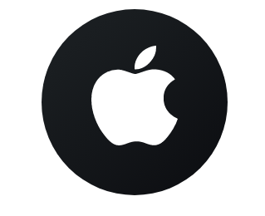

NAME – VIKALP VIDISH
STUDENT NUMBER – 2218769
MODULE CODE – BMMB7007
MODULE NAME – HUMAN RESOURCE MANAGEMENT
MODULE TITLE – APPLE’s HRM AND RECRUITMENT PROCESS

Executive Summary
Apple Inc. is considered one of the biggest and most prominent multinational technology companies. Over the years, it has achieved tremendous success and is recognized because of its innovative products and brand reputation. A culture of creativity, excellence, and diversity at Apple is embodied in its organizational structure and human resources management practices.
Apple’s recruitment, selection and onboarding processes are crafted to attract and assess and hire talented candidates who can contribute to company’s success and growth. It has a very tough and strict recruitment process to ensure that each and every position is occupied by the best candidates who share its vision of innovation and excellence. In spite of this streamlined recruitment, selection, and onboarding process, there is still scope for improvement. This report examines the current process of recruitment that is followed by Apple and identifies areas for improvement.
Following an overview of the organization's history and structure, the report analyses the company's human resource management model mainly in terms of the hiring process, by comparing it with the ‘best practice HRM model’ and the ‘HR value chain model’. Moreover, it provides a detailed information about Apple’s recruitment, selection, and onboarding process. Additionally, it provides information about the current issues with the recruitment process and provides suitable recommendations to overcome the issues.

Table of Contents
Executive Summary 1
1.0 Introduction 4
2.0 Apple’s Organisational Overview 5
2.1 Characteristics of Apple’s organizational structure 6
2.2 Apple’s Human Resource Management 6
3.0 Analysis & Comparison of Apple’s HRM Model 6
3.1 Best Practice HRM Model 6
3.2 Comparison of Apple’s HRM with Best Practice HRM Model 7
3.3 Comparison of Apple’s HRM with HR value chain model of HRM 9
3.4 Apple’s Recruitment, Selection & Onboarding Process 10
3.5 Weakness & Impact of Apple’s Hiring Process 11
3.6 Benefits of Improving the Overall Recruitment Process 12
4.0 Conclusion 12
5.0 Recommendations 13
6.0 Reference List 13

List of figures
Fig 1. Apple Organizational Structure……………………………………………………………………………………………….5
Fig 2.Seven Best Human Resource Practices…………………………………………………………………………………….7
Fig 3. HR Value Chain Model…………………………………………………………………………………………………………….9
Fig 4. Apple’s Selection Process……………………………………………………………………………………………………….10
Fig 5: Apple’s Racial Diversity in the Workforce (2021)…………………………………………………………………….12

1.0 Introduction
Apple Inc. was founded in the year 1976 by Steve Jobs and Steve Wozniak. It is one of the global leaders in terms of technology and innovation (Arocha, 2017). The company uses a simple apple logo as its unique brand image. Initially, Apple was only manufacturing computers, but in order to remain competitive with companies like Intel and Microsoft, it invested in research and development and gradually invented several new products like the iPod, iPad, iPhone, Mac, and Apple Watch. Apple also invented many services like iCloud, Apple Care, etc. Using good marketing strategies and a creative business model in conjunction with advanced technology and a unique design aesthetic, the company eventually became the symbol of a high-end, luxurious, and world-famous tech enterprise (Tian and Wang, 2022).
Innovative technology is one part of Apple's success; the other part is functional human resource management practises that play a crucial role in attracting and recruiting the best employees who, being talented and creative, share their vision and values and are responsible for the growth of the company. Although the recruitment process at Apple is highly selective, with a sheer focus on hiring the top talents, this might have also resulted in probable bias, in addition to the absence of diversity within the organization, with reports indicating that Apple's human capital mostly comprises of white and Asian men (World, 2020).
In this report, Apple's organizational profile and business model will be discussed, along with the company's human resource management framework in terms of recruitment, selection, and onboarding, as well as the gaps and potential opportunities for improvement. Moreover, it will also analyse the advantages of improving the recruitment, selection, and onboarding processes with suitable recommendations.

2.0 Apple’s Organisational Overview
Apple’s headquarters are situated in Cupertino, California, United States, at the centre of Silicon Valley, and the company has 47 other offices located globally. They design and produce different variants of the MacBook and Mac, one of the most premium personal computers and laptops in the world. Apple has disrupted the mobile phone market with its famous iPhone and App Store and is defining portable computing devices and mobile media’s future with its iPad (Arocha, 2017).

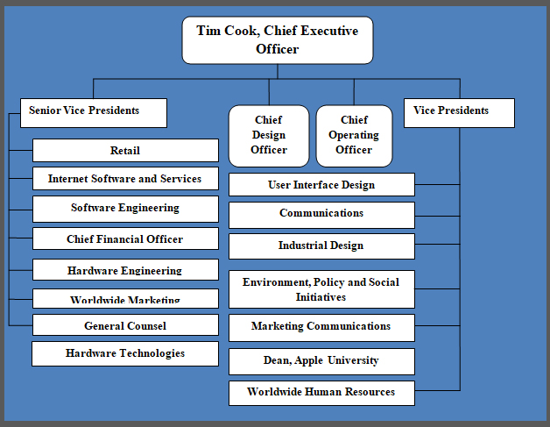
Fig 1: Apple Organizational Structure (Dudovskiy, 2021)
Apple follows a hierarchical and functional organisational structure. It was developed by its former CEO, the late Steve Jobs, with the aim of ensuring focused recognition of his creative ideas and having a clear vision for the business. The organizational structure was slightly modified in order to decentralise the decision-making process to encourage creativity and innovation in the company by the current CEO, Tim Cook (Dudovskiy, 2021).

2.1 Characteristics of Apple’s organizational structure
Hierarchical Structure: Maintaining more than 132,000 full time employees globally requires adhering to a hierarchical organization structure (Dudovskiy, 2021).
Functionality: The functional structure helps in avoiding conflict for resources between heads of product divisions. In addition to this it allows the company to develop new products that require substantial investments without worrying about short-term financial targets (Podolny and Hansen, 2020).
Intergroup and divisional collaboration: A highly productive and intensive collaboration exists between Apple’s various divisions and groups. The company's Board of Directors includes eight members with significant leadership experience across a range of industries. Two members are former CEOs and Chairmen of global companies, and three members are acting CEOs (Apple Inc, 2020).

2.2 Apple’s Human Resource Management
Human resource management (HRM) can be defined as an employee management process emphasizing employees as corporate assets. Since employees are considered business assets, the organization focuses on utilising them effectively so that risk can be minimised and return on investment can be maximized. (Bao et al., 2021)
Apple’s human resource model is based on recruiting talented, diverse, and independent employees who can perform their duties and contribute to the company’s progress in terms of innovation and creativity without much direction. A number of strategic human resource practises are also used by the company, such as selection and recruitment, emphasizing unique thinking, an employee rewards program, and incentives with compensation (Schaarschmidt, Homscheid and Kilian, 2019).

3.0 Analysis & Comparison of Apple’s HRM Model

3.1 Best Practice HRM Model
According to the 'best practice' model, which is also known as the universalist approach, all firms will be more successful by adopting the same best HR practices (Pfeffer and Veiga, 1999).
These practises are commonly known as high performance work systems (HPWS) and are designed to enhance employees' performance, skills, and commitment. It was assumed that these HR practises were universally applicable and successful if adopted (Khilji and Wang, 2006).
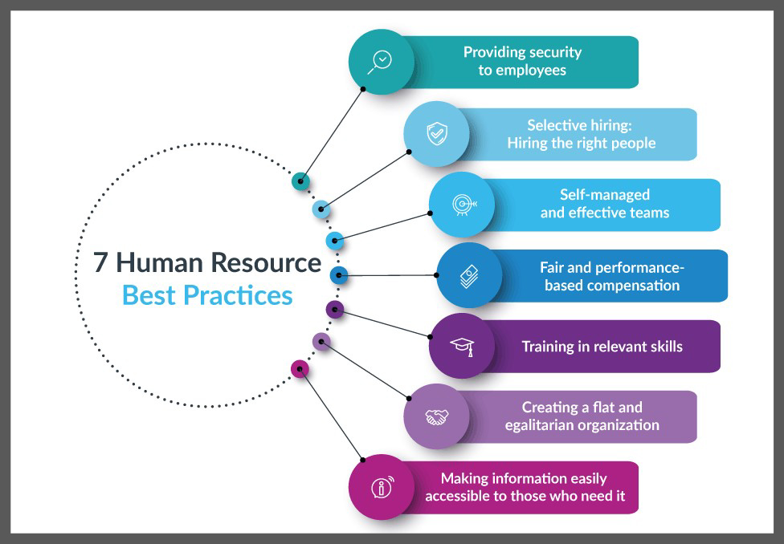
Fig 2: Seven Best Human Resource Practices (Vulpen, 2018a)

3.2 Comparison of Apple’s HRM with Best Practice HRM Model
Mentioned below are the similarities and differences between Apple’s HRM and the Best Practice HRM model in terms of recruitment, selection, and onboarding.
Similarity:
Selective Hiring:
This involves attracting a big applicant pool for each vacancy. This is followed by Evaluating candidates for compatibility with the organization's expectations, objectives, and values which is then followed by multiple rounds of screening to identify the key competencies and attributes that are essential. The last step is to involve senior executives or managers in the hiring process to monitor the performance and retention of new workers in order to assess the results and efficiency of the hiring process (Pfeffer, 1998).
Apple's recruitment process resembles the selective hiring approach of the best-practice HRM model. The hiring process is extremely thorough, with an intense and stressful interview round. The test designed for the recruitment process is much more difficult and challenging than the actual expertise and capacity required for the job (Tran and Dan, 2022).
Extensive Training:
Training helps not only in terms of professional expertise and enhanced product knowledge but also in getting the best of situations, specifically in a leadership role (Marchington and Grugulis, 2000). It was viewed by Boxall as a component of human process advantage, the idea that organizations want to maximise the contribution of exceptional and talented employees (Boxall, 1996).
Apple also provides development opportunities and extensive training for its employees in order to foster creativity and innovation. The company encourages its employees to learn and develop new skills themselves by awarding them stock if they make enough contributions (Lan et al., 2022).
Self-Managed and Effective Teams:
Employers identify this as a basic building block in their organization and treat it as a key attribute when hiring recruits. Typically, it is observed as a route to achieve more innovative solutions in addition to better decision-making (Marchington and Grugulis, 2000).
The company encourages teamwork and participation through its culture of feedback and collaboration. The current CEO of Apple, Tim Cook, is known to value teamwork and to include all levels of the company in his decision making, which has helped Apple maintain and attract top talent (Mathur, 2023).
Differences:
Unlike best practices in HRM, Apple favour’s a non-egalitarian talent management model, which means it doesn't invest much in developing and retaining lower-quality employees, causing a sense of inequality among employees (Vozza, 2017).
As opposed to the Best Practices HRM model, Apple has a highly secretive culture that limits information sharing and communication among employees and external stakeholders, hindering collaboration and innovation in some cases (Storey, 2014).
It is evident from the above analysis that Apple's HRM practices closely resemble the best HRM practices model; however, there are certain areas where they might differ or be improved.

3.3 Comparison of Apple’s HRM with HR value chain model of HRM
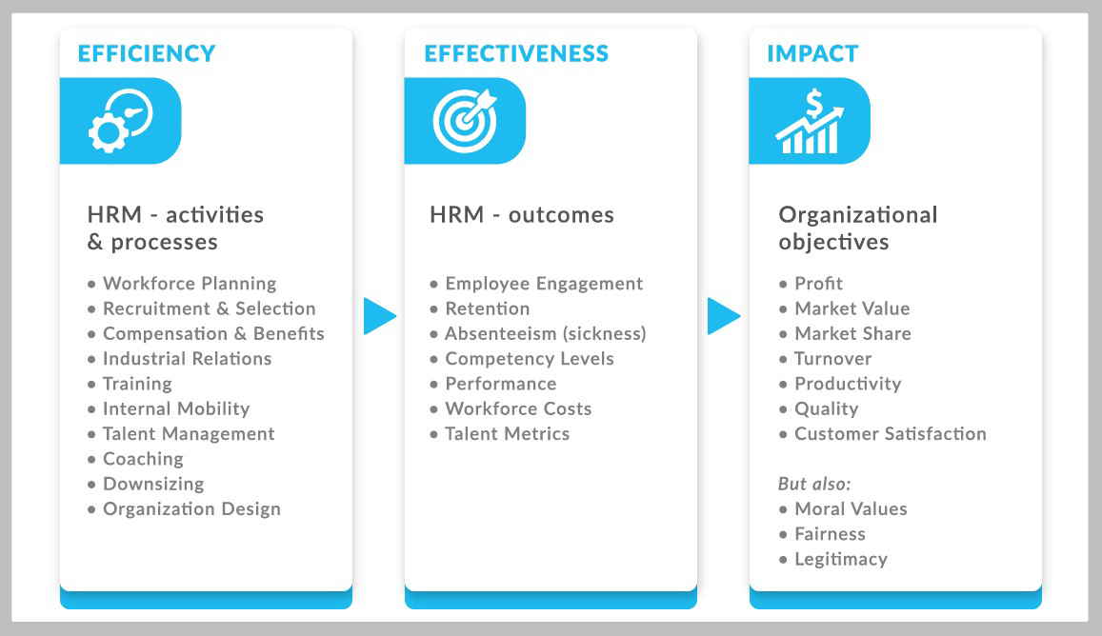
Fig 3: HR Value Chain Model (Vulpen, 2018b)
Human Resource Management at Apple can be compared to the HR value chain model of HRM in terms of how it aligns its HR activities with its organizational goals and measures its HR outcomes. For example:
Apple’s organizational goal is to create innovative products and services that delight customers in addition to adding value for shareholders. It is one of the leading innovation companies in the U.S. (Cegarra-Navarro et al., 2019).
Apple’s HR activities consist of hiring talented individuals for critical roles, fostering a culture rich in innovation and excellence, providing competitive benefits and compensation, offering training and development opportunities, and encouraging employee engagement and feedback (Apple, 2021).
Apple’s HR outcomes are evaluated by indicators such as employee satisfaction, productivity, retention, loyalty and creativity (Tudorache, 2021).
Apple’s HRM also follows the principles of strategic human resource management (SHRM), which is a system that links people management and development practices to long-term business objectives and results (CIPD, 2021a).
Since strategic HRM embraces both sides of the employment relationship: organizational performance and employee well-being, it has become a more balanced subject (Boxall, 2018). Apple's Strategic Human Resource Management (SHRM) team is responsible for a variety of functions, including recruiting and selection, incentive compensation, leadership development, employee development, and employee relations (BohatALA, 2018).

3.4 Apple’s Recruitment, Selection & Onboarding Process
Recruitment:
Recruitment is the process of finding the appropriate candidate for the job vacancy by generating a pool of candidates (Heery and Noon, 2008).
A company's recruitment process will depend on its size and resources. In spite of this, to make the process fair and effective it generally involves certain stages like defining the role, attracting applicants, managing the application and selection process, and making the appointment (CIPD, 2022).
At Apple, the recruitment stage includes the creation of an Apple account, completing the application form, and submitting a resume by visiting the Apple careers page. (Apple World Today, 2022).
In order to recruit the right people, the company looks for individuals who can demonstrate a good set of transferrable skills. The key transferable skills identified in Apple Inc. includes – motivation, team effectiveness, supportive communication, empowerment and conflict management (Trivedi, 2019).
Selection:
There are two main processes involved in selecting candidates: shortlisting and evaluating applicants. The selection process must be fair and free of unfair discrimination. It is recommended that recruiters let candidates know in advance when, how, and what type of assessment will be conducted during the selection process (CIPD, 2021b).
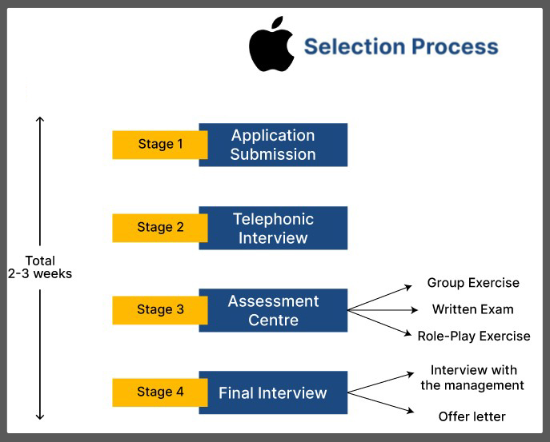
Fig 4: Apple’s Selection Process (Saini, 2023)
Apple uses different evaluation methods during the selection process which includes a telephonic interview, a test assessment at assessment centre and the final interview.
Telephonic Interview:
Shortlisted candidates are invited for the interview round. This round is conducted to check if the candidate possesses basic skills or knowledge required to join the company and it includes questions related to planning and organizing , problem -solving, communication and decision making (unstop, 2023).
Assessment centre test:
As part of the assessment centre test, candidates must perform a group exercise to test their ability to work as a team, a written exercise to evaluate technical skills, and a role-play exercise to assess their public speaking ability (Cooper, 2020).
Final Interview:
A final one-on-one interview is conducted by the director or senior manager before the offer letter is issued. Collaboration, creativity, curiosity, and expertise are some of the key skills that are evaluated during this round (The Economic Times, 2022).

Onboarding:
In the context of a new hire, onboarding refers to everything the new hire experiences as part of his or her entry and orientation into the organization and that prepares him or her for success. From an organizational standpoint, it’s the experiences and programs that can be designed to set up employees to become productive quickly (Stein and Christiansen, 2010).
Usually, the onboarding process is divided into four phases: Pre-onboarding process, Orientation process, role-specific training and completion of probation period (Team, 2022).
On the onboarding day at Apple, the orientation process occupies half of the day, and later, the new hires are gifted with a premium iMac as part of the company's welcome package. In addition to this, employees also receive company stickers with a welcome note and a t-shirt. Moreover, the company provides a variety of benefits, including commuting and health-related benefits (Team,2022).

3.5 Weakness & Impact of Apple’s Hiring Process
The company's code of secrecy prohibits employees from speaking publicly about their work experiences or providing feedback. As a result, there is a lack of information about the organization, which attracts fewer people than it should (Edwards, 2016).
Candidate selection is based more on their ability to fit the organizational culture than on their skills and experience (Rees and Smith, 2017). This strategy appears complicated and may limit talented candidates from applying for open positions in the company.
Most of Apple's employees are white or Asian men, compared to others (GlobalData, 2022). The morale of people belonging to different communities is lowered as a result. This also negatively impact the hiring process in terms of diversity.
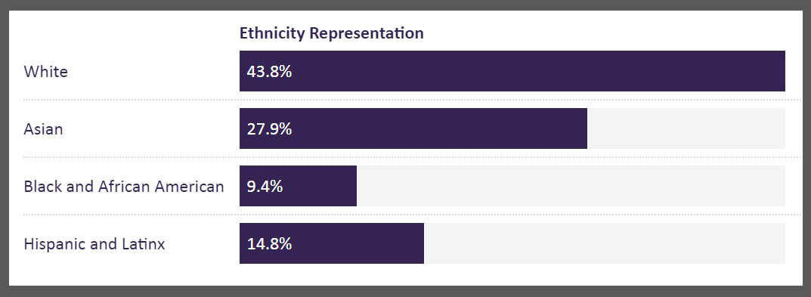Fig 5: Apple’s Racial Diversity in the Workforce (2021) (GlobalData, 2022)

3.6 Benefits of Improving the Overall Recruitment Process
Apple can observe the following benefits by improving the recruitment, selection and onboarding process:
Increment in the number of candidates for the recruitment process can be achieved by sharing more information and by conducting regular feedback and surveys from new hires.
Focusing more on the skillset instead of compatibility with the organizational culture during the selection process will give the company access to large number of skilled candidates during the selection process (Rees and Smith, 2017).
Hiring diverse candidates belonging to different ethnicity and gender will significantly increase the company’s ability to find more talented candidates and also improves its reputation (Schooley, 2023).

4.0 Conclusion
As a company, Apple values innovation, creativity, and excellence in its employees. It has a rigorous recruitment and selection procedure that includes screening, phone interviews, written assessments, and on-site interviews. Depending on the role and location, the procedure could take a few weeks or months. Apple’s selection criteria are based on domain knowledge, technical expertise, and behavioural alignment with the company culture. The onboarding process at Apple aims to provide new hires with the necessary resources, which include training, tools, and support, to be successful in their positions. The recruitment, selection, and onboarding process at Apple is thorough and has positive aspects such as attracting and retaining talented employees, providing competitive compensation and benefits to attract more candidates, providing excellent support during the onboarding and training process, and fostering a collaborative and innovative culture. However, it needs to work on some of the negative aspects, such as that the hiring process is lengthy, demanding, and stressful for candidate and so it is difficult to find candidates who meet all the expectations and requirements set by Apple; that it restricts inclusion and diversity in the recruitment process by giving preference to some personalities and cultures over others; and that the secretive culture limits information sharing and thus negatively impacts the selection process. By implementing the below recommendations, Apple can certainly reduce the negative aspects and make the recruitment, selection, and onboarding processes more effective and streamlined.

5.0 Recommendations
In light of the above conclusion, Apple should invest more in automating its recruitment and onboarding processes using AI (artificial intelligence). This will to some extent reduce the length of the hiring process by providing exact information about the schedule of assessment and interviews and thus will help in reducing the stress of candidates. In addition, it will also help the company by automating some of the repetitive tasks such interview scheduling, offer approvals, job posting and finding global talent. Moreover, AI can also be used in the selection process to conduct initial shortlisting and for giving feedback.
Another recommendation for Apple is to be more open in terms of information sharing and feedback. Increasing employee engagement by conducting regular surveys and feedback from new hires will help the company to understand the problems or gaps in the hiring process.
In addition to all this, It is recommended for Apple to certainly work on diversity inclusion as it is not only a morally right thing to do but will also benefit the company in order to find global talents. Maintaining a diverse environment also means that every employee is supported accepted and respected. This can be achieved by the use of ‘anonymous’ recruiting. This means removing any information that may provoke bias (e.g., ethnicity, gender) and compare candidates purely on their experience and credentials. Reprogramming an biased AI algorithms can also assist in hiring diverse candidates during the selection process. Moreover, investing in training and development for diverse employees will help in the overall onboarding process.

6.0 Reference List
Apple (2021) It takes exceptional people to run an extraordinary company. Available at: https://www.apple.com/careers/us/corporate-functions.html (Accessed: 7th March 2023).
Apple Inc. (2020) Annual report 2020. Available at: https://investor.apple.com/sec-filings/sec-filings-details/default.aspx?FilingId=14468826 (Accessed: 27 February 2023).
AppleWorld Today (2022) How Apple Hires: Secrets of Job Application, Interviews, and Employment. Available at: https://appleworld.today/archives/99667 (Accessed: 10th March 2023).
Arocha, J.B. (2017) ‘Getting to the Core: A Case Study on the Company Culture of Apple Inc.’ [Case Study], RECREATION, PARKS, AND TOURISM ADMINISTRATION, pp.14-23. Available at: https://digitalcommons.calpoly.edu/cgi/viewcontent.cgi?article=1074&context=rptasp (Accessed 25 February 2023).
Bao, H.J. et al. (2021) ‘A study on human resource function: recruitment, training and development, performance appraisal and compensation’, Journal of Global Business and Social Entrepreneurship (GBSE), 7(20), pp. 11-20. Available at: https://www.researchgate.net/profile/Nava-Ratnam-2/publication/348169401_A_STUDY_ON_HUMAN_RESOURCE_FUNCTION_RECRUITMENT_TRAINING_AND_DEVELOPMENT_PERFORMANCE_APPRAISAL_AND_COMPENSATION/links/5ff222ef45851553a0197bc1/A-STUDY-ON-HUMAN-RESOURCE-FUNCTION-RECRUITMENT-TRAINING-AND-DEVELOPMENT-PERFORMANCE-APPRAISAL-AND-COMPENSATION.pdf (Accessed: 27 February 2023).
BohatALA (2018) Strategic Human Resource Activities at Apple Inc. Available at: https://bohatala.com/strategic-human-resource-activities-at-apple-inc/ (Accessed: 7th March 2023).
Boxall, P. (1996) ‘The Strategic HRM Debate and the Resource-Based View of the Firm’, Human Resource Management Journal, 6(3), pp. 59-75.
Boxall, P. (2018) ‘The development of strategic HRM: reflections on a 30-year journey’, Labour & Industry: a journal of the social and economic relations of work, 28(1), pp.21-30. Available at: https://www.tandfonline.com/doi/full/10.1080/10301763.2018.1427423 (Accessed: 7th March 2023).
Cegarra-Navarro, J.G. et al. (2019) ‘An open-minded strategy towards eco-innovation: A key to sustainable growth in a global enterprise’, Technological Forecasting and Social Change, 148, pp. 1-10. Available at: https://www.sciencedirect.com/science/article/abs/pii/S0040162519302999 (Accessed: 7th March 2023).
CIPD (2021b) Selection Methods. Available at: https://www.cipd.co.uk/knowledge/fundamentals/people/recruitment/selection-factsheet#gref (Accessed: 10th March 2023).
CIPD (2021a) Strategic Human Resource Management. Available at: https://www.cipd.co.uk/knowledge/strategy/hr/strategic-hrm-factsheet (Accessed: 7th March 2023).
CIPD (2022) Recruitment: an introduction. Available at: https://www.cipd.co.uk/knowledge/fundamentals/people/recruitment/factsheet (Accessed: 10th March 2023).
Cooper, K. (2020) Interviewing at Apple: Be prepared for anything. Available at: https://candor.co/articles/interview-prep/interviewing-at-apple-be-prepared-for-anything (Accessed: 10th March 2023).
Dudovskiy, J. (2021) Apple Organizational Structure: a brief overview. Available at: https://research-methodology.net/apple-organizational-structure-a-hierarchical-structure-that-may-change-in-near-future/#_ftn1 (Accessed 26 February 2023).
Edwards, J. (2016) Apple employees describe the best and worst things about working for Apple. Available at: https://www.businessinsider.com/apple-employees-best-worst-working-for-apple-2016-12?r=US&IR=T (Accessed: 11th March 2023).
GlobalData (2022) Apple: Racial Diversity in the Leadership in 2021. Available at: https://www.globaldata.com/data-insights/technology--media-and-telecom/apple-racial-diversity-in-the-leadership-2091435/ (Accessed: 11th March 2023).
Heery, E. and Noon, M. (2008) A Dictionary of Human Resource Management. Oxford: Oxford University Press.
Khilji, S.E. and Wang, X. (2006) ‘Intended and implemented HRM: the missing linchpin in strategic human resource management research’, The International Journal of Human Resource Management, 17(7), pp.1171-1189. Available at: https://www.tandfonline.com/doi/full/10.1080/09585190600756384?scroll=top&needAccess=true&role=tab (Accessed: 3rd March 2023)
Lan, S. et al. (2022) ‘Organizational Behavior Theories Work in Apple Inc’, 2022 2nd International Conference on Management Science and Industrial Economy Development (MSIED 2022). University of Pittsburgh, United States, 15-18th May. Dudley: CSP 2022 the Authors, pp. 76-83.
Marchington, M. and Grugulis, I. (2000) 'Best practice human resource management: perfect opportunity or dangerous illusion?’, International Journal of Human Resource Management, 11(6), pp.1104-1124. Available at: https://www.tandfonline.com/doi/abs/10.1080/09585190050177184 (Accessed: 5th March 2023).
Mathur, N. (2023) FROM INNOVATION TO DOMINANCE: TIM COOK'S BLUEPRINT FOR APPLE'S SUCCESS. Available at: https://www.bbntimes.com/companies/from-innovation-to-dominance-tim-cook-s-blueprint-for-apple-s-success (Accessed: 5th March 2023).
Pfeffer, J. (1998) ‘Seven Practices of Successful Organizations’, California Management Review, 40(2), pp. 96-124. Available at: https://www.researchgate.net/publication/265114424_Seven_Practices_of_Successful_Organizations (Accessed: 4 March 2023)
Pfeffer, J. and Veiga, J.F. (1999). Putting people first for organizational success. Academy of management perspectives, 13(2), pp.37-48.
Podolny, J.M. & Hansen, M.T. (2020) How Apple Is Organized for Innovation. Available at: https://hbr.org/2020/11/how-apple-is-organized-for-innovation/ (Accessed: 26th February 2023).
Rees, G. and Smith, P. (2017) Strategic human resource management : an international perspective. 2nd Ed. London: Sage Publications Ltd.
Saini, G. (2023) ‘Must Know Apple Recruitment Process 2023 For Engineers’, Unstop [blog]. 2 February. Available at: https://unstop.com/blog/apple-recruitment-process (Accessed: 10th March 2023).
Schaarschmidt, M., Homscheid, D. and Kilian, T. (2019) ‘Application developer engagement in open software platforms: An empirical study of Apple iOS and Google Android developers’, International Journal of Innovation Management, 23(04), pp.1-27. Available at: https://www.researchgate.net/publication/325645453_Application_developer_engagement_in_open_software_platforms_An_empirical_study_of_Apple_iOS_and_Google_Android_developers (Accessed: 1 March 2023).
Schooley, S. (2023) 7 Ways to Improve Workplace Diversity and Inclusion. Available at: https://www.business.com/articles/diversity-and-inclusion-examples/ (Accessed: 11th March 2023).
Stein, M.A. and Lilith, C. (2010) Successful Onboarding: A Strategy to Unlock Hidden Value Within Your Organization. Mcgraw-Hill.
Storey, J. (2014) New Perspectives on Human Resource Management (Routledge Revivals). 1st Ed. London: Routledge.
Team, E. (2022) Apple Onboarding Experience. Available at: https://www.emexmag.com/apple-onboarding-experience/ (Accessed: 11th March 2023).
The Economic Times (2022) Want a job at Apple? CEO Tim Cook reveals four key skills that he looks for in his employees. Available at: https://economictimes.indiatimes.com/magazines/panache/want-a-job-at-apple-ceo-tim-cook-reveals-four-key-skills-that-he-looks-for-in-his-employees/articleshow/94659480.cms (Accessed: 10th March 2023).
Tian, W., Wang, M., and Wang, Q., (2022) ‘The Core Competentness of Apple Inc’ (from the Proceedings of the 7th International Conference on Financial Innovation and Economic Development, Zhejiang Gongshang University, China, 26th March 2022). Atlantis Press, 648, pp. 718-725.
Tran, N.Q., and Dan, C. (2022) ‘Apple's strategic approach to the issues of employer and human resource branding’, International Journal of Advanced Multidisciplinary Research and Studies, 2(4), pp. 780-788. Available at: https://www.researchgate.net/publication/362839867_Apple's_strategic_approach_to_the_issues_of_employer_and_human_resource_branding (Accessed: 5th March 2023).
Trivedi, S. (2019) ‘A Study on Development of Personal and Management Skills in Apple Inc.’ International Journal of Human Resource Development and Management, 9(1), pp.1-9. Available at: http://mail.ripublication.com/ijhrdm19/ijhrdmv9n1_01.pdf (Accessed: 10th March 2023).
Tudorache, A. (2021) How Apple uses the Balanced Scorecard. Performancemagazine. Available at: https://www.performancemagazine.org/apple-balance-scorecard/ (Accessed: 7th March 2023).
Vozza, S. (2017) Why employee at Google and Apple are more Productive. Available at: https://www.fastcompany.com/3068771/how-employees-at-apple-and-google-are-more-productive (Accessed: 27th February 2023).
Vulpen, E. (2018a) 7 Human Resource Best Practices (A mini-guide to HRM). Available at: https://www.aihr.com/blog/human-resource-best-practices/ (Accessed 4 March 2023).
Vulpen, E. (2018b) ‘The HR Value Chain: An Essential tool for Adding Value to HR’, Academy to Innovate HR [blog]. 30 April. Available at: https://www.aihr.com/blog/hr-value-chain-essential-tool-for-adding-value-to-hr/ (Accessed: 7th March 2023).
World, J. (2020) Apple Employee Diversity Report Shows White and Asian Men Take Majority of Top Jobs. Available at: https://businesschief.com/leadership-and-strategy/apple-employee-diversity-report-shows-white-and-asian-men-take-majority-top-jobs-1 (Accessed: 26 February 2023).

