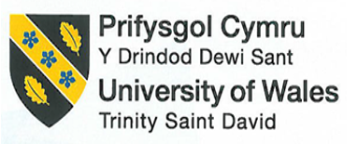

A COMPARISON OF THE MARKETING METHODS OF TWO MULTINATIONAL HOTEL BRANDS

Student Name: Polina Karlikova
Student ID: 2233365
Module Name: Marketing essentials
Module ID: BMIH40005
Lecturer’s Name: Christopher Wilkin

Introduction
Within any organisation, marketing leads the operational management and eventual success by keeping the customers engaged with the business. The competitive edge is also maintained through marketing where organisational innovation is the best practice for keeping customer retention on point and requiring the new one on board (Jobber and Ellis-Chadwick, 2019). Here in this essay, two UK-linked hospitality chains have been selected named Six Senses and Holiday Inn where the marketing department is supposed to venture out the target audience through extensive research. The main rationale behind choosing these hotel chains in the UK context is their promotional management to maintain top-tier hospitality. The essay will include these organisations’ marketing mix, market position, communication range, and strategic approach along with different generational and strategic approaches to marketing. Lastly, consider the relevant contemporary concern such as sustainability and green massaging will be recommended for future runs.

Main body
From a certain aspect, within the hospitality sector considering the national values is completely dependent on the market supply chain and organisational marketing perseverance which can elucidate the industry capacity (Buttle et al., 2016). The market analysis of both the hospitality chain the product and service performance over the years can be demonstrated through a definite analytical tool, the marketing mix. To be very specific, considering the product and services first, from the year of establishment of Six Senses was chiefly biased toward accommodation facilities and mesmerising experiences engaging the customers. However, considering the recent time, company evolution has led them to more sustainable progression for more customer acquisition and promotional gains, for example, plastic freedom within the hotel can be mentioned (sixsenses, 2023 a). On the contrary, Holiday Inn’s marketing approaches can be analysed by researching a detailed progression of the Holiday Inn in the UK context was more concerned about child-friendly accommodation fostering better and distinct experiences.
Continuing this the next thing is Pricing strategies in order to make the operation optimum by considering the marketing purposes and market values, diversified approaches could be beneficial. Here in this aspect, the best thing was value-based pricing strategies but in recent days after the global pandemic and the current recession in the UK, competitive pricing strategy is the approach for every organisation to ensure business authenticity, personal upliftment and sustainable management. Customer needs, organisational goals and compatibility with the eco-system are the main pillars of questionable marketing (Kemper and Ballantine, 2019). Likewise, the next thing is the place of distribution where both companies are supposed to venture into more and more new markets in the current era of globalisation by enhancing operational efficacy, evolving over the years. Considering the global perspective from the year of establishment, 1995, the venture initiated over 19 hotel chains in 16 countries and based on the current report, it is trying to acquire more 38 properties enhancing its development pipeline (sixsenses, 2023 b).
On the other hand, over 2900 location worldwide is acquired by Holiday Inn bringing more cultural diversity in its operation. Lastly, to consider the Promotional mix, Holiday Inn advertise both traditionally and digitally fostering a better understanding of different offers, promo codes and discount programme to attract customer more. In contrast, Six Sense in the global aspect considers digital media where in the year 2019, it created a new website to reinforce a tailor-made approach to content creation and branding through more creative and originality (hospitalitynet.org, 2019).
Every organisation, from a wider aspect, need to put more emphasis on the current market position to deal with the trends and future endeavours with efficacy. With the help of a comparing web portal named Similar Web, a great overview can be drawn, understanding the insight of both the company’s current ranking, traffic and website engagement and visit over time values. Considering the time period of three consecutive months between February 2023 and April 2023, both companies can be analysed through some definite market and customer-linked traits. First, to compare the website performances, Six Senses lies around 125k position and on the other hand, Holiday Inn have a rank of around 123K considering all the industry’s global ranking. Furthermore, considering only the industry rank, Holiday Inn is in a better position than Six Senses obtaining 604 and 614 ranks respectively (pro.similarweb, 2023). Besides, traffic and customer vigilance are other attributes to evaluate the market position of the aforementioned brands. 1.227 million website visits for Six Senses and here Holiday Inn in the given time has the visit almost 1.553 million. From this analysis and graphical presentation, both companies are growing eventually over time and promising growth opportunities., it can be said that holiday inn is in a better position regarding global perseverance (pro.similarweb, 2023).
[Refer to Appendix 1]
From the organisational point of view, customer experiences have a decent connection to range of marketing communication. According to Smith and Zook, (2019), customers are having a multichannel journey before acquiring any market and brand-specific reputation and accountability regardless of channels. To understand the market better segmentation, targeting and positioning analysis can get a better insight. In the demographic segmentation both the organisation, Six Senses and Holiday Inn are chiefly focused on the age group and gender of the target audiences. To be very specific, considering male customers first, Six Senses and Holiday Inn obtain a percentage of 49.19 and 46.52 respectively and the rest are acquired by females. Likewise, considering the Age group, 25 to 34 is the specific one for both the company’s most acquired customers (pro.similarweb, 2023).
[Refer to Appendix 2, 3]
The UK hospitality industry and related market growth opportunities and current size can be the value-based thing to targeting the market. Specifically, the growth and reachability can be measured where the statistics are showing a growth rate of 1.59% considering the CAGR 2023-2027 (Statista, 2023 a). Functional and experiential positioning can be mentioned further where both the band is playing a pivotal role in acquiring customer trust and connecting with their need and emotional requirements, sustainable measurements by the companies are the basis of these where both the hotel chain has taken a good range of future goal to make the operation eco-friendly benefitting customer’s livelihood.
Strategic marketing is a wider consideration and should be a concern of every organisation which is based on the level of marketing research and decision-making potential to mitigate the challenges efficiently. Mention the marketing strategies for both the name, some similarities and dissimilarities can be illuminated. Brand message reinforcement is a similar way of promoting brand values for both companies. Considering the marketing principle and strategic action, Holiday Inn is more intrigued in delivering the valued customer warm and mesmerising experiences to stay with pride and pleasure (ihgplc, 2023). On the other hand, the Marketing coordinator of Six Senses has encompassed their strategies that the brand message offers wellness and sustainable management as the core value for respecting the customer values, and perception, and amplifying the experiential positing. Contrasting this with dissimilarities, Holiday Inn often collaborate with many third parties to drive more customer engagement reinforcement strategies compelling with the content (Samuely, 2023). In contrast, to reinforce better marketing of the brand value, Six Senses are more concerned with social and environmental responsibilities and became the first in the global tourism plastic initiatives (sixsenses 2023 c).
Market communication and enhancement of marketing channels are firstly to be recommended where different activities regarding advertisement, personal selling, Sales promotion, public relation and direct marketing. This can lead both organisations to some effective future growth maintaining contemporary concerns. In the recent world, especially in the UK context, Ukraine-Russia war, Covid 19 and Brexit event, the industry has evolved a lot. Through a genuine concern, the hospitality industry should have been acquiring more vocational training options to engage the employee and other stakeholders more in supporting their career path. Collaborating with government programmes and growth schemes will continue to help the skill of employees handle environmental challenges better (assets.publishing.service.gov.uk, 2021).
From a certain aspect, these mentioned contemporary issues have altered the operational management and marketing approaches for the hospitality industry. Technological advancement has been responsible for emerging digital marketing, especially social media marketing engaging the influences to promote the brand values. In the UK context, this is so opportunistic and futuristic as well considering the social media penetration rate within the nation. According to the current statistics, the social media penetration rate in the UK remained at 90% in 2022 and growing year on year eventually (Statista, 2023 b). Another value-based strategic approach is green messaging from the organisational end where both Six Senses and Holiday are playing in sustainable management. Holiday Inn in this aspect set a Green Engage System to reinforce the different levels of sustainable management. On the other hand, to enhance marketing opportunities, Six Senses relies on its brand message which is “empty of waste, toxin and plastic to gain the spiritual attachment of the people and their joyful celebration” (six senses 2023 d).

Conclusion
From the above discussion, it can be concluded that marketing can play the most essential and pivotal role in order to reinforce the gradual progression of the hospitality brands such as Six Senses and Holiday Inn. The marketing strategies, market positions and holistic overview of the target market are the best things to be measured. Based on the current marketing strategies and evolution of actions, a similar web portal has analysed different market-linked attributes for both countries. Different generational and strategic approaches considering the current volatility in the environment and global market, have been recommended lastly, for both the brand to gain the marketing opportunities effectively.

References
assets.publishing.service.gov.uk (2021). Hospitality Strategy. Available at: https://assets.publishing.service.gov.uk/government/uploads/system/uploads/attachment_data/file/1003059/1200-APS-CCS0621819592-002-BEIS-Accessible2.pdf (Accessed 21 May 2023)
Buttle, F., Bowie, D., Brookes, M. and Mariussen, A. (2016). Hospitality Marketing. Taylor & Francis.
hospitalitynet.org (2019). Six Senses Launches a New Website. Available at: https://www.hospitalitynet.org/news/4094860.html (Accessed 20 May 2023)
ihgplc (2023). Joy of travel for all. Available at: https://www.ihgplc.com/en/our-brands/holiday-inn#:~:text=At%20Holiday%20Inn%20Hotels%20%26%20Resorts,staying%20for%20business%20or%20pleasure (Accessed 21 May 2023)
Jobber, D. and Ellis-Chadwick, F. (2019). EBOOK: Principles and Practice of Marketing, 9e. McGraw Hill.
Kemper, J.A. and Ballantine, P.W. (2019). What do we mean by sustainability marketing?. Journal of Marketing Management, 35(3-4), pp.277-309.
pro.similarweb (2023). Competitive Research. Available at: https://pro.similarweb.com/#/digitalsuite/websiteanalysis/overview/website-performance/*/999/2023.02-2023.04?webSource=Total&key=sixsenses.com,holidayinn.com (Accessed 21 May 2023)
Samuely, A. (2023). Holiday Inn promotes travel planning with mobile destination guide contest. Available at: https://www.marketingdive.com/ex/mobilemarketer/cms/news/strategy/23228.html (Accessed 21 May 2023)
sixsenses (2023 a). Six Senses. Available at: https://www.sixsenses.com/en (Accessed 20 May 2023)
sixsenses (2023 b). CORPORATE FACT SHEET. Available at: https://www.sixsenses.com/media/14698/six-senses-corporate-fact-sheet-0323.pdf (Accessed 20 May 2023)
sixsenses (2023 c). Six Senses Joins Global Tourism Plastics Initiative to Become Plastic Free by 2022. Available at: sixsenses.com/en/corporate/media-center/press-releases/2020/six-senses-joins-global-tourism-plastics-initiative-to-become-plastic-free-by-2022 (Accessed 21 May 2023)
sixsenses (2023 d). ENVIRONMENT. Available at: https://www.sixsenses.com/en/sustainability (Accessed 21 May 2023)
Smith, P.R. and Zook, Z. (2019). Marketing communications: Integrating online and offline, customer engagement and digital technologies. Kogan Page Publishers.
Statista (2023 a). Hotels - United Kingdom. Available at: https://www.statista.com/outlook/mmo/travel-tourism/hotels/united-kingdom#:~:text=Revenue%20in%20the%20Hotels%20segment,US%2422.44bn%20by%202027 (Accessed 21 May 2023)
Statista (2023 b). UK: social media penetration 2018-2027. Available at: https://www.statista.com/statistics/553582/predicted-social-network-user-penetration-rate-in-the-united-kingdom-uk/#:~:text=UK%3A%20social%20media%20penetration%202018%2D2027&text=In%202022%2C%20the%20social%20media,is%20expected%20to%20reach%2093.48%25 (Accessed 21 May 2023)

Appendices

Appendix 1 – Visit over Time Analysis
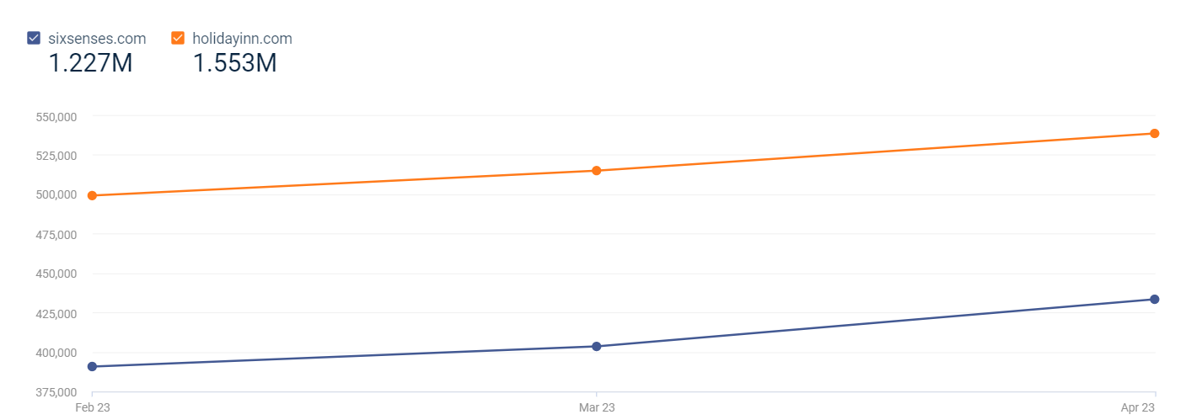
(Source: pro.similarweb, 2023)

Appendix 2 – Gender Distribution
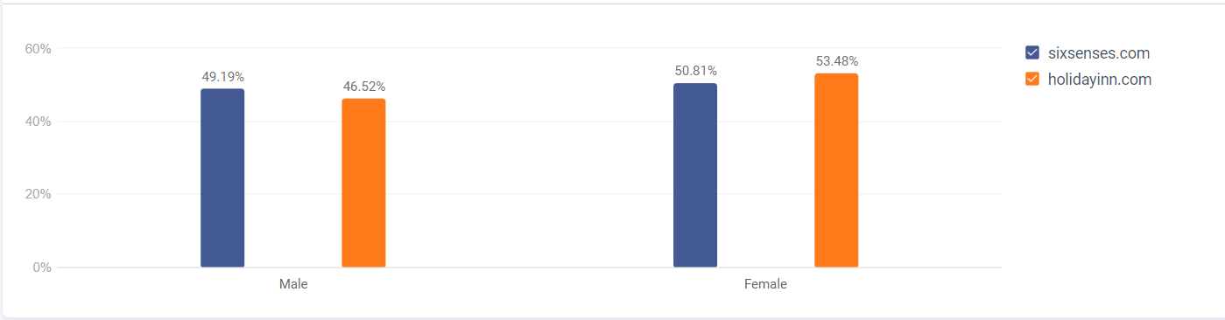
(Source: pro.similarweb, 2023)

Appendix 3 – Age Distribution
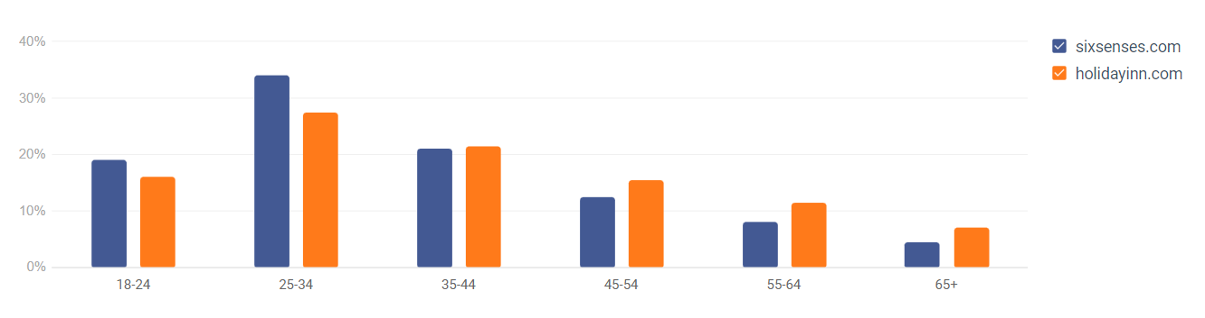
(Source: pro.similarweb, 2023)

Appendix 4 – Communication Plan Gantt Chart


