Name – Adriana Dulceneya Ribeiro Silva
Student Number – 2008480
Module Code - BMSK4002_LON
Module Title – Individual Report
Lecturer’s Name – Diya Ganguly
Assignment Title – Effective Team Working and Communication

Contents

Introduction 2
Define what communication is 2
Three Models of Communication 2
Communication Skills 5
Case Studies 6
Examples of poor communication in workplace 8
Suggestions for improvement by using theory 8
Conclusion 9
References 10

Introduction
Every professional must develop the ability to communicate effectively in order to transfer information and produce greater understanding. However, it is important to develop both verbal and non-verbal communication skills to avoid miscommunication (Baumann, 2017). In this report, the different models of communication have been discussed along with their application to the case studies. The aspect of miscommunication and its solutions within the case studies have been explored and the focus of poor communication problems and its improvement has been suggested.

Definition of communication
Communication could be described as the process which involves the transmission of information from one person to another to create or develop understanding in the mind of others (Velichkovsky, 2013). The word communication has been originated from “communicare” or “communis” which signifies the tendency “to impart” or “participate” or “share” information with others.

Three Models of Communication
There are different models of communication that helps to explain the process in which messages and information are exchanged across different entities. In these regards, the Shannon and Weaver model of communication is a prominent model that is designed to develop effective communication between the sender and receiver. The model also explicated the factors that affect the communication process such as Noise (Al-Fedaghi, 2012). The Shannon and Weaver model are as follows:

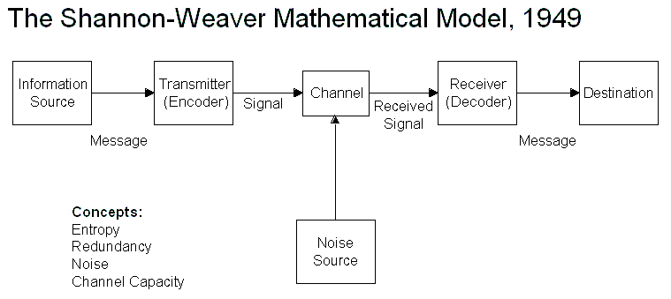
Figure 1: Shannon-Weaver's Model of Communication
Source: (Donohue, 2017)
The Shannon and Weaver model encompasses various concepts such as the information source at which the sender originates a message or information, the transmitter in which the encoders converts the message into the signal, noise in which the message is transferred to the decoder by the encoder through the channel and within which the message may get distracted or affected by physical noise like crowd noise, thunder and horn sounds, decoder in which the message is received which converts the signal into message and information destination where the message has been received by the receiver (Al-Fedaghi, 2012).
Schramm's model of communication is another important model which has developed its roots from the Shannon and Weaver model. This model of communication was proposed by Wiber Schramm in the year 1954 and takes into consideration to highlight the effectiveness of information if it is not put in words or meanings.

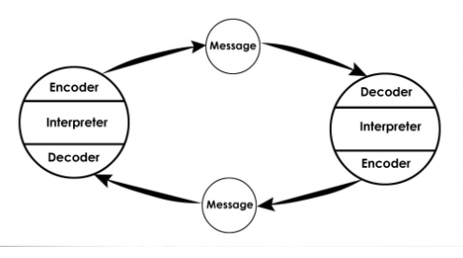
Figure 2: Schramm's model of communication
Source: (Elleström, 2019)
There are three important aspects within the Schramm’s model such as encoder, decoder and interpreter. Encoder is the one who sends the message, decoder is the one who receives the message, and the interpreter is the one with the role to interpret, understand and analyse the message sent to complete the communication process. It is not a usual traditional model of communication as it tends to break the receiver and sender model by making communication in a practical manner (Bylieva, Lobatyuk and Safonova, 2019). Therefore, encoding plays an important role in this communication model by appropriately converting thoughts into the content so that the message sent and received is correctly understood by both parties.

Berlo’s model of communication unlike Shannon & Weaver and Schramm operates under the principles of the SCMR model. The SCMR model stands for Source, Message, Channel and Receiver.
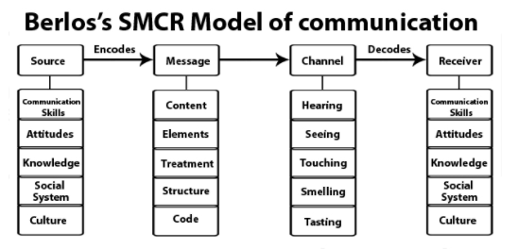
Figure 3: Berlo's model of communication
Source: (Talukdar, 2017)
The source within the model represents the sender who is responsible for sending the message. The sender uses communication skills, attitude, knowledge, social system and culture to transform thoughts into words to be transmitted to the receiver. The message is also called an encoding process which consists of the following elements such as content, elements, structure, treatment and code. Channel within the model represents the mode through which a message is sent to make the communication successful (Petersons and Khalimzoda, 2016). The five senses within the channel include hearing, touching, seeing, tasting and smelling. Finally, the receiver also called as decoding stage uses communication skills, culture, social system, knowledge and attitude to receive and provide necessary feedback to the sender to complete the communication process.

Communication Skills
Communication skills constitute an important part of daily life as it benefits individuals to share their feelings and thoughts with other people. Communication can be done in two different ways such as in the form of verbal and non-verbal communication.
Verbal communication can be defined as the type of oral communication at which point the sender uses oral mode to send the message to the receiver in the form of spoken words. There are two major forms of communication skills that need to present in order to make verbal communication successful such as spoken or written. Oral or spoken communication skills are the form of communication that is carried out through the mouth (Prabavathi and Nagasubramani, 2018). The presence of oral communication skills makes it easier for individuals to interact and share messages directly with one another. Examples of oral skills include telephonic conversation, interviews, meetings and lectures. Written skills within verbal communication involve sending a message through the help of writing orders and instructions. This skill is important as it helps in maintaining clarity which is often distracted in oral communication. Some of the examples of written communication skills include the use of letters, reports, office memos, memoranda and brochures.
Non-verbal communication on the other hand is the form of communication that involves body language, gestures and tone of voice to impart messages between the sender and receiver. The two major skills within non-verbal communication include gestures and facial expression which constitute an important part of body language (Sheth, 2017). The gesture skill can be used to express feelings and intentions to others. For example, in English-speaking nations, the use of “OK” sign as a gesture conveys a positive message whereas it is offensive in Germany and Brazil. Consequently, facial expressions also enable individuals to share thoughts and feeling with others. Some of the examples of facial expressions shown by individuals are happiness, anger, surprise, fear and disgust to let others know about their feeling and sentiments towards the final decision (Smith, 2013).

Case Studies
As per Maria and Pedro’s case study, there had been a clear miscommunication between the couple. Firstly, the conversation took place over the phone in which Maria had asked Pedro to get a chicken while Pedro had misunderstood it to be the kitchen and therefore, he went straight into the kitchen after getting home from work. On confrontation, it was found that Pedro thought that his wife has asked him to see her in the kitchen. The justification of this miscommunication could be due to interfering factors such as background noise. Pedro works at the building site where there could be substantial noises of the working of the machines and boulders. This noise could disrupt the receiver from receiving the actual message (Healey, De Ruiter and Mills, 2018). As per the Shannon and Weaver Model of communication, the information source is Maria who transmits a message of getting her a chicken, however at the information destination there had been substantial physical noise of machines and boulders at the building site which disrupted the receiver to receive the message (Al-Fedaghi, 2012). During this communication process, Pedro perceived that his wife has asked her to meet her in the kitchen instead of bringing her a chicken. A solution to this miscommunication is that Pedro could have excused his wife over the phone and gave her a call back when the background noise has stopped. This would have induced a clear noise-free conversation in which Pedro could have actively listened to his wife’s request of bringing her a chicken when returning from work.

The case study on the professor of English at a reputed Welsh University and the village people is crucial in understanding the context of miscommunication without any background noise or disruption. The professor’s house had been on fire and he rushed to the village screaming for help. It must be noted that the professor never visited the village considering the village people to be uneducated and engaged in manual jobs. However, the professor screamed for help by stating “The edifice is being consumed by a great conflagration!” However, none of the villagers could decode the language as they were uneducated and therefore no one came for help. On questioning, they revealed that the professor should have said that his house is on fire and they would have helped. The miscommunication in this regard has been raised due to the diversity in the English language that the professor had used. The same words when could be used in a simplified way would have been easily comprehended by the village people. In this regard, the use of dialect is significant for justifying the miscommunication. Due to the limited capacity of the brain, individuals (especially the village people who are uneducated) use a limited number of words. The dialects have several meanings which depend on the context and in this case, the meaning and the context of the spoken words are not comprehendible and clarified (Sayer, 2013). As per the Schramm Communication model, it could be said that there had been a communication circular between the sender and recipient of the message. However, the message is encrypted and passed on to the recipient with an inappropriate choice of words which have created a problem in decrypting the message. This model suggests that the decoding or decrypting of a message depends on different factors, for instance, it depends on how an individual is aware of the topic and how much knowledge the recipient possess in terms of interpreting the message (Elleström, 2019). In this case, the professor had used complex words for asking for help which made it difficult for the recipient or the village people to decode it as they do not have sufficient vocabulary knowledge about the English words. The solution to the problem would be that the professor should have prior communicated with the villagers to determine the level of English that they can comprehend and interact with. While doing so, the professor would be aware of using simple words to communicate with the village people and in this context; the professor could have simply said that his house is on fire.

Examples of poor communication in workplace
Poor communication in the workplace can significantly impact organisation performance by transmitting wrong messages to employees in the organisation. One crucial example of poor communication in the workplace can arise in the form of constantly interrupting. There is always a perception among employees to share their feeling and thoughts in the meeting to show their interest level (Boggaard, 2016). This process often results in providing individuals to jump into an ongoing communication thereby interrupting the overall flow of the message, resulting in poor communication within a team in the workplace.
Working with service users, failure to actively listen to the co-workers at the workplace is a significant example of poor communication. There are incidents where the leaders and/or employees operate in a disconnected way with the individuals as they fail to listen to them and thereby induce poor communications. Within workplace, if an individual fails to listen to a co-worker, then it would create an ecosystem of disregard and devalues the professional relationships (Jonsdottir and Fridriksdottir, 2020).

Suggestions for improvement by using theory
Poor communication practices can be overcome in the workplace through the help of communication accommodation theory (Giles, 2016). This theory is based on empowering individuals to change or adjust their behaviours while interacting with others. Thus, to manage the constantly interrupting issue, the theory would act in favour of changing the behaviour of individuals by influencing them to develop a safe space so that people can enjoy their time in completing their communication without getting interrupted (Gino, 2017).
Suggesting an improvement for the problem of active listening failure is to develop active listening skills by each of the workers within a workplace. It helps in building strong relationships and to increase the knowledge from the perspective of the speaker (Bodie, 2015). As per the communication accommodation theory, the human tendency must be to adjust to the behaviour in times of interaction. In this regard, there must be convergence in the process in which co-workers must adapt the active listening skills to reduce conflicts and miscommunication.

Conclusion
In conclusion, it can be said that communication is important on the professional front as it helps to build connections, develop trusts and increase the knowledge of various topics with minimised misunderstanding. In this regard, the case studies of Maria and Pedro and the Professor and Village People highlight the two different type of miscommunication such as the presence of noise and diversity in the English language. Models such as Shannon and Weaver model, Schramm model and Berlo’s model have been discussed. Further, examples of poor communication and suggestions for its improvement have been explored with theory.

References
Al-Fedaghi, S. (2012) 'A conceptual foundation for the Shannon-Weaver model of communication', International journal of soft computing, vol. 7, no. 1, pp. 12-19. [accessed 27 april 2021]
Baumann, N.A. (2017) 'The Importance of Effective Communication: Some Food for Thought', The Journal of Applied Laboratory Medicine, vol. 1, no. 4, pp. 460-461.
Bodie, G.D., Vickery, A.J., Cannava, K. and Jones, S.M. (2015) 'The role of “active listening” in informal helping conversations: Impact on perceptions of listener helpfulness, sensitivity, and supportiveness and discloser emotional improvement', Western Journal of Communication, vol. 79, no. 2, pp. 151-173.
Boggaard, K. (2016) 8 Bad Communication Habits You Need to Break Immediately, [Online], Available: HYPERLINK "https://www.inc.com/kat-boogaard/8-bad-communication-habits-you-need-to-break-immediately.html" https://www.inc.com/kat-boogaard/8-bad-communication-habits-you-need-to-break-immediately.html [Accessed, 30 April 2021].
Bylieva, D., Lobatyuk, V. and Safonova, A. (2019) 'Online forums: communication model, categories of online communication regulation and norms of behavior', Humanities & Social Sciences Reviews, vol. 7, no. 1, pp. 332-340. [Accessed 28 April 2021]
Donohue, (2017) Shannon-Weaver Model of Communication, [Online], Available: HYPERLINK "https://medium.com/design-theory-critical-thinking/shannon-weaver-model-of-communication-ce9ca9c14741" https://medium.com/design-theory-critical-thinking/shannon-weaver-model-of-communication-ce9ca9c14741 [30 April 2021].
Elleström, L. (2019) 'Modelling human communication: Mediality and semiotics', in Meanings & Co., Cham: Springer.
Elleström, L. (2019) Modelling human communication: Mediality and semiotics. In Meanings & Co., 1st edition, Cham: Springer.
Giles, H. (2016) Communication Accommodation Theory, 1st edition, London: Cambridge University Press.
Gino, F. (2017) How to Handle Interrupting Colleagues, [Online], Available: HYPERLINK "https://hbr.org/2017/02/how-to-handle-interrupting-colleagues" https://hbr.org/2017/02/how-to-handle-interrupting-colleagues [30 April 2021].
Healey, P.G., De Ruiter, J.P. and Mills, G.J. (2018) 'Editors' Introduction: Miscommunication', Topics in cognitive science, vol. 10, no. 2, pp. 264-278.
Jonsdottir, I.J. and Fridriksdottir, K. (2020) 'Active listening: Is it the forgotten dimension in managerial communication?', International Journal of Listening, vol. 34, no. 3, pp. 178-188.
Petersons, A. and Khalimzoda, I. (2016) 'Communication models and common basis for multicultural communication in Latvia. In SOCIETY. INTEGRATION. EDUCATION.', Proceedings of the International Scientific Conference , vol. 4, no. 1, pp. 423-433. [accessed 28 april 2021]
Prabavathi, R. and Nagasubramani, P.C. (2018) 'Effective oral and written communication', Journal of Applied and Advanced Research, vol. 3, no. 1, p. 29. [accessed 28 april 2021]
Sayer, I.M. (2013) 'Misunderstanding and language comprehension', Procedia - Social and Behavioral Sciences, vol. 70, pp. 738-748. [Accessed 28 April 2021]
Sheth, T. (2017) 'Non-verbal Communication: A significant aspect of Proficient Occupation', International Journal of Humanities and Social Science , vol. 22, no. 11, p. 6. [ Accessed 28 april 2021]
Smith, J. (2013) 10 Nonverbal Cues That Convey Confidence At Work, [Online], Available: HYPERLINK "https://www.forbes.com/sites/jacquelynsmith/2013/03/11/10-nonverbal-cues-that-convey-confidence-at-work/?sh=187a34bc5e13" https://www.forbes.com/sites/jacquelynsmith/2013/03/11/10-nonverbal-cues-that-convey-confidence-at-work/?sh=187a34bc5e13 [30 April 2021].
Talukdar, H. (2017) 'The Different Models of Communication-Their Differences, Lacks and Integrity, and their Association to Real Life Communication.', Asian Journal of Research in Social Sciences and Humanities, vol. 7, no. 8, pp. 36-50.
Velichkovsky, B.M. (2013) Communicating Meaning, 1st edition, LOndon: Taylor & Francis.

