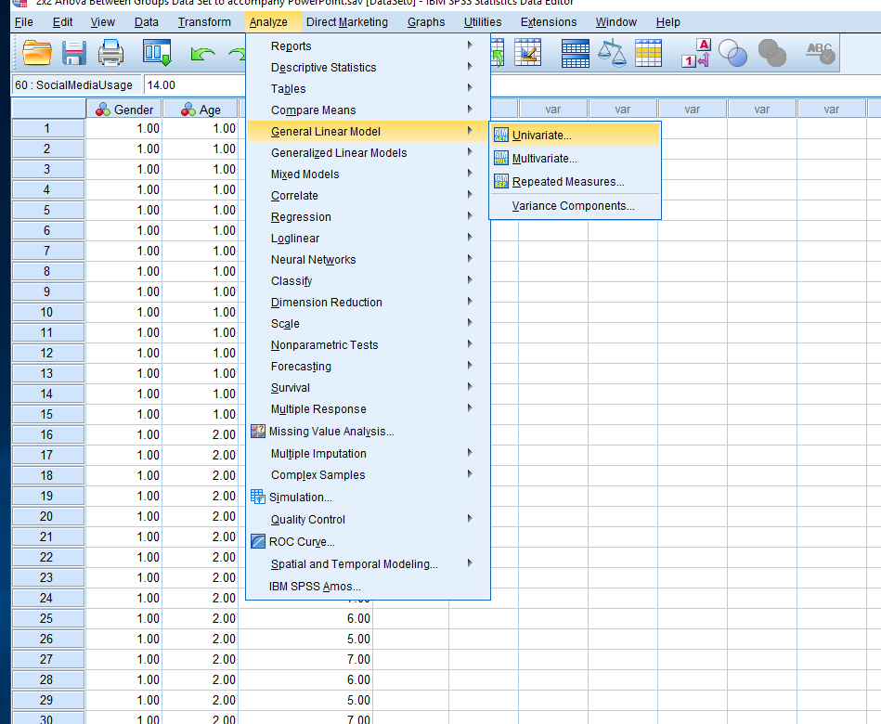
Once you have inputted your data correctly with your between groups factors “grouped” and labelled (e.g. 1 = Male, 2 = Female and 1 = Young, 2 = Old) and you have your DV scores in a separate row then you should be ready to give instructions to SPSS – For a 2x2 Between Groups Design you start with Analyse, General Linear Model, Univariate.

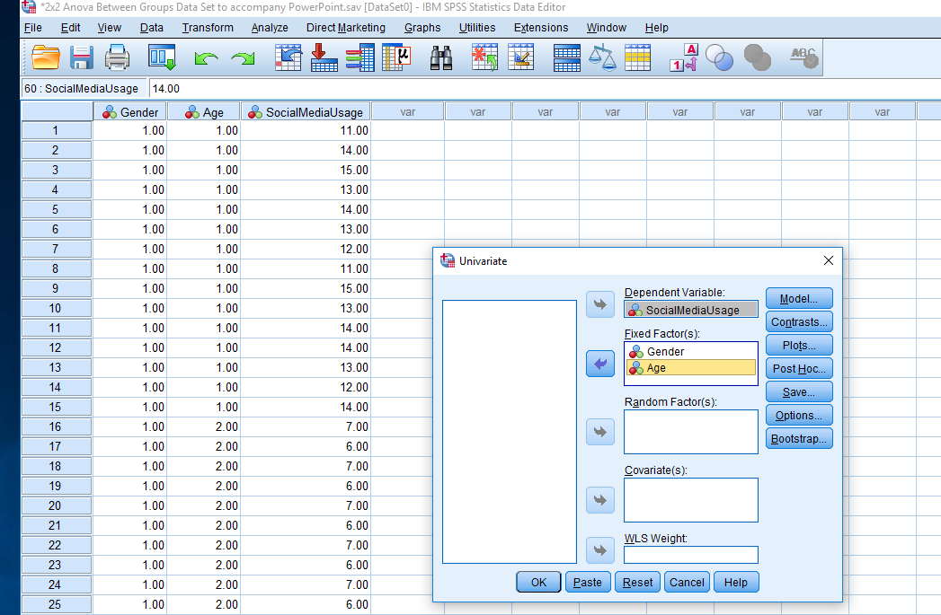
Place your dependent variable in the dependent variable box (using the top arrow) and your two factors (IVs) in the fixed factor(s) box using the next arrow down. In this case, Social Media Usage was the dependent variable and Gender and Age were the Factors. Then click plots.

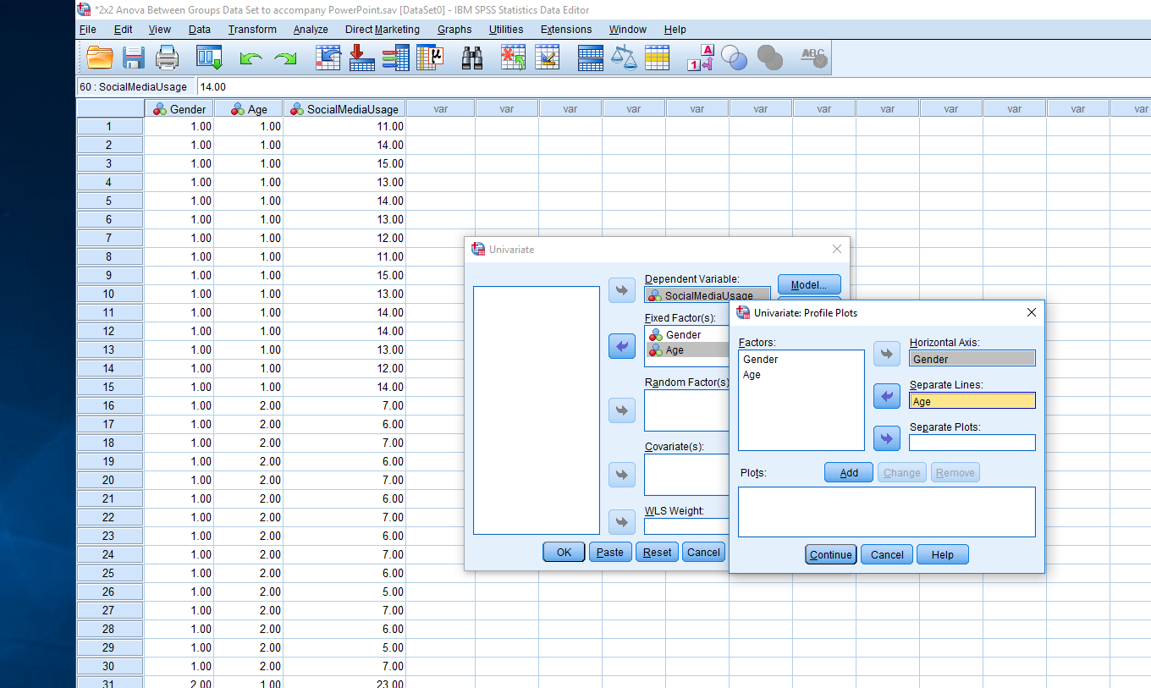
Place one Factor into the Horizontal Axis and the other factor into Separate Lines. Then click add, then continue and then click options.

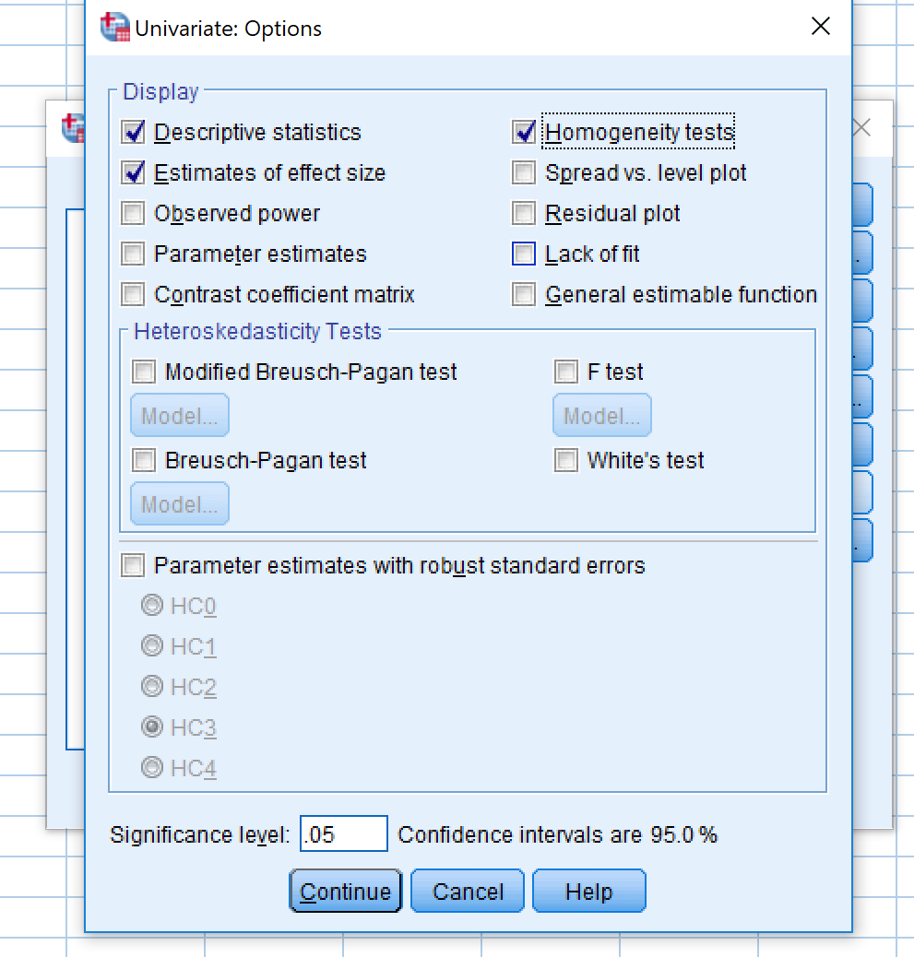
Check the descriptive statistics box, Estimates of effects size, Observed Power and Homogeneity Tests Then Continue, then EM Means.
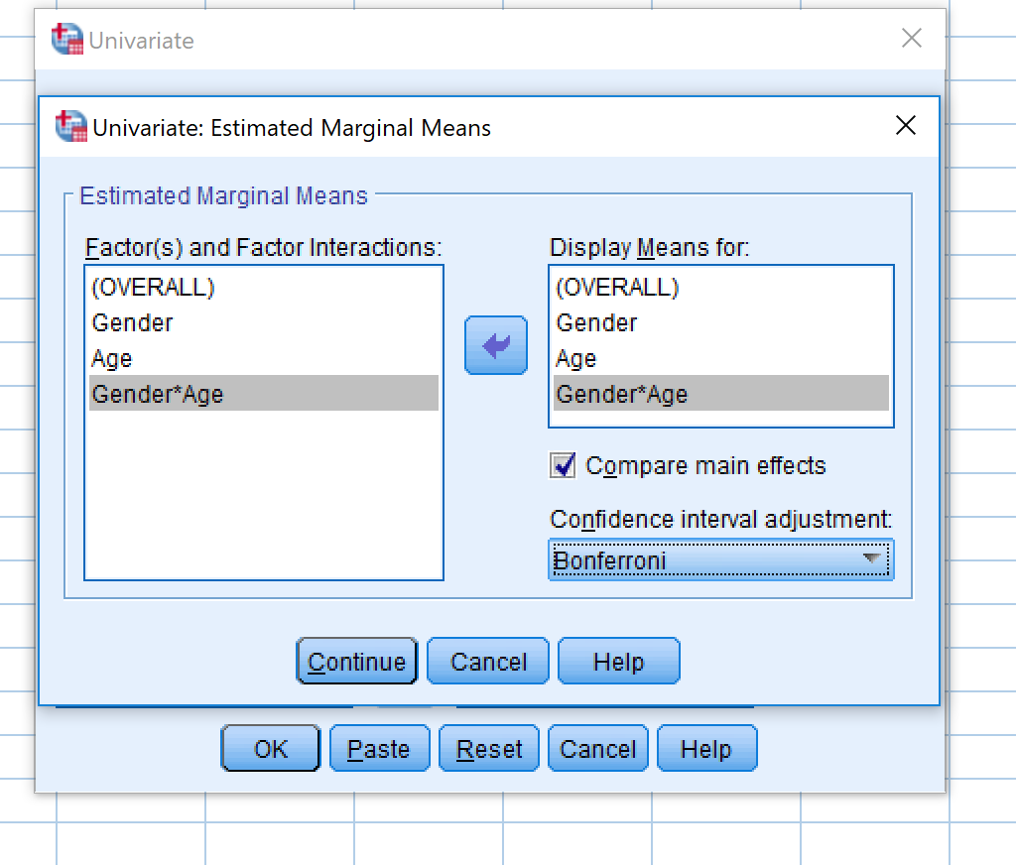
Move all factors into the right-hand box. Check compare main effects and select Bonferroni. Click Continue and then OK.
Output

Between-Subjects Factors
 |  | Value Label | N
Gender | 1.00 | Male | 30
Gender | 2.00 | Female | 30
Age | 1.00 | Young | 30
Age | 2.00 | Old | 30

This is telling us the means and standard deviations of your interactions, it also shows the mean and standard deviation of your main effects in the total sections. See video for guidance
Descriptive Statistics
Dependent Variable: SocialMediaUsage
Gender | Age | Mean | Std. Deviation | N
Male | Young | 13.2000 | 1.26491 | 15
Male | Old | 6.3333 | .72375 | 15
Male | Total | 9.7667 | 3.63587 | 30
Female | Young | 23.5333 | 1.40746 | 15
Female | Old | 16.8000 | 1.52128 | 15
Female | Total | 20.1667 | 3.71468 | 30
Total | Young | 18.3667 | 5.41698 | 30
Total | Old | 11.5667 | 5.44998 | 30
Total | Total | 14.9667 | 6.38581 | 60

This shows the Homogeneity of Variance for your between groups Anova
Levene's Test of Equality of Error Variancesª
Dependent Variable: SocialMediaUsage
F | df1 | df2 | Sig.
1.868 | 3 | 56 | .146
Tests the null hypothesis that the error variance of the dependent variable is equal across groups.
a. Design: Intercept + Gender + Age + Gender * Age

Tests of Between-Subjects Effects
Dependent Variable: SocialMediaUsage
Source | Type III Sum of Squares | df | Mean Square | F | Sig. | Partial Eta Squared | Noncent. Parameter | Observed Power^{b}
Corrected Model | 2316.067ª | 3 | 772.022 | 481.082 | .000 | .963 | 1443.246 | 1.000
Intercept | 13440.067 | 1 | 13440.067 | 8375.116 | .000 | .993 | 8375.116 | 1.000
Gender | 1622.400 | 1 | 1622.400 | 1010.991 | .000 | .948 | 1010.991 | 1.000
Age | 693.600 | 1 | 693.600 | 432.214 | .000 | .885 | 432.214 | 1.000
Gender * Age | .067 | 1 | .067 | .042 | .839 | .001 | .042 | .055
Error | 89.867 | 56 | 1.605
Total | 15846.000 | 60
Corrected Total | 2405.933 | 59
a. R Squared = .963 (Adjusted R Squared = .961)
This box shows the Anova results for your between group Anova for your main effects “gender” and “age” and your interaction.
The next 3 boxes would be important for a factorial anova of more than 2 levels as this is your post hoc analysys.
Pairwise Comparisons
Dependent Variable: SocialMediaUsage
(I) Gender | (J) Gender | Mean Difference (I-J) | Std. Error | Sig.^{b} | 95% Confidence Interval for Difference^{b}
 |  |  |  |  | Lower Bound | Upper Bound
Male | Female | -10.400* | .327 | .000 | -11.055 | -9.745
Female | Male | 10.400* | .327 | .000 | 9.745 | 11.055
Based on estimated marginal means
*. The mean difference is significant at the .05 level.
b. Adjustment for multiple comparisons: Least Significant Difference (equivalent to no adjustments).

Univariate Tests
Dependent Variable: SocialMediaUsage
 | Sum of Squares | df | Mean Square | F | Sig. | Partial Eta Squared | Noncent. Parameter | Observed Powerª
Contrast | 693.600 | 1 | 693.600 | 432.214 | .000 | .885 | 432.214 | 1.000
Error | 89.867 | 56 | 1.605
The F tests the effect of Age. This test is based on the linearly independent pairwise comparisons among the estimated marginal means.
a. Computed using alpha = .05

4. Gender * Age
Dependent Variable: SocialMediaUsage
Gender | Age | Mean | Std. Error | 95% Confidence Interval
 |  |  |  | Lower Bound | Upper Bound
Male | Young | 13.200 | .327 | 12.545 | 13.855
Male | Old | 6.333 | .327 | 5.678 | 6.989
Female | Young | 23.533 | .327 | 22.878 | 24.189
Female | Old | 16.800 | .327 | 16.145 | 17.455

Profile Plots

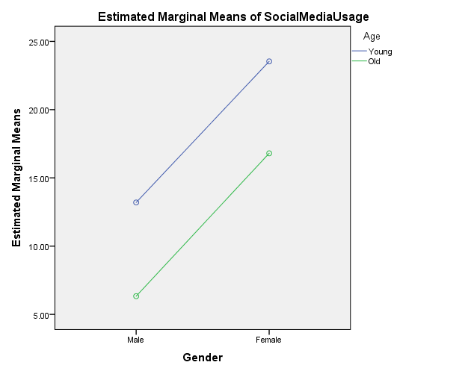
Here is your interaction plots.

