Cameron Dickson
Independent Project
Hanel Lean Lift
2014507
University of Wales Trinity Saint David

Table of Contents
Abstract 3
Company Background 3
Introduction to the Machine 4
The Problem 4
Aims and Objectives 5
The solution 5
Solution 1 – Thermal Sensor 5
Solution 2 – Firetrace Solution 6
Timing Plan 7
Research / Literature Survey 7
Work Carried Out 11
4 Ts Risk Assessment 11
Risk Assessment 13
Failure Mode and Effect Analysis 17
Project Work 19
Planned Preventative Maintenance Schedule 23
Risk Assessment After Project Completion 31
Results 34
Discussions and Conclusions 34
Recommended Further Work 35
Bibliography 37
Appendix 38

Abstract

The overall purpose of this study is to ensure the safety of Renishaw’s employees and Renishaw’s stock. Implementing a safe modification to pre-existing equipment that Renishaw’s insurance company has deemed liable to fires due to the motors within the equipment overheating. The insurance company stated that these can be caused by the motor overheating due to being used constantly or the motor overheating if a jam occurs. The motors are not equipped with any protection devices so if the motor was to be overloaded the motor would not stop but constantly run causing the motor windings to overheat and potentially cause a fire.

The solution to this problem that was chosen was implementing a temperature sensor to the motor which was then wired to a temperature relay. By adding this modification we are able to link these to the safety circuit on the machine. When the motor reaches a maximum temperature then the sensor will detect this and send a signal to the relay. This relay will then send a signal to the safety circuit which will ensure the machine goes into a state of emergency. By doing this it will be like someone has pressed an E-stop which will stop all machinery inside to stop moving like the motor.

Company Background
Renishaw is a global, high precision metrology and healthcare technology group. Renishaw design, develop and deliver solutions and systems that provide unparalleled precision, control and reliability. Renishaw are also a world leader in the field of additive manufacturing, where we design and produce industrial machines which ‘print' parts from metal powder. From transport to agriculture, electronics to healthcare, our breakthrough technology transforms product performance. As a maintenance engineer within Renishaw it is our job to maintain repair and keep all machines in Renishaw running and running efficiently too.

Introduction to the Machine

The project that will be undertaken is a modification on the Hanel Lean lift. The Hanel lean lift is a rational way of storing parts. The lean lift is a closed system that is computer operated. The computer stores the data of parts that are stored within the machine. By calling the shelf number of where the part is located the controlled lift called the extractor, which moves up and down via the smooth action rollers. Collecting and returning items to present to the operator at the front access point. Within Renishaw we have 11 lean lifts on site in miskin. However these are located in other Renishaw sites all around the UK. These lean lifts across Renishaw hold stock worth millions and are very essential to Renishaw. In fig.1 an example of a lean lift is shown.
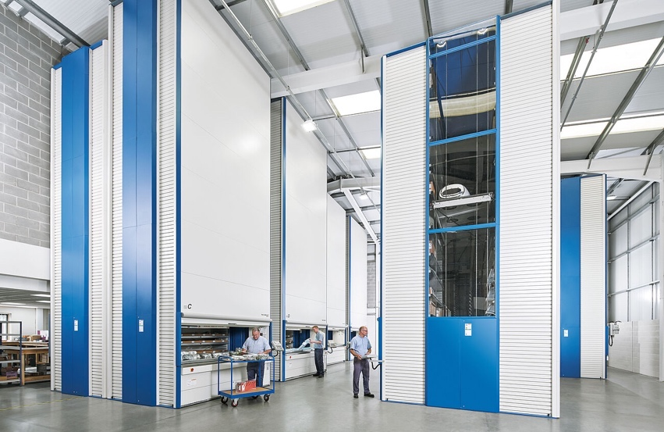

Fig.1 Example of a Lean Lift

The Problem

Renishaw uses Zurich for all insurance purposes across the site. Zurich has reached out to Renishaw that proposes that the lean lifts have a fault where the motor can overheat causing a fire within the lift. So in theory the lean lift when being used can catch fire and cause the lean lift to be destroyed and Renishaw to lose all parts stored within these machines. With the amount of stock parts that these lean lifts hold and the value of these parts that are stored within the machine a failure like this can not only affect the safety of Renishaw employees but also have a catastrophic failure to the business. One of the lean lifts on the miskin site holds around 5 million pounds worth of stock. This includes encoders and other electronic equipment like semiconductors. Another problem that could occur is the risk side if a fire was to occur. Within our products we keep stock of batteries and other components that are highly flammable and could cause explosions if caught on fire. This could cause serious damage to Renishaw also endangering the lives of the employees.

Aims and Objectives

The main objectives of this project is to research and find a solution to the problem. This will be firstly looked into by conducting a risk assessment and a failure mode effective analysis (FMEA). By conducting these assessments we are able to define the risks properly and decide on the likelihood and the consequences if these risks were to occur. Upon completion of the risk assessment and FMEA the best solutions to the problem will then be chosen by conducting a matrix analysis. Upon deciding on a solution this will be presented to senior management to ensure this agrees with Renishaw’s policies and the solution is a viable option. By conducting research for sourcing the correct parts, fitting the solution which will then result in testing and ensuring this solution does indeed work and minimises the risk. After completion of the solution a final risk assessment will be conducted to evaluate the effectiveness of the project and whether it has decreased the risk and consequences.

The solution

There could be many solutions to this problem which will be looked into great detail but one solution would be to put a thermal sensor onto the motor which will then be wired in to the safety circuit. So if the motor overheats the sensor will trigger and cut off the machine. More details will need to be looked at as an operator could turn the machine back on by resetting the safety circuit. A controller and HMI (Human Interface screen) could be added to allow more control on how the circuit will work.

Solution 1 – Thermal Sensor

Fitting a Thermal Sensor to the motor. The thermal sensor would detect the motor overheating. This in turn will then be designed so that it is integrated into the safety circuit. By using Siemens 1 Phase Temperature monitoring relay to monitor readings from the thermal sensor attached to the motor. The temperature relay will allow a signal be sent along the 24VDC line. If the motor overheats machine will go into an emergency stop state and will need to be manually reset when the motor has been checked by maintenance personnel or has cooled down to required temperature. Alongside the relay a thermal sensor has been added to the motor. The thermal sensor triggers and gives out an open signal at 100°C and a closed signal at 85°C. By wiring this into the safety circuit any heat from the motor that reaches over 85°C then the thermal sensor will trigger sending the open signal through the relay. In fig.2 the siemens temperature relay is shown and in fig.3 the temperature sensor that attaches to the motor is shown.

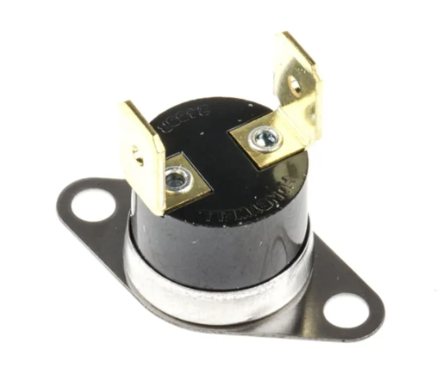
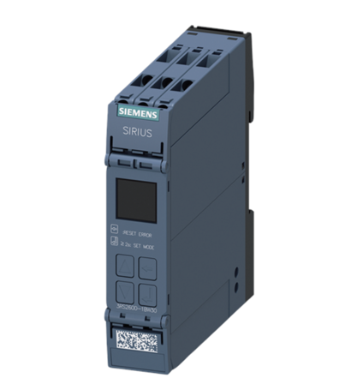

Fig.2 Temperature Relay Fig.3 Motor Temperature Sensor

Solution 2 – Firetrace Solution

My second solution will be fitting Firetrace Equipment to the Lean Lift. Renishaw does a lot of work with firetrace and it is used on a lot of our CNC machinery within the machine shop. It is mainly used on our lathes. The fire trace solution will detect and stop any fire that is caused by the motor. The Firetrace systems use detection tubing which is installed around the risk area and connected to a cylinder valve. The tubing is then charged with nitrogen and this pressure is utilised to hold the valve in the closed position. Should a high temperature or fire occur then the pressurised tubing will burst and the cylinder valve will activate deploying the extinguishant immediately onto the fire. You can also add a control switch to the system that will in turn not just stop the fire but will also be integrated into the safety circuit to stop the machine. Below in fig.4 you can see the fire trace system on one of our star lathes.

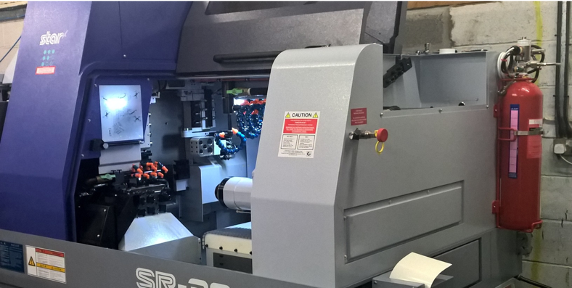

Fig.4 Star Lathe with Fire Trace system integrated

Timing Plan

For the timing plan of the project a Gantt chart was used throughout the project. Gantt charts offer an easy to understand visual depiction of project tasks, deadlines, and milestones. This makes it possible for my team members and senior managers to immediately understand the project's objectives, steps in order, and timetable. The Gannt chart was followed correctly and all deadlines were met. The Gannt chart that was used is attached within the Appendices.

Research / Literature Survey

To help aid the project of lift failures and to get a better understanding as to why there is a need to complete this project, extensive research will be undertaken and analysis of the risks of failures within using lifting machines. Also looking into certain products that are more flammable and dangerous if not stored correctly. By completing research and a literature survey there will be many factors that the project will benefit from. Being able to get a better comprehensive understanding of previous research that has been completed before. This will increase the understanding of the problem that the workplace is currently having. It will give insight into how to better this project and create an safe environment for the employees within Renishaw itself. Being able to identify common trends within the industry and look into the existing failures and solutions that have occurred. This will allow there to be a solution that will knowingly be safer by decreasing the level of risk currently. Also the previous published literature will help to validate the current project and show that the solution that will be put in place is correct. When conducting the research the use of regulations like Lifting Operations and Lifting Equipment Regulations 1998 (LOLER) and other regulations like the Health and Safety at Work Act 1974 will be useful. Also gathering data from the Health and Safety Executive (HSE) website. Another regulation that will aid in the project would be the use of the Provisions and Use of Work Equipment Regulations 1998 (PUWER). With the use of PUWER this will aid in understanding the correct procedures for the control of the machine. This control consists stopping a machine safely and ensuring the safety of the operator and employees around that area. Within UK laws there are several regulations that attempt to ensure employee and public safety, and these regulations coincide with important concerns like lift safety and fire occurrences. In order to reduce the dangers of mechanical failures and fire hazards, strict requirements apply to goods lifts, which are vital to the smooth operation of commercial spaces and businesses. Employers are required by the UK's regulations to ensure the safety of lifts and avoid fire occurrences. These legislations include the Lifting Operations and Lifting Equipment legislation (LOLER) and the Regulatory Reform (Fire Safety) Order 2005. Regular maintenance, inspections, and observance of fire safety procedures are required in order to comply with these rules. Even with regulations in place, there is always a chance of lift malfunctions and fires, therefore constant Preventative maintenance is required. From researching and better understanding of the LOLER regulation, implementing a Planned Preventative Maintenance (PPM) schedule to the lean lift will benefit this project. In doing so will ensure that monthly, 6 monthly and yearly checks are completed on the lean lift to ensure the safety of the employees and the employers equipment. Currently there is no schedule in place and very rarely are these goods lifts inspected. Currently in Renishaw only if a fault occurs will a contractor come on sight to inspect and fix the lift. With the likelihood of a fire risk within these lifts due to the motor overheating and the storage of products like batteries by completing this PPM schedule it will decrease the likelihood of these risks occurring. The employer are in charge of keeping accurate records of inspections which include inspection reports and any corrective maintenance measures implemented. During audits or inspections regulatory bodies may request access to these records which demonstrate adherence to LOLER. Creating and implementing a PPM schedule and booking this machine onto our system. They will adhere to LOLER as once these inspections have been carried out they are logged and saved within our internal systems. In order to detect potential risks related to our lean lift they are required to undertake risk assessments and adopt suitable risk control measures to reduce these risks. In order to do this a risk assessment will be completed before and after the project to ensure the likeliness of the risk has decreased. Failure Modes and Effective Analysis (FMEA) will also be undertaken within this project. By conducting a FMEA it allows you to identify all possible failures within the lean lift and correct these failures. Using the 4 Ts to understand risk mitigation better. The 4 Ts system is Tolerate, Terminate, Treat and Transfer. The 4 Ts risk mitigation task will be used within this project. Within Renishaw there are multiple products that are stored within lean lifts that are flammable and could cause explosions. Within the maintenance goods in this type of product that we have in stock is batteries. Recently Lithium batteries are used a lot more than Alkaline batteries. Lithium Ion batteries have many causes of failures. By Researching these failures there is an article that is produced by the Devon & Somerset fire and rescue team which highlights the main failures of these batteries and how to correctly store these batteries. A main cause of battery failure is thermal runaway. “Rapid Overheating” as stated within Lithium battery fires(no date) Devon and Somerset Fire and Rescue Service. Available at: https://www.dsfire.gov.uk/safety/home/battery-fires (Accessed: 09 May 2024) this is the process of thermal runaway. Thermal runaway is when the current within a battery causes the battery temperature to increase due to heat exposure. This then increases the current also, leading to fire and explosions which could cause catastrophic failures. With the motor overheating and catching fire this would aid the process of the current increasing in temperature and causing failures. Other failures of batteries would be the batteries are damaged during transportation or when unloading into our lean lift.
Looking into the statistics from the HSE website in 2022/2023 there were 12 fatal injuries by something collapsing and 9 fatal injuries from contact with moving machinery. Work-related fatal injuries in Great Britain(no date) Statistics - Work-related fatal injuries in Great Britain. Available at: https://www.hse.gov.uk/statistics/fatals.htm (Accessed: 01 May 2024).
By looking at these statistics it brings the realisation that there are not just fire risks from the lean lift. During PPM checks that will be implemented there will be inspections of the chains and pulley system that is used to collect the shelves and also complete checks on the emergency stop buttons and the light rails. The risk of the light guards not working and an operator leaning in too far could come into contact with the moving shelf. Also by inspecting from the service hatch the chains that hold the shelf in place there is an understanding of whether it is safe to enter the lift for future work that may need to be conducted within the lift. By doing this there will be a decreased likelihood of any risks occurring and that will aid into not adding to the HSE statistics of something collapsing.
When conducting research there will be a need to look into primary and secondary sources. A primary source are original documents that offer first-hand accounts or direct evidence on a subject are called primary sources. They have not been subjected to a second party's interpretation or assessment. Types of primary source material are the legislations like LOLER, Health and safety at work act 1974 and even the HSE website. Using this material that it is government regulated there is an understanding that the information has not been tampered or changed under a second party’s interpretation. The raw information and data that Is gathered from these sources will be 100% authentic.

Secondary sources are an interpretation of primary sources that analyse and summarise the primary sources. They give a summary of previous studies and frequently go into the ramifications of primary source study findings. An example of secondary source that is used within the project report is “Rapid Overheating” as stated within Lithium battery fires(no date) Devon and Somerset Fire and Rescue Service. Available at: https://www.dsfire.gov.uk/safety/home/battery-fires (Accessed: 09 May 2024). The source of the thermal runaway in batteries is an article of the information and safety guide to failures within Lithium batteries. This is a secondary source as it has summarised the faults that occur with lithium batteries and there safety advice when handling lithium batteries.
To complete a successful research and literature review comparing two sources is a crucial way of determining whether the two sources are agreeing and stating the same information. When researching safe places to store lithium batteries, comparing multiple sites aids in ensuring the correct information is being stated.
Firstly using the article of rapid overheating of lithium batteries by Devon and Somerset Fire and Rescue Service. Reading the article it is stated that you must “Keep batteries in a cool, dry place away from flammable materials and direct sunlight” and “Always use the charger supplied with the device or recommended by the manufacturer” . Lithium battery fires(no date) Devon and Somerset Fire and Rescue Service. Available at: https://www.dsfire.gov.uk/safety/home/battery-fires (Accessed: 09 May 2024). To ensure this information is correct, looking into another source to see if they are agreeing validates the information. When reading the article on Lithium batteries from Electrical safety first they state that “Only use the charger supplied with the battery. It is designed to steadily charge the battery at a predetermined rate, it will monitor the charge and avoid overcharging”. They also state “Do not charge lithium batteries where high temperatures or sunlight are to be expected”. Electrical Safety First. (n.d.). Lithium-ion Batteries. [online] Available at: https://www.electricalsafetyfirst.org.uk/guidance/product-safety/lithium-ion-batteries/.

Looking into these two sources you can see they agree on storing the batteries in a cool and dry place and keeping out of direct exposure to sunlight. They also state that over charging must be avoided as it can cause thermal runaway. Comparing these sources gives validation and credibility as when sources agree, the information is validated and the findings are given more credibility. Similar findings or conclusions from several sources imply that the findings are trustworthy and not the product of one-off events or mistakes. Also seeing agreement between the sources boosts your confidence in the accuracy and reliability of the information.

Work Carried Out

In order to commence the project, the identification of all the risks associated with the lean lift had to be completed. This was achieved by conducting a 4 Ts risk mitigation assessment and a comprehensive risk assessment on the machine.

4 Ts Risk Assessment

Tolerate, Treat, Transfer, and Terminate are the four components of the 4 Ts risk mitigation method. This method aids in methodically evaluating and controlling the risks related to the lean lift. Below is how the dangers associated with the goods lift relate to each of the four Ts:

Tolerate - Recognising the existence of small, manageable dangers is the first step towards tolerating them. When looking into tolerating minor risks these must still be acceptable within safety standards and regulations. Some examples of minor risks to the lean lift that are able to be tolerated are:

- Minor vibration of the equipment while in use. This does not affect the safety of the lift and will be tolerated.
- Noise of the machine. Within Renishaw equipment is noise tested every so often to ensure that it does not pass the maximum of 85 decibels due to regulations. The equipment used may be under 85 decibels but very close. This is tolerable as it does not exceed any safety regulations.
- Another example is sometimes the lift does not fully bring the shelf out. This is tolerable as just over time maybe a sensor has moved due to vibration. This does not affect the safety or how the machine operates, however an operator might have to pull the shelf out ever so slightly to reach parts at the back of the shelf.

Treat – Treating the risks involves taking actions to reduce the likelihood or impact of risks. Some of examples of this are stated below:
- Implementing regular maintenance and inspections to ensure all mechanical and electrical components are in good working condition.
- Installing safety barriers or interlocks to prevent accidental access to dangerous areas.
- Installing a modification to the lean lift to mitigate risk of fire.

To treat these risks there must be identification of all hazards. To do this a risk assessment must be conducted. Other measures that can be developed to mitigate this risk is a PPM schedule by doing this you are minimising the risk as monthly checks will ensure that any potential hazards such as mechanical failures, electrical issues, and operational errors are noticed and treated. Also regular training for operators ensure the equipment is used in a safe manner.

Transfer - Transferring risks means moving the risk to another party. Within Renishaw this would usually mean using contractors or insurance. Examples of this are stated below:

- Having comprehensive insurance coverage for the lift mitigates any financial risks associated with accidents or malfunctions. Within Renishaw the insurance company will come out to complete their own inspections and with this particular case tell us about faults with the equipment that is used within Renishaw.
- Contracting a certified maintenance company to handle the regular servicing and inspection of the lift. However, within Renishaw we will complete this ourselves. Although any big jobs to this equipment due to its nature of being a lift contractors are called out to ensure.

Terminate – To terminate the risk it refers to totally avoiding or getting rid of the risk by ending the activity or taking out the hazard. Some examples of this are stated below:

- If the Lean Lift is identified as unsafe due to any design flaws then it might have to be replaced or modified. In this particular case the motors used within the lean lift are faulty and can overheat due to a jam. By installing the temperature sensor and wiring it into the safety circuit this has terminated the risk.
- Even discontinuing the lean lift may have been an option or having no coverage from the insurance company if the risk was not terminated.

To terminate risk a comprehensive risk assessment and FMEA will be conducted to ensure all potential hazards are identified and terminated. Also any problems with the process will be solved by using an FMEA.

Utilising a risk assessment allowed the identification, analysis and mitigation of risk that in turn ultimately enhances the safety and ensuring that there is compliance with the relevant regulations. The relevant regulations in this particular case was LOLER due to the project being involved in lifting equipment.

Risk Assessment

Before conducting the risk assessment there were types of failures and hazards that were looked into. There were many different categories of hazard groups that were looked at. An example of these would be Mechanical Hazards. When looking at mechanical hazards there are lots of variables that need to be considered. These are stated below:

- Crushing
- Shearing
- Cutting
- Entanglement
- Trapping
- Impact of moving parts
- Stabbing
- Friction
- Ejection of parts from machine

Understanding and looking into these mechanical hazards helped a lot due to some of the hazards that were identified was from the impact of moving parts and the likes of friction within the parts of the machine. Looking into Hazards that could potentially cause harm due to electrical faults was the next step. Some of these hazards have been stated below:

- Contact of electrical equipment
- Thermal Radiation
- Chemical effects from electrical equipment shorting
- External influences of electrical equipment
- Faulty Electrical Equipment

This massively helped the understanding of hazards before conducting risk assessment. As there had been previous research into the thermal runaway from batteries and also the motor overheating would come under faulty electrical equipment. The final group of hazards that was looked at was guarding and safety devices. These are stated below:

- Guards
- Protection Devices
- Start/Stop devices

Within the set of hazards for a risk assessment a big hazard is the environment in which the equipment is surrounded by. Upon inspection of the lean lifts environment currently the service panel is being blocked by cupboards. With the PPM schedule and testing the motor sensor it is a lot safer for the service panel to be easily accessible. The image Fig.5 below shows the side of the lean lift blocked.
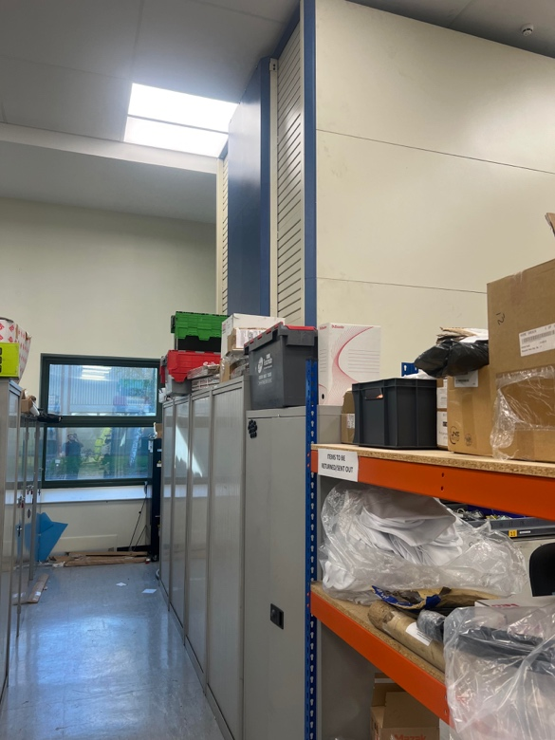 Fig.5 Lean lift service hatch blocked

Deeming this as a safety concerned the cupboard has been moved so that full accessibility is granted. By having this accessibility upon PPM inspections it is a lot easier to inspect the chains and motor without having to climb into the lift itself. As you can see below in Fig.6 the service door is now accessible and the chains are easily visible for checks.
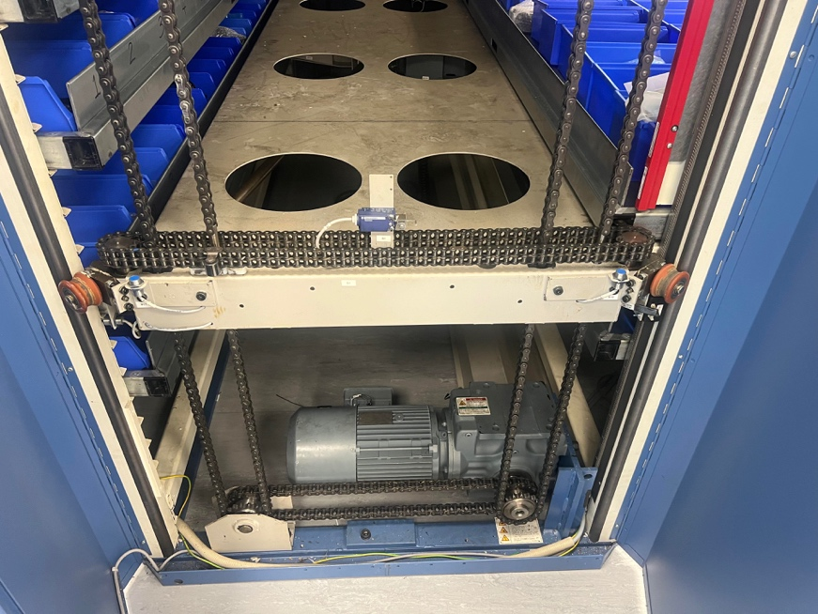Fig.6 Service hatch accessible

Looking into this group of hazards it gave a better understanding into why the risk assessment was being completed. The main purpose of the project is to stop a fire risk. However, conducting the risk assessment and looking into these hazard groups brought the realisation that it’s not just a faulty motor that can cause the risk, for example light guards not working correctly would put the operator in danger as they can lean into the machine without the machine stopping. This is why a PPM plan will be implemented so these risks will lose the likelihood of occurring.

When conducting this risk assessment a lot of risks and failures were identified. The risk assessment that was completed is shown below:

What is the Hazard? | Who might be harmed? | How might they be harmed? | Control that should be in place | Is required control in place? (Yes or No) | Action to implement required control | Time of Action | Actioner Name | Risk Probability  Highly Likely  Likely  Unlikely  Very Unlikely | Risk Severity  Fatality  Major Injury  Minor Injury  Near miss | Risk Rating  Extreme  High  Medium  Low
Motor overheating due to jam | Operator and employees in the vincity | Fire / Explosion | Thermal sensor on motor wired into the safety circuit to stop the motor | No | Implement sensor into safety circuit | 4 Months | Cameron Dickson | Likely | Fatality | High
Storage of Fire Risk goods (Batteries) | Operator and employees in the vincity | Fire / Explosion | Thermal sensor will detect heat within lean lift. Inspection of batteries before placing in lean lift to ensure goods are not damaged | No | Implement sensor into safety circuit | 4 Months | Cameron Dickson | Unlikely | Fatality | Medium
Chains connected to motor could get jammed | Operator and employees in the vincity | Chains could snap / flying parts | Thermal sensor on motor wired into the safety circuit to stop the motor | No | Implement sensor into safety circuit | 4 Months | Cameron Dickson | Likely | Fatality | High
Lack of grease on chains could cause friction | Operator and employees in the vincity | Fire / Explosion Chains could snap / flying parts | Better heat resistant grease / PPM plan put in place | No | Implement sensor into safety circuit | 4 Months | Cameron Dickson | Likely | Fatality | High
Motor to bring shelf in and out could get jammed causing a motor to overheat | Operator and employees in the vincity | Fire / Explosion | Thermal sensor on motor wired into the safety circuit to stop the motor | No | Implement sensor into safety circuit | 4 Months | Cameron Dickson | Likely | Fatality | High
Light guards not working | Operator | Coming into contact with moving parts | PPM plan to be put in place | No | Implement sensor into safety circuit | 4 Months | Cameron Dickson | Unlikely | Minor Injury | Medium
Loss of stock due to fire and potentially loosing machine shop | Renishaw | Loss of money and stock / injury to employees | Thermal sensor on motor wired into the safety circuit to stop the motor | No | Implement sensor into safety circuit | 4 Months | Cameron Dickson | Likely | Fatality | High
Lean lift being used on weekends where less people are in and aware of any problems with it | Operator and employees in the vincity | Fire / Explosion  Lack of personnel might go unnoticed for a while | Thermal sensor on motor wired into the safety circuit to stop the motor | No | Implement sensor into safety circuit | 4 Months | Cameron Dickson | Likely | Fatality | High

After completing the risk assessment the changes that will be made will improve safety of the machine and improve safety for operators and employees of Renishaw. As this will lead to a reduction of accidents and any injuries. It also shows and gives the maintenance department an enhanced level of risk awareness. By conducting the risk assessment the maintenance department have also conformed to regulations like the Health and Safety at Work Act 1974 and especially in this particular case the Fire safety Order 2005.

Failure Mode and Effect Analysis

Within the project there was a need to conduct a failure mode and effect analysis (FMEA). FMEA has many advantages for risk management and quality enhancement. First off, it helps company’s like Renishaw reduce risks and improve reliability by anticipating possible failure modes, their causes, and their consequences. Effective resource allocation is made possible by FMEA, which assists in prioritising risks according to their severity, likelihood of occurrence, and how easy it is to detect the failure. Failure Mode and Effect Analysis (FMEA) improves product quality, lowers defects, and increases customer or in this case the satisfaction of the insurance company by addressing failure modes at the design or development stage. In this case it will be conducted due to the modification needed on the lean lift. It also aids businesses in meeting legal obligations for risk management and product safety. FMEA also promotes a continuous improvement culture by integrating knowledge from past mistakes. Failure Mode and Effect Analysis also offers an organised and logical approach to risk management that aids in the prediction, risk mitigation and prevention of possible failures.

To complete the FMEA a template was created. Using this FMEA template that had been created a FMEA scoring system was introduced that aided in working out the Risk Priority Number (RPN). By looking at the highest RPN score after the FMEA has been completed it highlights the highest risks of the process and what possible failures should be looked into as they will need to be corrected first. The scoring system has 3 types of ratings. These ratings are the severity rating, the occurrence rating and the detection rating. These 3 types of ratings are stated below:
Severity Rating

1-2 | Failure is undetectable - will not cause any issues.
3-4 | Failure causes issue, but can be worked around temporarily.
5-6 | Failure cause machine stoppage.
7-8 | Failure causes machine stoppage and low to medium H&S risk.
9-10 | Failure Causes machine stoppage and serious risk to H&S.

Occurrence Rating

1-2 | Remote probability of occurrences | Once every 5 years
3-4 | Low probability of occurrences | Once every year
5-6 | Medium probability of occurrences | Once every 6 months
7-8 | High probability of occurrences | Once every month
9-10 | Very high probability of occurrence | Once every week

Detection Rating

1-2 | Almost certain to detect potential failure
3-4 | Good chance to detect failure
5-6 | Not likely to detect failure
7-8 | Close to zero chance to detect failure
9-10 | Zero probability of detecting potential failure

The FMEA that was conducted is shown below.

FMEA Hanel Lean Lift
System | Failure Mode | Failure Effect | Severity (1-10) | Potential Cause | Occurrence (1-10) | Control Measures | Detection (1-10) | RPN | Action Recommended
 | How can it go wrong? | Impact to production/H&S | Severity (1-10) | What causes the failure? | Occurrence (1-10) | What can be put in place to detect early? | Detection (1-10) | RPN
Modification | Motor Overheating | Production Stop / H&S | 9 | Chain Jam | 3 | PPM Plan and Training | 2 | 54 | Implement PPM and Training. Implement Sensor modification
 |  |  |  | Shelf Jam | 7 | Ensure guards are checked and not damaged on PPM | 2 | 126 | Implement PPM and Training. Implement Sensor modification
 |  |  |  | Electrical Failure | 3 | Keeping electrical panel free of debris and testing equipment | 5 | 135 | Implement PPM and Training. Implement Sensor modification
 |  |  |  | Faulty Sensor | 3 | PPM Plan and Conducting Heat gun test | 2 | 54 | Implement PPM and Training. Implement Sensor modification
 |  |  |  | Incorrect Grease being used | 7 | PPM Plan and Training, use better grease | 5 | 315 | Implement PPM and Training. Implement new Grease
Use of Hanel Lean Lift | General Faults | Production Stop / H&S | 7 | Operation of E-Stops | 2 | PPM Plan and Testing Operation of E-stops | 2 | 28 | Implement PPM and Training.
 |  |  |  | Loose Guarding | 3 | PPM Plan and Training | 2 | 42 | Implement PPM and Training.
 |  |  |  | Screen Failure | 3 | Stock of Spare screen and backlights for HMI screen | 2 | 42 | Ensure stock system is up to date. Training to ensure people correctly book out stock
 |  |  |  | Light Guard Failure | 7 | Stock of Spare light guards, Training to align light guards | 3 | 147 | Ensure stock system is up to date. Training to ensure people correctly book out stock. Training on aligning light guards

After conducting the FMEA it stood out that the highest risk priority number was due to the grease. This is because of human error when conducting PPM checks. It is very easy for a member of the department to not pick or use the correct grease. Measures will have to be put in place like specific PPM training for personnel on the equipment to ensure human error is kept to a minimal amount. Another suggestion is to implement a storage cabinet close to the Hanel Lean lift with everything needed to complete PPM on this machine. This gives no excuses to not being able to find the correct grease and use something different.

Project Work

When deciding the solutions there was research conducted into what would be a more cost effective solution. Looking into Solution 1 which was the temperature relay and thermal sensor. For this solution the parts were very simple to get and were all available on RS components. For solution 1 the parts I needed were. A Siemens temperature relay. Using this temperature relay allows me to set the temperature and then allows it to switch and send a signal down the 24v safety circuit. As seen below in Fig.7 this is the temperature sensor relay that will be used within solution 1.

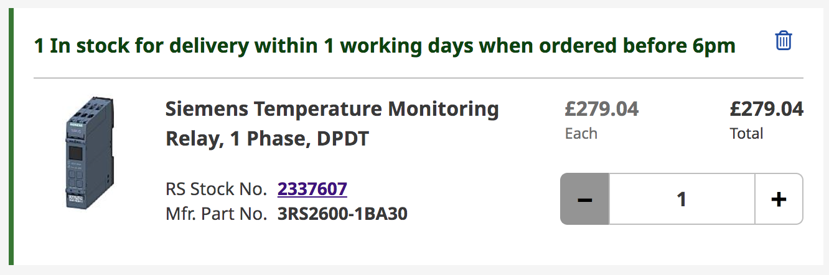
Fig.7 Temperature sensor Relay
The next part was a breaker. Using this breaker that could be wire up from the main 230v supply into the machine. By doing this if there was ever a fault it would trip and stop the modification to the machine. As seen in Fig.8 this is the breaker switch.

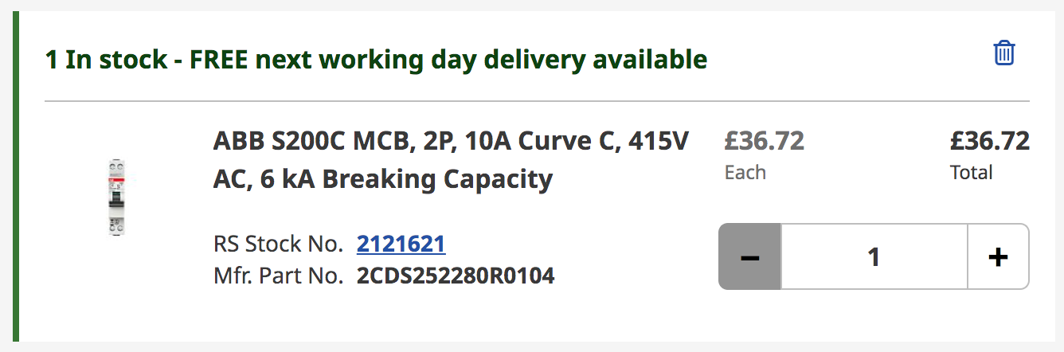
Fig.8 Breaker switch

The next part of the modification was to get a 24v power supply. This power supply is used to convert the 230v ac power in and convert it giving a output power of 24vdc allowing it to be connected to the 24v safety circuit. As seen below in Fig.9 this is the power supply


Fig.9 24v Power supply

There was then a need to order cable to wire up the design. Single phase 230v 3 core power cable was needed. This will be used to go through the breaker and powering the power supply. The cable that could be ordered would more than what is needed, however within maintenance this would always be useful to have as spare cable and would not be wasted. The power cable is shown in fig.10.
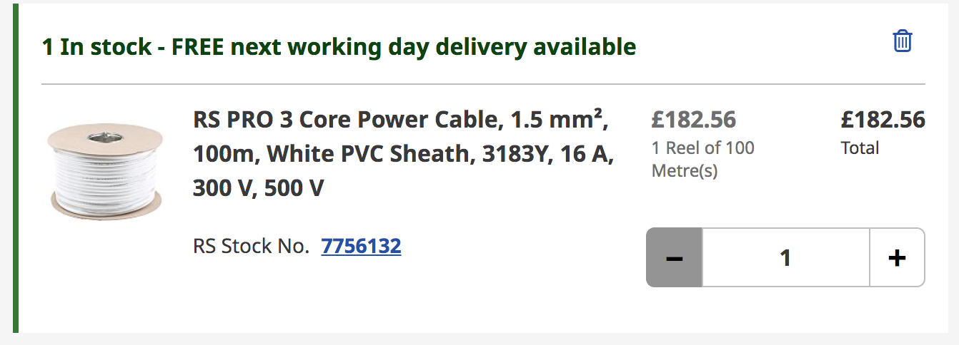

Fig.10 Power cable

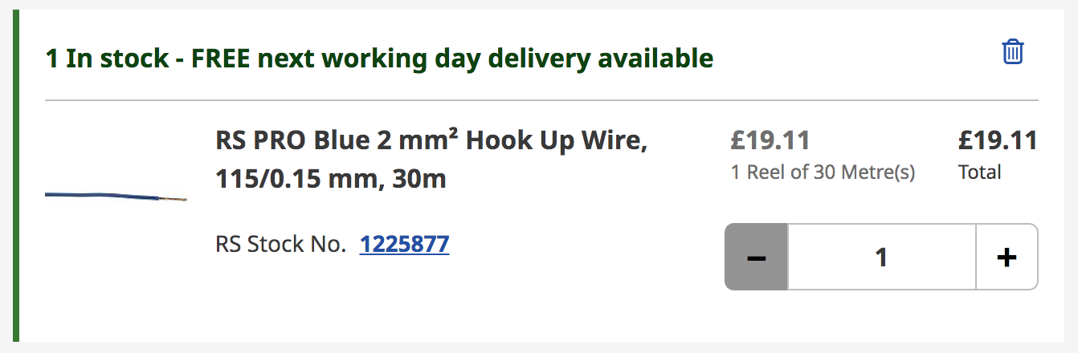
There was then a need for cable that would be used in the24vdc control circuit. Like the power cable more would need to be ordered however it would not go to waste within the maintenance department. Below in Fig.11 is the control cable that would be used.
Fig.11 Control Cable

The motor thermal sensor is already a part that is stocked within Renishaw as it is used on other machinery. The unit cost on the internal stock system for this is £75.38. The total for solution 1 comes to £738.46. This is a very cost effective solution as the amount of value that is stocked in these lean lifts is far greater than the £738.46 modification. This is an initial cost of the product. With the 11 machines that need to have this modification to them it brings the initial cost of £738.46 x 11 = £8,123.06. This initial cost is very reasonable due to the severity of failure on these lean lifts.

The advantages of this solution are cost of parts will be cheaper. No contractors will need to be called, can be sourced and fitted in house. Easy maintenance on the parts and wouldn’t rely on a call out from an external engineer. No need to service the parts. The only disadvantages from using this solution would be that the thermal sensor could trigger with heat from the environment even if the motor is not struggling and running as normal. Downtime of allowing the motor to cool down and reset. Faulty electrical equipment could be harder to diagnose. Also to wire up and diagnose could be harder as it is a complex system.

The second solution was the fire trace solution. This solution is very good as it has previously stopped a couple of fires from lathes when operators have machined hard materials at high speeds and forgot to turn the coolant on. After speaking with Firetrace and getting a quote for the work to be done to the lean lift. This came to an initial cost of £7,718.54 for 1 machine. The total for 11 machines is £7,718.54 x 11 = £84,903.94. The cost breakdown for this is extinguisher bottles are £4,218.54 each. The Install quote to put it into the machine was around £3,500 per machine. Another factor of this solution is that the ongoing service costs of £550 per machine. This includes the call out of an engineer, the labour costs and hotel accommodation for the engineer attending site.
The advantages of using the fire trace solution are that the system reacts quickly and minimises expensive machine damage and downtime. The systems can be easily retrofitted to existing equipment. Systems detect and extinguish fires with little or no damage to the equipment. However the disadvantages to this solution are that the initial cost will be expensive. System needs servicing every 6-12 months. Untrained Maintenance or incorrect servicing could cause the extinguishers to go off without a fire. Cost of bottles and pipework to be refitted if it does go off. Longer downtime if an external engineer needs to be called. The downtime to these will not be as great as currently there is stock of the extinguisher’s and a select few have been on Fire trace training and are able to service and change these bottles themselves. However feeding new detection tubing around the machine is not a quick procedure and long downtime would still occur.
Understanding the advantages and disadvantages of each solution will aid in choosing the best solution. To understand this better a matrix Analysis was conducted. This is shown below.
 | Temperature Sensor and Relay Modification | Fire Trace Retrofit Modification
Functions | Prevents the motor from overheating and triggers safety circuit | Detects and extinguishes a fire
Initial Product cost across 11 machines | £8,123.06 | £84,903.94
Maintenance | Heat gun test to be completed on the temperature sensor every 6 months | Bottles are serviced once a year
Capabilities | Triggers safety circuit when motor and temperature sensor reaches 100 degrees | Doesn’t prevent fire but when a fire occurs it controls amd extinguishes the fire
Ongoing costs | No on-going costs unless a part fails | Service charge of £550 per machine once a year

After conducting the matrix analysis a decision was made and presented to senior management. Solution 1 was selected as it is far more cost effective to go with solution 1 and implement the thermal sensor relay. Although the insurance company have specified that these lifts have previously caught fire. Within our factory they are not used every single hour of the working day they may be used 2-3 times an hour and are unlikely to overheat themselves unless a jam occurs. By using solution 1 the time plan can be shortened considerably as all the parts are readily available and the solution can be implemented almost immediately. To ensure that a jam doesn’t occur the PPM schedule that will be implemented will be very helpful.

Planned Preventative Maintenance Schedule

To complete the PPM schedule the monthly, 6 monthly and yearly checks that we do across all our machines at Renishaw was used. The PPM schedule you see below is a rough draft and this will be presented to senior management who will then be able to publish this and put it onto our schedule and system to be completed.
The monthly maintenance check takes around 1 hour to conduct and consist of the following steps :

- Visually inspect all guarding around the machine.
- Clear any accumulation of debris and clean as necessary.
- Check operation of E-Stops.
- Check operation of Light guard rails.
- Check the operation and condition of the work light and replace if damaged.
- Visually inspect all chains within the machine.
- Visually inspect sprockets attached to the chains.
As you can see in the monthly checks a lot of the steps that are taken are more simple checks like visual checks and quick checks like ensuring the safety circuit is working. A six monthly check will be very similar however it will implement a couple different steps to ensure the safe workings of the equipment.. These steps are stated below:

- Visually inspect all guarding around the machine.
- Clear any accumulation of debris and clean as necessary.
- Check operation of E-Stops.
- Check operation of Light guard rails.
- Check the operation and condition of the work light and replace if damaged.
- Visually inspect all chains within the machine.
- Visually inspect sprockets attached to the chains.
- Grease the chains within the machine Rocol Sapphire Extreme.
- Wipe down all sensors at the bottom of the machine.
- Conduct a temperature test on the thermal sensor (100 degrees) using a heat gun.
A yearly check also consists of the very basic checks but will have different steps that are not needed until a year has passed. The steps are stated below:
- Visually inspect all guarding around the machine.
- Clear any accumulation of debris and clean as necessary.
- Check operation of E-Stops.
- Check operation of Light guard rails.
- Check the operation and condition of the work light and replace if damaged.
- Visually inspect all chains within the machine.
- Visually inspect sprockets attached to the chains.
- Grease the chains within the machine using Rocol Sapphire Extreme.
- Wipe down all sensors at the bottom of the machine.
- Conduct a temperature test on the thermal sensor (100 degrees) using a heat gun.
- Carry out a Vibration Scan on the Motor.
- Home machine shelves and carry out reshuffle on lean lift.
Within the yearly PPM schedule a vibration scan on the motor should be completed. Within Renishaw on all our machines we use a Vibscanner. Using this the motor can be ran and with the use of the vibration scanner you are able to see how that motor is running. When you start to see bad results on the motor you will be able to change the motor and send the faulty one off for refurbishment. By doing you are not allowing the motor to unexpectedly fail which could cause the overheating of the motor and causing a fire. A reshuffle and calibration of the machine was also added into the PPM schedule. By doing this the lean lift will reorganise itself so the heaviest items are at the bottom. This will stop any stress and strains on the motors and chains as it will not have to work as hard.
After showing this to senior managers they were happy and put this through to be an actual document used and added to our PPM Schedule. Below in Fig.12 the PPM document is shown.
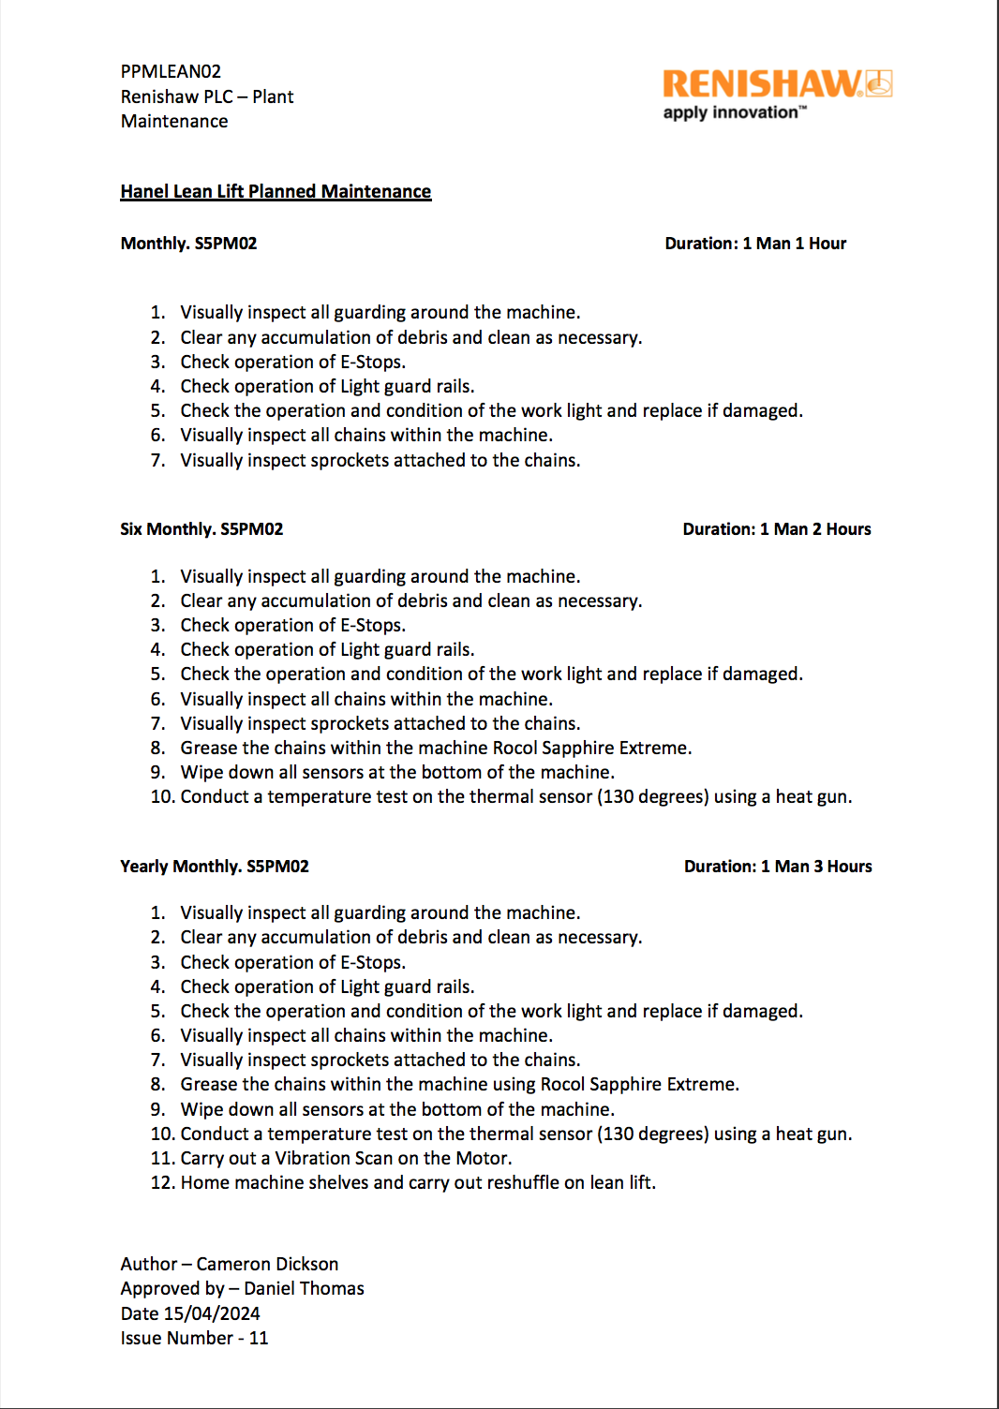
Fig.12 Planned Preventative Maintenance (PPM) Schedule
After completing the PPM schedule and getting it documented correctly the parts for modification had arrived.
Below in Fig.13 is a rough drawing that was created on how it was going to be wired up and integrate this modification into the safety circuit. First the drawing of the wiring into the temperature relay is shown below.
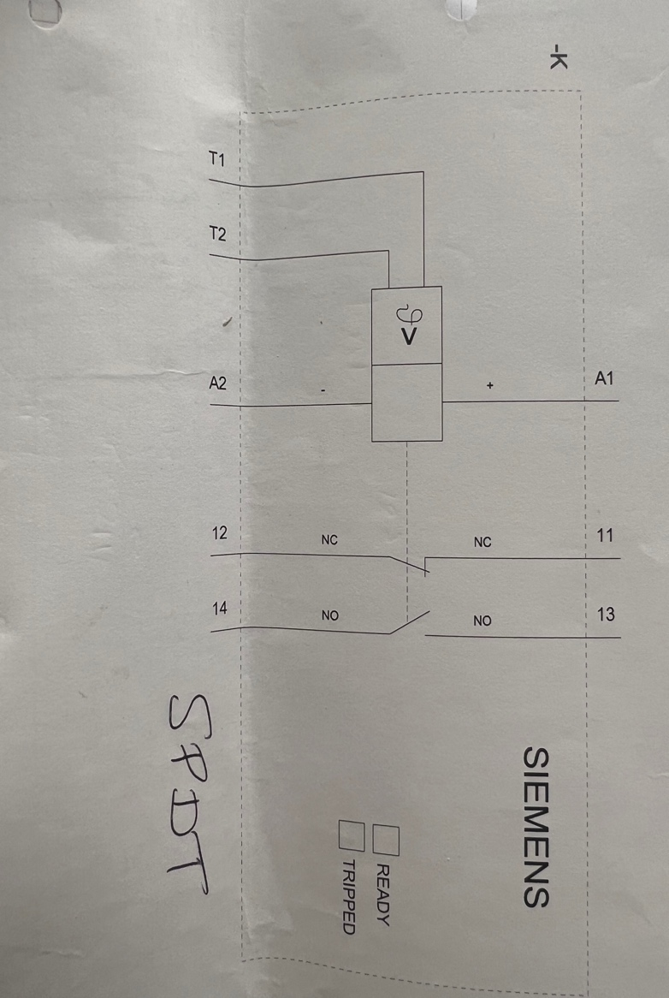
Fig.13 Temperature relay wiring drawing
Then a rough drawing for the wiring into the safety circuit is shown below in Fig.14
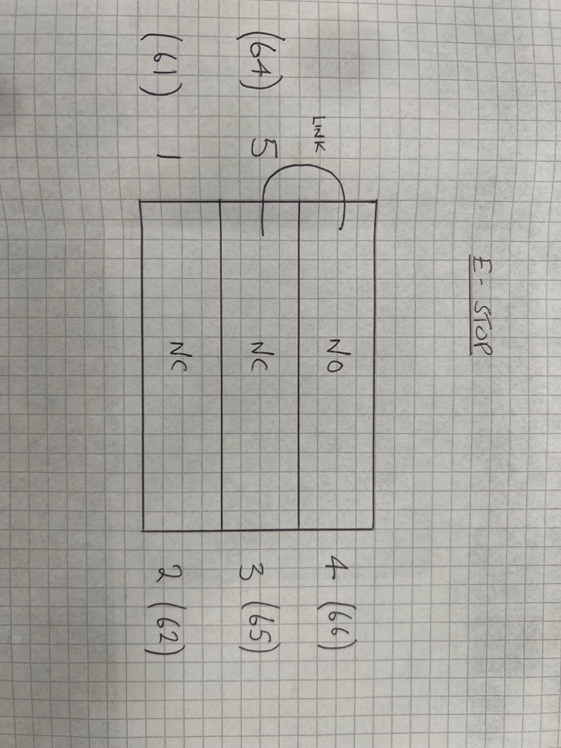
Fig.14 Safety Circuit wiring drawing
After completing this drawing the modification was ready to be wired up and ready to start testing to see if the temperature sensor and temperature monitoring relay is working correctly. Firstly the sensor was connect to the motor.
The motor already had predrilled and tapped holes to mount something like this sensor to it. The thermal sensor is able to read the temperature from the motor windings. The image below in fig.15 is the sensor secured to the motor.
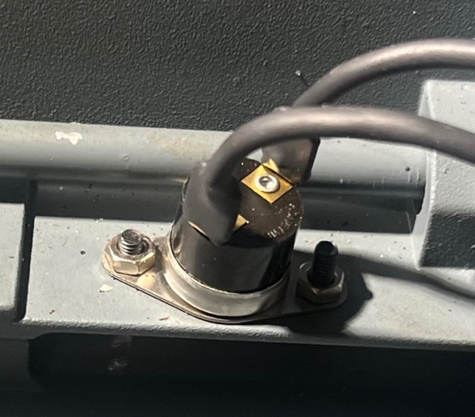 Fig.15 Temperature sensor secured to motor
After connecting the sensor to the motor, was then able to work in the panel and start inserting and wiring all the electrical components.
Firstly the breaker was installed which allows the 230vac supply to the power supply. Below in Fig.16 is an image of the breaker fitted into the panel and mounted on the din rail.
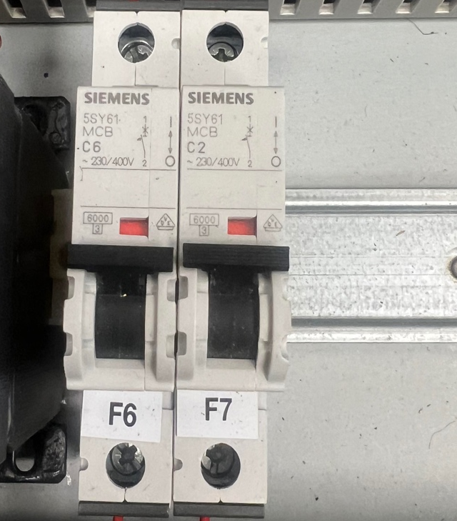Fig.16 Breaker switch mounted

After fitting the breaker the next step was fitting and wiring up the 24v Power supply. The power supply is what gives the 24vdc output and powers the relay siemens temperature monitoring relay. Below in Fig.17 is an image of the power supply fitted to the din rail.
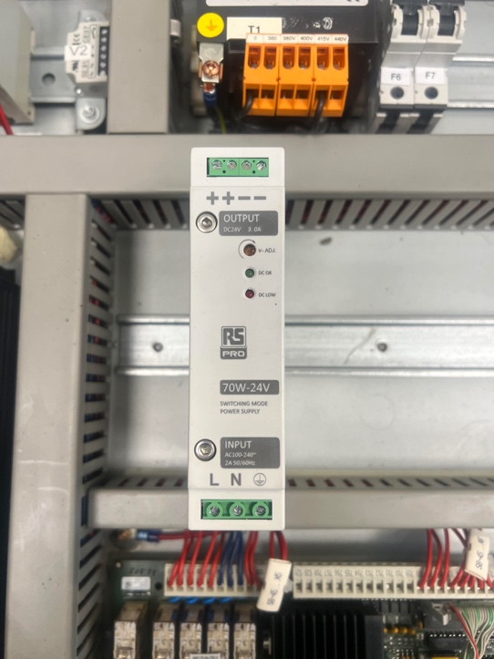Fig.17 Power supply mounted
Now that the power supply is fitted the next step was to insert and wire up the siemens temperature monitoring relay. Below in Fig.18 is an image of the relay next to the power supply.
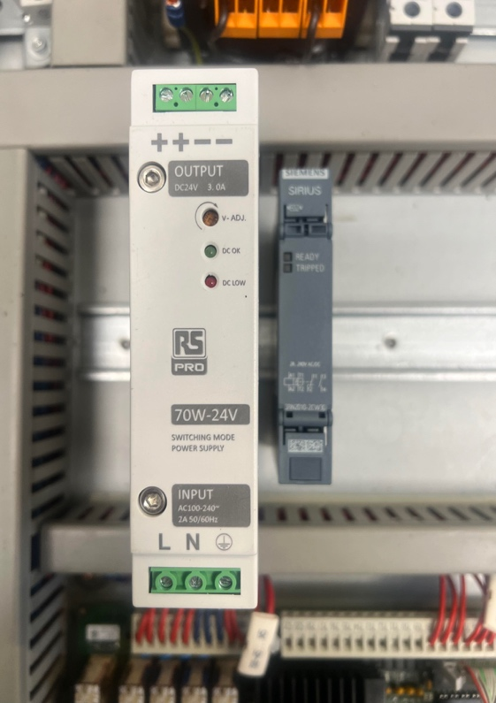Fig.18 Temperature relay

After fitting everything the next step was to wire up and power everything to see if it works. As you can see in Fig.19 the power supply and temperature relay is all powered on and working correctly.
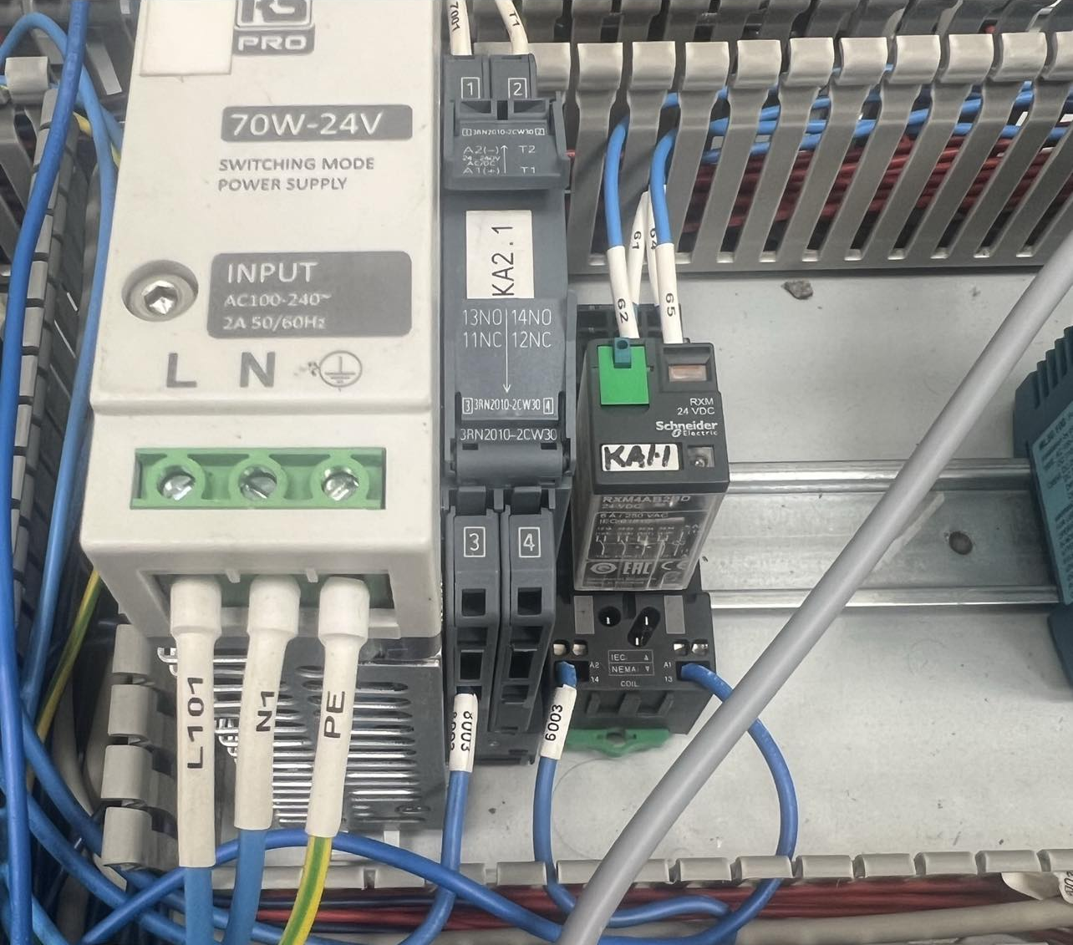Fig.19 Modification wired and powered up
After powering on and ensuring it all works the relay needed to be connected to the 24v safety circuit.
To test these a heat gun that was set at 100°C was used and also a calibrated temperature probe to ensure that the heat gun is working efficiently and correctly. Choosing this temperature sensor the understanding from the technical specification of the sensor was that at a 100°C then the sensor should have an open signal triggering the design and wiring and alarming out the machine and putting it into a state of emergency. Applying direct heat onto this sensor simulates if the motor is overheating. Below the testing of the temperature sensor with the probe and heat gun is shown. Heat gun test is shown as Fig.20 and calibrated temperature probe is Fig.21
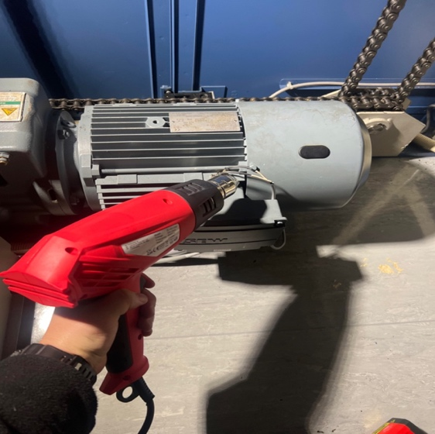
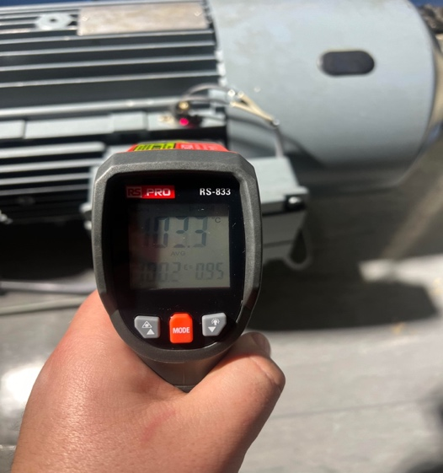

Fig.20 Heat Gun Test Fig.21 Temperature Probe Readings
After heating the sensor to 100°C the relays activated and the machine shut off. To confirm that the modification had worked correctly, a check on lean lift HMI screen was needed. Checking the HMI screen showed that the machine had alarmed out. Fig.22 below is the alarm message on the screen.
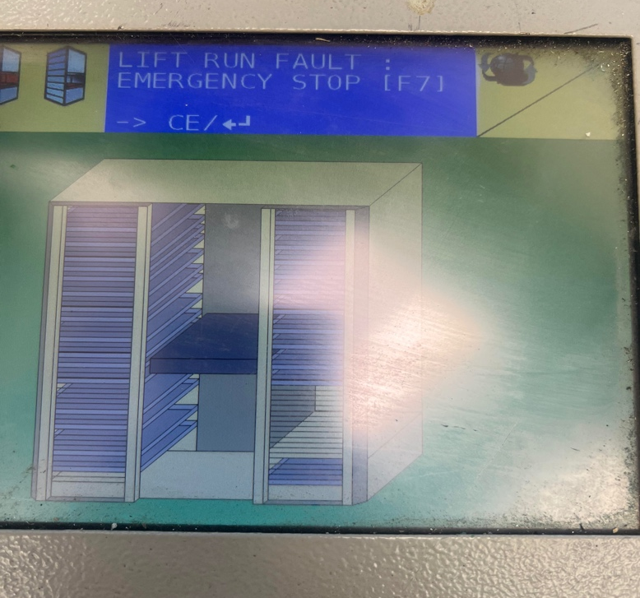Fig.22 Alarm in emergency state
The temperature sensor is set up so that after it has been triggered at 100°C it will not close that signal until the motor has cooled below 85°C. After giving it 30 minutes to cool down the machine was then able to reset and run again. This is a very good fail safe as a standard reset could cause damage to the motor. If an operator was to reset this every time and try running the machine it would constantly reset and fault out causing more damage to the overheated motor and even causing issues with the temperature sensor.

Risk Assessment After Project Completion

After the completion of the project a final risk assessment was conducted to ensure the project was a success. With implementing the project and adding a PPM schedule to the equipment the risk probability and the risk rating have decreased drastically. Having the modification installed to the machine eliminates the risk of a fire occurring to the machine has before the motor starts to properly overheat the machine would have already have stopped and started to cool down. Also with the constant checks and inspections done with the PPM schedule the likelihood of a fault occurring when there are not many employees working on the weekend has not drastically dropped.

What is the Hazard? | Who might be harmed? | How might they be harmed? | Control that should be in place | Is required control in place? (Yes or No) | Action to implement required control | Time of Action | Actioner Name | Risk Probability  Highly Likely  Likely  Unlikely  Very Unlikely | Risk Severity  Fatality  Major Injury  Minor Injury  Near miss | Risk Rating  Extreme  High  Medium  Low
Motor overheating due to jam | Operator and employees in the vincity | Fire / Explosion | Thermal sensor on motor wired into the safety circuit to stop the motor | Yes | Implement sensor into safety circuit | 4 Months | Cameron Dickson | Very Unlikely | Fatality | Low
Storage of Fire Risk goods (Batteries) | Operator and employees in the vincity | Fire / Explosion | Thermal sensor will detect heat within lean lift. Inspection of batteries before placing in lean lift to ensure goods are not damaged | Yes | Implement sensor into safety circuit | 4 Months | Cameron Dickson | Very Unlikely | Fatality | Low
Chains connected to motor could get jammed | Operator and employees in the vincity | Chains could snap / flying parts | Thermal sensor on motor wired into the safety circuit to stop the motor | Yes | Implement sensor into safety circuit | 4 Months | Cameron Dickson | Very Unlikely | Fatality | Low
Lack of grease on chains could cause friction | Operator and employees in the vincity | Fire / Explosion Chains could snap / flying parts | Better heat resistant grease / PPM plan put in place | Yes | Implement sensor into safety circuit | 4 Months | Cameron Dickson | Very Unlikely | Fatality | Low
Motor to bring shelf in and out could get jammed causing a motor to overheat | Operator and employees in the vincity | Fire / Explosion | Thermal sensor on motor wired into the safety circuit to stop the motor | Yes | Implement sensor into safety circuit | 4 Months | Cameron Dickson | Very Unlikely | Fatality | Low
Light guards not working | Operator | Coming into contact with moving parts | PPM plan to be put in place | Yes | Implement sensor into safety circuit | 4 Months | Cameron Dickson | Very Unlikely | Minor Injury | Low
Loss of stock due to fire and potentially loosing machine shop | Renishaw | Loss of money and stock / injury to employees | Thermal sensor on motor wired into the safety circuit to stop the motor | Yes | Implement sensor into safety circuit | 4 Months | Cameron Dickson | Very Unlikely | Fatality | Low
Lean lift being used on weekends where less people are in and aware of any problems with it | Operator and employees in the vincity | Fire / Explosion  Lack of personnel might go unnoticed for a while | Thermal sensor on motor wired into the safety circuit to stop the motor | Yes | Implement sensor into safety circuit | 4 Months | Cameron Dickson | Very Unlikely | Fatality | Low
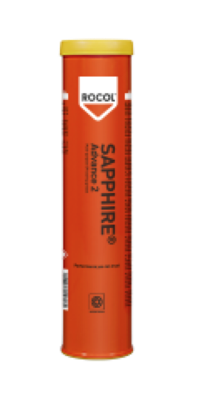
From completing this risk assessment and FMEA a big concern with the lean lift was using better grease to maintain the lean lift. Currently the grease used is just standard multipurpose grease with a max of 160°C. This is stated for bearings and motors however with the machine at risk of a fire it is safer to uprate this grease to use on the lean lift. Fig.23 below is a photo of the current grease used which is the Rocol sapphire Advanced 2.

Fig.23 Grease currently used

Looking into different types of grease Renishaw itself uses CITRAX EP No.1 which is supplied in cartridges which are harder to use unless going into the holders on our CNC machines. The CITRAX EP1 has a max temperature rating of 190°C. This is the maximum limit that is needed when looking for suitable grease. Upon researching an elevator equipment site suggest using the grease that is shown below in Fig.24.
Fig.24 Recommended grease for lift equipment
The research of the grease needed for lifting equipment was taken from the citation below.

www.elevatorequipment.co.uk. (n.d.). Lithium Grease - General Purpose EP5 - Elevator Equipment. [online] Available at: https://www.elevatorequipment.co.uk/sundry-items/general-hardware-consumables/lithium-grease-general-purpose-ep5 [Accessed 08 May 2024].
‌Also the specification from Granville was obtained that states the properties and operating temperatures and melting point of the grease. This specification is shown in Fig.25
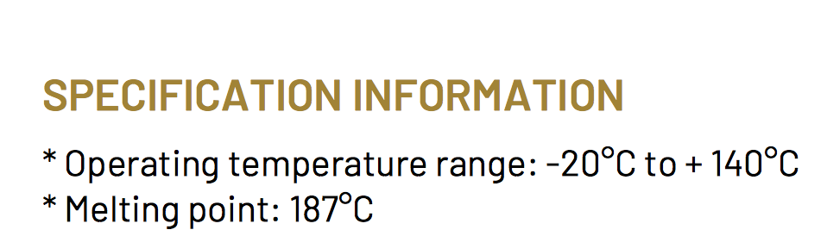
Fig.25 Granville grease specification

Understanding the grease needed for the lean lift the best option for the lean lift is to use Rocol Sapphire Extreme. Similar to what has been used previously, however the extreme allows for a max operating temperature of 235°C for short periods of time. Where the Rocol sapphire advanced 2 only allowed 160°C for short periods of time. This grease is readily available on RS and will be used in maintaining our lean lift and going over the specification of what a lift would need.

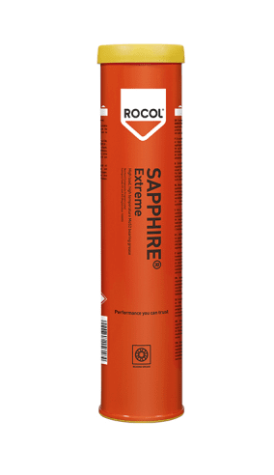
In Fig.25 and Fig.26 below this shows the details from the technical document and the grease cartridge that will be used to maintain the lean lift.

Fig.25 New grease to be used
Fig.26 New Grease technical data

Results

Upon completion of the modification to the lean lift, the results were what was expected and that the project was successful. The temperature sensor and temperature relay were working as expected and at 100°C it triggered and sent the machine into a state of emergency stop. Allowing the machine too cool down the machine was not ready until the temperature sensor was below 85°C. This fail safe is very useful as it stops a repeat issue of resetting the machine while the motor is over heated. The sensor will prevent a fire occurring on the motor which ensures the safety of Renishaw’s employees and Renishaw itself. Over the next 6 months date will be gathered on the modification as the concern is any false alarms that may occur with a change in the transient temperature. When the data has been gathered after the 6 months and there are no issues, this in turn will allow the true completion of the project by rolling this out to all 11 lean lifts currently within all of Renishaw’s sites.

Discussions and Conclusions

To conclude the project was a success as we have now implemented a safe and working modification that ensures the safety of Renishaw’s employees and Renishaw itself. To correctly conclude We must examine a number of crucial components of the temperature sensor and monitoring relay system in order to determine how well the implemented solution detects motor overheating and initiates the emergency stop. To evaluate the accuracy of the temperature sensor in measuring the motors overall temperature a heat gun test with a calibrated and accurate temperature probe was conducted. By doing this it ensured that once the motor sensor reached a temperature of 100°C it triggered and shut down the machine by putting it into a state of emergency. Another factor to evaluate is the response time of the temperature sensor. Once the temperature probe measured that the sensor had reached 100°C the sensor registered this and shut off the machine almost instantly. Evaluating the reliability and consistency of the temperature sensor is crucial, and solving this by introducing the heat gun test on the PPM schedule is a great way to ensure that the system that have been implemented is safe and remains safe over time.

A potential problem that may occur is that gathering data can only be achieved over time and this data would be the rate of false alarms this modification may cause. If the modification that was introduced causes unintended emergency stops activation this could be a huge flaw in the system. Gathering data in the future of genuine motor overheating events or a transient fluctuation of temperature that may accidentally cause the sensor to trigger could be crucial to finding out the full validity of this project and system that was put in place.

Recommended Further Work

After the completion of the work, the outcome was very pleasing and the project turned out really well. However there are a few ways that would improve the modification. Further work that could be recommended would be to add a temperature display or a small Human Machine Interface (HMI). With the current modification when the motor reaches the maximum temperature that the temperature sensor and relays allows it to it will cut off the emergency stop and place it into a state of emergency. By having a temperature display or a HMI it will be able to show the fault clearly to operators who may not know of the modification I have put in place or what the initial problem was. Even though our maintenance department would be the ones to come to the machine and look at it and certain personnel would understand the fault it could still be very confusing for people. The HMI display that tells the operator that a motor has overheated will ensure that they report this to the maintenance department where we can then investigate the temperature of the motor or if there is a fault with the sensor or relay themselves. Which we can then hand back when satisfied knowing that the machine is safe to use. Further recommended work would be to look into ordering spare parts for the modifications to ensure downtime is a minimum. Also drawing the wiring diagram properly and making instruction packs for other Renishaw sites to keep if there modification ever faults out and certain personnel is not there to solve it. A reset button could also be implemented instead of going into the panel and resetting the system by the relay itself. However, implementing a reset button is only useful once the temperature sensor has dropped to below 85°C and has closed the signal to the emergency stop. Another recommended test that could be conducted in the future is testing how long the temperature sensor stays accurate and measure the response time of the sensor in triggering the safety circuit. Over time the temperature sensor may degrade and loose accuracy. This could affect the response time and with the severity of the risk of fire and explosion you want the sensor to act quickly to ensure the safety of the operator and employees. To counteract this issue an update of the implemented PPM schedule when conducting the heat gun test to use the calibrated temperature probe and ensure that the response time stays within the region of a couple of seconds. By doing this it will ensure that the modification continues as a safe protection device. Within Renishaw the company is expanding massively and new lean lifts are being ordered. Further recommendation would be that procurement could install this modification before bringing it onto site as it is an manufacturers failure. To roll all the modifications out to all 11 lean lifts across multiple sites a PUWER assessment will have to be completed in order to do so. After gathering the 6 months data this will be completed. The PUWER assessment will need to be conducted as there has been modifications completed on the equipment.

Bibliography

www.hse.gov.uk. (n.d.). LOLER 1998 Lifting Operations and Lifting Equipment Regulations (LOLER) 1998: Open learning guidance. [online] Available at: https://www.hse.gov.uk/pubns/books/loler.htm.

Health and Safety Executive (1998). Provision and Use of Work Equipment Regulations 1998 (PUWER) - Work equipment and machinery. [online] www.hse.gov.uk. Available at: https://www.hse.gov.uk/work-equipment-machinery/puwer.htm#:~:text=PUWER%20requires%20that%20equipment%20provided.

‌Devon and Somerset Fire and Rescue Service. (n.d.). Lithium battery fires. [online] Available at: https://www.dsfire.gov.uk/safety/home/battery-fires.

Health and Safety Executive (1998). Provision and Use of Work Equipment Regulations 1998 (PUWER) - Work equipment and machinery. [online] Hse.gov.uk. Available at: https://www.hse.gov.uk/work-equipment-machinery/puwer.htm.
‌
HSE (2023). Statistics - Fatal injuries in Great Britain. [online] Hse.gov.uk. Available at: https://www.hse.gov.uk/statistics/fatals.htm.
‌
UK Government (2005). The Regulatory Reform (Fire Safety) Order 2005. [online] www.legislation.gov.uk. Available at: https://www.legislation.gov.uk/uksi/2005/1541/contents/made.
Electrical Safety First. (n.d.). Lithium-ion Batteries. [online] Available at: https://www.electricalsafetyfirst.org.uk/guidance/product-safety/lithium-ion-batteries/.
www.elevatorequipment.co.uk. (n.d.). Lithium Grease - General Purpose EP5 - Elevator Equipment. [online] Available at: https://www.elevatorequipment.co.uk/sundry-items/general-hardware-consumables/lithium-grease-general-purpose-ep5 [Accessed 04 May 2024]
‌
granvilleoil.com. (n.d.). Granville | Product Information - Granville Multi-Purpose Grease. [online] Available at: https://granvilleoil.com/prodInfo?pID=158 [Accessed 07 May 2024].
‌
RS Components (n.d.). RS Components. [online] Rs-online.com. Available at: https://uk.rs-online.com/web/.

Appendix

Gantt Chart



