Figure 1 (Health Essentials from Cleveland Clinic, 2020)
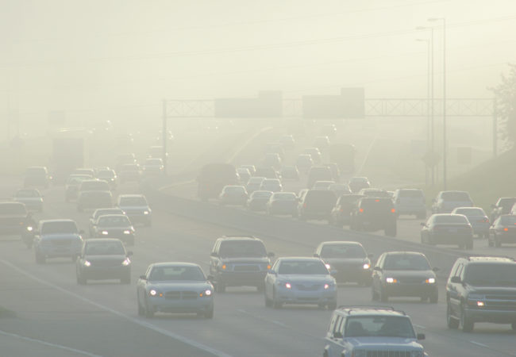

Combustion and Emission Study: Modelling Fuels and NOx.

Milo Ward | Powertrain and Sustainability | January 2020

Contents
Introduction 1
Task One 2
Air fuel ratio mass 3
CO2 produced 4
Enthalpy and calorific Value 5
Higher and lower heating value 6
Ideal fuel 6
Task Two 7
Flame Temperatures 7
Flame Temperature per degree 10
Nox 11
Task Two B 16
Base Model 16
Adding EGR 16
Conclusion 18
References 19

Introduction

The first aim of this report is to investigate a blended mixture of Methanol and Iso-octane, looking into its composition, the enthalpy on the product and what would be produced when the product is used as a fuel.
The second aim was to develop a NOx model running on the lean side of stoichiometric for Iso-Octane fuel, representing a real-life emissions test. It was then required that this model was taken further forwards and to see the effects of an ‘EGR’ system being used on the model. (EGR – Exhaust Gas Recirculation – Used to reduce emissions by allowing some of the exhaust gases back into the cylinder to reduce the temperature, by lowering the temperature the production of NOx goes down.)

Task One
Using Microsoft Excel, a 50/50 blend calculator for Methanol and Iso-Octane was produced, using basic information suppled such as the properties of the molecules in the fuel, the atomic weights of the elements and some equations provided by Dr Williams. It could produce a reasonable prediction of what is generated in an ideal situation.
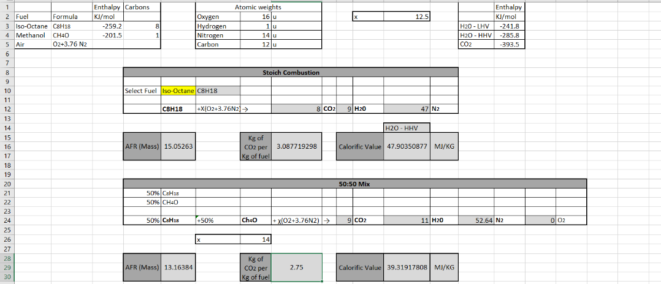

Figure 2 50/50 Blend Calculator created on Excel

To create this, the first thing needed is to find what would be produced once these two separate fuels are mixed, the chemical formula for these are: C8H18 for Iso-Octane and CH4O for Methanol. This means there are 8 Carbon atoms and 18 Hydrogen atoms in Iso-Octane and 1 Carbon atom, 4 Hydrogen atoms and 1 Oxygen atom in Methanol.
To blend these together, first the Carbons are added together, 8+1 = 9 so there are 9 CO2’s. Next the Hydrogens, there are 18 Hydrogens in Iso-Octane and 4 in Methanol, these add together to make 22, but as they produce H20, it is 2 Hydrogens per Oxygen molecule, so dividing this by 2. leaves 11 H2O molecules.
50%C8H18 + 50% CH40 +X(O2+3.76N2) → 9CO2 + 11H20 +?
Now this has been done, ‘X’ can be worked out, ‘X’ is needed to be able to see how much Oxygen and Nitrogen have been created. This is done as O = 2X, because there are two Oxygens to the ‘X’, there are 9 CO2 molecules, which have 2 Oxygens in, 18 O + the 9 Oxygens in H20. Leaving 29 Oxygens, 1 must be taken away as it is on the original side, then divide by 2 to get ‘X’ on its own and ‘X’ = 14. So now, ‘X’ multiplied by 3.76 gives the N2 created, 14 multiplied by 3.76 = 52.64 Nitrogen’s. This all assumes that complete combustion has occurred when these two products have been blended and used for combustion.
50%C8H18 + 50% CH40 +X(O2+3.76N2) → 9CO2 + 11H20 + 52.64N2

Air fuel ratio mass
With the resultant chemical balance being known, other important information can be worked out, the first of this is the AFR or the Air Fuel Ratio by Mass, which is the air mass over the fuel mass. First the mass of air must be known, knowing ‘X’ the amount of Oxygen Molecules is known, O2 = 2 Oxygen molecules, therefore 14 multiplied by 2 times the atomic weight of oxygen which is 16. This then needs too be added to the amount of Nitrogen in the air, 3.76, multiplied by the atomic weight of 14 and then multiplied by 2 (N2.) Although there are more components in air, it has been simplified and only the prominent gases have been used due to the small amounts of others.
As the air mass has be worked out, the fuel mass must also be worked out. Again, this is done by multiplying the number of molecules by how many are in the mixture and their atomic weight. So, for C8H18, there are 8 Carbon atoms weighing 12u and 18 Hydrogen atoms weighing 1u each, for CH4O, there is 1 Carbon atom weighing 12u, 4 Hydrogen atoms weighing 1u and 1 Oxygen atom weighing 16u.
Using what has been calculated, divide the air mass by the fuel mass, for the 50/50 blend of Methanol and Iso-Octane, this comes out at 13.16384. This is a stoichiometric burn and would realistically be impossible to achieve.
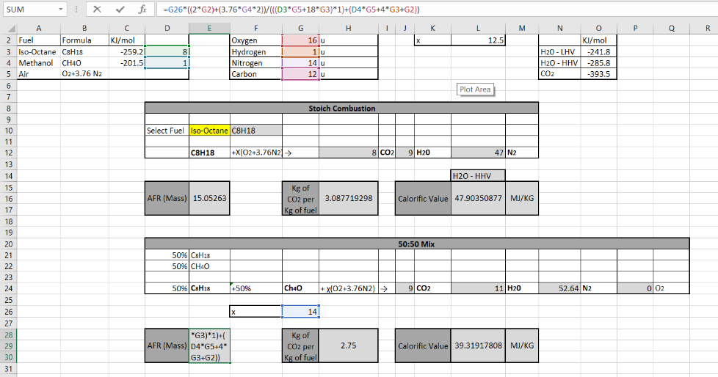

Figure 3 Blend Calculator showing how the AFR Mass was calculated

CO2 produced
Furthermore, the next part built in the blend calculator was to work out how many kilograms (Kg) of CO2 was being produced per Kg of the 50/50 blend being burnt. This could be calculated by seeing how many carbon atoms were in the first part of the mixture, and what has been created on the other side.
First, multiply the amount of CO2 that has been worked out previously in the calculator by the atomic masses of Carbon and Oxygen, giving the weight of what has been produced there. This is then divided by the atomic weight of the molecules in the start. For Iso-Octane that is 8 Carbons multiplied by 12u and 18u Hydrogens multiplied by 1. This is then added to the 1 Carbon molecule multiplied by 12u, 4 Hydrogens by 1u and the singular Oxygen molecule times 16u. In total there 396/114+32 = 2.7123 Kg of CO2 produced per Kg of fuel burnt.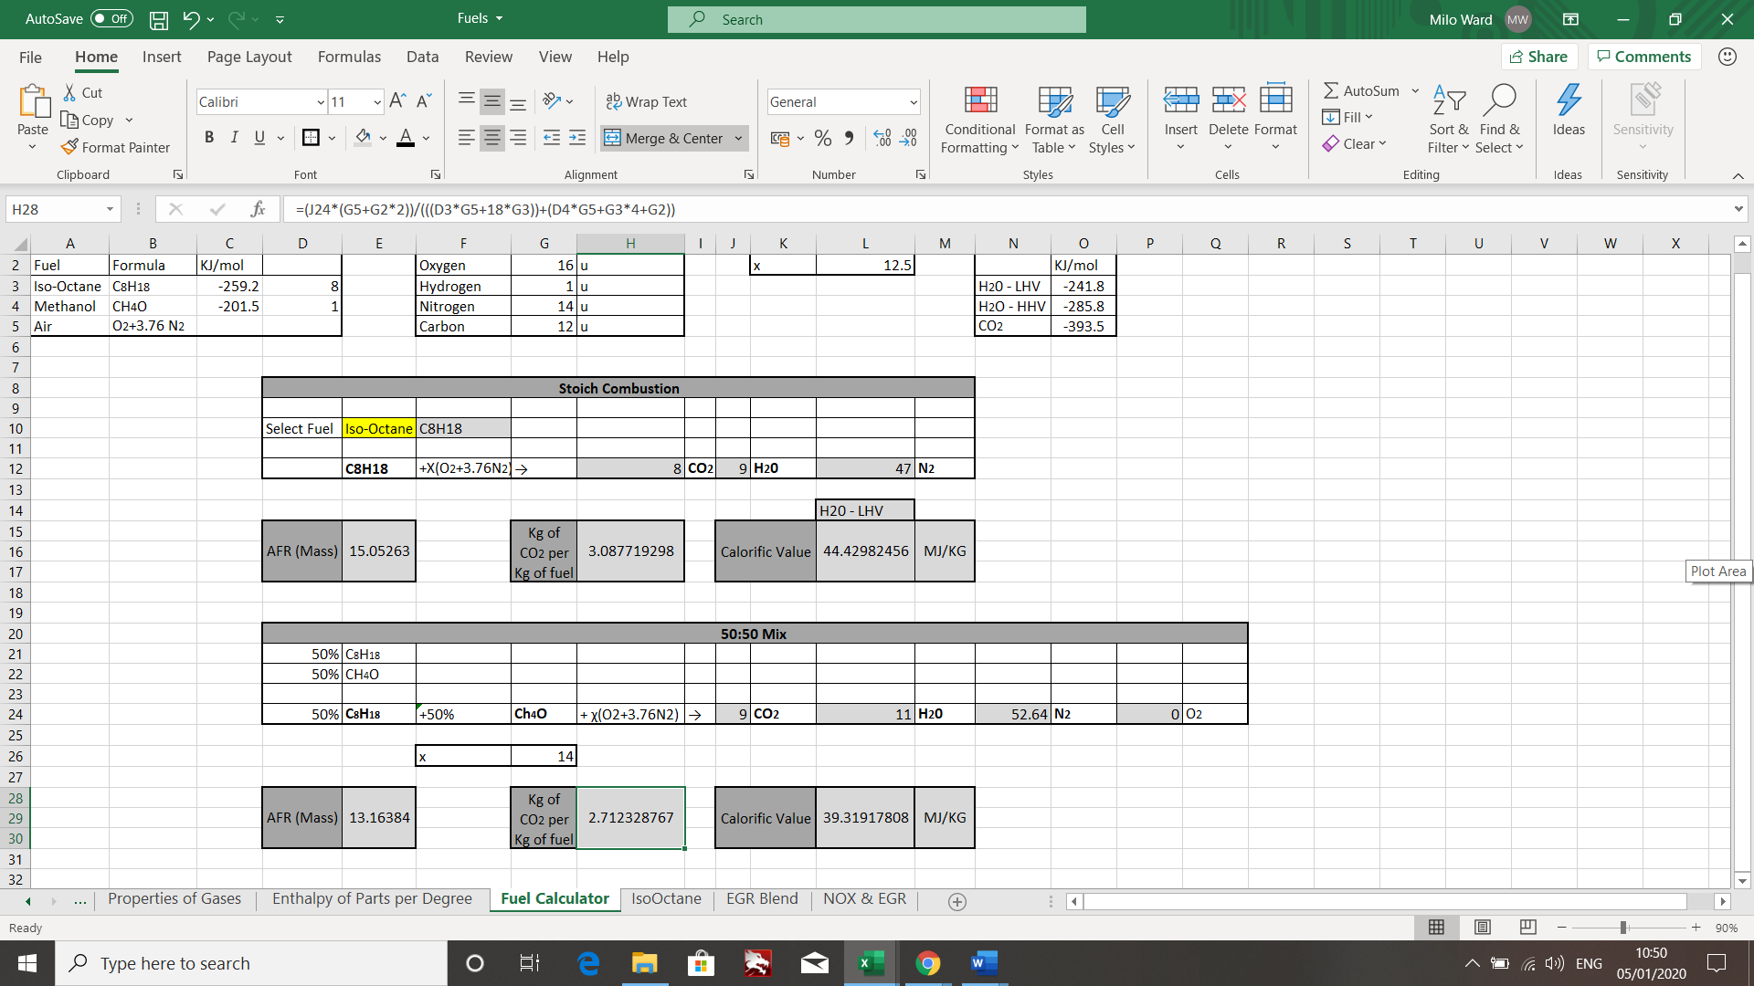
Figure 4 The fuel blend calculator showing CO2 Produced

Enthalpy and calorific Value
The following step of the blend calculator is to investigate and find the calorific value of the mixture of Methanol and Iso-Octane, which is done by combing the enthalpies of the two chemicals to discover the enthalpy of what has been created.
The first stage is calculate the enthalpy of the 50/50 blend, the enthalpy is the sum of the internal energy, plus the pressure and the volume. (H = E + PV.) (Encyclopedia Britannica, 2020) This can done by adding the enthalpies of Methanol and Iso-Octane together (-259.2+ -201.5) this is then added to the amount of CO2 that has been created, multiplied by the enthalpy of CO2 (9 × -393.5 × -1) The minus 1 is used to turn the enthalpies into positives rather than negatives. Now the CO2 enthalpy is known, just the H2O enthalpy needs to be found, this is done the same way as before (11× - 241.8 × -1.) All these enthalpies added together gives the overall enthalpy of the blended fuels, totalling 5740.6 MJ.
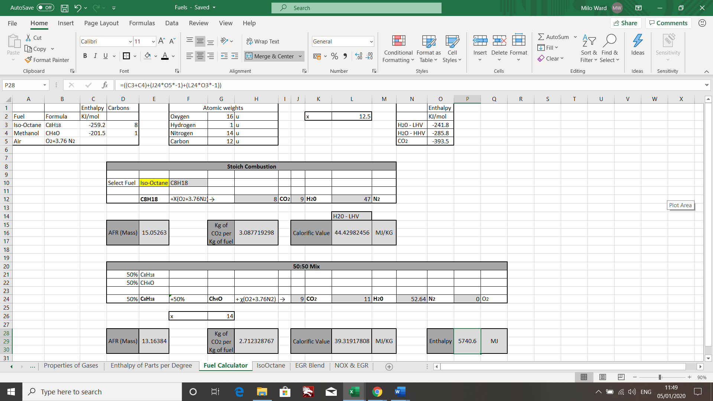
Figure 5 Showing how the enthalpy was worked out for the blended mixture
Now, knowing the enthalpy, the calorific value per kg of blend can be found, this is how much energy was released as heat during the combustion, calculated by taking the enthalpy of the blend and dividing it by the atomic weight of the molecules in the mixture. So, using the enthalpy of 5740.6MJ then dividing it by C8H18 (8 Carbons multiple by 12u and 18 Hydrogens by 1u) plus CH4O (1 Carbon by 12u, 4 Hydrogens by 1u and the singular Oxygen by 16u). Adding these together and dividing this by 5740.6MJ gives 39.319MJ/KG, which is the calorific value per kilogram of fuel.

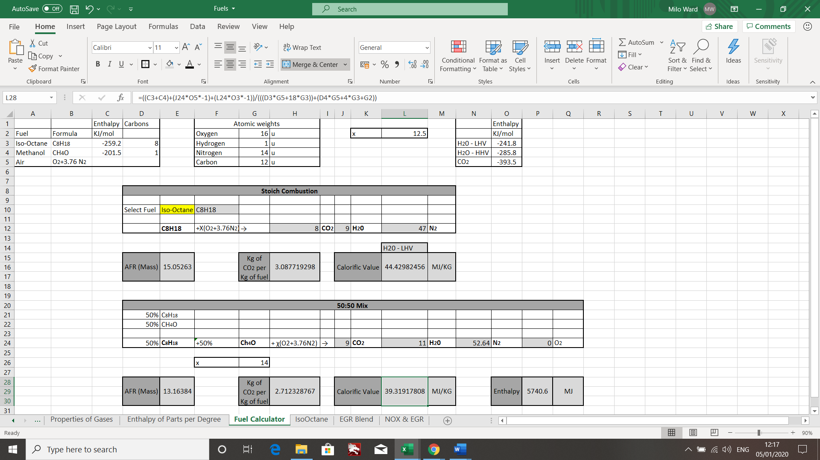
Figure 6 Showing the calorific value per kg of fuel.

Higher and lower heating value
One part that should be taken into consideration here is the lower and higher heating values of some of the parts, for example H2O has a lower heating value of 241.8 KJ/Mol for lower and a higher heating value of 285.8KJ/Mol. The difference between the higher and lower heating value is how the H2O is released after the combustion, for the higher heating value, the H2O is released as a liquid, the same way it went in. Whereas the lower heating value is released as vapour and therefore not released as heat. Throughout the blend calculator, the lower heating value was used, as it is assumed due to heat inside the combustion chamber that everything would have vapourised.

Ideal fuel
Although the most common fuels that are seen daily are Iso-Octane and Diesel, these are far from ideal fuels. For a fuel to be considered ideal it should have a high calorific value and a low ignition temperature, these two properties combined would then reduce the NOx that would be produced and lower the harmful gases produced. In more practical terms, the fuel would also need to be easy to contain, transport and be available in large resource. It is considered, the fuel currently available and the most similar in such properties is LPG, however there are some negatives, if inhaled or spilt on the skin it can have some very harmful consequences. (Emas.com.tr, 2020)

Task Two
The aim for task two was to create a NOx program running on the lean side of stoichiometric, this was again completed using Microsoft Excel, the basis of this was using the Zeldovich Model, although not the most accurate model as it tends to overestimate NOx emissions, it gives reasonable answers without being too complex. The first part of task two was to generate flame temperatures for Iso-Octane on its own and investigate the NOx produced while changing the equivalence ratio, from 0.6 Ф to 1.0 Ф. This was also done from SOC up to 40 bar in steps of 2 bar, to show what happens during combustion. Again, this is not the most realistic way of modelling this, but it gives approximate values.
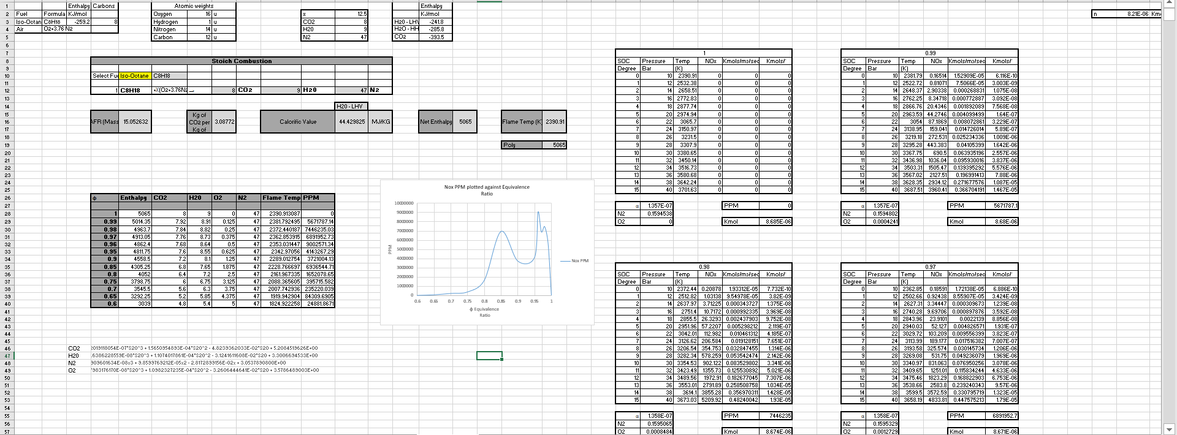
Figure 7 Overview of the NOx Model

Flame Temperatures
To create the NOx model, the first stage is to find out the different flame temperatures for each equivalence ratio as the higher the temperature, the more likely for NOx. To start to get the temperature use everything that has been found out in task one: AFR, Enthalpy, Calorific Value, and the amount of CO2 per Kg of fuel, however rather than the blended, just for the Iso-Octane.

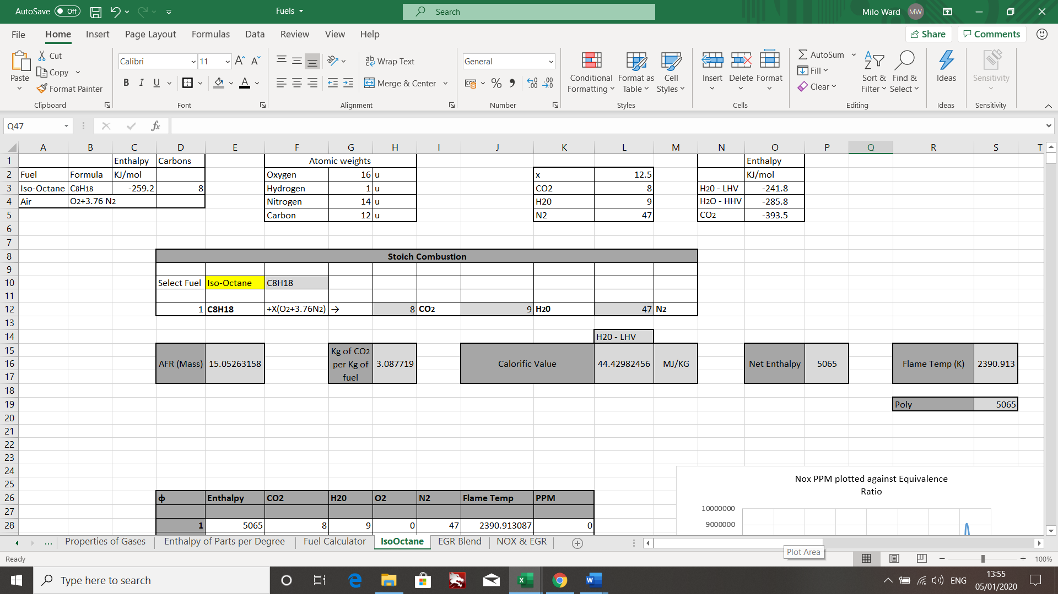
Figure 8 Iso-Octane only fuel information
Once all this information has been found, the next stage is to work out the enthalpy of every molecule for every degree that makes this fuel. Using the information provide by Dr Williams, the properties of each molecule every 50 degrees kelvin was provided. However, every 50 degrees kelvin is not accurate enough for what is needed to be able to match the enthalpy with the temperature.
To gain this extra information, putting the enthalpy per 50 degrees of each molecule (H20, CO2, O2, N2 and CO) into a graph, a 6th order polynomial trend line can be applied to the graph and this provides an equation of the trendline.
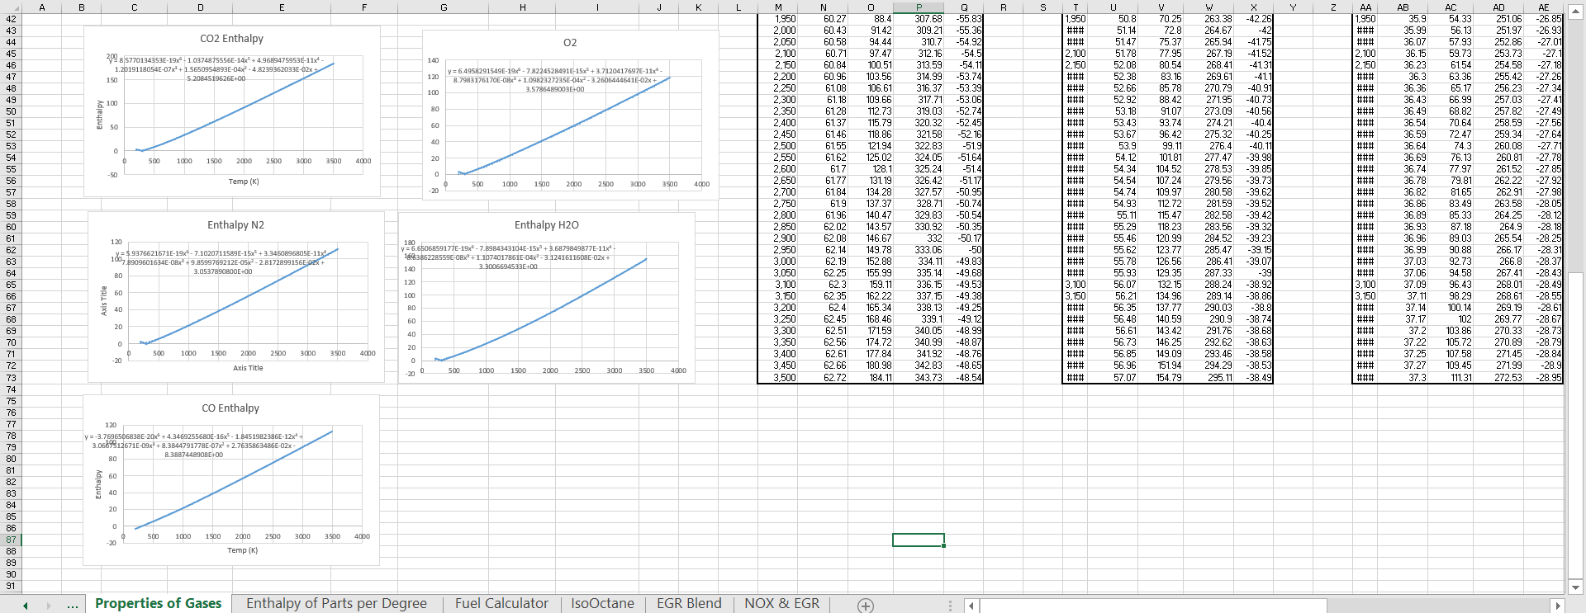
Figure 9 Enthalpy of each molecule every 50K put on a graph
Now the equation for the trendline can be used to use the goal seek function on Microsoft Excel. As the equation for each molecule can be used and multiplied by the number of molecules needed, to work out the enthalpy for each component. The key part of this equation is based on the temperature, as the enthalpy for each molecule changes with the increase of temperature. So, by making the temperature link into an empty cell, whereas the rest of the equation having cells referenced, majority of the information is known. The goal seek function can then be used, as the enthalpy for Iso-Octane at 1 φ is 5065MJ. Using the goal seek, it changes the temperatures of each molecule in the equation to match the 5065MJ enthalpy, once this is complete the flame temperature is known.
For 1 φ, with the enthalpy of 5065MJ, the flame temperature is 2390.913K. (See goal seek below) This same technique can be used again to be able to find the temperature for the other equivalence ratios. 1, 0.99, 0.98, 0.97, 0.96, 0.95, 0.9, 0.85, 0.8, 0.75, 0.7, 0.65, 0.6. The enthalpy for each ratio does need to be known as well but this is done by a drop-down box so that the right out amount of molecules for each ratio is accurate. 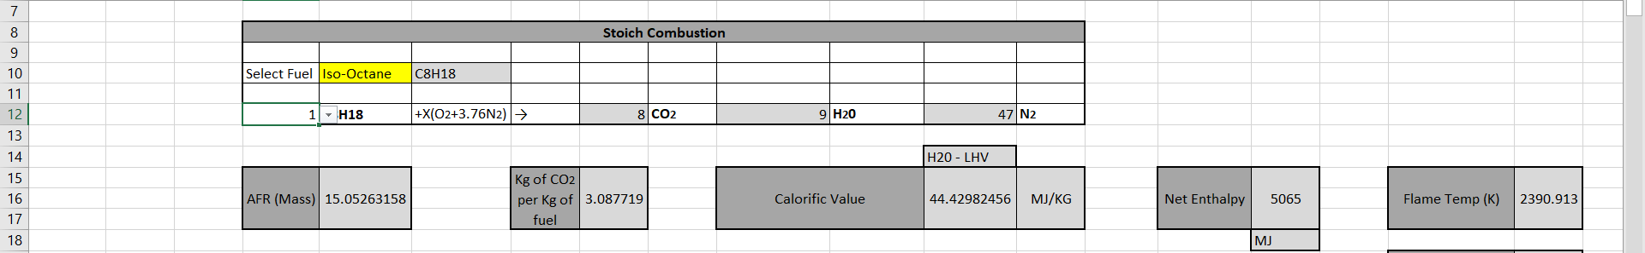
Figure 10 Showing the drop-down box to change ratio

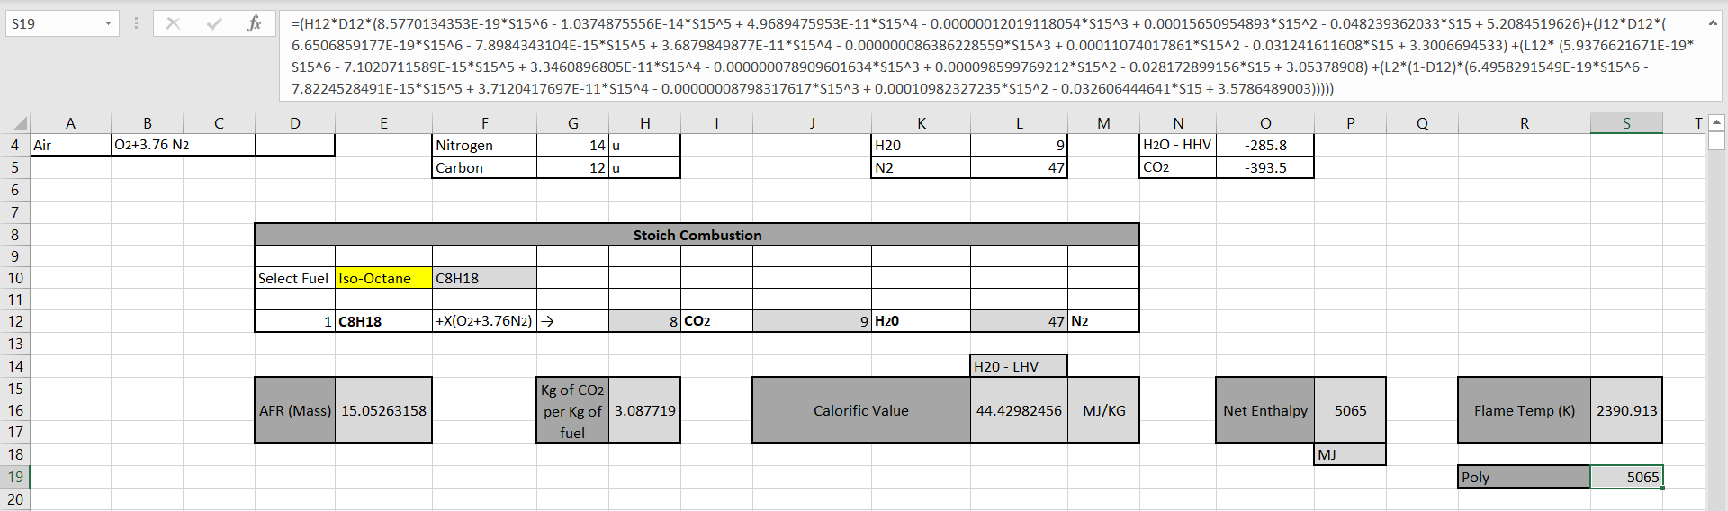
Figure 11 Showing the polynomial equation used to find the flame temperature

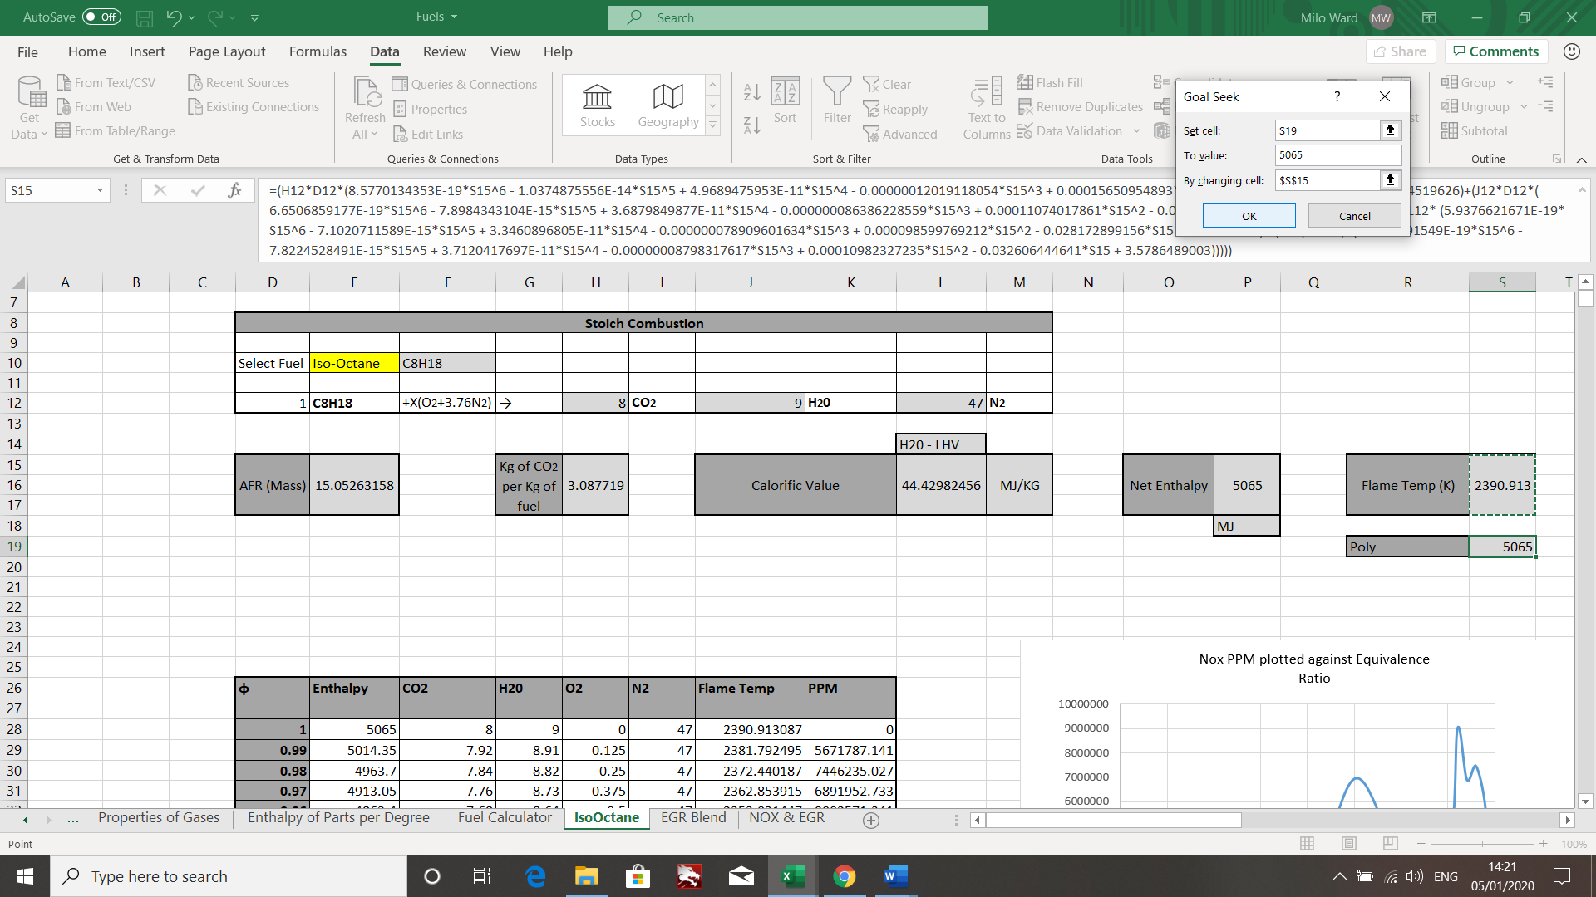
Figure 12 Using the goal seek function
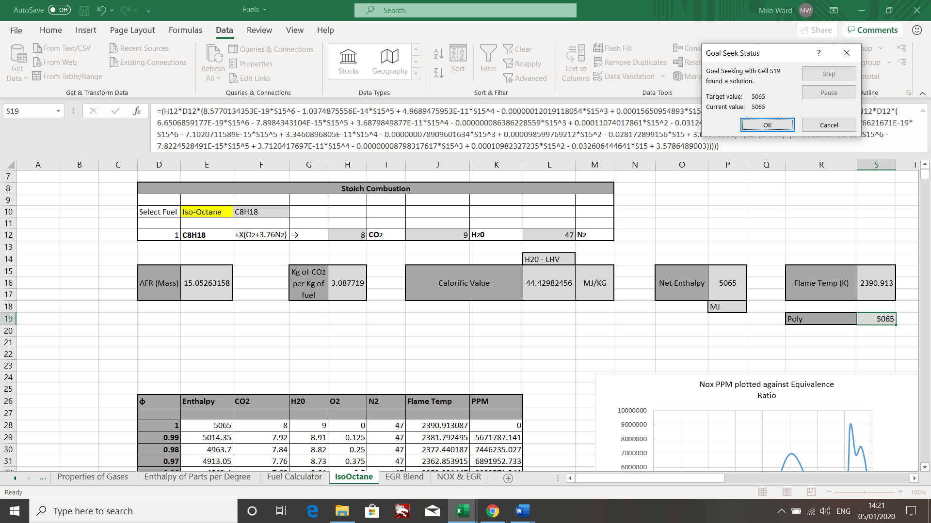
Figure 13 Goal seek function being completed

Now that these have all be completed, the enthalpy and flame temperature for each equivalence ratio is known, along with the amount of CO2, H2O, O2 and N2 molecules that are produced because of this combustion. The results have been put into the table below.
φ | Enthalpy | CO2 | H20 | O2 | N2 | Flame Temp
 |  |  |  |  |  | K
1 | 5065 | 8 | 9 | 0 | 47 | 2390.913087
0.99 | 5014.35 | 7.92 | 8.91 | 0.125 | 47 | 2381.792495
0.98 | 4963.7 | 7.84 | 8.82 | 0.25 | 47 | 2372.440187
0.97 | 4913.05 | 7.76 | 8.73 | 0.375 | 47 | 2362.853915
0.96 | 4862.4 | 7.68 | 8.64 | 0.5 | 47 | 2353.031447
0.95 | 4811.75 | 7.6 | 8.55 | 0.625 | 47 | 2342.97056
0.9 | 4558.5 | 7.2 | 8.1 | 1.25 | 47 | 2289.012754
0.85 | 4305.25 | 6.8 | 7.65 | 1.875 | 47 | 2228.766697
0.8 | 4052 | 6.4 | 7.2 | 2.5 | 47 | 2161.967335
0.75 | 3798.75 | 6 | 6.75 | 3.125 | 47 | 2088.365605
0.7 | 3545.5 | 5.6 | 6.3 | 3.75 | 47 | 2007.742936
0.65 | 3292.25 | 5.2 | 5.85 | 4.375 | 47 | 1919.942904
0.6 | 3039 | 4.8 | 5.4 | 5 | 47 | 1824.922258

Flame Temperature per degree
With the start temperature being known, these can now be used to run a basic simulation model of what would happen to the flame temperature during combustion, from 10 bar to 40 bar going up in 2 bar stages.
To calculate this, a basic equation is used ‘PV = mRT’, which is the ideal gas law. This can then be changed to ‘T2n/T1n = P2n-1/P1n-1’ as the pressure is known all the way through and T1 is the flame temperature that was calculated earlier, this can be used to generate the temperatures throughout the 10 bar to 40 bar combustion cycle, one thing to be aware of is that the polytropic index for this is to be used as 1.17. This is what is being used as n throughout the equation.
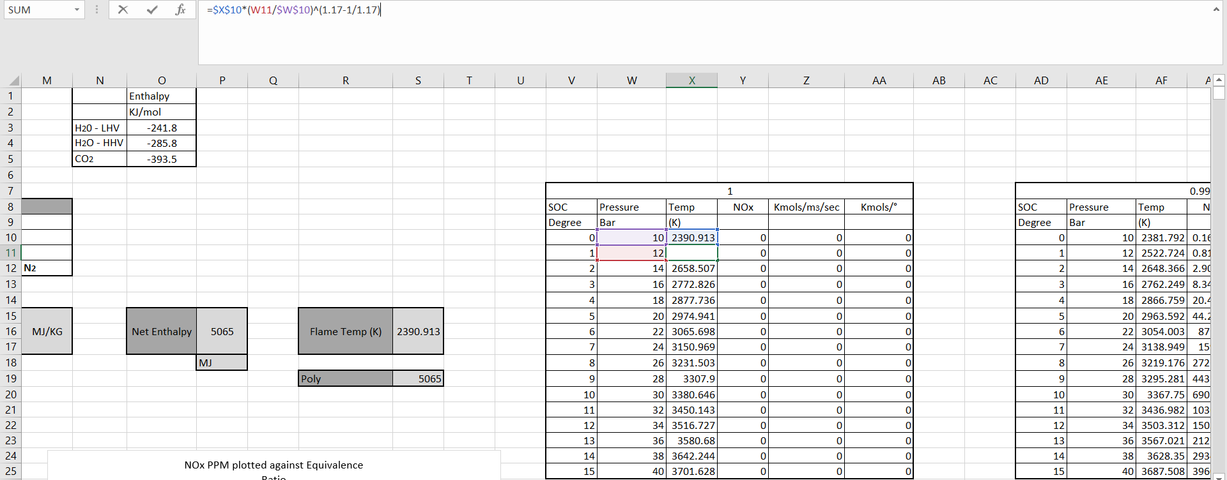
Figure 14 Calculating burn temperatures throughout the cycle.
This burn temperature is then done throughout the cycle and repeated for each of the different equivalency ratios. Now that the temperature is known at every degree after start of combustion, the Nox can be worked out.

Nox
With the temperature per degree past start of combustion, the Zeldovich model can now be used to see how much Nox is generated at each point. This is a fairly simple equation where the numbers are just plugged in to use it, however there are different forms of Zeldovich models, so the one that is being used is by Gunter P. Merker in ‘Simulating Combustion’. Which is as follows:
$$\frac{∂[NO]}{∂t}=4.7×{10}^{13}×\left[N_{2}\right][O_{2}]^{0.5}×exp⁡(\frac{-67837}{T})$$
However, this cannot be used straight away as first, $N_{2 }\& O_{2}$ need to be discovered for each of the equivalency ratios. This is done by working out ‘α’, which represents the Kmols in the mixture. This is done by first using the ideal gas law equation again, but this time to get ‘n’.
$$n= \frac{PV}{RT}$$
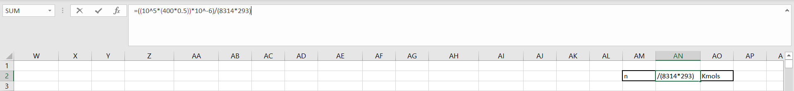
Figure 15 Finding 'n'
Once ‘n’ has been found, ‘α’ can be calculated. As it is a balance equation, ‘n’ is divided by what is being drawn in as air to give ‘α’. This does depend on the equivalence ratio, as this dictates how much air is bring used in the combustion. This needs to be repeated for each equivalence ratio so the ‘α’ is correct for all, and the $N_{2 }\& O_{2}$ will be calculated because of this.
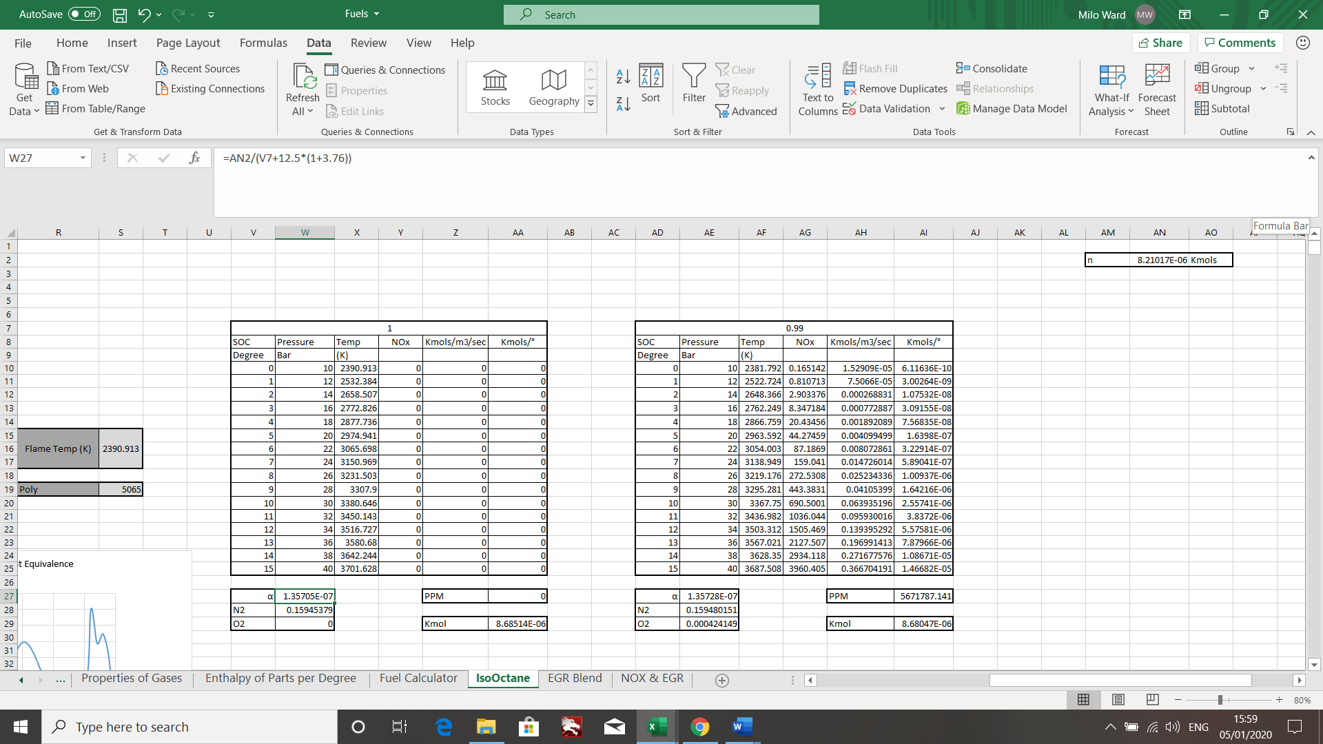
Figure 16 Showing 'α' being found for 1φ
To work out $N_{2 }\& O_{2}$ this is done by using the equations:

$O_{2}= \frac{N×α}{40 ×{10}^{-6}}$ & $N_{2}= \frac{N×α}{40×{10}^{-6}}$
Where N in O2 is the amount of O2 molecules and N in N2 is the amount of N2 molecules.
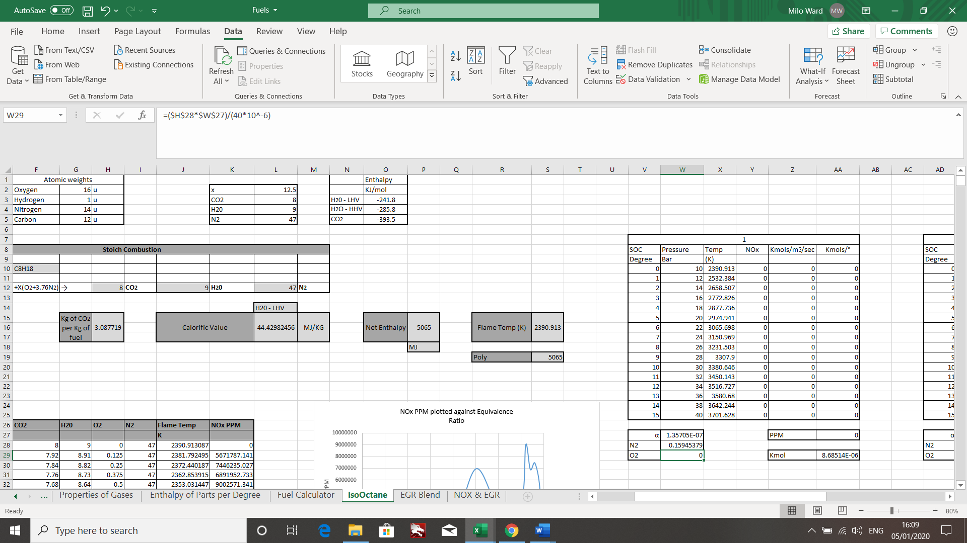
Figure 17 Finding out [O2]
Now that all this information has been found out, it can be used in the Zeldovich model and the amount of NOx per degree after the start of combustion can be found out, this is repeated for all equivalency ratios.

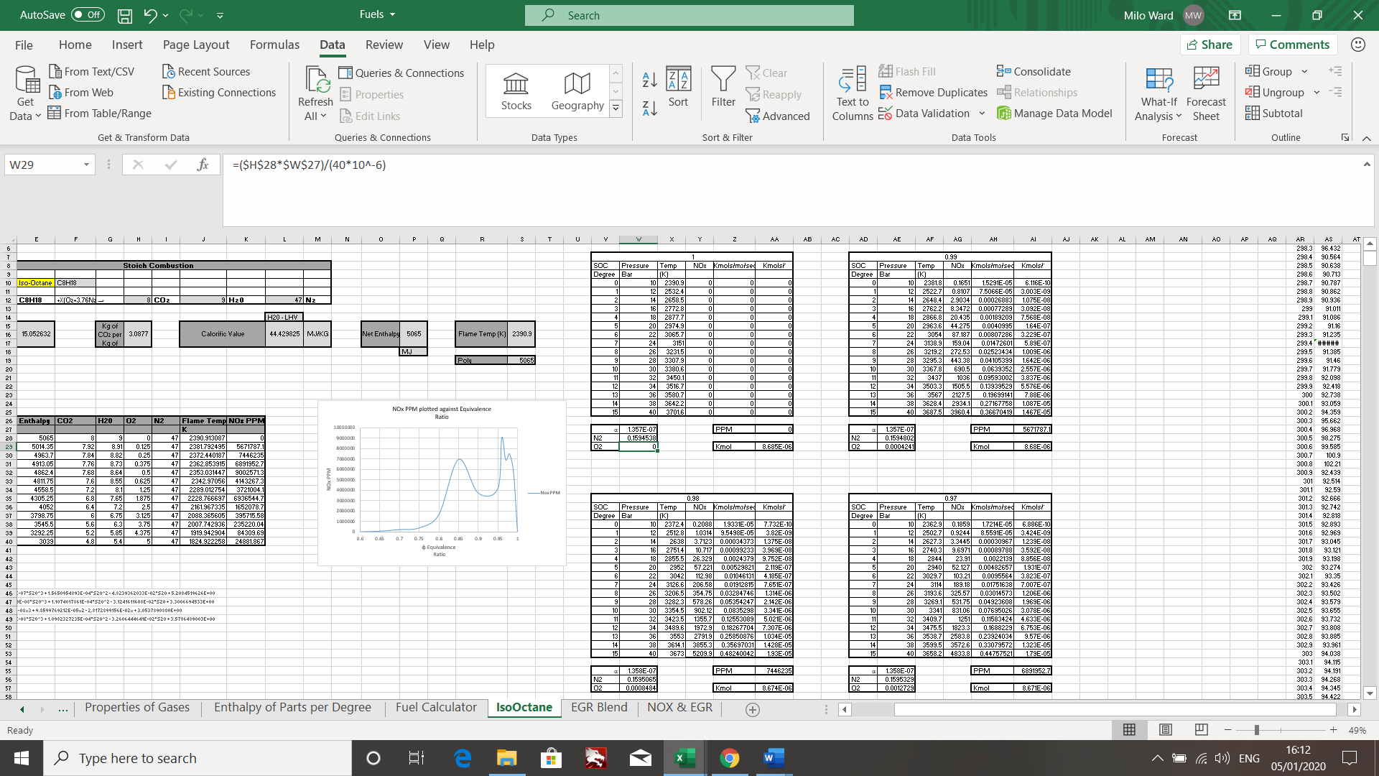
Figure 18 The NOx Figures for some of the φ

As in the above tables, once the NOx is known, the Kmols/m3/sec and Kmols/°. This is done by dividing the NOx by 6×1800(Revs per second of the engine) to get it into Kmols/m3/sec. Then dividing this by the combustion chamber volume at 40cc ×10^-6.

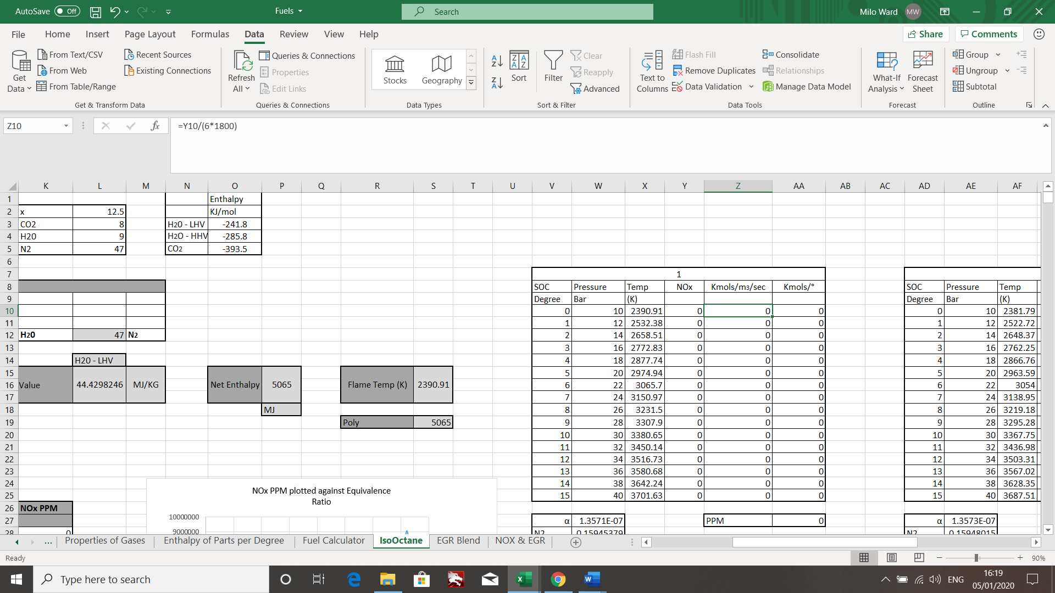
Figure 19 Changing from NOx to Kmols/m3/secs
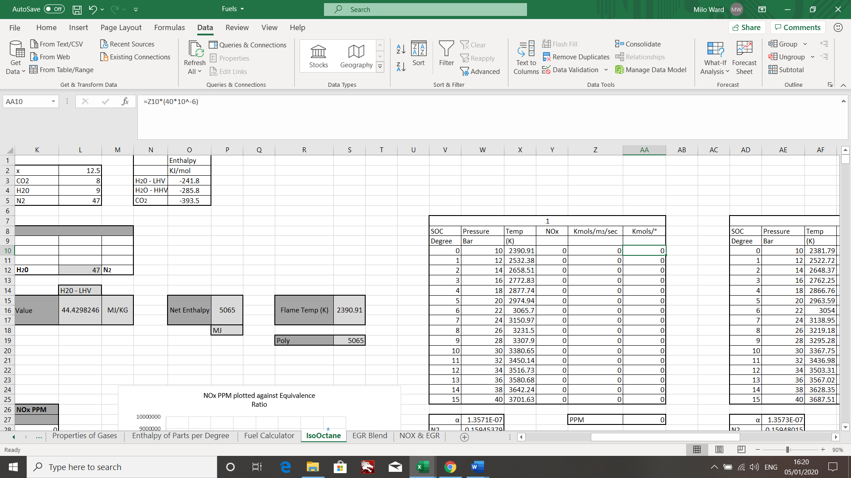
Figure 20 Changing from Kmols/m3/sec to Kmols/°
Having Kmols/°, this information can now be used to see how much NOx part per million is produced at these temperatures for the range of equivalency ratios. This can be done by summing up all Kmols/° for each degree after the start of combustion, then multiplying this by ${10}^{6}$ and then dividing this by the total number of Kmols in the exhaust. Which is worked out by ‘α × CO2 +H2O+O2+N2’ this is the total number of particles in there.
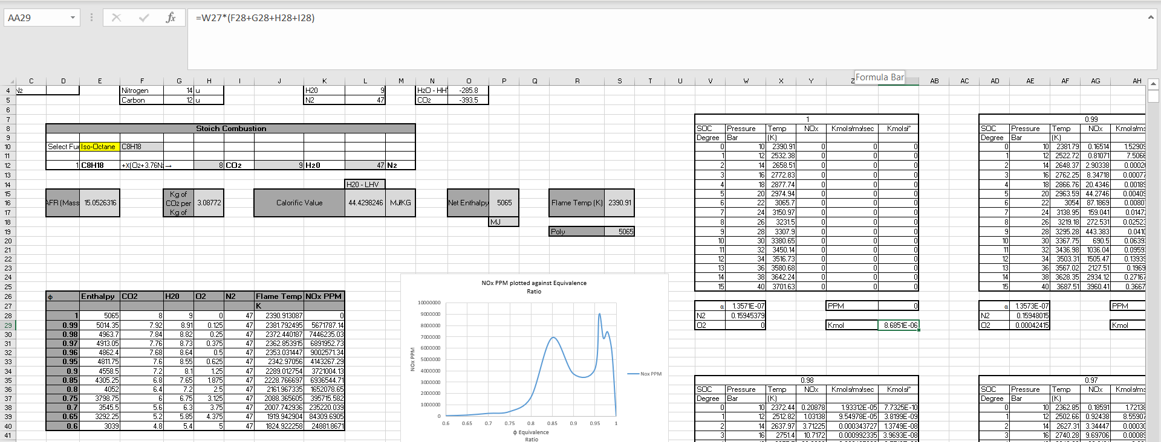
Figure 21 Showing the molecules being multiplied by α
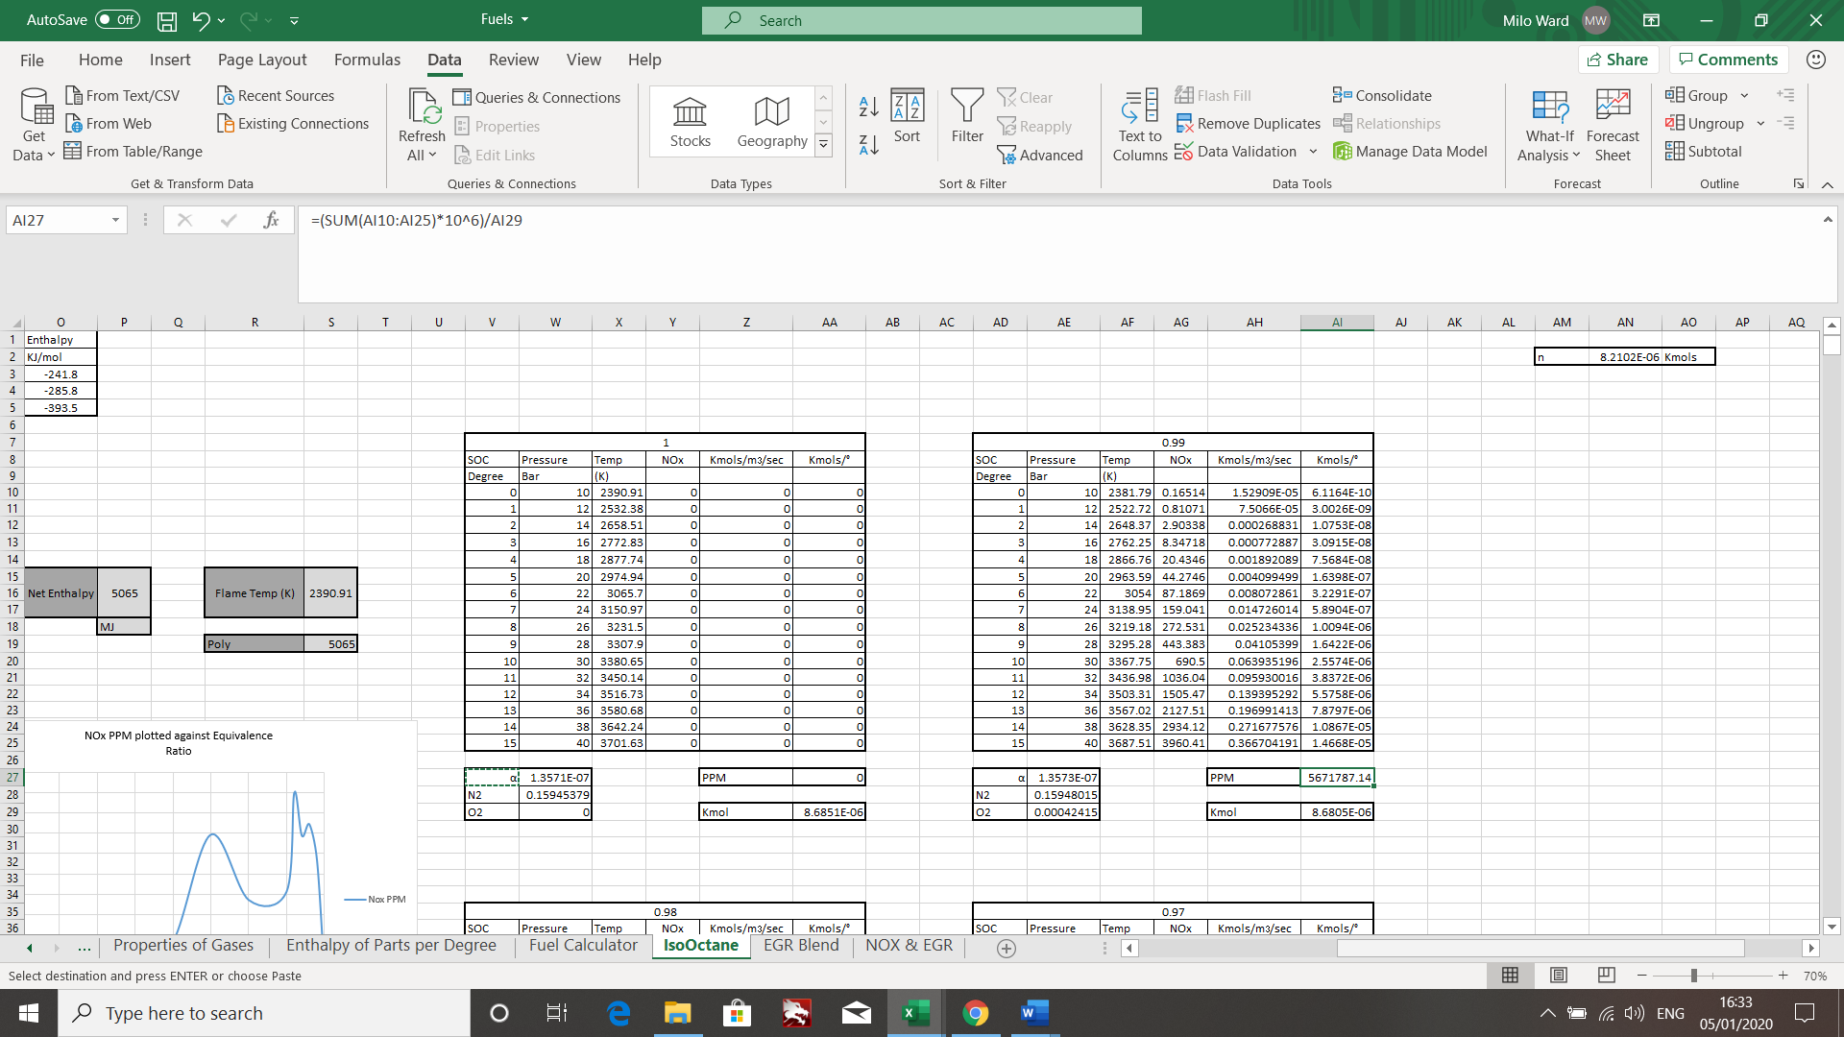
Figure 22 NOx parts per million being worked out by dividing by the total Kmols
Overall, this is the information generated from the above work.
φ | Enthalpy | CO2 | H20 | O2 | N2 | Flame Temp | NOx PPM
 |  |  |  |  |  | K
1 | 5065 | 8 | 9 | 0 | 47 | 2390.913087 | 0
0.99 | 5014.35 | 7.92 | 8.91 | 0.125 | 47 | 2381.792495 | 5671787.141
0.98 | 4963.7 | 7.84 | 8.82 | 0.25 | 47 | 2372.440187 | 7446235.027
0.97 | 4913.05 | 7.76 | 8.73 | 0.375 | 47 | 2362.853915 | 6891952.733
0.96 | 4862.4 | 7.68 | 8.64 | 0.5 | 47 | 2353.031447 | 9002571.341
0.95 | 4811.75 | 7.6 | 8.55 | 0.625 | 47 | 2342.97056 | 4143267.294
0.9 | 4558.5 | 7.2 | 8.1 | 1.25 | 47 | 2289.012754 | 3721004.13
0.85 | 4305.25 | 6.8 | 7.65 | 1.875 | 47 | 2228.766697 | 6936544.713
0.8 | 4052 | 6.4 | 7.2 | 2.5 | 47 | 2161.967335 | 1652078.651
0.75 | 3798.75 | 6 | 6.75 | 3.125 | 47 | 2088.365605 | 395715.5819
0.7 | 3545.5 | 5.6 | 6.3 | 3.75 | 47 | 2007.742936 | 235220.0389
0.65 | 3292.25 | 5.2 | 5.85 | 4.375 | 47 | 1919.942904 | 84309.69047
0.6 | 3039 | 4.8 | 5.4 | 5 | 47 | 1824.922258 | 24881.86707

When the NOx PPM is graphed against the equivalence ratio, this is the result.

Figure 23 NOx PPM against Equivalence Ratio
It can be seen in the first part of the graph that the lower the equivalence ratio, the lower the amount of NOx produced, this follows the correct trend as it is known that the lower the temperature the smaller amount of NOx is created. With the lower equivalence ratios, the starting point was a lower flame temperature, so the temperature doesn’t peak as high. However, around 0.9 to 0.97 there is a steep drop followed by a raise. Although, the calculations seemed to be correct, there could have been some human error here, as it was thought that this would take a more gradual curve that would not have peaks and troughs throughout the data. However, no error could be seen when searching through, but it may be there somewhere. The drop at the end is to be expected as that is at stoichiometric, so no NOx would be produced because everything would be burning perfectly. However, in real life this would be impossible to achieve. Another factor that should be taken into consideration is that the Zeldovich model used in this task over estimates the NOx production as it doesn’t take into account the reverse reaction slows down the NOx production and there could normally be some left over gases from the previous combustion which would slow down the production also.

Task Two B
For the second part of task two, the aim was to add an EGR (exhaust gas recirculation) into the model. It was asked to do this on 0.97 equivalence ratio, however to get the full spectrum it was done on all of the above equivalence ratios and then from 5%, 10%, 15% and 20%, along with every degree after the start of combustion, running the same pressures as in part A.

Base Model
The first stage was to move the model created above and copy it onto the next sheet, with this done, a flame temperature goal seek was set up for every fuel equivalence ratio so that when the new amount of molecules for every add in of the EGR the new flame temperature could easily be calculated.
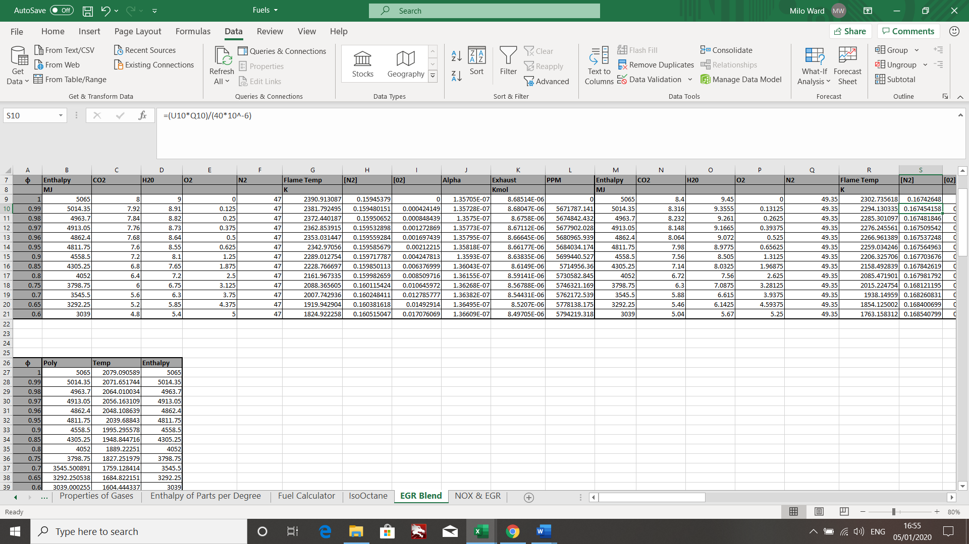
Figure 24 Base model set up and flame temperature down below

Adding EGR
The first stage for adding 5% EGR was to add the extra 5% of each molecule, so that the extra molecules would be present in the combustion chamber when combustion occurred. Once the extra 5% was added to CO2, H20, O2 and N2, the next stage could start.
This stage was to work out the new flame temperatures with the extra molecules that are now present, having the goal seek set up so that it would take the amount of molecules needed from the polynomials, the goal seek could be done to reach the same enthalpy as before. Below are the temperatures for each equivalency ration with 0%, 5%, 10%, 10% and 20% EGR.
0% | 5% | 10% | 15% | 20%
K
2390.913087 | 2302.735618 | 2222.049595 | 2147.781101 | 2079.090589
2381.792495 | 2294.130335 | 2213.885344 | 2140.001464 | 2071.651744
2372.440187 | 2285.301097 | 2205.504574 | 2132.012223 | 2064.010034
2362.853915 | 2276.245561 | 2196.904802 | 2123.810995 | 2056.163109
2353.031447 | 2266.961389 | 2188.083717 | 2115.395408 | 2048.108639
2342.97056 | 2259.034246 | 2179.948921 | 2107.098476 | 2039.68843
2289.012754 | 2206.325706 | 2130.376721 | 2060.270035 | 1995.295578
2228.766697 | 2158.492839 | 2082.973466 | 2013.325452 | 1948.844716
2161.967335 | 2085.471901 | 2014.976532 | 1949.755953 | 1889.22251
2088.365605 | 2015.224754 | 1947.739246 | 1885.259762 | 1827.251979
2007.742936 | 1938.14959 | 1873.88912 | 1814.377986 | 1759.128414
1919.942904 | 1854.125002 | 1793.338718 | 1737.05496 | 1684.822151
1824.922258 | 1763.158312 | 1706.137953 | 1653.374273 | 1604.444337
As the EGR increases, the flame temperature goes down, this is because the exhaust gases coming back in do not combust like the new fuel that is in the combustion chamber. Therefore, taking in some of the heat and reducing the overall temperature in the combustion chamber. This, theoretically would bring down the NOx parts per million.
Now that the base start temperature for each EGR percentage per equivalence ratio has been found, the same process of finding out the NOx can occur.
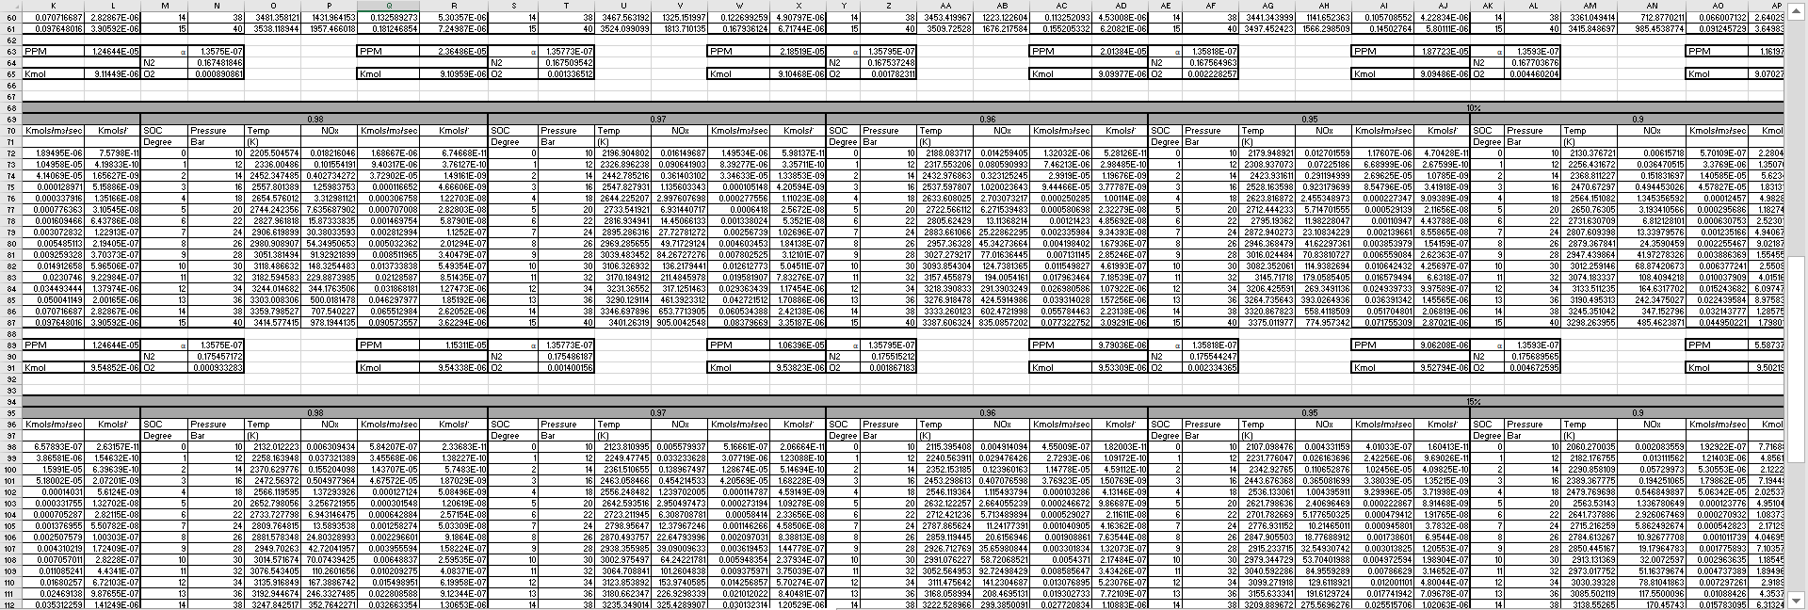
Figure 25 Working out the NOx and PPM for 5% 10% 15% and 20% for every φ for every degree after the start of combustion as per Task 2 A
With this information now being known, the NOx parts per million for each EGR can be seen below.
0% | 5% | 10% | 15% | 20%
NOx PPM
0 | 0 | 0 | 0 | 0
5671787.141 | 1367537.609 | 1305376.808 | 615873.3271 | 293697.5503
5674842.432 | 2596017.311 | 1208286.253 | 569222.8637 | 271030.9571
5677902.028 | 2400069.086 | 1115468.33 | 524680.0227 | 249417.8244
5680965.939 | 2213064.016 | 1026987.087 | 482273.6319 | 228870.9717
5684034.174 | 2064055.491 | 951105.9165 | 443535.9307 | 209043.188
5699440.527 | 1281074.673 | 588008.5822 | 272961.3928 | 128013.4936
5714956.36 | 814799.0841 | 363531.1946 | 164065.9853 | 74830.14082
5730582.845 | 391953.7299 | 175186.0999 | 79149.65388 | 36126.81137
5746321.169 | 184541.5811 | 81008.50421 | 35950.56048 | 16124.09964
5762172.539 | 75877.9548 | 32595.30304 | 14163.06038 | 6224.18368
5778138.175 | 26494.29788 | 11095.5968 | 4705.004742 | 2020.289004
5794219.318 | 7583.797519 | 3084.875446 | 1272.658175 | 532.5772705
As can be seen in the table above, the higher percentage of EGR that is put into the combustion process, the lower the amount of NOx part per million. Therefore, because of this trend, EGR valves are commonly used on many vehicles today, to reduce the harmful emissions that can be released during combustion. If stoichiometric combustion was possible, this would not be needed but as it is impossible to get a perfect combustion, using EGR valves are one of the many way’s manufactures are getting the emissions of their vehicles down. Some of the other ways this is done is through catalytic convertors and DPF’s among other things.

Figure 26 Graph showing the reduction in NOx PPM with the increase in EGR

Conclusion
In conclusion, the model built using Microsoft Excel gives reasonable results when looking into what is produced when two fuels (Methanol and Iso-Octane) are blended in a perfect world and they perfectly combust. Impossible to occur in real life, but this will certainly be on the right tracks.
Furthermore, the information gained through the above, allowed a moderately accurate NOx model to be created. Although there does seem to be some discrepancy in the data as the graph did not come out as smoothly as expected for the NOx produced, the rest of the information seem to be reasonable and not too far fetched from reality.
Taking this NOx model forward and adding in one of the real-life solutions for trying to reduce emissions, showed how much of a difference that EGR valves make to reducing the NOx production in an Iso-Octane engine. The data and graph that were produced from this, performed exactly as expected, and as the EGR percentage went up, the flame temperatures reduced along with the NOx produced too.
For these models to be taken further forward, first the base Iso-Octane faults would need to be found and corrected, so that would perform as expected and then some of the more complex NOx modelling equations would need to be used, such as the extended Zeldovich model which takes into account a third reaction due to the lack of oxygen , which causes the 2nd reaction to become weak, even though the 2nd reaction happens incredibly fast and for basic models is left.

References

Health Essentials from Cleveland Clinic. (2020). Smog and Pollution: What Do Air Quality Alerts Actually Mean?. [online] Available at: https://health.clevelandclinic.org/smog-and-pollution-what-do-air-quality-alerts-actually-mean/ [Accessed 4 Jan. 2020].
Emas.com.tr. (2020). LPG USE AND CARBON MONOXIDE (C0) POISONING. [online] Available at: http://emas.com.tr/en/content/663/lpg-use-and-carbon-monoxide-c0-poisoning [Accessed 5 Jan. 2020].
Encyclopedia Britannica. (2020). enthalpy | Definition, Equation, & Units. [online] Available at: https://www.britannica.com/science/enthalpy [Accessed 5 Jan. 2020].
Aleiferis, P., Behringer, M., OudeNijeweme, D. and Freeland, P. (2020). INSIGHTS INTO STOICHIOMETRIC AND LEAN COMBUSTION PHENOMENA OF GASOLINE–BUTANOL, GASOLINE–ETHANOL, ISO-OCTANE–BUTANOL AND ISO-OCTANE–ETHANOL BLENDS IN AN OPTICAL SI ENGINE. PHD. Department of Mechanical Engineering, University College London, UK.
(Williams, 2019)
Merker, G. (2006). Simulating combustion. Berlin: Springer.

