
Learning in the Digital Era
Olimpiu Robu 2233652
University of Wales Trinity saint David Birmingham

Academic skills –Time Management

Time Management and the benefits in study and employment
To some extent, everyone manages their time; the only question is how well they do it and what impact it has on what they do (Forsyth, 2013). If we are unable to manage time effectively, we need a method that may be applied to utilise time more effectively. A strategy for managing our time is necessary, as is a plan for how we will use the time that is yet ahead of us. We can have an "individual" time-use strategy aimed at completing a task, or we can have an "overall" time-use strategy in which you have several individual strategies that must be coordinated at any given time (Levin, 2007). As a logistics manager a good time management technique applied in the day-to-day decision making, will increase efficiency in the delivery of materials and subsequent outcomes. Logistics or distribution managers oversee organising products storage, transportation, and delivery and work on a tight schedule. Logistics Management is a fast-paced environment where an approach like the Pomodoro Technique can be used with superior results.
The Pomodoro Technique was designed by Francesco Cirillo in the 1980s. It breaks down the task into intervals that are usually 25 minutes long and are divided by short breaks using a kitchen timer. Each time period is called a "pomodoro," an Italian word for tomato. Identification of tasks, setting a timer for 25 minutes, uninterrupted work on tasks, a 5-minute break, repetition three times, and a 30-minute rest are the typical steps. This technique provides a simple process that improves productivity by enhancing focus and cutting down on interruption, boosting motivation and bolster the determination to achieve your goals. (Baniqued et al,2019)
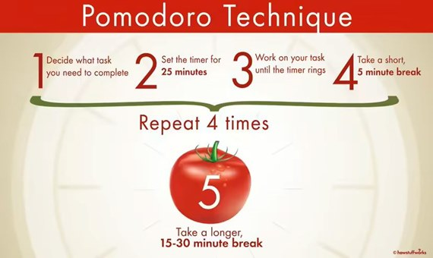
1 - https://science.howstuffworks.com

Baniqued, W.B. and Ariston, C.Z.D., (2019). THE POMODORO: EFFECTIVENESS TO GRADE 10 SCIENCE STUDENTS’TIME MANAGEMENT. QSU Research Journal, 8(1), pp.1-1.
Forsyth, P. (2013). Time: A key resource - opportunities and challenges. Third edition edn. London: Kogan Page Ltd.
HowStuffWorks. (n.d.). How the Pomodoro Technique Can Help You Get More Done. [online] Available at: https://science.howstuffworks.com/life/inside-the-mind/human-brain/pomodoro-technique.htm [Accessed 16 Feb. 2023].
Levin, P. (2007) Skilful time management! Maidenhead, England: Open University Press.

Submission of essay in Turnitin
After submitting the essay, I have found the procedure easy and straightforward with Turnitin being a very useful tool to crosscheck your work. Checking the similarity report that shows an 31% similarity, I have reached the conclusion that a better referencing, and a more in depth analysis of the reading lists provided, a better engagement with the course work and a better paraphrasing would help bring my similarity score down. After checking my work against the Assessment Criteria, I would award myself with a 60-69% mark for the engagement with the literature, for consulting a broad range of sources, and including the references looked up while working on the assignment. I also accurately interpreted qualitative and quantitative data and shown a solid comprehension of the concepts and guidelines of this assignment.
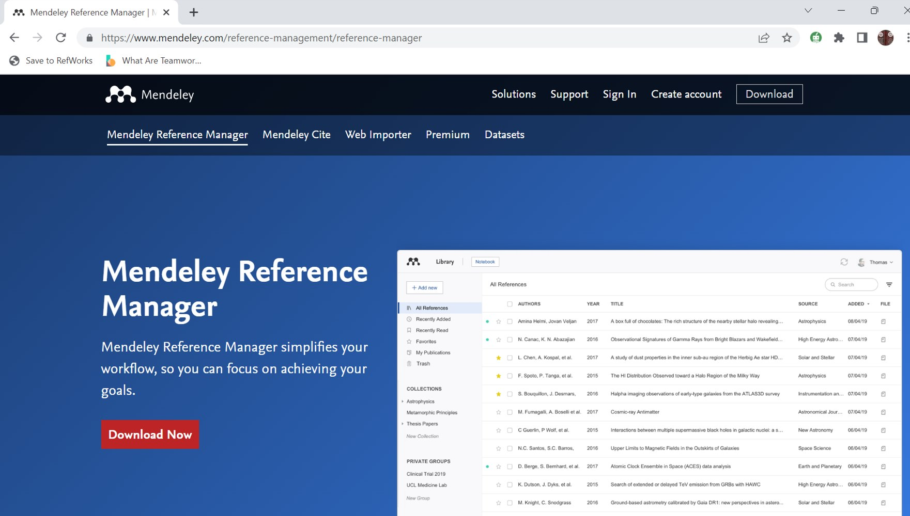
2 - As a Referencing tool I have chosen Mendeley for its simplicity and adaptability.
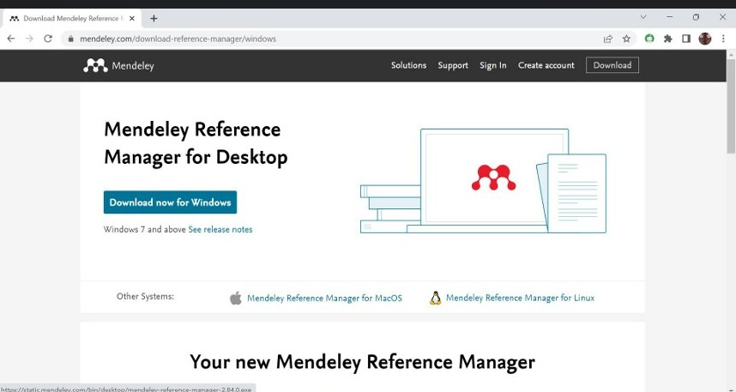
3 - After searching for the Mendeley App choose download for Windows
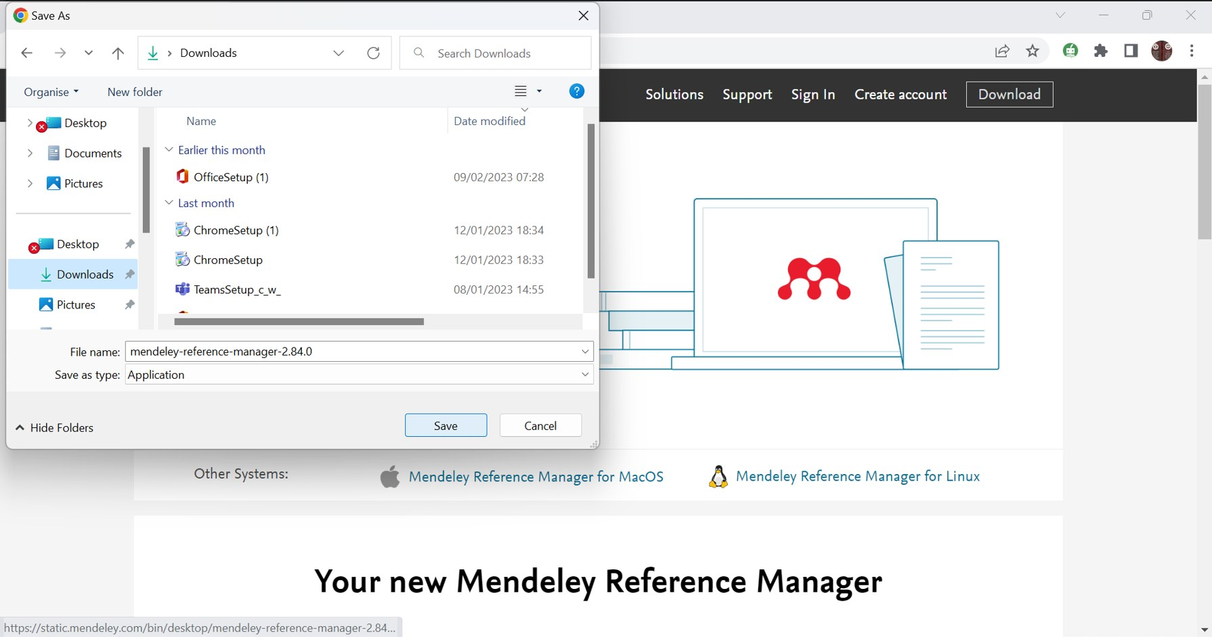
4 - Choose a location for download
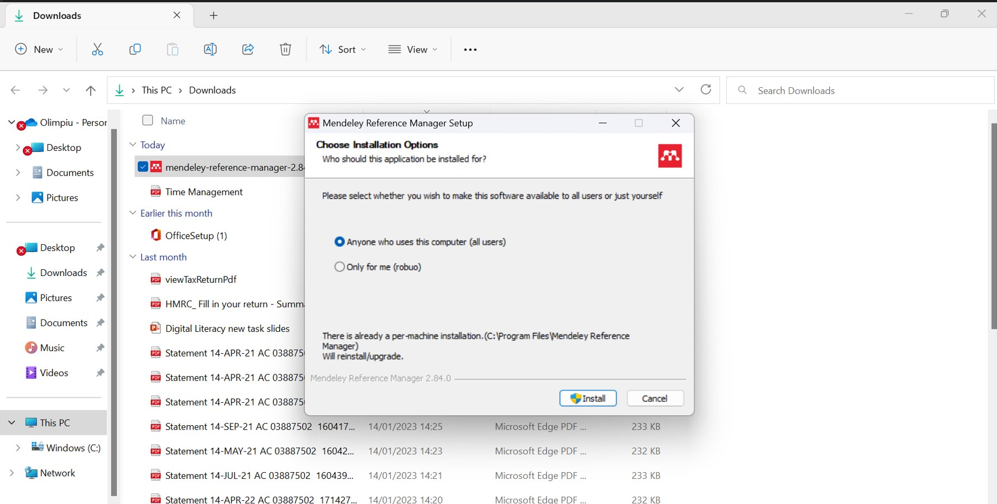
5 - Install the App as prompted
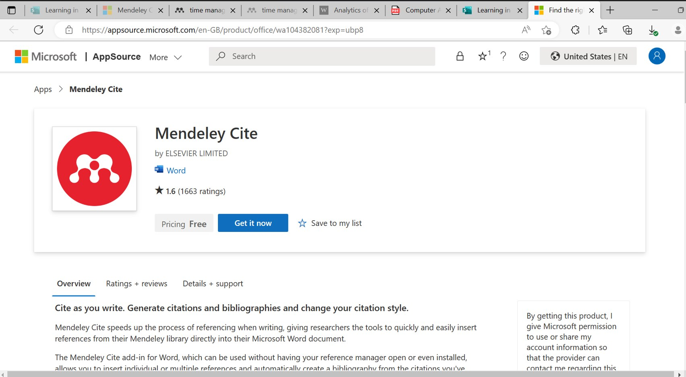
6 - Choose Get the App
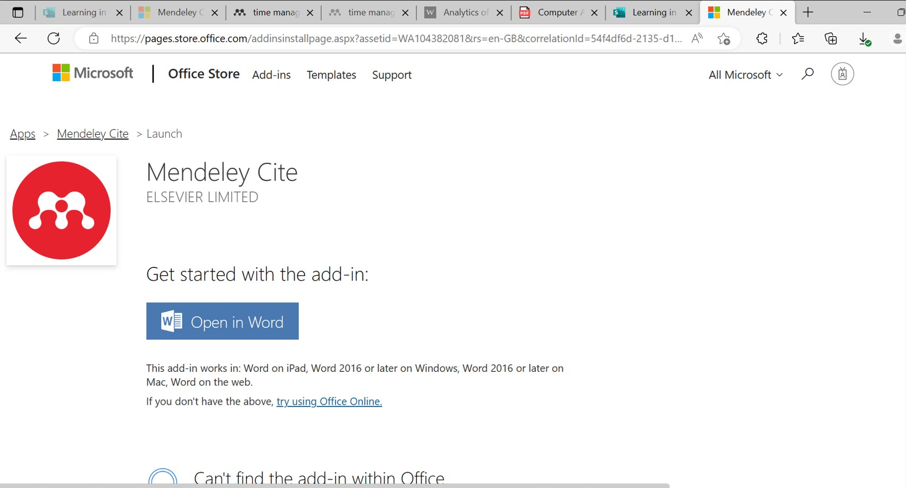
7 - Open In Word as prompted
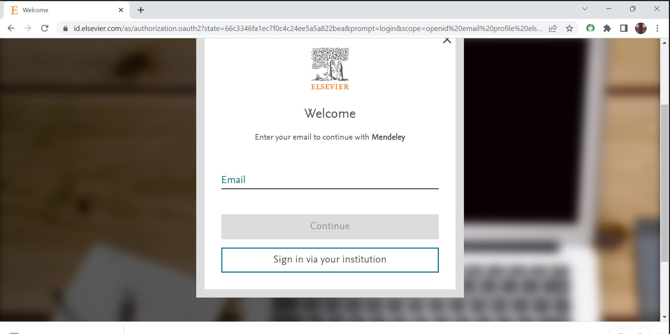
8 - Create an Account to have access to all features
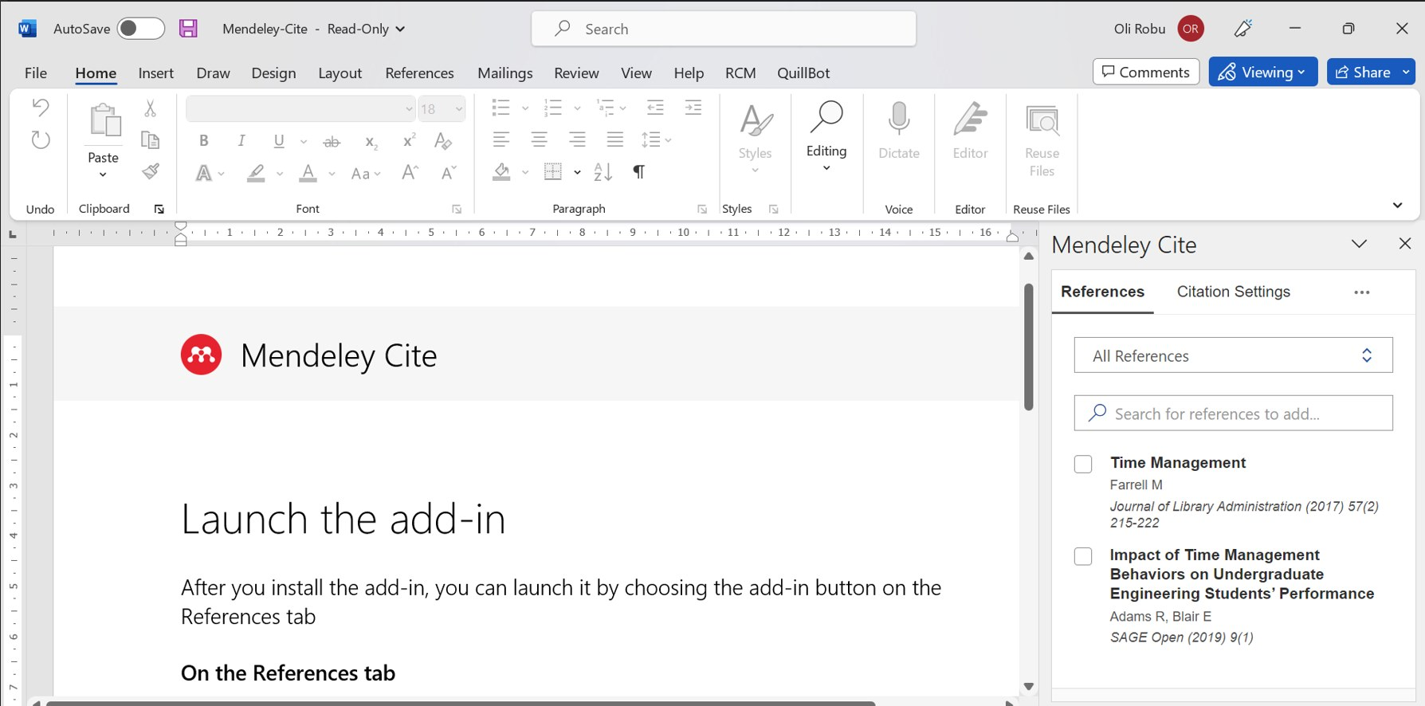
9 - Launch the add-in as prompted by Word
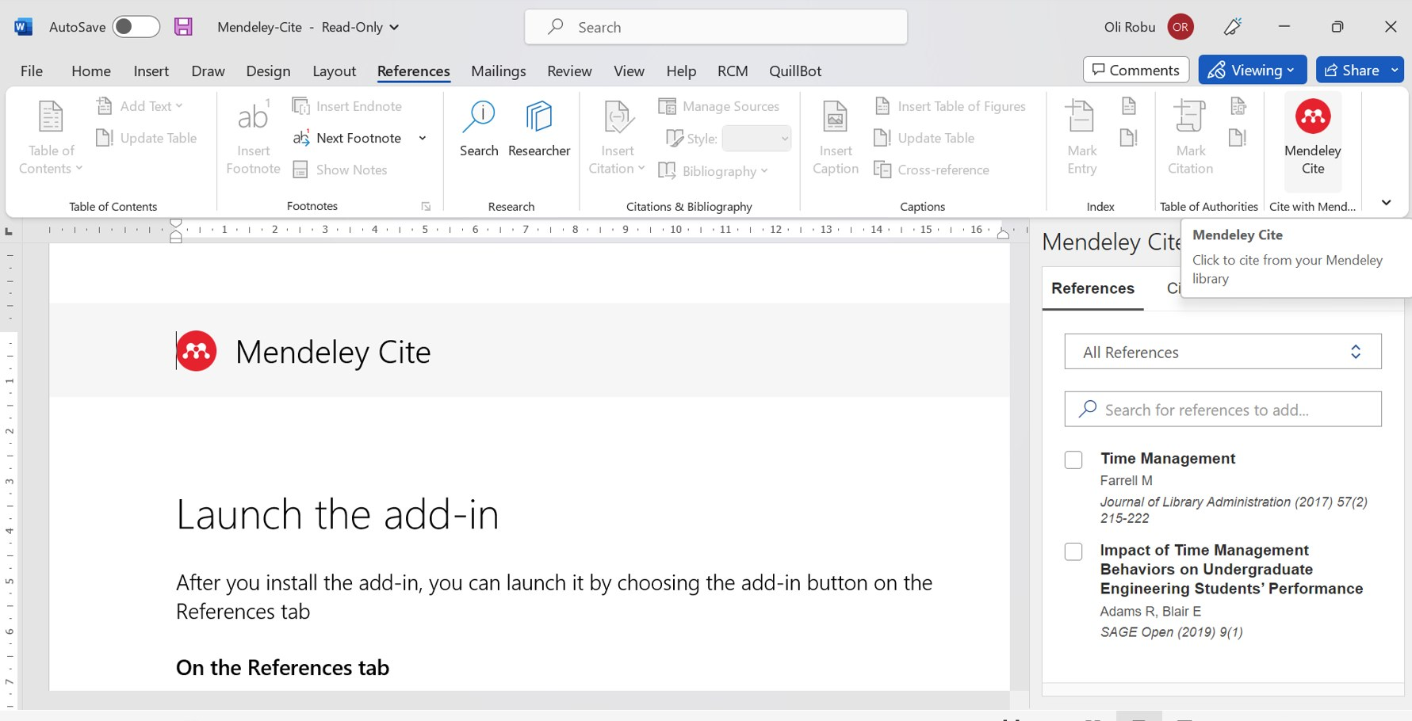
10 - Mendeley Cite will appear in the top right corner
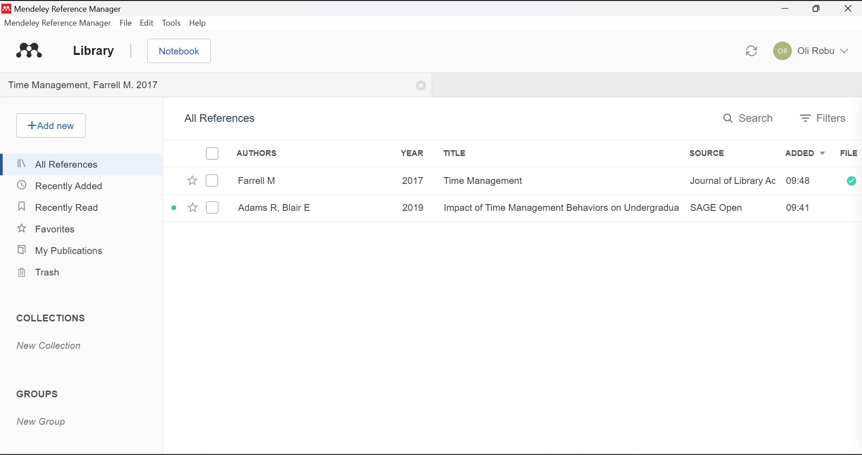
11 - There is the option off uploading all references in the App
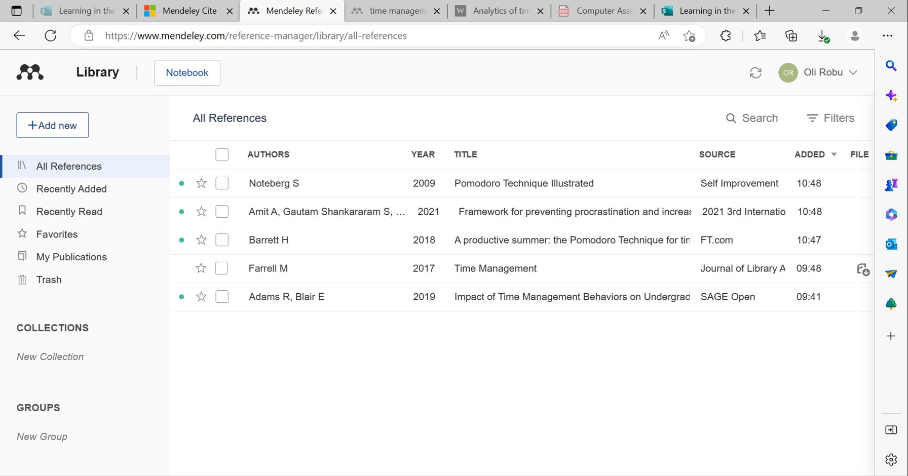
12 - These are the references that I used for my assessments.
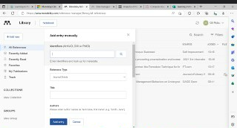
13 - References can added manually too

MacMillan, D. (2012), argues that Mendeley enables higher level information literacy by helping users focus on locating and organizing information and spend less time on citation details.
MacMillan, D. (2012), "Mendeley: teaching scholarly communication and collaboration through social networking", Library Management, Vol. 33 No. 8/9, pp. 561-569. https://doi.org/10.1108/01435121211279902

Academic E-Poster

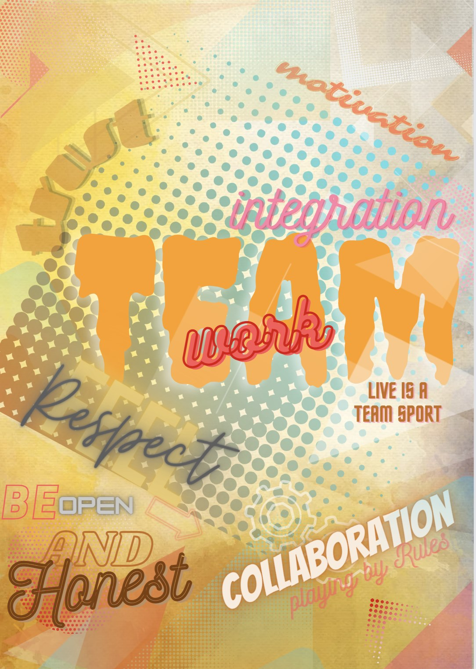
14 - Academic E-Poster
Natalia Gongearuc
Angela Efrem
Olimpiu Robu
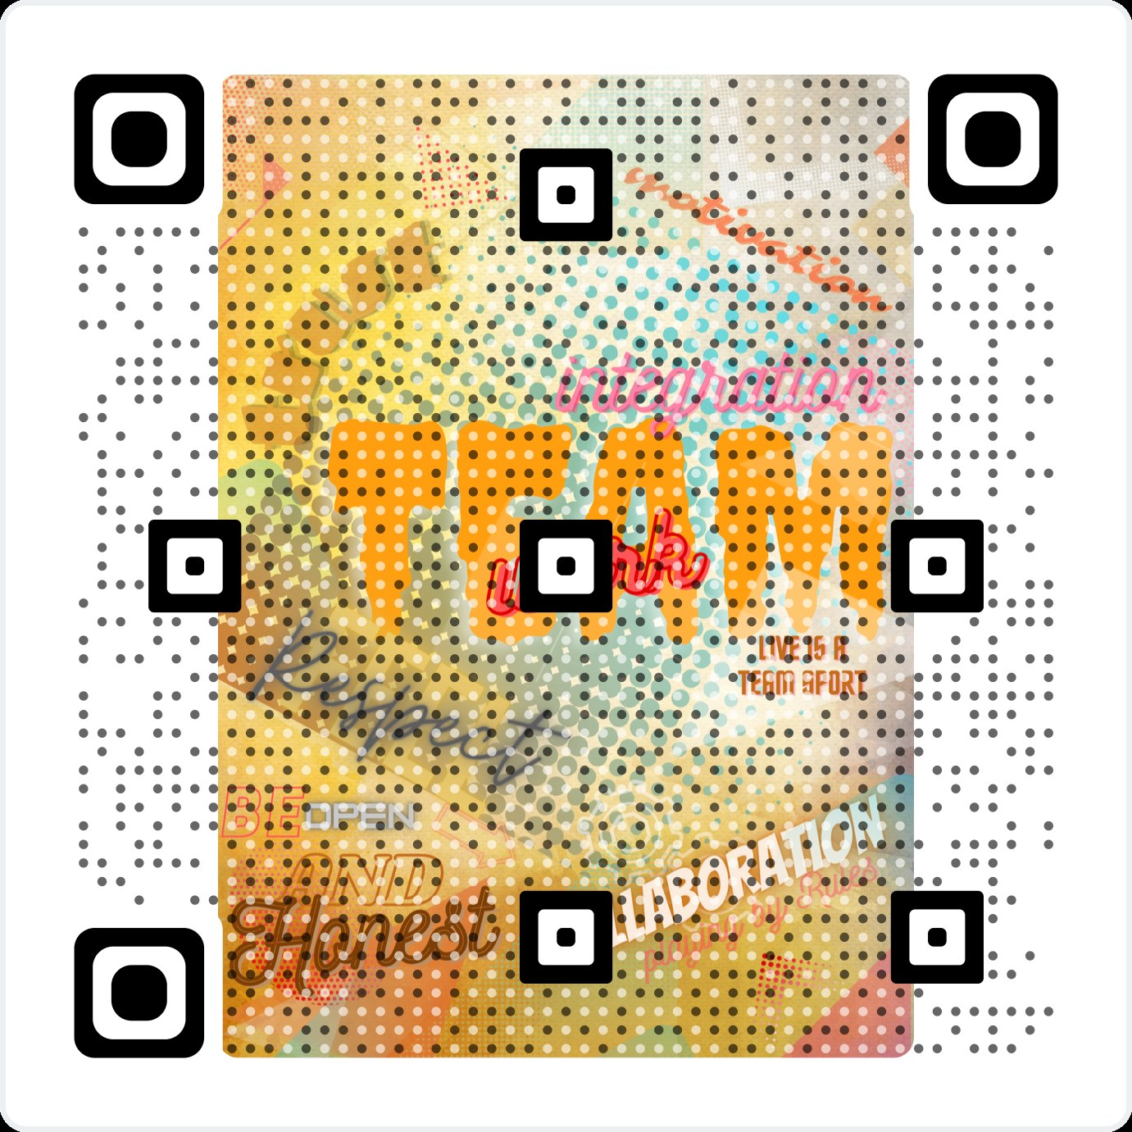
15 - QR code with link

Academic e-posters have become a popular medium for exchanging ideas and introducing research outcomes within academic circles (EDIT.org., n.d.). They are an innovative way to present the results and information obtained after scientific research (EDIT.org., n.d.). The academic poster has been, and will continue to be, an integral part of academic conferences. The change for the future is the medium, and the promise that it holds. As the world embraces electronic technology as the norm, so too will e-posters become the norm (Masters et al., n.d.). Teamwork skills can transcend all positive benefits of such decisive competencies and improve academic scores (De Prada et al., 2022). Teamwork creates lasting bonds of friendship which is one of its greatest purposes and objectives in schools. The use of electronic posters has evolved over the years, particularly with the switch towards remote work and remote collaboration. An academic e-poster on teamwork could stress the importance of collaboration in academic research and the significant improvement it can have on project outcomes. The poster could include a test case or illustrations of successful teamwork in academic research, demonstrating the benefits of combining various perspectives, skill sets, and ideas. The e-poster could also include recommendations and tactics for effective academic teamwork. This could include communication guidelines, task division, and conflict resolution. The poster could also reflect potential teamwork challenges and offer suggestions for how to overcome them. Teamwork involves collaboration, integration, and trust when each team member is open and honest with others, with mutual responsibility and respect. The benefit of teamwork resides in the creation of some unique ideas, and it is an excellent opportunity to maximise the talent and creativity of each of its members (Blog. Agrokebety.com, 2023). For this task we worked in a group of 3 students, and the task of creating the text containing the underlying ideas was mine. We collaborated using MS Outlook and WhatsApp by creating a group containing the members.

Blog. Agrokebety.com. (2021). “Что такое командная работа, почему она так важна и как влияет на успех?”, [online]. Available at https://blog.agrokebety.com/chto-takoye-komandnaya-rabota-ru, (Accessed 18 March 2023)
De Prada et al., (2022). Teamwork skills in higher education: is university training to their mastery? [online] Available from: https://prc.springeropen.com/articles/10.1186/s41155-022-00207-1 [Accessed 20 March 2022].
EDIT.org. (n.d.). Academic poster design templates. [online] Available from: https://edit.org/posters/academi -poster-templates [Accessed 12 March 2023]
Masters, K., Sandars, J. E., Gibbs, T., & Sandars, J. (n.d.). How to Make an Effective e-Poster Health Professionals’ Education in the Age of Clinical Information Systems, Mobile Computing and Social Networks View project iPads in clinical medical education View project How to Make an Effective e-Poster. [online] https://doi.org/10.15694/mep.2015.004.0001 (Accessed 20 March 2023)
Vicens, Q. and Bourne, P.E. (2007). ‘Ten simple rules for a successful collaboration’, PLoS Computational Biology. Available at: https://doi.org/10.1371/journal.pcbi.0030044.

Please see below the link to my E-Portfolio that was created with Microsoft Sway:


Learning in the Digital Era
Olimpiu Robu 2233652
Go to this Sway

https://sway.office.com/Ng6fkfmHDsGkAZKc?ref=Link

