Marketing plan written for

_____________________________ (Sheraton Hotel)______________________________

Student Name

____________________Cornel Stoica_____________________________

Student ID number
_______2206216____________

Marketing Essentials BMIH4005

Lecturer
Ruth Taylor Davies
________________________________

Introduction
The aim of the following marketing plan is focused on improving the market share and customer engagement. The Plan is purposed for the improvement of the Sheraton Hotel and resort business in Westminster, London. Different aspects of marketing such as competition, external situations and so on will be discussed.

Situation Analysis
5 'C's
“Company: SWOT analysis (Micro analysis)”
Strength | Weaknesses
The strength of Sheraton Hotel and Resort is the strong reputation of the brand. The company is renowned for its luxury services at affordable prices (Yap et al., 2022). The presence of the hotel in more than 463 locations is also one of its strengths.  Another strength of the company is the visibility of the brand and personalised and customisable services. The reliable and strong distribution network of the hotel is also one of its strengths. | The major weakness of Sheraton Hotel and Resort is the inability to integrate different work cultures into the business process. It has caused challenges for the hotel to shift to different segments of products due to the present culture.  Another weakness of the hotel is the high dependency on the domestic market, high depending on the domestic marketplace makes a vulnerable situation in economic rescission.
Opportunity | Threats
The opportunity for Sheraton Hotel and Resort can grow and expand the hospitality business in developing markets. The hotel can expand its market share with different developing markets such as Africa and so on.  The Hotel can effectively increase the engagement of new potential customers through online platforms and websites. | The increase in competitive pressure in the hospitality industry is one of the threats to Sheraton Hotel and Resort. Increasing competition can affect the customer base of the Hotel (Karki, 2018).  Another threat for the hotel is the recession of the nation’s economy. An increase in inflation will affect the operation of the Sheraton Hotel and Resort.

“Customers: Segmentation and Targeting”
Market Segmentation of Sheraton Hotel and Resort can be done through “Demographic and Psychographic” Segmentation.
Demographic Segmentation: Sheraton Hotel and Resort will focus on a demographic segmentation strategy to effectively highlight their customer. The customer for the hospitality service of the company will be single travellers, family travellers, married couples and so on in Westminster, London.
Psychographic Segmentation: The service offered by Sheraton Hotel and Resort will be focused on attracting business personnel, luxury seekers and so on in Westminster, London. The hotel will provide quality customer service and a comfortable experience (Cheng et al., 2021).

Targeting: The targeted customer for Sheraton Hotel and Resort will be Leisure seeking customers, business travellers visiting for business work, customers visiting for vacation and travelling customers for honeymoon in Westminster, London. The targeted audience will be both national and international tourists and visitors.

“Competitors: Porter five forces”
Porter’s five force analysis of Sheraton Hotel and Resort are as follows;
“Threats from customer barging power”; The hotel industry of Westminster, London consists of a different number of hotels and hospitality services which provide wide options for the customers to select the hospitality services, hence the level of threat is high (Eierle et al., 2022).
“Threats from substitute”; Similarly, there are different substitutes providing semi-luxury hospitality services to the customers in Westminster, London which can result in the divergence of the customer base, and the level of threat is high.
“Threats from Competitors”; The hotel segment is continuously developing and consists of a wide range of hotels in every location across London. However, due to the well-established and highlighted reputed brand the level of threat is moderate for Sheraton Hotel and Resort.
“Threats from suppliers”; Due to the presence of a wide number of suppliers at London the level of threat is low for Sheraton Hotel and Resort.
“Threats from new entrants”; The new emerging hotel has to invest large capital and time along with resources to compete with the company in London, hence the level of threat is low.
Collaborators: Sheraton Hotel and Resort has a positive relationship with its collaborators and partners. The hotel has a positive relationship with the parental body Marriott International. It also has partnered with Core performance and another online partners such as hotel booking websites and so on.

“Climate: PESTLE (Macro analysis)”
Factors | Influence
Political | The changes in the legislation and policies such as the implementation of the carbon tax will increase the operations cost of the Sheraton Hotel and Resort in the UK. Brexit has also impacted the employment of the hotel by changing the point-based system into an immigration system. it has impacted the temporary workers of the hotel. Covid also forcefully shut down the business operation of the company reducing the revenue of business.
Economical | The recession of the economy by increasing the rate of CPI by 12% has an immense impact on the business operation of the Sheraton Hotel and Resort (Eierle et al., 2022).
Social | The changing behaviour such as focusing on online services and technology force hotel to adapt to the demands and needs of customers.
Technological | Increasing the number of internet users by 92% in the UK will be beneficial for the Hotel. It has increased online booking by 17% providing opportunities to adapt online platforms (Capobianco et al., 2021).
Legal | Different legislation and regulation such as Health and Safety at the workplace, employee rights and so on should be adhered to by the Sheraton Hotel and Resort.
Environmental | Environment policies such as Environment Act, 2021 and so on should be followed by the hotel to minimise wastage and impact on natural resources.

Objectives
- Increase customer engagement in the hospitality of Sheraton Hotel at Westminster, London.
- Increase the market share of the hotel across London and the UK.
- Overcome the loss from the Covid and Brexit impact.
SMART
Specific | Measurable | Achievable | Relevance | Time-bound
Increase the customer engagement at Westminster, London | Increase in the engagement of the customers by 20% at London | utilising effective marketing strategies such as digital marketing and so on assisting the hotel to attract both national and international travellers. | Increasing customer engagement and occupancy rate assists the business in effectively increasing its brand reputation. | 6 months
Increasing the market share across the London market. | An increase in the market share by 15% in the London market will be a success for the hotel. | Performing market research and analysing the demand and requirements and effectively engaging in the hospitality business. | Increasing the market share of the hotel assists in effectively increasing the competitive edge in the marketplace. | 7 months
Overcome the challenges of Covid and Brexit | Effectively operating the business operation by adapting to the external situation. | Implementing effective business strategies such as cost-effective methods and so on. | Adapting to the changes from Brexit and Covid will assist the hotel to improve its sustainability. | 6 months

Strategy
The value proposition of Sheraton Hotel and Resort is “Warm, Connected and Community”. The hotel focuses on warm and pleasing services to the customers, the services provided to the customers make them feel connected as part of the organsiation (Goustaft, 2021). Lastly, the community is for customer-centric business operations. The hotel utilises Focused differentiation pricing from Bowman’s strategy clock.

Tactics
Marketing mix:
Product - Sheraton Hotel and Resort provides leisure and accommodation services to customers.
Place (Distribution) – The services of the Hotel are accessible both online and offline along with the third-party website. The services can be accessible in Westminster, London (Toma and Grădinaru, 2018).
-Price – The pricing of the services is focused differentiation pricing which services according to customization starting from £610 per night to £980 per night (Lim and Seo, 2021).
Promotion –Promotion of the services of Sheraton Hotel and Resort is mostly done through social media such as Instagram and email marketing.

Action
Gantt chart of marketing activities
Tasks | Start date | Duration (in days)
Preparation | 1-Jan-23 | 14
Market research | 15-Jan-23 | 63
Marketing channels schedule | 23-Mar-23 | 35
Gathering feedback | 1-May-23 | 28
Table 1: WBS
(Source: Self-developed)
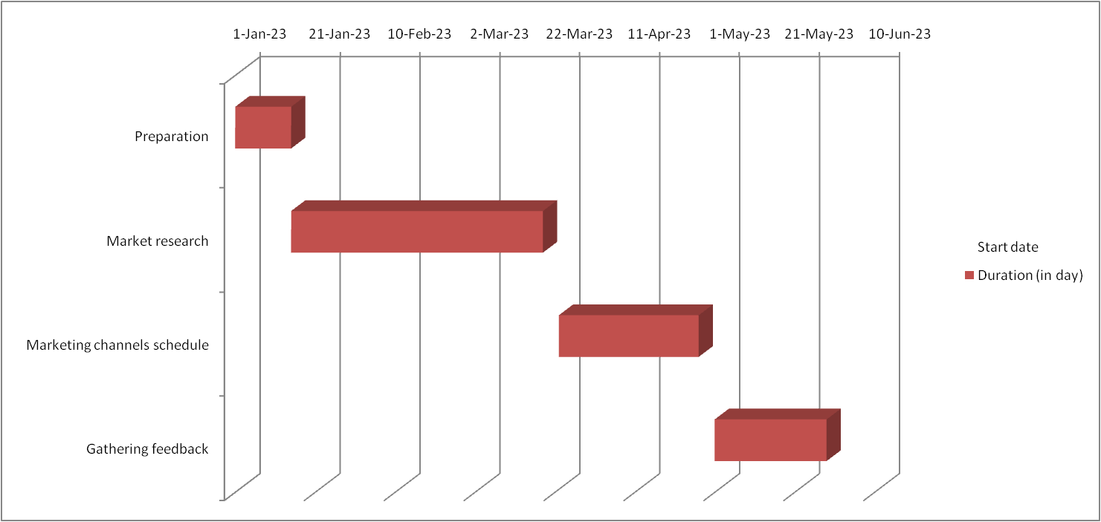
Fig 1: Gantt chart
(Source: Self-developed)

Control
The USP of Sheraton Hotel and Resort is the unique services and affordable prices designed with smart and independent travelling. The location of the hotel is located near the airport of London and the urban centre (Perenc, 2020). The hotels are friendly with an authentic sense of the local culture and customs. The guest can enjoy the local taste and choose unique flavours for beverages.
The success of the marketing plan can be measured through the increase in the market share of the hotel by 15% and the increase in the engagement of customers by 20% in London.

Conclusion
The above marketing plan has covered different aspects such as internal analysis, external analysis and identifying market threats and so on which are essential for an effective marketing plan. It has also showcased the marketing mix to promote and advertise the business. Lastly, USP is discussed to increase the marketing of the hotel.

References
Capobianco, N., Basile, V., Loia, F. and Vona, R., 2021. Toward a sustainable decommissioning of offshore platforms in the oil and gas industry: a PESTLE analysis. Sustainability, 13(11), p.6266.
Cheng, D., Wu, Y., Zhao, G. and Fu, S., 2021. A comprehensive survey on STP approach to finite games. Journal of Systems Science and Complexity, 34(5), pp.1666-1680.
Eierle, B., Hartlieb, S., Hay, D.C., Niemi, L. and Ojala, H., 2022. External factors and the pricing of audit services: A systematic review of the archival literature using a PESTLE analysis. Auditing: A Journal of Practice & Theory, 41(3), pp.95-119.
Eierle, B., Hartlieb, S., Hay, D.C., Niemi, L. and Ojala, H., 2022. External factors and the pricing of audit services: A systematic review of the archival literature using a PESTLE analysis. Auditing: A Journal of Practice & Theory, 41(3), pp.95-119.
Goustaft, V.V., 2021. INDUSTRIAL TRAINING REPORT INDUSTRIAL TRAINING at SHERATON SURABAYA HOTEL & TOWERS.
Karki, G.B., 2018. A brief environmental analysis of tourism and hotel industries and their impact on Nepalese base structure. KMC Research Journal, 2(2), pp.59-70.
Lim, H.W. and Seo, D.S., 2021. Improvement Strategy According to the Change of Hotel Environment. International Journal of Advanced Culture Technology, 9(2), pp.72-79.
Perenc, J., 2020. Factors determining the improvement of hotel service quality as seen by customers of Sheraton Hotel in Warsaw. Studia Periegetica, 30, pp.125-136.
Toma, S.G. and Grădinaru, C., 2018. The marketing mix in a luxury hotel chain. The Journal Contemporary Economy, 3(2), pp.105-111.
Yap, G., Saha, S. and Alsowaidi, S.S., 2022. The Competitiveness of Qatari Tourism: A Comparative and SWOT Analysis. Advances in Social Sciences Research Journal, 9(7), pp.187-210.

Appendices



