

Module: Marketing Management
Module code: LCMB7024
Title: Marketing Environment Analysis
Word Count: 2434
Lecturer: Dian Mayasari
Student Name: Nihar Rameshbhai Devani
Student ID: 2439635
Submission Date: 24th October 2025

Marketing Management
Marketing Environment Analysis

Table of Contents
Introduction 2
1. Critically analyses the macro marketing environment as an integral component of strategic marketing management 2
1.1 Technological Factors 2
1.1.1 Impact on Pioneering Organizations 2
1.1.2 Impact on Follower Organizations 3
1.1.3 Opportunities and Threats 3
1.1.4 Industry Cooperation and Strategic Adaptation 3
1.2 Economic Factors 5
1.2.1 Effect on Trailblazing Companies 5
1.2.2 Impact on Follower Organizations 5
1.2.3 Opportunities and Threats 6
1.2.4 Sustainable Development and Global Economic Transitions 6
2. How pioneering and follower organizations strategically respond to the selected external factors to maintain competitiveness. 7
2.1 Reactions to Technological Elements 7
2.1.1 Innovative Organizations: Strategies Driven by Innovation 7
2.1.2 Follower Organizations: Market Learning and Adaptive Innovation 8
2.1.3 Modifications to the Strategic Marketing Mix 9
2.1.4 Comparative Assessment 9
2.2 Reactions to Economic Elements 10
2.2.1 Leading Companies: Superior Positioning and Resilience in the Market 10
2.2.2 Follower Companies: Market Diversification and Cost Leadership 11
2.2.3 Modifications to the Strategic Marketing Mix 12
2.2.4 Long-Term Sustainability and Strategic Flexibility 12
2.3 Critical Analysis: Strategic Consequences 13
Conclusion 13
References 14

Introduction
In today's global business environment, strategic marketing decisions are significantly influenced by the macro marketing environment, or the external forces that influence a business' operations and competitiveness; in essence, force beyond a firm's control. Economic and technological variables have thus emerged as two of the most important macroenvironmental variables that drive influence. Focusing on Tesla and Toyota, this research will critically evaluate how fluctuations in these two variables may provide both opportunities and threats for both pioneers and followers in the automobile industry.

Critically analyses the macro marketing environment as an integral component of strategic marketing management

1.1 Technological Factors

1.1.1 Impact on Pioneering Organizations
Technological innovation is a significant source of competitive advantage for innovative organizations. Organizations like Tesla have established themselves as leaders in their industry by exploiting automated and artificial intelligence (AI) and the latest electric vehicle (EV) technologies. Grant (2021) argues that pioneers justly reap the benefits of first-mover advantages like control over critical technological patents, brand loyalty, and brand recognition.
This comes with both benefits and risks, however. The continuous advancement of technology increases expenses and risk through the necessity of research and development (R&D) expenditures. Pioneers run the risk of sacrificing market control, if some of the promised benefits from the new technology do not materialize (Hollensen, 2020). For example, existing manufacturers are investing heavily in EV technologies to stake their claim and continue to pressure Tesla to maintain its innovation pace.

1.1.2 Impact on Follower Organizations
For follower firms like Toyota, to leverage technologies developed elsewhere can be beneficial. They can usually enter the market after an early technology has matured to a more reliable and affordable level. They typically bear little of the initial R&D costs (Baker, 2022). Toyota's hybrid car strategy is an example of a successful follower strategy, as risk is mitigated while building on first ideas.
However, there are challenges for followers. The timing of adoption may limit their marketplace impact, and it may be difficult to overtake innovators on market share or consumer perceptions. Also, with the acceleration of digitalization, for followers to remain competitive, they will need to invest in connected car technology and smart manufacturing.

1.1.3 Opportunities and Threats
Opportunities | Threats
Availability of sophisticated data analytics  for consumer insights | Quick obsolescence of technology
Innovation-based market entry | Higher R&D costs
Working together with tech startups to  fosterinnovation | Risks to cybersecurity
The dynamic nature of technology empowers both trailblazers and followers, but it also exposes them to strategic uncertainty and high expenses.

1.1.4 Industry Cooperation and Strategic Adaptation
Another feature is how technological progress promotes industry ecosystems and strategic alliances. With advances in technology, it is difficult for any one organization to innovate alone. Innovative corporations like Tesla partner with software developers, battery manufacturers, and clean energy providers to co-create innovative products.

Follower firms capitalize on collaboration strategically as well—though, it is often characterized by a focus on the cost-benefit and technology transfer in their collaborations. Toyota, for instance, can use the established technology through its joint-ventures with Panasonic for battery research without having to pay the development costs entirely. Such collaboration keeps their costs low and helps follower firms close the innovation gap.

Collaboration entails both threats and opportunities. A joint venture can expose the business to the risks of over-dependence on vendor external suppliers and/or the leakage of intellectual property (IP). Hollensen (2020) states that firms that do not manage the exchange of information properly, run the risk of losing their technological edge. Therefore, in order to protect proprietary capabilities and engage in the appropriate value of collaborative innovations, both front-runners and followers are mandated to establish explicit governance systems.

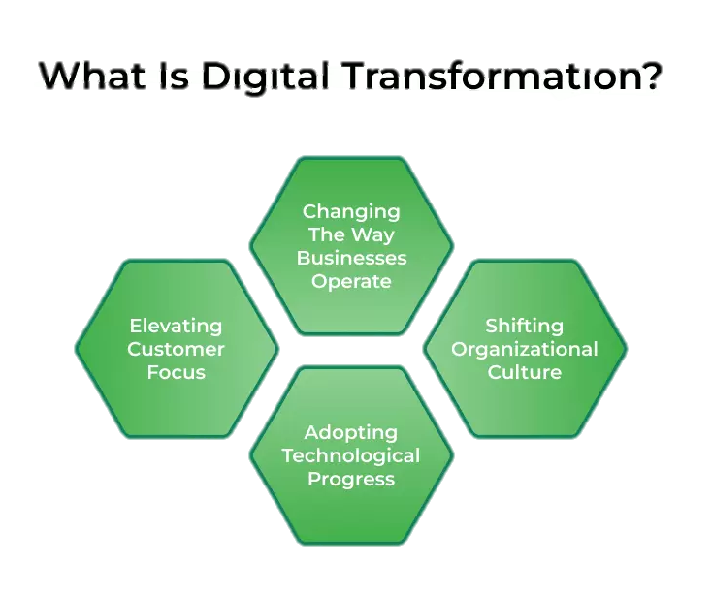
Figure-1 Technological Factors in Business Environment Analysis, available at Faster Capital (2025)

1.2 Economic Factors

1.2.1 Effect on Trailblazing Companies
Marketing techniques are directly impacted by economic factors including customer purchasing power, inflation, and exchange rates. Pioneers like Tesla profit from increased consumer confidence and demand for high-end, environmentally friendly cars during times of economic stability. However, because their products frequently target high-income clients with discretionary purchasing capacity, pioneers are more vulnerable during recessions (Jobber & Ellis-Chadwick, (2020).
Pioneers in the EV sector are likewise impacted by fluctuating energy prices. Opportunities may arise as a result of rising oil costs stimulating demand for electric vehicles. On the other hand, economic downturns can hinder innovation and cut R&D spending (IMF, 2024).

1.2.2 Impact on Follower Organizations
Follower organizations, such as Toyota, are usually more resilient during economic downturns due to their global supply chains and product diversification. They can make adjustments to their pricing strategies and focus on value to maintain customers. In fact, Toyota has managed to stay profitable during periods of economic volatility as a result of its production efficiency using the “lean manufacturing” (Ohno, 1988) model.
However, global economic uncertainty puts follower companies at risk with disruptions to their own supply chains, as well as shifting raw material prices and currency changes. As a result, it is important for followers to establish strong financial and sourcing plans to mitigate this risk.

1.2.3 Opportunities and Threats
Opportunities | Threats
Growth of markets in developing nations | Economic recession affecting demand
Access to cheaper global labour markets | Currency fluctuations
Increased focus on sustainable production | Supply chain cost pressures

1.2.4 Sustainable Development and Global Economic Transitions
In recent years, global economic changes, and particularly the pivot toward sustainability and green growth, have transformed the competitive dynamics for various industries. Currently, many governments link plans for economic recovery to environmental objectives and provide incentives for renewable and low-carbon technologies. This change aligns with the mission of leaders such as Tesla, creating opportunities for incentives for their businesses as well as for goodwill from consumers (IMF, 2024).
Follower companies, for example, Toyota, can also benefit from these changes while channeling sustainability through their value chains, such as trough hybrid technologies or circular economy initiatives (Baker, 2022). Sustaining this momentum may negatively influence business performance over financial horizons - for example, the significant capital expenditures and long-term commitment to implement changes to adapt to a different economy can lower financial performance in the near-term.
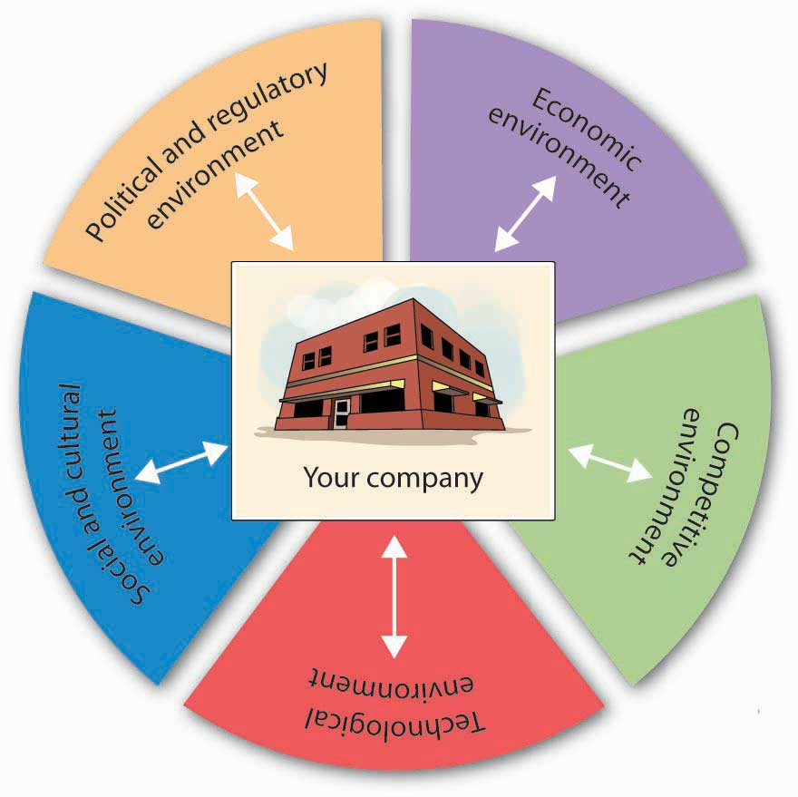
Figure 2: Gomez Albrecht, M., Green, M. & Hoffman, L. (2023) Principles of Marketing (OpenStax)

2. How pioneering and follower organizations strategically respond to the selected external factors to maintain competitiveness.

2.1 Reactions to Technological Elements

2.1.1 Innovative Organizations: Strategies Driven by Innovation
To react to technological upheavals, innovative and flexible companies are essential. For instance, Tesla's main marketing approach combines technological leadership with product innovation. Tesla establishes itself as a technologically superior and ecologically conscious brand by emphasizing high-performance electric cars and cutting-edge self-driving Software.
Using data analytics and artificial intelligence (AI) to forecast customer behavior and enhance performance upgrades through over-the-air software, Tesla's R&D spending is focused not only on new product development but also on customer experience. This strategy promotes the business as a "tech brand" as opposed to a conventional automaker and supports the idea that innovation is ongoing.
But this tactic also presents difficulties. Pioneers are at risk financially due to high R&D costs, quick product cycles, and unpredictable technological returns. Tesla uses its energy sector (solar and battery storage) and subscription-based services to diversify its revenue streams in order to reduce risk. The Ansoff Matrix approach of "product development" and "diversification" to maintain long-term growth is in line with this kind of diversification (Hollensen, 2020).

2.1.2 Follower Organizations: Market Learning and Adaptive Innovation
In response, follower businesses frequently embrace tried-and-true technology and improve them for greater effectiveness. For example, Toyota employs a "fast-follower" approach, learning from the achievements and mistakes of trailblazers before introducing its own cutting-edge ideas. Incremental innovation is demonstrated by Toyota's hybrid technology, such as the Prius, which builds on early EV advancements while lowering financial and technological risks.
The business adheres to the Kaizen principle, which promotes constant development through incremental, tiny inventions (Ohno, 1988). Reliability, affordability, and trustworthiness are the marketing advantages that result from this operational excellence. Toyota offers both mass-market and hybrid vehicles to appeal to a range of income levels, in contrast to Tesla's premium positioning.

2.1.3 Modifications to the Strategic Marketing Mix
Technological advancement has affected leaders and followers in their branding and customer interaction practices. Innovative brands like Tesla communicate directly with clients through digital marketing ecosystems that leverage owned platforms, social media, and online communities instead of traditional dealerships. This direct-to-consumer (DTC) approach not only lowers distribution costs but also provides brands with greater control over their image.
Following companies like Toyota have adopted hybrid marketing channels that combine online and offline interaction. Toyota's marketing transformation includes a robust CRM system that anticipates post-purchase needs and provides customized customer interaction through AI. While followers may be slower to innovate, they too can leverage digital transformation strategies to enhance productivity and their relationship marketing.
Ultimately, both innovators and followers demonstrate that success relies not on technologies per se but on how successfully marketing strategies convert innovation into value recognized by consumers.

2.1.4 Comparative Assessment
The conflicting strategies illuminate a strategic paradox: while 'followers' lead through stability, 'pioneers' lead through disruption, market expansion and brand equity underscore the Tesla efficacy approach's potential for both high risk, but equally high reward. The Toyota efficacy approach demonstrates long term viability and profitability through scalability and less risk.
Toyota combines cost leadership with targeted differentiation through production optimization and hybrid alternatives, while Tesla relies upon differentiation and distinction value through innovation. Both styles are consistent with Porter's Generic Strategies (Porter, 1985)
Therefore, technology can not only level the field and generate competition, but provides new strategic choices based on market positioning and organizational capacity.
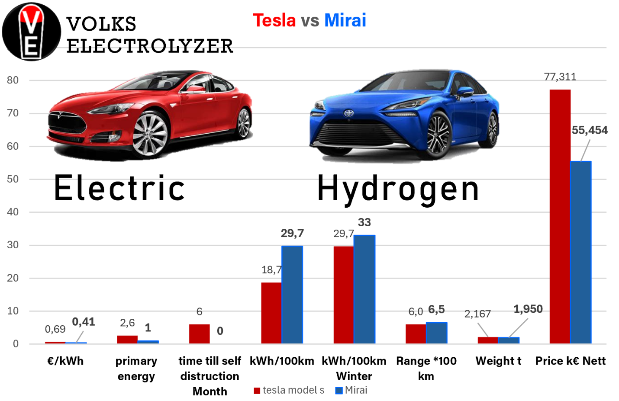
Figure 3: Volks Electrolyzer (2024) ‘Tesla vs Mirai: Electric and Hydrogen Vehicle Comparison’

2.2 Reactions to Economic Elements

2.2.1 Leading Companies: Superior Positioning and Resilience in the Market
The economy heavily shapes the marketing strategies of innovators. To protect its cost structure and brand equity, Tesla has retained a premium pricing strategy. By positioning itself as a luxury sustainable brand, Tesla can attract affluent customers who tend to remain stable even during economic contractions. This approach aligns with the Value-Based Pricing Model outlined by Kotler et al. (2022) that emphasizes perceived innovation and environmental impact over cost.
As a response to inflation and the pressure of costs worldwide, Tesla has initiated local production through Gigafactories in numerous locations. Geographical diversification mitigates costs linked to supply chains and potential risk linked to currency exchanges. Tesla also demonstrates glocalization—applying global strategies in response to local economics (Hollensen, 2020)—in its shift to local production.
Economic downturns, however, can still work against sales growth by constraining consumer spending. To intervene, Tesla invests in loyalty marketing and brand communities, which provide repeat business and positive word-of-mouth promotion, which are affordable in recessions.

2.2.2 Follower Companies: Market Diversification and Cost Leadership
In uncertain financial times, Toyota and other following firms succeed by diversifying its markets and maintaining its cost leadership position. Toyota maintains its gross profit margin even when global demand decreases through its lean production methodology. The company prioritizes operating efficiency and economies of scale, which are two important pillars of its marketing mix approach that prioritizes dependability and price (Ohno, 1988).
Additionally, Toyota is expanding its markets in the robust economies of developing countries such as Southeast Asia and India. By modifying its pricing and product strategies to local purchasing power, Toyota stabilizes its worldwide revenue streams. Geographic diversification through the Ansoff Market Development Strategy reduces uncertainty and risk of the established western markets (Grant, 2021).
Finally, to entice investors who share its values for environmental and social governance (ESG), Toyota makes investments in green bonds and sustainable financing - which increases access to funds during periods of financial uncertainty.

2.2.3 Modifications to the Strategic Marketing Mix
During difficult economic times, both innovators and imitators modify their 4P's (Product, Price, Place, Promotion)
Element | Pioneers (Tesla) | Followers (Toyota)
Product | Advanced EVs with software integration and sustainability appeal | Hybrid and fuel-efficient models with proven reliability
Price | Premium value-based pricing | Competitive pricing focused on cost leadership
Place | Direct-to-consumer online model; Gigafactories for local supply | Extensive dealership networks; global distribution

2.2.4 Long-Term Sustainability and Strategic Flexibility
In an unpredictable economy, businesses have to balance short-term survival with long-term advantages. In the long-term, Tesla will engage in sustainable modes of innovation and aligning its brand with global climate objectives. Moreover, its economic resilience is bolstered by government subsidies related to renewable technologies.
Toyota lessens economic risk through its long-term capabilities in strategies like flexible supply chains and diversified manufacturing networks. The COVID-19 pandemic highlighted the importance of supply chain agility, and Toyota's just-in-time model was adapted to all essential parts of the supply chain influencing buffer stock, which effectively combines resilience and efficiency.
Sustainability marketing is part of the economic strategy for both organizations. Sustainability has grown from a cost of compliance to a marketing form of strategy, as consumers have increasingly shown a preference for businesses that demonstrate environmental stewardship and ethical responsibility commitments.

2.3 Critical Analysis: Strategic Consequences
The differing responses from pioneers and followers illustrate the importance of a strategic fit between marketing management and awareness of the macroenvironment. Toyota focuses on flexibility and risk reduction much more than Tesla does on proactive innovation.
Both companies exhibit dynamic capabilities or the ability to identify, seize, and reconfigure resources they deploy in reaction to environmental changes when viewed through a strategic marketing lens (Teece, 2018). While Toyota is reconfiguring its existing resources to respond to technological and economic changes effectively, Tesla is seizing the opportunities presented by new technology through product innovation.
This discussion also underscores dependence between technological and economic forces. Economic context affects how quickly technology is adopted and shaped at scale; however, technology can also improve cost efficiency and create new markets. Thus, successful organizations will need to develop integrated marketing plans that combine creativity with sound fiscal management.

Conclusion
In conclusion, both challenges illustrate the key driver of economic and technological factors for businesses in achieving and sustaining a competitive advantage. For example, Tesla exemplifies the success of pioneers leading in innovation, transformation to digital, and sustaining a business around sustainability and technology. Conversely, Toyota represents followers where they can strategically diversify their market among multiple brands, while still focusing on cost and flexible innovation practices. Followers of businesses are positioned at some middle ground between stability and steady growth, while pioneers are concerned with high risk and sufficient investment. Ultimately, what delineates an organization's long-term success in a volatile macro environment is their ability to combine innovation, flexibility, and strategic marketing maneuvers that turn external challenges into opportunities for ongoing and greater benefit.

References
Baker, M. (2022) Marketing Strategy and Management. 8th edn. London: Palgrave Macmillan.
FourWeekMBA (2024) ‘Tesla Competitors.’ Available at: https://fourweekmba.com/tesla-competitors/ (Accessed: [23/10/2025]).
Grant, R. (2021) Contemporary Strategy Analysis. 11th edn. Hoboken, NJ: Wiley.
Hollensen, S. (2020) Marketing Management: A Relationship Approach. 4th edn. Pearson Education.
International Monetary Fund (2024) World Economic Outlook 2024: Resilience and Risks. Washington, D.C.: IMF.
Jobber, D. and Ellis-Chadwick, F. (2020) Principles and Practice of Marketing. 9th edn. Maidenhead: McGraw-Hill Education.
Kotler, P., Keller, K. L., Goodman, M. and Hansen, T. (2022) Marketing Management. 4th European edn. Harlow: Pearson Education.
Nunes, P. and Breene, T. (2021) Jumping the S-Curve: How to Beat the Growth Cycle, Get on Top, and Stay There. Boston, MA: Harvard Business Review Press.
Ohno, T. (1988) Toyota Production System: Beyond Large-Scale Production. Portland, OR: CRC Press.
Porter, M. E. (1985) Competitive Advantage: Creating and Sustaining Superior Performance. New York: Free Press.
StrategicManagementInsight (2025) ‘Porter’s (Three) Generic Strategies Explained.’ Available at: https://strategicmanagementinsight.com/tools/porters-three-generic-strategies/ (Accessed: [23/10/2025]).
Teece, D. J. (2018) ‘Business Models and Dynamic Capabilities’, Long Range Planning, 51(1), pp. 40–49.
Volks Electrolyzer (2024) ‘Tesla vs Mirai Comparison Chart.’ Available at: https://v-electrolyzer.de (Accessed: [23/10/2025])

