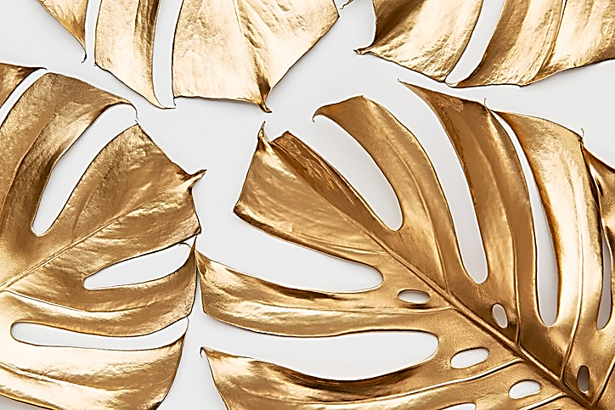
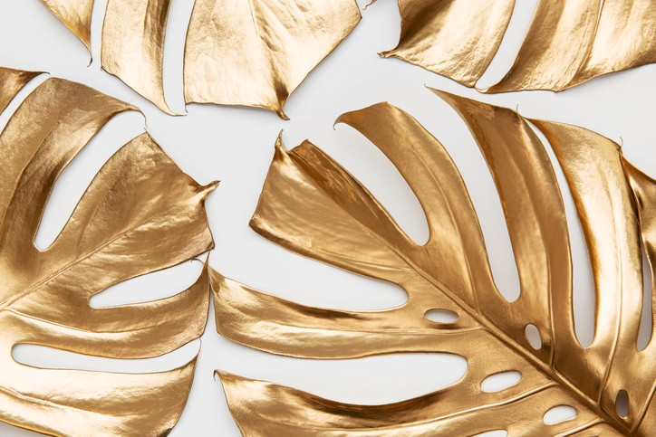
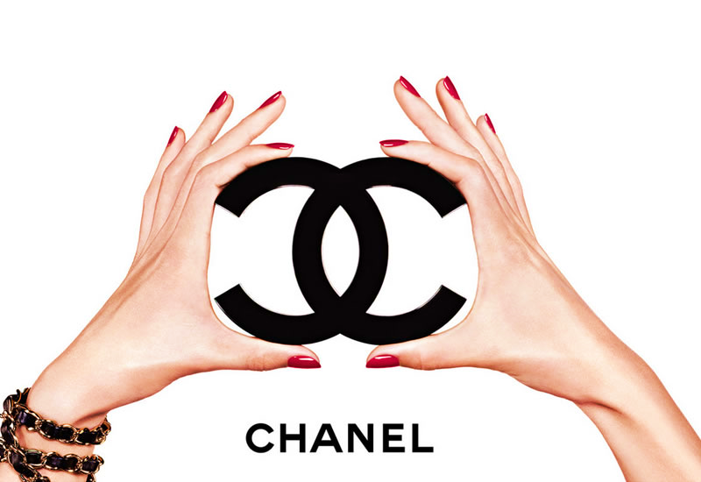

COCO CHANEL
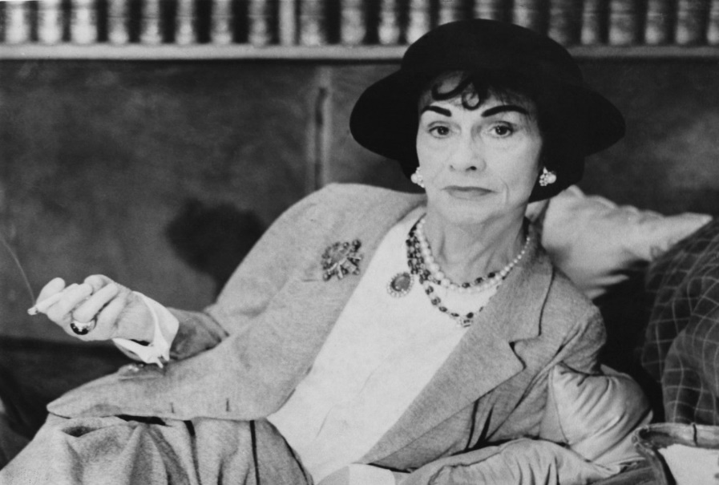
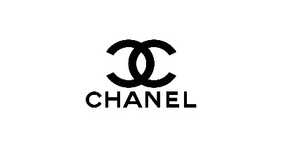
BLOG
Group Project of:
Dimitrina Petrova Dan Fillimon Petya Elchinova
Ivanka Nikolova Marina Stefanovska
Petya Elchinova

The History about
Coco Chanel and her
Fashion empire

The first taste of clothing…
I In the early 20’s, Gabrielle was very disappointed w in the fashion influence. ‘’Luxury must be comfortable, ot otherwise it is not luxury’’, Coco Chanel had said many t times. Therefore, introduced the Parisian market her rev revolutionary idea of the legendary Chanel suit (1925).
The idea was innovative as she used elements from man’s attire emphasising the comfort over the multiple layer dresses. It was time for all women to say goodbye to the corsets and enjoy wearing the new Chanel’s designs.
Another great fashion achievement was revealed in 1926 – The iconic little black dress. Chanel picked a colour related with excellent taste, elegance and sophistication, showing how chic it could be for an evening attire. Nowadays, this ‘’little black dress’’ could be found in any self-respecting women wardrobe as a sign of exceptional taste. Thank you, Coco Chanel!
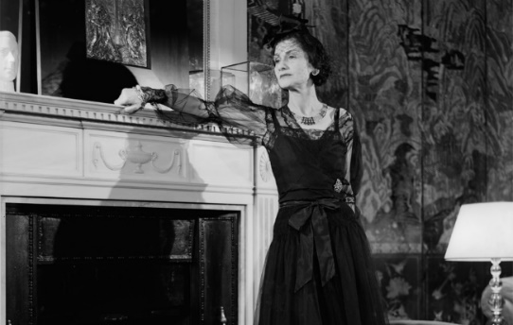
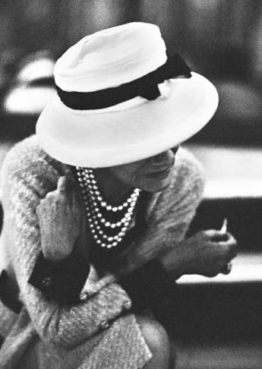
Coco Chanel’s first boutique…
Pulled from poverty, Chanel rose from the poorhouse to create a stylishness of liberation wear that fairly transformed the aspect of females’ fashion. Later in 1909, at age 26, Coco Chanel opened her first boutique for hats in Paris. The hast she created were very different and not at all in typical elaborate. Coco’s fashion was ease and modern, letting females to be fashionable and at the same time practical. But for Coco Chanel the hats were just beginning.

An orphan girl…
Who was Coco Chanel? Gabrielle Bonheur Chanel, born in August 1883, France was raised in an orphanage, where she developed her sewing skills. Later in life, Gabrielle had brief carrier as cabaret singer where she accepted her famous nickname Coco. Being one of the most attractive singers on the dancefloor, Coco Chanel managed to fascinate one of the wealthiest men in France at that time. His name was Etienne Balsan, the man who believed and admired her designer talent and gave her a place where she could establish her brand in 1910.

The real success Coco’s first strategic concept for opening a new boutique was to find a good location. Only six hours by train, southern from Paris was located adorable seaside town called Deauville. A cosmopolitan and favourite place for royalties and emperors. This was the compilation of people that Coco Chanel wanted to attract. In 1913, Coco managed to open the doors of her new fashion boutique – the first women’s collection designed exclusively for women.

The fragrance of the war
After the triumphal start of Coco’s fashion carrier, the world begun to change. In the summer of 1914 Europe was plunged into a devastating conflict. This was not time to high fashion due to the misery and despair. However, the war revealed an opportunity for Coco to use her creativity talent and bring to the French society. In 1923 Coco made a daring move and released her first perfume, names after her lucky number. Chanel N5 was the world’s most expensive fragrance.
Coco was the industry leader during the 20’s and 30’s, depending on herself, she symbolised the post war aspirations a generation of newly emancipated woman. But soon due to the international economic depression in 1939 Coco was forced to close her business.

Created by Dimitrina Petrova

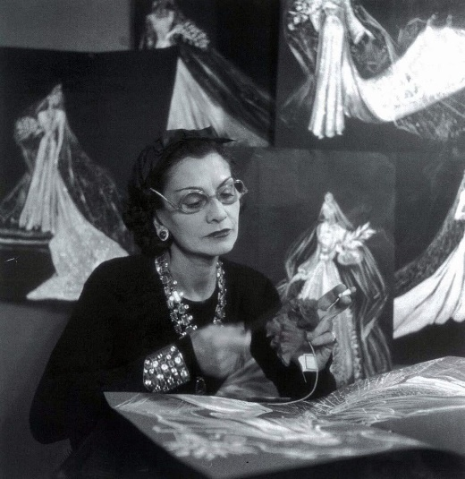
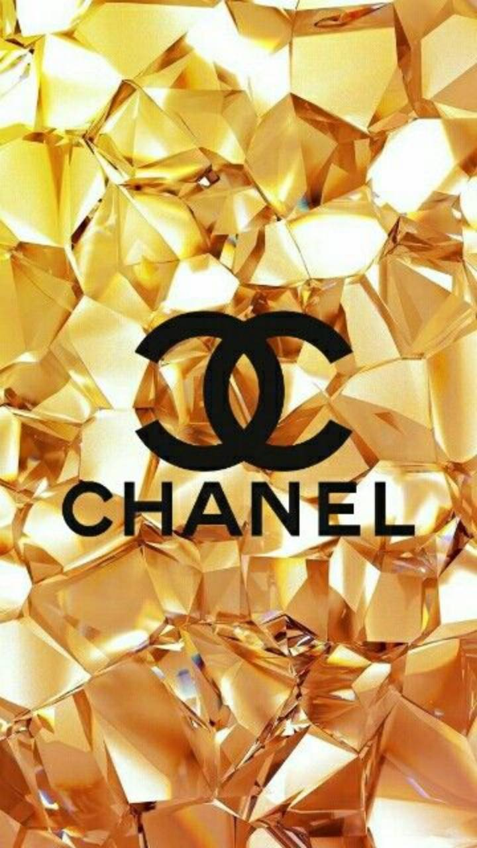
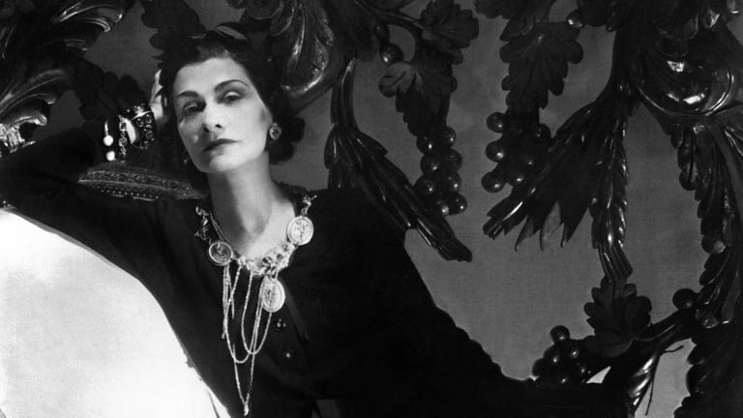
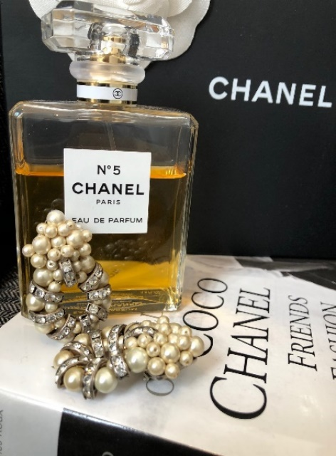
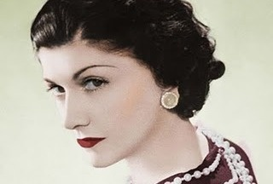
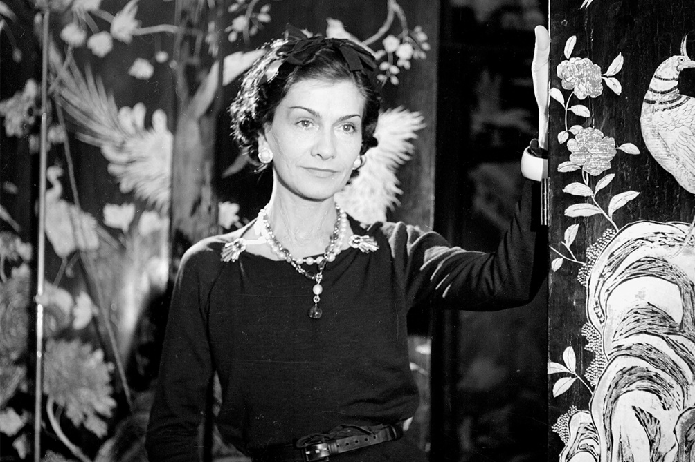

Another story asserts that the interlocking C’s belong to the only true love of Coco – Arthur ‘’Boy’’ Capel who was the main inspiration of Chanel’s collections. Others claim that Coco had permission from her friend Irene Bretz who owned The Chateau de Cremat in Nice. The interlaced letters have been part of the vineyard symbol decorated over the property’s doors and windows.
Chanel today – mission and vision
In 1982, Karl Lagerfeld became the creative director for the brand until his death in 2019. In 2018, Chanel moved its headquarters to London from New York revealing its worldwide revenue for the first time.
The mission, value and vision statements of Chanel are expressed by their internal company structure and their customers satisfaction. Chanel is a renowned brand representing the unique image of elegance, chic and sophistication from the commencement of the fashion house up until today. The mission statement of Chanel is ‘’To be the ultimate house of Luxury, defining style and creating desire, now and forever.’’
Throughout the years, Chanel remains to stimulate women with its eternal perception of fashion. Therefore, this is her vision of the organisation for being a functional fashion leader of the industry.

The return
In 1954 once again she returned to the fashion industry in Paris to launch her first post war collection. She did not get the respect of her collection from Europe, however she found redemption from overseas. In 1960 Chanel as brand was greater than ever and Coco herself was idolized. Her business was worth over £100m. For second time in her lifetime, Coco succeeded. Officially working, at the age of 88, Coco Chanel a fashion industry icon died at her Ritz apartment alone.

The Logo
Chanel’s logo is one of the most recognised logos worldwide. And the truth about its creation is still a myth.
One of the stories behind the opposite-facing and interlocking C’s is that the letters stands for the founder’s name Coco Chanel.

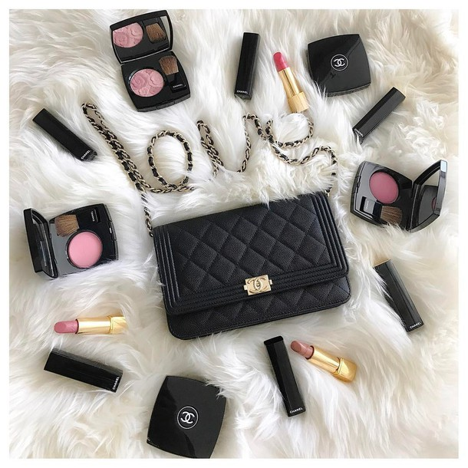
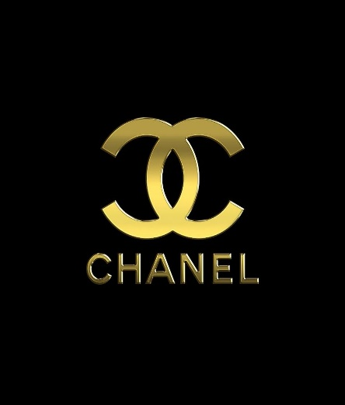
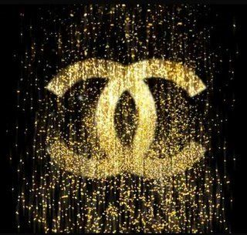
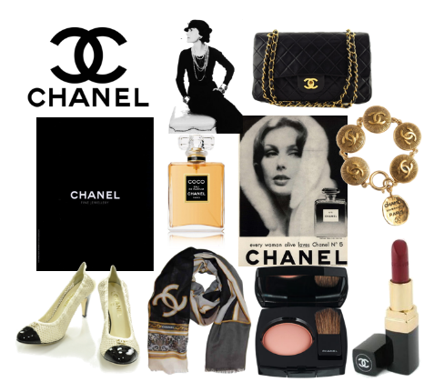
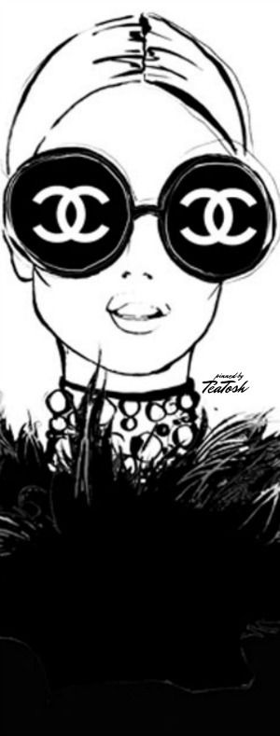
Created by Petya Elchinova
Chanel has focus on luxury branding strategy. Arguably, it has focused on the production of high-quality products in variety, which are also highly priced. A luxury brand, as defined by Ko, Costello, and Taylor is associated by the perception of quality, high value, uncommonness, among other characteristics. Accordingly, Chanel has been on the forefront in product marketing, where it utilizes market segmentation, target as well as positioning strategies. The female gender is arguably one of the largest markets of the products, owing to the production of several categories that favours the target.
As for the Chanel’s products history, the first hats to be created were recognized by the name Chanel Modes, over the year’s tremendous growth took place and a new collection of Sports Wear was introduced. The brand was able thrive over the years due to a firmly built reputation in the fashion industry and diversification to the iconic first fragrance. Currently, creations of Chanel include fashion, beauty, luxury accessories, ready–to –wear and haute couture. Its luxury branding strategy is reflected by the variety of products, which reflects quality and value. Through packaging, Chanel reflects its brand image by incorporating minimalism and authenticity. As the director of package development in the brand mentions, merchandising is similar to theatre, therefore, the initial contact with the brand is the package.
Women creations sold by the brand include variety type of handbags, dress, and shoes, make up and skin care, jewellery and bikinis. Among its fragrances, Chanel is famed for the No. 5 Perfume that comes in a perfume spray purse and bottle, as well as others such as Cristalle, Coco Mademoiselle, Coco Noir and Chance Eau Fraiche. In the men’s section the brand produces watches, perfumes that come in bottle spray and perfume bottles, shoes and after shave fragrances.

A product can be defined as something that is created to satisfy a specific want. According to Butje, a product can be a service brought to the market to meet customer needs. Chanel’s products include fashion, fragrance, eyewear, fashion, make up as well as skincare. Chanel brand purposes to be the Ultimate House of luxury, expressing style and creating desire, now and in the future. It seeks to offer high quality products to clients and most significantly, through its luxury branding strategy, it has continued to win the hearts of global clients. Women comprises the main target market of the highly valued products.

Our Products are our image

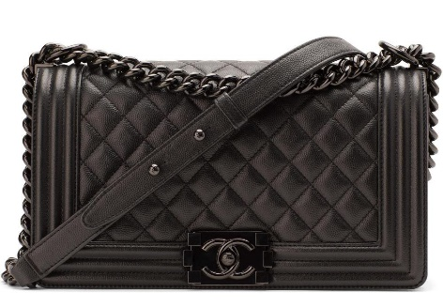
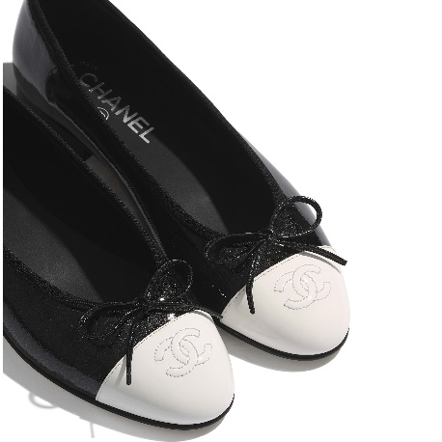
Created by Petya Elchinova
Shiny Goatskin & Patent Calfskin
Black & White
heel height 0.4 in ( mm )

The pair of flat shoes is comfortable yet chic and as ageless as the model stiletto. Two – Tone flats are familiar for the monocrome colors, CC stitching and little bows. Our own Coco Chanel worn them and evidently she was avocate for comfortable designs for women. The Chanel Ballerina has been loved for many years and coveted by both young and old generations.

Two – Tone Flats
So Black, Shoulder Strap Drop Max: 19",
Shoulder Strap Drop Min: 10", 7"H x 11" W x 2.5" D

The Boy Bag

The Boy Bag is one of our products, which was inspired by the founder. Coco Chanel was exceptionally tomboy-ish and she was generally inspired by Men’s wear, her biggest muse and lover was Boy Chapel. Therefore, many years after Karl Lagerfeld paid homage to the men in her life by the creation of the Chanel Boy Bag. The Boy Bag is among our best sought – after bags and it is a timeless piece our brand. It is characterized by the main body design framed by a series of Lego brick lock and straight edges. Following its versatility, the Boy Bag is crafted in categories of materials such Leather in caviar, patent and lambskin types. In addition, the creation is uniquely altered and experimented to offer special editions and tastes to our Women. We produce The Boy Bag in categories such as So Black, Iridescent and Exotics.

Products:

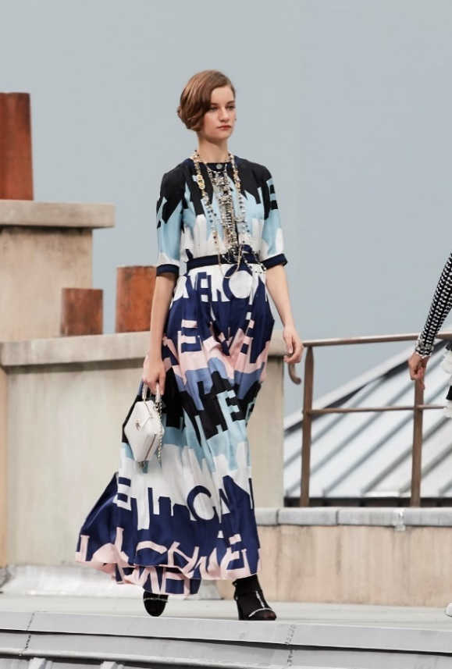
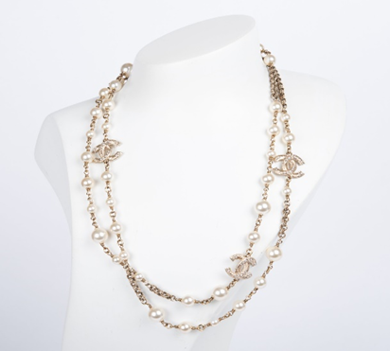
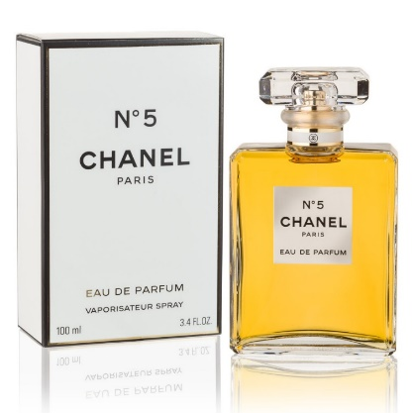
Printed silk, Black, Blue, Pink & White
Dress
Faux pearls & crystals
Double strand
CC logo golden color hardware

Our founder, Coco thought that if women could buy jewelry that was affordable than real gemstones, they were able to well accessorize every outfit they wore in stead of sticking with few unfashionable pieces. The iconic Chanel necklace is a classy strand of faux pearls with liked CC charms. The perals of 3 different sizes adds the beauty and elegance to our Women.
Faux Pearls

Created by Petya Elchinova
Top Notes: Bergamot, Aldehydes, Lemon and Neroli
Middle Notes: Rose, Jasmine, Lily of the Valley and Orris
Base Notes: Sandal, Vetiver, Vanilla and Amber

The product is the very first product we launched under the category of fragrance. Our Chanel No.5 product is currently popular and sold across many of our brand’s boutiques and department stores in the United Kingdom. The fragnrance is created for women, with top notes such as neroli, bergamot and aldehydes and base note of musk, vanilla and amber. The scent was legendarily worn by Marilyn Monroe and it remains among our highly ranked top selling fragrance in the world. Chanel No.5 displays an indefinable femininity, youthful, sexy and romanic attitude.

Chanel No.5

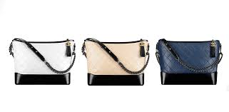
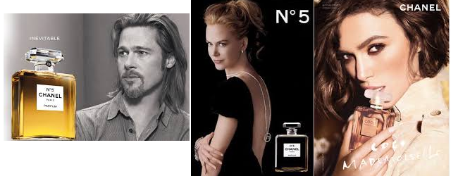
Created by Dan Fillimon
Most luxury brands’ pricing depends upon not just exclusivity and availability, but also on its ability to provide consistency across its offerings- and Chanel is no different. It thus takes its image and perception very seriously and makes sure that consistency exists in its offerings.
It has made sure that its offerings have the same relative pricing (considering currency valuations and exchange rate fluctuations) and value across its region of distribution ranging from Europe to Asia and the Americas. The differential pricing was an issue it faced in the year 2015, when the Euro was facing extreme depreciation. It realised that this depreciation has made its products cheaper for its Chinese customers who had understood this gap and started making round trips to Europe to buy in bulk. Case in point is its very famous Gabrielle Hobo Bag. The bag costs almost the same across the world.

Chanel is a brand one associates with extravagance, social- status, luxury, indulgence and most importantly, exclusivity. Hence, its pricing indicates the same. It is not just an “expensive” product. It is a product that lets you enter an elite club of users, letting the user “rub shoulders” with the likes of Keira Knightley, Brad Pitt, Nicole Kidman- Chanel’s celebrity endorsers
Figure 1: Source: Made by Student (2020); Adapted from (Chanel, 2020)

Chanel’s pricing strategy:

Chanel's Gabrielle Hobo Bag (small) price across the world, 2020
 | USA | $4900
 | UK | £3,980
 | Australia | AUD 6,120
 | Singapore | SGD 6,100

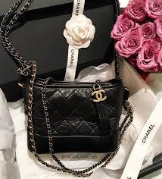
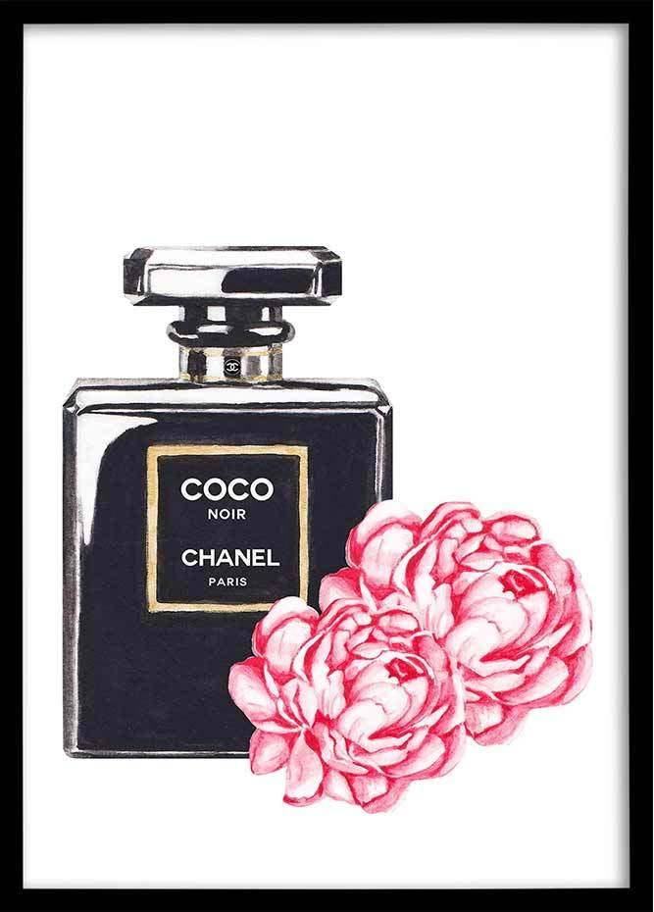
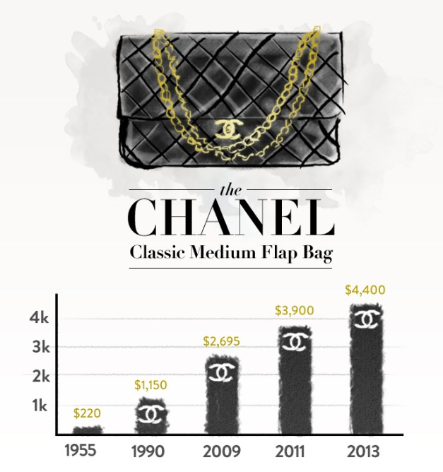
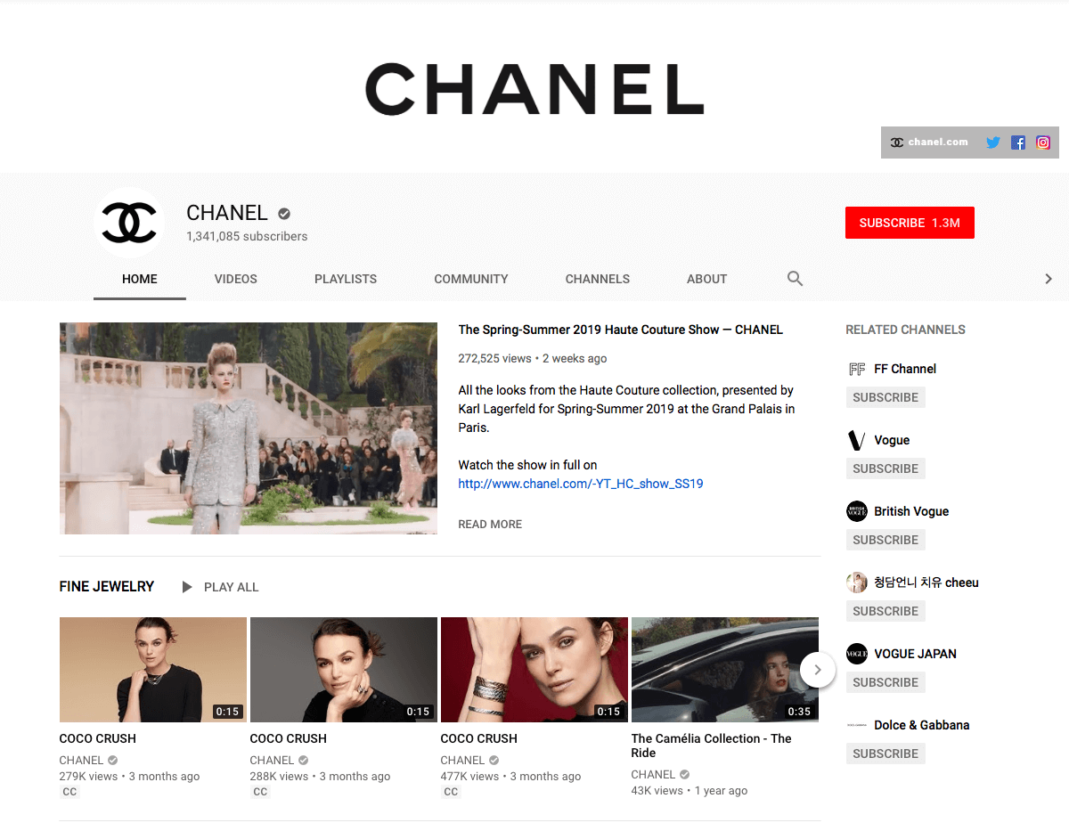
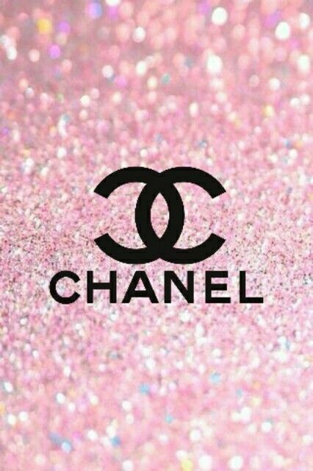
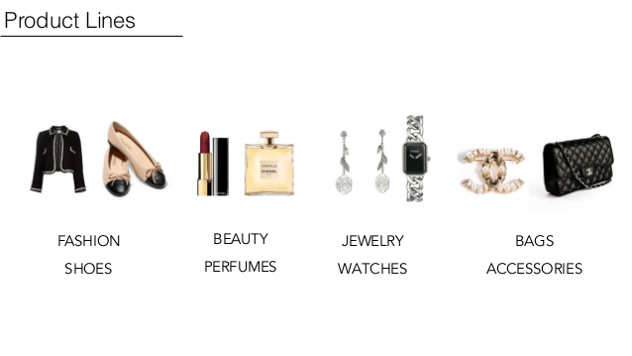
Created by Dan Fillimon
Another aspect that has emerged in the pricing strategy of luxury houses is the digital presence. A recent study conducted found that consumers that bought luxury items both, online and in-store, tend to spend 50% more per year than those customers who purchase in-store only.
With highly prices products, people need to feel and touch the product, but the digital space for brands like Chanel is revamping the idea. The brands are now including in their websites style advice, and story boarding, thus making them much more than just a place to shop. These websites are thus reinforcing the brand for the principle it stands for- exclusivity and consistency in the product and the experience.
At the end of the day, a brand wants to make its voice heard to its audiences- explaining them what they stand for and how can they change the lives of their customers. To help communicate this, pricing strategy plays a vital role. Pricing helps customers corroborate the image sold to them and the actual image present.
Chanel is one such brand that makes sure that it provides to its customers, exclusivity and tangible luxury which ultimately justifies the premium price they end up paying for it.

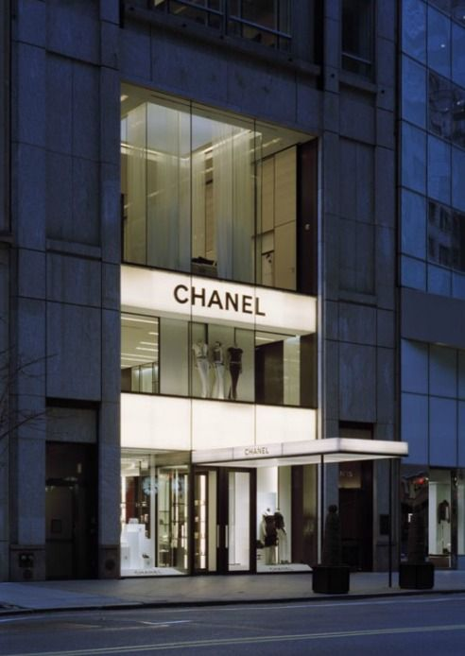
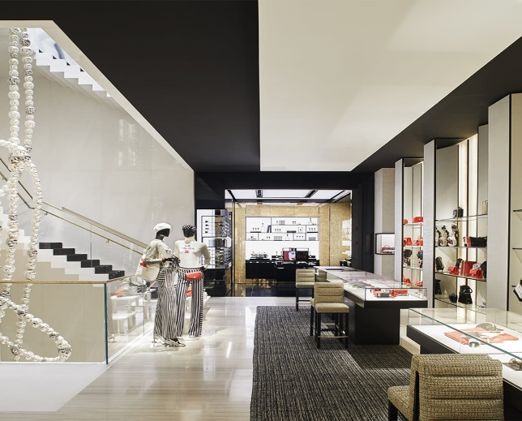
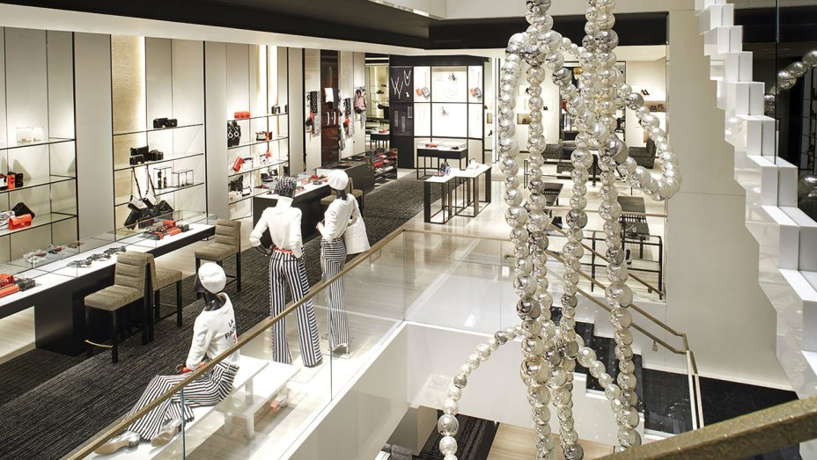
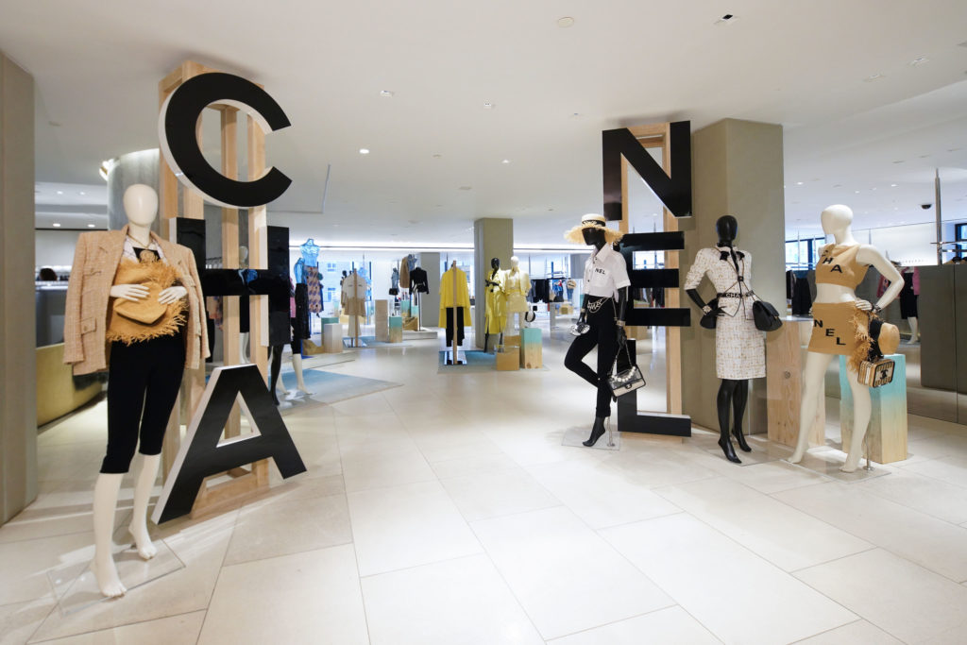
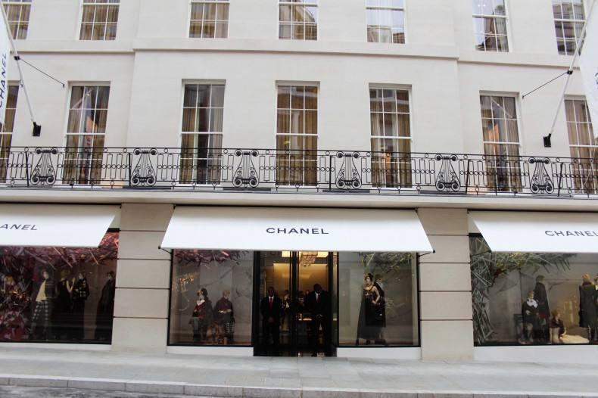
Created by Marina Stefanovska
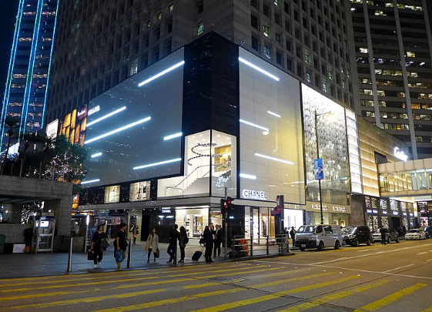

OUR Direct Distribution Strategy

The Chanel Company utilizes both direct and indirect distribution strategies for its lucrative products and services. Chanel does not do mass production and procurement of its products. This is a strategy that has given our brand its reputation. We produce high-quality brands that are scarce in supply; hence our prices are high. This explains why our Chanel stores are located in the vibrant street in luxurious cities. Our company has distribution stores located across France’s major cities and the popular world countries such as Italy, United States, United Kingdom, Netherlands, South Korea, Germany, Puerto Rico, Australia, among other countries. The Chanel Company has more than 310 boutique stores strategically located in wealthy communities in Europe, Asia, Oceania, and America.
According to our marketing strategy, mentioning the place is very critical in determining the success of marketing. It outlines where the company is located and different distribution channels that avail the product to the consumers. The primary role of place in the marketing mix is to avail the services and products to the target consumers at the right time and reasonable prices. Our Company channel headquarters are located in Paris, France. We specialize in provision in high-end luxurious fashion such as accessories, brandy clothes, luxurious products, beauty products, and fragrances such as perfumes.
Chanel’s Location and Distribution

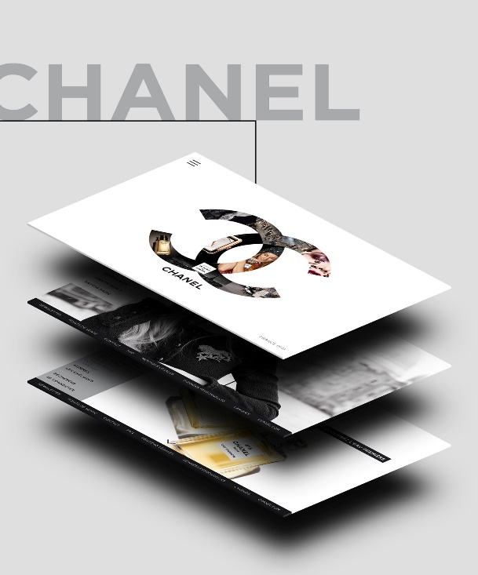
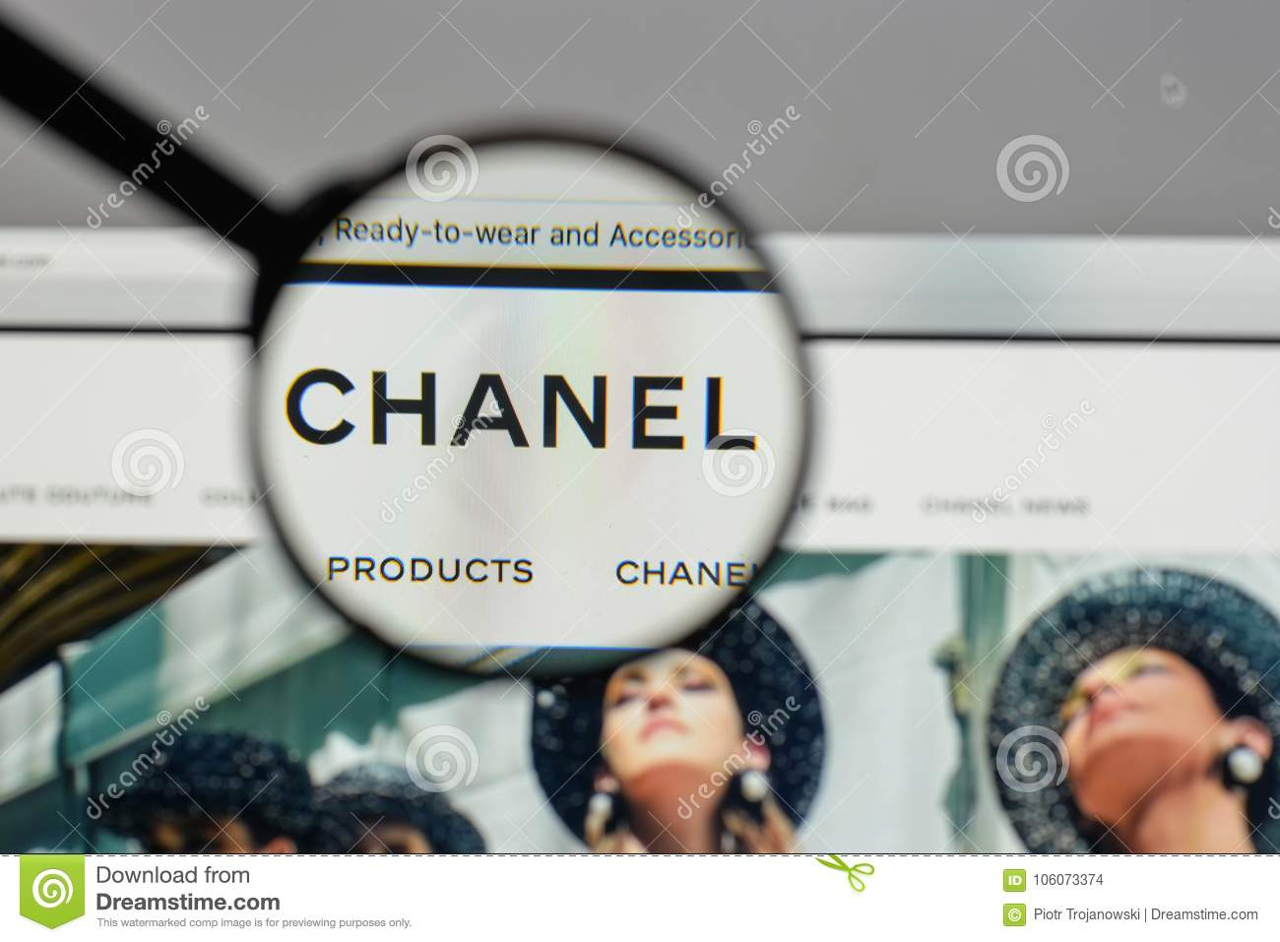
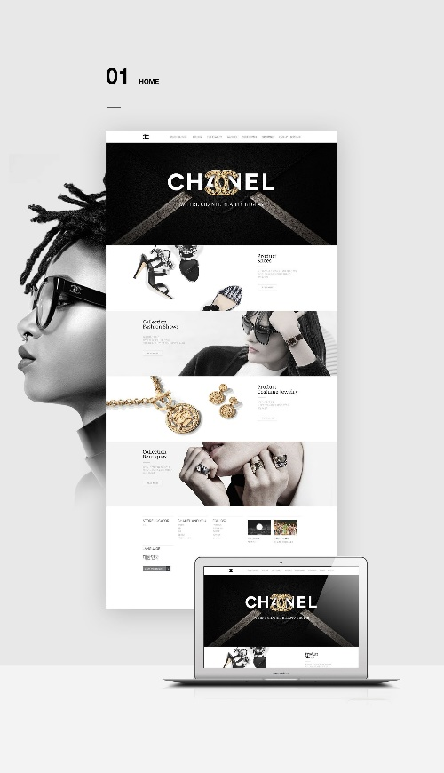
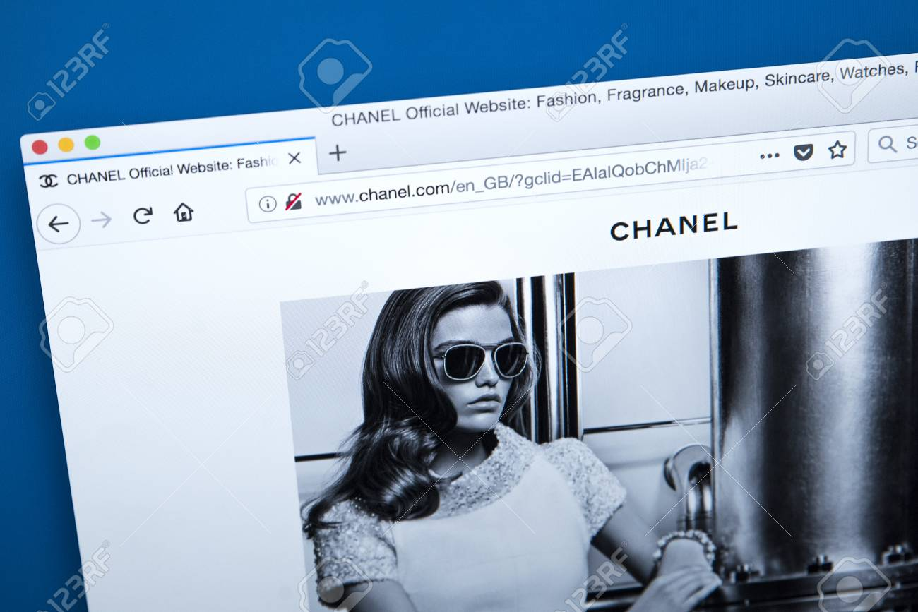
Created by Marina Stefanovska
Our Indirect Distribution Channel
Indirect distributions or multichannel distribution methods are as well embraced strategies to distribution Chanel products. Our company has numerous independent wholesalers and retailers across the world that purchases Chanel products. These distributors include e-commerce sites such as Alibaba online stores, high-end supermarkets, multi-brand stores, and exclusive stores, which plays a significant role in reselling Chanel products. This implies that the distribution method accounts for a considerably high sales volume of the Chanel company since the target market is easily reached. It is also help in eliminating all the risks associated with retailing products and services directly to consumers, such as storage cost, shipping cost, and labour. The method further plays a critical role in the brand promotion of Chanel by maintaining the top-notch standards of the company. This is because it is given a free advertisement by the wholesalers who must carry out marketing for the product to resale.

Owing to the large number of elite consumers who are in are not near Chanel stores, the online platform has been developed where orders are placed. The online platform can be found on the website link https//: www.channel.com. placing an order is the easiest thing ever. Just create an account in the platform with correct bio information that should be verifiable upon shipment of the orders. Through the platform, one can order watches, perfumes, jewellery, among other products. The company has over 310 licensed retails outlets across strategically rich places. This means one can easily access their services at the airports, 5-stars hotels, and abnormally rich streets of London, Dubai, New York, among others. Individuals can buy any of our products of whichever amount from these outlets. The original method of offering services and products was directly from the stores. The culture of placing these outlets at such a strategic location to easily reach the target consumers.

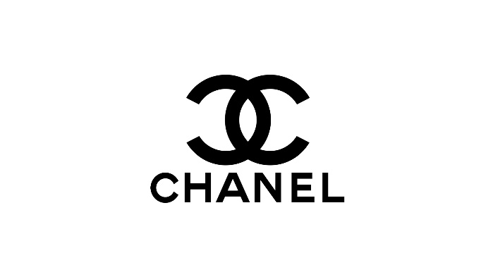
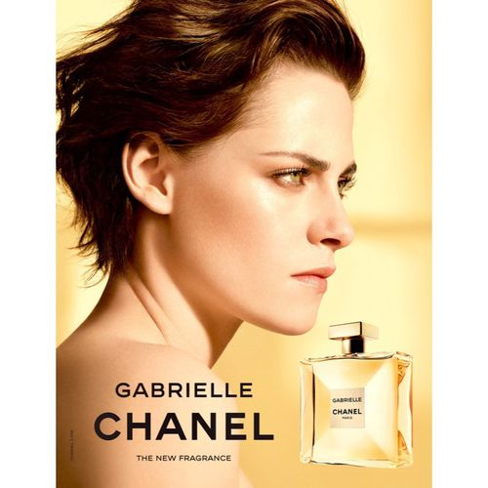
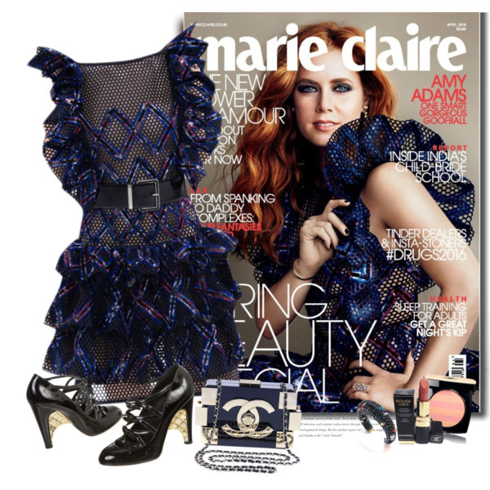
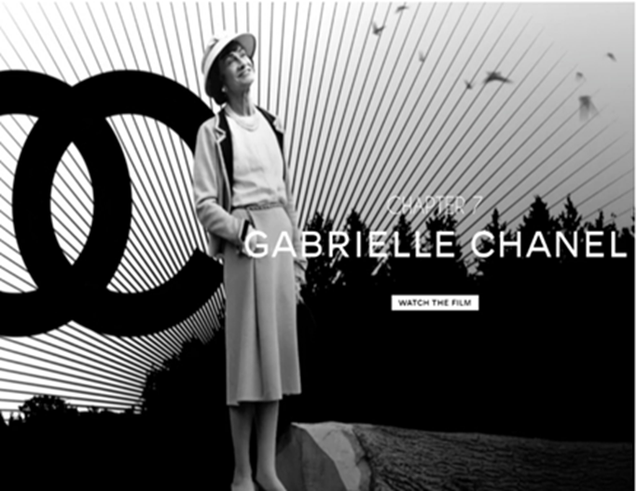
We sell our products in selected stores only. We are heavily investing in training people selling the products to create brand loyalty and awareness. We do not offer any sales promotion for our products. For advertisements: we usually use places ads in fashion magazines like Marie Claire, Vogue and Elle. We choose to advertise in expensive magazines that specifically cater towards influential buyers.

Created by Ivanka Nikolova
Promotion is usually used by a company to communicate with customers with respect to their product offerings. Chanel is using a mixed promotional strategy to advertise luxury products via different channels. Our products are well known as a premium range exclusive and creating a royalty experience. The competition amongst luxury brands is fierce; however, our company promotions are leading the market. We use a different type of promotion as such as advertising, public relations and other—especially television adverts around Christmas. Television advertisements used by Chanel as effectively with the customers. Storytelling is another way to communicate between the brand and the consumers on the levels of consciousness and unconsciousness. The head of the brand Karl Lagerfeld has directed many mini films for revitalizing our brand image. The key elements covered in such films were the brand history, feminism, city of Paris and pursuit of perfection. All the aspects created a strong consumers perception towards the brand as well the brand loyalty. We have managed to effectively utilise in our promotions the use of the films too. For example, in the movie “Once upon a time” the head designer used the silent form of the film in order to revive the memories of origin of our brand. It is also known the use of nostalgia for creating a strong brand image. This film traced the time when Coco first began her business in the fashion industry in 1910. The visual representation included the simple minimalist hats with the over-embellished style people adopted in those days.

Our Promotion Scheme

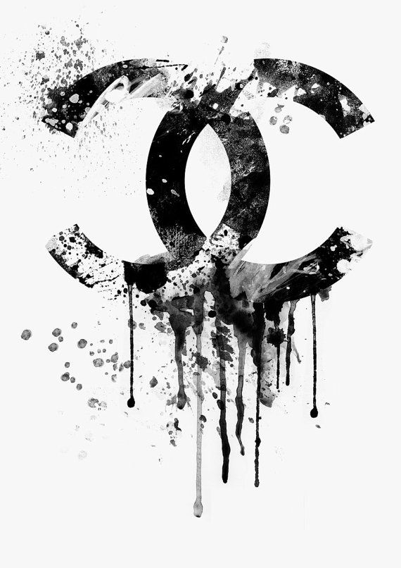
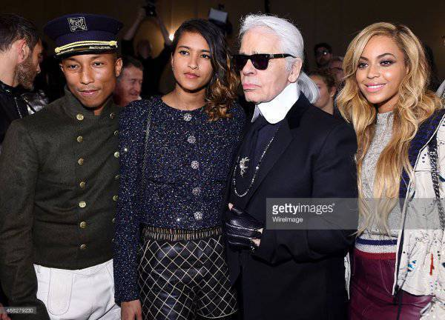
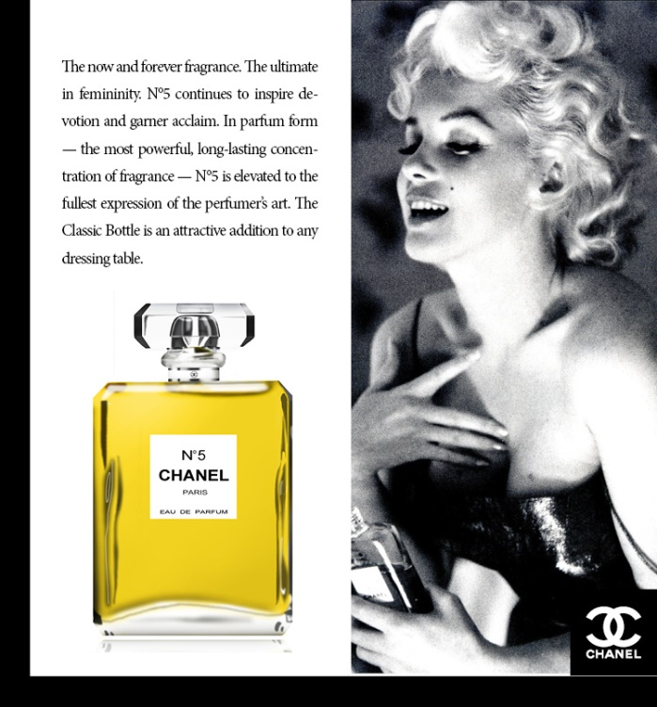
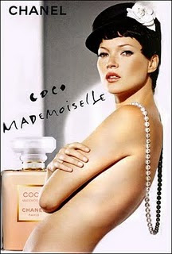
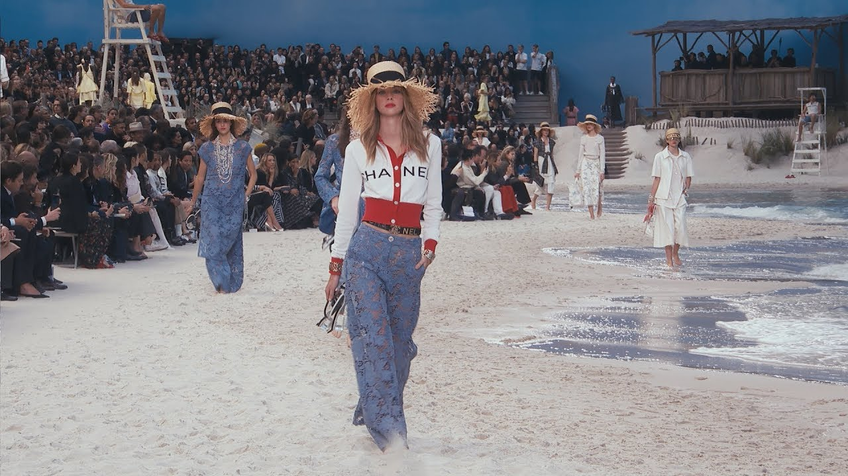
Apart from the advertisement, we are promoting our products through celebrity endorsement. We carefully select various models and actors – Marilyn Monroe, Keira Kutilizing, Nicole Kidman, Kirsten Stewart, and other. By utilising the celebrity image, we have immortalised the brand name that symbolises the heritage, lineage and mastering in providing a luxury experience.
Created by Ivanka Nikolova
Also, we are promoting our products during the fashion shows taking place every year in four cities as such as New York, Milan, Paris, and London.

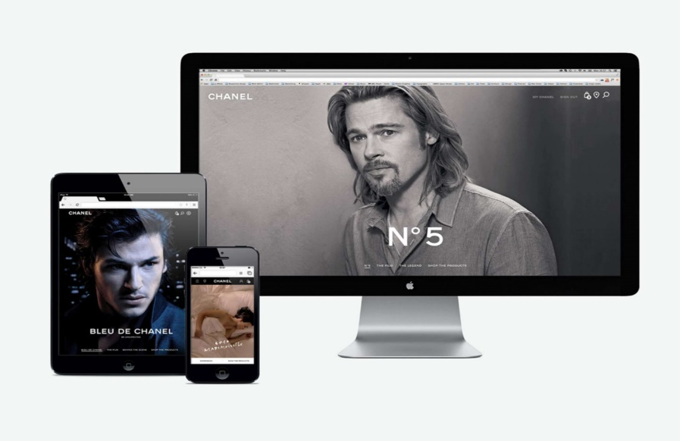
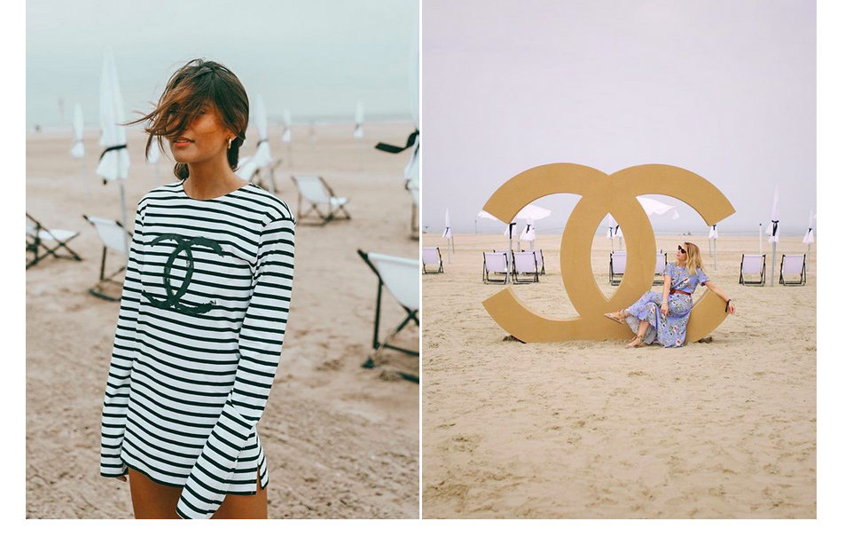
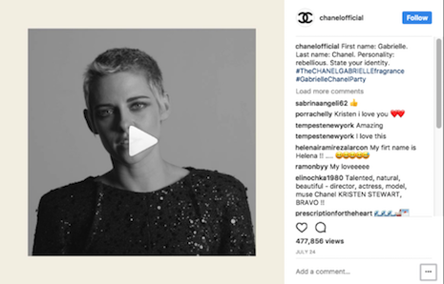
Created by Ivanka Nikolova
Spanish and French influencers @belenhostalet and @youmakefashion in Deauville - Instagram: belenhostalet / youmakefashion
One of the new steps Chanel has taken in the promotion strategy is to deepen its relationships with influencers. Including exclusive experiences, from fashion show invitations to thematic events for social media stars. Most recently we invited influencers to Deauville for the launch of our three new fragrances. Our primary purpose is to engage with medium- and long-term influencers who like our brand, identify with it and represent our value.

In recent years we have acknowledged the power of the social media. Furthermore, it has become a powerful tool to introduce our range and engaged with the customers. We are using platforms such as –Facebook, Instagram. YouTube and Twitter-with substantial investment in content and promotion, particularly in video. The competition in recent years amongst the luxury brands in social media is huge. However, we can proudly say that our brand Chanel the French jewel in the crown currently dominates. We have more than 57 million followers globally. Our videos on Facebook and Instagram managed to generate a vast number of views.
https://www.youtube.com/watch?v=RjhHXBjIbww

Lastly, the launch of Instagram Shopping helps brands to link products featured on posts with their own eCommerce shops. The big news for us as a company is that with a global account of 28 million followers, we are the first to test this service. Another step we have taken is long term partnership with eCommerce company Farfetch for the development of digital innovations in our physical stores. To offer a more personalised experience to our customers when purchasing our luxury brands. Currently, only our cosmetics and fragrances are available to purchase online compared to a global strategy for the growing online shopping market.

Kristen Stewart video in a Chanel Instagram post

[Sidebar Title]

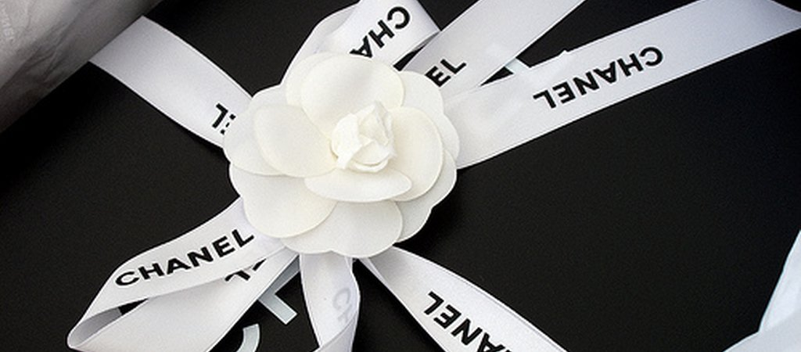
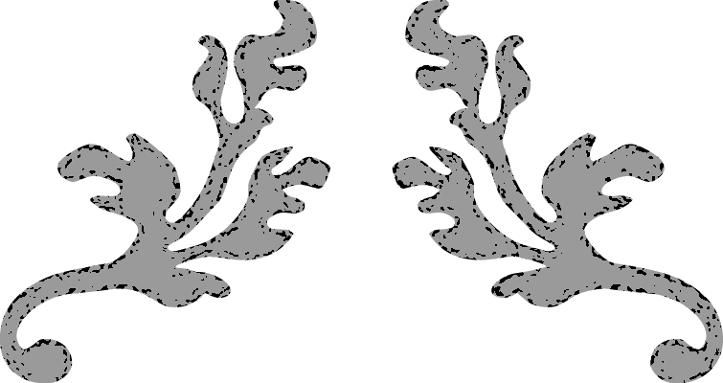
‘’Success is most often achieved by those who don’t know that failure is inevitable.’’
Coco Chanel

Sources of information – references:
Background:
Business of Fashion, Dec. 20, 2018; Company snapshot, Business of Fashion-website, Accessed on 28/02/2020, Available at: https://www.businessoffashion.com/organisations/chanel
Shellie Karabell, Oct. 12, 2015; Fashion and Finance Coco Chanel, Forbes, Accessed on: 02/03/2020, Available at https://www.forbes.com/sites/shelliekarabell/2015/10/12/fashion-finance-and-coco-chanel/#3e6c46807cb4
Inside Chanel, Chanel official web site, Chanel.com, Accessed on 28/02/2020, Available at: https://inside.chanel.com/en/chanel-and-the-arts
True facet, Feb. 12, 2015; The story behind the logo: Chanel, Rolex, Hermes and Longines, Truefacet.com, Accessed on 04/03/2020, Available at: https://www.truefacet.com/guide/story-behind-logo/
Chaney, L., (2011), Chanel – An Intimate Life, ‘’Afterwards’’ p. 7-443
Product:
Affordableluxurys. (n. d.). CHANEL Classic Faux Pearl & Crystal CC Long Necklace. Available at: https://www.affordableluxurys.com/product.html/chanel-classic-faux-pearl--crystal-cc-long-necklace-3 , (Accessed on: 24.04.2020)
Alston, I. (2014). Coco Chanel. TAJ Books International.
Butje, M. (2012). Product Marketing for Technology Companies. London, England: Routledge.
Chanel. (n.d.). Ballerinas, shiny goatskin & patent calfskin, black & white - CHANEL. Available at: https://www.chanel.com/en_WW/fashion/p/sho/g02819y53816/g02819y53816c0229/ballerinas-shiny-goatskin-patent-calfskin-black-white.html . (Accessed on: 24.04.2020)
Chanel. (n.d.). Calfskin & Ruthenium-Finish Metal Black BOY CHANEL Handbag | CHANEL. Available at: https://www.chanel.com/us/fashion/p/A67086Y0995394305/boy-chanel-handbag-calfskin-ruthenium-finish-metal/ . (Accessed on: 24.04.2020)
Chanel. (n. d). DRESS- PRINTED SILK, black, blue, pink & white. Available at: https://www.chanel.com/en_WW/fashion/p/rtw/20S-podium/look-057.html . (Accessed on: 24.04.2020)
Chanel. (n. d.). NÂ°5 - Cologne & Fragrance | CHANEL. Available at: https://www.chanel.com/us/fragrance/women/c/7x1x1x30/n5/ . (Accessed on: 24.04.2020)
Ewing, E. (2014). History of 20th century fashion. Pavilion Books.
Ferretti, A., & Rocca, F. (Eds.). (2013). A Matter of Fashion: 20 Iconic Items that Changed the History of Style. White Star Publishers.
Ko, E., Costello, J.P. and Taylor, C.R., 2019. What is a luxury brand? A new definition and review of the literature. Journal of Business Research, 99, pp.405-413.
Koda, H., & Bolton, A. (2005). Chanel. Metropolitan Museum of Art.
Mazzeo, T. J. (2011). The secret of Chanel No. 5: The intimate history of the world's most famous perfume. Harper Collins.
Milbank, C. R. (2002). The couture accessory. Harry N. Abrams.
Price:
Chanel, 2020. Chanel. [Online] , Available at: https://www.google.com/search?q=chanel&rlz=1C1DFOC_enIN663__663&oq=chanel&aqs=chrome..69i57j69i59j35i39l2j69i60l4.2288j0j4&sourceid=chrome&ie=UTF-8#
Chanel, 2020. Chanel Financial Results. [Online]
Available at: https://www.chanel.com/us/financial-results/
[Accessed 2020].
ContactLab, 2018. Report: Online Offer Dive and Pricing Landscape 17-18. [Online]
Available at: https://webcache.googleusercontent.com/search?q=cache:6qoJ0GR9_BAJ:https://contactlab.com/en/more/reports/contactlab-report-ood-17-18/+&cd=1&hl=en&ct=clnk&gl=in
[Accessed 2018]
Place:
Chanel, E. (2020). CHANEL Official Website: Fashion, Fragrance, Makeup, Skincare, Watches, Fine Jewellery. CHANEL. Retrieved from https://www.chanel.com/.
Deepak, R. K. A., & Jeyakumar, S. (2019). Marketing management. Educreation Publishing.
Jones, G., & Grandjean, E. (2018). Coco Chanel: From Fashion Icon to Nazi Agent.
Jurše, M., & Jager, J. (2017). Marketing channel strategy management in international markets. International Journal of Innovation and Learning, 21(2), 127-148.
Saylordotorg, E. Marketing Strategy, and Place. Saylordotorg.github.io. Retrieved 19 April 2020, from https://saylordotorg.github.io/text_small-business-management-in-the-21st-century/s11-07-marketing-strategy-and-place.html.

Promotion:
Aaker ,D.A and Biel, A (2013) 'Brand equity & advertising: advertising’s role in building strong brands', Psychology Press, (), pp. .
Alston, I (2014) Coco Chanel, : TAJ Books International.
Brun, A. and Castelli, C (2013) 'The nature of luxury: a consumer perspective', International Journal of Retail & Distribution Management , 41( ), pp. 823-847.
Mc Carthy,J (2019) ' Karl Lagerfeld's legacy', Drum, (), pp. [Online]. Available at: https://www.thedrum.com/news/2019/02/19/karl-lagerfeld-dies-how-the-chanel-creative-director-influenced-the-ad-world (Accessed: 30th April 2020).
Rowley,J (1998) 'The changing face of current awareness services', , 30(3), pp. .

