PERSONNEL RESOURCING AND DEVELOPMENT
Student name: Alina Cristina Ionita
Lecturer name: Jemma Smith
Student ID: 2246123
Executive Summary
This research proposal focused on the Strand Palace Hotel. This hotel has seen many generations come through its doors and has also faced a lot of struggles as well. This was a research based on the analysis of the impacts of socio-economic factors regarding the employee's performance management and monitoring in different modes of work. This research has been based on hospitality and the hotel is based in the UK. There were a few recommendations given to improve their knowledge about hybrid modes. Since the company has been stuck in their traditional ways, they are now trying to move forward and keep up with the times.
Contents
Introduction 4
Background 4
Discussion 5
Conclusion 8
References 10

Introduction
This research proposal will focus on the Strand Palace Hotel. This discussion will include different modes of work in terms of hospitality. There will be an examination of the issues of employee performance management. There will be an analysis of the background of the company as well as an identification of the current issues and impacts of the socio-economic factors. These factors will be considered which might have an impact on the monitoring and management of employees in different work modes. In the discussion, there will be a summary provided on the topic with findings on the same. There will be various examples of the chosen hotel and how they can monitor and manage their employees in different work modes. Lastly, there will be a conclusion of the findings and an overall summary of the work. A few recommendations and solutions could also be mentioned as well. The hotel that has been selected is known as Strand Palace Hotel which is based in London, UK. The strategies that this hotel will use to monitor and manage the employees tend to depend on the work mode that they have adopted. Since it is a hotel, they must come to work at least once a week to get things done.

Background
The company that has been chosen is called Strand Palace which has its headquarters in London, UK. This is a large hotel that belongs on the north side of England. This has been positioned to the Covent Garden that belongs on Trafalgar Square and the River Thames. The first lot of customers were welcomed in 1909 (Strand Palace Hotel, 2024). The palace is on the oldest and finest streets. There is a lot of history that goes hand in hand with London. There is a lot of old architecture and design that belongs to the olden days which makes people visit the palace. Since it has been around for so many decades, it has seen the monarchs, governments and everything in between. They have been through it all and have been seen in multiple wars, but survived through it all. This hotel has been selected for this analysis and discussion. The socio-economic factors will be discussed that tend to analyse employee monitoring and management in different modes of work (Papademetriou et al., 2023). The mode of work that has been followed in the company is the office work arrangement which is the most commonly used mode.
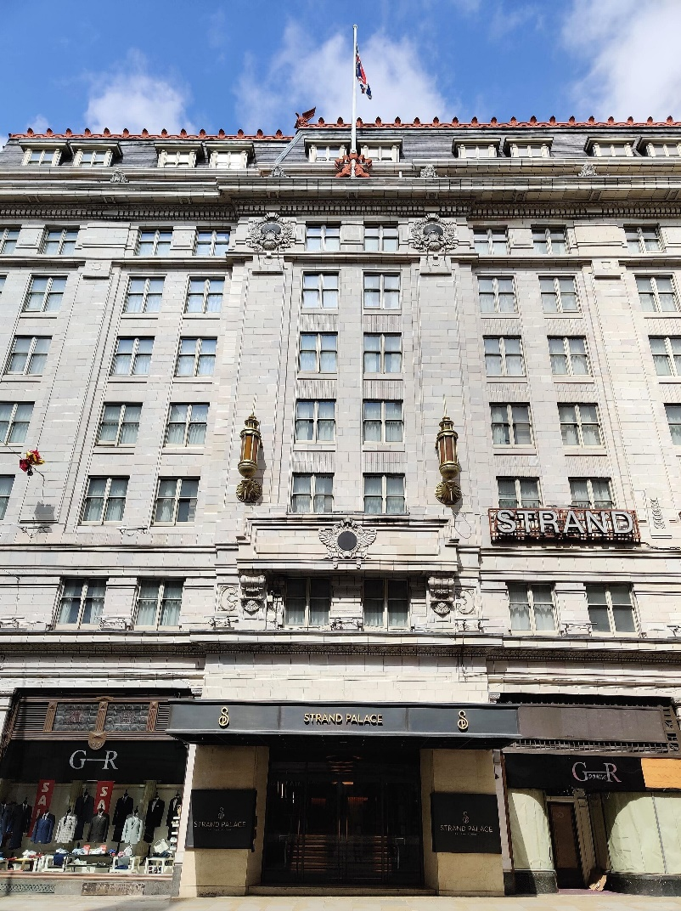
Figure 1: Strand Palace Hotel
(Source: Strand Palace Hotel, 2024)

Discussion
This research has focused on the current issues involving the monitoring and management of employees about the different kinds of work modes that have been adopted by businesses that currently exist. Strand Palace Hotel uses approaches that are not yet developed or updated and they also use the traditional work modes. To analyse the different kinds of work modes, they need to see what mode of work is the most effective for their kind of company and business (Urbaniec et al., 2022). They need to also consider different other approaches and keep alternate options open. The productivity of each of the approaches needs to be analysed as well as they need to make sure that each of these models is taken into account. Strand Palace Hotel will have to check out and see if there are methods used for the monitoring and the various issues or concerns that employees may have depending on the work modes that they are working in (Alreahi et al., 2022). They need to also consider how the company will have to monitor the needs as well as build up a level of trust in both, a hybrid and remote setting.
Socio-economic factors to consider
There are so many socio-economic factors that have to be considered, especially for a company like Strand Palace Hotel that has been around for decades and is still stuck to the old and worn-out traditional methods. They need to see if there is proper access to technology, and they need to find out if the employees of the hotel have any kind of access to technology and if they have a proper internet connection if they are in hybrid mode (Ravalier et al., 2020). They need to also see if the practices and approaches that they use to monitor the employees can burden the employees who belong to backgrounds of poor and low income. These are the kinds of factors that tend to help them have a better life. As they tend to use traditional methods, there are a lot of issues that employees face in the hotel. They are not very informed nor do they have any kind of knowledge about the digital world. In this work mode, the employees are working full-time. They have a sit-in arrangement that obligates them to work from a certain time to a certain time every single day except the days when they have their holidays. Managers in this workspace tend to have a more direct and clearer view of the employees who are coming into the office. They know exactly what is going on and whether or not the employees are doing their tasks efficiently or effectively (Pokojski et al., 2022). Due to their physical presence at work, they can see what is being done. It shows how each of the employees work, how the work has been found, the amount of work that they do and they are also able to talk to the employees and give them feedback regarding their work as well. Due to the physical presence, the team will be able to hold meetings whenever they want and share ideas and enthusiasm as well. They can conduct meetings in person at any time while they are in the office. They can communicate with one another directly and face-to-face. There is a set schedule when the employees are at the office and there is a certain structure that is provided and routine provided for the employees as well. There is a sense of community through traditional modes of work.
Monitoring and management of employees in Strand Palace Hotel
Due to the competitive area of work, there are many strategies that Strand Palace Hotel has developed to stay ahead in the game. They can gain advantages and have an edge over the others as well. The first work mode that will be discussed is the traditional work mode that they have been using for decades. Firstly, with the help of this work mode, the employees are doing their work on time and are even attending all the meetings that are being held. The second work mode that has been selected for this discussion is the hybrid mode even known as the flexible work mode (Leesakul et al., 2022). This has been implemented in the strategies of Strand Palace Hotel because they have been laughing behind while all the other hotels in the UK are far ahead in terms of technology and advancement. It seems that in the mode of hybrid or flexibility, many kinds of tools or software could be used to monitor and manage each of the employees and even see the amount of progress that they have made. It is easy to track and keep updated in this mode as compared to the traditional mode. It is easier to organise and manage. Many platforms are used to communicate with one another. Applications like Zoom and Slack help businesses get things done and communicate with one another by setting up online meetings with others. Once the employees are set, they can connect with the managers through a stable and available internet connection (Manokha et al., 2020). This helps the employees to stay on track and helps the employers keep track of the employees and their tasks as well.
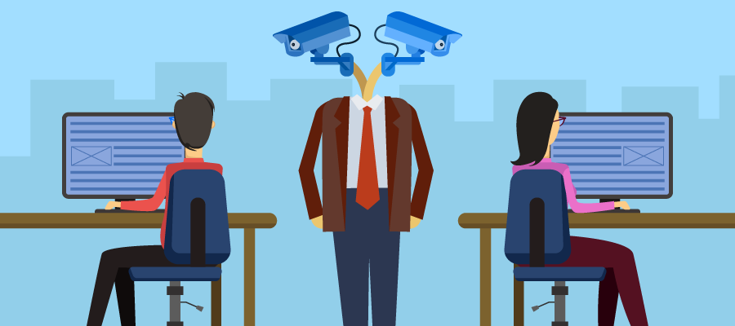
Figure 2: Employee Monitoring
(Source: Maltseva, 2020)
Solutions
Many kinds of solutions help in addressing different challenges of the monitoring and management of the employees in Strand Palace Hotel. There are many policies that Strand Palace Hotel has to develop that will be clear and comprehensive. The data of the employees will be analysed and monitored. Managers will also have to talk and interact with their employees more directly regarding why they are being monitored in this way and the various benefits that it could bring to one another (Maltseva, 2020). There should be feedback given by the employees regarding the experiences that they may have during the overall practices and processes of this. Once this process has been initiated by the hotel, they need to then focus on the outcomes. They will then focus more on the way they will be able to achieve certain objectives that the hotel may have as well as the results that they may get out of it. They need to be given the proper resources that are needed for the employees to manage their time effectively. They will also be able to keep track of their progress as well as stay updated. Lastly, they should also be able to give their employees the best training possible. They should train their managers and ensure that they are the best in leadership and have the best skills to communicate with the employees in a way in which they will understand everything clearly and will not be confused (Witasari and Gustomo, 2020). They need to also ensure that the employees before they start their work know about the various tools used in the hotel and have the skills for them. If not, then they are to develop skills for this and improve their knowledge as well. They need to be well-trained and educated on things like this.

Conclusion
To conclude, there has been a research proposal on Strand Palace Hotel and how they can monitor and manage the performance of their employees. Since this company is a very old one and most of its operations are still being done the same way, it has been difficult for them to change their whole outlook. Various socioeconomic aspects have been considered and discussed while talking about the different kinds of work modes as well. There were various examples provided as well as a few recommendations that would help the hotel improve. Various recommendations have been given to modernise the work modes that Strand Palace Hotel has been dealing with for the past years. They are now able to adapt to the new ways and methods that would help them monitor and manage the employees but in a faster and easier way. Firstly, they should be able to develop policies that would help them to proceed with their monitoring. They will make sure that the employees are aware of the fact that they are being monitored and why they need to be monitored in this way. They will be discussing how they will be monitored as well as the various benefits that this would bring the employees and the managers or company as well. They should also remind the employees of their rights and their rights to the privacy of their data as well. There are also steps and methods used that would help them check out their data and even keep track of it themselves. Secondly, they would make sure that they are as transparent with the employees as they are with the higher authority. They should not keep anything from them and communicate with them with language that is open and honest, clear and concise. If any employees tend to have a problem or issue with this, then they are encouraged to speak out and tell the management their concerns. They will then respond to them with proper feedback and solutions. Any kind of feedback and questions are encouraged regarding the process of monitoring the employees. Since the employees are the ones being monitored, the companies need to inform the employees about all steps taken.

References
Alreahi, M., Bujdosó, Z., Kabil, M., Akaak, A., Benkó, K.F., Setioningtyas, W.P. and Dávid, L.D., (2022). Green human resources management in the hotel industry: A systematic review. Sustainability, 15(1), p.99.
Leesakul, N., Oostveen, A.M., Eimontaite, I., Wilson, M.L. and Hyde, R., (2022). Workplace 4.0: Exploring the implications of technology adoption in digital manufacturing on a sustainable workforce. Sustainability, 14(6), p.3311.
Maltseva, K., (2020). Wearables in the workplace: The brave new world of employee engagement. Business Horizons, 63(4), pp.493-505.
Manokha, I., (2020). The implications of digital employee monitoring and people analytics for power relations in the workplace. Surveillance and Society, 18(4).
Papademetriou, C., Anastasiadou, S. and Papalexandris, S., (2023). The effect of sustainable human resource management practices on customer satisfaction, service quality, and institutional performance in hotel businesses. Sustainability, 15(10), p.8251.
Pokojski, Z., Kister, A. and Lipowski, M., (2022). Remote work efficiency from the employers’ perspective—What’s next?. Sustainability, 14(7), p.4220.
Ravalier, J.M., McVicar, A. and Boichat, C., (2020). Work stress in NHS employees: A mixed-methods study. International journal of environmental research and public health, 17(18), p.6464.
Strand Palace Hotel, (2024). Welcome to the Strand Palace Hotel.https://www.strandpalacehotel.co.uk/index.html (Accessed: May 11th, 2024)
Urbaniec, M., Małkowska, A. and Włodarkiewicz-Klimek, H., (2022). The impact of technological developments on remote working: insights from the polish managers’ perspective. Sustainability, 14(1), p.552.
Witasari, J. and Gustomo, A., (2020). Understanding the effect of human capital management practices, psychological capital, and employee engagement to employee performances. The Asian Journal of Technology Management, 13(1), pp.1-15.

