Managing People
Role of technology in monitoring remote working facilities

- Student’s name: Name : Petrica Dana
- Student ID -2215984
- Module code –LCBB 5004
- Module name – Managing People
- Lecturer-Dr Mushfiqur Rahman

- Table of Contents
- 1. Introduction 3
- 2. Role of technology in sustaining the performance of employees 3
- 3. Techniques for measuring performance of remote workers 5
- 3.1 Tools for Tracking real time activities 5
- 3.2 Deadline and work completion portals 6
- 3.3 Communication and team assessment platforms 7
- 3.4 Survey organiser platforms 7
- 4. Techniques for appraising productivity of remote workers 7
- 4.1 Polling booth applications 7
- 4.2 Analytic dashboards 8
- 4.3 One on one meetings 8
- 4.4 Integrated digital noticeboards 9
- 5. Conclusion 9
- References 10

1. Introduction
The trends of remote working facilities and the inclination of employees to work from home are enhancing rapidly after the global surge of the COVID-19 pandemic due to well-known circumstances (Nundy, et al, 2021). The impact of the pandemic and inclination towards working from home has also been observed in the corporate sectors of the UK. An approximate figure of 49% of all the working professionals in the UK have reported working from home at least once a week during the work days. However, several challenges are faced by employers and recruiters in the enhancing surge of employees being inclined towards asking for remote working allowances (Musa, 2023). Therefore, this report is dedicated to analysing the frequently occurring challenges and concerns after allowing the workers to report with flexibility. Furthermore, this report is also determined to explore the feasibility of technological advances in easing the concerns of human resource management while providing WFH allowance to employees.

2. Role of technology in sustaining the performance of employees
After the global surge of the COVID-19 pandemic renowned organisations in the UK have started to focus on the technological advances and developments made by scientific knowledge to keep track of employees who work from remote areas (Haseeb et al, 2019). These technological advances are advantageous for keeping track of the activities done by employees along with providing them an operating system to stay updated about the organisational operations. Furthermore, the applications and software are also helpful for providing the user interface and digital portal for the employees to keep reporting to the higher authorities.
In the United Kingdom (UK), several industries such as information and communication (ICT) allow their employees to work from remote areas and flexible timings (Galanti, et al, 2021). Along with that professional, scientific and technical (PST) sectors were also inclined to offer similar flexibilities to the employees. Several purposes needed to be accomplished due to which several industries' corporate world is adopting digital channels to stay connected with the employees and organising the sessions for monitoring their quality. Several aspects are considered in these sessions of online platforms such as nurturing the employees, analysing their qualifications for recruitment, forecasting the prospective events and influencing the workers.
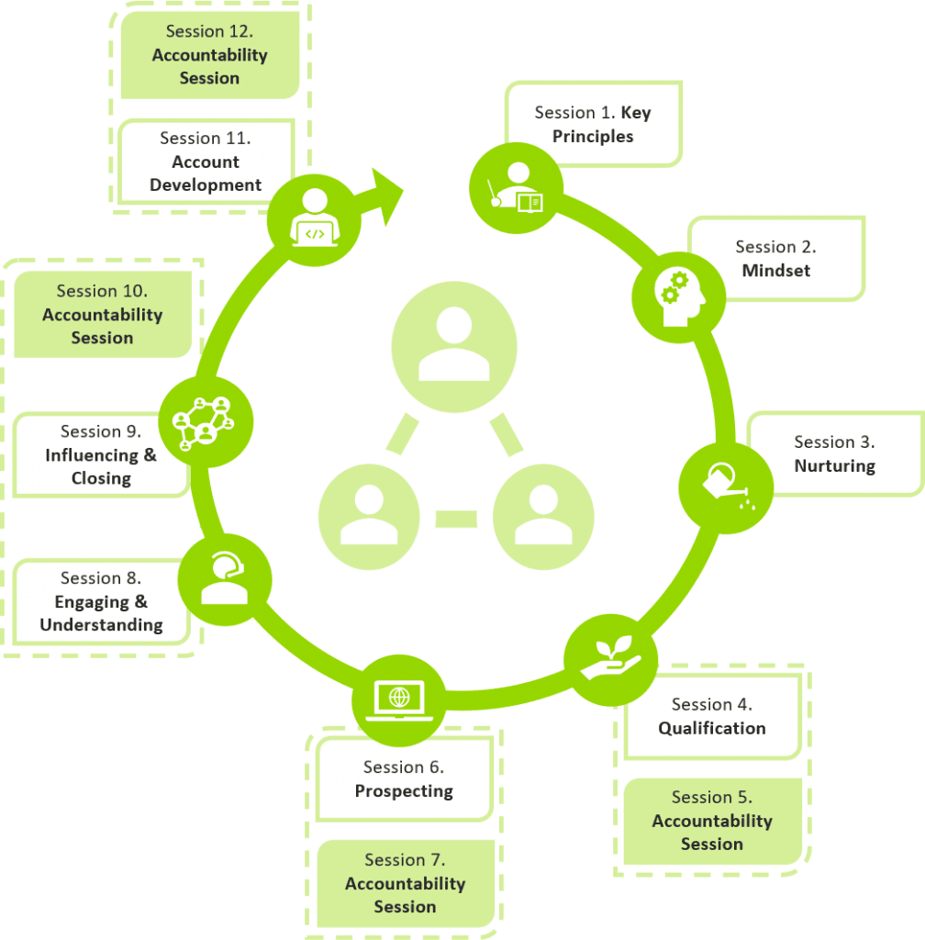
Figure 1. Aspects of technological advances in sustaining employee productivity
Source: Author
These technological advances have been proven to be beneficial for employers to monitor the quality and performance of work done by employees from distant areas from the organisational premises (Kurdi, 2020). Observably the extent of attending Zoom call meetings and video call sessions during and after the covid 19 pandemic has been remarkably enhanced due to the inclination of employees to not report to the office premises. Although several considerations have been addressed by renowned organisations to uninterruptedly proceed with the quality performance of employees during the allowance of working from remote areas. The facilities provided by higher authorities to employees and human resource management have been discussed below.
- Administrative portals: the digital portal saluted for human resource management helps the managing authorities to smoothly interact with lower designation employees with their computer systems (Alhamad, 2022).
- Facetiming sessions: The platforms of video sessions and Facetime are efficient in providing a sustainable channel for uninterrupted communication between different designations and colleagues of an organisation to collaborate.
- Official websites: The official website of organisations helps the employees keep updated about the improvisions and events that are being organised by their institutions along with attending them.
Challenges of digital disruption
The adoption of technological advances has also been challenging since human resource management has often been observed to be overly dependent on these tools which can be negatively influential on the organisational operations (Ordonez, 2019). Along with that, the challenges related to technical glitches and certain responsiveness from digital equipment have also been proven to be significant challenges in the implementation of digital disruption for human resource management.

3. Techniques for measuring the performance of remote workers
It is essential to precisely measure the productivity of employees who are working from remote areas along with remarking and identifying fluctuations in their performance based on certain parameters (Wang, 2021). Therefore, after the surge of Covid 19, there are several digital platforms and equipment that have been developed to monitor the performance and work quality of remote working employees. Along with tracking the productivity of employees, these tools are also contributing to enhancing their work quality along with receiving feedback and internal inputs on the organisational operations. A detail-oriented identification and analysis of these tools is presented below.

3.1 Tools for Tracking real-time activities
The software and tools that are dedicated to tracking real-time activities are determined to gain statistical data about quantitative productivity offered by the employees towards the operations of an organisation (Rashid and Louis, 2019). These tools are determined to track the login hours of employees along with the time spent on their systems and portals provided by the corporate institutions. Completing a certain extent of login hours is innate in the business model of several corporate institutions along with their regulations. These login hours are essential to keep track of in the industry such as customer support and the educational sector. Therefore, evaluating the overall productivity of employees within a certain timeframe, these tools are also dedicated to monitoring the real-time activities of employees who are working from remote areas (Wan, 2020). Rather than examining the productivity on qualitative parameters judging the working activities of employees on quantitative criteria is also beneficial for preventing the uncertainties related to micromanagement.
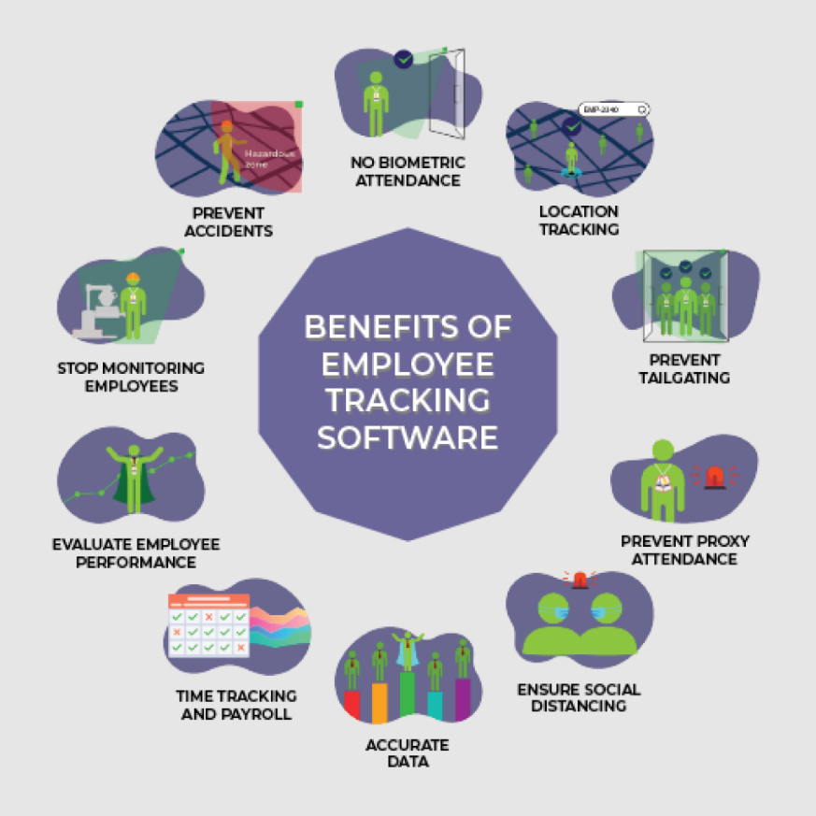
Figure 2. Functionality of employee tracking software
Source: (Author)

3.2 Deadline and Work Completion Portals
Due to the over-flexible environment and leniency provided to the remote working employees, it is essential to clarify the deadlines and time frame determined for a certain task that needs to be completed by them (Pamidimukkala, 2021). Therefore, the platforms determined to update the information about the deadline of given assignments along with the time frame decided to complete them are essential to established by the organisations for achieving appropriate productivity. Along with that, the computer software and applications determined to update the deadline and time frame of given tasks also contribute to setting feasible and clarified goals for the employees to track their progress of work. With the help of the software and tracking the progress of work assigned to employees, it is also pragmatic to track their real-time activities and monitor the working schedule.

3.3 Communication and Team Assessment Platforms
Digital platforms that are solely dedicated to accomplishing the purposes of effective communication are essential to be established for allowing employees to work from remote areas and flexible hours (Garro-Abarca, 2021). Therefore, after the surge of a global pandemic, several platforms have been developed that serve the purpose of leading workers to interact with each other and higher authorities on online channels. Along with the interfaces dedicated to chatting and communicating via texting, platforms for video sessions and face timing are also widely available for business institutions. Following that, it is advantageous to implement communicative portals and software for business organisations that are looking forward to providing their employees with a work-from-home (WFH) allowance.

3.4 Survey organiser platforms
Organising surveys and interviews are essential for obtaining insights into the opinions of remote workers about organisational operations and facilities provided to all the workers (Fulop, et al, 2023). The responses obtained from employees are also Advantages for improving the quality of practices along with facilities provided to the employees which is essential for their long-term retention. There are several platforms available on the Internet that allow employees to provide their reviews and feedback on institutional education anonymously and without being identified. Therefore, these channels offer a stage for the employees on which they can raise their voices in the context of facilities provided to them in WFH. These feedback and reviews allow the employer and employees to communicate with each other along with improving each other’s understanding and presenting their viewpoints. By utilising the survey organiser platforms, employers can also track the productivity of employees and their inclination towards enhancing their quality of performance in routine operations.

4. Techniques for appraising the productivity of remote workers

4.1 Polling booth applications
To analyse the overall performance of employees and the productivity of workers who are working from home the strategy of the polling booth can be beneficial since it allows the higher authorities to evaluate their workers (Ralph, et al, 2020). There are several polling booth applications available online which are within the reach of all the professional institutions that allow employers to vote for the employees and rank them in order of their performance. This ranking system works as a scale on which all the employees are arranged in order of their inclinations towards growth opportunities and standing out from their other colleagues. The grading system is also beneficial for a personal reflection for all the employees in which they can compare themselves with their coworkers and become more encouraged to improve their quality of performance. Along with that, polling booth applications are also inclusive since they are prone to collect the reviews of all the different higher authorities based on their viewpoints about the performance of a particular employee.

4.2 Analytic dashboards
The analytic dashboards are beneficial for both tracking real-time activities and evaluating the overall performance of employees in a given time frame. Furthermore, these dashboards also provide chatbots and automatic responses that are priorly fed into the operating systems to ensure fast responsiveness and time official proceedings of all the remote operations on a routine basis (Limperopoulos, 2022). It is one of the most prominent challenges of remote working facilities that employees do not stay engaged with the activities of organisational premises on a routine basis. Therefore, the analytic dashboards contribute to keeping them engaged more frequently by organising online events and sessions for them to keep in touch with the superior designation employees along with coworkers. However, it needs to be ensured that these dashboards are user-friendly and convenient to utilise since not all the employees of organisations are technologically savvy.

4.3 One-on-one meetings
The platforms that are available to all of the employees on a collective basis are beneficial and time-efficient to proceed with the routine operations of corporate institutions. However, it is also essential to ensure that the employees are being monitored on an individual level. Therefore, to mitigate the challenge of lack of individual focus and remote working facilities, the method of one-on-one meetings is advantageous and efficient (Diab-Bahman, 2022). These personalised meetings are dedicated to interacting with employees and providing them with necessary commands for future objectives and prospective operations. One of the most remarkable benefits of organising these interactive sessions is that it allows the higher designation authorities to provide the employees with personalised and customised recommendations rather than collectively.
Furthermore, human resource management (HRM) can also organise the workforce of employees by segregating it into sessions by personally conveying them about the assigned tasks (Galanti, 2021). It is also more convenient for employees to submit their feedback and reviews on personalised meetings rather than on collective platforms.

4.4 Integrated Digital Noticeboards
The digital notice boards that are integrated with the operating system of all the organisational departments are efficient in sustaining the connectivity and alignment of the workforce along with recognising the employees (Borse, et al, 2021). Lack of belongingness and responsibility is one of the major challenges of remote working facilities provided by companies that are faced by higher authorities frequently. Therefore, to enhance the accountability of employees and increase their sense of belongingness, it is essential to integrate all the workforce and task alignments along with providing them recognition for their performance.

5. Conclusion
It can be concluded from the information gathered from different sources in the above segments that Remote working facilities can be challenging for employers in different organisations. These challenges are more frequent in some corporations such as the institution that require routine updates about the assignment completion of their employees. Furthermore, it is also observed that there are several scientific developments and digital platforms that have been developed after the global surge of Covid 19 to provide convenient facilities to employers and employees. These facilities are beneficial for conveniently and interruptedly proceeding with the work-from-home tasks. A user-friendly interface and fast responsiveness are the qualities that have to be integrated into these platforms to improve the quality of experience and productivity of employees along with the convenience of employers.

References
AlHamad, A., Alshurideh, M., Alomari, K., Kurdi, B., Alzoubi, H., Hamouche, S. and Al-Hawary, S., 2022. The effect of electronic human resources management on organizational health of telecommuni-cations companies in Jordan. International Journal of Data and Network Science, 6(2), pp.429-438.
Borse, V., Mishra, W. and Loudon, G., 2021, November. Sorry you're on mute: Towards determining the factors that impact the productivity and job motivation of remote workers and a conceptual framework. In Proceedings of the 12th Indian Conference on Human-Computer Interaction (pp. 47-58).
Diab-Bahman, R. and Al-Enzi, A., 2020. The impact of COVID-19 pandemic on conventional work settings. International Journal of Sociology and Social Policy, 40(9/10), pp.909-927.
Fulop, N.J., Walton, H., Crellin, N., Georghiou, T., Herlitz, L., Litchfield, I., Massou, E., Sherlaw-Johnson, C., Sidhu, M., Tomini, S.M. and Vindrola-Padros, C., 2023. A rapid mixed-methods evaluation of remote home monitoring models during the COVID-19 pandemic in England. Health and Social Care Delivery Research, 11(13), pp.1-151.
Galanti, T., Guidetti, G., Mazzei, E., Zappalà, S. and Toscano, F., 2021. Work from home during the COVID-19 outbreak: The impact on employees’ remote work productivity, engagement, and stress. Journal of occupational and environmental medicine, 63(7), p.e426.
Galanti, T., Guidetti, G., Mazzei, E., Zappalà, S. and Toscano, F., 2021. Work from home during the COVID-19 outbreak: The impact on employees’ remote work productivity, engagement, and stress. Journal of occupational and environmental medicine, 63(7), p.e426.
Garro-Abarca, V., Palos-Sanchez, P. and Aguayo-Camacho, M., 2021. Virtual teams in times of pandemic: Factors that influence performance. Frontiers in Psychology, 12, p.624637.
Haseeb, M., Hussain, H.I., Kot, S., Androniceanu, A. and Jermsittiparsert, K., 2019. Role of social and technological challenges in achieving a sustainable competitive advantage and sustainable business performance. Sustainability, 11(14), p.3811.
Kurdi, B. and Alshurideh, M., 2020. Employee retention and organizational performance: Evidence from banking industry. Management Science Letters, 10(16), pp.3981-3990.
Lymperopoulos, L., 2022. Investigation on how people analytics have the potential to improve managerial and business decision making processes during the COVID pandemic era and beyond, wherein teleworking is a common practice.
Musa, S.F.P.D., 2023. Preparing the youth for the future of work through apprenticeship programme in Brunei. Higher Education, Skills and Work-Based Learning, 13(1), pp.113-130.
Nundy, S., Ghosh, A., Mesloub, A., Albaqawy, G.A. and Alnaim, M.M., 2021. Impact of COVID-19 pandemic on socio-economic, energy-environment and transport sector globally and sustainable development goal (SDG). Journal of Cleaner Production, 312, p.127705.
Ordóñez de Pablos, P. and Labra Gayo, J.E., 2019. Rethinking key issues for understanding the new challenges of disruption and digital transformation in companies and economies. Behaviour & information technology, 38(9), pp.873-875.
Pamidimukkala, A. and Kermanshachi, S., 2021. Impact of Covid-19 on field and office workforce in construction industry. Project Leadership and Society, 2, p.100018.
Ralph, P., Baltes, S., Adisaputri, G., Torkar, R., Kovalenko, V., Kalinowski, M., Novielli, N., Yoo, S., Devroey, X., Tan, X. and Zhou, M., 2020. Pandemic programming: How COVID-19 affects software developers and how their organizations can help. Empirical software engineering, 25, pp.4927-4961.
Rashid, K.M. and Louis, J., 2019. Times-series data augmentation and deep learning for construction equipment activity recognition. Advanced Engineering Informatics, 42, p.100944.
Wan, S., Qi, L., Xu, X., Tong, C. and Gu, Z., 2020. Deep learning models for real-time human activity recognition with smartphones. Mobile Networks and Applications, 25, pp.743-755.
Wang, B., Liu, Y., Qian, J. and Parker, S.K., 2021. Achieving effective remote working during the COVID‐19 pandemic: A work design perspective. Applied psychology, 70(1), pp.16-59.

