APPLICATION OF BIODEGRADABLE PLASTICS AND REDUCED
CONSUMPTION OF MICROPLASTIC PRODUCTS CONTRIBUTING TO
THE GREAT PACIFIC GARBAGE PATCH

Name: Moshfique Khaled Chowdhury
Student No. 2017480

Module: Contemporary Themes in The Hotel and Hospitality Sector
Module Code: BMIH6001

Lecturer’s Name: Lola Villard

Abstract
The use of bioplastics and biodegradable products are important to improve the sustainability of the hotel chains in the UK. In general, there are almost 350 million tons of plastics produced worldwide every year (Statista, 2023). Besides that, these vast amounts of plastic could lead to problems of handling and environmental pollution around the hotel premises. In a global context, these smaller contributions could lead to a situation of “Great Pacific Garbage Patch”. The use of biodegradable plastics, especially those that could be recycled within days of use by the customers within the recycling facility of the hotel itself could be useful. Biodegradable plastics are those which generally degrade into the environment, particularly soil in comparison to the traditional plastic products. Also, alternative to the plastic products, wrappers made up of paper, cloth, and others that could also be used in service of the customers. In case of the restaurants, plastic products are mainly used for taking customer orders, which were printed or taken on paper, of biodegradable plastic wrappers. Also, during check-in and check-out of the customers into and out of the hotels, papers were also used by some hotels to take in pieces of information. The SWOT analysis is being done to analyse the strengths, weaknesses, opportunities and threats faced by the organisations regarding the implementation of a specific policy. In this case, the policy implementation regarding less use of microplastic products and use of biodegradable plastics by the hotel industries in the UK and their role in the creation of the global problem of the “Great Pacific Garbage Patch” was done. In conclusion, it could be said that the reduced use of plastics would improve the business of those hotels in the hospitality sector of the UK.
KEYWORDS: Biodegradable plastic, Great Pacific Garbage Patch, restaurants, Manchester, SWOT analysis, check-in.

TABLE OF CONTENTS
1.0 Introduction 4
2.0 Overview of Literature 4
2.1 Degradation of biodegradable plastics 4
2.2 Role of microplastics in Great Pacific garbage patch 5
2.3 Impact of single use plastics on environment 5
3.0 Application of the use of biodegradable plastics in hotels 7
4.0 Evaluation of the future policies and management options 11
5.0 Recommendations 12
6.0 Conclusion 13
Reference List 14
Appendices 16

1.0 Introduction
The use of bioplastics and biodegradable products are important to improve the sustainability of the hotel chains in the UK. In general, there are almost 350 million tons of plastics produced worldwide every year (Statista, 2023). For example, this huge generation of plastic waste leads to climate change issues. In the hotel industry, the main use of the plastic happens to service the customers. Specially, during serving them food items. Or, during providing the customers with certain amenities in the room. Like napkins, wrapping items for bedsheets, towels, and body soaps or shampoos among others. In the restaurants within the hotels, food items were generally wrapped in plastic wrappers before serving to the customers. All these had the potential to generate a vast amount of plastic waste, that needs to be taken care of by the management of those hotel chains. Besides that, these vast amounts of plastic could lead to problems of handling and environmental pollution around the hotel premises. In a global context, these smaller contributions could lead to a situation of “Great Pacific Garbage Patch”. The use of biodegradable plastics, especially those that could be recycled within days of use by the customers within the recycling facility of the hotel itself could be useful (Scirp, 2021). Also, micro plastic products that are easily biodegradable could be useful in reducing the operating costs of the hotel industry.

2.0 Overview of Literature
The pieces of literature that were evaluated are given below.

2.1 Degradation of biodegradable plastics
According to the author, Idris et al. 2023, the degradation of biodegradable plastics is relatively easy to other products of single-use-plastics (SUPs). From packaging and food containers to disposable razors and hotel toiletries, the SUPs category includes them all. Synthetic plastics, which are created from non-renewable resources like petroleum and natural gas, take decades to break down in nature and cause plastic pollution everywhere, especially in marine areas. This requires holistic solutions to improve the situation (Idris et al. 2023). In the hotel and hospitality industries, the biodegradable plastic products had emerged as a crucial alternative in improving the situation. There are various types of biodegradable polymers using “starch”, “cellulose”, “lignin”, “reinforced plastic fibres” and others were used. These products were deemed as eco-friendly and also improved the sustainability of the products used by the management of those hotels in serving their customers. [Referred to appendix 1]

2.2 Role of microplastics in Great Pacific garbage patch
According to the author, Yu et al. 2023, the abundant use of microplastic products by the global hotel and hospitality industries is a big contributing factor behind the “Great Pacific Garbage Patch”. It had been observed that at least 10% of the plastic that had been used entered the marine ecosystem doing great damage to the ecosystem. Additionally, the entire lifespan of plastics includes the development, manufacture, and post-consumer disposal phases. Also stages like collecting, sorting, and recycling (Yu et al. 2023). Certain plastic debris enters the ocean owing to insufficient management and is also carried by wind and sea currents. After entering the ocean, these plastic products then carried through the ocean currents across the globe. Due to the unique nature of the currents, these plastic products are generally assembled in certain areas of the ocean, which contributes to the phenomenon like the “Great Pacific Garbage Patch”.

2.3 Impact of single use plastics on environment
According to the author, Di Paolo et al. 2022, single-use plastics had a major impact on the environment of surrounding areas of the hotels and also had a significant impact on the emission of greenhouse gas as well. The intersecting zones of each subtropical gyre are where 10–20 million tons of plastic flow into the oceans each year, but as of late, plastic trash has been discovered in several seas and shorelines around the globe (Di Paolo et al. 2022). It had been observed that hotel industries contribute to the generation of these wastes in a significant manner. The goals of the management of the hotel industry were to first, an overview of the life cycle assessment of single-use plastics that is in use in their organisation. Then to try to select alternative products to that of plastics that reduce, eliminate, or replace the carbon dioxide equivalent emissions by alternatives. Reduced pollution from plastic trash is a clear benefit of minimization or deletion rules, but these measures frequently also result in lower greenhouse gas emissions over the course of the component's life cycle (Ajaj et al. 2022). A full matrix of the carbon footprint values for various single-use plastic goods and their relative substitution with biodegradable plastic or multiuse material were produced as a consequence of the development of a novel particular approach, which was completed in step two.

PESTLE Analysis
Political
As the use of biodegradable plastic products would also improve the perception of being friendly towards the environment of the local areas. And, this would also improve the situation regarding reduction of the marine plastic pollution as well, with political significance.
Economic
The improvement of sustainability as a result of use of alternative products to plastics among the customers could also lead to the generation of more revenues in the tourism sector of the UK as well.
Social
The reduced use of plastic products could also lead to an improvement of the impression of the business prospects related to environment-friendly policies among the customers.
Technological
With the increasing use of the digital technologies in the day-to-day service and management of the hotel industries, it improved this condition. As a result of less requirements of the use of plastic products. The use of big data analytics, regarding the storage of the customer data instead of the manual process which requires definite quality of plastics is a contributing factor.
Legal
Following the implementation of a plan to reduce the use of single-use plastics, the decrease of CO₂ equivalent emissions may be determined right away. These would also contribute to improving the confidence of the customers who are conscious regarding the environment towards the hotel brands, those who follow these mentioned policies.
Environmental
The implementation of the use of biodegradable plastics would help to improve the environmental sustainability regarding air, water, and soil pollution in the surrounding areas.
Political | Economic | Social | Technological | Legal | Environmental
Use of biodegradable plastic products would also improve the perception of being friendly towards the environment of the local areas. | The improvement of sustainability could lead to the generation of more revenues in the tourism sector of the UK. | The reduced use of plastic products could also lead to an improvement of the impression of the business prospects related to environment-friendly policies among the customers. | The use of big data analytics, regarding the storage of the customer data instead of the manual process which requires definite quality of plastics is a contributing factor. | These would also contribute to improving the confidence of the customers who are conscious regarding the environment towards the hotel brands, those who follow these mentioned policies. | Use of biodegradable plastics would help to improve the environmental sustainability regarding air, water, and soil pollution in the surrounding areas.

Table 1: PESTLE analysis
(Source: Self-generated in MS Word)

3.0 Application of the use of biodegradable plastics in hotels
The application of plastic products in hotels mainly happens in the service of the customers. Those products are mainly used in room service to the customers, as well as in restaurant services. Biodegradable plastics are those which generally degrade into the environment, particularly soil in comparison to the traditional plastic products. Also, alternative to the plastic products, wrappers made up of paper, cloth, and others that could also be used in service of the customers. In case of the restaurants, plastic products are mainly used for taking customer orders, which were printed or taken on paper, of biodegradable plastic wrappers (Obebe et al. 2020). Also, during check-in and check-out of the customers into and out of the hotels, papers were also used by some hotels to take in pieces of information. Here, in the context of Manchester, these plastic products contributed to water pollution of the river Mersey. Also, this contributes to the global emergency of the “Great Pacific garbage patch”.
In Manchester, the UK, most of the hotels operating in the hospitality industry have adopted to the policy of using reduced amounts of plastics to keep information of the customers. These pieces of information could be fed into the central computer systems, which could be easily stored and useful in creating digital footprints. This digital footprint is for the longer term, which could be useful in keeping a record of the customer data as well (Lechthaler et al. 2020). This could be used by the management authority of those hotels, to encourage them to use the services again. This could help in improving the amount of business as well. Besides that, the use of digital technologies in storing data would be beneficial to the local environment as well, as it could help in the reduction of the use of plastics or paper.
The less use of plastic products could also be helpful in the lifestyle and sustainability of the customers as well. "Healthy and Sustainable Lifestyles" of Consumers are those who prioritize holistic health, personal development, environmentally friendly living, global social justice, and taking care of their families and a more sustainable society. The sustainability score of the particular industry could also be improved as a result of adopting to useful and newer technologies (Barrowclough et al. 2020). For example, the implementation of policies regarding the serving of water in metal glasses or bottles to the customers in hotels instead of plastic products would improve the sustainability level among the customers to improve in a drastic way. This would also contribute to the global justice towards reducing carbon emissions.
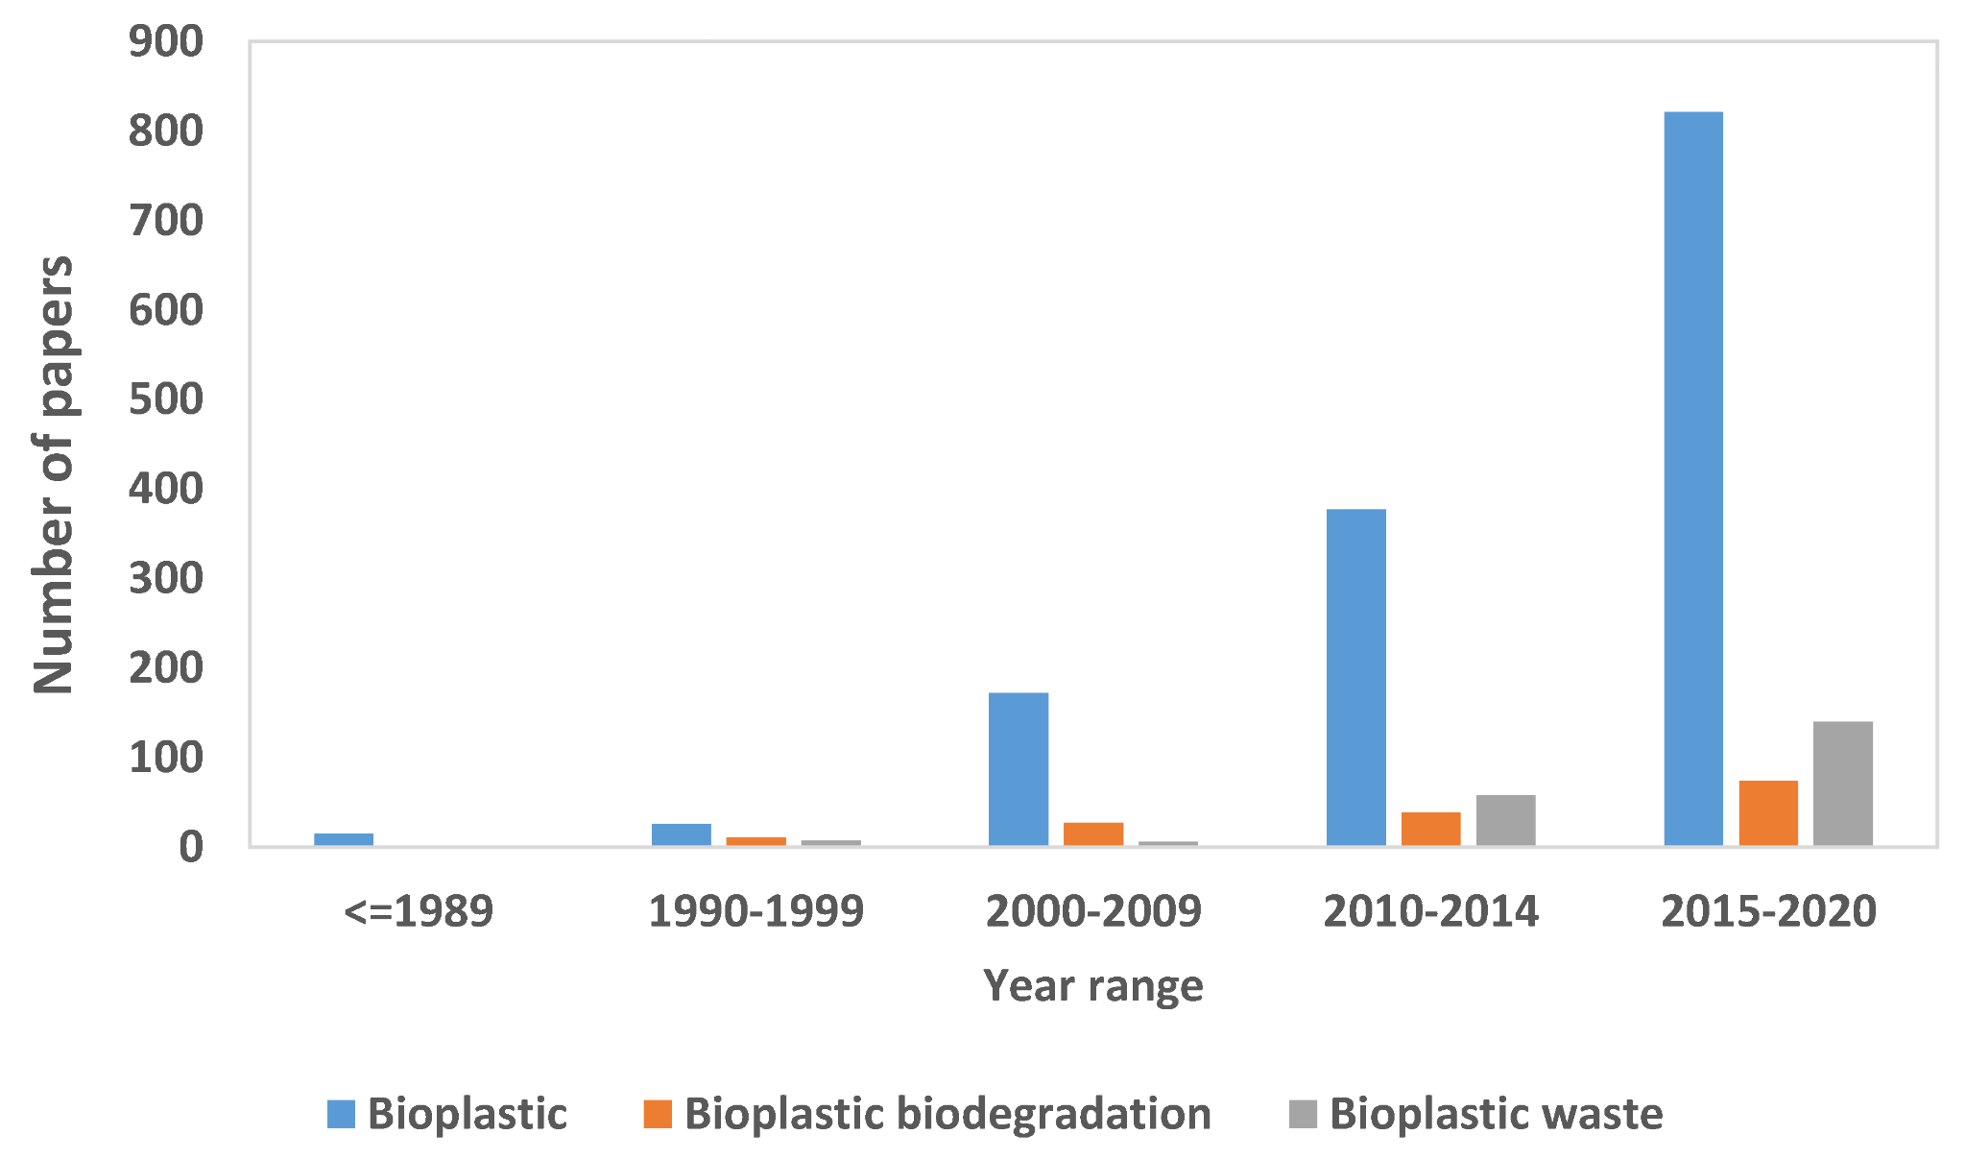
Figure 1: Bioplastic wastes generated by the hotel and hospitality industry of UK
(Source: www.mdpi.com)
Also, during the service of food to the customers in the restaurants, the hotels could serve them in ceramic utensils instead of one-time used plastic plates, serving bowls, or glasses among others. Also, the serving could be done using robots, instead of human beings, mainly waiters. This would also reduce the generation of plastic and other wastes, which ultimately improves the sustainability of those hotels (Vargas et al. 2020). The use of these utensils would also improve the sustainability among the hotel chains in the UK.
Regarding the improvement of sustainabilities from the hotel chains, as a result of reduced use of microplastic products could lead to also contribute to reduced emissions of carbon, which would improve the climate change situation as well. Also, as most of these hotel chains have their business in large urban centres of the country, like Manchester (Merritt, 2023). The reduced use of plastics could also contribute to reducing the overall generation of solid waste to the municipal authorities. As in the UK, the yearly generation of solid plastic wastes reached almost 400,000 tonnes in 2022, the implementation of the policy that leads to reduced use of plastic products in serving the customers would contribute to improving this situation (Umaru et al. 2021). This could indirectly also improve the financial sustainability of the hotel industry as well.
Besides that, as a result of reduced use of plastic products among the hotels could also help in reducing the greenhouse gas emissions. Also, they contributed to the improvement of the energy efficiency of the hotels. That means the hotel staff and management could serve their customers in an efficient way but with very less amount of energy. The use of alternative products in place of plastic products also has a social and cultural management of the customers as well (El-Jourbagy et al. 2021). This would also improve the freshwater resources available to the hotel regarding serving their customers. As an efficient management of plastic products with reduced use could also help in the conservation of freshwater resources. [Referred to appendix 2]
So, in an overall context, it could be said that the use of alternative products in relation to the plastic products could improve the customer experience, and also contribute to the mitigation of climate change. As, the use of alternatives to the plastic products, wrappers made up of paper, cloth, and others that could also be used in service of the customers could lead to the increased environmental sustainability of the local area (Romero Mosquera, 2019). For example, in the greater London area, UK, implementation of the policies focusing on the use of biodegradable plastic products had reduced the air and water pollution by 37%. This is a good example of reducing the carbon emissions from the hotel industry as well. And, this had also improved the customer perception towards those hotels.
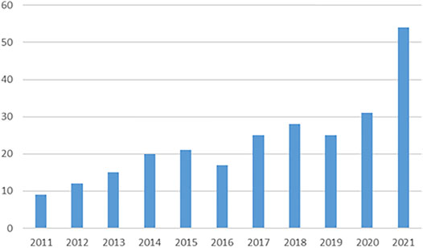
Figure 2: Decentralized food waste composition
(Source: www.frontiers.org)

4.0 Evaluation of the future policies and management options
The evaluation and analysis of the improvement of sustainability regarding the management of the customers, and also financial and moral responsibility towards the society. The evaluation could be easily done by the SWOT analysis. The analysis is given below.
SWOT Analysis
The SWOT analysis is being done to analyse the strengths, weaknesses, opportunities and threats faced by the organisations regarding the implementation of a specific policy. In this case, the policy implementation regarding less use of microplastic products and use of biodegradable plastics by the hotel industries in the UK and their role in the creation of the global problem of the “Great Pacific Garbage Patch” was done. The main points that were discussed as per the SWOT framework were “strengths”, “weaknesses”, “opportunities”, and “threats”.
- Strength: The main strengthening reasons behind the implementation of the regulations regarding the use of biodegradable or alternative products to microplastics among the hotel chains in Manchester, the UK were manyfold. As, the successful implementation of the policies regarding the use of alternative products in service of their customers improves their financial stabilities. As these products were becoming relatively cheaper in comparison to plastic products and also environment-friendly. Also, the use of these products improves the impression of the brands among the customers regarding being caring towards the environment.
- Weaknesses: Crucial weaknesses that is being identified include the lesser availability of these alternative biodegradable plastic and other alternative products in front of the hotel chains in the UK. As the demand of these products surpasses the supply, it leads to a drastic increase of prices which needs urgent attention. As, this would help the hotel chains to design their plastic-related policies.
- Opportunities: Although there are challenges regarding the gap between the demand and supply of these biodegradable alternative products, there are ample opportunities available. The opportunities include the generation of new employment opportunities in front of the youths in the UK (Keshamma, 2022). Also, the implementation of policies regarding the use of alternative products in place of plastics improves the perception among the customers who are aware of the dangers of plastics.
- Threats: The major threats or issues faced by the management of the hotel chains include the unavailability of these alternative products as a result of demand-supply gaps. This could lead to a drastic increase of the price of these products, and could negatively impact the policies of the organisation in implementing plastic-free practices. As a result, the goal of the organisation regarding the use of alternatives gets damaged. And, also hampers the local marine environment.
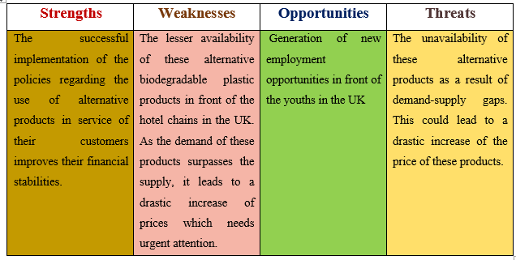
Figure 3: SWOT analysis
(Source: Self-generated in MS Word)

5.0 Recommendations
The recommendations regarding the policies of the hotel chains in the UK about the use of plastics were given below.
- The hotel chains should try to improve the use of plastic alternatives so that it could reduce the negative impact on the environment.
- The management of the hotels should change the items daily used to serve their customers from SUPs to items like straws, toiletries, and cutlery made up of paper or wood items (McCaffery et al. 2023).
- The hotel chains of the UK should collaborate with local, as well as third-country suppliers of these products early so that they could get these products in an ample manner.
- Regular monitoring of the staff used in serving their customers should be carried out by the management.

6.0 Conclusion
In conclusion, it could be said that the plastic waste generated by the hotel and hospitality industry is a major contributing factor behind the creation of global emergencies like the “Great Pacific Garbage Patch”. The hotel industry of Manchester had already adopted some relevant policies in changing the use of plastic products in serving their customers. This would also improve their impression of the customers, who were increasingly environment-friendly to meet their goals. This had also contributed to the improvement of the tourism industry in the region. They also provide the customers with certain amenities in the room alternative to the plastics. Like napkins, wrapping items for bedsheets, towels, and body soaps or shampoos among others. Thus, in an overall context, it could be said that the reduced use of plastics would improve the business of those hotels in the hospitality sector of the UK.

Reference List
Ajaj, R. et al (2022) A revision for the different reuses of polyethylene terephthalate (PET) water bottles. Sustainability, 14(8), p.4583.
Barrowclough, D. and Deere Birkbeck, C. (2020) Transforming the global plastics economy: the political economy and governance of plastics production and pollution (No. 142). GEG Working Paper.
Di Paolo, L. et al (2022) Carbon Footprint of Single-Use Plastic Items and Their Substitution. Sustainability, 14(24), p.16563.
El-Jourbagy, J. et al (2021) Creating an Industrial Regulatory Framework to Reduce Plastics. Berkeley Bus. LJ, 18, p.94.
Idris, S.N. et al (2023) The degradation of single-use plastics and commercially viable bioplastics in the environment: A review. Environmental research, 231, p.115988.
Keshamma, A. (2022) Plastic Mitigation, The Worldwide Effort. Available at: https://booksagapublications.org/books [Accessed on: 20/10/2023]
Lechthaler, S. et al (2020) The way of macroplastic through the environment. Environments, 7(10), p.73.
McCaffery et al. (2023) Zero Plastic in Hotels: Leading question: Is plastic-free the new norm in hotels? Available at: https://www.taylorfrancis.com/chapters/edit/10.4324/9781003218425-16/zero-plastic-hotels-rachel-mccaffery-jo-hendrickx-nicolas-dubrocard [Accessed on: 20/10/2023]
Merritt, J. (2023) Plastic Pollution: Evaluating the Effectiveness of a Circular Economy Solution (Doctoral dissertation).
Obebe, S.B. and Adamu, A.A. (2020) Plastic pollution: causes, effects and preventions. Int J Eng Appl Sci Technol, 4(12), pp.85-95.
Romero Mosquera, M. (2019) Banning plastic straws: the beginning of the war against plastics. Environmental and Earth Law Journal (EELJ), 9(1), p.1.
Scirp, (2021) Quantitative Analysis of the Sized Ranged Plastic Debris on Beach Shoreline along the Limbe Coastline, Cameroon. Available at: https://www.scirp.org/journal/paperinformation.aspx?paperid=126045 [Accessed on: 20/10/2023]
Statista, (2023) Plastic Waste Worldwide – Statistics & facts. Available at: https://www.statista.com/topics/5401/global-plastic-waste/#topicOverview [Accessed on: 18/10/2023]
Umaru, I.J. et al (2021) Toxicity and environmental plastic disposal, its death and survival rate.
Vargas, A., Beange, M. and Vargas, E. (2020) Reducing the Impact of Plastic Pollution in a Rural Coastal Area: Focus on the Hospitality Industry & Tourism of the Central Nicoya Peninsula, Costa Rica. Sustain. Communities Rev, 13, pp.1-25.
Yu, R.S. and Singh, S. (2023) Microplastic Pollution: Threats and Impacts on Global Marine Ecosystems. Sustainability, 15(17), p.13252.

Appendices
Appendix 1: Loop of life cycle of bioplastics
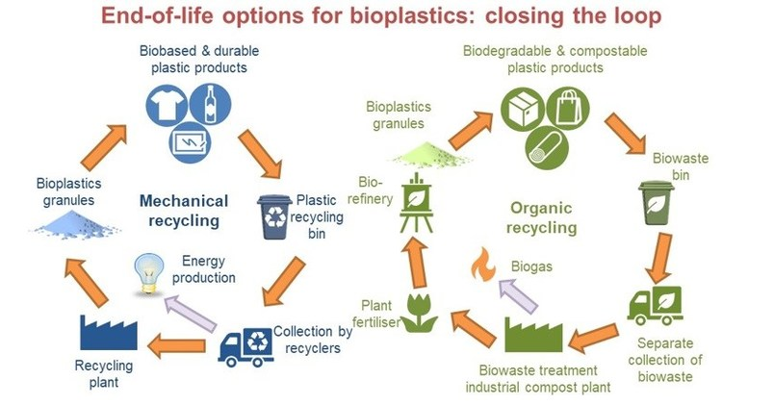

(Source: www.mdpi.com)

Appendix 2: Plastic Waste Management Market Size
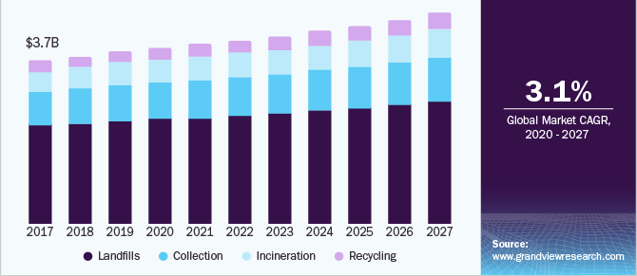
(Source: www. grandviewresearch.org)

