

ASSESSMENT 1

EFFECTIVE TEAM WORKING AND
COMMUNICATION
BMSW4002_LON

LECTURER: DIYA CANGULY
STUDENT: ANA-MARIA NEAGU
STUDENT ID: 2009930

TABLE OF CONTENTS

1. INTRODUCTION………………………………………………………………………………2
2. MODELS OF COMMUNICATION……………………………………………………………2
2.1. SHANNON AND WEAVER MODEL OF COMMUNICATION (1948/49) …………......3
2.2. DAVID BERLO THEORY OF COMMUNICATION (1960) ……………………………3-4
2.3. WILBERT SCHRAMM’S MODEL OF COMMUNICATION (1954) …………………….4
3. COMMUNICATION SKILLS …………………………………………………………….…4-6
4. CASE STUDIES IN COMMUNICATION…………………………………………………….6
5. EXAMPLE OF POOR COMMUNICATION IN THE WORKPLACE ………………………7
6. CONCLSION AND SUGGESTIONS FOR IMPROVEMENTS OF
COMMUNICATION…………………………………………………………………………….…8
7. REFERENCES ………………………………………………………………………..……9-10
8. APPENDIX ……………………………………………………………………………….. 11-13

1. INTRODUCTION

‘’What is communication?’’
‘’Communication is simply the act of transferring information from one place, person or group to other.’’ [Wikipedia]
To communicate means to interact. Interaction between individuals can take place through several ways such as verbal, nonverbal, written, and visual. Communication has the following components: message, receiver, and sender. To communicate is important due to the following aspects: it is a good way to accumulate knowledge, help to form relationships and most important to transmit information, emotions and feeling to others.

2. MODELS OF COMMUNICATION

There are a variety of communication models. In all models, the authors express their opinions in an original way about the entire communication process. In this report I will analyze the fallowing three ingenious models of communication.

2.1. SHANNON AND WEAVER MODEL OF COMMUNICATION (1948/49)

This model of communication is defined as the most basic model. It is a simple model but there are aspects which make is to look complicated such as people or the environment. The main pieces of this theory of communication are the sender, message, channel, and receiver. The theory is easy and very specific in demonstrating the fundamental process of communication which is referring to sending and receiving the information that has been send. Unfortunately, there are some negative aspects of the theory as well.
The biggest limitation is that that the model reflects the time and the place when it was created. Back in 1940’s Claude Shannon and Warren Weaver they were working in telephone industry so the model it is focusing more on ‘’technology communication’’ then in face-to-face interaction.
Lastly Shannon – Weaver model failed to include the notion of nonverbal communication and feedback. At the base, the model is an explicit and fundamental one but more appropriate for the time it was created then these days. Used in nowadays can create misunderstandings and unfinished communication processes between people.

2.2. DAVID BERLO THEORY OF COMMUNICATION (1960)

David Kenneth Berlo was a successful writer who wrote the book ‘’The process of communication’’. In this book is related the different aspects of communication. The model of communication he created it was inspired after Shannon’s and Weaver model. This time Berlo includes verbal and nonverbal communication and highlights the emotional side od the message. The theory includes the fallowing components: Sender/source, message, channels, and receiver. Also, each of this component includes different elements which impact or influence the process of communication.
Same as Shannon and Weaver model there is no feedback from receiver in the interaction process. /Another disadvantage the theory have is that the participants need to be at the same level for communication to take place. In the end Berlo omitted to specify any barriers to communication.

2.3. SCHRAMM’S MODEL OF COMMUNICATION (1959)

Schramm’s model explains is a traditional approach the communication process. This method determinate how communication take place between two persons. It includes the fallowing elements: sender, message, receiver, and this time feedback.
Wilbert sustains that communication process is incomplete if there is no feedback from receiver. It is a real cycle of communication and is it the only one that highlights the nowadays interaction process. This model shows how important it is the feedback in communication. Receiving a feedback from decoder the sender understands if the message it’s been received and understood. A big disadvantage of this model is that Schramm’s does not talk about the semantic noise that might change the course of communication process of understanding the message. I would like to mention that I personally find this communication theory suitable for all types of communications. I support this technique due the fact that it is a simple model, easy to understand and implement. The model also includes the idea of beliefs, values and background that can change the message interpretation. In another hand it is a unique model of communication because is the only circular one and involves the notion of feedback which I think it is playing a very important role that prevents misunderstandings and mistakes in interpretation of communication message. Lastly, Wilbur Schramm’s created this model of communication as a reply to Shannon and Weaver model which from his point of view was not coherent.

3. COMMUNICATION SKILLS

Communication skills are the ability which an individual uses to transmit and procure different type of information. Being able to communicate it is efficient in everyday tasks, relationships, workplace and in day-to-day life. I believe that being able to communicate it is the most important life skill a person could have. We are created to communicate as huma beings. Through communication we manage to develop both our personality and our relationships with other people. There are always things that you can do to improve this skill and make your way to communicate more effectively.
There are four ways to communicate on daily bases or four types of communication: verbal, nonverbal, written, and visual as I already specify in the introduction. In the fallowing context I will be discussing about the types of communication.
Verbal communication it is about what we are saying. It is focusing on spoken communication and on using the speak to transmit information. In verbal communication it is very important to consider the tone of voice and the language you are using because it can change the interpretation of message. Engaging this factor in a conversation you are showing respect, understanding and the exchange of remarks will be more effective. Also, verbal communication is the most used form of communication. This fact is because it is saving time and it is easier to have. The feedback is also faster, and the emotion are easy to read through face-to-face interaction.
Nonverbal and visual communication is referring to facial expression, gestures, body language and it is known as a body interaction. It is a way to communicate without using any works. Most common tactics of nonverbal communication are body language, eye contact and facial expression. This type of communication by using the body interaction it gives important information about how a person might feel or receive the information. By decoding someone’s body gestures it helps us to have a better approach and can lead people to developed better relationships.
Written communication contains all the information transferred through written messages, letters, manuals, reports, telegrams etc. It is a limited type of communication and it is time-consuming, meaning it take more time to be created, send and to receive a feedback. Is an appropriate way to communicate at long distances, it helps keeping records of evidence and it is an easy way of sending bad or unpleasant news.
All this type of communication I have specified above are very important in our day-to-day life. Along with them I would like to mention also mention the fallowing skills: stress management, listening, emotion control and effective communication. All these abilities and many others empowers healthcare workers with effectiveness and efficiency at workplace. In this way all patients of the organisation will feel valued, cared, and treated with dignity and respect. These skills also improve the care services and work environment of care workers. Mastering good communication skills is essential because is allowing others to understand the information more accurately. As a healthcare provider having the ability to explain, listen and empathize brings to care receiver’s satisfaction. All care workers should have the ability to handle the skills so this way they deliver the best care, and the quality of services will increase within the organisation.

4. CASE STUDIES IN COMMUNICATION

In this paragraph I will analyze two of the case studies of poor communication that I learned during this semester. I will be focusing on the errors of communication from case studies and give solution on how they could have been avoided.
First case study it refers to ‘’Maria and Pedro’’ (case content is included is appendix). This case it fits into Shannon-Weaver model which is the most appropriate to highlight the situation. In here the error was the misunderstanding of information transmitted. Due the fac that Pedro was at workplace there was a noise intervention which affected the understanding of message Maria was sending. Regearing the model of communication to which the case belongs in the conversation was missing the feedback as well. A solution to avoid the situation of misunderstanding could have been for Maria to make sure the message was understood by requesting a feedback from Pedro. Also, he could have confirmed the message send by Maria by repeat it back. This way the communication process it would have been effective and there would have been no error.
The second case study I chose to discuss about is ‘’The professor and the village people’’ (the content is included in the appendix). This case is highlighted by Berol’s model of communication. I support this fact because the message he was trying to send was not clear enough to be decipherable. The professor used sophisticated language that included words that not everyone has on their vocabulary and that are less common. A solution is avoiding the communication issue would have been for the professor to use a clear language composed of simple and concise words in the transmission of the message. Also, if he had asked for feedback to ensure that the receivers have understood the message, he would have had a chance to transmit it again, this time is a clear and efficient way.

5. EXAMPLES OF POOR COMMUNICATION IN THE WORKPLACE

In this topic I will be giving two examples of poor communication, issues resulted and possible solution in order to be avoided, that I had to face at my previous workplace.
- ‘’It was a busy Saturday at the restaurant I worked. When we were dealing with such situation, we helped each other the whole team of waiters. So, I took an order of drinks of another colleague and hurried to delver to the table the bartender specified. After a while, the colleague who had taken the order goes to the table with another line of same drinks. The customers of the table refuse it as they received already, and we realize that the bartender made a mistake due to the work pressure. After the incident we had to dispose of the second order. The manager seeing the situation he blames me and my waiter colleague and deducted the extra order from our salary. He did not give us a chance to explain, and he took immediate action.’’
The situation I have described it is focusing on three issues which are the lack of active listening, negative attitude and multitasking due the lack of staff of poor management of the organization. The bartender was struggling with orders and maintenance because he was dealing all alone with all tasks. Due the lack of active listening, the manager attitude was negative and inefficient in solving the issue. The situation could have been avoided if the manager would have implemented active listening skills and patience. The negative emphasis discouraged the employees and decreased the work output. This example is it highlighted by Berol’s Model of Communication. I sustain this due the factors that are impacting the curse of conversation and results.
- ‘’One day the manager of the restaurant asked me to take care of the order for the restaurant supplies. He specified me that mush be ready by nest week. On Monday, the beginning the following week he come to me in order to collect the list, but I was not ready with it as he did not specify to me the exact date, he need it. This fact led to a negative attitude on his part and to a contradictory discussion between us.’’
This example emphasizes the inefficient communication due the lack of information. The manager gave a task with unspecific deadline. The poor communication incident could have been avoided if the manager would have been offered the specific information of deadline and checked the progress of the task. This example fits also within Berol’s Model of communication because of content and code of the message, which was unclear and the attitude of source, in this case manager’s negative attitude.

6. CONCLUSION AND SUGGESTIONS FOR IMPROVEMENTS OD COMMUNICATION

Communication s an important part of our lives. It helps us interact to express our feelings, thoughts and views/ideas. Communication it is the key to success relationships at works but also in our everyday life. Through communication we define ourselves as people and we differ from others. Weather is written or verbal, communication helps the things around us to work. I could say that the world revolves around her. Tn any field communication is necessary. In the modern era of which we are apart, communication tends to fall in second place. Even if people have forgotten in a way to communicate and relationships are not so verbal like before I believe technology is the new way to interact. Technology has become a necessity in nowadays, especially when we refer to pandemic situation we try to face. Every human being has an instinctive need to communicate as it is part our human nature. There are always ways to improve our communication. This is only possible by working on our skills and learning how to master them. As in the models specified above, the ways are obvious. In principle exercising on active listening, language, tone of voice, clarity, showing empathy and requesting feedback we will be more effective when communicating.

7. REFERENCES

- McQuail, D., & Windahl, S. (1993). Communication models: for the study of mass communications (2nd ed.). Longman.
- Molen, Gramsbergen-Hoogland & Gramsbergen-Hoogland, Yvonne H., 2005. Communication in organizations: basic skills and conversation models, Hove: Psychology Press.
- Scammell, B., 1990. Communication skills, Basingstoke: Macmillan.
- Moss, B., 2017. Communication skills in health and social care 4th ed., London: Sage.
- Coll, X., 2012. Communication skills in mental health care: an introduction, London ; New York: Radcliffe Pub.

- Burnard, P., 1992. Communicate! a communication skills guide for health care workers., London: Edward Arnold.

- Kaplonyi, Jessica et al., 2017. Understanding the impact of simulated patients on health care learners’ communication skills: a systematic review. Medical education, 51(12), pp.1209–1219.
- Key & Key, Mary Ritchie, 2019. Nonverbal Communication Today Reprint 2019.,
- Lyle, J., 1991. Body language, London: Hamlyn.
- McAnany, Emile G, 2014. Wilbur Schramm: beginnings of the "communication" field. Communication research trends, 33(4), p.3.
- Mulberry House, 2006. Record keeping (written communication) training, Norfolk: Mullberry House.
- Peel, M., 1995. Improving your communication skills 2nd ed., London: Kogan Page.
- Green, A., 2006. Effective communication skills for public relations, London: Kogan Page.
- Coll, X., 2012. Communication skills in mental health care: an introduction, London; New York: Radcliffe Pub.
- Marlene Y Satter, 2016. Poor communication skills hinder millennials in workplace. Benefits Selling. Breaking News, pp. Benefits Selling. Breaking News, 2016–04-13
- Jia, Moyi, Cheng, Jiuqing & Hale, Claudia L, 2017. Workplace Emotion and Communication. Management communication quarterly, 31(1), pp.69–87.
- Tripathy, Mitashree, 2018. ROLE OF CREATIVE THINKING AS AN IMPERATIVE TOOL IN COMMUNICATION AT WORKPLACE. Journal of organizational culture, communication and conflict, 22(2), pp.1–7.

APPENDIX

APPENDIX A
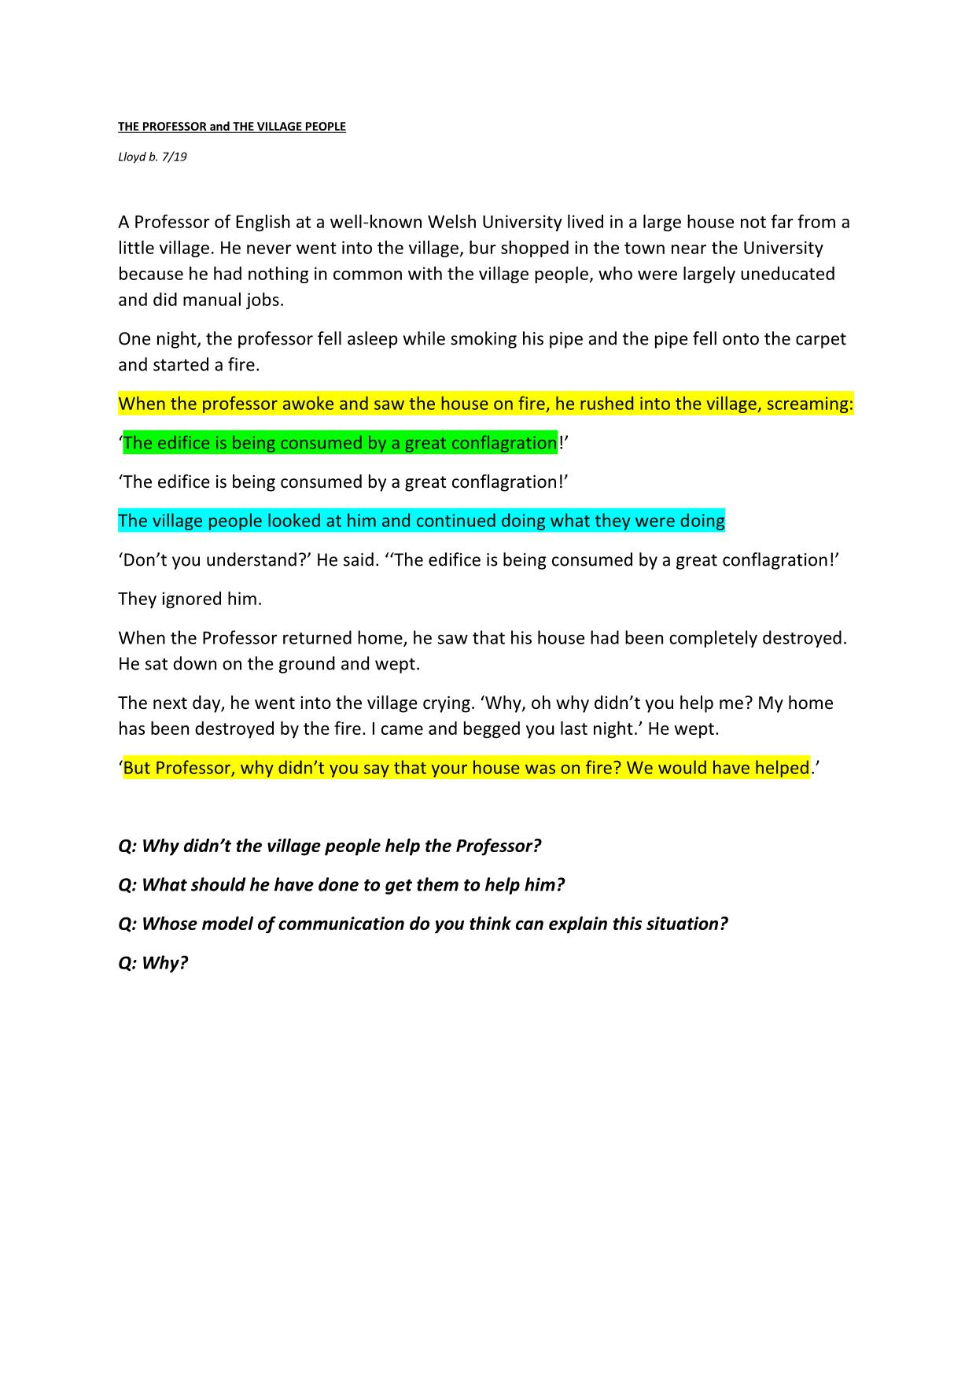
APPENDIX B
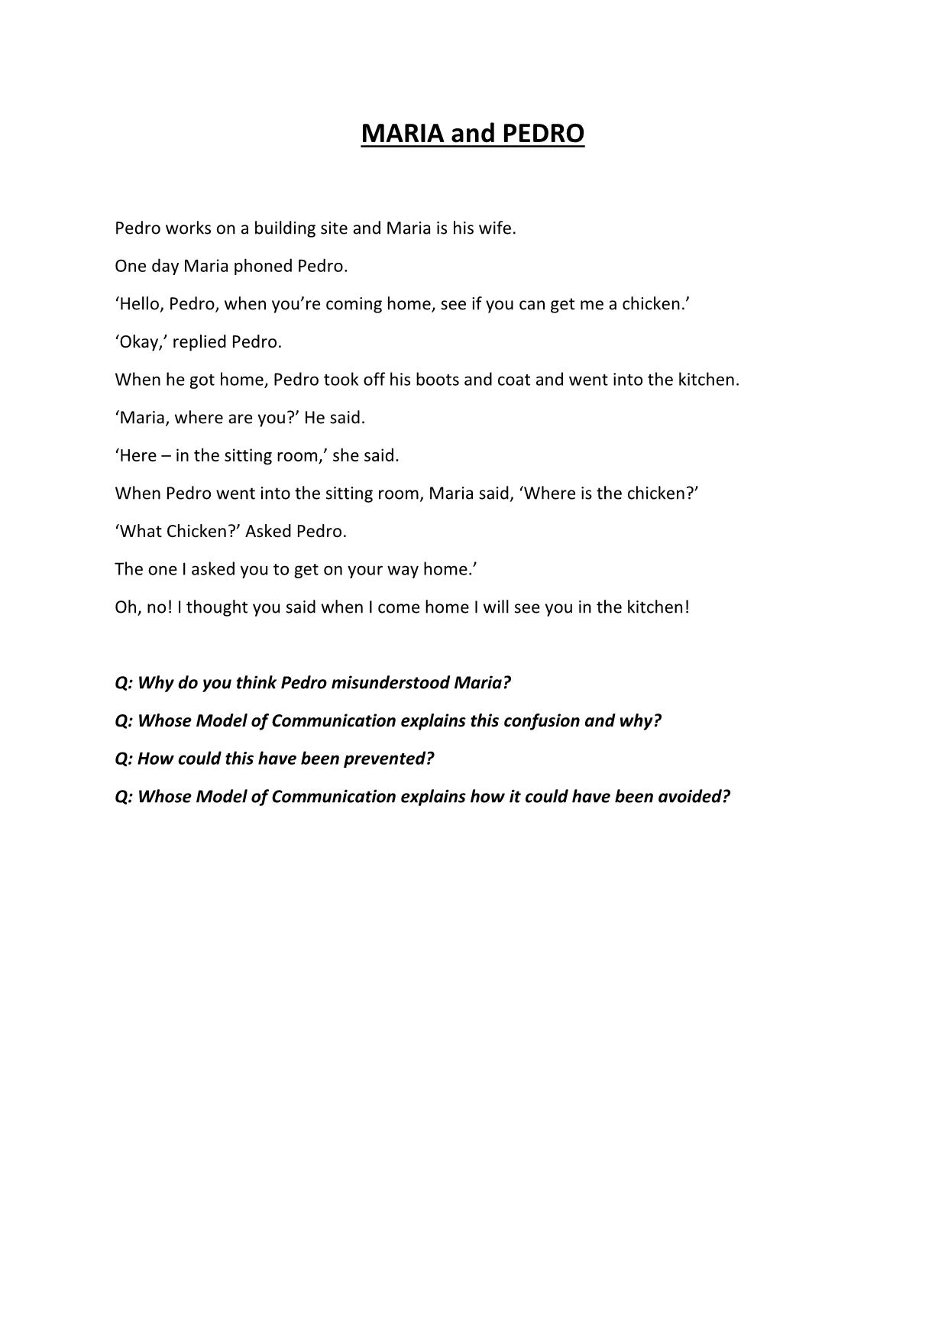
APPENDIX 3
(WEEK 3 LESSON EXERCISE)

Ana(worker): Good Morning Mihaela!
Mihaela(employer): Good Morning Ana! How can I help you? Ana(worker): I am writing to you to ask kindly for some days off. I woke up with a really bad flu and I cannot come to work for few days. Would be that possible? Mihaela(employer): Of course. You can have free until end of the week if you want. I will just need a confirmation from your GP. Thank you for letting me know! Ana(worker): many appreciations! will bring a GP sick letter confirmation. See you next week. Goodbye!
Mihaela(employer): Have good rest and see you soon!
APPENDIX 4
(https://www.communicationtheory.org/osgood-schramm-model-of-communication/)
SCHRAMM’S CIRCLE OF COMMUNICATION

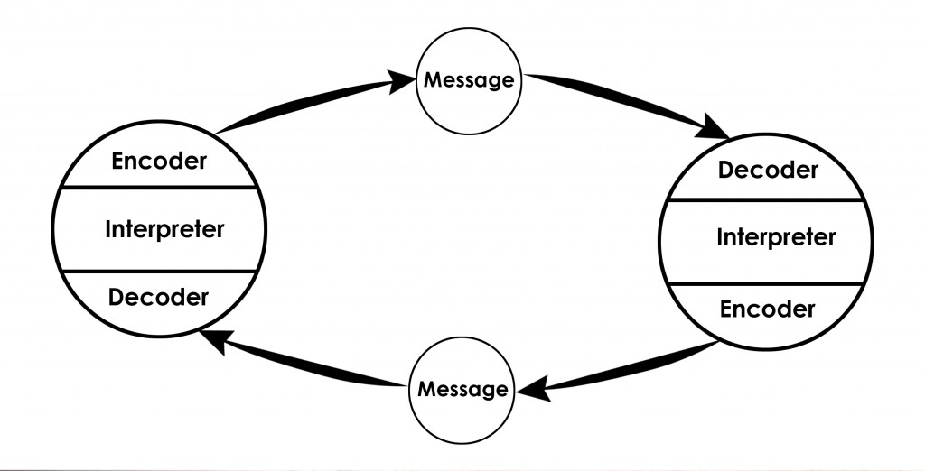

APPENDIX 5
(https://leverageedu.com/blog/wp-content/uploads/2020/04/Berlos-Communication-Model.png)
BERLO’S MODEL OF COMMUNICATION

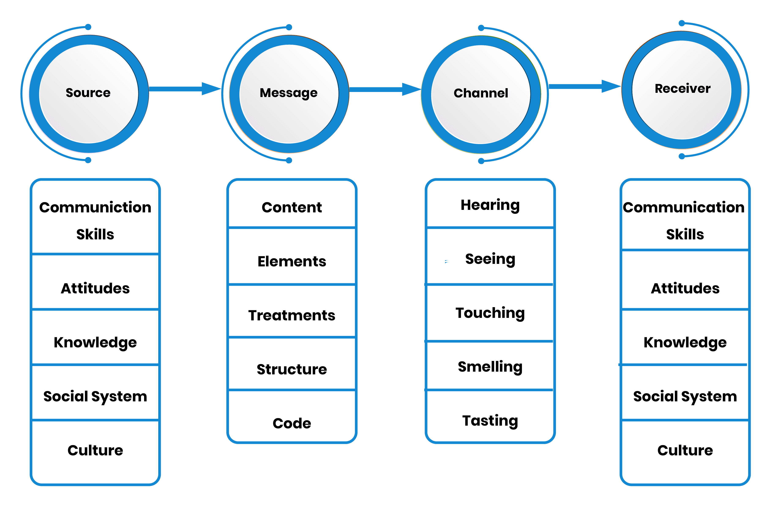

APPENDIX 6
(https://michellemathiasfsp.blogspot.com/2018/11/shannon-and-weavers-model-of.html)



