The Global Business Environment A1
(LCBB4005)
Lecture:Rexon Nitng
Student:Nadya Vasileva
Student ID :1908838
Group -1 BAMB

Table of Contents
Introduction 2
(a) Major forces shaping the business environment of the car manufacturing industry 2
(b) Opportunities and challenges present for car manufacturing and most feasible positions for firms currently in the market 5
Conclusion 8
Reference List 10

Introduction
Business environments are extremely important to be effectively and efficiently gauged. These help in order to comprehend the surrounding threats and opportunities for a firm. In the case of this study the industry of car manufacturing has been looked into and further the business environment has been effectively defined.

(a) Major forces shaping the business environment of the car manufacturing industry
“Porter’s Five Forces Analysis”
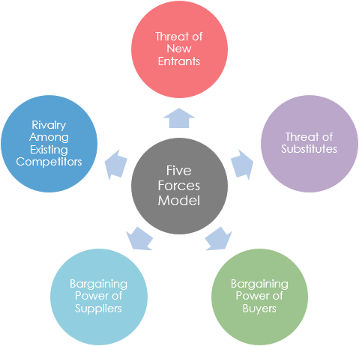
Figure 1: “Porter’s Five Forces”
(Source: Influenced by Porter, 2016)
Power of Buyers (Moderate)
The power of bargaining held by consumers to purchase a car is “moderate”. Porter (2016) observed that buyers are price sensitive and look for cars that offer them value for money. However, buyers did not pose an immense threat for backward integration of an organisation. Increase in competition and changes in consumer preferences hold a strong power in persuading the prices of the products.
Power of Suppliers (Low)
The suppliers of the car manufacturing industry possess “low” influence on the decisions made by a car manufacturing organisation. According to Rothaermel (2016), suppliers of automobile parts receive bulk orders that make them highly dependent on the companies for their business sustainability. In this context, the power held by them to bargain their rates is considerably low. This is because of the availability of suppliers and ease with which brands can switch.
Threat of substitutes (Moderate)
The car industry faces a threat of sanction from increasing awareness among individuals towards reducing their carbon footprint. Improvement in the public transportation facilities in European countries along with cost benefits from using the same has a significant influence on the purchasing motive of consumers.
Threat of new entrants (Low)
Entering the automobile industry is considered difficult due to a large amount of capital investment along with production inputs required. Minniti and Venturini (2017) observed that taxation policies, access to distribution channels along with production cycles have a direct impact on new entrants within the car industry. Existing organisations like Toyota, Hyundai and others thereby face minimal risk in this aspect.
Existing rivalries (High)
The rivalry among top car brands including Honda Motor Company, BMW Group, Tesla as well as Toyota Motors among others is considerably high. Oreský (2018) ascertained that car manufacturing companies focus on highlighting their features and design using effective marketing leading to an intensification of competition. Brands are required to focus on product differentiation for gaining a competitive advantage in the global market.
PESTLE Analysis for car manufacturing across the globe
Political | - The current impact of Covid-19 has led to the reinforcement of national boundaries once again strictly (McKibbin and Fernando, 2020).  - Countries are keen to open up international borders and are seeking to stabilize their economies at first (McKibbin and Fernando, 2020).
Economic | - The job loss in the industry for the UK alone is expected to be 24,000 (theguardian.com, 2020).  - The annual manufacturing production amount is expected to be cut by a one-third amount for car and light commercial vehicle production, on an annual basis (theguardian.com, 2020).
Social | - Vehicle sales dropped due to the lack of mobility during the Covid-19 pandemic and led to a 33.3 % sales loss for Ford alone (msn.com, 2020).  - Total US vehicle sales fell by at least 34% alongside Fiat Chrysler losing 38.6% of their sales volume (msn.com, 2020).
Technological | - The global car market has been seen to shift over to more electronically based systems for ensuring a greater driving experience (Shadrin and Ivanov, 2016).  - Further, the global manufacturing industry has adopted the strategy of industry 4.0 to engage in active batch manufacturing for cars (Zhong et al. 2017).
Legal | - Revised fuel efficiency requirements, require cars to be fuel-efficient and provide an average rate of fuel efficiency at 54.5 miles per gallon by 2025 (Investopedia.com, 2019).  - Globally the car emission rate targets have been reduced by at least 10g CO₂ for every kilometre (Climatechangeauthority.gov.au, 2020).
Environmental | - The United Nation Sustainable Development Goals for the year 2020 govern the current basis of the environmental requirements for the manufacturing of automobiles (Ordonez-Ponce and Khare, 2020).  - The focus on green environment and energy requires automobile manufacturers to drastically change their designs to ensure lowered rates of pollution (Wiedmann and Lenzen, 2018).
Table 1: Pestle Analysis
(Source: As influenced by Luomaranta and Martinsuo, 2019)
Evaluation of the changes in the car industry
The car manufacturing industry has witnessed innovation and growth due to the incorporation of newer technologies over the past few years. Bailey and De Propri (2017) observed that the uncertainty caused due to the Brexit referendum has directly affected the car manufacturing industry globally. Brands have invested in enhancing their research and development programs for gaining an advantage over their competitors’ further increasing competition among the existing brands. For instance, the introduction of electric cars by top brands including Tesla and Volkswagen has witnessed increased initiatives by other organisations to utilize innovative technologies for developing the same (Forbes.com, 2019). The growing power of consumers has further been witnessed over the past few years leading to studies conducted by top brands to ascertain their preferences and enhancing the customer service delivery process. The need for cleaner and safer automobile options has led to an increase in EMVs to regulate carbon emissions (Parliament.uk, 2019). Over the past few years, changes in the external business environment towards the manufacturing of environmentally friendly automobiles, integration of disruptive technologies and the need to meet changing consumer demands have greatly dominated the car manufacturing industry globally. It can be understood that the coronavirus pandemic has also affected the case of the car industry adversely. A major dip in manufacturing and sales is indicative of a deteriorating situation. It is inferred that primarily the industry is weakened due to the limited prospect of mobility during the time of the pandemic.

(b) Opportunities and challenges present for car manufacturing and most feasible positions for firms currently in the market
Product Life cycle
It can be derived that every product has a specific lifecycle which it follows and further beyond that lifecycle there is no space left for the product in the market. In the case of the automobile manufacturing sector, it is inferred that the current models or technologies that have been invented have helped in ensuring a longer maturity period for older automobiles. The study of Yeh and Walter (2017), indicates that there are two kinds of innovations which are present, one is major disruptive innovations which speed up the process of existing product life cycles, and another one is of supportive innovations which ensure that existing products have longer life-cycles.
For the prospect of the automobile industry it can be viewed that for a majority of the years, the main focus has not been a disruptive transition in manufacturing. Instead, there has been a wide range of supportive innovation which have been used in accordance with the development of the regulations of the environment. Some of these innovations are the development of fuel and emission efficient engines which are to be used in case of the market. Vu et al. (2017), states that the integration of electronic technology in cars and IT-supported systems have helped in order to ensure that the driver can gain a safer driving experience overall. Another instance of a supportive innovation was that made by Toyota when it introduced six-sigma, TQM and lean management for the purpose of enhancing its supply chain.
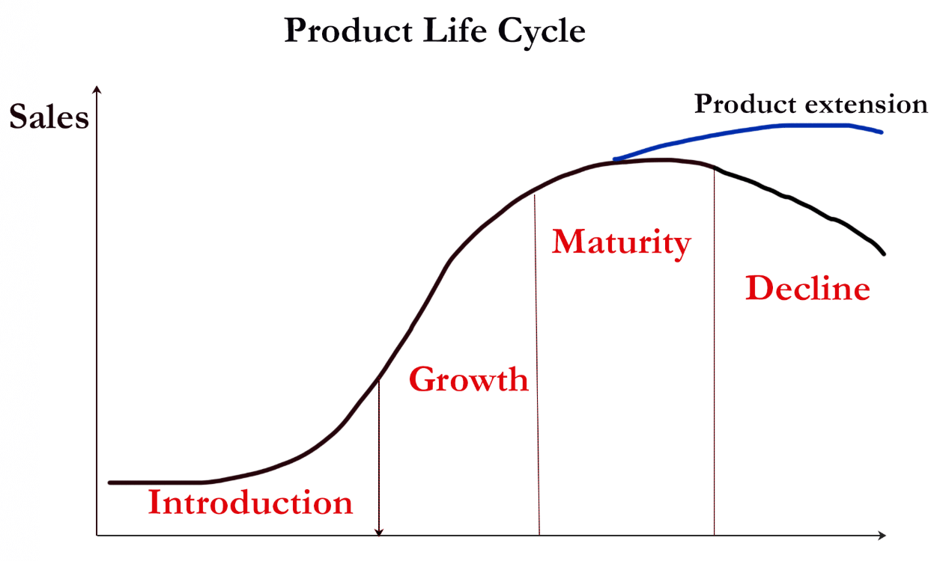
Figure 2: Product-Development Life Cycle
(Source: As influenced by Horvat et al. 2019)
However, it can be seen that in recent times focus has been shifting over to the prospect of the manufacturing of electric vehicles. As per the study of Lemme et al. (2019), it can be viewed that electric vehicles are viable alternatives as they help in reducing the rate of emissions significantly and aid to a green environment. The company of Tesla is one of the key players and the company which brought in the current disruption in the market with respect to the automobile market essentially. This disruption essentially changed the due course of the market, as the current models of cars have lost time to reach from their late maturity stage to the stage of market decline. Thus, firms need to position themselves to move to the production of electric vehicles slowly over time.
Porter’s Value Chain Strategy
The automobile manufacturing value chain is heavily influenced by the prospect of the activities of the supply chain of an organisation. It is imperative to understand that the value chain of an organization in automobile manufacturing depends heavily upon the resources that it acquires and the channels of distribution that are available. In the light of current trends of the industry, it can be deduced that the procurement systems will undergo a major change as old automobile parts will become out-dated due to technological advancements. The study of Pietrobelli et al. (2018), indicates that the development of new technology leads to a need for quick innovation by the existing suppliers of a company or a change of primary suppliers of an organisation.
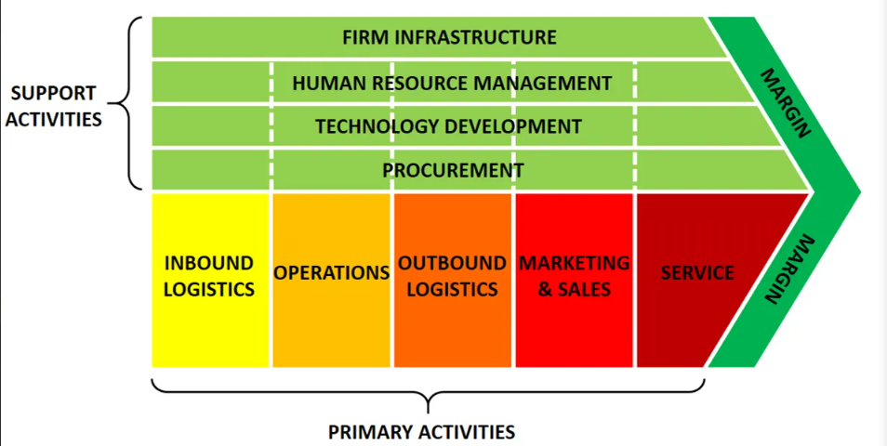
Figure 3: Porter’s Value Chain Model
(Source: As influenced by Ruan, 2020)
In the context of the activities of the value chain, it is analysed that the importance of developing technology and production is extremely necessary and further there are major changes in case of firm infrastructure. As per the views of Yin et al. (2018), a major change in the manufacturing process of automobiles after the system of TQM was that of industry 4.0. Industry 4.0 was essentially developed in Germany to support the batch production of automobiles by reducing the effort input and subsequently reducing the product costs. This helped in ensuring an appropriate scope for sustainable development of the automobile industry.
Thus, with respect to the automobile industry, companies are required to position themselves in areas of technological soundness. Thus, the major focus of the companies needs to be on the prospect of developing technology to support the manufacturing of electric vehicles and engines. Furthermore, the outbound logistic operations need to be well aligned with the case of inbound logistics operations. Finally, it can be viewed that procurement and the selection of appropriate suppliers are important and need to be done in accordance with the new regulations pertaining to the effect on the environment and quality requirements.
SWOT Analysis
Strengths  - Strong abilities of procurement  - High capabilities of innovation  - Saturated market  - Low probability of new market entry | Weaknesses  - Lack of disruptive innovation  - Lack of proper integration of technology  - Lack of sustainable technology development
Opportunities  - Shifting market taste towards electric vehicles  - Increased focus on sustainable procurement  - Availability of industry 4.0 (Zhong et al. 2017). | Threats  - Customer tastes and preferences shifting away from automobiles due to pollution  - Increased environmental regulations  - Falling sales due to Covid-19 (theguardian.com, 2020).
Table 2: SWOT Analysis
(Source: As influenced by Pietrobelli et al. 2018)
Analysis
In respect to the current automobile industry, it can be viewed that a large amount of focus lies in the case of the development of a sustainable system of procurement. It is inferred that the salient opportunities lie in case of the electric car market and a further shift into the production of automobiles using the industry 4.0 systems. It is also derived that the prospects of shifting consumer tastes and preferences onwards sustainability and reduction of pollution indicate a limited lifespan for current oil-based automobiles. Furthermore, the falling sales due to Covid-19 is another major issue that needs to be understood and it can essentially be mitigated as the industry is a large industry with a limited number of payers. Further market saturation also helps in ensuring sustainability through the pandemic period. Companies need to seek to make the most of the available opportunities.

Conclusion
It can be derived from the study that the car manufacturing market has faced serious loss due to the pandemic of Covid-19. However, it can be viewed that the market also is disrupted by the prospect of electric vehicles which are causing a decline for oil-based automobiles. I is recommended that firms shift over to the prospect of electric vehicles and also develop systems for procurement of products and parts in sustainable ways due to greater environmental focus.

Reference List
Bailey, D. and De Propris, L., (2017). Brexit and the UK automotive industry. National Institute Economic Review, 242(1), pp.51-59.
climatechangeauthority.gov.au, (2020). International implementation of vehicle emissions standards. Available at: http://www.climatechangeauthority.gov.au/reviews/light-vehicle-emissions-standards-australia/international-implementation-vehicle-emissions#:~:text=1%20summarise%20passenger%20vehicle%20emissions,and%20proposed%20a%202020%20target [Accessed on: 20 June, 2020]
Forbes.com (2019). Top Automotive Trends In 2019: A Year Of Wows And Woes. Available at:https://www.forbes.com/sites/sarwantsingh/2019/02/11/top-automotive-trends-in-2019-a-year-of-wows-and-woes/#69a4318c1be8 [Accessed on: 29 June 2020]
Horvat, A., Granato, G., Fogliano, V. and Luning, P.A., (2019). Understanding consumer data use in new product development and the product life cycle in European food firms–An empirical study. Food Quality and Preference, 76(5), pp.20-32.
investopedia.com, (2019). What Regulations Affect the Automotive Sector? Available at: https://www.investopedia.com/ask/answers/042015/how-much-impact-does-government-regulation-have-automotive-sector.asp [Accessed on: 20 June, 2020]
Lemme, R.F., Arruda, E.F. and Bahiense, L., (2019). Optimization model to assess electric vehicles as an alternative for fleet composition in station-based car sharing systems. Transportation Research Part D: Transport and Environment, 67(6), pp.173-196.
Luomaranta, T. and Martinsuo, M., (2019). Stakeholders’ involvement in additive manufacturing innovations. European Operations Management Association Conference. 8(9), pp.122-152.
McKibbin, W.J. and Fernando, R., (2020). The global macroeconomic impacts of COVID-19: Seven scenarios. 8(3), pp.178-229.
Minniti, A. and Venturini, F., (2017). The long-run growth effects of R&D policy. Research Policy, 46(1), pp.316-326.
msn.com, (2020). Ford sales fall 33.3% due to coronavirus, stay-at-home orders. Available at: https://www.msn.com/en-us/money/companies/ford-sales-fall-33-3-due-to-coronavirus-stay-at-home-orders/ar-BB16fPN9?ocid=bingcovid [Accessed on: 19 June, 2020]
Ordonez-Ponce, E. and Khare, A., (2020). GRI 300 as a measurement tool for the United Nations sustainable development goals: assessing the impact of car makers on sustainability. Journal of Environmental Planning and Management, 17(2), pp.1-29.
Oreský, M., (2018). How New Technologies in Manufacturing Affect Rivalry, Industry Structure and Marketing Strategy. Central And Eastern Europe In The Changing Business Environment, P.298.
Parliament.uk (2019). Automotive Sector Report. Available at:https://www.parliament.uk/documents/commons-committees/Exiting-the-European-Union/17-19/Sectoral%20Analyses/4-Sectoral-Analyses-Automotive-Report.pdf [Accessed on: 29 June 2020]
Pietrobelli, C., Marin, A. and Olivari, J., (2018). Innovation in mining value chains: New evidence from Latin America. Resources Policy, 58(8), pp.1-10.
Porter, M., (2016). GBN Education: The Five Forces of Strategy. Education, 8(2), pp. 98-154.
Rothaermel, F.T., (2016). Competitive advantage in technology intensive industries. In Technological innovation: Generating economic results. Eds. 4. Bingley: Emerald Group Publishing Limited.
Ruan, S., (2020). Research on Strategic Cost Management of Enterprises Based on Porter’s Value Chain Model. In Journal of Physics: Conference Series, 1533(2), pp.220-256.
Shadrin, S.S. and Ivanov, A.M., (2016). Technical aspects of external devices into vehicles’ networks integration. International journal of applied engineering research, 11(10), pp.7003-7006.
theguardian.com, (2020). UK car industry ‘could lose one in six jobs due to Covid-19 crisis’. Available at: https://www.theguardian.com/business/2020/jun/23/uk-car-industry-jobs-due-covid-19-smmt-redundancies [Accessed on: 21 June, 2020]
Vu, V.T., Sename, O., Dugard, L. and Gáspár, P., (2017). Enhancing roll stability of heavy vehicle by LQR active anti-roll bar control using electronic servo-valve hydraulic actuators. Vehicle system dynamics, 55(9), pp.1405-1429.
Wiedmann, T. and Lenzen, M., (2018). Environmental and social footprints of international trade. Nature Geoscience, 11(5), pp.314-321.
Yeh, S.T. and Walter, Z., (2017). Determinants of service innovation in academic libraries through the lens of disruptive innovation. College & Research Libraries, 77(6), pp.795-851.
Yin, Y., Stecke, K.E. and Li, D., (2018). The evolution of production systems from Industry 2.0 through Industry 4.0. International Journal of Production Research, 56(2), pp.848-861.
Zhong, R.Y., Xu, X., Klotz, E. and Newman, S.T., (2017). Intelligent manufacturing in the context of industry 4.0: a review. Engineering, 3(5), pp.616-630.

