
Sports Industry Research
Project Report M6X02100
Assignment 2

Student Name
Thomas Mathew Lloyd

Project Title
Barriers To Participation In Sports And Physical Activity For Males And Females Aged 18-22 Within The UWTSD Student Union

Acknowledgements
Throughout the writing of this research project I have received a great deal of support and assistance. I would like to thank Andrew Thomas, Matthew James and James Prosser for providing guidance and feedback throughout the academic year.
I would also like to thank my dad, brother and grandmother for supporting me throughout these stressful times. Without their support and care, I would be completely lost.

Abstract
This research project focuses on the students of University Of Wales Trinity Saint David Swansea in the Student Union and the barriers that stops them from participating within sport or physical activity. To ensure that this research project was to be accomplished, a clear aim was needed to be identified. The aim of this research project was to;
- Critically analyse the barriers that influence participants in sport and physical activity for University Of Wales Trinity Saint David Swansea students in the Student Union.
To ensure that the aim is achieved, objectives had been made. The objectives that were determined to carry out the aim:
- Research key literature on the benefits of physical activity on adult health
- To evaluate student perceptions and influences on sport and physical activity
- Identify key recommendations for the student union to inform future policy
This question is focused to understand the main barriers that is stopping students from participating in sport or physical activity and the reasons as to why the number of participations drops as they get older. Throughout this project, many different barriers will be spoken of, from students not having enough time to get active to students not having enough motivation or confidence in them to pick up a sport. To find the most accurate answers as possible, I had decided to create a questionnaire that was made for the students of the university and a member of the Student Union. This method was used to understand the true feelings and opinions of the students on getting active and to acknowledge the barriers that isn’t allowing them to get active.

Contents Page (use relevant number of pages)
Acknowledgments
Abstract
List of tables or illustrations
- Introduction

  - Purpose Of Research
  - Summary Of Research

- Literature Review

- Methodology

  - Qualitative Research
  - Quantitative Research
  - Mixed Methods
  - Methodological Approach
  - Questionnaire
  - Methods Of Data Collection
  - Methods Of Analysis

- Findings

- Conclusion

- Recommendations

- References List

- Bibliography

- Appendices

List of Figures or illustrations
- Figures
Figure 1A
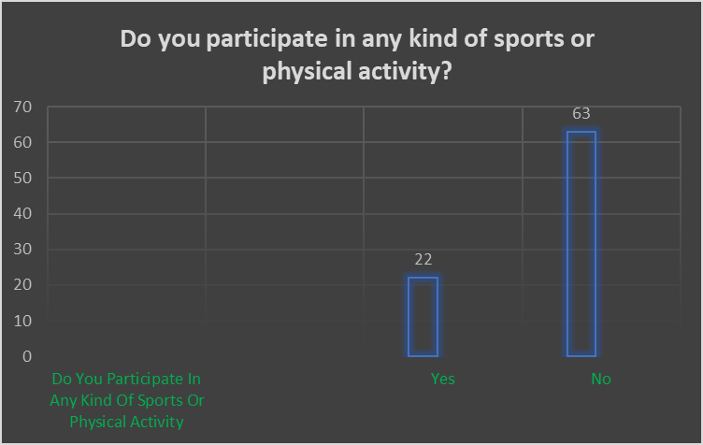

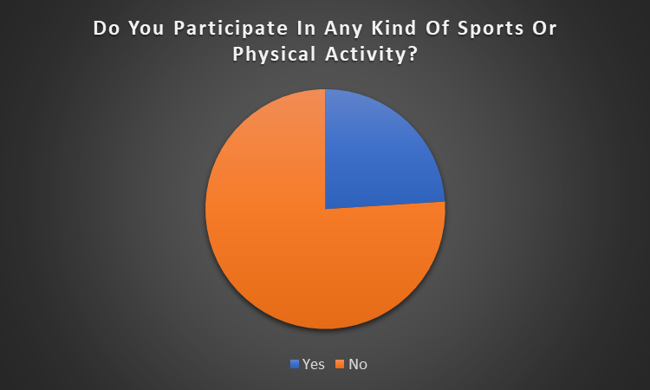

Figure 1B
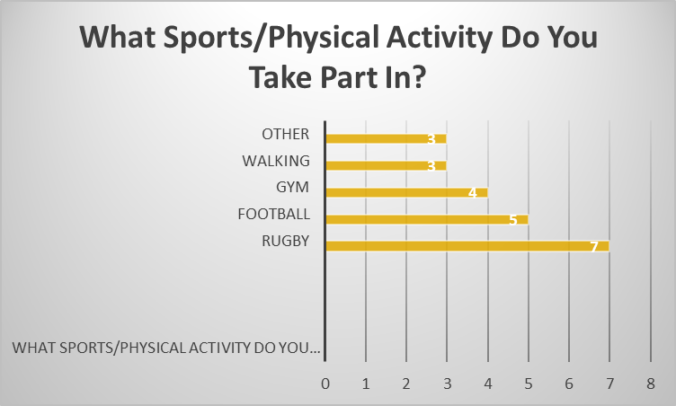

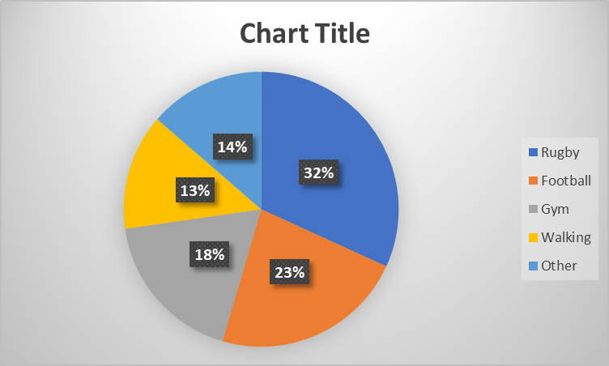

Figure 2
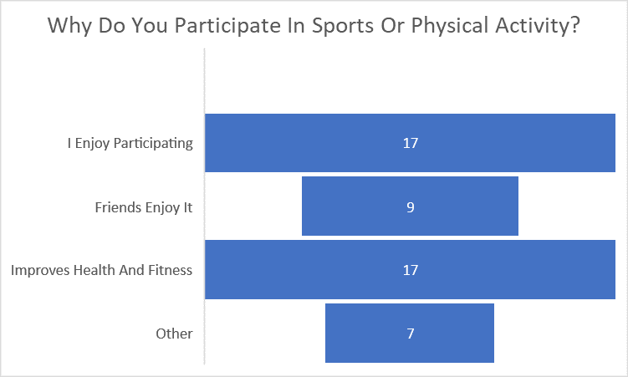

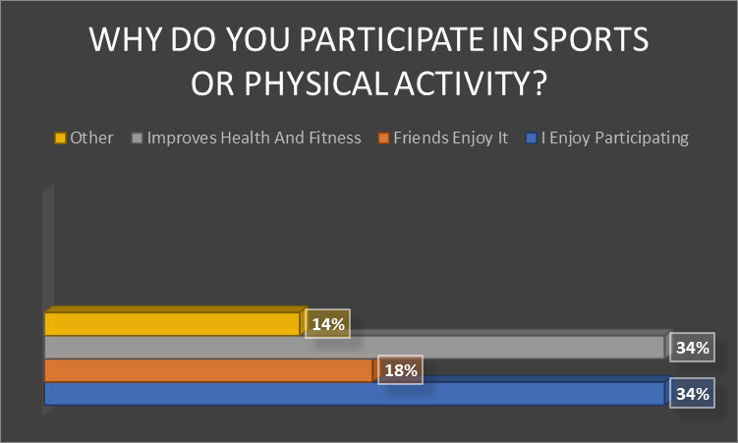

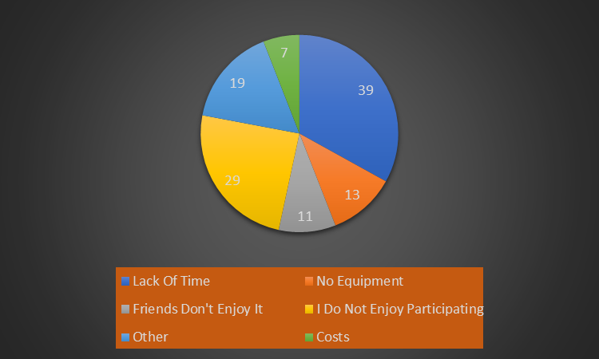
Figure 3

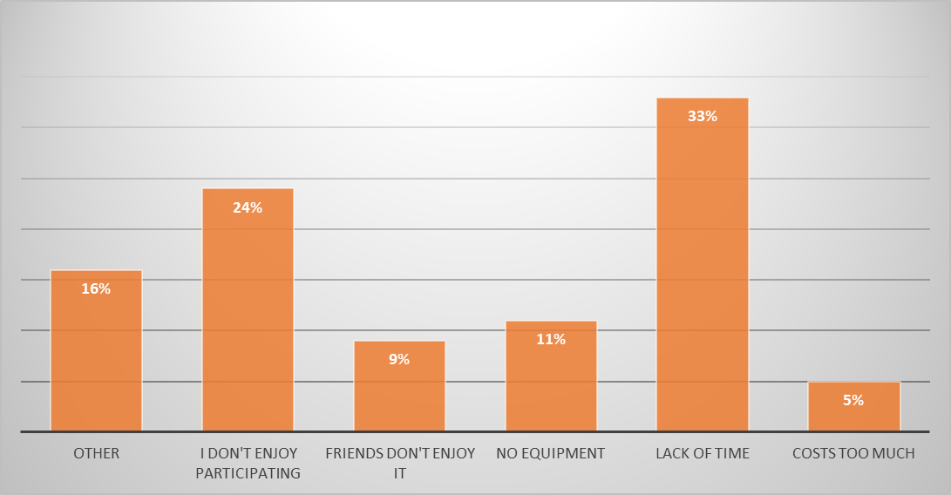

Figure 4
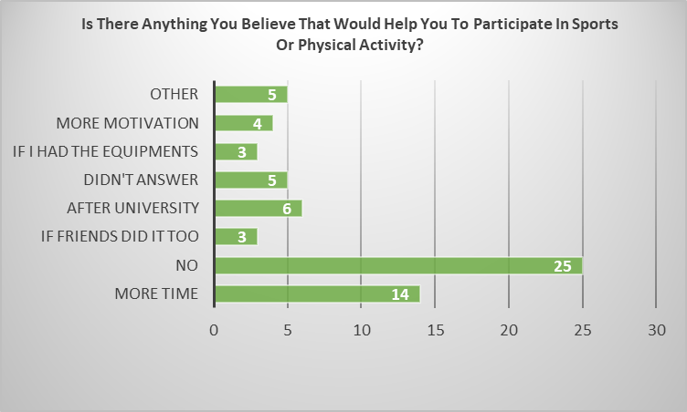
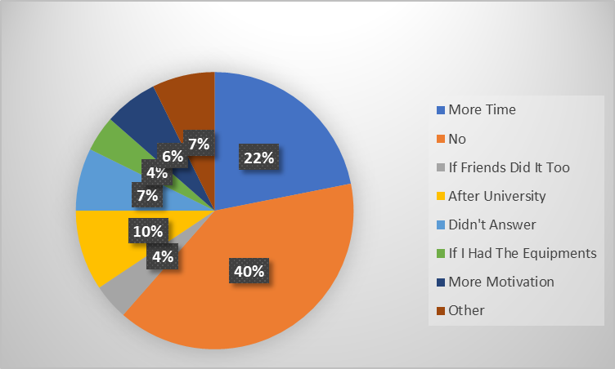

Figure 5
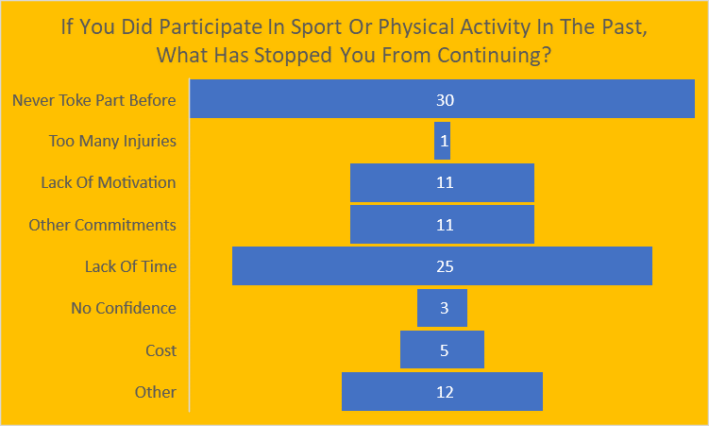

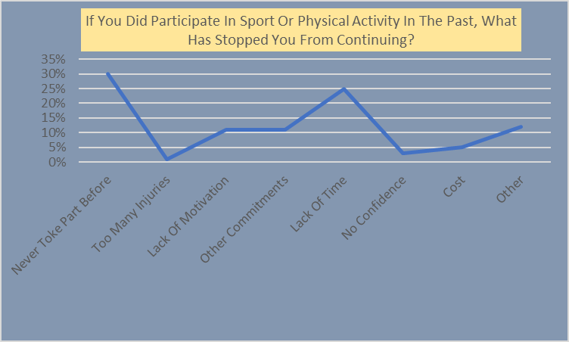

Figure 6
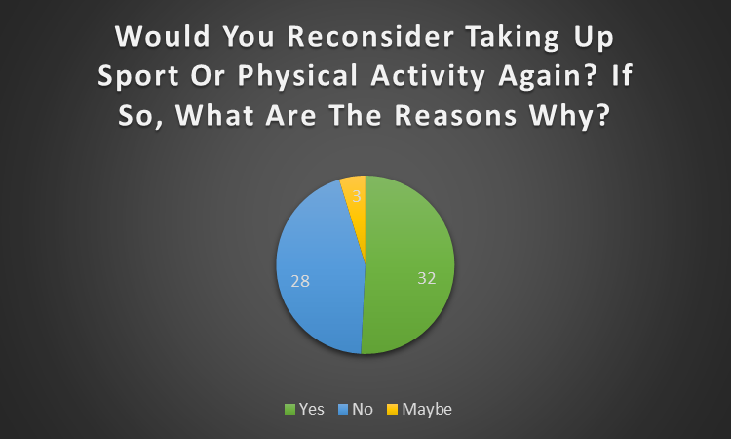
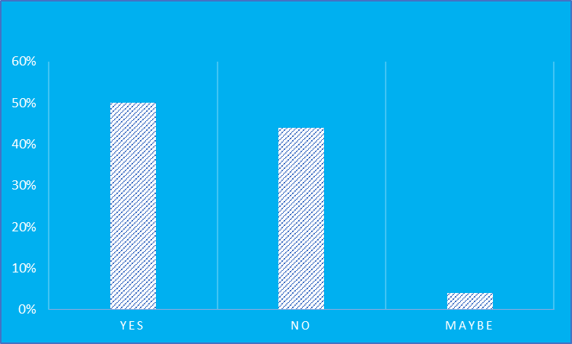

Figure 7
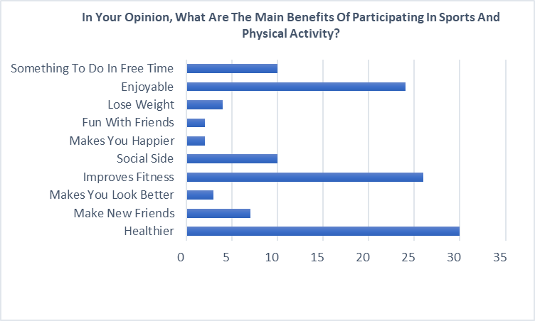
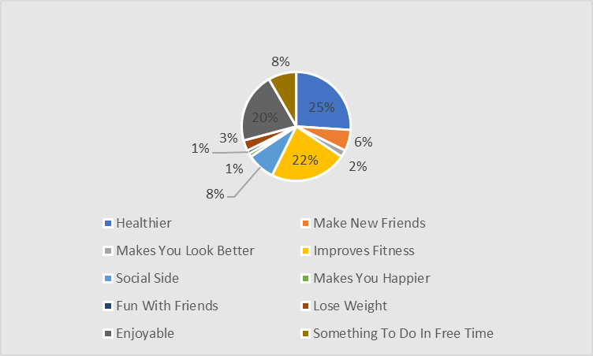

Figure 8
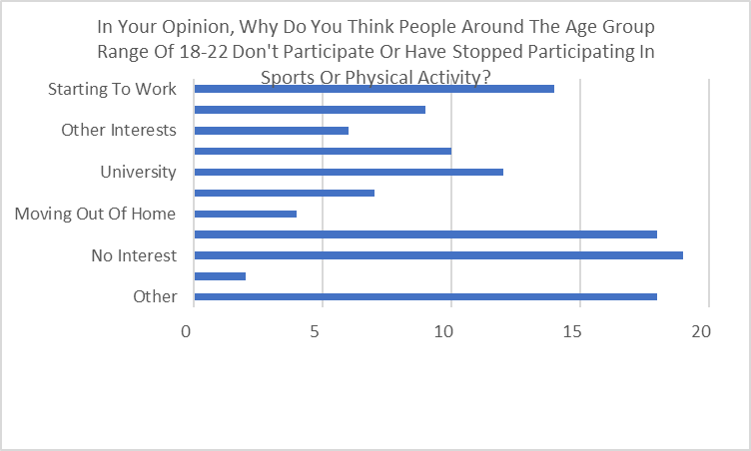
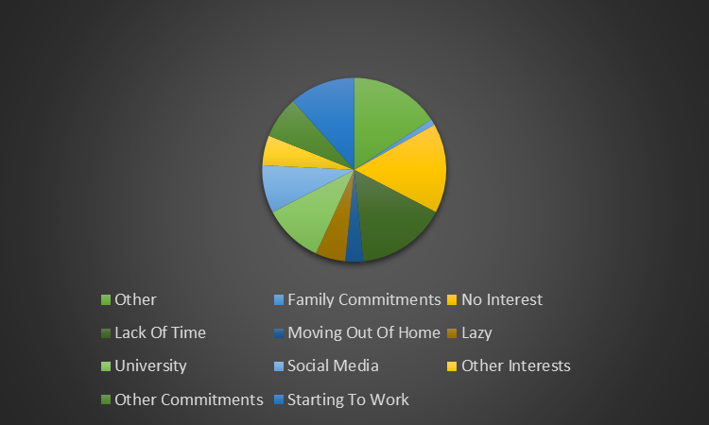

Main body – Introduction (use relevant number of pages)
According to Buyn (2018), emerging into adulthood is a time of social, physical, structural and psychological changes which may influence the barriers to and motivations for sport and physical activity. Students within university represents a specific subgroup in this period as they are affected by difference changes such as structural life circumstances with the beginning of their studies. Normally, a student’s lives is characterized by sedentary behaviour such as attending lectures/classes and the social side. But, physical activity during these ages are very important as it can affect future patterns of adult health.
According to FE Sport and Active Lifestyles Survey (2018), the percentage of people who participate in sport and physical activity declines by the age of 18. When turning 20+, the percentage of people participating declines a further 6% down to 36%. This research also focuses on the barriers that stops the students from getting involved, from “not being interested” to “lack of time”.
During this research, a questionnaire had been conducted to identify the accurate reasons as to why people around the ages of 18-22 do not participate in sport or physical activity. By creating a questionnaire, it would give a greater sense of understanding of the barriers that is stopping the students from participating and getting active. The questions included a mixed method approach of both qualitative and quantitative approaches. By doing so, it would give the results a deeper understanding of the barriers of participating in sport and physical activity among the students within the university. The questions were both open and closed as it was looking for the student’s true opinions and feelings towards getting active in sports and physical activity.
Throughout the research project, different chapter will be addressed. The first chapter will be the literature review. This chapter will provide a survey of scholarly sources regarding participation level barriers. These studies would provide an overview of the current knowledge, it will also allow me to identify relevant methods and theories. With the help of the surveys, I would be able to identify themes, gaps and debates. The surveys would discover trends and patterns, different themes, debates, contradictions and conflicts.
The second chapter of the research project is methodology. The methodology produces different steps. The first step will explain the different approaches to researching, for example the qualitative, quantitative and mixed methods. After explaining the different approaches of researching, I will explain which approach will be more suitable for my research project and for my aim and objectives. Thirdly, the methods of data collection would be explained for example when, where and how the questionnaire was conducted. Lastly, the method of analysis will be addressed, for example how the questionnaire data was analysed.
The third chapter of the research project will be the findings. This chapter will set out the results of the questionnaire that had been provided to the students of the university. The results will contain a detailed description of the outcomes to each question. The graphs and bar charts of the questionnaire answers will be added into the findings chapter, thus will show the full results with percentages.
The 4th chapter of this research project is the conclusion. This chapter will summarise and reflect on the research with a brief summary. The summary will provide the key findings throughout the project and what results that were expected.
Lastly, the final chapter will be the recommendations. This section will provide recommendations of what is needed to be done to stop the number of young adults from dropping out of sports and PA from declining further.

Main body - Literature Review (use relevant number of pages)
The Sport Journal – Athlete Burnout: Is The Type Of Sport A Factor? Holden, (2014)
Athletes sometimes become disenchanted with sport participation and stop competing at what might have been the pinnacle of their sport careers. Prior research has determined that athletes are likely to burnout if they are participating in sport for reasons other than sport attraction. However, prior research has not studied female athletes’ comparative levels of burnout among various sports. The purpose of this study was to determine the level of burnout in female collegiate athletes based on their sport of choice. (Shelley L. Holden)
This journal suggests how athletes start to begin to feel the burnout and how it decreases performances and negatively impacts them both mentally and physically. It shows the negative impacts that can lead to athletes such as chronic stress. Pines (1993) noted that burnout is a state of fatigue and emotional exhaustion which is the result of step-by-step process disillusionment and it quite often found among strong ndividual athletes who are highly motivated. Because of this, athletes become more disenchanted with sport participation and stop competing at what should be the pinnacle of their sporting careers, this is a common occurrence.
Many researchers have been involved within this journal, an example of this is athletes are likely to experience burnout if they are participating in sports for reasons other than the sport attractive. Coakley (1992) conducted interviews with athletes who play at a high level who had been burnt out, it was determined that burnout was directly related to the social organization of intense sport participation.
Since burnout is stress related, some athletes may be more susceptible to the effects of stress than others. Researching why athletes are more affected by chronic stress than other is a valuable question that can further advance the conceptual knowledge on burnout as it relates to athletes. Therefore, the purpose of the current study was to determine if there was a variation in the level of burnout by sport among female collegiate athletes. (Holden, 2014)

When Do Young Adults Stop Practising A Sport? An Event History On The Impact Of Four Major Life Events. Houten, Kraaykamp, Breedveld (2015)
This study investigates the relationship of 4 different major life events that happens that usually stops young adults from participating in sports or physical activity. This study investigates the relationship between major life events and sport participation during the transition to adulthood. Previous retrospective and longitudinal studies found that sport participation over the life course is characterised more by changes in activity level and sort of activities than by dropping out of sport with increasing age. (Butcher, Lindner, & Johns, 2002).
Major Life Events
- Begin/start a brand-new job
- Moving out of home/start to live on one’s own
- Marriage
- The birth of one’s first child
These major events, additionally, bring new roles and social responsibilities, like maintaining a professional and family network, providing for a partner, and taking care of a child, which are likely to be of greater importance than sport-related roles and responsibilities. The social payoffs of existing sport activities will therefore diminish, and likely be traded off against career and family social needs (Van Houten et al., 2014, 2017).
The road to adulthood is marked by milestones such as leaving full-time education, beginning work, engaging in an intimate relationship, starting to cohabit, getting married, and birth of the first child (Arnett, 2007; Hirvensalo & Lintunen, 2011; Kilmartin, 2000). These so-called ‘transition events’ represent changes from adolescence to a more adult status within different life domains (Bell & Lee, 2005). These transitions bring new roles and responsibilities, alongside a new organisation of everyday life (Borgers, 2015).

MOVE IT: Increasing Young People’s Participation In Sport. (Will Norman and Lauren Kahn, 2012)
This study goes through the problems of participation levels in sport within the country. By naming the problems the country has, the study suggests ways to overcome it with recommendations. Many examples of figures are being shown within the study, an example of this is the proportion of people participating in active sports with age, children are far more likely than adults to engage in sport. One of the biggest drop-offs happens between the ages of 16-24, dropping from 97% to 75% and this is more likely a result of leaving school. (Department for Culture, Media and Sport, Taking Part Survey, 2009/10).
Another figure shows the proportion of pupils are participate 120 minutes or more in PE every week, with the numbers dropping as the pupils get older. 95% participation rates are documented at amongst 7 to 8-year olds, this number drops down to 66% amongst pupils aged 14-15 and then drops to significantly to 22% for 18 year olds. (Department for Education, Annual PE and School Sport Survey, 2009/10).
This study suggests the different example as to what they believe are the barriers that is stopping young adults from participating in sports and physical activity. The examples are the following: Technology, safety and academic pressure.
Technology
Young adults have grown up having an unprecedented range of different opportunities to avoid being bored without going outside and breaking a sweat. Thanks to the likes of online gaming, computers, mobile phones, social media, television, it has dominated the lives of young people. These sedentary activities prevent the young people from maintaining a healthy level of keeping active. A recent study found that young adults spend up to 6 and a half hours a day infront of screens. (Quentine Fottrell, 2018)
Academic Pressure
Exams and academic pressure influence young adults’ availability of becoming active. The number of assignments that is presented to the young adult can cut back the time spent doing and participating in sport and physical activity. Young adults often frame their academic achievements and because of this physical activity and sport is then turned to a choice rather than a must. Young adults tend to put their academic studies first rather than staying active and keeping fit.

Differences Between Adolescents Staying In And Dropping Out Of Organized Sport
Research show that participation in organised sport seems especially important in relation to several health factors. Unfortunately, dropout from organized sports increases during adolescence. Adolescent participation in physical activity during youth bestows several health benefits, including positive changes in adiposity, skeletal health, psychological health, and cardiorespiratory fitness (Loprinzi, Cardinal, Loprinzi, & Lee, 2012). However, research indicates that participation in PA declines during adolescence (Aarnio, Winter, Peitonen, Kujala, & Kaprio, 2002) and that many youth do not accumulate the minimum of 60 min of daily physical activity recommended for health (Belton, Meegan, Woods, & Issartel, 2014).
The extant literature demonstrates that participation in organized sport is especially important in relation to certain health factors, such as physical activity level and cardiorespiratory fitness (Aires et al., 2012; Graham, Sirard, & Neumark-Sztainer, 2011). However, participation in organized sport also seems to impart other major advantages. For example, in a large Norwegian population study, adolescents that participated in organized sport reported the following: having more good friends; spending more time out with friends; being more pleased with their parents; having a higher level of well-being at school; skipping school less frequently; being more likely to have plans to achieve a higher education; spending less time looking at computer, tablet and/or cell phone screens. (Bakken, 2017).
In Norway, even though almost all children participate in organized sport, a high dropout rate exists with increasing age (Seippel et al., 2011). For instance, new data reveal that while 72% and 69% of Norwegian boys and girls, respectively, are engaged in organized sport at the age of 14, only 42% and 28% report engaging in organized sport at the age of 19. This constitutes a tremendous dropout rate and is especially pronounced among girls and adolescents of low socioeconomic status (Bakken, 2017). To prevent dropouts, identifying and understanding the precise factors that contribute to dropping out among adolescents is critical.
The extant literature has found that dropouts may attributed to a lack of enjoyment, lack of the opportunity to play, lower perceptions of competence, poor performance, social pressure, slower maturation, injuries, lack of fulfilment of basic psychological needs, poor relationships with teammates and/or coaches, and later birthdate in relation to competitive year (Crane & Temple, 2015).

Perceived Barriers Of Young Adults For Participation In Physical Activity. (Anjali, Manisha Sabharwal, 2018)
This study was aimed to explore the different barriers to sports and physical activity among college students, which was via a qualitative research design. During this study, there was 8 focus groups discussions with the help of 67 college students aged between 18-24. 48 of which were females and 19 were males.
There is convincing evidence that regular physical activity is protective against unhealthy weight gain whereas sedentary lifestyles, particularly sedentary occupations and inactive recreation such as watching television, promote it. Despite the known physical activity benefits, there is a decline of regular exercise in college-aged students (El-Gilany et al., 2011; Al-Eisa and Al-Sobayel, 2012)
Physical activity is an individual choice but the amount of physical activity a person does is also determined or influenced by different factors. While the individual influences are important, physical activity is also influenced by social and community or environmental factors (Pender et al., 2006; Fitzgerald and Spaccarotella, 2009) which have sometimes been overlooked.
This study suggests different dimension of socio-ecological framework. These frameworks include multiple levels, which includes personal, social and environmental. Personal barriers that include being too tired, no energy for physical activity, stress, physical discomfort, time constraint, lack of knowledge/skill, boredom and much more.
Personal Barriers
Time constraints:
“I don’t get much time for it because I make myself busy in other tasks like taking tuitions after college hours.” (Participant 34, Male, DS, 21 years).
Lack of time emerged as a major consistent barrier to physical activity participation along with technology related activities; the influence of peers, parents, and teachers; safety concern; inaccessibility and cost of facilities; competition; and body-centred issues (Dwyer et al., 2006).
Lack of energy/sleep:
“Travelling daily takes a lot of time and consumes a lot of my energy...” (Participant 5, Female, DS, 21 years).
The students that toke part revealed that due to work assignments, they would have to stay up really late at nights and because of this, they didn’t have the energy to get up in the mornings and do some exercise.
Social Barriers
Another barrier mentioned was a lack of social support. This social support came from family and friends. According to previous studies families and friends who were not interested in being actively represented a barrier to physical activity

(Motl et al., 2007; Gómez-López et al., 2010). During the focus group, the participants also discussed the lack of support they received from their friends and family as a barrier of not doing any physical activity.
Family Control/Discouragement
“You don’t need to wake up early and if you want to, then you better study in that time.” (Participant 55, Female, DS, 20 years).
After this was said by one participant, another student responded with an incident when she wanted to go on a walk, but her parents’ answer was:
“First study and then do household chores.” (Participant 49, Female, DS, 19 years).
Peer Pressure/Discouragement
Support from family members and spouses, friend support seems to play a significant role in physical activity participation (O’Dea 2003; Hohepa et al., 2007; Kiernan et al., 2009; Cerin and Leslie, 2010).
“They said that it’s not important to exercise, just take rest, cool" (Participant 44, Female, DS, 19 years).
Environmental Barriers
Participants also stated aspects of environment and neighbourhood as barriers that stopped them from exercising. Examples of the environmental barriers that were said were: safety, the lack of settings, costs and much more. The participants also spoke about the safety issues, disrespectful comments, traffic, the internet, mobile phones and more.
Lack Of Resources/Opportunities
Usually, parks are perceived to be environments where people go for a run or get physically active. When asked about if the participants go to parks, the responses that were given is that there are no parks available in the areas that they live in.
“Locality constraints. Like we don’t have a park in our area. So we can’t be strolling in front of our neighbor’s house.” (Participant 49, Female, DS, 19 years).
Financial Cost
A big environmental barrier that was answered was the cost that is associated within exercising programs. The costs that were spoken about was towards the commercial gyms and fitness centres and how costly the memberships and classes are.
“Gym is there [in college] but for membership, we have to pay 500 Rs extra [apart from college fee].” (Participant 45, Female, DS, 19 years).
It is important to be aware of the value that it is related to the parent’s support who provide monetary backing to the youth as they are dependent on their parents (Siddiqi et al., 2011).

Childhood Drop Out In Football And The Effects On Participation As A Young Adult. (Jason O’Callaghan, 2010)
'Childhood drop out' is an issue sports providers endeavour to address as they attempt to meet the Government’s targets for participation (DCMS, 2002). Previous research (Carroll and Loumidis, 2001; Malina, 2001; Daley, 2002 and Green et al., 2005) has focused on reasons why children stop participating, but this study aimed to build on this to identify the affect childhood drop out in sport has on participation as a young adult.
A qualitative approach was adopted through 7 different semi structured interviews, with all participants taking part dropping out of football during their childhood years after participating for a minimum of 2 years. The reasons for the lack of participation was because of lack of fitness, football not being fit into their routine and the difference between youth and adult football being too big and great in terms of the pressure, competitiveness and physicality. Due to the significant drop out rates after compulsory schooling (Allender et al., 2006) further research should investigate the options available to football players at this time as this study has found the transition into adult football is challenging and it is unlikely that a player will return once they have dropped out.
Due to the potential of drop out, much research has focused on the tracking of childhood participation into adulthood participation (Malina, 2001 and Kristensen et al., 2008) as the rational is being physically active as a child will lead to greater levels of physical activity as an adult (Wigger, 2001). Despite this, previous research has predominately focused on why children drop out and what prevents them from maintaining participation through to adulthood. Therefore, the purpose of this study is to examine the effect dropping out of sport as a child has on their participation as a young adult, with a specific focus on football due to the increased emphasis on competitive sport (DCMS, 2008).
This study focused on many aims, such as to identify why children drop out of football after participation for a sustained period of time, to explore the consequences of dropping out on participation when as a young adult, to discover the reasons as to why people don’t return to the sport they once played and to bring in recommendations for maintaining or increasing the number of young adults participating in football.

Main body – Methodology (use relevant number of pages)
Qualitative Research
According to (Denzin and Lincoln, 1994), Qualitative research is multimethod in focus, involving an interpretive, naturalistic approach to its subject matter. This means that qualitative researchers study things in their natural settings, attempting to make sense of, or interpret, phenomena in terms of the meanings people bring to them. The qualitative researches tend to use a variety of different methods, an example of these are diary accounts, documents, ethnography, open ended questionnaires and participants observation. These researchers tend to use different variety of methods to help understand how people perceive their social realities and how they act within the social world.
Quantitative Research
The aim for quantitative researchers is to establish the general laws of phenomenon and behaviour across different contexts or settings. Usually, these researches are used to test a theory and able to support or reject it. Quantitative researches tend to gather data in a form or numerical, which can then be put into categories, ranked or also measured in units of measurement. For example, this type of data is used to construct tables of raw data or can be put into graphs.
Mixed Methods
A mixed methods research involves collecting, analysing and integrating both qualitative and quantitative research. Usually, this approach is being used to provide a greater understanding of the research problem, rather than using one method. A mixed method approach can be used in many situations such as to validate the results obtained from the other method or to elaborate, build or clarify a finding from a different method or to use.
Explanation Of Methodological Approach
The methodological approach I had decided to undertake to ensure I conquer my aim was to create a questionnaire with multiple questions which provided both open and closed questions. The participants had the opportunity to tick as many boxes as they’d want in the multiply choice questions and also had the chance to express their opinions. I had decided to create a questionnaire as it can be classified as a quantitative approach. This research strategy reflected the aim of the research project as it was looking for the student’s true opinions on participating within sports and physical activity. One of the key objectives to ensure this aim was successful was to identify key recommendations for the student union to inform future policy. A way of bringing this into the questionnaire was by asking the student’s themselves what they believe are the main benefits of participating in sports or physical activity. By doing this, it would give the Student Union a better understanding of what getting active within sports or physical activity can do to a student, both mentally and physically.
Although the use of questionnaire can be a mixture of both methods, it does have advantages and disadvantages when gathering data. When providing questionnaires to participants, it can be difficult to obtain a good rate or response. Usually, there is no motivation for the participants to respond with, which can then give an untrue record. Because of this, if not answered truthfully, the data can be misleading. Even though there are disadvantages of using questionnaires, the advantages overshadows it. Firstly, questionnaires are relatively straight forward to analyse, the participants have time to think about answering the questions, there is no time limit, the answers can be as short or if they want to provide. To most participants, the format is similar as they may have answered many questionnaires in the past. By using a questionnaire to collect date, it gives the participants the opportunity to provide their true opinions and because of that, it works perfectly for my aim:
- Critically analyse the barriers that influence participants in sport and physical activity for UWTSD students in The Student Union.
The Questionnaire
Within the questionnaire, 9 questions were set out which would interest the participants that do get active and plays sports or physical activity and the participants who do not. The questionnaires were handed out to students within the university and they had as much time as they’d like to fill them in. According to (Cleave, 2017), If asking respondents to answer surveys that are too long or that contain irrelevant questions, you run the risk of them becoming tired and uninterested in the task at hand. This will result in a decline in the quality of the data they provide and the possibility of negative brand perceptions, which is called questionnaire fatigue. An example of the questionnaire can be seen in the appendices.
Methods Of Data Collection
According to (Geneva Workshop, 2017) a questionnaire is a research instrument that consists of a series of questions and other prompts for the purpose of able to gather information from the respondents. A questionnaire allows the researcher to collect the most accurate and complete data in a logical flow, this is done in order to be able to reach reliable conclusion from what we are planning to observe. Overall, a questionnaire that is well-designed would meet the research goal, objectives and would be able to minimize unanswered questions, a problem that is common to many surveys.
According to (Geneva Workshop, 2017), the researcher should clearly define the target, study populations from which he/she collects data and information. Before being able to create the questionnaire, the researcher should decide on the content, each question should be able to contribute to testing one of more of the research question established in the research design. The questions within the questionnaire can be:
- An open format questions, which is a question that doesn’t need a set of responses.

- A closed format questions, which is a question that takes the form of a multiple-choice answers.
The questionnaire was conducted within the university campus, by doing this, the chance of finding the right candidates to do the questionnaire was greater. After finding the right place to conduct the questionnaires, it was then about the timing on when to hand out the questionnaires to the participants. The questionnaires were decided to be conducted throughout the days when I was present on the university campus. This would be a big advantage as the questionnaires would be able to be handed back to me on the same day as they were conducted, thus giving me plenty of time to analyse the answers. To ensure that the questionnaires were handed out to the right students, I asked every student if they were a member of the Student Union, if answered “yes”, the questionnaire would be handed to them. Also, to ensure that the participants were eligible to have their answers counted, the first question of the questionnaire would ask for the participants age, if answered 18-22 then the questionnaire would be eligible for the research, if answered over the age of 22, the questionnaire would not be used for the research.
Method Of Analysis
After receiving the results of the questionnaires, the next step was to analyse the results. Before preparing the data and analysing, a check for any missing data was vital. By doing this, no wrong data would go into the research and by doing that, the readings of the data would inaccurate. The software that was used to analyse the data was Excel. This method of analysis was kept for the research as it was able to create graphs and pie charts to show the results of the questionnaire. According to Cook (2016), the advantages of using Excel are wide and varied. With the powerful analytical tools included within Microsoft Excel you can analyse large amounts of data to discover trends and patterns that will influence decisions. Microsoft Excel’s graphing capabilities allows you to summarize your data enhancing your ability to organize and structure your data. (Cook, 2016) Excel created the graphs and analysed the percentages of each answer given by the students, giving out the full results of each question. The graphs can be seen in the findings.

Main body – Findings (use relevant number of pages)
1A – Do you participate in any kind of sports or physical activity? If so, what do you take part in?
The first question in the questionnaire was to see if the participant was active or participated in sports or PA. By asking this question, it gave me a sense of understanding as to how many participants that take part in the questionnaire are getting active. As the results show, 85 participants volunteered to take part in the questionnaire with 22 saying that they are active and 63 saying they are not. After receiving the full results, out of the 85 participants that take part, 74% declared that they do not get active by taking part in sport or PA.
This result shows that the students who are a member of the student union are not very active.
1B – What Sports/Physical Activity do you take part in?
The 2nd part of the first question of questionnaire was towards the 22 participants that said that they are active and take part in sport or physical activity. There we 4 main answers towards this question with 7 participants saying that they get active by playing rugby, 5 said they participate in football, 5 said that they like to keep active by going on walks and 4 enjoys going to the gym. Other answers that were given were: Netball, athletics and cricket.
Rugby is a popular sporting choice for the students in the student union.
2 – Why do you participate in any kind of sports or physical activity?
The 2nd question was again towards the participants who get active. The majority of the students stated that they enjoy sports or physical activity as it is enjoyable, and it also improves health and fitness. Also, 9 of the students admitted that they participate in sport and PA as their friends enjoy it too, by having friends to get active with, it gives the students the boost on confidence in which they need.
3 – If you do not participate in sports or physical activity, what are the reasons why?
The 3rd question was towards the 63 student who do not get active and decide not to participate in any kind of sport or PA. Due to the project surrounding the barriers as to why the student do not participate in sport or PA, 6 options were available to the students: Lack of time, friends don’t enjoy it, no equipment, don’t enjoy sports or PA, cost and other.
Out of the 63 students that this question implemented to, 119 boxes were ticked with many students ticking more than 1 box. One answer dominated the other options and that was the lack of time the students don’t get active, which can be due to university work, starting a job, family commitments, relationships and much more. This box got ticked 39 times. The 2nd most popular answer was that the students simply don’t enjoy participating and getting active but instead doing other things in their free time. 29 students ticked this box. Surprisingly, the 3rd most popular answer was the “other” option and the students gave their own reasons as to why the do not get active. The reasons are as followed: Not interested in sport or PA (6), university work getting in the way (5), working, relationship, other commitments, no car, nobody I know does sport, not sporty, not comfortable and don’t fancy it.
4 – Is there anything you believe that would help you to participate in sports or physical activity?
Out of the 63 students that taken part in this question, 60 answers were given, 5 students didn’t give an answer. Out of the answers given, the answer “no” was given 25 times, which resulted in 41% of the answers that was given. This showed that almost half of the students that answered this question have no interest in taking part in sport or PA in the future and nothing will convince them. As said in the previous question, the second most popular answer was “more time”. 14 students would start to get active and participate in sport or PA if they had more time to do so, instead, they are too busy to start thinking about it. The 3rd most popular answer is almost as identical as the 2nd most popular answer, this time 6 students declared that they would get active after university finishes. This shows once again that these 6 students are too busy with work and have no time to join a sports team or to get physically active. Instead, they would get active after the busiest time of the year is over, which would give them more time to get active rather thinking about university work. 4 students gave the answer of “more motivation”, 3 students said they would get active if they had the equipment and 3 students said if their friends did it too. Other answers such as transport trouble, if there was a local sports team around, if the memberships costs were cheaper and if they had less shifts at work.
5 – If you did participate in sports or physical activity in the past, what has stopped you from continuing?
The next question was towards the students that did participate in sports or PA but decided to stop for different reasons. This question was created to understand what made them decide to stop taking part and getting active which could give future students a better understanding on how to keep getting active when times get tough. During this question, 98 answers were given with students giving more than 1 reasons as to why they decided to stop getting active. The most popular answer that was given was “never taken part in sport or PA before”, which got 30 answers. Out of the 63 students, 30 of them have never taken part in sport or physical activity before. For the students that did take part in sports and physical activity, the main reason as to why they stopped taking part was lack of time, which has become a popular answer during this questionnaire.
6 – Would you reconsider taking up sports or physical activity again? If so, what are the reasons why?
The following question was towards the students that once participated in sports or physical activity but stopped for various reasons. As regards to this question, there was only 3 answers that were optional, and these were; “yes”, “no” and “maybe”. “Yes” would be answered by the participants that would reconsider taking up sport and physical activity again, in which they had to stop due to a specific reason. “No” would be answered by the participants that had no interest in taking up sport or physical activity again which can be due to them not enjoying, their friends are not interested and much more. The most interesting answer that can be given is “maybe”, this would be answered by the participants that are not sure whether they will reconsider taking up sports or physical activity again. Out of the 63 students that toke part in this question, 32 of them declared that they would reconsider taking up sport again, this was over 50% of the voting. The participants also gave a reason as to why the would take up sport or physical activity again. The most popular answer was given by 12 students who said it was ‘enjoyable and fun in the past’. The next popular answer was “after university finished”, this follows the trend of students not being able to take part in sport and physical activity because of the lack of time.
7 – In your opinion, what are the main benefits of participating in sport or physical activity?
This question addressed all students. By asking this question, it made the students think on their feet as to why taking part within sports and physical activity and getting active is so important and that is has many benefits to it. 112 answers were taken from 85 students with many students answering more than once. Many different answers were given but only 3 answers were popular. Out of the 112 answers, 30 of which were “you get healthier”, 26 answers were “improves your fitness” and 24 of the answers were “it is enjoyable”. The following results are shown below:
- You get healthier (26)
- Improves your fitness (26)
- It is enjoyable (24)
- Social side (10 answers)
- You make brand new friends (7 answers)
- Lose weight (4 answers)
- Something to do in your free time (3 answers)
- Makes you look better (3 answers)
- Makes you happier (2 answers)
- Fun with friends (2 answers)
This result shows that the students who do not participate in sports or PA know the benefits of getting active, but due to the barriers that’s not allowing them to take part, they cannot participate.
8 – In your opinion, why do you think people around the group range of 18-22 don’t participate or have stopped participating in sports or physical activity?
The last question once again makes the students think on their feet. Instead of asking the participants about how important sports and physical activity is both mentally and physically, the students were asked why they believe people around their age group drop off participating in sports and physical activity. Out of the 85 students that answered the question, 117 different answers were confirmed. The answer that most of the students came up with was “no interest”, “lack of time”, “getting a job” and “university”. Other answers that were given are as followed:
- Other commitments (9)
- Too lazy (7)
- Other interests (6)
- Social Media (4)
- Moving out of home (4)
- Video games (3)
- Relationships (3)
- Family commitments (2)

- Friends don’t enjoy do it (2)

Main body – Conclusion (use relevant number of pages)

This researched aimed to critically analyse the barriers that influence participants in sport and physical activity for UWTSD students in The Student Union. Based on the quantitative and qualitative methods of analysing, it can be concluded that the barriers that are stopping the students from taking part in sports and physical activity can be prevented. The results of this research project indicate that students have the interest in them to get active and to participate in sport and physical activity after the barriers that are stopping them are prevented.
Before undertaking this research project, expectations regarding the participation level within the university were low as the sports teams such as the rugby and football team struggle to find students who wish to participate within their respected teams. Due to this and the importance of education and receiving good grades, the level of students who participate in sport or physical activity were expected to be low before handing out the questionnaires.
After receiving the results from the questionnaire, many surprising results appeared. As seen in the findings chapter, one of the most extraordinary results was that 50% of the current students who do not take part in sports or physical activity would participate again in the future. After receiving the results, many students also gave a reason as to why the would participate again, for example students declared that participating in the past was fun/enjoyable and that they would take up sport or physical activity again after university finishes. This results in the students not having much time to do activities that they want to do due university and other commitments. During the questionnaire, this would be a theme. Remarkably, throughout the question, the option of “lack of time” was ticked over 90 times. This would be a big problem throughout the questionnaire as many students had stated they simply don’t have enough time to join a sports team or do any sorts of physical activity.
One of the key questions that was asked during the questionnaire was towards the students that do not take part in sports or physical activity. The students were asked if there was anything that would help them to participate in sport or physical activity again in the future, 14 students declared they would take part if they had more time, doubled the amount of the number the second answer received, which was “after university” with 6. As said in the study “Perceived Barriers Of Young Adults For Participation In Physical Activity. (Anjali, Manisha Sabharwal, 2018), it suggests that there are different dimensions of socio-ecological framework. The framework includes multiple level of barriers which are personal, social and environmental. This study goes through the different barriers that blocks students from getting active. A finding that was compared between the questionnaire results and the study was the similarity on time constraints. Both the study and questionnaire show that students don’t get active because they are too busy. Another similar between the study and questionnaire is cost. Students admitted that they do not get involved in physical activity and sport because of the cost. As stated in the study, a big environmental barrier that was answered was the cost that is associated within exercising programs. (Anjali, Manisha, Sabharwal, 2018).

According to Houten, Kraaykamp, Breedveld (2015), the study of “When Do Young Adults Stop Practising A Sport? An Event History On The Impact Of Four Major Life Events”, major life events such as beginning/starting a brand new job and moving out of a home is one the biggest major reason as to why young adults stop participating in sports or physical activity. During the question “In your opinion, why do you think people around the age group range of 18-22 don’t participate or have stopped participating in sports or physical activity?”, the answer of “moving out of home” received 4 answers while “starting to work” received 14 answers. This study and questionnaire show that students typically move out of their home and start a brand-new job to afford to live elsewhere affects on them participating within sports and physical activity.
Lastly, as seen in the results of the questionnaires, one of the biggest impacts of not being able to get active is due to university and the academic pressure that comes with it. According to the study “MOVE IT: Increasing Young People’s Participation In Sport”, Norman and Kahn, (2012), exams and academic pressure influences young adults within their availability of becoming active in sport or physical activity. The number of assignments that is presented to the students can cut back the time for them to be participating and keeping active. This was shown in the questionnaire results that university greatly impacts students and their time to keep active. An example of this in the questionnaire is when asked “Is there anything you believe that would help you to participate in sports or physical activity?”, 6 students declared that they would start to participate after they finish university. This result shows that students are not able to do sporting activities until after university is finished, this can be due to the level of assignments or the university lifestyle. Another example of why university is preventing students from getting active, when asked in the questionnaire “In your opinion, why do you think people around the age group range of 18-22 don’t participate or have stopped participating in sports or physical activity?”, the answer of “university” was said 13 times, which made it the 5th highest answer of the question.

Main body – Recommendations (use relevant number of pages)
To increase future participation levels within sport and physical activity, a recommendation for the future would be to bring in more sports teams to the university, alongside sports facilities. By bringing in state of the art facilities with equipment’s, it would motivate students in getting active. An example of this is the “Carmarthen Campus Sports Centre” which has its very own Trinity Sports Centre and Health Suite. Inside the centre is a health and fitness suite which includes the best Technogym fitness equipment and resistance machines, the sports hall includes a multipurpose sports hall which can be used for a range of different sports such as 5-a-side football, netball, badminton, basketball, indoor wall climbing and much more. Lastly, the sports centre provides a swimming pool which gets the students active. Based on the findings, half of students within the University Of Wales Trinity Saint David Swansea who had taken part within the questionnaire have no motivation or interest in taking part in sports or physical activity. This can be due to the university not providing a gym or have its very own sports centre, instead, the students rely on gyms from different areas. This recommendation suggests an action that can be taken in the future, will the university provide gyms and sports centres to the students? If so, the level of students in the university that participate within sports or physical activity would rise.
Are the costs of taking part in sports or physical activity too much? According to the questionnaire findings, students find taking part in physical activity too costly. An example of this is local gyms, students are currently put off becoming active by the cost of gyms. This brings up a question for future researches, would gyms benefit or not by cutting down costs? By cutting down costs, it would bring in more students and members to use their facilities and equipment’s. But, on the other hand, cutting down it’s membership cost would lose money for the gym. If gyms would become cheaper, it would benefit highly on the students as they would be able to afford it, they would get more motivated and friends would be able to join them. There are many advantages and disadvantages of cutting down the costs, which can be researched in future projects.
Another recommendation for future research is the benefits of promoting sports and physical activity. Due to the questionnaire targeting students within the student union, for future prospects, the student union would be able to promote getting active to the students and by doing this, a lot more students would take up the offer. As seen in the findings results, almost half of the students didn’t take part in sports or physical activity because they didn’t want to. By promoting the benefits of sports and PA, it would give the students the little extra motivation that they need to become healthier and to become active. One way of promoting sports and PA is by creating flyers and posters to stick around the university. The flyers and posters would introduce students to the health benefits that getting active can do to you, such as it helps chemicals in the brain, has a positive effect on your mood, benefits the heart, lungs, muscles and bones.

Reference List (use relevant number of pages)
Us.sagepub.com. 2020. [online] Available at: <https://us.sagepub.com/sites/default/files/upm-binaries/55588_Chapter_1_Sample_Creswell_Research_Design_4e.pdf> [Accessed 30 April 2020].
Mcleod, S., 2020. Qualitative Vs Quantitative Research | Simply Psychology. [online] Simplypsychology.org. Available at: <https://www.simplypsychology.org/qualitative-quantitative.html> [Accessed 30 April 2020].
Ltd, W., 2020. Mixed Methods Research. [online] Resourcecentre.foodrisc.org. Available at: <http://resourcecentre.foodrisc.org/mixed-methods-research_185.html> [Accessed 30 April 2020].
Research-Methodology. 2020. Questionnaires. [online] Available at: <https://research-methodology.net/research-methods/survey-method/questionnaires-2/> [Accessed 30 April 2020].
Economicsnetwork.ac.uk. 2020. 1.3 What Is The Purpose Of Questionnaires? | The Economics Network. [online] Available at: <https://www.economicsnetwork.ac.uk/handbook/questionnaires/13> [Accessed 30 April 2020].
Taylor & Francis. 2020. The Transition To Adulthood: A Game Changer!? A Longitudinal Analysis Of The Impact Of Five Major Life Events On Sport Participation. [online] Available at: <https://www.tandfonline.com/doi/full/10.1080/16138171.2019.1603832> [Accessed 30 April 2020].
Fottrell, Q., 2020. People Spend Most Of Their Waking Hours Staring At Screens. [online] MarketWatch. Available at: <https://www.marketwatch.com/story/people-are-spending-most-of-their-waking-hours-staring-at-screens-2018-08-01> [Accessed 30 April 2020].
DeFranzo, S., 2020. Give Survey Respondents The Option Of Choosing An 'Other' Response. [online] Snap Surveys Blog. Available at: <https://www.snapsurveys.com/blog/give-survey-respondents-option-choosing-other-response/> [Accessed 30 April 2020].
Cvent.com. 2020. Qualitative Vs. Quantitative Research Methods | Cvent Blog. [online] Available at: <https://www.cvent.com/en/blog/events/qualitative-vs-quantitative-research-methods> [Accessed 1 May 2020].
Gfmer.ch. 2020. [online] Available at: <https://www.gfmer.ch/SRH-Course-2017/Geneva-Workshop/pdf/Data-collection-methods-Abawi-2017.pdf> [Accessed 1 May 2020].
Cleave, P., 2020. 5 Ways Of Preventing Questionnaire Fatigue. [online] Blog.smartsurvey.co.uk. Available at: <https://blog.smartsurvey.co.uk/5-ways-of-preventing-questionnaire-fatigue> [Accessed 1 May 2020].
Diehl, K., Fuchs, A., Rathmann, K. and Hilger-Kolb, J., 2018. Students’ Motivation for Sport Activity and Participation in University Sports: A Mixed-Methods Study. BioMed Research International, 2018, pp.1-7.
Unihub.mdx.ac.uk. 2020. [online] Available at: <https://unihub.mdx.ac.uk/__data/assets/pdf_file/0030/187518/How-To-Write-An-Abstract-New-Format.pdf> [Accessed 1 May 2020].
Systems, S., 2020. Advantages Of Microsoft Excel. [online] TurboFuture. Available at: <https://turbofuture.com/computers/Advantages-of-Microsoft-Excel> [Accessed 1 May 2020].
Scribbr. 2020. How To Write A Dissertation Conclusion | Checklist And Examples. [online] Available at: <https://www.scribbr.co.uk/thesis-dissertation/conclusion/> [Accessed 1 May 2020].
Scribbr. 2020. The Literature Review | A Complete Step-By-Step Guide. [online] Available at: <https://www.scribbr.co.uk/thesis-dissertation/literature-review/> [Accessed 1 May 2020].
UWTSD, W., 2020. Carmarthen Campus Sports Centre | University Of Wales Trinity Saint David. [online] Uwtsd.ac.uk. Available at: <https://www.uwtsd.ac.uk/student-life/sport/carmarthen-campus-sports-centre/> [Accessed 1 May 2020].
Kahn, L. and Norman, W. (n.d.). MOVE IT Increasing young people’s participation in sport. [online] Available at: https://youngfoundation.org/wp-content/uploads/2012/10/YOF1716_Nike_report_08_12_web_1.pdf

Bibliography (use relevant number of pages)
Drake, A. (2012). Barriers to participation in sport. [online] prezi.com. Available at: https://prezi.com/ygptackmv9u8/barriers-to-participation-in-sport/
Super, S., Wentink, C.Q., Verkooijen, K.T. and Koelen, M.A. (2017). How young adults reflect on the role of sport in their socially vulnerable childhood. Qualitative Research In Sport, Exercise and Health, 11(1), pp.20-34.
Lse.ac.uk. (2015). Cost is the biggest barrier to young people’s participation in sport because a third live in poverty – 12 – 2015 – News archives – News and media – Website archive – Home. [online] Available at: http://www.Ise.ac.uk/website-archive/newsAndmedia/news/archive/2015/12/Cost-is-the-biggest-barrier-to-young-peoples-participation-in-sport-because-a-third-live-in-poverty.aspx
Bailey, R. (2012) Young adults and Sport: motives and barriers. [online] Blogspot.com. Available at: http://talkingeducationandsport.blogspot.com/2012/01/young-adults-and-sport-motives-barriers.html
QuadExcel.com. 2020. Top 5 Benefits Of Microsoft Excel. [online] Available at: <https://quadexcel.com/wp/top-5-benefits-of-microsoft-excel/> [Accessed 1 May 2020].
Software-matters.co.uk. 2020. Software-Matters: The Benefits Of Using Microsoft Excel. [online] Available at: <https://www.software-matters.co.uk/microsoft-excel-benefits.html> [Accessed 1 May 2020].

Appendices (use relevant number of pages)
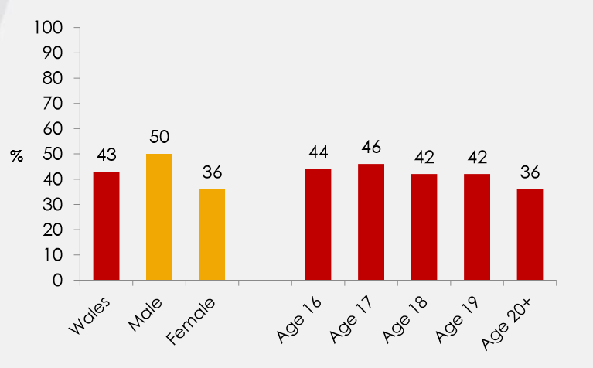
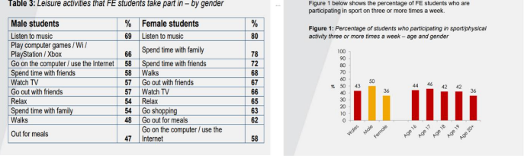
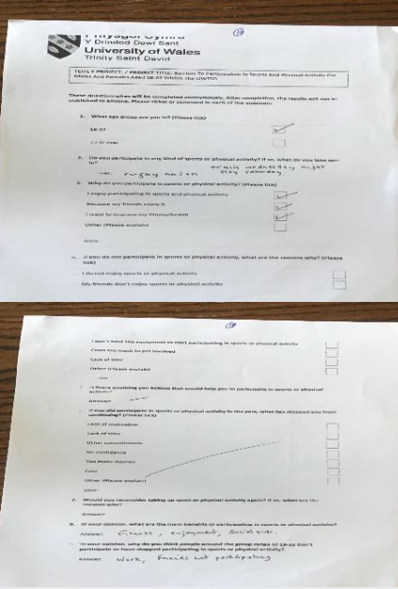
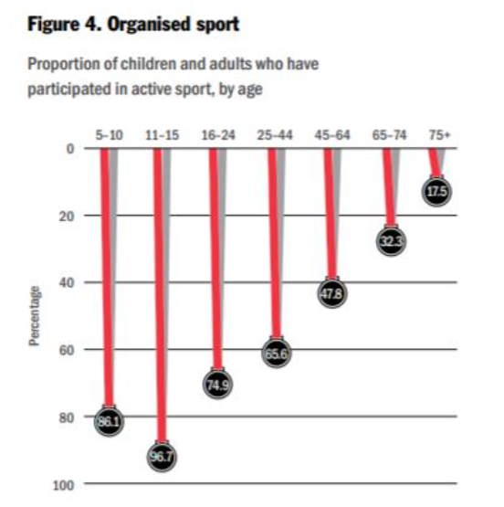
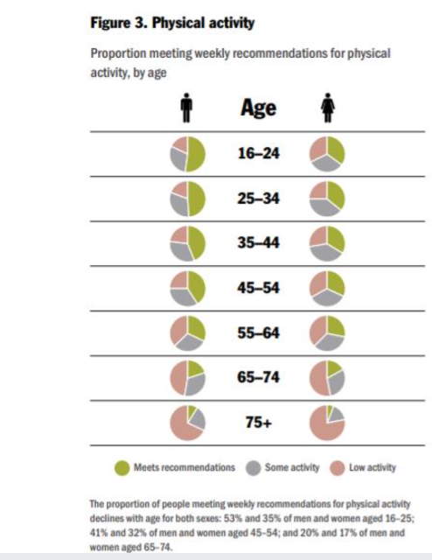

Insert Ethics Form P1 into the table below

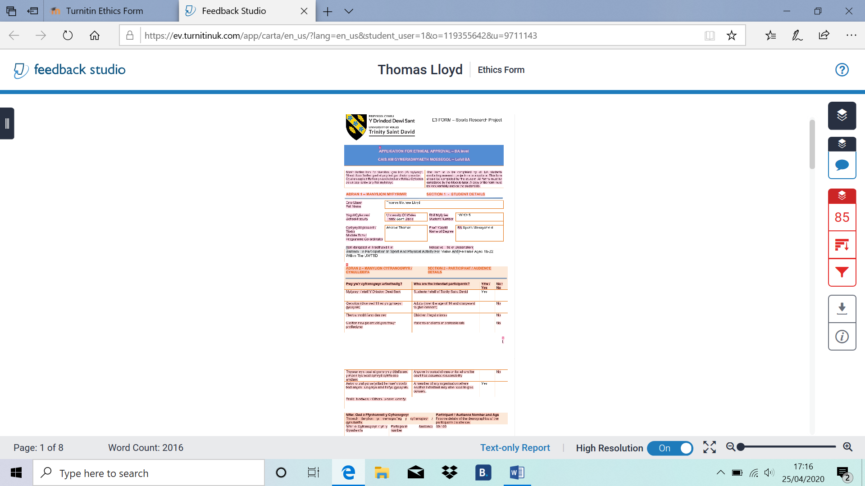

Insert Ethics Form P2 into the table below

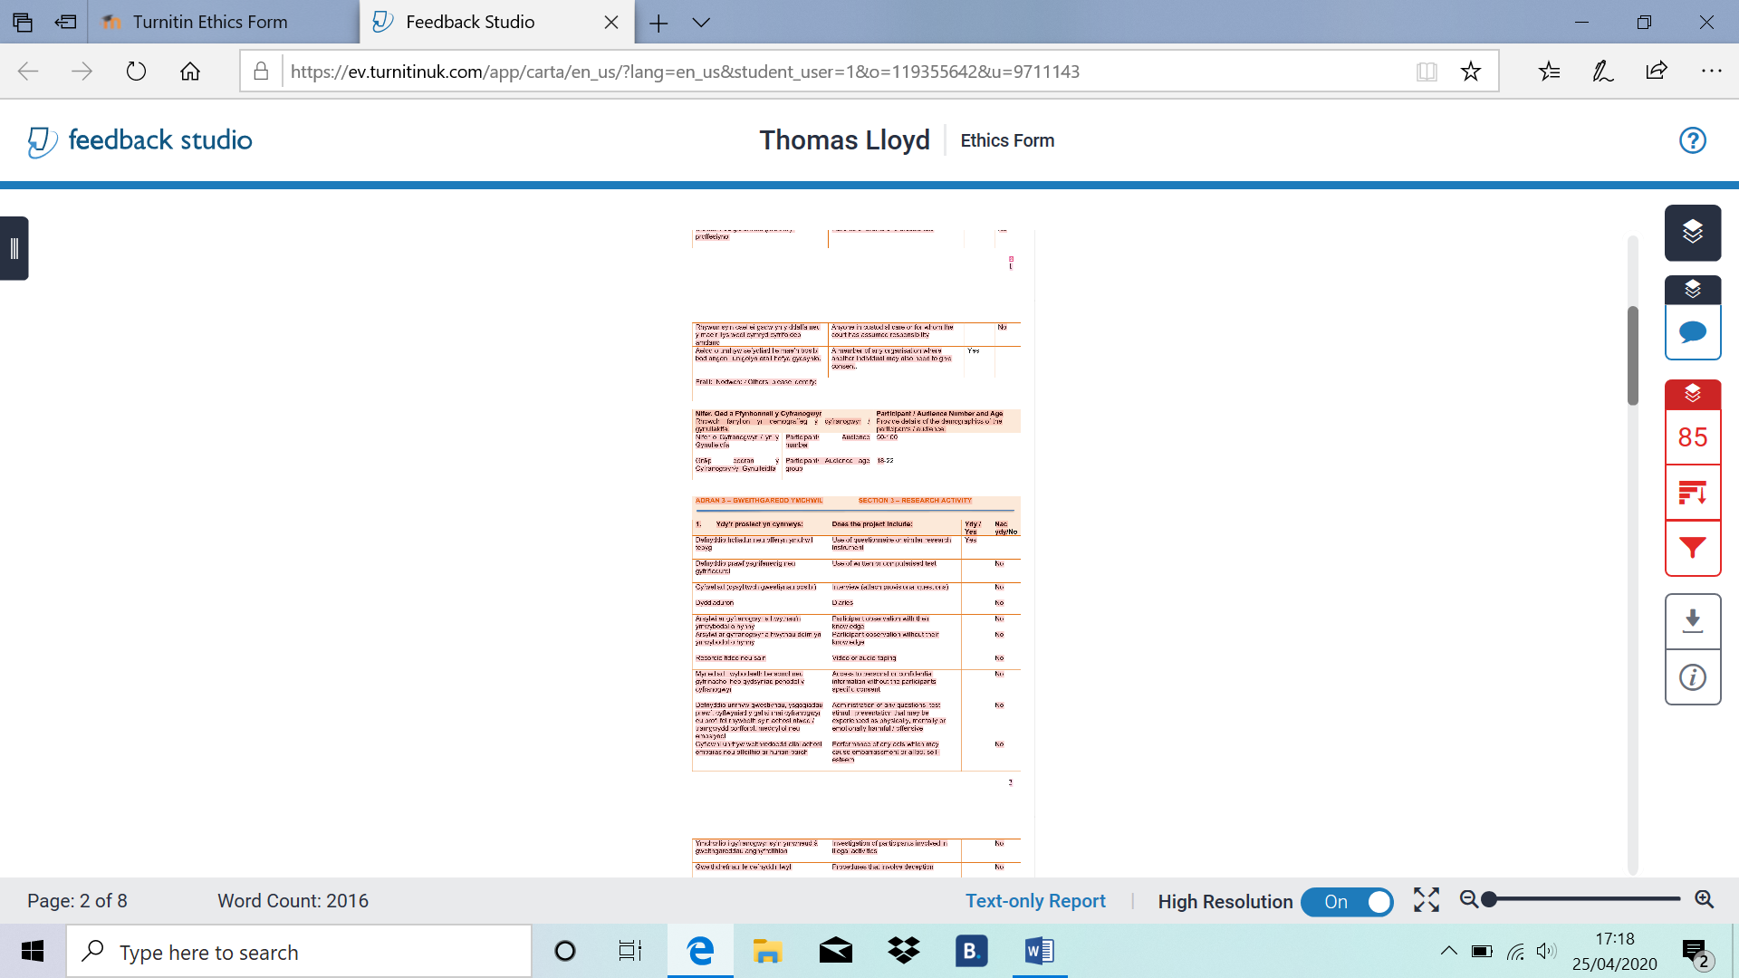

Insert Ethics Form P3 into the table below

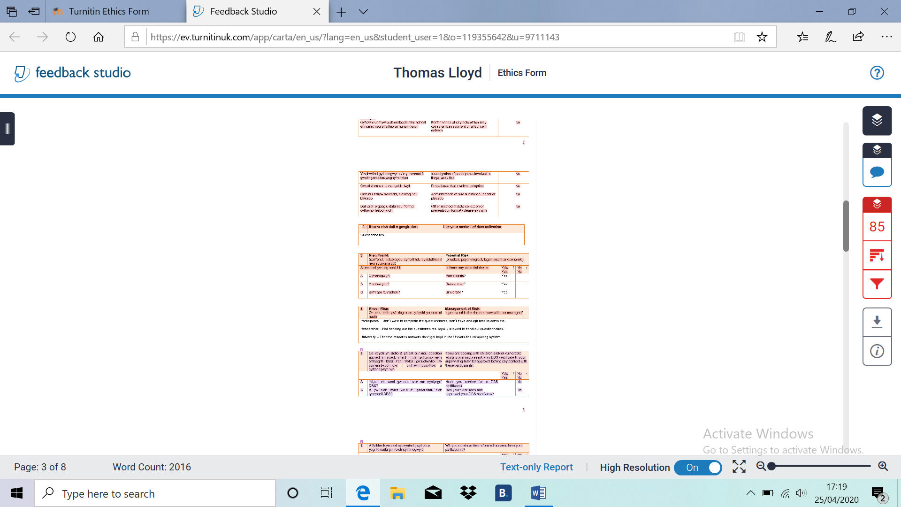

Insert Ethics Form P4 into the table below

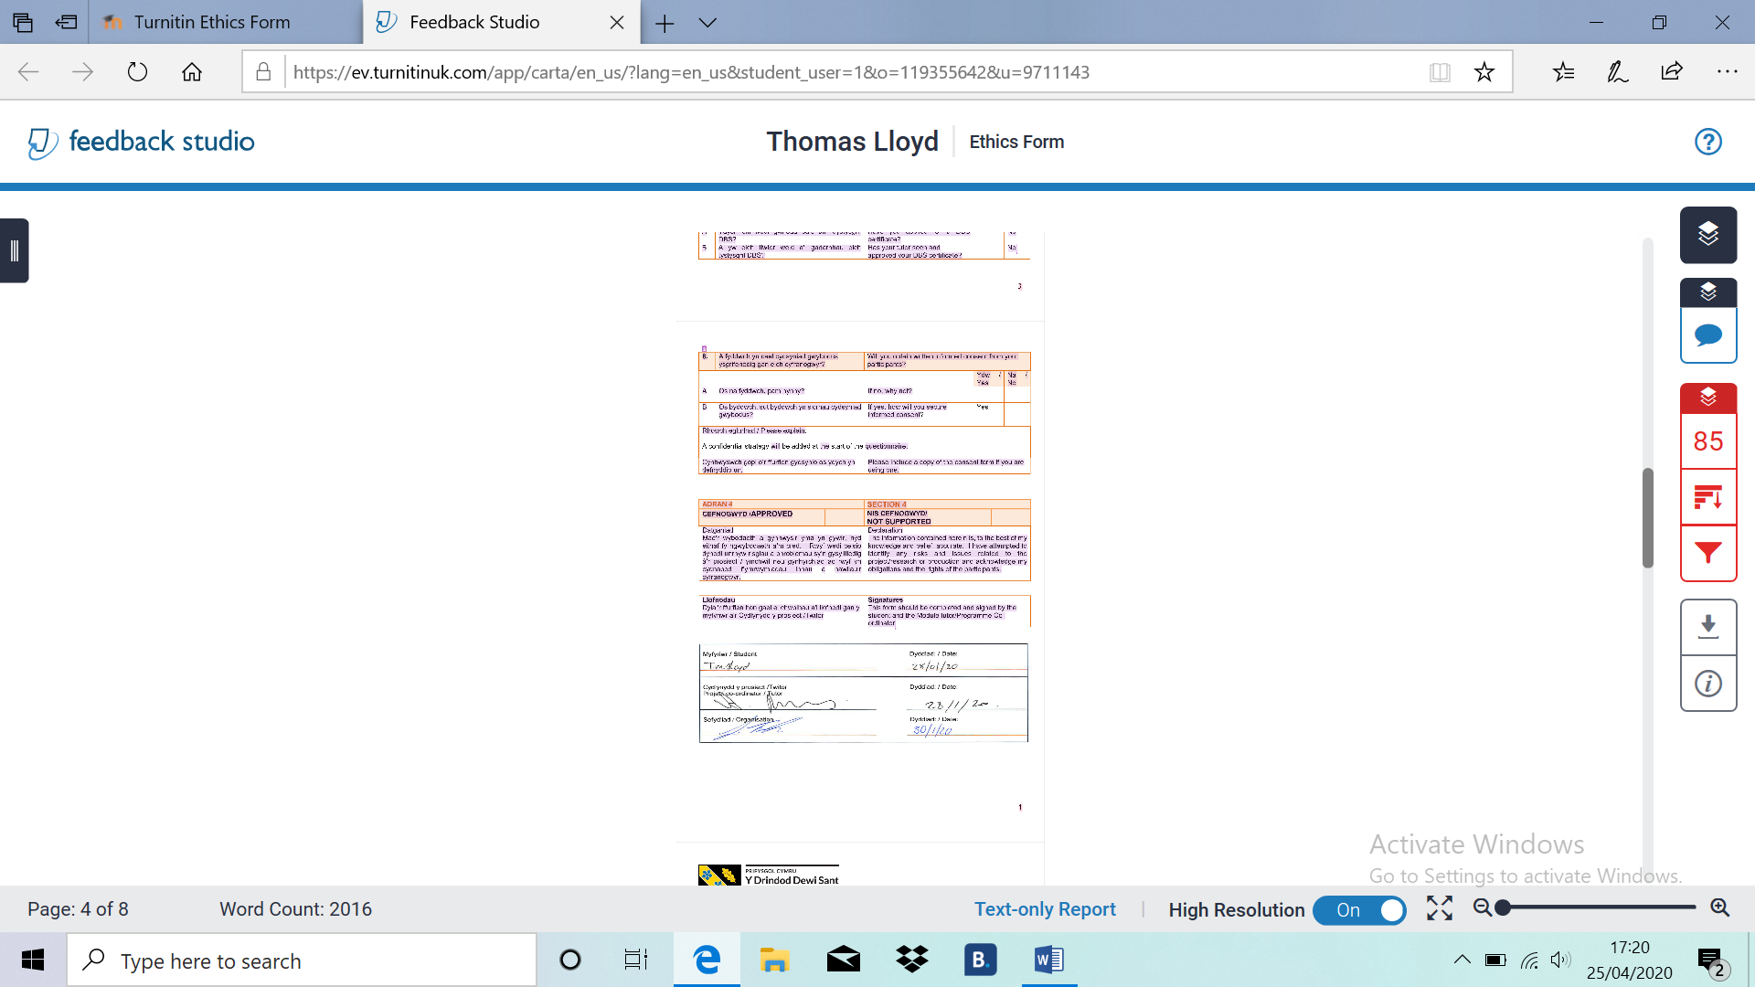

Insert Ethics Form P5 into the table below

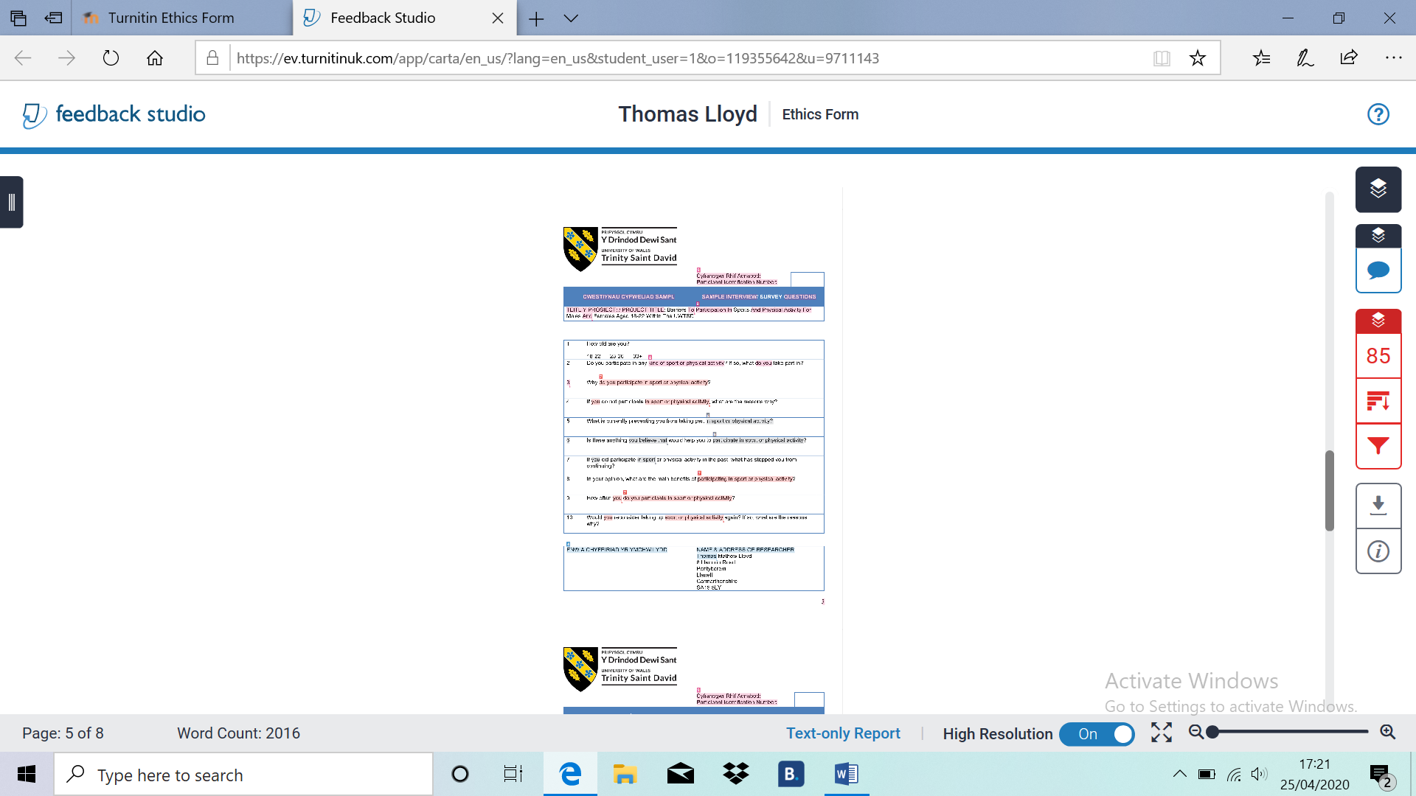

Insert Ethics Form P6 into the table below

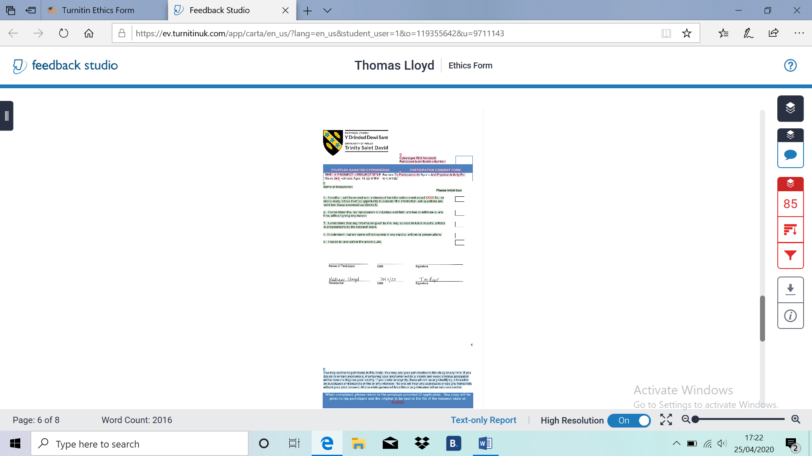

Insert Ethics Form P7 into the table below

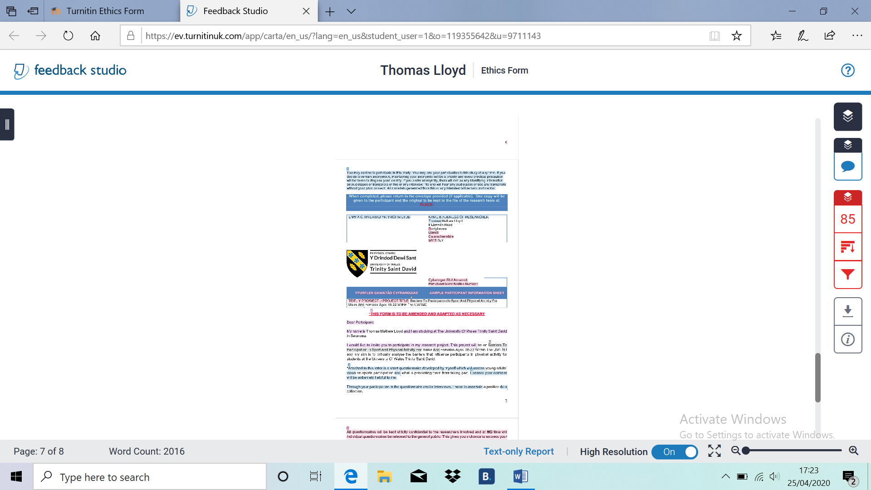

Insert Ethics Form P8 into the table below

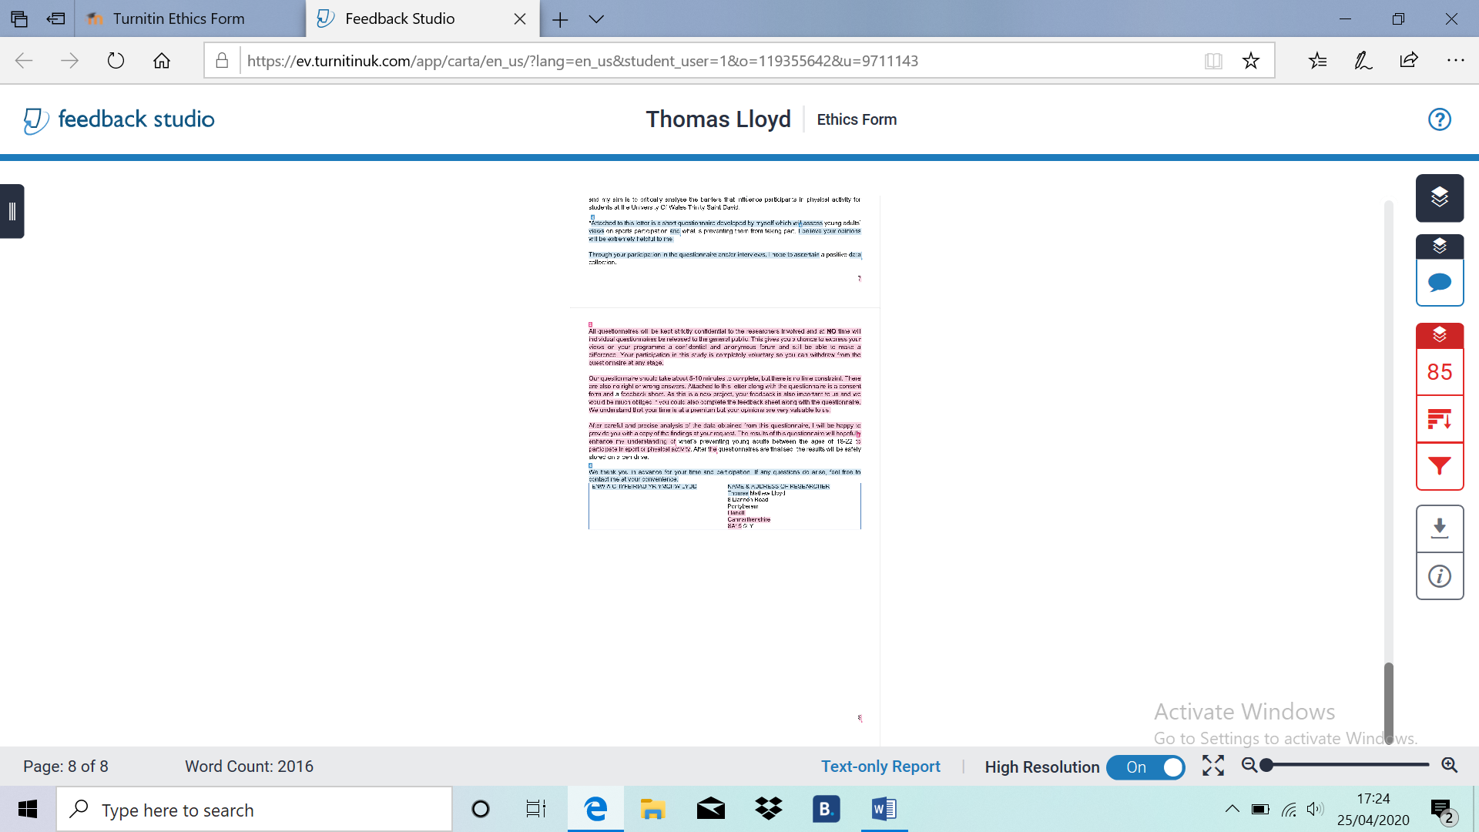

Insert Ethics Form P9 into the table below

Submission Evidence

Faculty Office (1 x Paper Copy, Bind Professionally)
+
Online Turnitin Submission (prior to Deadline)



BA Sports Management Portfolio

Research Project
Report

UWTSDSport

