Programme: BA in Business Management
Module: Project Management
Module code: LCBB5005
NAME OF LECTURER: Dr Molly Jack
STUDENT NAME AND NUMBER: Valentina Georgieva Pencheva - 2023164
WORD COUNT: 2,500 Words (+/- 10%)
Assessment 1

Table of Contents
Introduction 3
Main body 4
Project methodology 4
Project specifications 5
Time 5
Cost 5
Scope 6
Work-breakdown structure 7
Stakeholder management 7
Risk management 9
Project performance evaluation 11
Conclusion 12
References 14

Introduction
Elizabeth Line is one of the most discussed projects in UK due to its significant cost overruns and delays. The project faced severe various challenges which led to many turbulences and concerns. The current essay aims to explore various perspectives of the project management process, emphasising on critical elements, such as project methodology, time, cost, scope, stakeholder management, risk assessment and more. This is considered to be a good foundation for critically evaluating the overall project performance and assessing the different reasons causing the observed project’s inconsistencies and deviations.
Assessing Elizabeth Line is essential due to various reasons, including the importance of the project for increasing quality of transportation in London, as well as the significance of identifying and evaluating mistakes during project completion, so that they can be avoided in the future. The line is expected to carry 200 million passengers per year by increasing London’s rail capacity by 10% (Sandle, 2022). As shown below, the line has 41 accessible stations and ten of them are completely new (South Eastern Railway, 2022). Apart from developing the transportation system of the city, the project is perceived as a main tool for decreasing congestion, crowding and pollution.
Figure 1 – Elizabeth line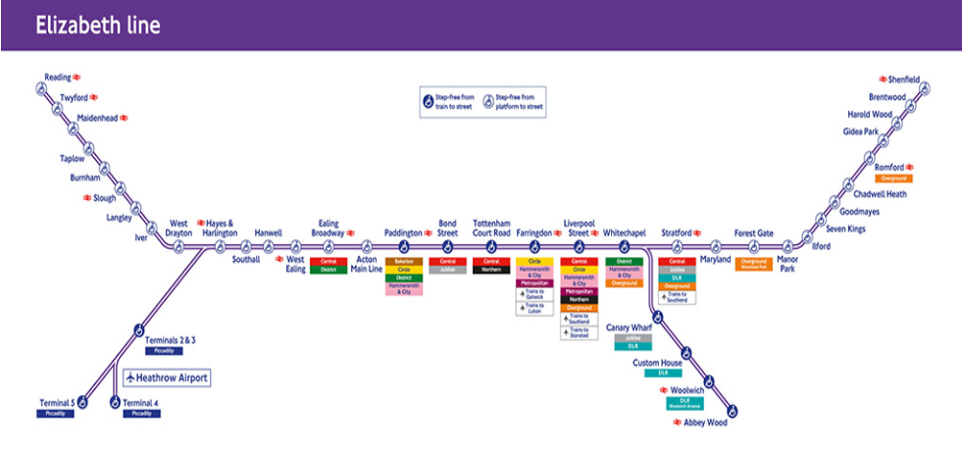
Source: South Eastern Railway (2022)
The project was completed with significant delays and finally finished in 2022; thereby, consuming13 years and an investment of £18.8 billion (calculated with adjusted cost overruns) (Sandle, 2022). This makes it not only one of the largest infrastructure projects in Europe, but also one of the most discussed and debated in terms of project management expertise and decision-making.

Main body

Project methodology
Project methodologies are perceived to be some of the main reasons for project failures or delays which motivate the discussion of the topic. By definition, project methodology is a systematic procedure of selecting a method through which a project is organised and implemented (Muller, 2016). The choice of project methodology is directly related to the success of different projects, as it defines the way through which it is conducted, implemented, monitored and controlled (Muller, 2016).
The top three project methodologies which are usually integrated include Waterfall, Agile and PRINCE2. Waterfall methodology is considered to be the most straightforward and linear approach towards project management which is based on dividing related activities in phases flowing downward (Westland, 2021). It is appropriate for highly structured projects which would lead to much higher costs, if something needs to be changed underway (Westland, 2021). Agile methodology, on the other hand, is based on evolving and collaborative way to organise work across different teams (Westland, 2021). Agile methodology is based on developing an adaptive framework which welcomes changes and allows for adjustments in project elements, so that overall completion is not disturbed. It is often used for software projects which consistently evolve and adapt to new requirements and contexts (Westland, 2021).
PRINCE2 methodology stands for Projects IN Controlled Environments and is a structured certified methodology (Westland, 2021). It was initially developed by UK government for IT projects but is nowadays widely applied for other types, as well. It follows specific principles, themes and procedures which are applied in the specific case of the project under discussion (Westland, 2021). Most likely, this is the project methodology used for Elizabeth Line. This methodology is assumed to be very appropriate for complex projects as different areas of the project are managed separately which tends to decrease risks and increase effectiveness.

Project specifications

Time
Construction of Elizabeth Line started more than 12 years ago back in 2009 and was claimed to be Europe’s biggest infrastructure project at the time (Sandle, 2022). Initially, it was planned to complete the project by the end of 2018. The main reason for the huge delay is claimed to be caused by series of problems with safety testing and signalling systems even before the disruptions caused by the recent pandemic outbreak (Sandle, 2022). In addition to that, the full project is now planned to be finished in May 2023, as currently it operates partially (Weaver, 2022; Crossrail, 2022a). The original timeline of the project is shown below.
Figure 2 – Initial timeline
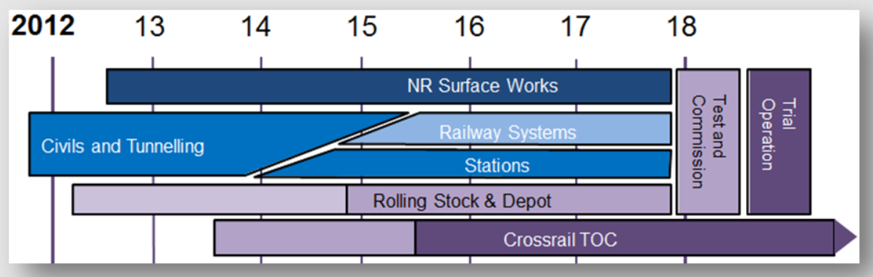
Source: Weaver (2022)
It is interesting to point out that even the 2012 plan indicates a 12-month slip, as passengers cannot be carried until the successful completion of the trial running (Weaver, 2022). This, combined with the assumed time needed for training staff, commissioning and trial operation, shows a potential delay of more than two years (Weaver, 2022).

Cost
As of 2010, the project had a budget of £14.8 billion (Sandle, 2022). Apart from the significant delay of three and a half years, the project was also finalised with a severe cost overrun. As of 2022, the total investment of Elizabeth Line is equal to approximately £18.8 billion (Sandle, 2022). The funding and financing details of the project are shown below.
Figure 3 – Funding and financing of Elizabeth Line
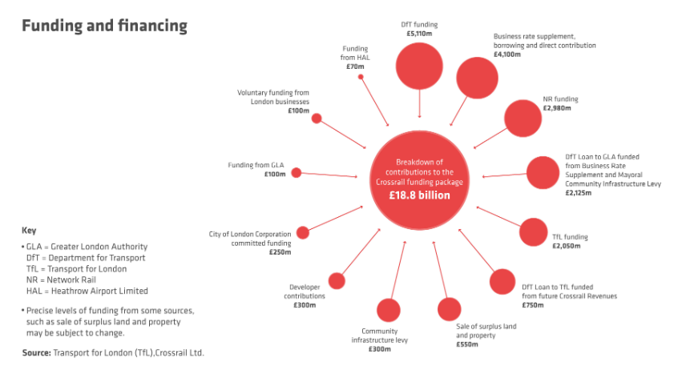
Source: Crossrail (2022b)

Scope
The scope of this infrastructure project is quite extensive. The route has 41 stops, ten of which are new, and comprises a total of more than 100 km in length (South Eastern Railway, 2022). Initially, 12 trains per hour will run in each direction through the middle section of the line which includes 21 km of tunnel (Sandle, 2022). Later in 2022, the central section will be connected to other branches in the east and the west part, allowing services to almost double in terms of scope (Sandle, 2022). In total, 70 new Class 345 trains service the Elizabeth Line (Keay, 2022). The total route of 100 km includes 41 m of tunnels and underground tracks, as well as 59 km above ground lines (Keay, 2022). The trains are all equipped with Wi-Fi, air conditioning and have the capacity of carrying up to 1,500 people each (Keay, 2022). The trains are developed in a way to use 30% less energy than current trains mainly due to better insulation which reduces heat loss (Keay, 2022). The implementation of modern signalling systems will allow expanding the capacity to operating 30 trains per hour (one on every 2 minutes) (Keay, 2022).

Work-breakdown structure
As a part of project planning, a detailed work-breakdown structure has developed, showing all main areas of activities, responsible units and various elements and connections which have to be considered during project implementation. The breakdown structure shows on-network and central section works separately for better comprehension, monitoring and control.
Figure 4 – Work-breakdown structure
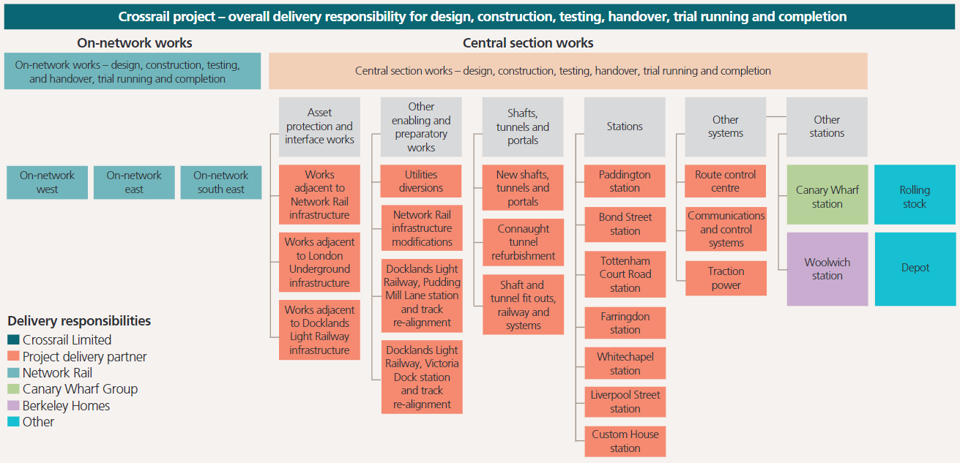
Source: Wright and Palczynski (2017)
The work-breakdown structure is considered as a main factor of influence on project’s success, as it plans and outlines the main areas of works and different links and sequences of operations. If this structure is not prepared in a direct consideration with different alternative risks and potential disruptions, the likelihood for project delays and other inefficiencies delays is considerably higher.

Stakeholder management
Stakeholder management is also essential for ensuring project success, especially in the case of large-scale projects like Elizabeth Line. As discussed by Karlsen (2002), stakeholder groups include all parties which can affect or be affected by the project. In the general case, stakeholders can be internal (directly involved in the project) or external (outside the direct implementation and completion of the project but still interested in and/or affected by it) (Karlsen, 2002). When considering the specific context of Elizabeth Line, examples of internal stakeholders can be the civil engineers, architects, construction site workers, project managers, funding institutions, controlling bodies and many other parties who are directly involved in the implementation of the project and its completion. Examples of external stakeholders would include potential passengers, local communities in the areas of the route, media, private businesses, non-governmental organisations and many more.
Large-scale projects like Elizabeth Line have a very diverse and big range of stakeholder groups which can affect the project. Therefore, the process of properly engaging and managing stakeholders is essential. It starts with an accurate identification and assessment of each alternative stakeholder group. For this purpose, very often, the power-interest grid model is applied. It is based on evaluating various stakeholders in a direct reflection of their potential power and interest in the project and, based on this information, dividing them in four distinctive clusters which define the way their needs and expectations are addressed (Moreno-Marimbaldo and Manso-Callejo, 2020). The model framework is shown below.
Figure 5 – Power-interest grid
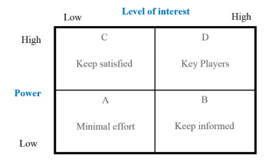
Source: Moreno-Marimbaldo and Manso-Callejo (2020)
The use of this model is very important because stakeholder groups who have high power of influence may directly affect the implementation of the project and thus, should be closely managed and addressed. In the case of Elizabeth Line, it can be stated that key players are governmental bodies who have the power to impose legislative changes that can directly affect the project completion, as well as the organisations responsible for its management and delivery. Stakeholders with high power of influence but relatively low interest include other regulators, investors and the workforce engaged in completing the project activities. Stakeholders with low power and low interest include media and non-governmental organisations. The stakeholders with low power but high interest include potential travellers, private businesses and local communities.

Risk management
Identifying, planning and addressing different risks which can affect the project completion and/or lead to potential deviations from the initial plan and schedules. This is usually performed using the risk matrix model. As discussed by Guo (2015), the risk matrix allows project managers to classify various risks and then develop strategies and programs through which they can be addressed and mitigated.
Table 1 – Risk matrix
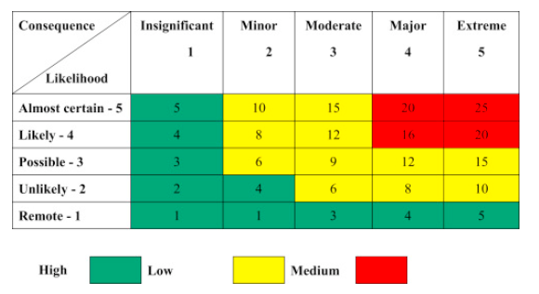
Source: Guo (2015)
In the context of Elizabeth Line, there main risks considered to have highest impact on such projects are the cost overruns and the resulting delays. According to Low (2022), the project got delayed due to unexpected complexities, such as the excavation of archaeological sites on the route. Edwards (2022) also highlights the numerous accidents during construction phases, resulting in four fatal incidents. This combined with collapsing tunnels and other unexpected accidents further delayed and increased the costs of the project.
Hughes (2022) suggests that, according to a whistle-blower, Elizabeth Line trains are also faulty and impose severe risks of serious injuries and even death of passengers. This is associated with the trains being fitted with metal boxes near the passenger doors which risk exploding from a build-up of gas (Hughes, 2022). This has also been confirmed by Transport of London chief, although he denied danger for the public (Talora, 2022). Still, as pointed out by Churchill (2022), this is a risk that has to be addressed, as it can have a severe consequence on the full completion of the project, as well as the utilisation and use of the line afterwards. Other risks are imposed by the fact that Elizabeth Line trains are too long for some stations and they rely on selective door opening which can also cause sufficient problems (Mansfield, 2022). Mulligan (2022) suggests that the biggest risks of the project which are already evident are the significant delays and costs overruns.
Some of the main potential risks and alternative strategies for their mitigation are summarised below.

Table 2 – Risk assessment in the case of Elizabeth line

Risk | Assessment | Strategies
Delay of completion | HIGH | - Develop an accurate plan and adjust it to occurring changes along with close and monitoring of various activities.  - Plan based on conservative approach, allowing greater gaps between tasks.
Cost overruns | MODERATE | - Consider the impact of every change on costs and pre-assigned budget.  - Monitor and control every activity and its potential impact on costs.  - Implement cost control techniques.
Accidents | MODERATE | - Ensure health and safety on site.  - Provide detailed and in-depth training to every worker and require sub-contractors to do the same.  - Assess performance according to health and safety standards and provide feedback.
Poor quality | MODERATE | - Carefully select materials used, subcontractors and workers involved according to the best ratio between price and quality offered.  - Monitor and control performance on a regular basis.  - Compare actual quality on each stage with planned and expected one.

Project performance evaluation
Based on all information presented above, it can be considered that Elizabeth Line project has many areas of improvement and these should be evaluated in order for such risks not to occur in similar projects in the future.
As it has been outlined, the project increased in cost significantly from the planned £14.8 billion to £18.8 billion actual cost (Sandle, 2022). This represents an increase of almost 30% which is a huge difference. This gap indicates potential low quality of cost control and risk management, as the deviations are perceived to be caused by events which could have been better forecasted and managed. Some of the main reasons for the increase in costs include technical complexities, differences between planned and actual compensation plans paid to local businesses, the effects of the pandemic and many more (Edwards, 2022).
The project also failed to be completed on time. Currently, the delay is approximately 2.5 years, but it is expected that the line will be completely finished in 2023, which would further increase it. However, as it has been pointed out previously, the time gap could have been predicted back in 2012 based on the timeline developed back then and the progress of the project at the time. It can be stated that the project failed to comply with this objective.
In terms of quality, it can be suggested that the project is rather successful, as it is developed according to expected standards, with innovative solutions and offers a premium travelling experience (Sandle, 2022).
Although the impacts of some unexpected events, such as the pandemic and fatal accidents, the majority of reasons for significant delays and overruns could have been avoided or mitigated with better project management expertise and competence. Despite the fact that such delays and cost overruns are rather a trend in construction industry, in the current case, most of them could have been better handled. This is suggested to have a positive impact on overall project performance.

Conclusion
Empirical evidence shows severe delays and cost overruns in the case of Elizabeth Line project, the majority of which could have been addressed and mitigated differently. The analysis of the project reveals significant gaps in planning, monitoring and control of project activities and these should be used as an example for future projects of similar sort. The assessment of the project revealed that Elizabeth Line rather failed in terms of time and cost objective but is a success when quality of performance is addressed. Considering the impact of some unexpected events, such as COVID-19 pandemic disruptions and fatal accidents, it can be assumed that the delays and overruns are within acceptable grounds.
However, gaps in project monitoring, control and management should be further evaluated in greater depth, so that they can be avoided in the future. It is recommended that, in other projects, planning is also based on including time buffers between different stages and project activities, so that these can be used in case partial delays occur. Better cost control and adjustment techniques are also recommended, so that such significant overruns are mitigated. Health and safety standards and trainings should also be a priority. Thus, it is possible to achieve not only higher quality, but also improved efficiency in handling potential risks. The Elizabeth line project also demonstrates the importance of being flexible given the fact that the project lasted more than 13 years – a period of major technological, political, economic and other changes. In this context, long-term projects require a periodic re-assessment of assumptions, budgets and schedules. From a practical point of view, it is impossible to accurately predict input costs, regulatory and other external changes for 10 and more years ahead of time. Therefore, decision makers have to conduct a periodic re-assessment of the project plan and respective changes in order to more effectively implement a large-scale project.

References
Churchill, D. (2022) Elizabeth Line Blast Risk: Trains on London’s Pristine New Transport Link Have a Fault That Could Cause Metal Boxes to Fly Off, Whistle-blowers Say, [online] Available: https://www.dailymail.co.uk/news/article-10894425/Trains-Londons-Elizabeth-Line-fault-cause-injury-whistleblowers-say.html [Accessed: 3 September 2022]
Crossrail (2022b) Funding, [online] Available: https://www.crossrail.co.uk/about-us/funding# [Accessed: 2 September 2022]
Crossrail (2022а) Crossrail Project Update, [online] Available: https://www.crossrail.co.uk/news/articles/crossrail-project-update [Accessed: 3 September 2022]
Edwards, T. (2022) Elizabeth Line: How the ‘Perfect’ Project Became a Nightmare, [online] Available: https://www.bbc.com/news/uk-england-london-61409591 [Accessed: 3 September 2022]
Guo, L., (2015) Implementation of a Risk Management Plan, International Journal of Nursing Sciences, Vol. 2(4), pp. 348-354.
Hughes, S. (2022) Crossrail: Fault on Some Elizabeth Line Trains ‘Could Wipe someone Out’ Claims Whistle-blower, [online] Available: https://www.mylondon.news/news/zone-1-news/crossrail-fault-elizabeth-line-trains-24172117 [Accessed: 2 September 2022]
Karlsen, J. (2002) Project Stakeholder Management, Engineering Management Journal, Vol. 14(4), pp. 19-24.
Keay, L. (2022) Elizabeth Line, [online] Available: https://news.sky.com/story/elizabeth-line-years-of-delays-and-billions-over-budget-but-can-crossrail-transform-the-capitals-fortunes-12619900 [Accessed: 3 September 2022]
London Gov (2020) Crossrail: The Project at a Glance, [online] Available: https://www.london.gov.uk/sites/default/files/crossrail_-_project_at_a_glance.pdf [Accessed: 4 September 2022]
Low, H. (2022) Elizabeth Line: What Is It And When Will It Fully Open? [online] Available: https://www.bbc.com/news/uk-england-london-61505172 [Accessed: 4 September 2022]
Mansfield, I. (2022) Elizabeth Line Trains Are Too Long For Some Stations, [online] Available: https://www.ianvisits.co.uk/articles/elizabeth-line-trains-are-too-long-for-some-stations-54856/ [Accessed: 5 September 2022]
Marshall, J. (2020) Crossrail Costs to Top £19 Billion as Bosses Confirm 2022 Opening, [online] Available: https://www.building.co.uk/news/crossrail-costs-to-top-19bn-as-bosses-confirm-2022-opening/5107598.article [Accessed: 3 September 2022]
Moreno-Marimbaldo, F. and Manso-Callejo, M. (2020) Methodological Approach to Incorporate the Involve of Stakeholders in the Geodesign Workflow of Transmission Line Projects, International Journal of Geo-Information, Vol. 9(1), pp. 178-204.
Muller, R. (2016) The Impact of Project Methodologies on Project Success in Different Projects/Environments, International Journal of Managing Project in Business, Vol. 9(2), pp. 1-37.
Mulligan, E. (2022) How Much Did the Elizabeth Line Cost? [online] Available: https://inews.co.uk/news/how-much-did-elizabeth-line-cost-when-crossrail-project-started-delays-explained-1649736 [Accessed: 3 September 2022]
Sandle, P. (2022) London’s $24 Billion Crossrail Finally Opens, [online] Available: https://www.reuters.com/world/uk/londons-24-billion-crossrail-finally-opens-2022-05-23/ [Accessed: 1 September 2022]
South Eastern Railway (2022) The Elizabeth Line is London’s Newest Railway, [online] Available: https://www.southeasternrailway.co.uk/tickets/more-ways-to-travel/elizabeth-line [Accessed: 5 September 2022]
Talora, J. (2022) Elizabeth Line: Tfl Chief Andy Byford Admits Train Fault But Says ‘No Risk’ To Public, [online] Available: https://www.standard.co.uk/news/london/tfl-elizabeth-line-fault-andy-byford-crossrail-whistleblower-door-box-b1005067.html [Accessed: 3 September 2022]
Weaver, P. (2022) London’s Elizabeth Line Now Open (Sort-of), [online] Available: https://mosaicprojects.wordpress.com/2022/05/27/londons-elizabeth-line-now-open-sort-of/ [Accessed: 3 September 2022]
Westland, J. (2021) Top 10 Project Management Methodologies: an Overview, [online] Available: https://www.projectmanager.com/blog/project-management-methodology#:~:text=A%20project%20management%20methodology%20is,work%20while%20facilitating%20team%20collaboration. [Accessed: 3 September 2022]
Wright, S. and Pakzynski, R. (2017) Crossrail Programme Organisation and Management for Delivering London’s Elizabeth Line, Proceedings of the Institutions of Civil Engineers, Vol. 170(CE6), pp. 23-33.

