Lilian Earp - 1800301
An Investigation into the Concept of the ‘Garden’ as the Sacred Landscape of the Afterlife in Ancient Egypt.
An Investigation into the Concept of the ‘Garden’ as the Sacred Landscape of the Afterlife in Ancient Egypt.

The gardens of Ancient Egypt were an essential part of life, providing food, shelter, and often also a religious space. For the Egyptians, the afterlife was an extension of that existence, a chance for immortality. These two aspects of Egyptian life overlapped, with garden representations common in tombs. Wilkinson argues that the Ancient Egyptian Garden “mirrored the features of a mythological landscape, and of the world of the afterlife”. In addition, there is also the argument that a beautiful garden was an essential aspect of relaxing in the afterlife. Nevertheless, not all scholars agree. Farrar states that “many Egyptians included a prayer in their tombs so that after death they might be able to return and sit in the shade of their garden”. This suggests not that the garden should be a reflection of the Field of Peace, but instead that it was a necessary space in both life and death. I argue that that sacredness is applicable to some gardens, such as temple or tomb gardens, but not to all. Some gardens in Ancient Egypt reflect the sacred landscape of the afterlife, whilst others do not.
I will base the discussion of gardens on Gell’s theory of the Technologies of Enchantment. Gell argues that art objects “are beautifully made, or made beautiful”, meaning that objects, or in this case, frescoes and strikingly built gardens, are able to enchant the person who experiences them, “casting a spell over us so that we see the real world in an enchanted form”. Some garden decoration could have the ability to project the enchanted viewer into the space of the afterlife, by surrounding them with decoration that aims to reflect that sacred landscape. A second applied theory is New Materialism, which “emphasizes the materiality of the world”. When considering the question of the sacredness of a space, New Materialism rejects the “distinction between the physical world and the social constructs” and “opens up the possibility to explore how each affects the other”. Considering the relationship between the garden and the sacred landscape of the afterlife, New Materialism demonstrates that the lines between the social construct of the afterlife and the physical garden can be diminished, particularly within a mortuary context or garden designed to reflect the sacred landscape of the afterlife.

Setting the Scene
The ancient Egyptian belief of the afterlife was based on the idea that the deceased would reach the ideal and ever-lasting afterlife after passing through a series of trials to prove their righteousness. This was guided by funerary texts which also provide our knowledge of the Egyptian Afterlife. The Egyptian idea of what we might call paradise had several names, such as the Field of Peace, Field of Reeds, or Field of Offerings. This area included gardens, pools and waterways, all abundant and fertile. Here, the dead continued their lives, able to plow, sow and harvest the fields, and travel along the canals in boats. This mythological garden was the end goal for most, there are clear parallels between the abundance of paradise, and that of the garden. It is important to take into account the symbolism of plants, animals and ornaments within these sacred spaces is crucial, as they give insight into the attached meaning behind the gardens. Different plants would have often been associated with a particular deity. For example, the Temple of Mentuhotep II has a sacred grove consisting of Sycamore and Tamarisk trees which are connected to Hathor and Osiris respectively. This in turn associated Mentuhotep with the daily rebirth of the sun. These symbolic connections between aspects of the garden and the gods mean that it is likely there were distinct symbolic links between the depictions of the Field of Reeds, and the gardens that were built by the Egyptians. Furthermore, Wilkinson argues that the placement of a garden or sacred space was symbolic. Therefore, shrines to Hathor were built across the mountains in which she reputedly lived. Each garden had a symbolic purpose, mimicked by the plants and features in it. Symbolism was an integral aspect in Egyptian religion, and the garden was central to religious life. Wilkinson argues “the whole design of a building and its garden was used to imitate and represent the landscape of their religious mythology”. Certain elements of gardens, such as the enclosure wall, water – often in the form of a central pool – and of course the plants. Garden would take the form of orchards or groves, or were filled with flowers. Therefore, I suggest the following preliminary definition of a garden in Ancient Egypt: a walled plot of land that contains plants with a practical use or a symbolic meaning, and a sacred pool or other form of irrigation.

Gardens in Ancient Egypt
This section aims to analyse the relationship between the Egyptian afterlife, and the gardens of Ancient Egypt. There are numerous examples in Egypt which I argue have been designed in connection with the Field of Reeds. These vary in size, the wealth of owners, and religious settings. Evidence of gardens is given in the form of physical remains, frescoes, and in textual references. Descriptive letters and poetry which mention or describe gardens, such as the garden city of Piramesse can help place gardens within a cultural context.
Furthermore, gardens were not reserved for the rich and elite. Whilst there is evidence for gardens that belonged to the wealthy, there is also evidence for gardens for the workmen and general citizens of Ancient Egypt, such as those in the Workmen’s Village at Amarna. Some examples of these gardens will be discussed, with reference to their association with the afterlife. There are several impressive examples of gardens, that have some degree of connection to the sacred landscape of the afterlife, and these include the Botanical Chamber at Karnak, and Amarna, including the Twin Parks of Maru Aten, the Palace Frescoes, and the Workmen’s Gardens. Furthermore, the Letter of Panbesa and the Tale of Sinuhe are also relevant, since these textual descriptions can help to demonstrate what the ‘perfect’ garden may have been like, or what their connection to the afterlife was.
The important Temple of Amun at Karnak has a separate and self-contained complex – the Ank-menu – at the back of this inner enclosure wall. Masquelier-Loorius argues that part of the Ankh-menu was used in worship of Sokar. Sokar, through his relation to Osiris, is connected to the afterlife. The Botanical chamber, being separate and accessible only by passing through these rooms, does not seem to be connected with Sokar. The walls of this room are beautifully decorated with a frieze of animals, birds and plants, creating an attractive and rich menagerie within the room. This array of plants includes palm, pomegranate, lettuce, and fig trees, as well as creatures such as cow, gazelle, geese, mountain dove, and quail. The ceiling is painted with the night sky. Live animals would have been a part of many gardens and menageries, surrounding the Pharaoh with the living world. In this case, the representations depict the extent of Thutmoses’ empire, the Pharaoh has included examples of animals and plants from conquered lands. However, they may well have the same function. The inclusion of native animals that people were reliant on shows that the decorative garden reflects the needs of life and the afterlife. The gardens of the afterlife were believed to have been full of everything an Egyptian needed to live a full, easy and pleasurable afterlife, including animals such as cows for milk, meat and to plow the fields. Therefore, this chamber would be an example of the delights of a garden and of the afterlife. Considering the originally vivid colours, it would have transported those within – the Pharaoh, Priests of Amun, and the god himself – to a garden. It could have given them a glimpse both of the afterlife that they had aimed to reach, and the lands claimed by Thutmoses. Furthermore, this space clearly was designed to enchant, with the intricately decorated walls and painted ceiling. On the other hand, the dedication texts within the room show that the Pharaoh wanted the representation to be of wildlife found in Retjenu, which is now modern-day Northern Israel. However, Laboury disagrees, arguing that the Botanical Chamber is especially sacred, as it is separate from the rest of the temple, and therefore elevated. This particular sacredness is not due to the connection to the afterlife, but that it was the place of the Initiation Ritual for the Priests of Amun. Egyptian temples would have had a functional garden attached, which would have provided food to feed the priests, as well as offerings to the god of that temple. The Botanical Chamber is not that, it did not exist to be a representation of a working garden, although it may well have provided a space for offerings to be made, but not the offerings themselves. Whilst the Botanical Chamber at Karnak is an impressive depiction of a garden environment within a temple, and is undoubtedly sacred, this sacredness does not have strong links to the Afterlife. Whilst there is a connection, this comes in the form of general worship and mythology associated with Amun, and is not the purpose of this representation of a garden. The Botanical Chamber at Karnak does not reflect the sacred landscape of the afterlife, but was an undeniably sacred space within the sacred landscape of Karnak.
Unlike the Botanical Chamber at Karnak, evidence for gardens and their sacred character at Amarna is extensive and diverse. It stands out due to the evidence for workmen’s gardens, as well as those in the impressive palace complex. Additionally, more private gardens within the palace complex itself can be proven. This demonstrates that gardens were not only an important part of (religious) life for the elite, but that everyone, including those who built the city, would have had access to similar. The range of gardens found at Amarna demonstrates that not all gardens were equally sacred, and that not all gardens reflect the afterlife in the same way.
The Maru Aten twin parks were two walled parks, the larger of which appears to have been built for the royal women. Both contain the typical features of an Ancient Egyptian garden, with lakes, small religious buildings, protective walls, and cultivation plots. Every building within had decorated with scenes of birds, animals and all types of important, beautiful or useful plants, often even across the plaster floors. The construction of the parks hints at their sacred nature, with the northern park having an artificial island that consisted of a small and intricately decorated shrine to Aten. Other evidence of the sacredness of these gardens comes from the name ‘Maru’, meaning sacred place. Furthermore, with the significance of Aten at Amarna, the gardens and palaces were filled with representations of this sun god, highlighting the city’s connection to their deity. These two gardens had been designed to reflect not only the grace of the god Aten, but also the ideal landscape in which he resides. The representations of Aten found within not only make them a sacred space, but highlight the connection to the gods. Like the Field of Reeds, believed to be a place of “rest and abundance”, the Maru-Aten twin parks were a place where visitors could rest, relax, and be surrounded by the light and abundance of Aten. New Materialism suggests that ideas of the ideal/sacred landscape, afterlife, and gods/temples interact, and that each concept should not be looked at as an individual, but as a whole. Furthermore, the god is not the original foundation of these ideas, but one aspect, and the material world influences the social construct of the afterlife. Therefore, the world of ancient Egypt influenced the perception of the afterlife. The garden is a reflection of the world the Egyptians lived in, as is the afterlife.
The palaces and gardens at Amarna contained decorative frescoes. It is assumed that this should compensate for living plants of not yet established full gardens. Amongst the assortment of plants seen in the frescoes of the gardens were Lotus. The symbolism of the Lotus relates to the afterlife, resurrection, and to the Sun god, therefore connecting the gardens further with the afterlife. The frescoes had further advantages; they could have enchanted visitors. This means not that there was a particular spell woven in, but that the beauty and splendour drew the eye, and demonstrated the wealth and power of the ruling class, and the beauty of Aten. As Gell argues in his Theory of Technologies, these frescoes, these objects of art, encourage the viewer to see the beauty, within the world, the gardens, and allow them to experience a taste of the Field of Peace whilst still in this world.
The workmen’s gardens at Amarna were not nearly so grand as the royal gardens outside of the main city. Nevertheless, they served similar functions, although with perhaps more of an immediate focus on feeding the owner. They would have been much smaller, and focused on food over beauty, although of course many plants would have served both functions. One plant likely grown in the workmen’s gardens was the date palm, which in its symbolic meaning was connected with the sun god. This suggests that the gardens of the workmen had at least some connection to the sacred, although this may well have not been their main function. In this case, the garden was less likely to have been designed to enchant, and was more necessary to feed the owner. Therefore, in terms of a place of beauty in which to relax, these simpler gardens do not immediately seem to reflect the afterlife. However, this ignores an essential aspect of the Field of Reeds, that it was a place of abundance in which food grows freely. Nevertheless, this does not necessarily stand up, since readily available food is a requirement for survival, meaning it is absurd to argue that a garden of food reflects the abundance of the afterlife, when the much more reasonable explanation is that an abundant afterlife existed as a reward, an easy continuation after a lifetime of toiling for food.
The range of gardens at Amarna demonstrates the diversity in Ancient Egyptian gardens, from simple personal gardens to extravagant, elite gardens. There are symbolic links within these gardens to the afterlife. However, the extent to which each of these three examples could be considered a sacred garden varies. The workmen’s gardens would have been the least sacred, despite their inherent symbolic meaning. They are necessary to feed the people; however, they still contain the traditional sacred elements of an Egyptian garden. The gardens within the palace, have a more sacred aspect to them. This is more in terms of the relationship to Aten and the sun, than it is to the afterlife.

Textual evidence delivers vague references, as it does not always discuss a specific garden. The letter of Panbesa does not describe an individual garden area, but instead the richness of the city of Piramesse, which includes garden areas within the city. The letter discusses that “life passes in constant abundance … meadows are green with vegetables … irrigated fields … onions and sesame are in the enclosures … The vine, the almond-tree, and the fig-tree grow in the gardens … the red fish is in the lotus-canal … fish are in the pools of the inundation … fruits from the nurseries … flowers from the gardens”. This text describes the city, and the areas that overflow with abundance. Clearly, Piramesse, was a city rich in plants and animals, which required cultivated gardens to support such abundance. Here, it is evident that a garden is not simply a place for pleasure, but a necessity. This particular text does not go into the detail of gardens as a ‘sacred space’, it gives insight into the need for gardens not only to grow food, but to grow such items for worship; “fruits from the nurseries, flowers from the gardens, birds from the ponds, are dedicated to him”. From this, it can be argued that even if the garden in question is geared towards production over worship, the use of plants and flowers produced still links the garden to worship and afterlife, and therefore one could argue that it is still considered a sacred space. The gardens as part of the city enchant the writer, who appears to love the abundance and beauty of a garden city. Yet again, this does not appear to have much relevance to the afterlife, although we are limited by the contents of the letter. While there are clearly sacred spaces within the city, as produce for worship came from gardens attached to temples, without further archaeological detail we cannot understand the gardens of Piramesse any further.
Unlike the Letter of Panbesa, the Tale of Sinuhe discusses the home and mortuary complex afforded to a court official, including mentions of the garden. Whilst the relationship of other gardens to the sacred landscape of the afterlife is dependent on the context, the sacred spaces associated with a mortuary context have a much closer relationship to the Field of Peace. The home is accompanied by a grove, with “all its trees freshly planted”. Furthermore, a mortuary complex was built, “with fields in it and a garden in its proper place”. Whilst there is no further detail, one can assume that it would have followed the same formula as all other Egyptian gardens mentioned above. However, what makes this fictionalised account important is that it highlights the necessity of a mortuary garden, particularly for those who were powerful enough to afford a mortuary complex. Gardens within mortuary complexes (real/physical and painted/decorative) have a stronger connection to the afterlife. Their presence within the mortuary complex is essential, they are reflective of the afterlife. Tomb frescoes often depict the life of the owner, effectively writing themselves into the afterlife, through depiction already in it. They can give insight into how the owner expects to exists in their afterlife. Furthermore, the tomb gardens were a place in which the soul of the deceased found refreshment, with the water not only required to keep plants alive, but as a place where the spirit could stop and drink. A tomb garden not only reflected the sacred landscape of the afterlife, but bought it into this world.

The sacred grove, next to the ‘Red’ Pyramid of Sneferu at Dashur, demonstrates the difficulties faced when growing plants in a hostile desert environment. The trees were planted in pits, which would have been dug into the sand, and filled with soil transported from the edges of the Nile. Because this mortuary complex is so far into the desert, the grove would have been watered by hand, or the trees would have died. Dashur represents one of the earliest sacred groves, from the early 4th Dynasty.

The funerary complex of Ramesses III is another example of the formulaic Egyptian sacred garden. It would have consisted of several enclosures, containing pools, a well, and rows of trees. Whilst the physical evidence for its splendour is lacking, Ramesses describes the complex as; “gardens and arbour areas filled with fruit and flowers ... a lake before them supplied with lotus flowers … planted with trees and vegetation like the delta”. However, this passage suggests that the model for such abundance is not the afterlife, but the rich, Nile-fed Delta to the north. On the other hand, Farrar argues that this connection to the Delta refers to Papyrus beds. Despite this, it seems likely that it could refer to both, that the pools were surrounded by papyrus, and that the general richness of the gardens mimicked the growth found in the Delta.

In conclusion, the evidence that the ancient Egyptian garden was a reflection of the afterlife is mixed, and dependant on the particular garden and its context. This essay has discussed three main arguments that focus on gardens and their sacredness. These are: that all gardens were a reflection of the sacred landscape of the afterlife, that a garden was a necessity, and was not a sacred space, and that the sacredness of a garden differed, depending on the context of that particular garden. It is the final argument that I would say is the most accurate.
The sacredness of the garden in Ancient Egypt was variable. While all have an inherent connection to both this and the afterlife as well as functionality combined with pleasure, not all gardens were built as a sacred space. The gardens depicted within a tomb, had a much closer link to the afterlife, due to the connection with death, the afterlife journey, and rebirth. Those built within a temple complex had their own meaning, and whilst these were undeniably very sacred spaces, they did not necessarily reflect the Egyptian idea of paradise. Other gardens, such as personal or pleasure gardens, had less of a focus on the sacred, but were essential for food, shade and as a space for rest and relaxation. Ancient gardens lacked the clear delineation between necessary use and pleasure that we see today. Furthermore, the gardens of the temples provided a source of income for the temple and its associated cults. Most gardens were multi-use spaces, and that use could change, depending on who the garden was used by.

Image Appendix
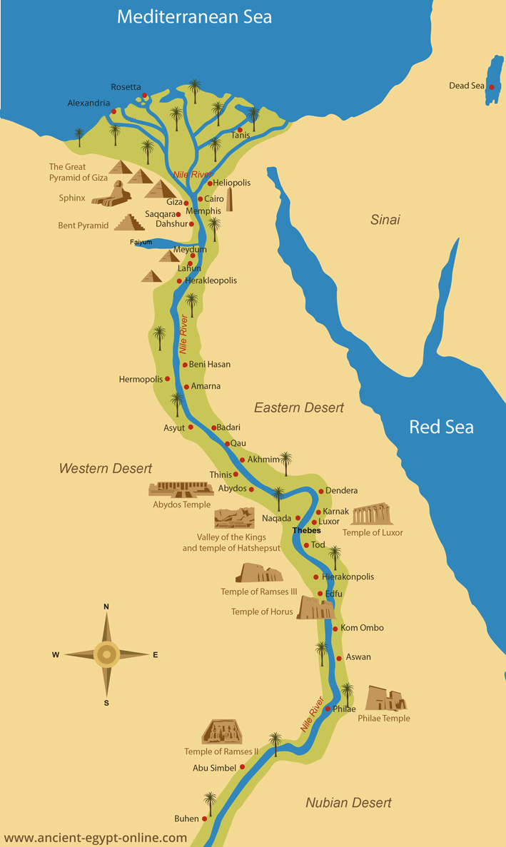
Figure 1: – A Map showing Ancient Sites in Egypt (Ancient Egypt Online)

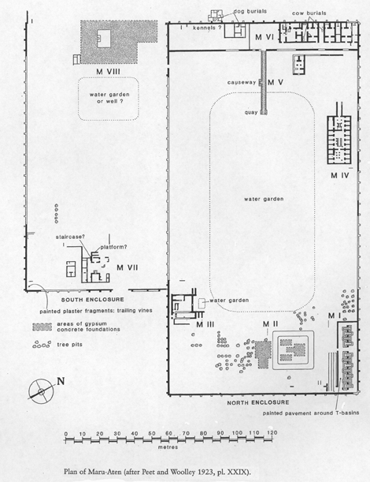
Figure 2: Map of Maru-Aten (Amarna Project, 2017)

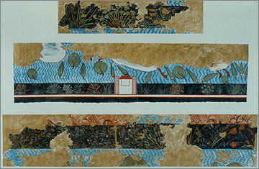
Figure 3: Copy of the North Palace Garden Court Frescoes (Amarna Project, 2017)

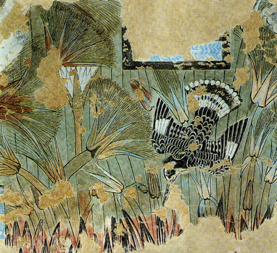
Figure 4: Amarna Fresco, showing a Kingfisher and Reeds. (Time Trips)

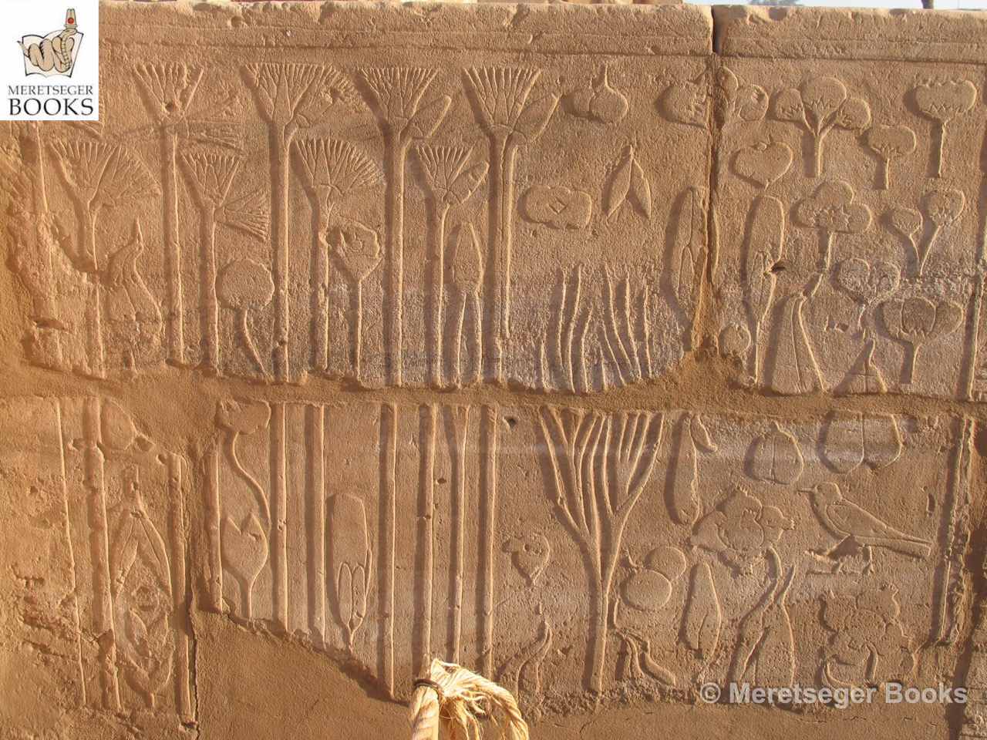
Figure 5: Karnak Botanical Garden (Meretseger Books)

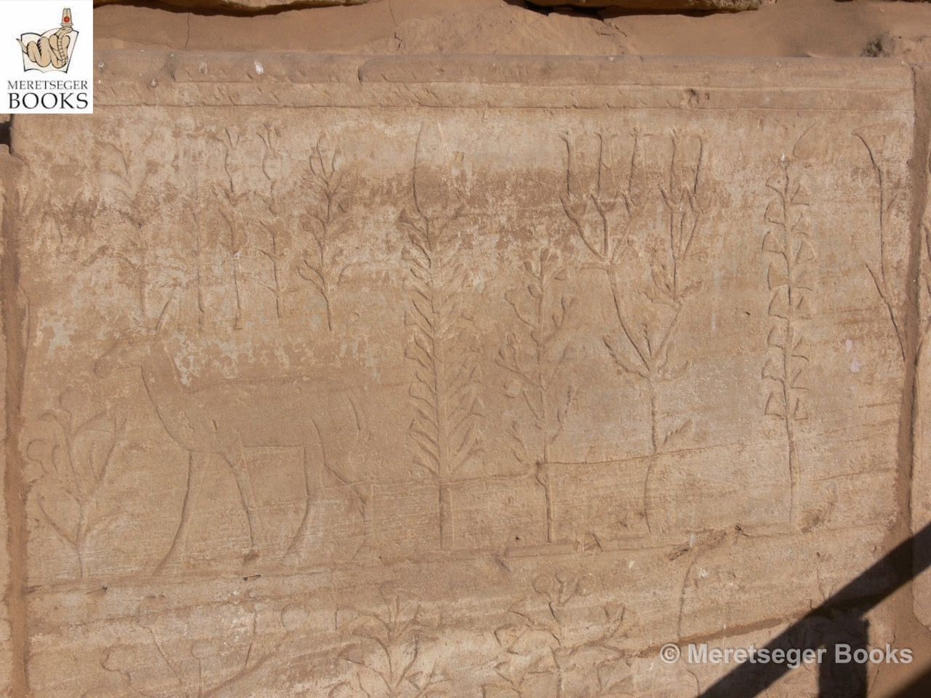
Figure 6: Karnak Botanical Garden (Meretseger Books)

Bibliography
Adams, W.H. (1991). Nature Perfected: Gardens Through History, New York: Abbeville Press
Brugsch, H.K. (2015), A History of Egypt under the Pharaohs, Derived Entirely from the Monuments, Volume 2, Seymour, H, Smith, P [trans], Cambridge: Cambridge University Press
Carroll, M. (2003). Earthly Paradises: Ancient Gardens in History and Archaeology, London: British Museum Press

CULTNAT, (2010), The Botanical Chamber, the Temple of Karnak الحجرة النباتية, [online video] Available at: https://www.youtube.com/watch?v=S9qRw7LUqyE (Accessed: 11th March 2020)
Farrar, L. (2016). Gardens and Gardeners of the Ancient World: History, Myth and Archaeology, Oxford: Oxbow Books
Fox, N.J, and Alldred, P. (2019) ‘New materialism’ In Atkinson, P.A., Delamont, S., Cernat, A., Sakshaug, J.W. and Williams, M. (eds.) SAGE Research Methods Foundations. London: Sage. Available at: https://methods.sagepub.com/foundations/new-materialism (Accessed: 24th April 2020)
Gell, A. (1992) “The Technology of Enchantment and the Enchantment of Technology” in Coote, J. and Shelton, J. Anthropology, Art and Aesthetics, Oxford: Clarendon Press
Grindley, J. (2017). Gardens in Ancient Egypt. Available at: https://blog.liverpoolmuseums.org.uk/2017/04/gardens-in-ancient-egypt/ (Accessed 4th October 2019)
Kelder, J.M, and Cline, E.H, (2018) ‘In the Midst of the “Great Green”: Egypto-Aegean Trade and Exchange’, in Spier, J, Potts, T, Cole, S.E, Beyond the Nile: Egypt and the Classical World Los Angeles: The J. Paul Getty Museum
Laboury, D, (2007) ‘Archaeological and Textual Evidence for the function of the “Botanical Garden” of Karnak in the Initiation Ritual’ in …. Available at: https://www.academia.edu/6281079/Archaeological_and_Textual_Evidence_for_the_Function_of_the_Botanical_Garden_of_Karnak_in_the_Initiation_Ritual (Accessed 15th April 2020)
Masquelier-Loorius, J. (2017) ‘The Akh-menu of Thutmosis III at Karnak. The Sokarian Rooms’ in Rosati, G, Guidotti, M.C, (ed) Proceedings of the XI International Congress of Egyptologists Oxford: Archaeopress Publishing LTD Available at: https://www.academia.edu/15293492/The_Akhmenu_of_Thutmosis_III_at_Karnak._The_Sokarian_rooms (Accessed 15th April 2020)
Mourad, A.L, (2017) ‘Invaders of Obscure Race?’ Understanding the Hyksos, Available at: http://www.asor.org/anetoday/2017/02/invaders-of-obscure-race-understanding-the-hyksos/ (Accessed 29th April 2020)
Parkinson, R, B, (2009) The Tale of Sinuhe and Other Ancient Egyptian Poems 1940 – 1640 BC, Translated by R. Parkinson, 2nd edn, Oxford: Oxford University Press
Taylor, J.H. (2010) Spells for Eternity: The Ancient Egyptian Book of the Dead, London: The British Museum Press
Wallis Budge, E.A. (1905) The Egyptian Heaven and Hell, Peru, Illinois: Open Court Publishing Company
Wilkinson, A. (1994). ‘Symbolism and Design in Ancient Egyptian Gardens’, Garden History, 22(1), pp.1-17. Available at https://www.jstor.org/stable/1586999 (Accessed 4th October 2019)
Wilkinson, A. (1998). The Garden in Ancient Egypt, London: The Rubicon Press

Image Bibliography
Figure 1 – Ancient Egypt Online, Ancient Egypt Maps, Available at: https://www.ancient-egypt-online.com/ancient-egypt-maps.html (Accessed: 3rd May 2020)
Figure 2 – Amarna Project, (2017), Maru-Aten, Available at: http://www.amarnaproject.com/pages/amarna_the_place/maru_aten/index.shtml (Accessed: 3rd May 2020)
Figure 3 – Amarna Project, (2017), North Palace, Available at: http://amarnaproject.com/pages/amarna_the_place/north_palace/index.shtml (Accessed: 3rd May 2020)
Figure 4 – Time Trips, Akhenaten, Available at: https://www.timetrips.co.uk/pharaoh%20akhenaten.htm (Accessed: 3rd May 2020)
Figure 5 – Meretseger Books, ’Karnak-Botanical garden-001’, Botanical garden of Thutmosis III, Available at: https://www.meretsegerbooks.com/gallery/212/botanical-garden-of-thutmosis-iii/ (Accessed: 4th May 2020)
Figure 6 – Meretseger Books, ‘Karnak-Botanical garden-005’, Botanical garden of Thutmosis III, Available at: https://www.meretsegerbooks.com/gallery/212/botanical-garden-of-thutmosis-iii/ (Accessed: 4th May 2020)

Taylor, 2010, pp. 6
Adams, 1991, pp. 34
Wilkinson, 1994, pp. 2
Farrar, 2016, pp. 29
Carroll, 2003, pp. 8
Gell, 1992, pp. 43
Gell, 1992, pp. 43
Fox et al, 2019, pp. 1
Fox et al, 2019, pp. 3
Fox et al, 2019, pp.3
Taylor, 2010, pp.10
Wallis Budge, 1905, pp.42
Taylor, 2010, pp.107
Taylor, 2010, pp.107
Wallis Budge, 1905, pp.44
Carroll, 2003, pp. 61.
Carroll, 2003, pp. 62
Wilkinson, 1994, pp. 2
Wilkinson, 1994, pp. 2
Wilkinson, 1994, pp. 2
Wilkinson, 1994, pp. 2
Wilkinson, 1998, pp.13
Grindley, 2017
Farrar, 2016, pp.15
Farrar, 2016, pp.8
Quoted in Brugsch, 2015, pp. 97
Parkinson, 2009, pp. 21-53
Laboury, 2007, pp. 27
Masquelier-Loorius, 2017, pp. 396
CULTNAT, 2010
Farrar, 2016, pp. 15
CULTNAT, 2010
Masquelier-Loorius, 2017, pp. 395
Wilkinson, 1994, pp. 5
Laboury, 2007, pp. 28
Taylor, 2010, pp. 123
Mourad, 2017
Laboury, 2007, pp. 29
Laboury, 2007, pp. 30
Wilkinson, 1994, pp. 6
Farrar, 2016, pp. 10-11
Farrar, 2016, pp. 30
Farrar, 2016, pp. 10
Farrar, 2016, pp. 10
Wilkinson 150 – 1??
Wilkinson, 1998, pp. 150
Farrar, 2016, pp. 10
Wilkinson, 1998, pp. 146
Taylor, 2010, pp. 107
Wilkinson, 1998, pp. 147
Wilkinson, 1998, pp. 146
Wilkinson, 1998, pp. 99
Gell, 1992, pp. 44
Gell, 1992, pp. 44
Farrar, 2016, pp. 30
Farrar, 2016, pp. 30
Wilkinson, 1994, pp. 2
Farrar, 2016, pp. 31
Quoted in Brugsch, 2015, pp. 97
Quoted in Brugsch, 2015, pp. 97
Parkinson, 2009, pp. 42
Parkinson, 2009, pp. 42
Farrar, 2016, pp. 1
Farrar, 2016, pp. 1
Wilkinson, 1994, pp. 2
Farrar, 2016, pp. 6
Farrar, 2016, pp. 6
Farrar, 2016, pp. 6
Farrar, 2016, pp. 6
Farrar, 2016, pp. 5
Farrar, 2016, pp. 8
Quoted in Farrar, 2016, pp. 8
Quoted in Farrar, 2016, pp. 8
Farrar, 2016, pp. 9
Carroll, 2003, pp. 8
Adams, 1991, pp. 34
Carroll, 2003, pp. 64

