Joshua Lewis (1805618)
Bmsp4004 – Generating Business Data and Analysis
Assignment TWO – Data Analysis and Report
Tutor: Roisin Mullins

Contents:
Page 3………………………………………………………. Introduction
Page 4………………………………………………………. Stages of modelling
Page 5………………………………………………………. Data analytics
Page 6………………………………………………………. Data Visualisation
Page 7………………………………………………………. Spreadsheet Modelling
Page 8………………………………………………………. Weather data file
Page 11…………………………………………………… Prosumer File
Page 12……………………………………………………. Carbon Appliance file
Page 13……………………………………………………. Evaluation
Page 14……………………………………………………Reference list

Introduction
Throughout this assignment I will demonstrate my understanding of essential concepts and principles of modelling and analysing data. To begin I will be looking at the data theory ideas. Secondly, I will demonstrate my use of different functions on four different excel files. I will explain how I used these functions to clean the data on each file. To conclude I will evaluate the strengths and weaknesses of using a spreadsheet for decision making purposes.

Stages of modelling
There are six important steps to consider in the stages of modelling process.
- Recognising a problem
- Defining the problem
- Structuring the problem
- Analysing the problem
- Interpreting results and making a decision
- Implementing the solution
(Evans, 2014)
The most important is being able to recognise a problem in the first place. Without accepting there is a problem you won’t be able to find a solution. After recognising there is a problem you must define what the problem is, this is part or the process in overcoming the problem. Structuring the problem means setting out a plan of goals and objectives and identifying potential problems beforehand. Analytics is one of the most important steps while going through this process. This involves experimentation, you must try different techniques and scenarios to find the correct solution. Interpretation and decision making are down to management, they must understand the limitations of model and the underlying assumptions. Implementation of the solution is when you must apply the results of the model back to the real world.

Data Analytics
Data analytics is the science of analysing raw data and being able to form a conclusion about the information. The majority of techniques and processes have been automated into mechanical processes and algorithms that analyse the data for human consumption. Data analytics is a broad term that encompasses many diverse types of data analysis. Any type of information can be subjected to data analytics techniques to get insight that can be used to improve things. The process involved in data analysis involves several different steps:
- The first step is to determine the data requirements or how the data is grouped
- The second step in data analytics is the process of collecting it. This can be done through a variety of sources such as computers, online sources, cameras, environmental sources, or through personnel.
- Once the data is collected, it must be organized so it can be analysed. Organization may take place on a spreadsheet or other form of software
- The data is then cleaned up before analysis. This means it is scrubbed and checked to ensure there is no duplication or error, and that it is not incomplete.
(Frankenfield, 2019)
Data analytics is important because it allows businesses to make full use of their resources and optimize performance. Business can find more efficient ways of running and storing data by implementing it into a business model. Companies also use Data analytics to analyse consumer trends and satisfaction. Data visualisation tool are important because of the size of ‘big data’ files that currently exist. Data files are becoming increasingly huge, so these tools are essential to analyse them.

Data Visualisation

Data visualisation is the graphical representation of information and data. By using visual elements like charts, graphs and maps, data visualisation tools provide an accessible way to see and understand trends, outliers and patterns in data. (

There are big advantages and benefits of good data visualisation, the visualisation of the data allows users to quickly identify trends, it allows the data to be processed quickly and organises data appropriately. If you were to look at a large spreadsheet of data it would take a while to analyse it, by putting that data into a visualisation format you can analyse it almost instantly. There are a few types of data visualisation such as:
- Charts
- Tables
- Graphs
- Maps
Throughout the spreadsheet files in the assignment I have used a range of data visualisation to present the data I have analysed.

Spreadsheet Models
A model is a program which has been developed to copy the way a system works in real life A model aims to predict events based on the relationship. Modelling works well in spreadsheets because all the calculations have been set up using formulas. So, when you change one value all the values related to it will update automatically.
There are both advantages and disadvantages of models, the upsides are equipment will not be damages during this process and nobody is put in any danger. The models are purely computerised, and it is then up to human implementation to carry through the results and use them in the real world. Models can be run and re run time and time again, allowing for trial and error. If you don’t manage to get the right model first time round you can always re do it. Modifications can be put in place quickly and test can be re-run instantly.
On the other hand, the results will on depend on the quality of the model and how much data is used to process in the first place. Models and simulations can’t completely recreate real life situations and must be interpreted carefully. Training I needed to be able to use and produce top quality models.

Weather data file
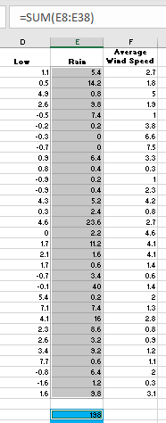
The first data function I used was the SUM function, I used this function to determine the total rainfall. The formula used to get this information was “=SUM(E8:E38)”.
The SUM function is one of the easier functions to use on excel, but it can be very beneficial when used. Using the formula to calculate the sum is important because if any of the numbers changed in the ‘rain’ column, the total sum would automatically update. Whereas if you didn’t use the data function but instead calculated it yourself, if any changes were to occur the total number would not be updated.

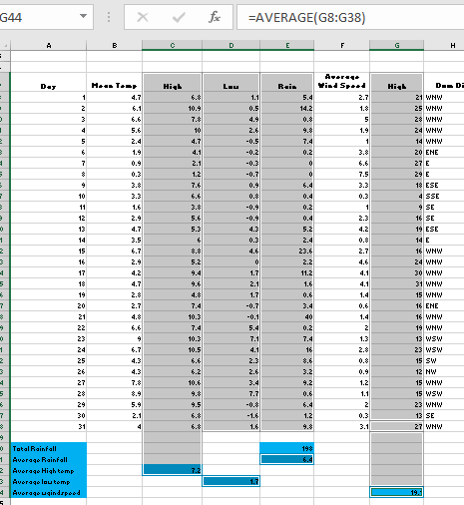
The next function I used on this file was Averages, I used the average function on four occasions to collect different information such as Average rainfall, Average high temp, Average low temp and average Wind speed. One example of a formula I used is “=Average (E8:E38)” The cells would differ depending on what information I want to extract from the spreadsheet.
Similarly, with any data function the importance of using the formula to achieve the answer will enable the information to update automatically if there is a change. Also, if you use one of these answers in another formula, they will all be connected.
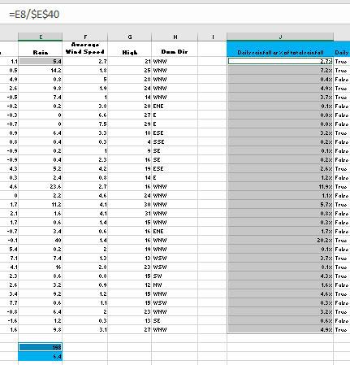
Percentages was another function I used in this file. This function is a little more complex than the first two. Firstly, I wanted to find out the daily rainfall as a % of the total rainfall, to do this I used the total rainfall which I calculated earlier on. The formula I used was “=E8/E40” I also used the F4 function to ensure that the same formula would work for the remaining cells using their own data.
As I explained earlier about the importance of formulas, Because I have used the total rainfall result in this function, if any cell is changed within that column it would automatically update throughout the work.
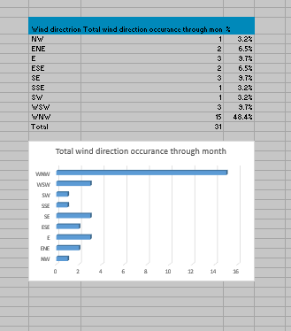
Another example of the use of percentages, I created a table showing the occurrence of wind directions throughout the month. I then turned this data into percentages and produced a bar graph to represent the data. The formula I used was similar to the one previous shown.
To create the bar chart, I highlighted the relevant information and used the insert chart function.

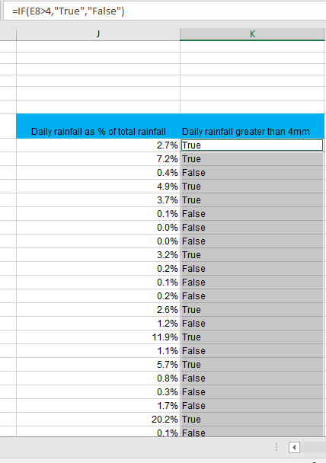
Next, I wanted to ask a question in the database, the question I asked was ‘daily rainfall greater than 4mm’. To gather results for this question I used the IF function.
From the screenshot you can see the formula I used. “=IF(E8>4,”TRUE”,”FALSE”) what this formula means is If the chosen cell (e8) is greater than (>) 4, the answers I used were ‘true’ and ‘false’ although it is possible to use numeric terms if you wanted.
The IF function can be used to gather a range of information throughout the spreadsheet.

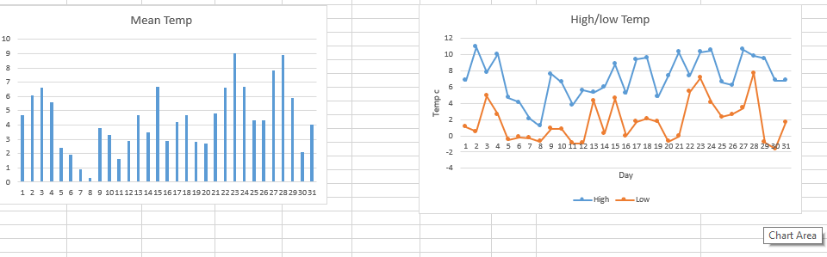
The final tasks I competed on this file was to create a bar chart and a graph chart using the information regarding the temperature. The purpose of charts and graphs is too clearly present data making it easier to read and understand. Once information had been cleaned it can be transferred into bar charts and graphs ready to present.

Prosumer file
The first step I decided to take on the prosumer file was to remove any duplicates; this is a straight forward task which can be done by highlighting all the data then heading to the Filter button in the data tab. I then selected to filter by company name so and duplicates with the same company name would be deleted. I thought this may be necessary because duplicates could be misleading when you are extracting information from the database.

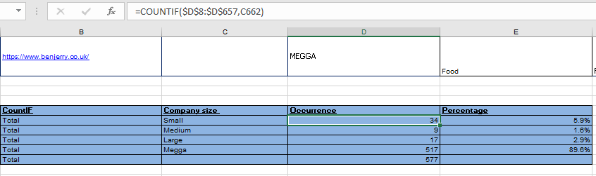
The next thing I wanted to find out was how many times each company size business occurred throughout the database, to do this I decided to use the COUNTIF function. I created this small table and used the formula “=COUNTIF(D8:D657,C662)” I also used the F4 function to make sure the formula was correct for each cell. Additionally, I added an extra column to present the % of occurrence.
The count If is an excellent feature to use, especially on large databases because you can process all the information and present it a manor which is easy to manage. For example, it would be a big task to go through each row and count manually, but this feature does the counting for you and presents the data clearly.
I then turned this information into a Bar chart to present the findings. I used the same method to do this as previously shown.

Appliance Carbon file
In this file I demonstrated my understanding of the VLOOKUP function, I decided to use the VLOOKUP function to present data regarding KG CO2 usage per year on the TV appliances.
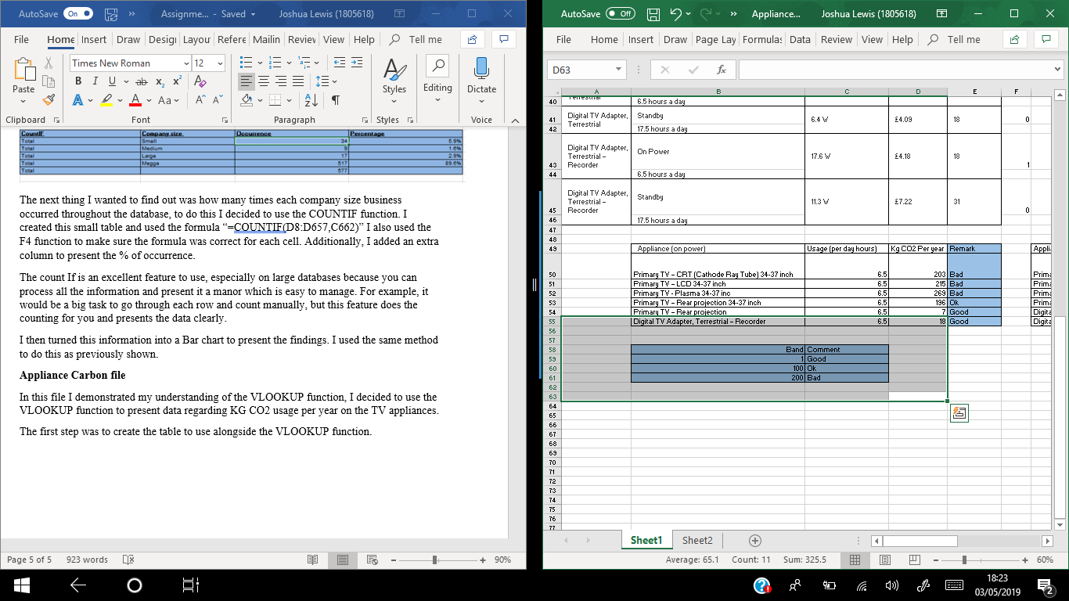
The first step was to create the table to use alongside the VLOOKUP function.
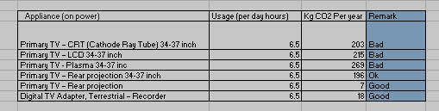
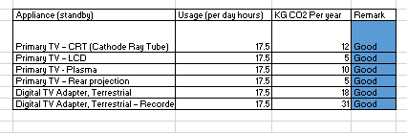
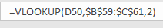
This is the table I created to present the data for the appliances (on power). With the formula I used. I decided to replicate this process and create an equivalent table for appliances (on standby). As shown below.
There are many advantages of using a VLOOKUP function, you can easily find the values in large spreadsheets.

Evaluation
Throughout the report I believe I have demonstrated the use of a range of different formulae. Throughout the four data files I have manged to show my understanding of different functions. As well as extracting data from the files using the different functions, I have managed to express the results well using data visualisation. I have also shown understanding of the theory of the work and explained different features well.
Throughout the report and the data files I would have like to have spent more time on the data files and demonstrated more usage of the functions. Apart form the weather file which I believe I cleaned up well, the other three files only shown minimum amount of data cleaning. Although across all four files I managed to include the majority of functions showing good understanding of extracting data.

Reference list:
Evans, J (2014) Business analytics ‘stages of modelling’.
Frankenfield, J (2019) Investopedia ‘Data Analytics’ https://www.investopedia.com/terms/d/data-analytics.asp

