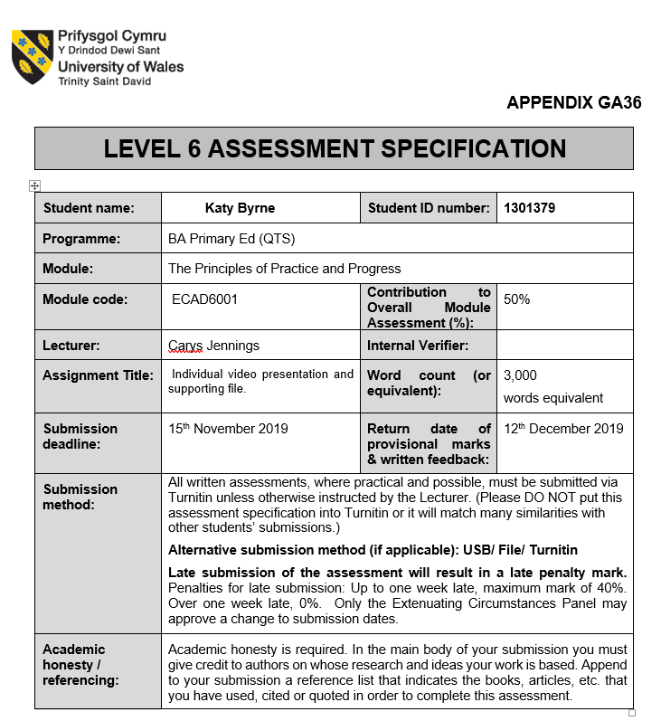

Introduction to the module
This file will propose an intervention focussing on raising the attainment in literacy, numeracy and digital competence of the more deprived children within a primary school setting; the school is located in a highly economically deprived area in Swansea and the children targeted for this intervention will be those receiving free school meals as this is broadly used indicator for children and families who may be living in poverty. It is evident that the purpose of this module is to raise the awareness for students to the other responsibilities that go beyond teaching; highlighting other factors that may place a barrier to children’s learning and progression. By delving into the themes of the module students can get an insight to the barriers and how they are caused and also begin to understand and develop possible solutions or coping mechanisms to either prevent these barriers or aid in overcoming them. This understanding gained through lectures and personal research will benefit students while on professional teaching practice and throughout their professional teaching career. Throughout this module the main aim for students has been to develop a personal understanding of the policies put in place in Wales that relate to supporting children in all aspects of their life, including their education. A variety of elements relating to this have been explored such as: poverty, transitions, multi-agencies support, raising attainment and well-being. Each of these themes can contribute to the progress of a child and it is vital that trainee teachers along with all other stakeholders of a school are aware of their impact and role on a child’s education.

Poverty in Wales
In spite of the ‘Prosperity for All’ strategy (Welsh Government, 2017) and ‘The Well-being of Future Generations (Wales) Act’ which has set well-being goals relating to a creating a “prosperous” and “more equal Wales” (Welsh Government, 2015, p.3), Wales is currently the poorest nation with the United Kingdom (Wales Online, 2013); Wales has 4.1% of the population currently unemployed compared to the 3.95% average in the UK (Statista, 2019). While high unemployment rates can specify the prosperity in an area, it is becoming more common in Wales that many working families are still living in poverty Coughlan (2017). The overall poverty statistics will undoubtably have an effect on the number of children also living in poverty in Wales; currently a third of children living in poverty in Wales (PSE, 2010) and even with the implementation of the ‘Child poverty strategy for Wales’ (Welsh Government, 2015) in 2015 which set out to eradicate child poverty, it appears that the government won’t succeed in achieving their goal by their set date in 2020. Poverty is closely linked to unemployment, poor educational outcomes, poor mental and physical health and strained relationships among families (Barnard, 2018), the ‘Prosperity for All’ strategy (Welsh Government, 2017) recommends that all public sector agencies must work together to eradicate these issues linked to poverty and it is evident that poverty is national focus and the Welsh Government are determined to tackle it and the effect it has on the country.

Poverty and Education
Maslow’s theory of ‘Hierarchy of Needs’ (2013) expresses that a human must have a strong physiological foundation, where their basic needs are met, in order to develop further fulfil needs relating to self-esteem and confidence and go on to self-actualisation in relation to creativity and morality; yet for those families and children who are living below the poverty line their basic and safety needs such as food and a secure home are not being met. This therefore creates a barrier for the development of these children but also for the teachers trying to teach these children as part of mainstream education. It is evident that poverty has a role to play in the educational growth of any child living in deprivation and suitable achievable interventions need to be put into place to support and overcome this barrier.

Proposed Intervention
The proposed intervention is aimed at raising the attainment in literacy, numeracy and digital competence for the more deprived children within the school and will target children receiving free school meals (FSM) by using parental engagement to do so. It is a common practice to measure child deprivation through the number of children receiving free school meals (Northern Ireland Assembly, 2010) however Butler (2013) and (Foster, 2015) argue that this method has now become outdated as many families are now deemed as ‘working poor’ implying that many families are in low paid jobs and are still struggling to pay for their families necessities; Butler (2013) also adds that there are many children entitled to FSM however with the stigma and shame that comes along with accepting this, families are reluctant to accept the support. However, for the purpose of this intervention and the lack of more current policy to measure child poverty, the indicator of FSM will be used to target the pupils in need. This intervention was developed based on the recommendations provided by Estyn in the 2014 report of the intended school, following this recommendation the head teacher concluded that raising attainment for children receiving FSM was to be a key element to the school development plan. Further supporting the necessity to target these children, eradicating child poverty is also a national priority in Wales and such policies have been put in place by the Welsh Government to address this such as ‘Child Poverty Strategy for Wales’ (Welsh Government, 2015) and ‘Education in Wales: Our national mission’ (Welsh Government, 2017). The UNCRC ‘Rights of the Child’ (1989) states that all children have the right to an education and to become the best versions of themselves however, a child suffering in deprivation would face barriers to this right, therefore as the school is rights respecting school this barrier needed urgent attention. The removal of deprivation and child poverty from the ‘Draft Additional Learning Needs Code for Wales’ (Welsh Government, 2018) supports Shaw et al., opinion that poverty is “both a cause and an effect” on special educational needs by not an additional learning need in its own right (Shaw et al., 2016, p.1); Ward (2016) disagrees and states that poorer families are more likely to have children with special needs further arguing the removal of this need from the code of practice. Noting the 5% rise of children receiving FSM within this school, the issue of poverty within the school remains of high priority irrespective of its removal from the code of practice in relation to the school context. It is evident that there is a “persistent under-achievement by those from more deprived and disadvantaged backgrounds” (Welsh Government, 2017, p.23) and in order to combat this shortfall it is vital that parents’ are part of the improvement of their children’s skills while developing their own to end the generational poverty cycle (Egan, 2013, Sime and Sheridan, 2014). As Bronfenbrenner’s ‘Ecological Model of Child Development’ (2009) system presents that two of the closest systems that contribute to a child’s development is family and the classroom it is evident that these to ‘microsystems’ must work in tandem to best support child. Ainsworth (2002) adds that you must change the mindset of a community in order to break the poverty cycle developed over generations, with the lack of positive role models within a family or community who don’t place emphasis on the best outcomes, in all aspects of life, for themselves and their children will also cloud a child’s development in relation to the world around them (Cox, 2000). Therefore, this intervention will focus on the development of skills across the three cross curricular responsibilities (Welsh Government, 2019) for both parents and children; focussing initially on children in a year 5 class and to be implemented to the rest of key stage 2 depending on its success. The sessions will be held after school every two weeks for an hour and 15 minutes, the day to be chosen by parents to best accommodate their schedules; it was important to note that the sessions were not set too close together as to not overwhelm parents as Ellis (n.d) explores one of the possible reasons as to why parents don’t participate as time. The purpose of the intervention is to allow children to put the skills learnt in school into practice in real life contexts by working on tasks that would directly impact the parent’s life such as budgeting, shopping-list writing and developing the parent’s CV writing, for example; a key element that is vital to the proposed new curriculum by Donaldson (2015) who states that skills are best retained when used as part of real life experiences. This method of learning encompasses Vygotsky’s ‘scaffolding’ method in which there is a support given to introduce new skills and removed when understood (Miller, 2011). In turn this will also support the development of skills of the pupil’s parents as they will be working on such tasks that directly impact their lives; a recommendation outlined by Children's Commissioner for Wales as part of the ‘Child Poverty Strategy’ (2012). These types of tasks will also allow the children involved to demonstrate to their parents the skills that they have learnt and are continuing to develop, this places the ownership of the learning onto the children and will deepen the motivation they have during lessons; encompassing the ‘Gradual Release of Responsibility model’ (Frey and Fisher, 2013). Lakin (2013) proposes that this motivation will strengthen the understanding of the learning and allows for a higher chance that the particular skill being learnt will be remembered and correctly used in the future, while Dweck (2012) supports this theory and states that strong intrinsic motivation is vital to the understanding of new skills. The children will also be accessing the first three tiers of ‘Blooms Revised Taxonomy’ (Darwazeh, 2017) as they will first recall the information previously leant, explain to their parents how to complete this new task using those skills and then apply those in a practical manner. Throughout the sessions there will be a considerable focus on guiding parents as how to best support their children at home to further support their education, the will be done on a one to one basis with each parent spending a few minutes discussing methods; this will provide an individualised plan suiting both the parent and child and clear practical strategies that the parents can implement at home (Education Endowment Foundation, 2018). In relation to the content of the sessions, each week will have a different focus (either a literacy, numeracy or digital competence skill) that will be directly linked to what the children have been learning on over the past two weeks since the last session. For instance, it may be a suggestion to request that parents come to the session with utility bills that include percentages, therefore allowing the children to put into practice the fraction work that they have been developing during the mathematics sessions. As Tuggle (2012) notes that many students leave school without the ability to manage money, consequently a task such budgeting finances relating to bills, saving and disposable cash would not only put the fractions work learnt in school into a real-life context for the children but also educate parents as how to best budget, making the task worthwhile for both parties. The majority of the sessions will be child lead, in order for the children to fully put their newly learnt skills into practice, a method of learning that is advocated by the Reggio Approach (2005) and Eisner (2011) as the learning is cemented through experience. As the children will be demonstrating to their parents the process of getting to the correct answer they will clearly display the current methods used in school; as the Family Maths Toolkit website (n.d) outline that mathematics teaching strategies have evolved since the previous generation learnt maths and it is vital that there is clear continuum of methods used at home and at school. An added benefit of ensuring that these sessions are child lead once the task has been outlined, is that it provides time to openly discuss with parents what types of things they would want to be covered within the coming sessions, a recommendation noted by Estyn as part of their good practice report, which recognises a school that values the parents voice (Estyn, 2013). Following the first step of this intervention, possibly to take place in the next term, the vision would be to begin to incorporate these parents in the school community and invite them to participate in school activities during the school day. As these parents would have learnt how best to support their child in activities such as reading, a first step would be to possibly involve them within the Foundation phase of the school to listen to readers with the aim to work their way up through the years within the school. This is fully supported by the Children's Commissioner for Wales as part Child Poverty Strategy (2012) who recommend that activities like this are beneficial for both parents and children. This would provide these parents with school-based work experience utilising the skills they have learnt within the intervention. This could be further extended by asking them to support during school trips and outdoor activities; the additional cost of this would be for the DBS certificate for each individual willing to be involved, however this cost would be outweighed by the added support given to learner by these volunteers. Cooking and fitness classes could also be offered after school as part of the further exploration of this intervention to begin to target the health and well-being aspects that are difficult to achieve for those families living in poverty (Elliot, 2016). Further equipping parents with life-long skills that will allow them to lead by example and positively impact positive physical and mental health of not only themselves but their children also (NHS, 2018). To further support this intervention within whole class teaching time, the theme of the term could revolve around ‘aspirations’, using circle time to talk about dream jobs or what it means to be a good citizen; this theme would encompass one of Donaldson’s (2015) core purposes as well as the Education of Sustainable Development and Global Citizenship framework (Welsh Assembly Government, 2008). Within the further development of this intervention it would be vital to include multi-agency working and include members of the local community such as local PCSO’S, community nurses and local businesses into school, as Kerr et al., (2014) outlines that children must understand their locality as a whole in order to overcome poverty; allowing the children to associate with these upstanding members of the community in order to discuss the importance of education, health and well-being will not only provide the children with positive role models but also enrich the children’s education (Gasper, 2010). To conclude, although this intervention is primarily aimed at raising the attainment of children receiving FSM in literacy, numeracy and digital competence the overall impact goes beyond this. As the intervention includes upskilling parents’ literacy, numeracy and digital competence skills, raising aspirations for children and provides parents with the strategies to support their child in leading healthier life the intervention would then not only impact the academic success of these children but also impact their mental, physical and emotional health and wellbeing. Many of the causes and solutions to generational poverty are addressed within the intervention and by creating initiating a positive change within a school setting that can be implanted at home by parents could possibly aid to the reduced chance that these children will be suck in the poverty cycle.

Evaluation
I found the collection and analysis of documents aspect of the project enjoyable and quickly realised that many of the documents, as they related to poverty in Wales, were linked and supported one another, sharing the same visions. Through this background reading using a range of sources it became extremely effortless to support key points due to understanding of a range of policies in place in Wales. In order to present my intervention, I decided to use iMovie to create my presentation as I had used it previously and was familiar with its working. I found this process very straightforward as the software allowed to me stop and start at various points. In relation to the module I feel that it was a valuable asset towards my professional development in relation to my QTS, as the module provided an insight into the purpose and use interventions in a primary school setting. While on professional teaching practice I observed various interventions however I was unsure as to why and how they had come into being; this topic gave me a clear understanding as to how interventions work from start finish. I have also learned there are many rationales as to why an intervention may be introduced, these may link to school development plans, Estyn reports or wider government policy. I have also noted that through developing my intervention many of the methods and strategies used to implement it apply to the ‘Professional standards for teaching and leadership’ (Welsh Government, 2019); if this intervention were to be applied in a real context the pedagogy standard relating to involving parents and carers in a child’s educational development would be achieved. The leadership descriptor regarding leading programmes and projects would also be applied to this intervention along with the professional learning strand involving wider reading and research. Using this intervention as a tool as to how to progress professionally I feel will really benefit and prepare me for not only my final teaching practice but also my first qualified teaching role. The research process has made me aware that there many other responsibilities that go along with being a teacher and has made me more mindful to factors that go beyond my classroom.

Word count: 2977

Reference list
Ainsworth, J. W. (2002). “Why Does It Take a Village?” The Mediation of Neighbourhood Effects on Educational Achievement, Social Forces 81 (1): 117–152.
Barnard, H. (2018). Poverty in Wales 2018. [online] JRF. Available at: https://www.jrf.org.uk/report/poverty-wales-2018 [Accessed 14 Nov. 2019].
Blake, A. (2013). Wales confirmed as the poorest nation in UK. [online] Wales Online. Available at: https://www.walesonline.co.uk/news/wales-news/wales-confirmed-poorest-nation-uk-1879362 [Accessed 14 Nov. 2019].
Bronfenbrenner, U. (2009). Ecology of Human Development. Cambridge: Harvard University Press.
Butler, P. (2013). Thousands of children ineligible for free school meals but live in 'hidden poverty'. [online] the Guardian. Available at: https://www.theguardian.com/society/2013/mar/07/children-ineligible-free-school-meals-poverty [Accessed 12 Nov. 2019].
Cadle Primary School (2019). Home | Cadle Primary School. [online] Cadleprimaryschool.co.uk. Available at: https://www.cadleprimaryschool.co.uk/ [Accessed 5 Nov. 2019].
Children's Commissioner for Wales (2012). Child Poverty Strategy. [online] Childcomwales.org.uk. Available at: https://www.childcomwales.org.uk/wp-content/uploads/2016/04/CCfW-Child-Poverty-Strategy-2012-e.pdf [Accessed 12 Nov. 2019].
Coughlan, S. (2017). Free meals 'unreliable poverty measure'. [online] BBC News. Available at: https://www.bbc.co.uk/news/education-39479028 [Accessed 12 Nov. 2019].
Cox, D. (2000). Combating Educational Disadvantage. London: Falmer Press.
Darwazeh, A. (2017). A New Revision of the [Revised] Bloom's Taxonomy. Distance Learning, 14(3), 13-28.
Donaldson, G. (2015) Successful Futures. Crown Copyright. Available at: http://gov.wales/docs/dcells/publications/150225-successful-futures-en.pdf [Accessed 13 Oct. 2019].
Dweck, C. (2012). Mindset. London: Robinson.
Education Endowment Foundation (2018). WORKING WITH PARENTS TO SUPPORT CHILDREN’S LEARNING. [online] Educationendowmentfoundation.org.uk. Available at: https://educationendowmentfoundation.org.uk/public/files/Publications/ParentalEngagement/EEF_Parental_Engagement_Guidance_Report.pdf [Accessed 12 Nov. 2019].
Egan, D. (2013). POVERTY AND LOW EDUCATIONAL ACHIEVEMENT IN WALES: STUDENT, FAMILY AND COMMUNITY INTERVENTIONS. [online] Jrf.org.uk. Available at: https://www.jrf.org.uk/sites/default/files/jrf/migrated/files/wales-education-poverty-summary.pdf [Accessed 5 Nov. 2019].
Eisner, E. (2011). The arts and the creation of mind. New Haven: Yale Univ. Press.
Elliot, I. (2016). Poverty and mental health. [online] Mentalhealth.org.uk. Available at: https://www.mentalhealth.org.uk/sites/default/files/Poverty%20and%20Mental%20Health.pdf [Accessed 12 Nov. 2019].
Ellis, J. (n.d.). Reasons Parents Don't Participate in School Activities | Synonym. [online] Classroom.synonym.com. Available at: https://classroom.synonym.com/reasons-dont-participate-school-activities-7902836.html [Accessed 12 Nov. 2019].
Estyn (2013). Parents take an active part in school life. [online] Estyn.gov.wales. Available at: https://www.estyn.gov.wales/effective-practice/parents-take-active-part-school-life [Accessed 12 Nov. 2019].
Estyn (2014). A report on Cadle Primary School. [online] Primarysite-prod-sorted.s3.amazonaws.com. Available at: https://primarysite-prod-sorted.s3.amazonaws.com/cadle-primary-school/UploadedDocument/4b9c6e9e10624a5eb212251a07c7fb12/cadle-inspection-june-2014.pdf [Accessed 5 Nov. 2019].
Estyn (2017). Building partnerships to improve aspirations and outcomes in science and technology | Estyn. [online] Estyn.gov.wales. Available at: https://www.estyn.gov.wales/effective-practice/building-partnerships-improve-aspirations-and-outcomes-science-and-technology [Accessed 12 Nov. 2019].
Family Maths Toolkit (n.d.). Current maths teaching methods | Family Maths Toolkit. [online] Familymathstoolkit.org.uk. Available at: https://www.familymathstoolkit.org.uk/current-teaching-methods [Accessed 12 Nov. 2019].
Foster, D. (2015). On the edge: the working families who struggle to make ends meet | Dawn Foster. [online] the Guardian. Available at: https://www.theguardian.com/society/2015/may/27/working-families-struggle-make-ends-meet-poverty-liverpool [Accessed 14 Nov. 2019].
Frey, N. and Fisher, D. (2013). Gradual Release of Responsibility Instructional Framework. [ebook] ASCD. Available at: https://pdo.ascd.org/lmscourses/pd13oc005/media/formativeassessmentandccswithelaliteracymod_3-reading3.pdf [Accessed 14 Nov. 2019].
Gasper, M. (2010). Multi-agency working in the early years. London: SAGE.
Kerr, K., Dyson, A. and Raffo, C. (2014). Education, disadvantage and place. Bristol: Policy Press.
Lakin, L. (2013) Developing Independent Learning in Science. Maidenhead. OU Press.
Maslow, A. (2013). Theory of human motivation. [Place of publication not identified]: Black Curtain Press.
Miller, R. (2011). Vygotsky in perspective. Cambridge ; New York: Cambridge University Press.
NHS (2018). What can I do if my child is very overweight?. [online] nhs.uk. Available at: https://www.nhs.uk/live-well/healthy-weight/very-overweight-children-advice-for-parents/ [Accessed 12 Nov. 2019].
Northen Ireland Assembly (2010). Free School Meal Entitlement as a measure of deprivation. [online] Archive.niassembly.gov.uk. Available at: http://archive.niassembly.gov.uk/researchandlibrary/2010/19110.pdf [Accessed 12 Nov. 2019].
PSE (2010). Wales has worst child poverty in UK | Poverty and Social Exclusion. [online] Poverty.ac.uk. Available at: http://www.poverty.ac.uk/report-wales-child-poverty/wales-has-worst-child-poverty-uk [Accessed 12 Nov. 2019].
Shaw, B., Bernardes, E., Trethewey, A. and Menzies, L. (2016). Special educational needs and their links to poverty. Joseph Rowntree Foundation.
Sime, D. and Sheridan, M. (2014). ‘You want the best for your kids’: improving educational outcomes for children living in poverty through parental engagement. Educational Research, 56(3), pp.327-342.
Statista (2019). Unemployment rate of Wales 2018 | Statista. [online] Statista. Available at: https://www.statista.com/statistics/529486/unemployment-rate-of-wales/ [Accessed 14 Nov. 2019].
Thornton, L. and Brunton, P. (2005). Understanding the Reggio approach. London: David Fulton.
Tuggle, K. (2012). Teaching Gap: 83% of Teens Don’t Know How to Manage Money. [online] Fox Business. Available at: https://www.foxbusiness.com/features/teaching-gap-83-of-teens-dont-know-how-to-manage-money [Accessed 12 Nov. 2019].
United Nations General Assembly (1989). The United Nations Convention on the Rights of the Child.
Ward, H. (2016). Children from poor families 'twice as likely' to have special needs. [online] Tes. Available at: https://www.tes.com/news/children-poor-families-twice-likely-have-special-needs [Accessed 13 Nov. 2019].
Welsh Assembly Government (2008). Education for Sustainable Development and Global Citizenship. [online] Hwb.gov.wales. Available at: https://hwb.gov.wales/storage/eaf467e6-30fe-45c9-93ef-cb30f31f1c90/common-understanding-for-school.pdf [Accessed 14 Nov. 2019].
Welsh Government (2017). Prosperity for All: the national strategy. Cardiff: Crown.
Welsh Government (2018). Draft Additional Learning Needs Code for Wales. [online] Gov.wales. Available at: https://gov.wales/sites/default/files/consultations/2018-12/draft-additional-learning-needs-code-for-wales_0.pdf [Accessed 10 Nov. 2019].
Welsh Government (2019). Draft Curriuculum for Wales 2022: Languages, Literacy and Communication - Hwb. [online] Hwb.gov.wales. Available at: https://hwb.gov.wales/draft-curriculum-for-wales-2022/languages-literacy-and-communication/ [Accessed 29 Oct. 2019].
Welsh Government. (2019) Professional standards for teaching and leadership. Cardiff: Crown. Available at: https://hwb.gov.wales/storage/19bc948b-8a3f-41e0-944a-7bf2cadf7d18/professional-standards-for-teaching-and-leadership-interactive-pdf-for-pc.pdf

Appendix
Appendix 1 School Development Plan
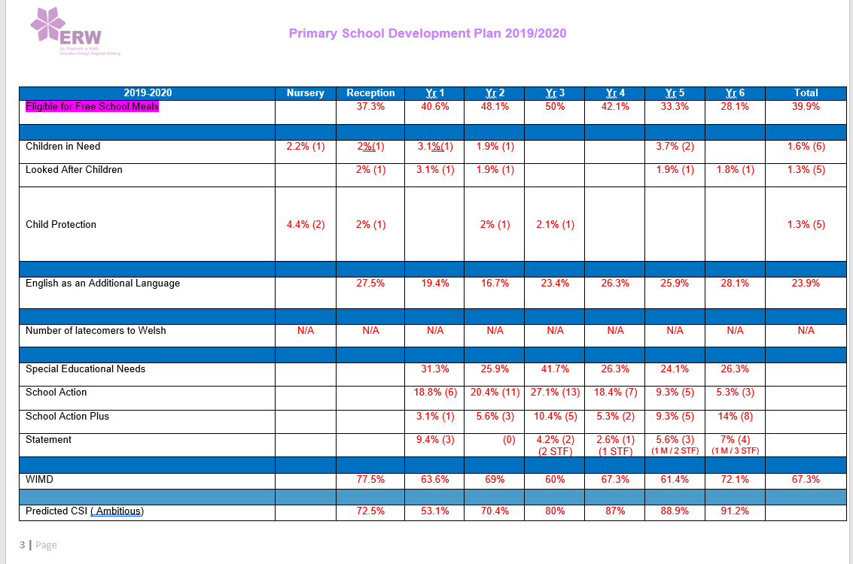
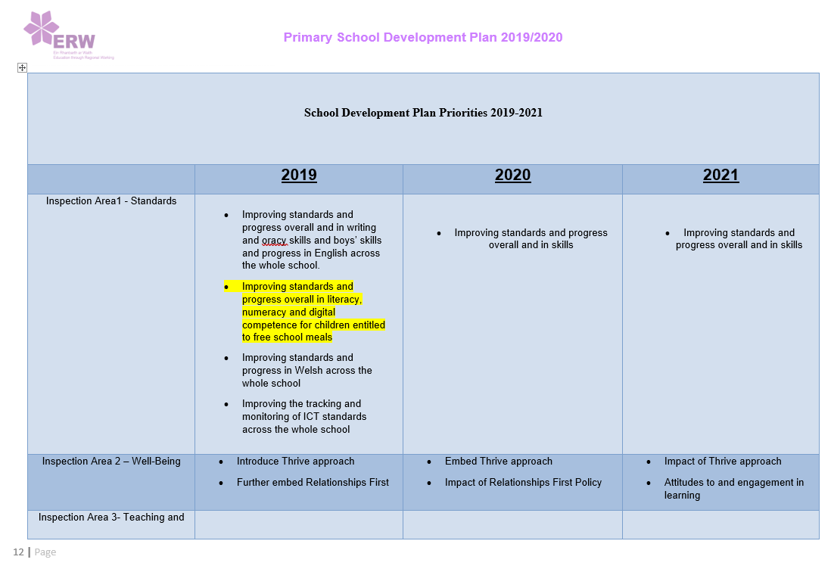
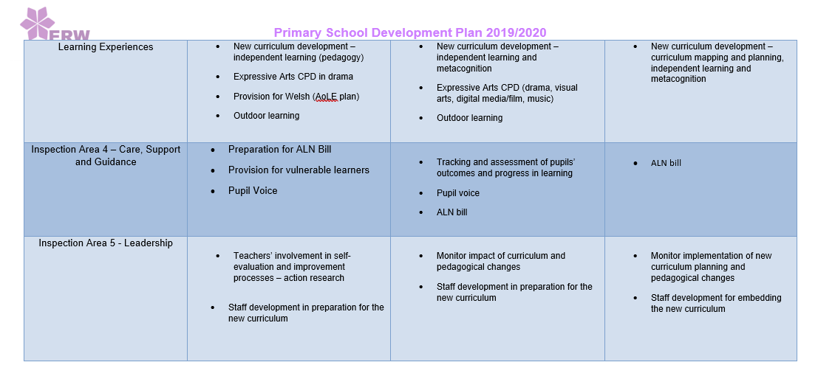
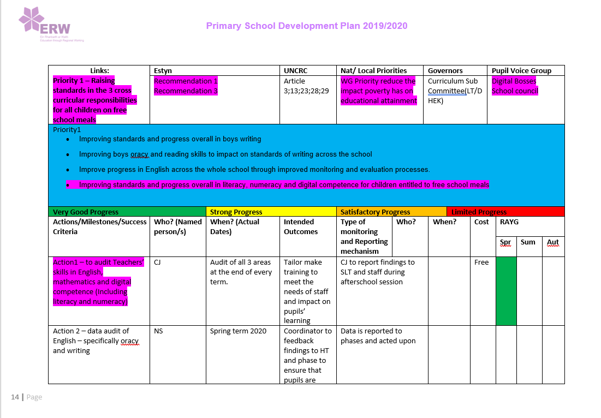
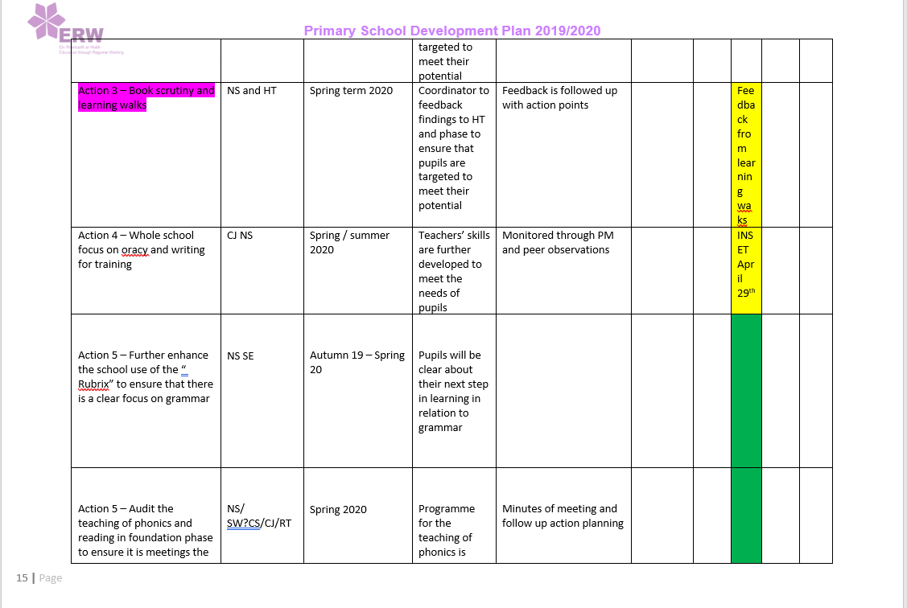
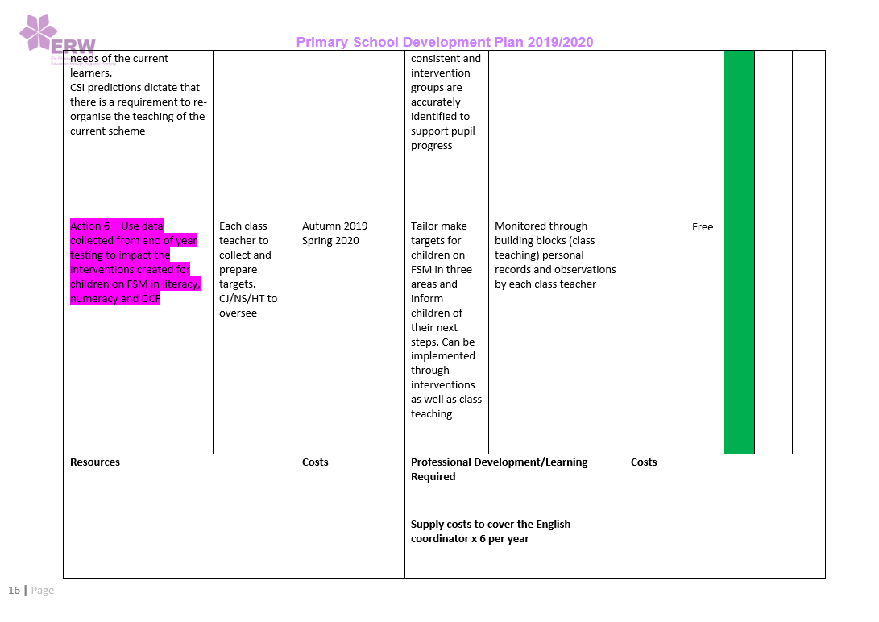

Appendix 2 School context from Estyn
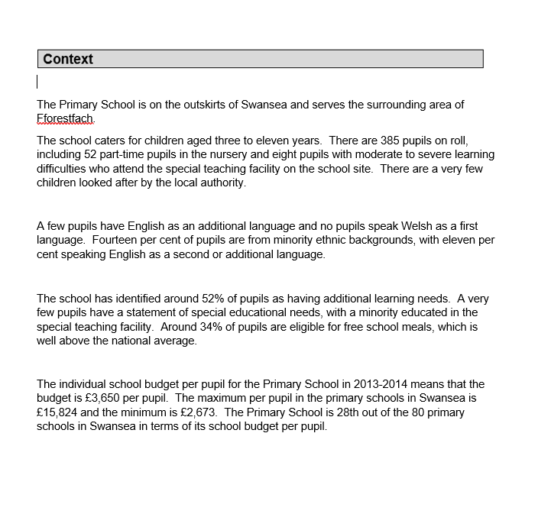

Appendix 3 Estyn recommendations for school
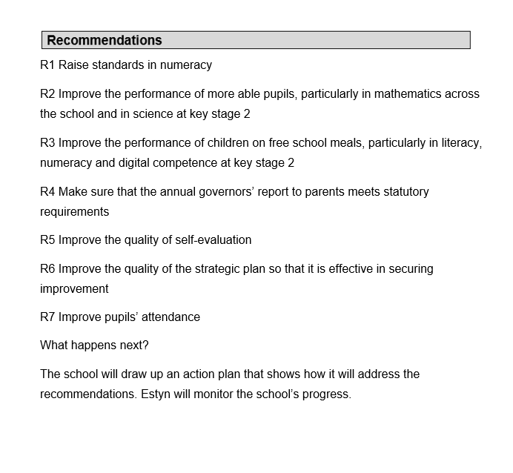
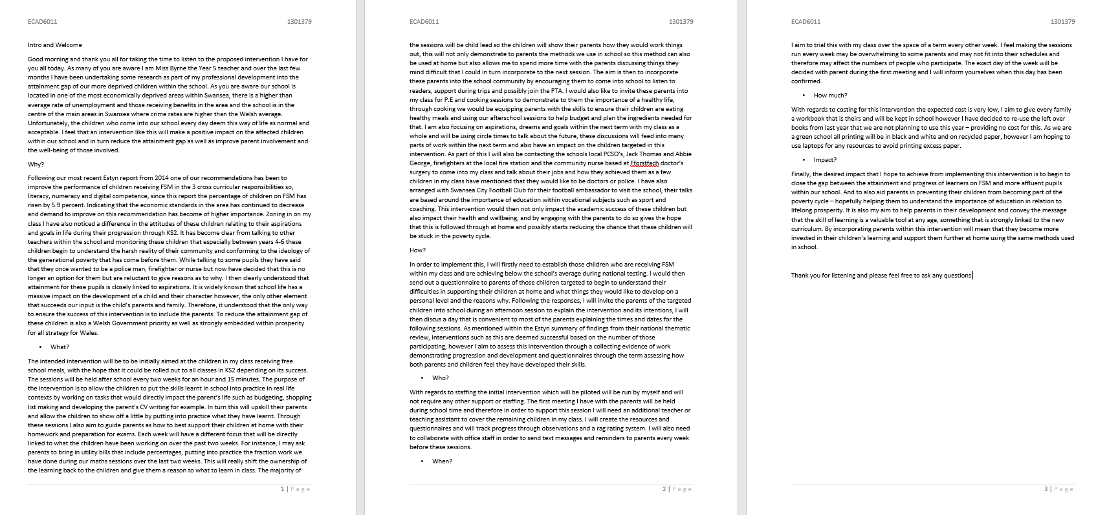
Appendix 4 Script

