SamanthaJade Williams – 2205436
Electrical Engineering – ACDA5001
Analysis of an RLC network

Abstract 3
Introduction 3
Method 3
Results 6
Discussion 8
Conclusion 10

Abstract
The power factor correction section of the assignment required the power factor correction circuit to be built using values specified in the brief. The brief also specified that a power factor of 0.95 or above must be reached after power factor correction, and in the case of an initial power factor of 0.95, the power factor after power factor correction must be above 0.95. The next section of the assignment asked for analysis of phasor diagrams at varying states including at resonance, 25Hz both above and below resonance and at 50Hz. The final section required a description of the relationships between the power factor correction and resonance, maximum power transfer and energy efficiency. The initial calculated value for power factor was 0.95, meaning that the required power factor needed to be above this value. The power factor after power factor correction was 0.9999.

Introduction
Resonance in a Power Factor Correction (PFC) circuit occurs when the inductance and capacitance create a parallel resonant circuit, amplifying harmonic frequencies. This can lead to high currents, voltage stress, and decreased efficiency. Proper design, including damping and harmonic filtering, is crucial to prevent these issues. Power Factor Correction (PFC) improves the efficiency of electrical systems by aligning voltage and current phases. It reduces energy losses, lowers costs, and prevents system overloads. PFC uses capacitors, inductors, or active components to correct the power factor, enhancing system stability. The Maximum Power Transfer Theorem states that maximum power is transferred when the load impedance matches the source impedance. In Power Factor Correction (PFC) circuits, this concept is crucial for efficient energy transfer. Matching impedances minimizes energy losses, improves system efficiency, and ensures optimal power delivery. Proper component selection in PFC circuits (capacitors, inductors, etc.) helps achieve impedance matching, enhancing power factor and reducing operational costs while improving the overall performance of the power system. In AC circuits, power factor correction (PFC) improves efficiency by adjusting the phase relationship between current and voltage. RLC networks (resistors, inductors, and capacitors) are used to correct power factor. Inductive loads cause a lagging power factor, which capacitors can counteract by leading the current. Resonance in RLC circuits can also help optimize power transfer. Active PFC circuits use active components to dynamically improve power factor, especially in complex systems with harmonic distortion.

Method
For Task 1, the circuit was designed with the following values:
- $R_{src}$(source resistance) = 2.2Ω
- Load Inductor (L) = 54 mH
- Load Resistor (R) = 36Ω
The circuit was a power factor correction (PFC) circuit, designed to improve power system efficiency by reducing the phase difference between voltage and current. Initially, a graph of load voltage versus current was plotted to determine the phase difference (ϕ) before power factor correction. This phase difference indicates how much of the supplied power is being used effectively, with a power factor of 1 meaning that nearly all power is utilized efficiently.
To calculate active power, the formula used was:
$P=VICos\left(ϕ\right)$ where P is the active power, V is the load voltage, I is the current, and cos(ϕ) is the power factor.
Next, reactive power was calculated using:
$Q=VISin\left(ϕ\right)$ where Q represents the reactive power, which is the power oscillating between the source and the load.
The apparent power S, which is the total power supplied to the circuit, was calculated as:
$S=VI$
This represents the sum of both real (active) and reactive power. With these calculations, the goal was to improve the power factor to above 0.95. To do this, the resistor current ($I_{R}$) was calculated using:
$$I_{R}=Cos\left(ϕ\right)I_{LR}$$
This value was then used to find the total current $I$ using:
$$I=I_{R}Cos\left(ϕ\right)$$
The capacitor current ($I_{C}$) was then calculated, followed by the capacitive reactance ($X_{C}$), using:
$$X_{C}=\frac{V}{I_{C}}$$
Finally, the required capacitance ($C$) was found by rearranging the formula for capacitive reactance:
$X_{C}=\frac{1}{2πfC}$ where$f$ is the supply frequency. The capacitor value was chosen to correct the power factor and bring it above the target of 0.95, improving the overall efficiency of the circuit.
The initial power factor was calculated by finding the phase angle using $ϕ=\frac{t}{T}$ where $t$is the phase difference and $T$is the time for a complete cycle. The value for $ϕ$is then used in the equation $PF=Cos\left(ϕ\right)$. The values for both $t$and $T$were both found using the waveforms shown in figure 1. After the capacitor value ($C$) was calculated, the value was inserted into the circuit and the waveform documented in figure 2.
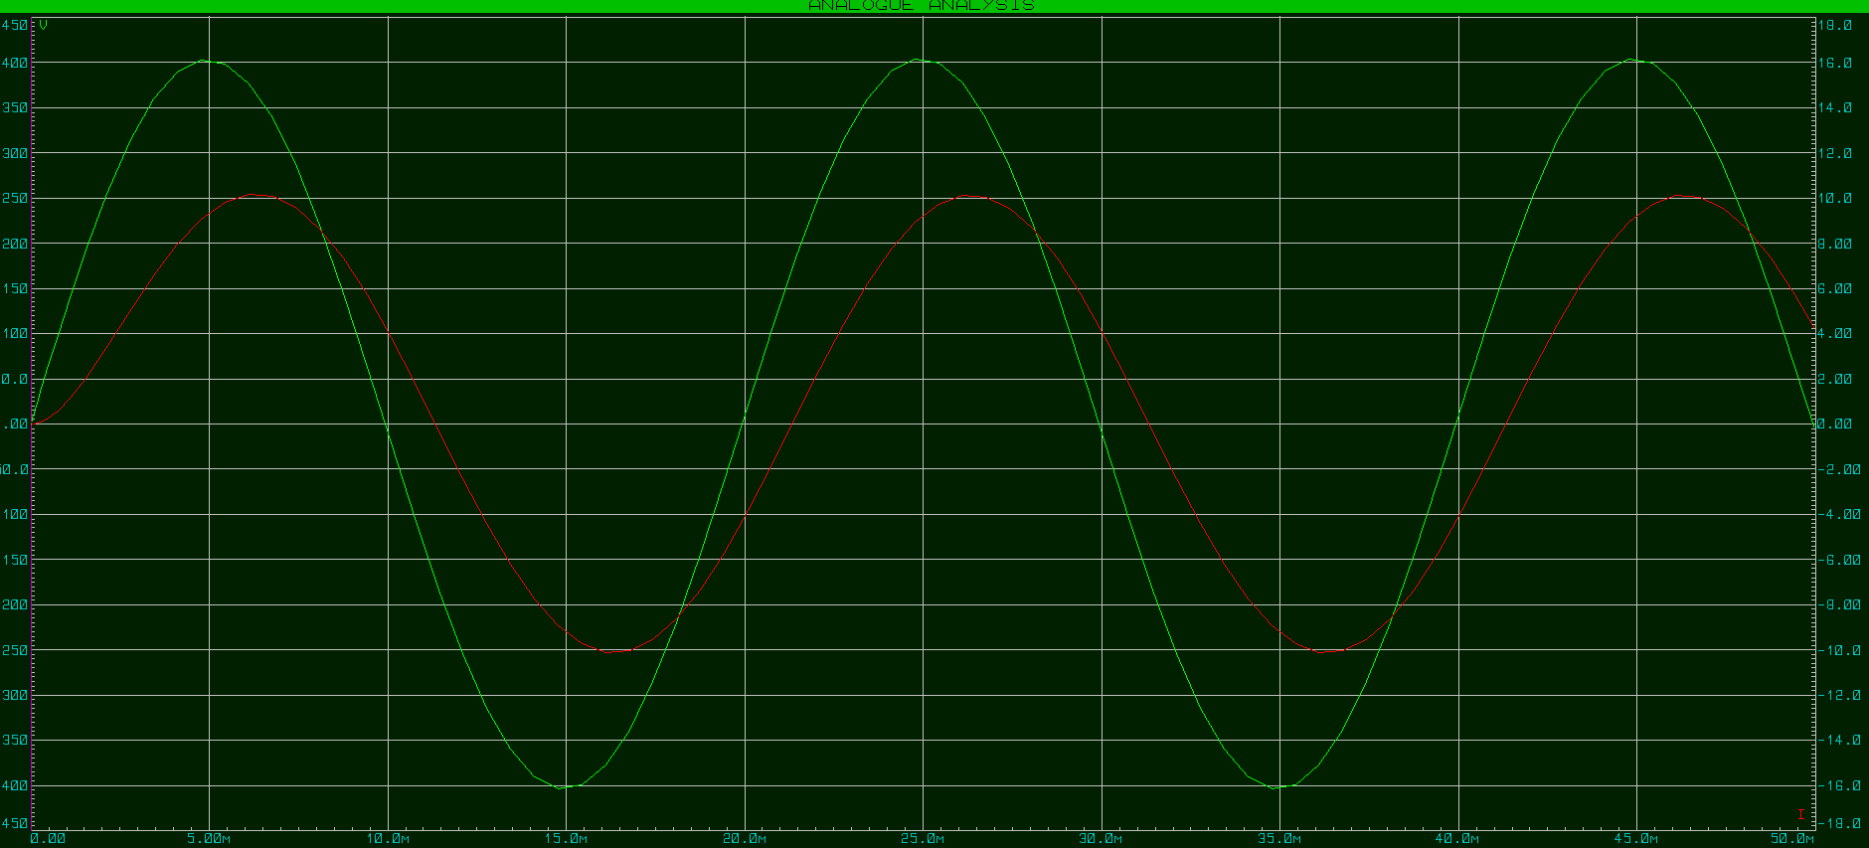
Figure 1: Waveform before PFC
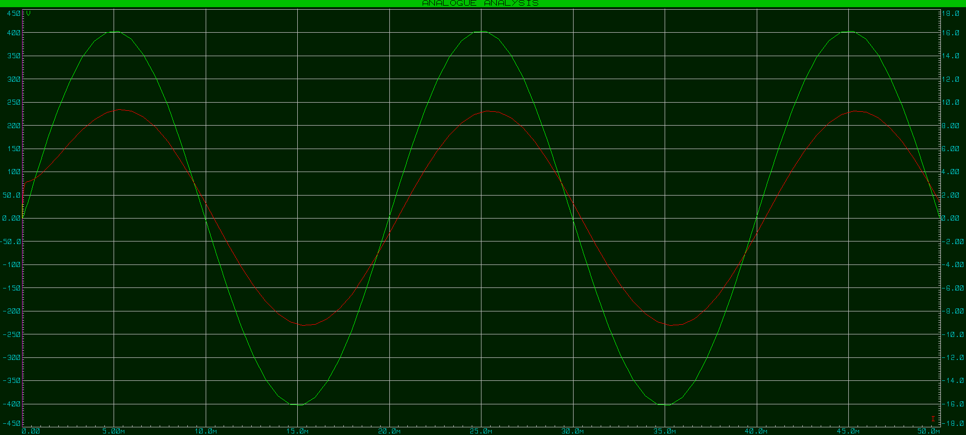
Figure 2: Waveform after PFC
As the power factor approaches 1, the energy stored in the capacitor and inductor in an AC circuit changes significantly. A power factor of 1 means the voltage and current are in phase, indicating efficient power usage with no reactive power.
The capacitor stores energy in the form of an electric field, and in AC circuits, it causes the current to lead the voltage by 90 degrees. In power factor correction, the capacitor compensates for the inductive reactance by supplying reactive power that counters the lagging current caused by inductors. As the power factor nears 1, the capacitor’s role diminishes, storing less energy since the current and voltage are nearly in phase.
The inductor, which stores energy in the form of a magnetic field, causes the current to lag the voltage by 90 degrees, contributing to reactive power. In a power factor correction system, the capacitor neutralizes the inductor’s effect. As the power factor improves, the inductor’s energy storage decreases, and the system primarily uses real power.

Results
Task two requested a series of phasor diagrams at varying states of resonance which are shown below.
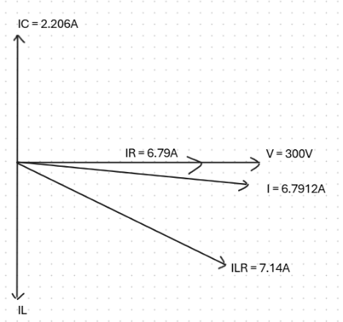
Figure 3: Phasor diagram at 50Hz
The phasor diagram in Figure 3, with a frequency of 50Hz, illustrates the voltage and current relationships in the circuit before power factor correction, where the calculated power factor is 0.95. In the diagram, the voltage is the reference vector, and the current lags it due to the inductive reactance in the circuit. This phase difference of 18° results in a power factor of 0.95, indicating a relatively efficient use of power, but still with some reactive power present due to the inductive load.
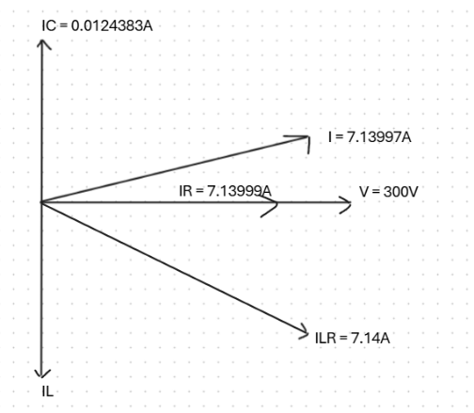
Figure 4: Phasor diagram at resonance
The phasor diagram in Figure 4, at a resonant frequency of 141.566Hz, shows that the current leads the voltage. At this frequency, the inductive and capacitive reactance are nearly equal in magnitude but opposite in sign. As a result, the reactive components cancel each other out, but the current still leads the voltage due to the net effect of the capacitor's influence in the circuit. This phase difference means that although the circuit is near resonance, the power factor is still less than 1, and there is still some reactive power in the system.
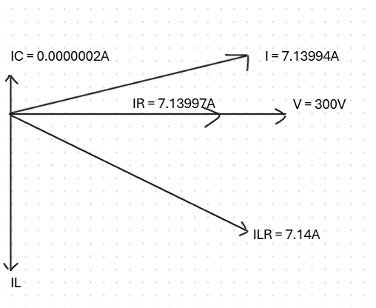
Figure 5: Phasor diagram at 25Hz above resonance
The phasor diagram in Figure 5, at 25Hz above resonance, shows that the current is still leading the voltage. At this frequency, the circuit operates in a condition where the capacitive reactance dominates, causing the current to lead the voltage. The inductive reactance is now lower than the capacitive reactance, and the overall impedance of the circuit is more capacitive. This results in a phase shift where the current leads the voltage, but there is still some reactive power present, as the current is not perfectly in phase with the voltage.
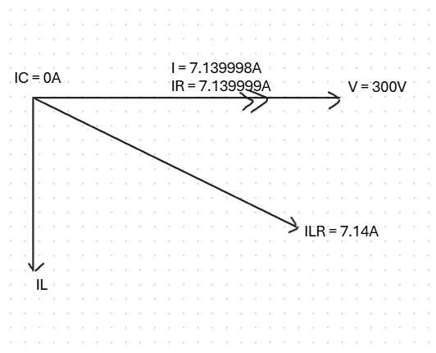
Figure 6: Phasor diagram at 25Hz below resonance
The phasor diagram in Figure 6, at 25Hz below resonance, shows that the current and voltage are in phase due to the calculated value of the capacitor current ($I_{C}$) being 0A. In this case, the capacitive reactance is higher than the inductive reactance, and the overall circuit behavior is inductive. Since the capacitor current is zero, the total current in the circuit is solely due to the inductive load, and the voltage and current are in phase, resulting in a power factor of 1 and no reactive power.
Before power factor correction, the circuit had the following parameters:
- $I_{LR}$ = 7.14A (load current), $I_{R}$ = 6.79A (resistor current), and $I_{C}$= 2.206A (capacitor current), with a total current of $I$ = 6.7912A.
- The capacitive reactance ($X_{C}$) was 135.993Ω, and the required capacitor value for power factor correction was 23.406µF.
The power calculations before correction were:
- P = 1937.64W (active power),
- Q = 629.58VAR (reactive power),
- S = 2037.36VA (apparent power).
The power factor before correction was 0.95, indicating that the current was lagging the voltage, and reactive power was present in the system. The phase angle between current and voltage was approximately 18.19°.
After the application of the capacitor (23.406µF), the power factor improved significantly, reaching 0.9999. This indicates near-perfect alignment between the current and voltage with minimal reactive power in the system. The power factor correction effectively reduced the phase difference to almost zero, improving the circuit’s efficiency by eliminating the reactive power and minimizing the lag between current and voltage. The result was a highly efficient system with minimal energy loss due to reactive power.

Discussion
The results of the power factor correction circuit reveal how critical adjustments, such as capacitor addition, can optimize power delivery and improve energy efficiency. Before power factor correction, the circuit's power factor was 0.95, indicating that the current was lagging the voltage, and the system had a noticeable reactive power component. The calculated active power was 1937.64W, while the reactive power was 629.58VAR, and the apparent power was 2037.36VA. These calculations show that although the system was performing well, some energy was wasted due to the presence of reactive power.
After the capacitor (with a value of 23.406µF) was introduced, the power factor improved to 0.9999, bringing the current and voltage into near-perfect alignment. This correction minimized the phase difference between them, which had been 18.19° before the capacitor was added. By reducing this phase difference, the system minimized reactive power, which reduces the inefficiency caused by the periodic exchange of energy between the source and reactive components.
The improvement in power factor effectively means that the circuit now uses the supplied power more efficiently, as all the apparent power is converted to active power. This is indicative of a significant reduction in energy loss due to reactive power.
In AC circuits containing inductive and capacitive components, resonance occurs when the inductive reactance and capacitive reactance become equal, resulting in the circuit's impedance being minimized. This can lead to high current values and instability in the system. However, resonance can also be used beneficially to tune circuits for specific conditions, such as maximizing power transfer. Before the power factor correction, resonance might have been a concern if the inductive and capacitive reactance were inappropriately matched. However, the introduction of the capacitor helped ensure that the inductive reactance and capacitive reactance were properly balanced, preventing excessive currents due to resonance.
In this case, the capacitor value of 23.406µF was selected based on the calculated impedance and phase angle. This adjustment reduces any risks related to resonance, allowing for more stable system performance. By introducing the correct amount of capacitance, resonance effects were neutralized, and the system avoided high, destabilizing currents while improving power factor.
Maximum power transfer occurs when the impedance of the load matches the impedance of the source. This principle states that for maximum energy efficiency, the real power delivered to the load should be maximized while minimizing losses. However, in an AC circuit, reactive power and phase differences can impede maximum power transfer. Before power factor correction, the circuit was not operating at maximum power transfer. The presence of a power factor of 0.95 meant that the load was not absorbing power as efficiently as it could. The phase difference of 18.19° represented a delay between the current and voltage, meaning that not all the supplied energy was effectively used by the load.
By introducing the 23.406µF capacitor and improving the power factor to 0.9999, the circuit became much closer to a state of maximum power transfer. With the capacitor in place, the phase angle between current and voltage was reduced to nearly zero, indicating near-perfect impedance matching between the source and the load. This improvement in power factor ensures that the maximum usable power is delivered to the load, as the total power transferred is now entirely real (active power) and not lost as reactive power.
Energy efficiency is a critical consideration in any electrical system, particularly in systems where reactive power contributes to energy losses. Before the power factor correction, the system consumed a substantial amount of reactive power (629.58 VAR), which contributed to energy inefficiencies. Reactive power causes additional current flow through the system, leading to losses in transmission and distribution.
After power factor correction, the power factor was improved to 0.9999, resulting in the near elimination of reactive power. This significantly enhanced the circuit’s energy efficiency. By reducing the phase difference and matching the current with the voltage, the system consumes less reactive power and converts more of the supplied energy into useful active power. This reduction in reactive power improves the system's efficiency and minimizes transmission line losses.
The correction transformed the circuit into a much more efficient system, where the total power usage is more effective in doing actual work rather than just circulating reactive power. This translates into savings on energy consumption and improved system performance.

Conclusion
The results show that before power factor correction, the circuit had a power factor of 0.95, with current lagging and reactive power present. After applying a 23.406µF capacitor, the power factor improved to 0.9999, reducing the phase difference and minimizing reactive power. This correction led to a more efficient system, with almost all apparent power converted into active power.
Power factor correction is essential in reducing energy losses caused by reactive power, enhancing the circuit’s efficiency by ensuring the current and voltage are nearly in phase. Resonance plays a crucial role in AC systems, as improper matching of inductive and capacitive reactance can lead to high currents and instability. By selecting the correct capacitor, resonance effects were controlled, contributing to stable system performance. Power factor correction maximizes the usable power delivered to the load, optimizing energy efficiency, and reducing unnecessary energy consumption.

