Wendy’s adopting modern technology
STUDENT NAME – JOEL FERNANDES
2030119

Table of Contents

Introduction 3
Background of the company and how it became an international brand 3
Values of Dave Thomas 3
Challenges of using modern technology 3
From paying in cash to a card or contactless payment, 4
Internet and its benefits and losses 4
Benefits of POS system 5
From a family of restaurants to an international franchise 5
Insights to modern technology 5
Impact of the new technology 6
Wendy's is about family and enhancing the system to make the job easier for its staff. 6
WELERN app of Wendy’s 7
Benefits of the new technology 7
Fault While using the technology 7
Conclusion 8
References 8

Introduction
In order for Wendy today to remain applicable and viable, they need new development in technology to understand what can significantly benefit their business. Since they introduce new technologies and procedures, new technologies can be at chances with present regulatory bodies. Therefore, it now falls on them to lead their industry to lobby for transformation in the regulations. New tech should be included into present business processes to implement its full potential. However, getting the new technology is not sufficient. After purchase, the existing systems as well as procedures require to be familiar to include the new technology in a manner that limits disturbance and the requirement for additional training, whereas still taking benefit of all the new technologies has to offer. Here, the challenges before the incorporation of modern technology, the insights to the technology incorporated, and its impact on Wendy’s have been discussed.

Background of the company and how it became an international brand

Figure 1: Company Logo
Source: (Who We Are | Wendy's, 2021)
Wendy’s, now a world-renowned restaurant brand, was first established by Dave Thomas. The first restaurant was opened in Ohio’s Columbus in the year 1969 (Who We Are | Wendy's, 2021). They had items like patties in square shapes with its corner hanging out from a side of the bun, which had a circular framework. It offered an impression of an overwhelming amount of meat of good quality. As the business started to capture the attention of many consumers, Dave Thomas came up with a unique burger. The brand name was formed as per Dave Thomas's daughter. The main perspective of Dave was to focus on family-friendly foods. Besides, his vision was to offer fresh foods to the nice people surrounding them that facilitates family gatherings.

Values of Dave Thomas
The restaurant brand established by Dave Thomas concentrated on several values that led to the success of the Wend's. The main value Dave focused on was quality. He stipulated that quality is the brand's recipe. The company does not cut corners, and quality is of utmost significance, along with treating everyone as if the job relies on it. The next value that Dave pursued was about doing the right thing, as it would result in framing a good reputation. The third value that had Dave moving was always to treat individuals respectfully. He simplified these values by encouraging others to be nice (Kursawe, 2020). The fourth value was to pursue profit via hard work, a concentration on quality, and offering the best services to customers. Moreover, Dave had always been willing to give something back to society and established the Dave Thomas Foundation for Adoption.

Challenges of using modern technology
Advancements in technologies have rendered several benefits for every industry, making businesses more efficient than before. Technology advancements have also provided optimistic outcomes in the food sector, making it more effective and productive. It is worth mentioning that the population across the globe is increasing at a good speed, and it is becoming tougher to satisfy the increasing food demand (Kennedy et al. 2017). As nutritious food consumption is becoming a major concern for the majority of individuals, the awareness for good standards of foods is enhancing. In order to satisfy such altered demand from customers, technological advancements would be crucial in the food sector. Technology should be utilized in such a way that it would satisfy the growing need for nutritious and good-standard Food.

From paying in cash to a card or contactless payment
Contactless payment is referred to as tap by the retailers and banks. Contactless payment permits customers to fund goods and services by their debit card or credit cards through RFID technology. These are also recognized as chip cards without the requirement to swipe, put a PIN, or sign for a transaction. To use this system, the customer needs to tap the payment card since for the development of new technologies, and consumers want to choose different kinds of cash payment methods, Wendy chose to use the contactless payment for their customers (Kennedy et al. 2017). Contactless payment is measured as a fast and easy method to pay as it does not need customers to input a PIN.

Internet and its benefits and losses
The Internet is the familiar and inventive establishment within the technology world is the Internet. This is perhaps the best creation thus far. The speed of communiqué becomes quicker, which is got by the web. The internet avoids physical borders, thus giving Wendy's products and facilities heightened revelation to an international audience. This can direct to improved sales since the business provide reaches new markets (Sindelar, 2020). These platforms that are considered to join people become powerful, comparatively low-cost marketing networks that can be implemented by Wendy.
However, the internet has also upped the market for several different kinds of businesses. To be at the front of consumer's minds, businesses have the option to slash prices hugely, that has also severely decreased profit margins (Kursawe, 2020). A lot of examples can be found of complaints that have moved out ‘viral’ besides that have forced organizations to change their approaches or change their items, effecting in a loss of income.

Benefits of POS system
Technologies speed up everything besides POS also do the same for store's purchase deal. While users mix POS systems with other modules like Inventory Management also Loyalty Programs, it could carry a seamless knowledge for shoppers. Furthermore, the Loyalty Program included with POS could create the procedures of controlling besides spending reward more suitable. POS system displays all items on the screen by a thumbnail to select and adds to cart simply with smart groups helping them correctly recognize products they want (Sindelar, 2020). Besides, POS also reduces human errors by decreasing human interference in Wendy, which means most of the physical steps are now prepared automatically and specifically by the POS system. On the other hand, several business losses can be minimized through implementing POS. Besides, POS helps to keep track of cash flow as well as products in a severe way.
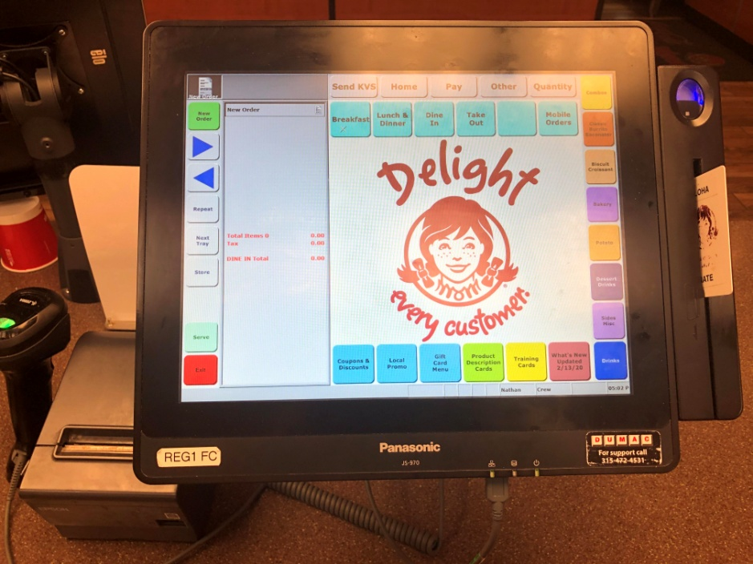
Figure: POS System of Wendy
(Source: Sindelar, 2020)

From a family of restaurants to an international franchise
The company was started in the year 1969 in Ohio and slowly, it started to spread all over the world. In today's scenario, the company has a presence in thirty-two countries with their wide variety of items. However, the owner never thought to have received so many positive responses in quite a few years (Sindelar, 2020). Firstly, with their good number of food items in Ohio, the company started to receive demand from the customer to open their franchise in the international market. Soon, as per the customer needs, the company has now been able to open numerous branches in the international market.

Insights to modern technology
The company in 2016 was able to gather revenue of around 1.43 billion dollars with a 129.0 million dollar cash flow system. It was able to show the customer that they have the ability to adapt to the concept of digitalization. However, it is not a big deal for Wendy to adopt the concept of digitalization, as it can happen anytime, anywhere (Onyema, 2019). For instance, a digitalization concept of a food shop can happen everywhere. Maybe it is a Campbell soup or general electric. Now, as the company has transformed, they are the first one in the market to introduce the concept of kiosks in terms of reducing labour costs. The main motive of Wendy to adopt the strategy of digitalization is their reduction of labour costs expenses. Moreover, the company was able to fulfil their goal in 2020 with an accomplishment of global sales of around 12 billion dollars.

Impact of the new technology
The owner has now decided to adopt certain new technologies by replacing old ones. The function of information is to make the company or give the company overall transformation to act properly. Besides, the move enables the company to invest more in technologies. As a result, it can be said that the move has resulted in layoffs. However, information technology has positively impacted Wendy, like to function properly to Third Party Company (Onyema, 2019). Wendy has fallen for its restaurant support centre in Dublin. In all these years, Wendy has invested a lot to bolster its technological capabilities. Alongside, the digital sale of the company raises up to three hundred percent in 2020. Furthermore, the company has thought of making open lines of communication to make sure that their food products remain fresh.

Wendy's is about family and enhancing the system to make the job easier for its staff
The restaurant chain Wendy’s has always been focused on providing a better standard of foods to its consumer, where the atmosphere supports family gatherings. As per the values of the founder, Dave Thomas, the restaurant has always hoped for offering the best quality service and food to its customers by upholding the values of treating every customer and employee respectfully and being nice while interacting with everybody. The novel technology incorporated at Wendy’s had concentrated on offering the employees to work more effectively and productively to save time in the entire procedure of the business. The technology was created in such a way that the workers could utilize their time efficiently. The technology is also useful in reducing the time of processing the food orders, along with improving the payment system. The technology was built in the form of software, known as WELERN (Sindelar, 2020). The application is perceived to be the second-best thing in the restaurant. It is learning and training system. Using the application, the workers can get access to the most updated pieces of training. The pieces of training are projected to enhance the expertise of the workers in providing the best quality service to the consumers.

WELEARN app of Wendy’s
WeLearn is one of the best things in Wendy. This is their own learning as well as training system whereas the staff gets access to the pieces of training to help them develop their skills and knowledge. On the other hand, WeLearn is the most innovative app where the employees are provided with all the training they require being ready to promote or start. Furthermore, the training process, it can enhance organizational productivity and efficiency (Cavenett et al. 2018). This app is also easy to access as well as innovative to keep accountable what the employees have done and what they need to improve.
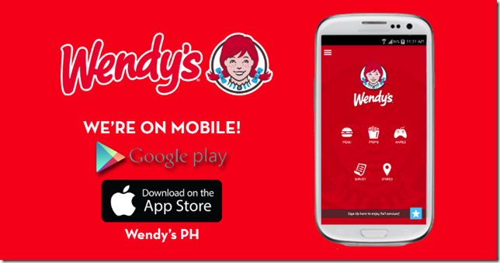
Figure: WeLearn App of Wendy
(Source: Who We Are | Wendy's, 2021)

Benefits of the new technology
There are a lot of benefits besides adopting new technologies in a food-based company. However, adopting a new technology does not mean the company is getting benefitted; all the crew members are equally getting benefits. Customers nowadays do not like to wait in the shop for a longer time and hence Wendy has decided that with their new technology, the timing of the order should get shorter (Cavenett et al. 2018). The adoption of kiosks has allowed the company to get many positive responses from the customers. Customers really liked the shorter time of food arrival as most of them really have limited time to manage their office and mealtime.

Fault while using the technology
Likewise, with many positive approaches present within the adoption of new technology, there also lies fault. The fault that arises is the internet, the internet has the ability to down all the system crashes. It is clear that there is a numerous variety of automation which can lead Wendy to face many challenges, both relatively and eternally (Onyema, 2019). Wendy also faces issues with the usage of new technology like staffing adequately, serving healthy and fresh food, and always preparing Food at present condition and meets the demands of the customers.

Conclusion
New tech should be included into present business processes to implement its full potential. Therefore, it can be concluded that contactless payment is a fast and easy method to pay as it does not need customers to input a PIN. The Internet is the familiar and inventive establishment within the technology world. Furthermore, it can be opined that POS systems display all items on screen by a thumbnail to select and add to cart simply with smart groups helping them correctly recognize products they want.

References
"Wendy's Founder, Dave Thomas, and the Kalamazoo Kewpee". WWMT. January 8, 2002. Archived from the original on July 1, 2007. Retrieved June 4, 2008.
Cavett, W., Baker, S., Waycott, J., Carrasco, R., Robertson, E., Vetere, F. and Hampson, R., 2018, December. Deploying new technology in residential aged care: staff members' perspectives. In Proceedings of the 30th Australian Conference on Computer-Human Interaction (pp. 200-204).https://www.academia.edu/download/62112263/Deploying_New_Technology_in_Residential_Aged_Care_Staff_Members_Perspectives20200216-79618-1hjr37g.pdf
Sindelar, J.J., 2020. R. Bruce Tompkin, Wendy Bedale, Andrew Milkowski, Kathleen Glass, and. Antimicrobials in Food, p.219.https://books.google.com/books?hl=en&lr=&id=0ZUBEAAAQBAJ&oi=fnd&pg=PA219&dq=benefit+of+POS+system+in+Wendy&ots=PglKdz5iwu&sig=-L02lHran36En1nMVaFKqQCLC_U
Taylor, Kate. "Here's why Wendy's Burgers are Square". Business Insider. Retrieved September 14, 2016.
Wendys.com. 2021. Who We Are | Wendy's. [online] Available at: https://www.wendys.com/who-we-are [Accessed 30 August 2021]
Onyema, E.M., 2019. Opportunities and challenges of the use of mobile phone technology in teaching and learning in Nigeria-A Review. International Journal of Research in Engineering and Innovation, 3(6), pp.352-358. https://www.academia.edu/download/63336242/Opportunities_and_challenges_of_the_use_of_mobile_20200517-57771-1u7jrmh.pdf
Kennedy, O., Elizabeth, A., Robert, O. and John, S., 2017. Monitoring And Fault Detection System For Power Transmission Using Gsm Technology. In Proceedings of the International Conference on Wireless Networks (ICWN) (pp. 93-97). The Steering Committee of The World Congress in Computer Science, Computer Engineering and Applied Computing (WorldComp). https://www.researchgate.net/profile/Amuta-Elizabeth-2/publication/318967439_ICW3355_publication/data/5988835245851560584f593f/ICW3355-publication.pdf
Eaton, Dan (December 19, 2008). "Fast food dies slow death downtown". Retrieved March 8, 2009.
"Leadership Team". Wendy's. Retrieved May 18, 2016.
"The Wendy's Company". Retrieved February 7, 2018.
Kursawe, K., 2020, October. Wendy, the good little fairness widget: Achieving order fairness for blockchains. In Proceedings of the 2nd ACM Conference on Advances in Financial Technologies (pp. 25-36).https://dl.acm.org/doi/abs/10.1145/3419614.3423263
Witts, Sophie (October 12, 2020). "Wendy's on track to open first UK restaurant in 20 years". The Caterer.
Jump up to:ª ^{b} Perrin, Isabella (June 2, 2021). "Wendy's first UK restaurant opens in Reading today". Reading Chronicle. Retrieved June 2, 2021.

