Mohammed Jahirul Haque Torofdar
(1714787)

Digital Skill and Research Methods (DSR)
(BMSK4003)
Balendran Kandasamy

Contents
Introduction: 2
Evaluation of the effectiveness of the use of modern technologies within the workplace: 3
Exploring social media as a tool for marketing, information gathering, and communication: 6
The use of social media as a tool for marketing: 7
The use of social media as a tool for gathering information: 8
The use of social media as a tool for communication in the workplace: 8
Creating the professional online presence: 9
Conclusion: 11
Reference: 12

Introduction:
The business of the modern world fully depends on the technology. The use of proper technology may provide the competitive advantage to the business by reducing the cost of production or may increase the quality of the products. Sometimes the technology is used to promote the products with lower cost but effective way. The technological innovation helps the organisation to operate its business activities at a very lower cost. However, digital skill is a kind of ability that helps to find, analyze and create important content by using the information technology. Here, throughout the report, the effectiveness of the modern technologies on the workplaces is discussed.

Evaluation of the effectiveness of the use of modern technologies within the workplace:
In the UK, still, a number of adults have lower skill about digital technologies and their use. According to statistics, nearly 22% people in the UK do not have the basic knowledge about the good use of the modern technologies (Akkucuk, 2016). In the workplace, there is also a huge need for the employees who have possessed a good knowledge of the digital skill. In a study, it has found that nearly 77% SME implemented the modern technologies in their workplace and the number is increasing day by day. Thus the need for good digital skilled employees is increasing rapidly. On the other hand, the technologies can be used in every place in the workplace.
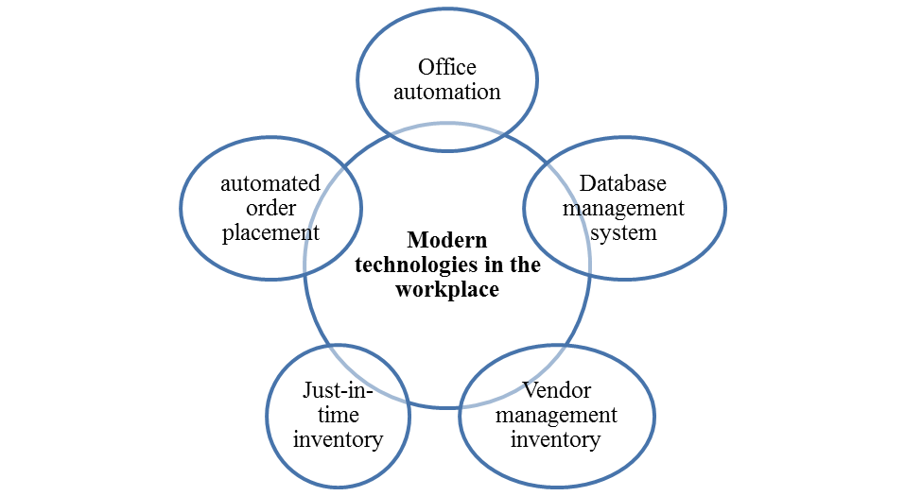
Figure 1: the use of modern technology on the workplace of the UK
Database management system: The database management system is used by almost all large and medium business in the modern world. The database management system is a system for collecting, organizing and recording the important data for the internal use of the organisations. The data from the database management system helps the business to take the important decision for operational or business necessaries. Thus, the database management system is used to collect and customize the necessary data for taking the important decision for business purposes. The success of business mostly depends on how effective a business can take a decision and the success of the decision depends on the availability of the required data and the database management system ensures the availability of required data (Barker & Gaut 2012).

Automated order processing: Automated order processing system is used by almost all of the online shops. This is the system where a specialized software is used to take and process orders automatically (Cohen & Zaidi 2012). It reduces the time and increases the efficiency of the order processing system. This also enables the company to handle or process a multiple order at a time. Moreover, it provides relaxation to the customers to order products for buying purpose.
Office automation: Nowadays almost all of the small and large business automated their office as it increases the efficiency of the operations of the business. It involves the collecting, organizing, summarising and recording information for further use in taking decisions or other purposes. So, it increases the productivity of the organizations by reducing the time of taking decisions and the implementation of the decision. Moreover, the office automation helps the business in every sector of the business. For example, to reduce the cost of operations by reducing the use of paperwork.
Electronic data interchange: The modern digital technologies enable the business to communicate with various partners electronically. By using the electronic system, the organization can send and receive the data in an electronic form. It reduces the cost of the communication and at the same time increase the efficiency of the communication.
So, it can be said that the importance of the modern technologies in the workplace is very significant and their main contribution in the workplace is that it reduce the cost of the operations and increase the efficiency, effectivity, and accuracy of the business operations.

Exploring social media as a tool for marketing, information gathering, and communication:
Social media is very popular all over the world. The 85% of the Internet users of all over the world use the social media for the various purposes and the number of the user is increasing rapidly. Though its main purpose is to increase the communication among the people now it can be used for various business purposes.
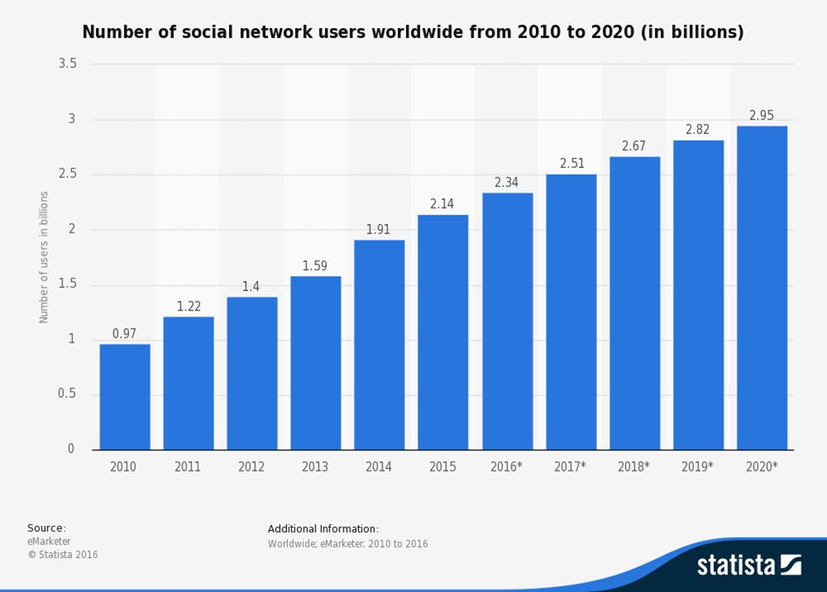
Figure 3 number of social user in the worldwide: source: (Eliot, 2016).

According to a statistics, it has found that almost 42 million people in the UK have used various social media such as Facebook, Twitter, Instagram etc. The Facebook is in the dominant position in these sectors as nearly 36 million people in the UK use the Facebook. Thus the Facebook covers 75% of market share in this sector, on the other hand, the Twitter captures only 10% of market share.
Below is a screenshot of my Facebook profile
https://www.facebook.com/jahir.torofdar
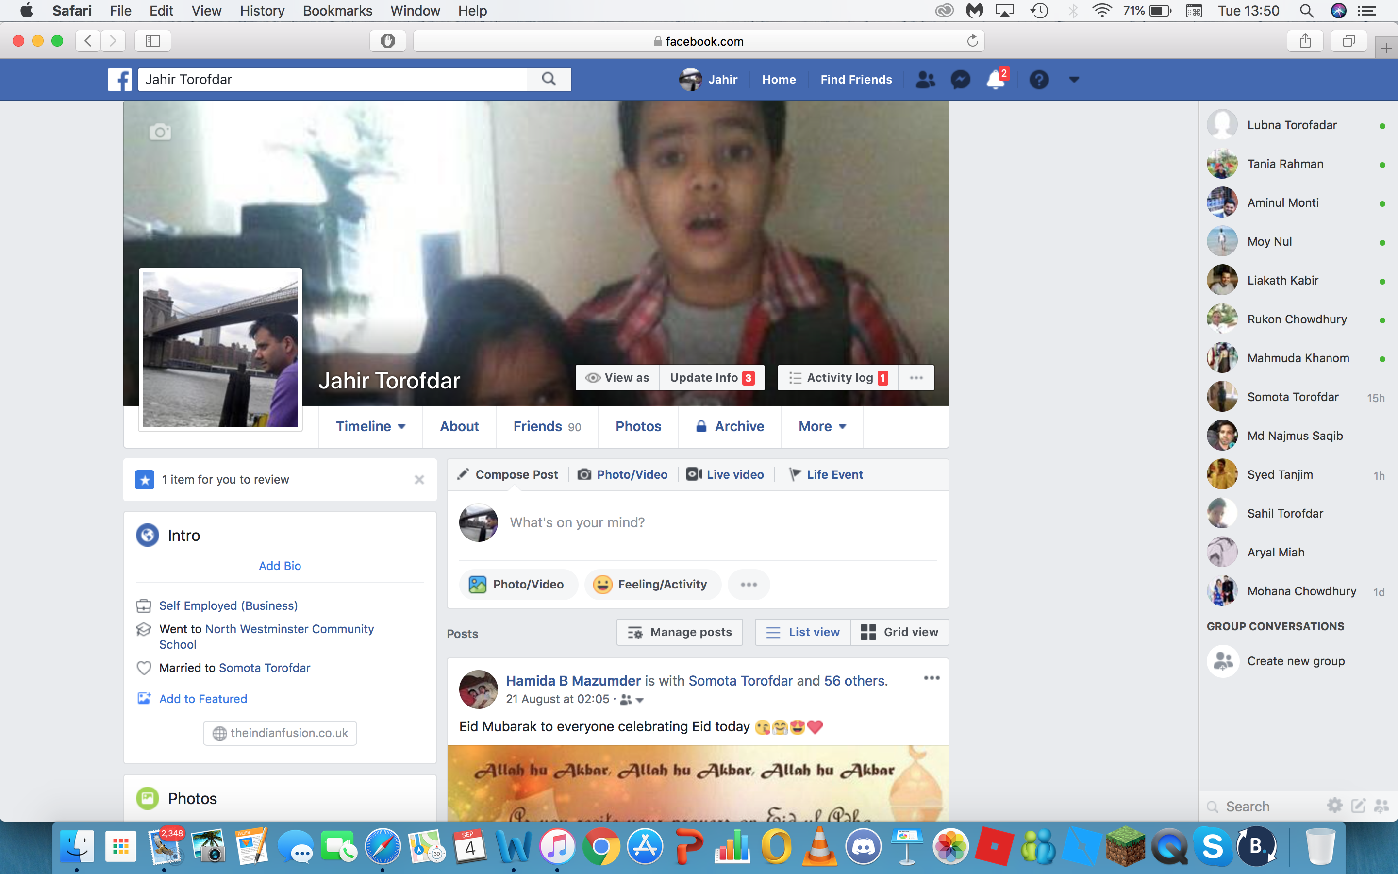

The use of social media as a tool for marketing:
Now the business organisation focuses the social media for performing their marketing activities. As most of the people of the UK spend a number of times in the social media so it effective for the business organisation to draw the attention of their target customers by using the social media (Corporation 2018). Now, the organisations use the social media for promoting their products and improve the customer relationship management by reviewing and providing the customer service to the customers. Now the customers can use the social media to order their target product easily and effectively. In a study, it has found almost 60% organisation of the UK has used the social media for performing their marketing activities and the trend of the spending is upward so it can easily understand that the spending will increase in the future. However, in the last year, the total spending on the social media is 38 billion (Eliot, 2016). Moreover, by using the Facebook, mow the business organisation can satisfy all the customers’ queries and in this method, both the customers and the organisations feel comfortable. So, the use of social media for performing the marketing activities is very effective as the advertising in the social media now gets the highest media coverage than any other media for advertising for the products.

The use of social media as a tool for gathering information:
As most of the people of the UK use the social media and share information about their taste, fashion, religion so, the business organisations can collect this information and use this information to understand about the taste and demand of their target customers. So, the organisation can produce products, which can fulfill the demand of the customers in best possible ways. The cost of collecting information is much lower for the organisation than the other sources of collecting information. However, the organisations can collect their desired information through an online survey in the social media. Besides, the organization can understand about their position in the market by getting information from the social medias many users of the social media expresses their experience about a particular product in the social media. So the organisation can use this information for getting insight into the required change in the products to make the customers satisfied (Eliot, 2016). Moreover, the organisation can collect both qualitative and quantitative data through the social media. Finally, the rating system in the social media also helps the organisation in getting a clear understanding about the brand equity of their products and services.

The use of social media as a tool for communication in the workplace:
The main purpose of the invention of the social media is to increase the communication among the people. In the social media, the people can express their feelings and thoughts freely. Moreover, the social media enables the organisation to connect with a large number of people that helps to increase the communication between the people. However, the employees of the organisation can use the social media to communicate with each other. For example, the employees can create a secret group in the Facebook to communicate the business information to each other. The employees can also chat with the other employees to share information. So, the social media can be used to share both personal and professional information easily. The use of social media is also effective, as from it the higher level manager can get the thoughts of the lower level manager.

Creating the professional online presence:
The professional online presence means the presence the individual’s career interest in the social media, which helps the organisation to find out their required employees to carry out their business activities. So, nowadays, a number of business organization use the social media to analysis the professional image of the individuals to analyze the individuals about their expertise and interest to recruit the effective employee for the business band this rate is increasing day by day as it becomes the effective ways to recruit the proper employees for the organisations.

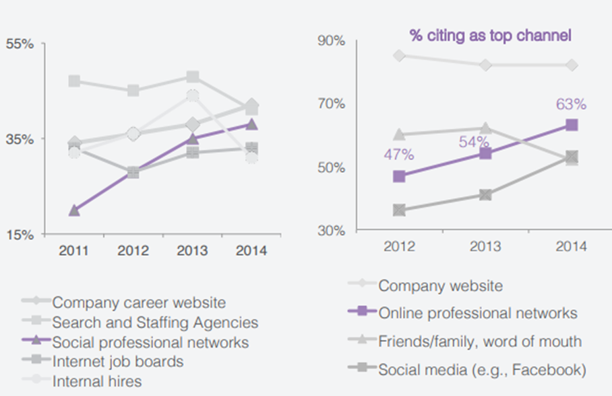
Figure 4: the social and online professional networks used for recruitment : source: (Facts, 2018).
The above chart shows the percentage of recruiting employees from using the social media by the organisations. In this ways, a social professional network is created where the fresher or the experienced employees provide the expertise and their interest of working felid as well as their experience is shown and fro that the company can use this information to select the employees for a particular position. Thus the employees should create their professional image by providing the accurate information about their experience, career interest and expertise in a proper way. By using the following way the professional image can be developed:
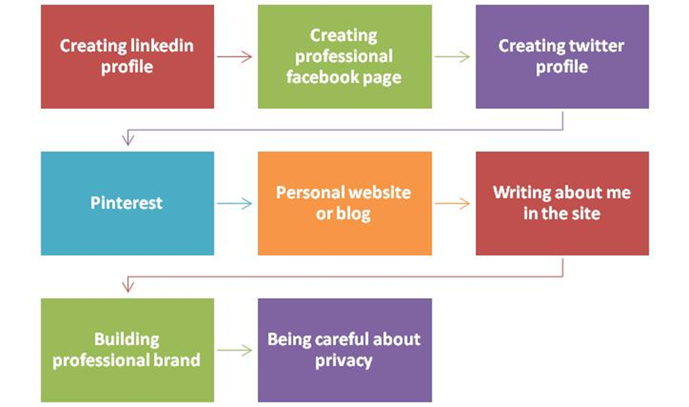
Figure 5: the process of creating a professional image in social media and ensuring the online presence: source: (Facts, 2018).
From the above chart, it can see that this process is started from the opening a Linkedin, Facebook and Twitter account and then provide the interest. Personal information and other necessary information is to build the professional brand which reflects the professional; image of the employees. Moreover, the employees should be very careful. About the privacy about their information because the privacy is very important as one can use this information to harm them.
So, the building up professional image is very useful both for the employees and the organisations as the organisations can recruit they're expected theirs by analyzing the information that is expressed in the professional image (Keyton, 2017). However, the employees should provide the accurate information in the professional image.

Conclusion:
The use of modern technologies can reduce the number of labor that reduces the cost of operations as well as it increases the efficiency in the operations, which reduce the waste and also increase the quality of the products and services. So the proper use of the modern technologies may provide the competitive advantage to the company over its major rivals. However, the success of the modern business also depends on the effective use of modern technologies. Besides, a social medium which is another gift of modern technologies provide a number of advantages to the organizations as it can be used for performing marketing purpose, collecting information and building the professional image which helps the various organisation to recruit proper employees.

Reference:
Akkucuk, U. (2016). Handbook of research on developing sustainable value in economics, finance, and marketing.
Barker, L., & Gaut, D. (2012). Communication. Needham Heights, MA: Pearson Professional Education.
Christopher, M. (2016). Logistics and supply chain management. Harlow (England): Pearson.
Cohen, M., & Zaidi, M. (2012). Global skill shortages. Cheltenham, U.K.: Edward Elgar.
Corporation, M. (2018). Digital Skills - Microsoft UK. Retrieved from https://www.microsoft.com/en-gb/athome/digitalskills/
Eliot, G. (2016). The mill on the Floss. New York: Open Road Integrated Media.
facts, O. (2018). Topic: Online and social media recruiting. Retrieved from https://www.statista.com/topics/2727/online-recruiting/
Facts, S. (2018). Topic: Social media usage in the UK. Retrieved from https://www.statista.com/topics/3236/social-media-usage-in-the-uk/
Göranzon, B., Hammaren, M. and Ennals, J. (2006). Dialogue, skill and tacit knowledge. Chichester, England: J. Wiley & Sons.
Keyton, J. (2017). Communication research. New York: McGraw-Hill Education.
Vlachvei, A., Notta, O., Karantininis, K. and Tsounis, N. (2017). Factors affecting firm competitiveness and performance in the modern business world.

