

Global Ethics

Unit name:Global Ethics
Module code：BMBM6008
Lecturer:Mike Durke
Student name: Qihan Jia
Student ID number ：2304172
Date submitted:01/12/2024

An exploration of cultural differences in business ethics

Executive summary
This report will explore the challenges posed by cultural differences in business ethics in a globalized market. We will examine the ethical issues facing by the businesses who operating internationally, including labour standards, environmental regulations, corruption and intellectual property.
We found there have differences ethics in different countries. These differences manifest themselves in a variety of ways, including different gift-giving customs, which can create ethical dilemmas for businesses seeking to build a global presence. In addition, low-cost manufacturing countries exploit vulnerable groups’ causes a serious ethical issue. Also, environmental regulations are weak in some regions, leading to severe environmental degradation, including air pollution and overexploitation of natural resources, with adverse impacts on the global climate and indigenous communities. In addition, corrupt practices such as bribery remain prevalent in some areas, posing legal and reputational risks to businesses. Also, IP protection are varying from country to country, making it challenging for companies to effectively protect their innovations and technologies. To address these ethical challenges, we had recommend some ways such as the governments should comply with international labour standards and enforce strict labour regulations. Companies must conduct thorough supplier audits to ensure workers are protected.

Table of Contents
Executive summary 2
1.0 Introduction 3
2.0 Cultural variances in business ethics challenges 4
2.1 Labour standards and workers’ rights 4
2.2 Environmental standards 5
2.3 Corruption and Governance 6
2.4 Intellectual property rights 6
3.0 Solution 7
3.1 Improve labour standards and workers’ rights 7
3.2 Strengthen environmental regulations 7
3.3 Increase transparency and accountability 8
3.4 Create international agreements 8
4.0 Companies that have successfully managed to trade ethically in the global marketplace 8
5.0 Conclusion 10
6.0 References 10
Appendices 13

1.0 Introduction
In today's globalized world, businesses can now expand globally. When entering international markets, company will encounter many challenges, one of the challenges is cultural differences in business ethics. While the pursuit of profit is a common goal for businesses around the world, we must also act ethically. However, “normal” moral behaviour is varying from culture to culture. This is because one country may view certain practices as standard and ethical, another party may view the same practices as morally objectionable and infringing upon its cultural, political and social values regarding business ethics. For example, in countries such as China and Japan, gift giving is a way to build and strengthen business relationships. In these cultures, providing gifts to partners or clients is seen as a sign of goodwill and respect. However, in the United States or many European countries, giving gifts may be considered bribery or unethical behaviour.
To understand these issues, we will explore cultural variance in business ethics challenges. After investigating, we will provide some solutions to tackle these issues. We will also explore the companies that have successfully managed to trade ethically in the global marketplace.

2.0 Cultural variances in business ethics challenges

2.1 Labour standards and workers’ rights
The labour cost in the US is high and the US is stricter in protecting labour rights, so the company will choose to operate in those countries that are low cost and less focus on protecting employees. This often creates some ethical issues. In many low-cost manufacturing countries, workers often face unsafe and unhealthy working conditions. For example, in 2013 the Rana Plaza collapse in Bangladesh killed more than 1,000 workers (International Labour Organization, 2023). This accident occurred because of structural failure and the building was not intended for factory use. This is a common problem in many low-cost manufacturing areas, where buildings are often repurposed for industrial use without adequate safety modifications.
Besides that, moving companies to countries with low labour costs can also increase the use of child labour. For example, Côte d'Ivoire and Ghana are the world's largest cocoa producers, accounting for more than 60% of global production (Kakaoplattform, n.d.). One study found that 23% of cocoa workers surveyed said they had worked without pay (Appendix 1). In addition, children as young as five have been found working in hazardous conditions for long periods of time, including using sharp tools and being exposed to harmful pesticides (Food Empowerment Project, 2022). However, it is ethical in these countries since most of these child workers come from poor families and rely on cocoa farming for their livelihood, so parents are forced to involve their children to earn money. Furthermore, cocoa sell price on global markets is low which is hard to sustain the costs of sustainable production. This economic pressure forces companies to find cheaper labour such as child labour.
Furthermore, vulnerable groups such as immigrants and refugees are exploited in low-cost countries. The employment conditions for these migrant workers are poor and include excessive working hours, low wages and possible physical and psychological abuse. These conditions violate the human rights and international labour law. These workers are lack of legal protection which makes them particularly vulnerable to exploitation. For example, in Thailand’s seafood industry, migrant workers from neighbouring countries are often mistreated (Hidden Chains, 2018).

2.2Environmental standards
Sweden has strict environmental regulations and implements policies to reduce greenhouse gas emissions and promote renewable energy (OECD, n.d.). In addition, Germany has strict laws in place to address air and water pollution to improve energy efficiency and reduce carbon emissions. Germany’s “Energiewende” policy aims to phase out nuclear power and fossil fuels in favour of renewable energy (IEA, 2020). So when operating in these countries, the company will have more strict control to act as an ethical company. However, industry often lacks of oversight and releases pollutants into the air, water, and soil in countries with weak environmental regulations. This will leads to serious environmental degradation. For example, air pollution has reached severe levels in many areas of China and India, largely due to emissions from factories, power plants and vehicles (Zhu, 2005). China and India is the top 10 countries with the worst air pollution index and China had become one of the biggest emitters of greenhouse gases (Appendix 2).
Also, lax environmental standards can lead to overexploitation of natural resources. Some companies choose to go to some areas for mining and logging, which will leading to excessive deforestation, loss of biodiversity and depletion of water resources. One of the examples is Amazon. Due to continuous deforestation, the global climate is affected. The destruction of forests will release large amounts of carbon dioxide into the atmosphere, which will exacerbating global warming (Carrington, 2021). Not only that, it also encroached on indigenous lands, resulting in displacement and loss of livelihoods for these indigenous peoples.

2.3Corruption and Governance
Corruption has always been a topic of debate. For example, businesses may encounter requests for bribes or facilitation payments from government officials and regulatory agencies in Malaysia. These payments will speed up the bureaucratic process. Although this is illegal, but it is an uncivilized rule in Malaysia (CriGroup, 2020). Companies who engage in this practices will gain an unfair competitive advantage over ethical companies. These company can complete projects faster and at lower cost which had puts ethical companies at a disadvantage. However, it is illegal in most of the country and may violate anti-corruption laws and regulations as well as harm a company's reputation and destroy the trust among stakeholders.
Siemens is one of the example of a multinational company who faces the ethical dilemmas due to corruption. Siemens operates in various sectors including energy, healthcare, transportation and telecommunications. In 2000s, Siemens is accused of engaging in systematic bribery to obtain contracts, licenses and preferential treatment in many countries, including illegal payments to government officials, intermediaries and decision-makers in various industries (Schubert and Miller, 2008). This resulted in Siemens having to pay huge fines totalling billions of dollars. It severely damage the company's reputation, which also causes a loss of trust among stakeholders such as shareholders, customers and employees.

2.4Intellectual property rights
Intellectual property rights are protected by a range of national and international laws and treaties. However these laws vary from country to country which can be challenging for businesses operating globally. Besides that, even if intellectual property rights are recognized and protected in law, but it can be challenging to enforce these rights in practice. Some countries, such as China, have weak enforcement mechanisms and are more tolerant of intellectual property infringement . This has led to rampant counterfeiting and piracy and damaged the revenue and reputation of legitimate businesses. The U.S. Trade Representative stated that China is one of the world's major sources of counterfeit and pirated goods and also engaged in forced technology transfer, cyber theft and other unfair trade practices that harm the interests of U.S. intellectual property rights holders (Aaron Wininger, 2022). China's intellectual property rights often lack transparency, consistency and fairness.
Apple Inc. and Samsung Electronics Co., Ltd. are one of the example. Apple Inc. and Samsung Electronics Co., Ltd. are two of the world's leading smartphone manufacturers with operations around the world. Due to the fierce competition in the smartphone industry, companies are constantly developing new features and technologies. However, Apple accused Samsung of copying certain design elements and user interface features of its iPhone, such as the device’s rounded corners and rectangular shape (Kastrenakes, 2018). Apple is trying to sue Samsung to protect its intellectual property and maintain a competitive advantage. However, the two companies have had different verdicts in different jurisdictions. The lawsuit illustrates how intellectual property rights are interpreted differently in different countries.

3.0 Solution

3.1 Improve labour standards and workers’ rights
Governments should comply with international labour standards that set by the International Labour Organization (ILO). For example, after the Rana Plaza collapse in Bangladesh, international had pressure the Bangladesh to develop protocols and require companies to ensure the safety of workers in the country's garment factories such as inspection safety, refurbishment and worker training programs to meet international labour standards. Besides that, companies can conduct comprehensive audits of their suppliers to ensure that those suppliers adhere to labour standards. For example, Nike was criticized in the 1990s for poor labour practices in its supply chain, such as the use of child labour. Therefore, Nike established the Fair Labour Association (FLA) and conducted strict audits to inspect the supplier’s factories (Nike, 2018). In addition, we can invest in education and skills development programs in low-cost manufacturing countries. For example, the Rugmark Foundation (now GoodWeave) established a certification system to ensure that child labour was not used in the production of rugs. Also, the organization invests in adult education and skill development programs to replace child labour (GoodWeave, n.d.).

3.2 Strengthen environmental regulations
Government can take proactive measures, such as controlling emissions and setting waste management standards to deal with global environmental challenges. One example of a successful environmental legislation is the EU ETS. It permits businesses to exchange emissions allowances and establishes greenhouse gas emission restrictions for various industries inside EU member states. This can assists them in reducing carbon emission and also make the air environment better. Besides that, we also can encourage the company to adopt sustainable production methods to reduce the use of resources. We also can educate the consumer to know how to choose an ethical product. For example, the MSC label on seafood products is used to inform consumers that the products are produced by sustainably managed fisheries. In this way, consumers is more easily to identify and support the ethics business.

3.3 Increase transparency and accountability
We must ensure openness and transparency during our operations in the globe. In addition, governments must impose severe penalties on companies that are under corruption. For example, Estonia has put in place a very effective and transparent e-government system, so that citizens can access government services and information online (Vassil, 2016). It has made Estonia become one of the least corrupt countries in the world. Besides that, Operation Car Wash was a prominent anti-corruption investigation in Brazil. It exposed a vast network of corruption among senior politicians and business leaders (Watts, 2017). Many of those involved were prosecuted and sentenced. Also, in order to encourage consumers to report corruption, governments and organizations can establish mechanisms to protect whistle-blowers.

3.4 Create international agreements
Governments should develop international agreements that protect intellectual property rights (IPR) across countries to make it easier for businesses to navigate global markets and protect their IP. TRIPS, for example, stipulates the minimum standards for intellectual property protection and enforcement that member states must comply with (World Trade Organization, 2019). In addition, for countries with weak intellectual property protection, local governments should actively crack down on counterfeiting and piracy and impose severe penalties on intellectual property infringements.

4.0 Companies that have successfully managed to trade ethically in the global marketplace
Even it is hard to trade in a global marketplace ethically. But there had some company have successfully managed to trade ethically in the global marketplace. One of the examples is Patagonia. The company uses organic cotton and recycled materials in its products to reduce its environmental impact. This is because traditional cotton cultivation requires extensive use of pesticides and chemicals (Patagonia, n.d.). Patagonia minimizes its reliance on petroleum-based resources and contributes to trash reduction by using organic items. They can attract consumers who also appeal to the eco-conscious. The company also shares its production location and details openly, including disclosing the factories they work with, the working conditions within those factories, and the environmental impact of its production processes. In this way, they can build relationships with customers. Furthermore, Patagonia contributes to several environmental projects and allocates a portion of its earnings to conservation efforts.
Another example is The Body Shop. The Body Shop has always refused to use animals in research. They promised to produce cruelty-free goods which had a positive impact on the market and enhanced the customer knowledge of the ethic cosmetics options (The Body Shop, n.d.-b). In addition, The Body Shop ensures their material is purchased in fair prices through supplier who are participate in fair trade (The Body Shop, n.d.-a). This also assists those farmer to improve their living standards and promotes sustainable community development. Besides that, The Body Shop has always sourced high-quality natural ingredients that are better for consumers’ skin and more environmentally friendly. This will inspire other companies to adopt similar practices and shift to more ethical and sustainable practices.
Besides that, Fairphone also can serve as an example. Fairphone values fair labour practices in its supply chain, such as they ensure that miners and factory workers involved in smartphone production receive fair wages and work in safe working conditions (Fairphone, n.d.). In addition, the electronics industry often uses minerals that are linked to human rights violations and environmental degradation. So, Fairphone implements rigorous sourcing and auditing processes to ensure that the minerals used in its phones will not fund armed conflict or contribute to human rights abuses. Not only that, Fairphone's phones are designed to be easily repaired and upgraded, which extends the life of the phone and reduces electronic waste. Also, Fairphone is focusing on using reuse and recyclable materials in its phones and packaging. This approach will minimize reliance on virgin materials and helps reduce the carbon footprint of its products.

5.0 Conclusion
We can conclude that different countries have different ethical standards in labour standards, environmental regulations, corruption, and intellectual property rights. However, even though it is difficult to let the company operate ethically globally, but Patagonia, The Body Shop, and Fairphone serve as a successful example of who can operate ethically in different countries. The government should strictly enforce international labour standards, environmental regulations, and anti-corruption measures to solve these problems. They should also need to develop international agreements that coordinate cross-border intellectual property protection. Also, the company can invest in education in poverty countries, adopting sustainable production methods and increasing the company's transparency and accountability. As a consumer, we can also prioritize ethical businesses that focus on social responsibility and sustainability.

6.0 References
- Aaron Wininger (2022). Chinese Customs Announces a Batch of Typical Cases of Intellectual Property Infringement. [online] The National Law Review. Available at: https://www.natlawreview.com/article/chinese-customs-announces-batch-typical-cases-intellectual-property-infringement [Accessed 8 Jan. 2024].
- Carrington, D. (2021). Amazon rainforest now emitting more CO2 than it absorbs. [online] the Guardian. Available at: https://www.theguardian.com/environment/2021/jul/14/amazon-rainforest-now-emitting-more-co2-than-it-absorbs [Accessed 8 Jan. 2024].
- CriGroup (2020). Major Bribery and Corruption Cases in Malaysia ABAC® Group. [online] Available at: https://abacgroup.com/major-bribery-and-corruption-cases-in-malaysia/ [Accessed 9 Jan. 2024].
- Fairphone (n.d.). Good working conditions. [online] Available at: https://www.fairphone.com/en/impact/good-working-conditions/ [Accessed 8 Jan. 2024].
- Food Empowerment Project (2022). Child Labor and Slavery in the Chocolate Industry. [online] Available at: https://foodispower.org/human-labor-slavery/slavery-chocolate/ [Accessed 8 Jan. 2024].
- GoodWeave (n.d.). Ending Child Labor in Global Supply Chains. [online] Available at: https://goodweave.org/ [Accessed 8 Jan. 2024].
- Hidden Chains (2018). Rights Abuses and Forced Labor in Thailand’s Fishing Industry. [online] Available at: https://www.hrw.org/report/2018/01/23/hidden-chains/rights-abuses-and-forced-labor-thailands-fishing-industry [Accessed 8 Jan. 2024].
- IEA (2020). Germany 2020. [online] Available at: https://www.iea.org/reports/germany-2020 [Accessed 8 Jan. 2024].
- International Labour Organization (2023). The Rana Plaza disaster ten years on: What has changed? [online] Available at: https://www.ilo.org/infostories/en-GB/Stories/Country-Focus/rana-plaza#intro [Accessed 8 Jan. 2024].
- Kakaoplattform (n.d.). Cocoa facts and figures . [online] Available at: https://www.kakaoplattform.ch/about-cocoa/cocoa-facts-and-figures#:~:text=The%20biggest%20cocoa%2Dgrowing%20countries [Accessed 8 Jan. 2024].
- Kastrenakes, J. (2018). Apple and Samsung settle seven-year-long patent fight over copying the iPhone. [online] The Verge. Available at: https://www.theverge.com/2018/6/27/17510908/apple-samsung-settle-patent-battle-over-copying-iphone [Accessed 8 Jan. 2024].
- Nike (2018). Human Rights and Labor Compliance Standards. [online] Available at: https://about.nike.com/en/newsroom/resources/human-rights-and-labor-compliance-standards [Accessed 8 Jan. 2024].
- OECD (n.d.). Climate policies and Sweden’s green industrial revolution. [online] Available at: https://www.oecd-ilibrary.org/sites/fb75b5d7-en/index.html?itemId=/content/component/fb75b5d7-en#:~:text=Sweden [Accessed 8 Jan. 2024].
- Patagonia (n.d.). Cotton for Change . [online] Available at: https://www.patagonia.com/our-footprint/cotton-for-change.html [Accessed 8 Jan. 2024].
- Schubert, S. and Miller, T.C. (2008). At Siemens, Bribery Was Just a Line Item. The New York Times. [online] 20 Dec. Available at: https://www.nytimes.com/2008/12/21/business/worldbusiness/21siemens.html [Accessed 8 Jan. 2024].
- The Body Shop (n.d.). COMMUNITY FAIR TRADE. [online] Available at: https://www.thebodyshop.com.my/about-us/brand-values/community-fair-trade#:~:text=We%20pay%20fair%20prices%20and [Accessed 8 Jan. 2024].
- The Body Shop (n.d.). CRUELTY FREE AND FOREVER AGAINST ANIMAL TESTING. [online] Available at: https://www.thebodyshop.com.my/against-animal-testing [Accessed 8 Jan. 2024].
- Vassil, K. (2016). Digital Dividends Estonian e-Government Ecosystem: Foundation, Applications, Outcomes. [online] Available at: https://thedocs.worldbank.org/en/doc/165711456838073531-0050022016/original/WDR16BPEstonianeGovecosystemVassil.pdf [Accessed 8 Jan. 2024].
- Watts, J. (2017). Operation Car Wash: The biggest corruption scandal ever? [online] the Guardian. Available at: https://www.theguardian.com/world/2017/jun/01/brazil-operation-car-wash-is-this-the-biggest-corruption-scandal-in-history [Accessed 8 Jan. 2024].
- World Trade Organization (2019). Overview: the TRIPS Agreement. [online] Available at: https://www.wto.org/english/tratop_e/trips_e/intel2_e.htm [Accessed 9 Jan. 2024].
- Zhu, Z. (2005). POLITICAL ECONOMY OF CHINA AND INDIA: DEALING WITH AIR POLLUTION N THE TWO BOOMING ECONOMIES. [online] (7), pp.123–132. Available at: https://dialnet.unirioja.es/descarga/articulo/1993815.pdf [Accessed 27 Nov. 2023].

Appendices
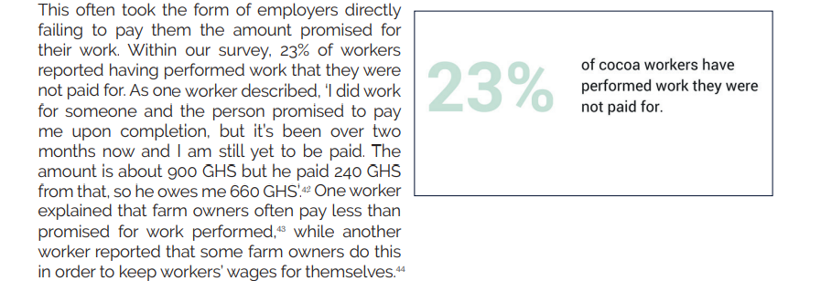
Appendix 1: 23% of cocoa workers surveyed said they had worked without pay. Retrieved from: https://respect.international/wp-content/uploads/2018/06/The-Global-Business-of-Forced-Labour-Report-of-Findings-University-of-Sheffield-2018.pdf
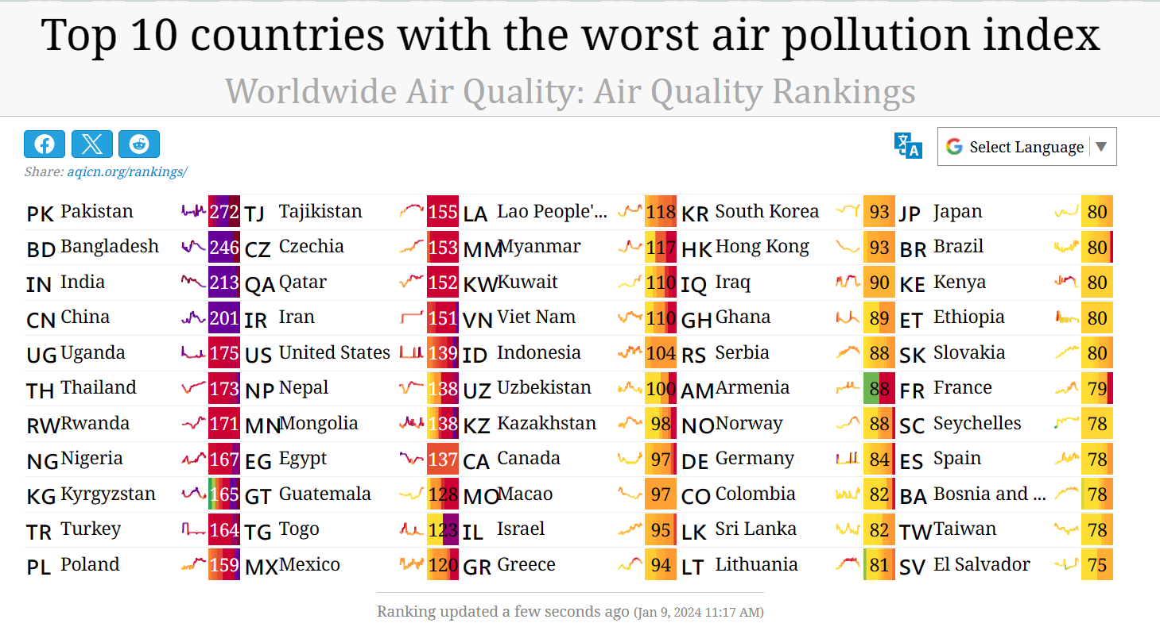
Appendix 2: China and India is the top 10 countries with the worst air pollution index. Retrieved from: https://aqicn.org/rankings/

