HTML & CSS Web Development

Tomos Leggett 1901852
Web Development
Internet Technology and Security

Table Of Content
HTML & CSS Web Development Table Of Content Introduction
Requirements
Purpose and Subject Matter Target Audience
Relevance Implementation
Screenshots Validation
HTML CSS
Evaluation
Usefulness (usability and utility) Search Engine Optimisation Accessibility
WCAG 2.1 Guidelines
aXe - The accessibility Engine
References

Introduction
In this report, the author will be evaluating the creation and design of their newly developed website, “Student Apps”. The report will give an overview of the website’s purpose, along with screenshots and information on what the author thought went well during the development, and what could have improved.

Requirements

Purpose and Subject Matter
“Student Apps” is a website designed and developed as a repository for software that the author has found useful for students to use. It is designed so that all software on the website is free and easily accessible, and lists the advantages of the software, what the software is used for, a quick link to download the software

on your desired platform, what platforms the software is available under, links to the mobile versions of the software, screenshots and a video demonstration of the software in action.

Target Audience
The target audience of this website is aimed to target Students, such as;

University Students Secondary School Students College Students
The website is designed with emphasis on the availability of the software, including a filter in which software must either be “freemium” or “free” to be listed on the repository itself.

Relevance
The author of this report feels as if the website itself is relevant as it supports students by giving them a centralised access point for software that is both free and helpful. This will make the process of finding alternative software or free software less tedious, as students will no longer need to do research on finding the right software, such as free alternatives to more known paid software, or software that would help their study process in the first place.

Implementation

Screenshots

Index

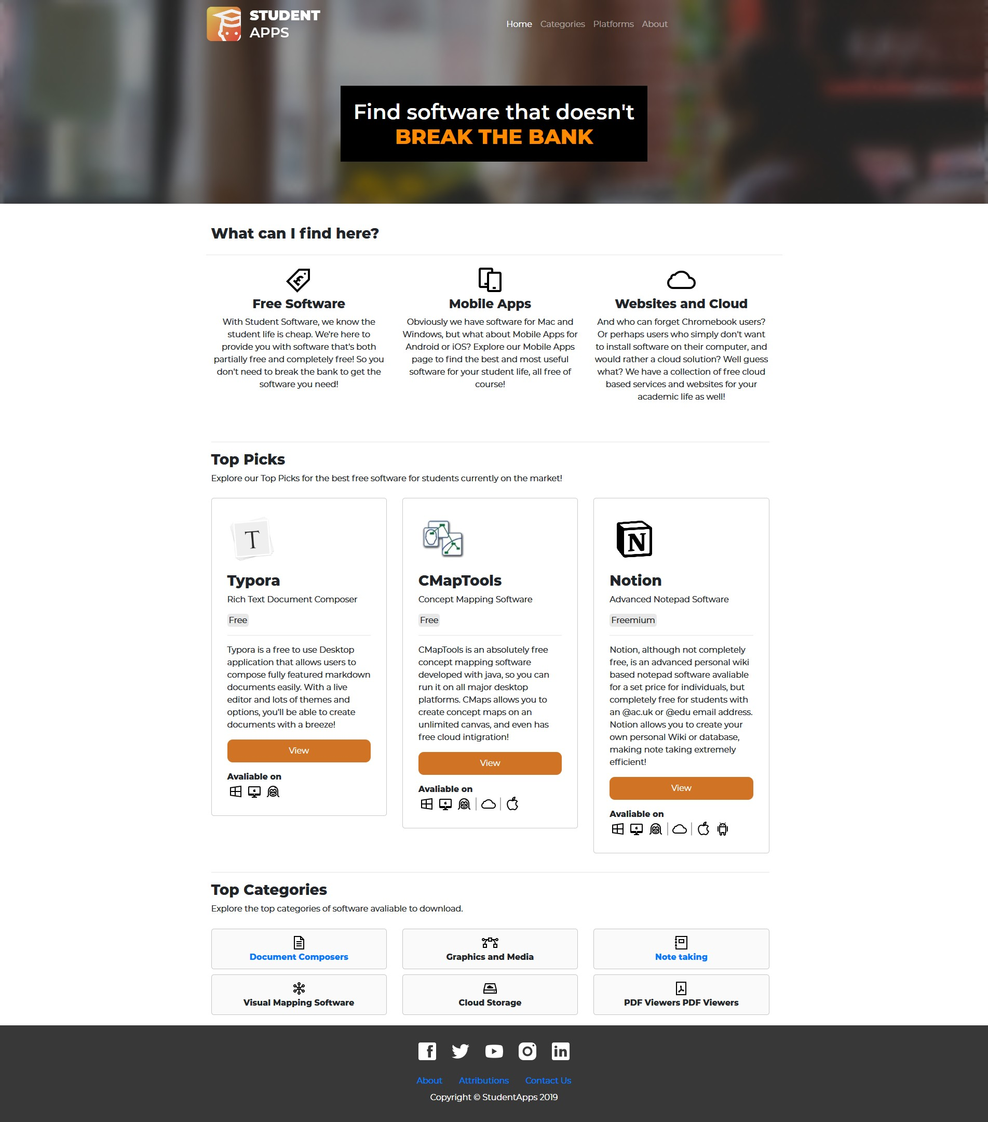

Categories
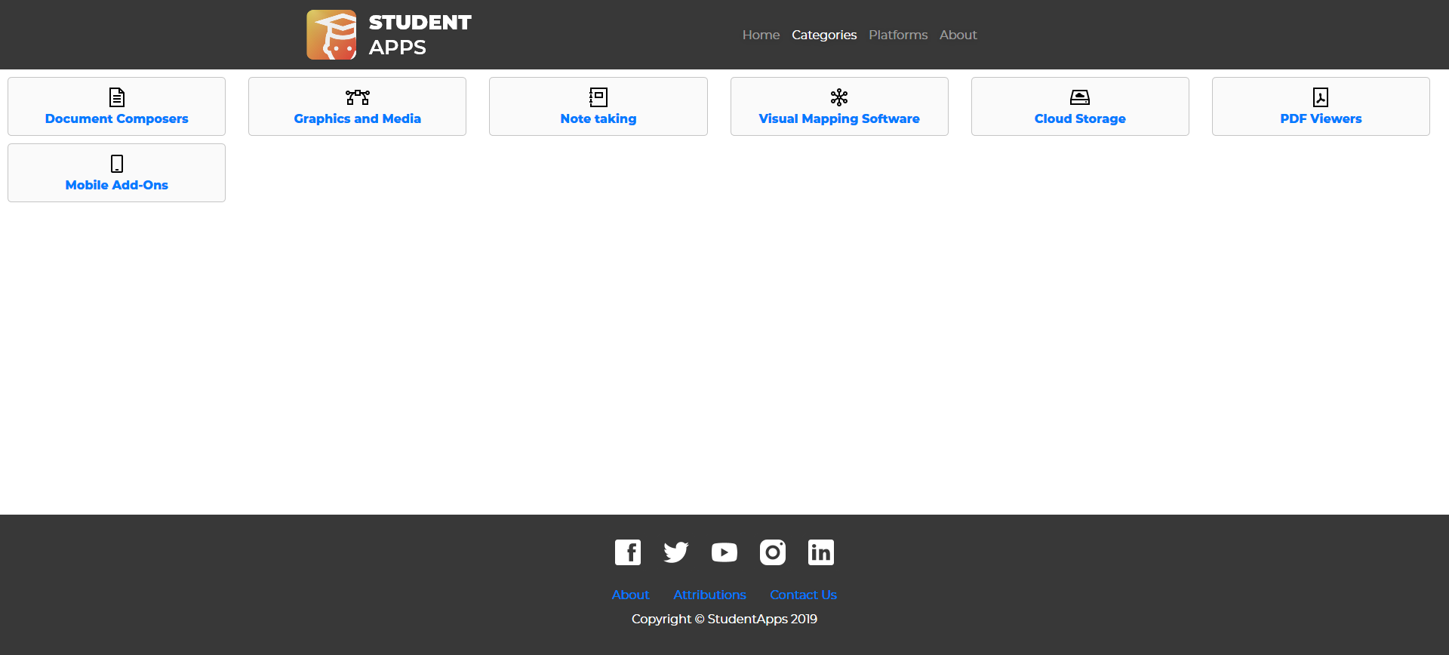

About

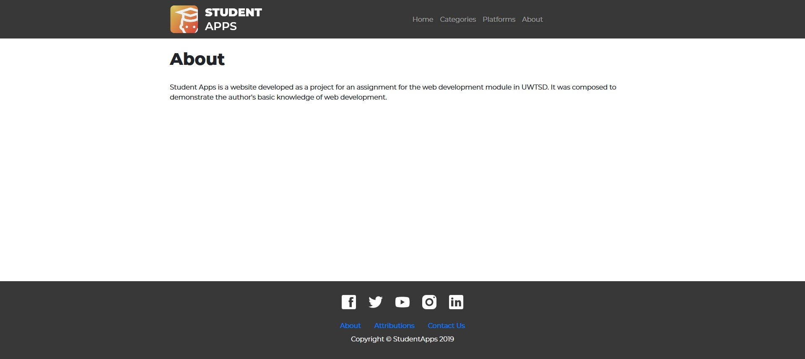

Attributions
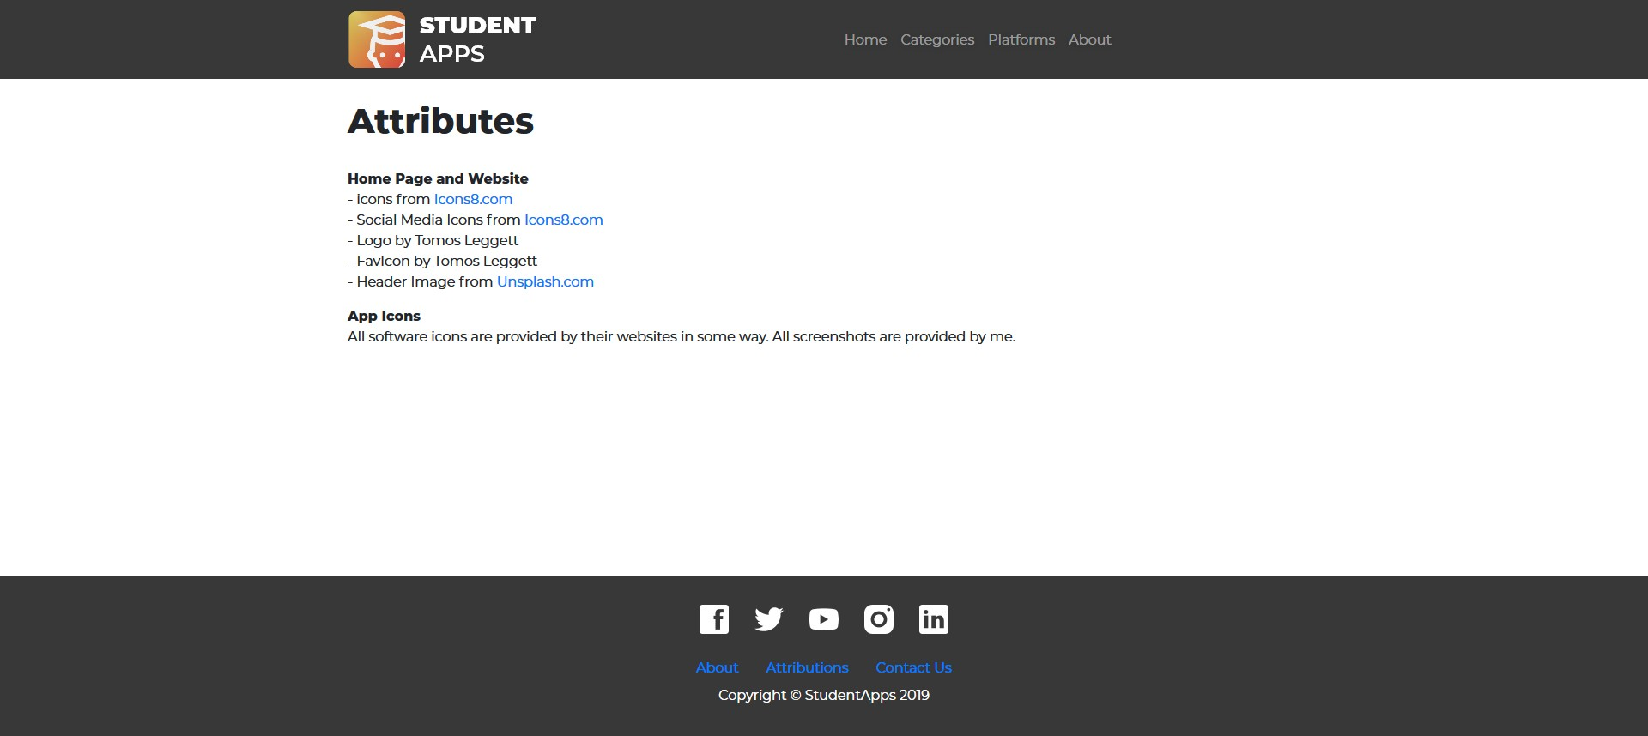

Contact Us
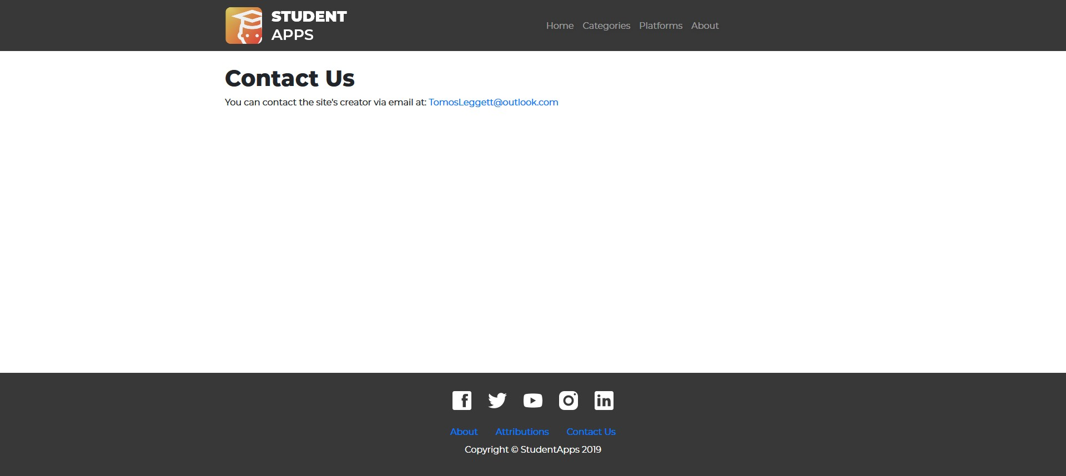

About

Categories > Document Composers
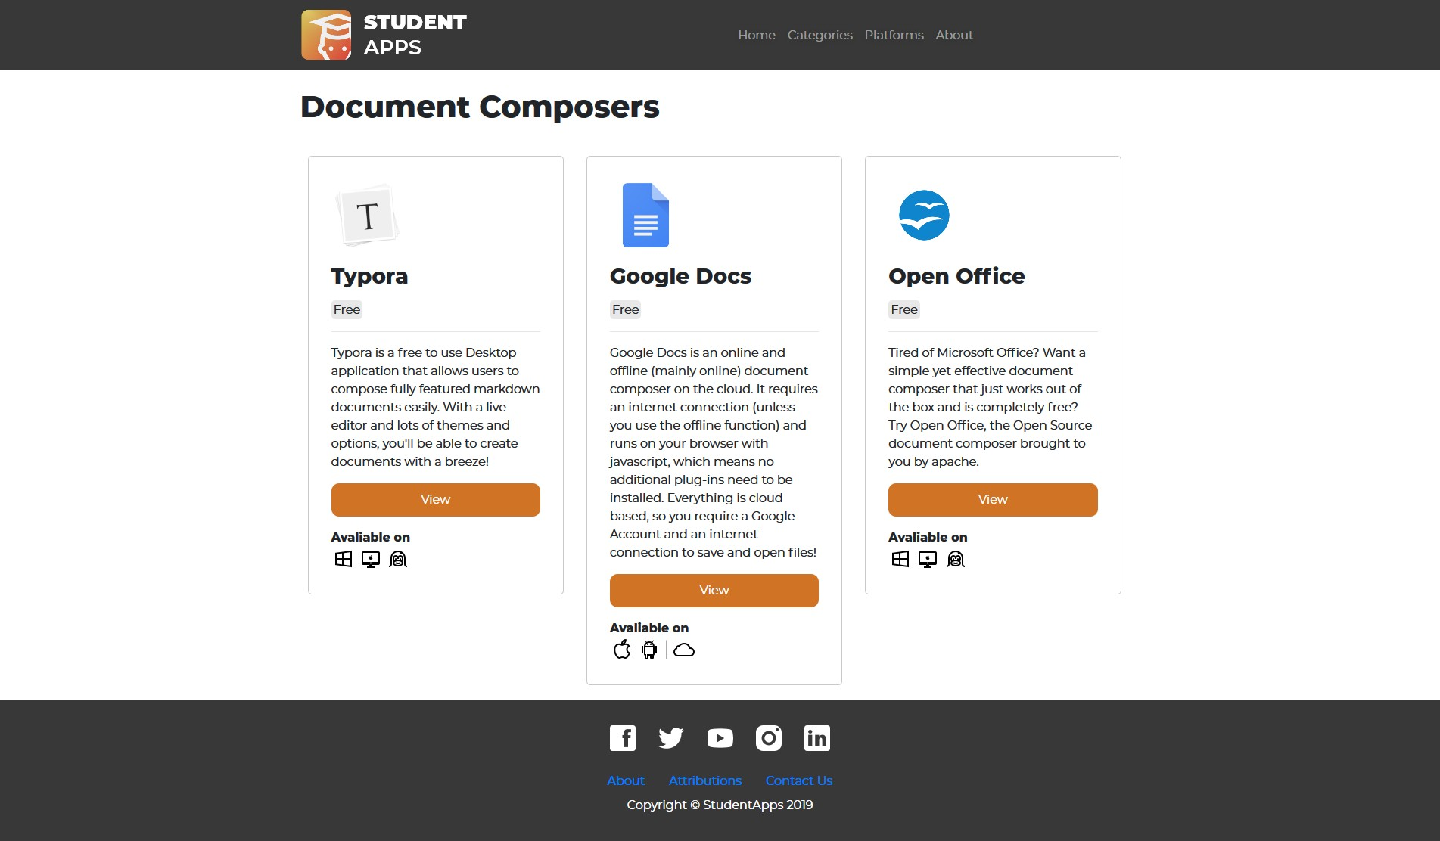
Categories > Note Taking

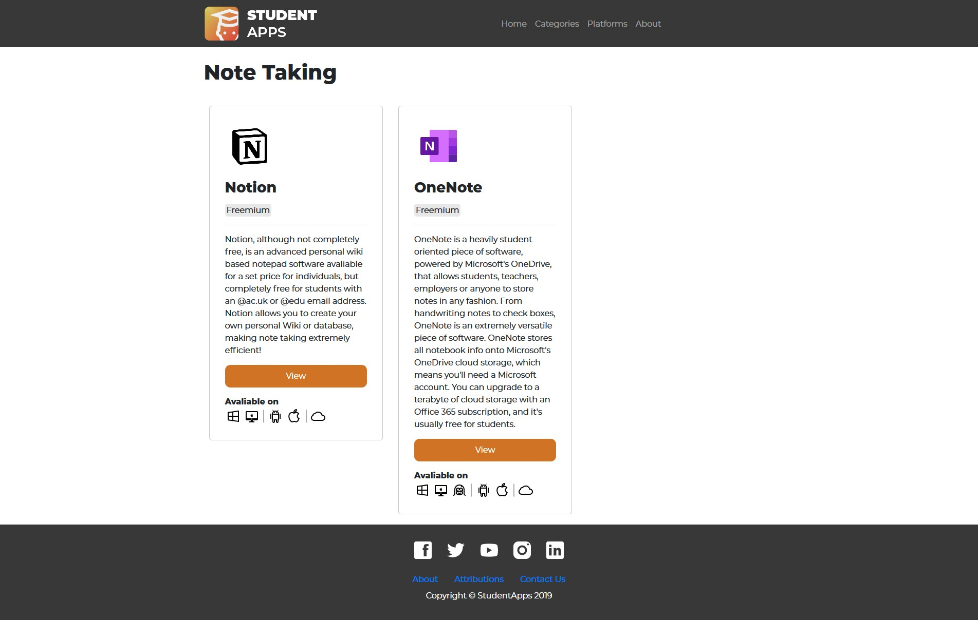

Categories > Document Composers > Typora
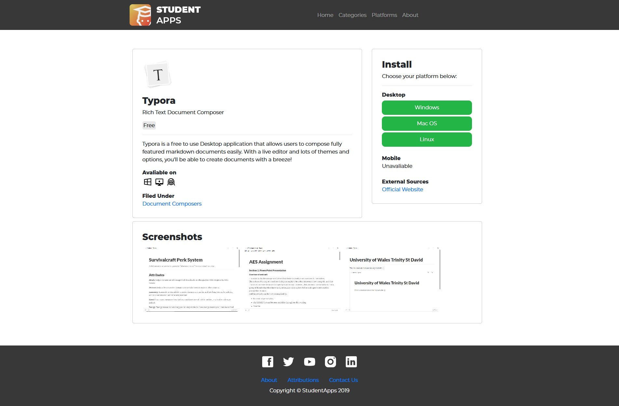

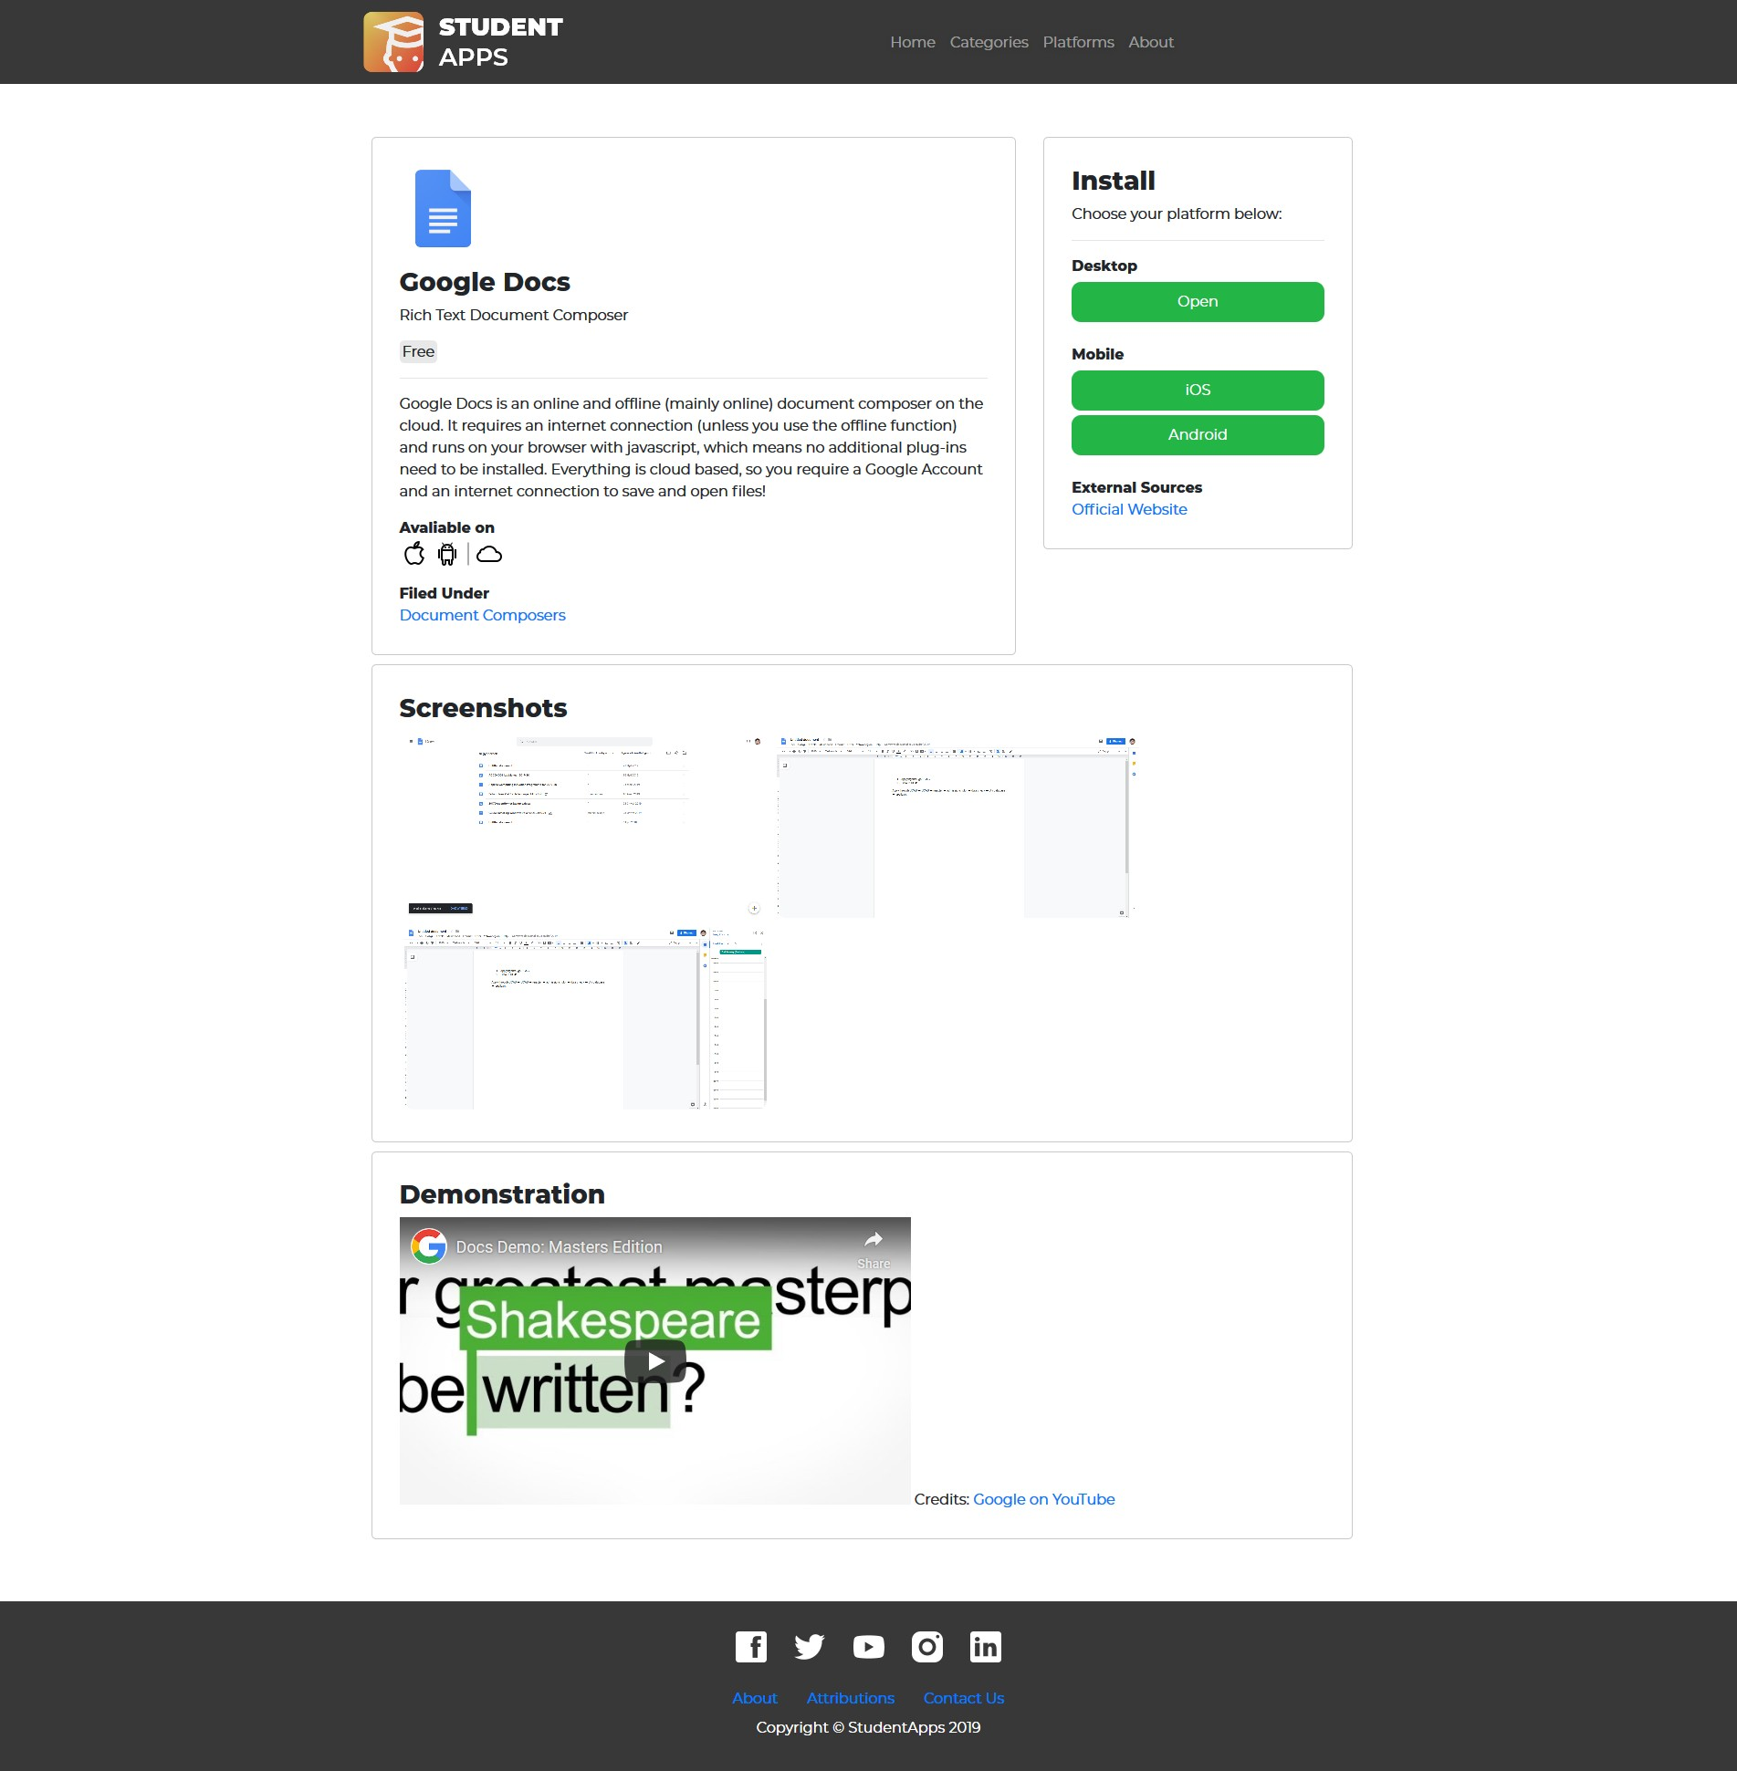
Categories > Document Composers > Google Docs
Categories > Document Composers > OpenOfice

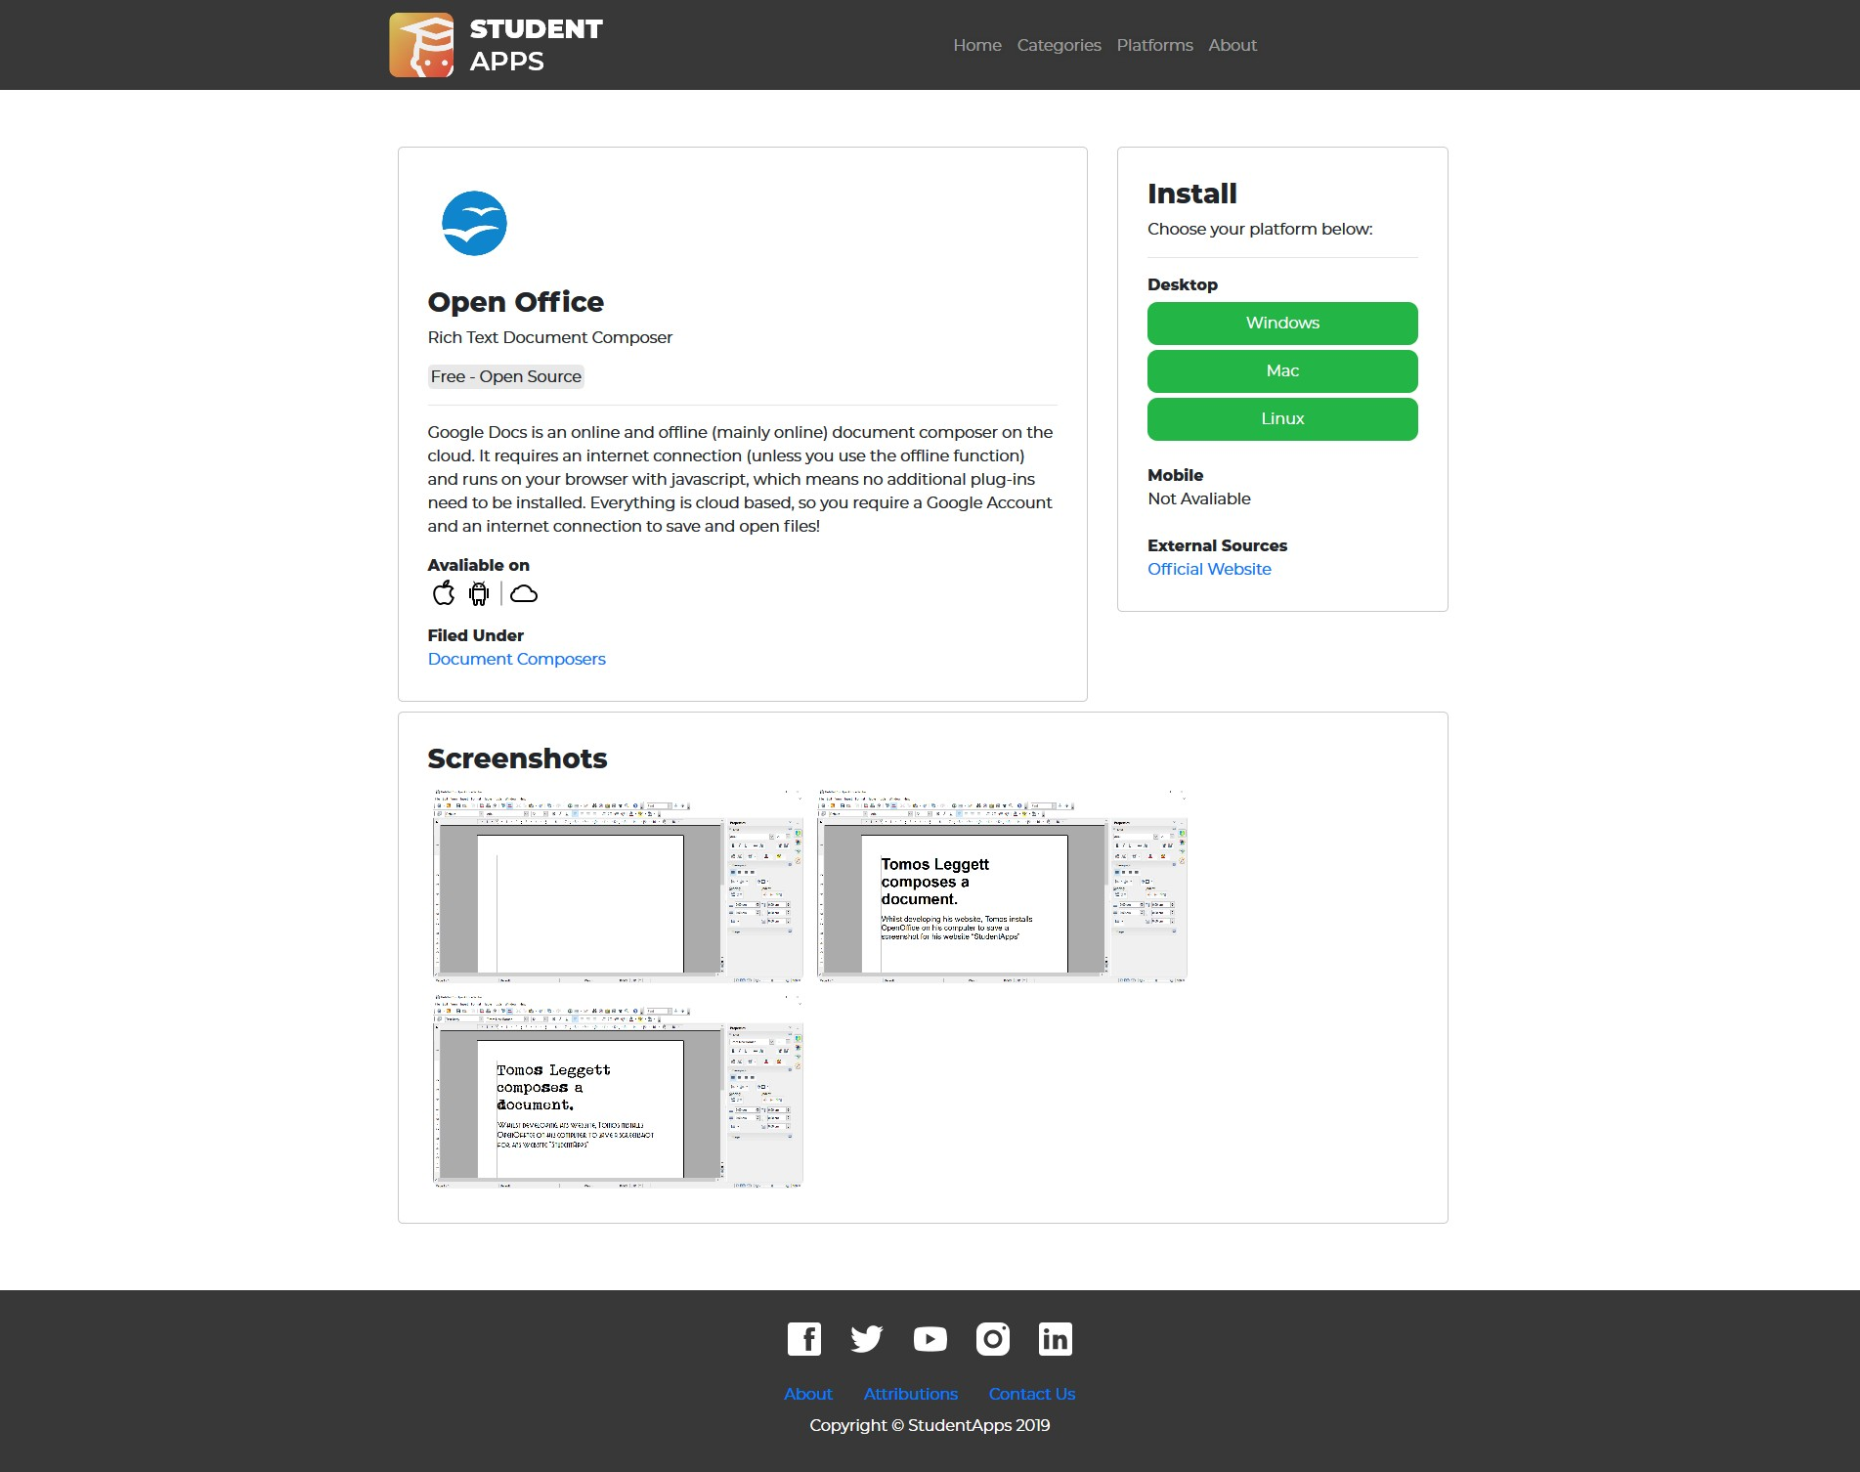

Categories > Note Taking > Notion
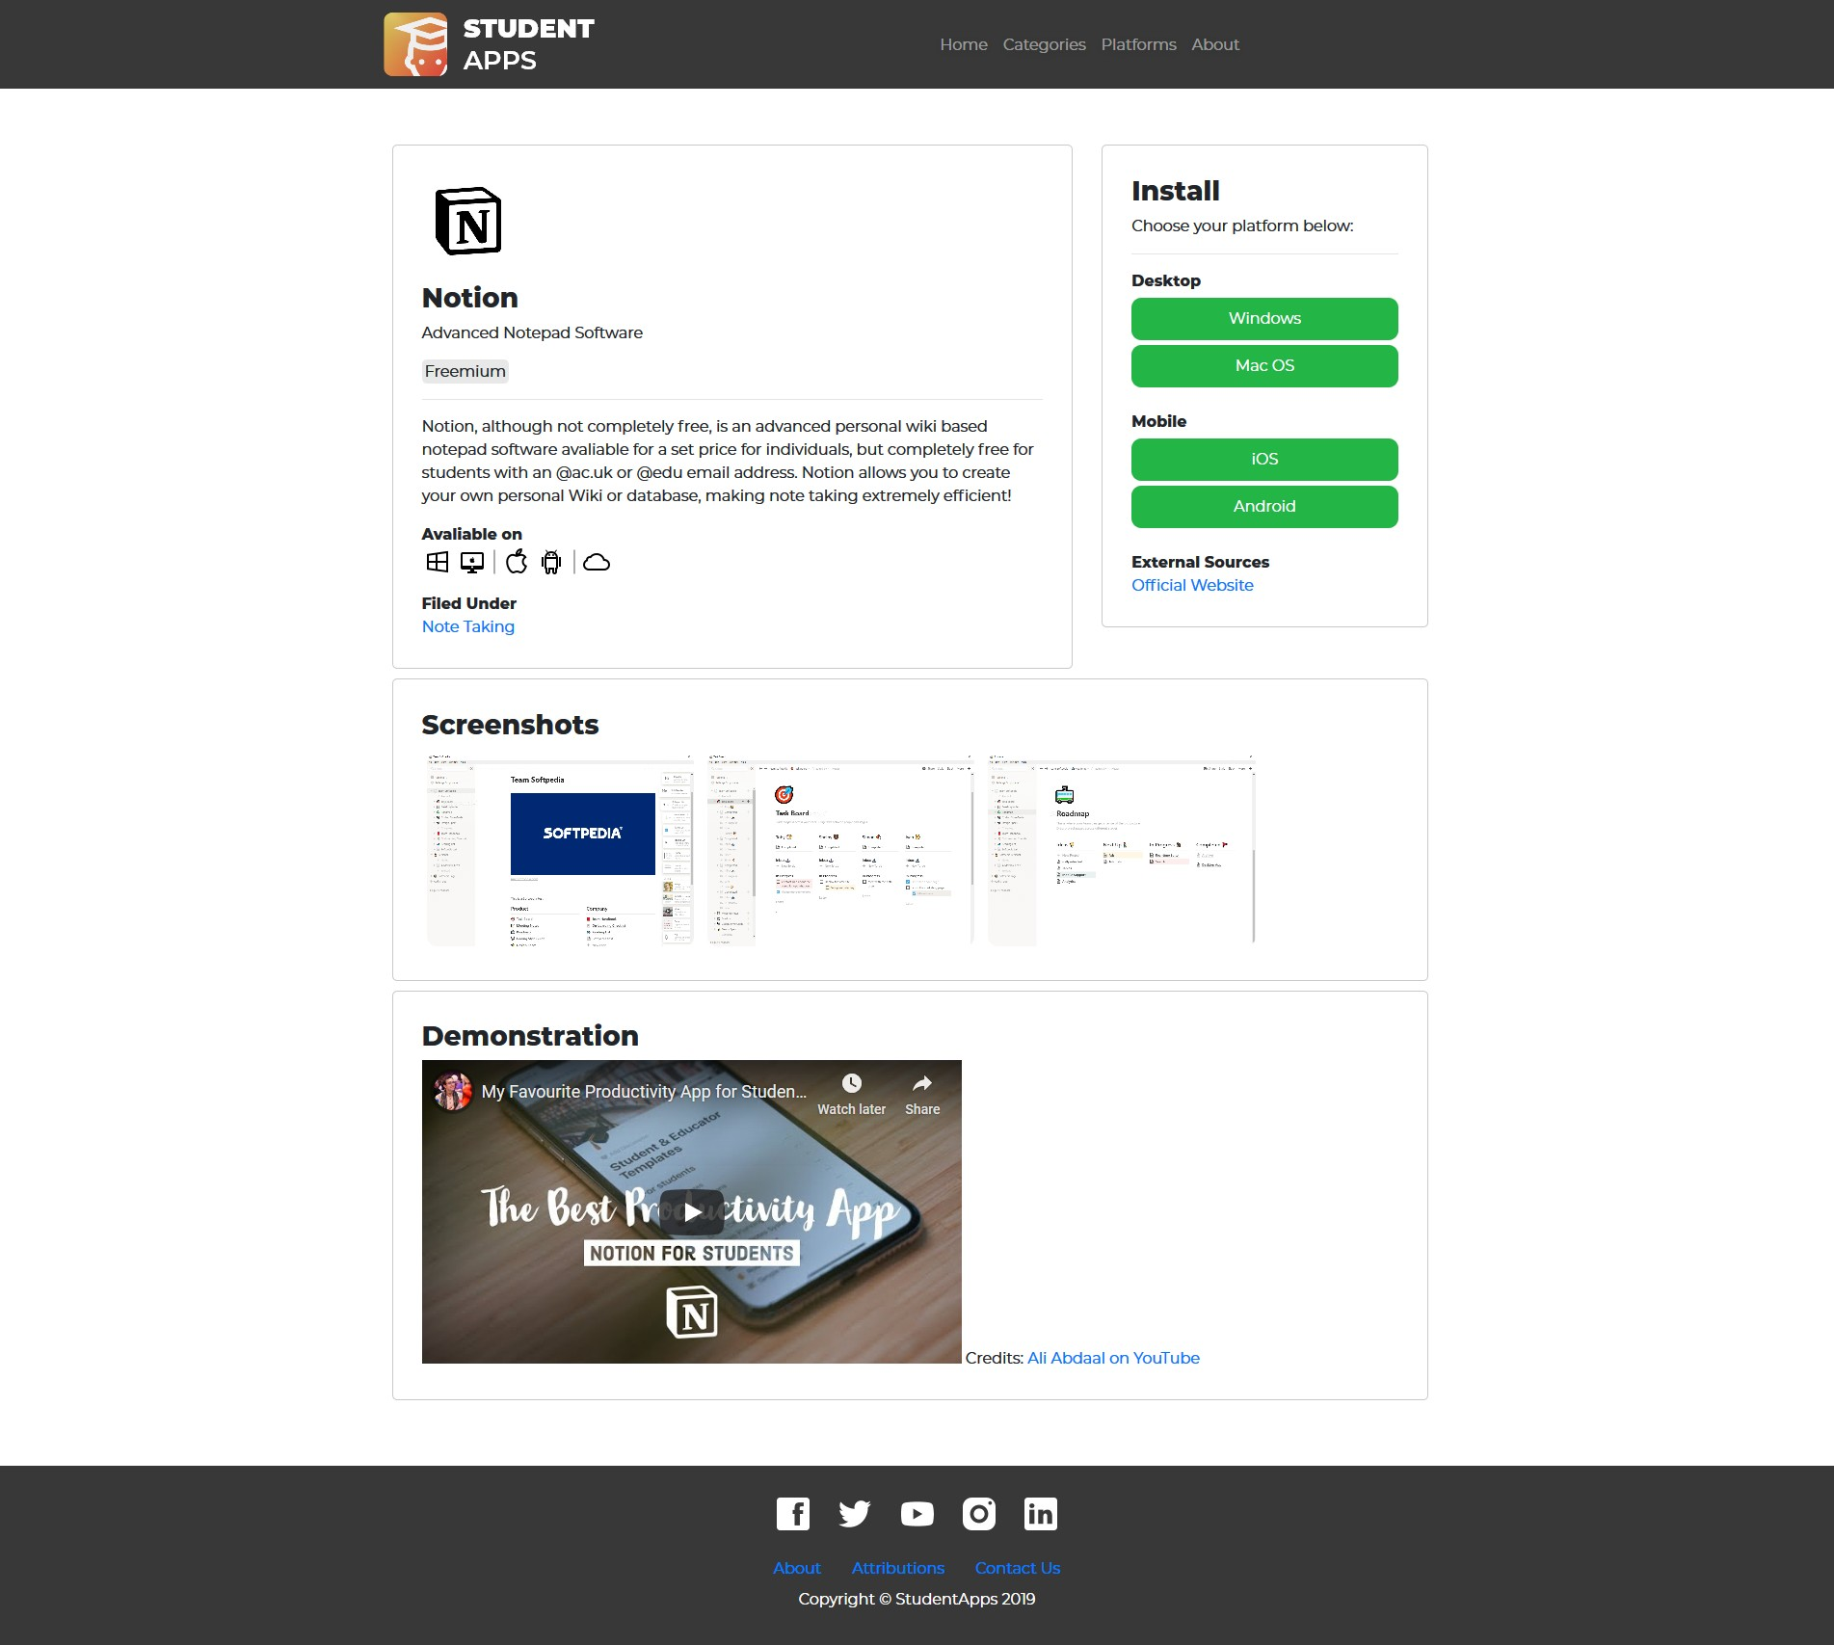

Index > CMapTools

Validation
HTML
The author decided to run their index page through a HTML validator as the brief described and received the following errors:
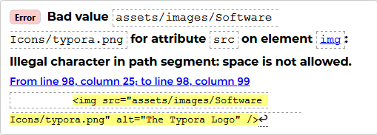
To correct this issue, the author removed the spacing between “Software” and “Icons” on the “Software Icons” directory and also the “category” and “icons” on the “category icons” directory.

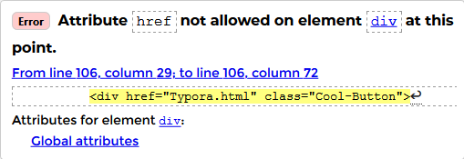

The author removed the unnecessary “href=“Typora.html”” line from the divider’s tag to correct this issue.
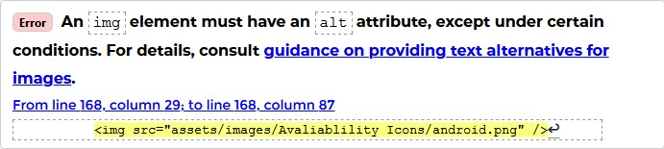
The author added an alt description to the image to resolve this issue. And to all other images that had a missing “Alt” tag.
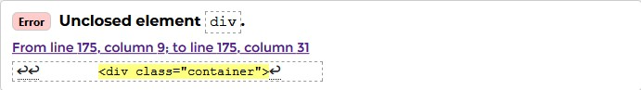
The author closed the divider with an additional “/div” tag underneath the divider’s code.
CSS
There were no errors found for the author’s CSS code.

Evaluation

Usefulness (usability and utility)
When evaluating a website, it is important to focus on the key aspects of what makes a website good. One of those key aspects, is “usefulness”. This aspect evaluates the website’s ability to perform the task it was designed for. According to Patrick Sexton, one of the guidelines for Google Webmaster is:

“Create a useful, information-rich site, write pages that clearly and accurately describe your content” [1]

In order for your website to be information rich, it needs to be original. This means that all data on the website must be enriched with original information. This includes information that isn’t available on other websites, such as more in-depth information on the availability of a product. [2] The author feels as if the information given in the description of the software on the front page’s showcase

and in the software description pages is adequate, with basic information on what the user can expect from that software, the price, the platforms the software is available on, screenshots, video demonstrations and a link to the social page.
However, the author could have produced a clearer way to convey the platform availability information, as currently, the website simply displays a row of icons the software is available in, like so:


The issue with this, is that the icons themselves aren’t clearly labelled, which means that unless the student themselves knew the logos and their meanings, this can appear as rather confusing. The author also feels as if they could have added greater detail to the description of the software, such as what makes it useful for students, what makes it better than other alternative software, etc. The information currently available on the Student Apps website is simply a short summary on what the software does, and how useful it is for students. It could have been a lot more in-depth and original, and could even contain a review system by the author, such as their opinions and thoughts on that particular software.
The design of a website is also important, as a well-designed website allows the user to navigate through the website’s pages easily, thus ensuring the content is delivered properly. According to Axia Public Relations, “Your website should clearly define what your product does through videos or text and what your company promises or guarantees” [3]. The author feels as if their website meets these guidelines. Buttons are designed in a hierarchy, which means the design of a button determines the importance of the action, [4] such as the primary actions containing large colourful widely padded boxes to help visualise the placement of the most important buttons. Most notably in the “View” buttons:

Whilst the “View” buttons, which were important, had large padded boxes around them, less important secondary buttons, such as the link that sends the user to the app’s developer homepage, looked like this:


With that being said, the author believes that the website they’ve developed is widely accessible, with clearly labelled hyperlinks appearing on the header of the website on all pages, and a large title on each page indicating the type of content on the page. However, if the author was to suggest ways they could have improved their website in the future, they would have suggested the use of a better way to sort their pages, rather than just by “category”, they could have sorted by “device type” or “platform”.

Search Engine Optimisation

Search Engine Optimisation is a measure of how well your website will perform under search engines, such as Google, and where your website will be categorized based on search results. You’ll need to make certain edits to your website to ensure that it appears as close to the top as possible on search engines. According to moz.com, the most important steps for search engine optimisation are: [5]

How accessible your website is to web crawlers
The author feels as if all pages on their website should be accessible to crawlers, according to oncrawl, the website itself contains the following important traits that lead to an accessible web crawl:
All pages are in some way linked between each other. All pages can reach the main index page in some way.
All pages can be examined, no information is contained in images or encrypted.
There are links to other pages on the internet, such as download pages. [6]

How related the information is on your website to the original search term
The author feels as if the keywords and the information on the description of the software is adequate to give results for searches based on the software that the searcher is looking for, however, due to a lack of “related software” or “alternatives to” section, the author believes the website could have had better search engine optimisation when searchers are researching for alternatives or similar software to the software they currently use.

Keyword optimisation attached to the index page
The author feels as if the keywords attached to the index page are well optimised for search engine optimisation.

Good UX and UI design, including a fast loading time
The website itself loads within less than 1 second, about 0.5 seconds. According to hobo-web, Google prefers a website loading speed to be at least 2 seconds, and aim for 0.5 seconds. The author also feels as if the user interface and experience design is also adequate. [7]

Good amount of links from other websites directing to your website, such as citations
As the author isn’t currently hosting their website, this factor cannot be evaluated.

1. Good Title, URL and Description to increase the CTR rankings
The author feels as if their website has a good title and URL system to increase their CTR rankings, as the title is relevant to the page, and contains the words “student apps”.

Accessibility

WCAG 2.1 Guidelines
The four main principles, according to the British Government, for web accessibility comprised of WCAG 2.1 guidelines [reference] are:
Principle 1: Perceivable

The author has provided text alternatives by adding “alt” tags with a description for all images on their website
The author is using a YouTube iFrame for their videos, which already comes with an automatic transcript generator
The author’s website does not use colour to distinguish between items The author’s website’s text colours clearly distinguish from the background colour
All content is accessible when the website is scaled to 200% All content is accessible when the website is scaled to 400%
All text is rendered properly, no text is embedded within images (with exceptions to software screenshots of course)
Custom fonts do not make the website less accessible Custom orientations do not make the website less accessible
Principle 2: Operable
The website can be accessed with a keyboard only
The website does not have any moving content other than videos which can be paused easily
There is no blinking or flashing content
There is no need of a “skip to content” link on the author’s website The website uses descriptive titles for pages and frames
Users can move through content on the author’s website in a way that makes sense
Descriptive text ensures that users are aware of where links direct them
Active focus is managed by the browser, the author could have improved upon this issue
There are no mouse events on the author’s web pages There are no shortcut keys on the author’s website
Principle 3: Understandable
Plain English is used throughout the website Sentences are relatively short on the author’s website
No words or phrases that people won’t recognise are used No abbreviations are used
Only one language is used to develop this website
Features are consistent throughout the website, i.e. all buttons look the same
There are no fields throughout the website
There are no forms to fill to implement the need to add a system in which people can identify and correct errors in forms
Principle 4: Robust
The website has been validated by a HTML validator
The author feels as if assistive technology should be able to understand all components and their purpose
There are no modals on the author’s website

aXe - The accessibility Engine
The author ran the aXe engine on their website and found:

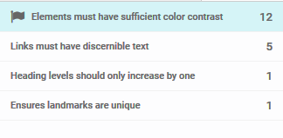

The first 12 errors were contrast violations, which the author fixed through editing their CSS code.
The second error was in regard to the social media icons having no text for accessibility readers to read.

The author fixed this issue by adding text in between the tags. This enabled screen readers to read the links. To hide the text, the author simply added a font- size:0px to the social media menu on their CSS file:
- #social-media-menu > a{
- background-image: url(../images/social-icons.png);
- width: 50px;
- height: 50px;
- display: inline-block;
- border-radius: 5px;
- background-size: 350px 100px;
- margin: 5px;
- font-size: 0px; 10 }

and then simply added the text to the attributes instead:

- <a href="https://www.facebook.com/StudentApps" target="_blank" id="Facebook">Facebook</a>
- <a href="https://www.twitter.com/StudentApps" target="_blank" id="twitter">Twitter</a>
- <a href="https://www.youtube.com/StudentApps" target="_blank" id="YouTube">YouTube</a>
- <a href="https://www.instagram.com/StudentApps" target="_blank" id="Insta">Instagram</a>
- <a href="https://www.linkedin.com/StudentApps" target="_blank" id="LinkedIn">LinkedIn</a>

References
[1,2] P. Sexton, "Creating useful and information rich websites", Varvy.com, 2020. [Online]. Available: https://varvy.com/usefulinformationrich.html. [Accessed: 08- Jan- 2020]
- H. Feran, "What makes a website useful and accessible?", Axiapr.com, 2020.

[Online]. Available: https://www.axiapr.com/blog/what-makes-a-website-useful
-and-accessible. [Accessed: 08- Jan- 2020]
- "UI cheat sheets: buttons", Medium, 2020. [Online]. Available: https://uxdesig n.cc/ui-cheat-sheets-buttons-7329ed9d6112. [Accessed: 08- Jan- 2020]
- "Beginner's Guide to SEO [Search Engine Optimization]", Moz, 2020. [Online]. Available: https://moz.com/beginners-guide-to-seo. [Accessed: 08- Jan- 2020]
- "How to make a crawlable site - OnCrawl", OnCrawl, 2020. [Online]. Available: https://www.oncrawl.com/technical-seo/how-to-make-a-crawlable-site/. [Accessed: 08- Jan- 2020]
- Hobo-web.co.uk, 2020. [Online]. Available: https://www.hobo-web.co.uk/your- website-design-should-load-in-4-seconds/. [Accessed: 08- Jan- 2020]

marking criteria and Student FEEDBACK

This section details the extent to which the assessment criteria are demonstrated by you, which in turn determines your mark. The marks available for each category of skill are shown. Lecturers will use the space provided to comment on the achievement of the task(s), including those areas in which you have performed well and areas that would benefit from development/improvement.

Common Assessment Criteria Applied (Assignment 1) | Marks available | Marks  awarded
1. Engagement with Literature Skills

Provides a good discussion of the concepts but the supporting related research is missing. Expand the scope of reference sources consulted to further improve your research work. (Grade mark: 58.00%) | 25 | 14.5
2. Knowledge and Understanding Skills

Demonstrates a very good understanding of the standards used to design and implement a website and a very good understanding of the validation results. An excellent evaluation of the website has been provided. (Grade mark: 90.00%) | 20 | 18
3. Cognitive and Intellectual Skills

4. Practical Application Skills

Generally, a very good attempt featuring a simple website with well-thought-out content. The home page in particular is very good and looks quite professional, but sadly some of the other pages have not been completed to the same standard and give an overall impression of an incomplete site, and you also have a few broken links. Nonetheless, there are some well-put-together pages in the submitted website. Some things to note: Please avoid having links to non-existent pages in your main menu and the contrast of the main navigation is a bit low. Yes, I know you have used the Bootstrap template, but you can use CSS to override the styles. Also, remember to highlight the main menu link of the currently active page and open links to external websites in a new tab. Generally, I would have liked to see the website packaged differently so that it does not give the impression of an incomplete site, as well as some more variation of content particularly on the contact and about page. See your report for some other minor comments. (Grade mark: 74.00%) | 50 | 37
5. Transferable Skills for Life and Professional Practice

The report is of a good standard. See your report for additional suggested improvements. Please also note that you were required to submit a Word report version and NOT a pdf document. (Grade mark: 70.00%) | 5 | 3.5

Assignment Mark (Assessment marks are subject to ratification at the Exam Board. These comments and marks are to give feedback on module work and are for guidance only until they are confirmed. ) | Late Submission Penalties (tick if appropriate) |  | 73%
 | Up to 1 week late (40% Max) |  | 73%
 | Over 1 week late (0%) |  | 73%

