

University of Wales Trinity Saint David
School of Engineering

Simon Ellis-Williams
P150613

Vehicle testing and analysis
M6X00415

19/12/2019

Tim Tudor

Contents
Table of figures iii
1) Introduction 1
2) Equipment 2
2.1 Base Performance simulator 2
2.2 Motec I2 2
2.3 Setup sheet 2
3) Experimental procedures 3
3.1 Test plan 3
3.2 Aerodynamic calculations 3
3.3 Maths channels 5
4) Results 6
4.1 Lift and drag 6
4.2 Lateral acceleration 7
4.3 downforce front and rear 8
4.4 Centre of pressure 8
4.5 tyre loadings 9
4.5.1 Anti roll bar 9
4.5.2 Spring rates 12
5) Conclusion 14
References 15
Appendix 1 16
Appendix 2 18
Appendix 3 19

Table of figures
Figure 2-1 2
Figure 2-2 . 2
Figure 2-3 2
Figure 3-1. 3
Figure 3-2. 5
Figure 4-1 6
Figure 4-2. 6
Figure 4-3. 7
Figure 4-4. 9
Figure 4-5 . 10
Figure 4-6 11
Figure 4-7 12
Figure 4-8 13

Introduction
The following report aims to analyse the effects of different suspension and aero settings on a vehicle, and the effects these have on the vehicles handling. Data for an Aston Martin DB9 race car was collected using a simulator which allowed the users to alter different areas of the car’s suspension and aero dynamics. A coast down test, and multiple laps of Silverstone circuit were performed, each with different settings which were changed according to a test plan agreed upon by the group.
The data was then imported into Motec for analysis and to produce further data via maths channel equations. From this data, tyre loads are looked at during entry, apex, and exit of low and high-speed corners. Comparisons of how the changes to the cars set up affected the performance and handling of the vehicle are then made, before deciding on a set up that suits the driver, and is right for the car and circuit.

Equipment

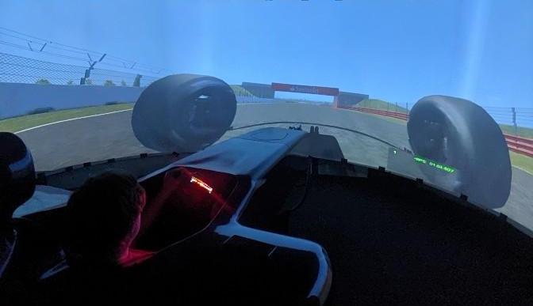
2.1 Base Performance simulator
To generate the necessary data for the test, the Base Performance Simulator was used, running Rfactor racing software. The vehicle used for the simulation was an Aston Martin DB9 race car, driven by Ainsley Martin. The track selected for the test was silverstone international circuit.

2.2 Motec I2
Figure 2-1Ainsley Martin using the Base Performance simulator in UWTSD
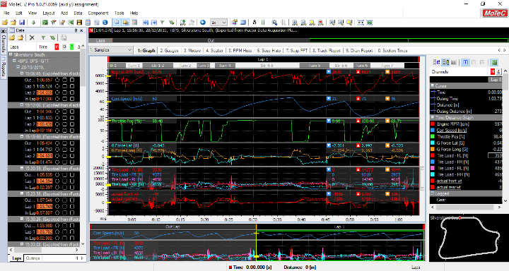
Motec I2 was also used to collect and process the data. Motec is a powerful data analysis program that logs data collected from sensors on the car through the ECU. The program allows the user to manipulate the data and draw further data and conclusions via mathematical equations or math channels. Motec also shows the actions of the driver, and allows users to create graphs to display results more clearly.
Figure 2-2 Screen grab of Motecs user interface. Distance/time graphs are shown in the middle section, the log of each run is shown on the left, and specific data and a map of the circuit is shown on the right.

2.3 Setup sheet
The setup sheet is an excel file used by Motec to reference data on the vehicles set up. Settings of the car’s suspension, aero, gearing, and other vehicle specifics can be entered in rows which are named according to the time and date the data was originally logged. Motec then applies the correct set up for each run. Maths channels also reference the setup sheet, giving different data for each run. A full copy of the set up sheet can be seen in the appendix
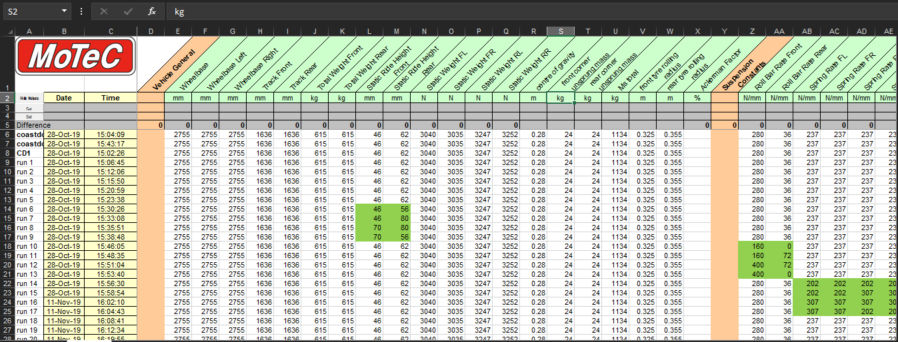
Figure 2-3 Motec setup sheet. Individual runs are shown by each row, with each parameter of the cars setup listed along the top in green. The yellow columns are the times and dates of each run.

Experimental procedures

3.1 Test plan
The overall test involved thirty-three runs in total looking at different splitter and wing variations, ride hights, anti-roll bar settings, spring stiffness, and damper bump and rebound. Each run is compared to a baseline run with all setting as standard, helping to show the effect of the adjustments on the vehicles handling. The driver’s opinion on the handling of the car was also noted, commenting on if the car felt too sensitive, too vague, or nice to drive.
A table of the runs and the parameters on the car that were changed can be seen below, with a full version with values in the appendix.
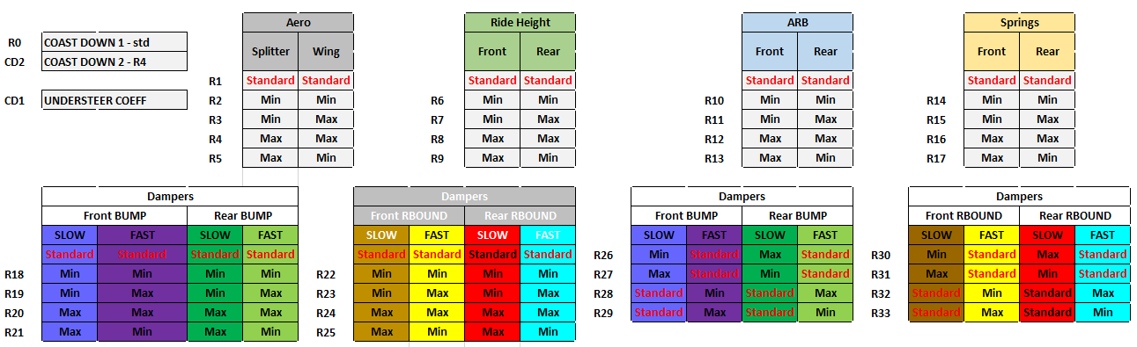
Figure 3-1 test plan for simulation runs including aero settings, ride height, anti-roll bar setting, spring stiffness, and damper bump and rebound settings.
From the gathered data six runs will be analysed to see the effects the changes had on the cars handling. Tyre loads and amount of weight transfer occurring at low and high-speed corners will be analysed and compared to other run data. The runs chosen to be analysed for this report are as follows:
Table 1 - table displaying the runs to be analysed and how the aerodynamic and suspension parameters are being altered
Coast downs: | Standard settings
Coast downs: | Max splitter, max wing
Run 10 | Anti roll bar front | Anti roll bar rear
Run 10 | minimum | minimum
Run 12 | Anti roll bar front | Anti roll bar rear
Run 12 | maximum | maximum
Run 14 | Spring rate front | Spring rate rear
Run 14 | minimum | minimum
Run 16 | Spring rate front | Spring rate rear
Run 16 | maximum | maximum

3.2 Aerodynamic calculations
As can be seen, the first two runs were coast down runs to asses the affects of changing the splitter and wing parameters of the vehicle. Coast down testing is an industry method of testing for aerodynamic loads on a vehicle and is conducted by accelerating the vehicle to a high speed and then disengaging the drivetrain, letting the vehicle coast until it stops naturally. This is carried out on a straight, flat road, on a day with as little wind as possible so as to achieve the most accurate result. (Gururaja, 2016) the speed and time data gathered from these runs is then used to find deceleration rates, rolling resistance, values for lift and drag, and their respective coefficients.
With the data gathered from the simulation runs, the aero loadings on the front and rear tyres of the vehicle were calculated by finding the difference between the tyre loadings at a standstill, then at maximum velocity, the extra force on the tyres equating to the aero force acting on each axle. (Equation 1a & b)
 | $$Aero load front =F_{vmax front} - F_{static front}$$ | (1a)

 | $$Aero load rear =F_{vmax rear} - F_{static rear}$$ | (1b)
These values where then added to find the total aerodynamic load on the vehicle, with the total value then being used in the lift equation along with the maximum velocity to work out the coefficient of lift (eq 2)
 | $$Coefficient of lift=\frac{{lift}_{tot}}{0.5 x ρ x \frac{{Vmax}^{2}}{1.2}}$$ | (2)
The aerodynamic centre of pressure was then also calculated to find where the aerodynamic loads were acting on the car longitudinally (eq 3)
 | $$\frac{{aero}_{front}}{{aero}_{total}} x 100$$ | (3)

Deceleration rates were then calculated at the beginning of the coast down when velocity was high, and toward the end when velocity was low, using the times that the velocity values were taken. (eq 4)
 | $$decelleration = \frac{V_{2}-V_{1}}{T_{2}-T_{1}}$$ | ()

These values were used to calculate rolling resistance (eq 5)
 | $$low speed decelleration x vehicle mass$$ | (4)

Mass times deceleration was worked out for the high-speed deceleration, and low speed deceleration values giving values for ma1 and ma2, with the difference between these values giving the total aerodynamic drag (eq 6)
 | $$(mass x decelleration_{high})-(mass x decelleration_{low})$$ | (5)

The mean velocity of the two high speed deceleration values was then used to calculate the coefficient of drag (eq 7)
 | $$Coefficient of drag=2 x \frac{drag}{ρ x \frac{{Vmean}^{2}}{1.2}}$$ | (6)
Which was then used to work out the aerodynamic efficiency of the vehicle (eq 8)
 | $$Aerodynamic efficiency = \frac{coefficient of lift}{coefficient of drag}$$ | (7)

3.3 Maths channels
Building upon the maths channels from the previous weight transfer assignment last year, new channels for aerodynamics were created, showing how the aerodynamic values of the car changed over the course of a lap. Maths channels allow a Motec user to create mathematical equations using values specified within the setup sheet, and from other values calculated by previous maths channels. These were then displayed as data traces.
Maths channels using the equations above were created to show lift and drag, downforce acting on the front and rear axles, lift and drag coefficients, and centre of pressure.
The full list of maths channels can be seen in the appendix.
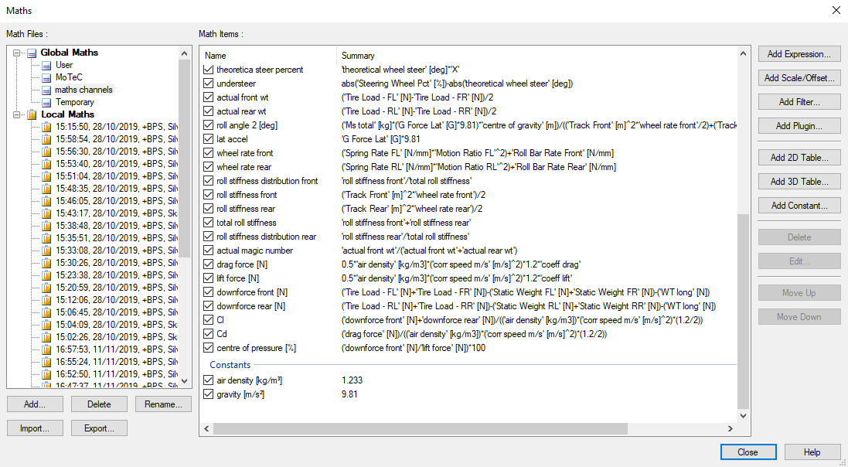
Figure 3-2 Motec maths channels window. Maths channels are equations using values from the setup sheet to calculate other important values that may be needed. the equations can be seen under the summary header.

Results

4.1 Lift and drag
Once data maths channels and data traces were created for downforce and drag. A comparison between the baseline run with standard settings for aero was made and the results can be seen in figure 4-1. The results show that downforce and drag values acting on the car remain close.
R Tarulescu’s research shows that an increase in the angle of attack of a rear wing leads to an increase in downforce and a slight increase in drag. (Tarulescu, 2017) Run 2 used minimum splitter and wing values of 1-1, so less downforce and drag would be expected compared to the baseline run, which used a splitter and wing setting of 2-8. But as can be seen, run 2 unexpectedly created slightly more downforce at turn 2 which is a low speed corner, producing 830N on the baseline run compared to 1040N during run 2. Analysing the speed difference of the car during the two runs at this corner, the driver was traveling at 25m/s during the baseline run and 28m/s during run 2 which would affect the downforce value, but as the splitter and wing are at lower values, this is still more than expected.
The same is also seen at the high speed areas on the straights 4-5 and 5-6 with run 2 producing more downforce at these speeds. At the highest speed of straight 4-5, the baseline run recorded a high speed of 71m/s whereas run 2 recorded a speed of 72m/s. The downforce recorded at these points are 6395N for the baseline run, and 6615N for run 2, which again is not what is expected with lower wing and splitter settings.
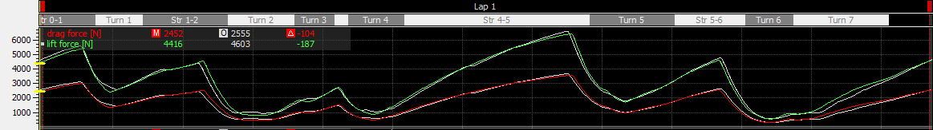
Figure 4-1 Baseline run and run 2 lift and drag comparison. The coloured line is baseline and white lines show run 2. Splitter and wing angles were at minimum for run 2, so a decrease in lift should be expected
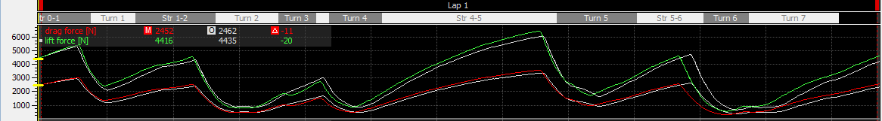
Figure 4-2 baseline run and run 4 lift and drag comparison, white lines show run 4. Splitter and wing angles were at maximum during run 4, so an increase in lift should be expected, but is not seen.
Comparing the baseline to run 4, where splitter and wing were at maximum value, it would be expected that a large increase in lift is observed, but it can be seen that the opposite is true. As the vehicle accelerates along straight 4-5, the lift value is lower than the baseline, and at its peak reaches 6026N at a speed of 69 m/s, compared to the baselines 6615N at 71m/s. The drag values also show that drag is not responsible for this as drag has also slightly decreased, again, not what would be expected with an increased wing angle.

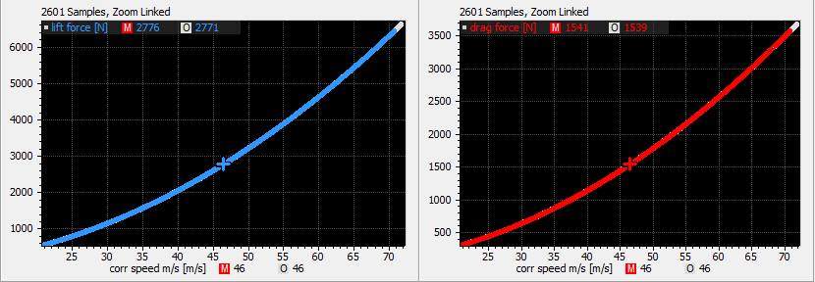
Figure 4-3 Correlation between speed and downforce, and speed and drag for the baseline run in blue and red, and run 2 in white. Both runs follow exactly the same curve.
Comparing the baseline runs speed vs lift graph, it can be seen that lift and drag for both runs are actually equal. This is not as expected, as stated before with the lower settings for wing and splitter applied, less downforce and drag should be seen. Although this is the case, the curve of the line does show that downforce is proportional to velocity squared (NASA, 2020), although the results do slightly over calculate this, possibly down to an error in the math channels.

4.2 Lateral acceleration
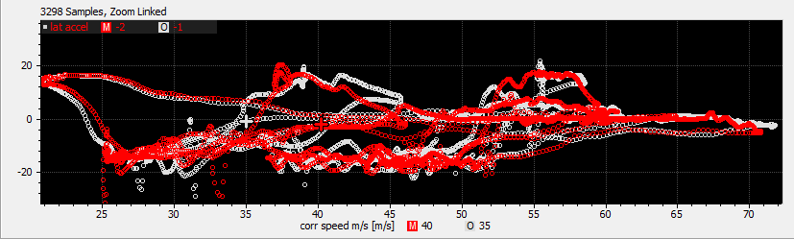
Figure 4-4 plot showing lateral acceleration against speed in m/s for baseline in red, and 2 in white.
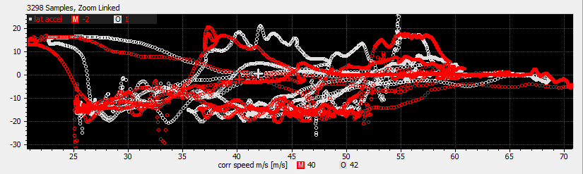
Figure 4-5 plot showing lateral acceleration against speed in m/s for baseline in red, and 4 in white.

4.3 downforce front and rear
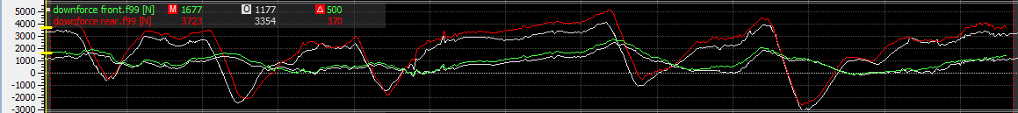
Figure 4-6 Data trace showing downforce acting on front (green) and rear (red) axles for baseline, with run 2 overlaid in white.
Looking at the data for front and rear downforce of lap 2 compared to the baseline, it can be seen that there is a noticeable drop in the amount of downforce seen at the rear of the car over the lap. This is expected as the rear wing is set to minimum. A small drop in front-end downforce is also noticeable due to the splitter being set to minimum also.
This suggests there is a problem with the coefficient of lift equation.
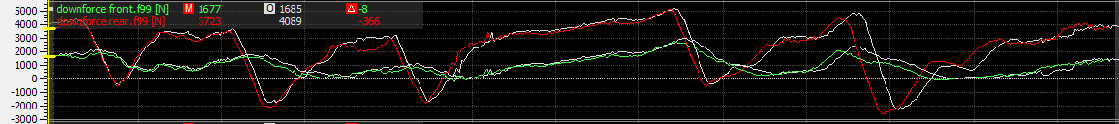
Figure 4-7 data trace showing downforce acting on front (green) and rear (red) axles for baseline, with run 4 overlaid in white
During run 4, when the splitter and wing were both set to maximum values, the data shows that the amount of downforce seen is to be closer to the baseline results, only increasing in a few areas mainly due to driver inputs.
drag has increased over run 2, and slightly increased over the baseline results, showing that the increase in wing and splitter does incur more drag, as expected.

4.4 Centre of pressure
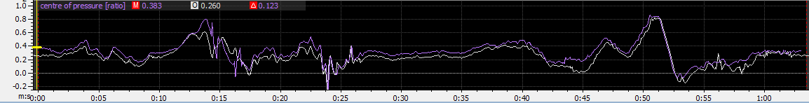
Figure 4-8 Plot showing centre of pressure across the entire lap in purple for baseline, with run 2 overlaid in white
The centre of aerodynamic pressure is measure as a percentage from the rear axle of the vehicle. Having minimum wing and splitter settings, it is shown in run 2 that the centre of pressure is slightly closer to the rear of the car for the majority of the lap. This is apparent especially through straight sections where the car is at high speeds such as around 0:35s. this is as expected, as a wing at minimum setting will still produce downforce, where as the splitter will only catch a small area of high pressure at the front of the car.

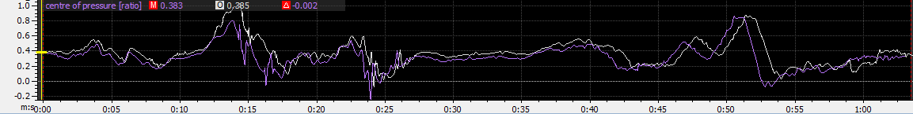
Figure 4-9 Plot showing centre of pressure across the entire lap in purple for baseline, with run 4 overlaid in white
Once the splitter is extended to maximum in run 4 however, the aero balance of the car can immediately be seen to change and move further forward the front axle. Although the wing has also been increased, it has already been shown that little downforce at the rear is seen as the wing increases past baseline value in figure 4-7. In this simulation, the adjustment of the splitter has a greater effect at the front of the car than adjusting the wing at the rear of the car.

4.5 tyre loadings

4.5.1 Anti roll bar
Looking into the effects of altering suspension parameters, runs 10, 12, 14, and 16 analysed tyre loadings during low and high speed corners. To establish a baseline, the tyre loads from the baseline run during corners 2 (low speed) and 5 (high speed) were used, both being right hand corners. During this run the settings for springs and anti roll bars were as follows
springs front | springs rear | arb front | arb rear
237N/mm | 237N/mm | 280N/mm | 36N/mm

Figure 4-4 graphs showing the tyre loadings of each wheel during low and high speed corners for the baseline run with settings as standard.
As can be seen, as the car initially turns into the corner, the difference between left and right loadings can be seen to differ as the load of the car shifts to the left. As the vehicle accelerates out of the corner, the loadings on the two rear tyres, especially the rear left, increase, show that the most load is in the rear left corner. The opposite tyre at the front right of the vehicle sees a large decrease in load during turn in as the brakes are released and the vehicle begins to turn through to the apex, and a slower return to normal loading as the car straightens and accelerates out of the corner.
During high speed cornering, similar trends are observed, but as the driver keeps the power on all the way through the turn, as opposed to the slow speed corner, where the driver suddenly accelerates, the rear right sees a more gradual increase.

Figure 4-5 Graphs showing tyre loadings for run 10 with minimum anti roll bar settings front and back during the vehicles entry, apex, and exit to a low and high speed corner.
Run 10 altered the front and back anti roll bar to minimum settings.
springs front | springs rear | arb front | arb rear
237N/mm | 237N/mm | 160N/mm | 0N/mm
Anti rolls bars limit the amount of roll the body experiences when cornering, acting like a spring between the chassis and the axle, with the more force being applied to it, the more it resists by pushing the body back, and the wheel into the ground harder. (Tan Vu, et al., 2019). The effect of minimal anti roll bars on the vehicle should show that as more body roll happens, less force is applied vertically to the outer wheels. (Czaja & Hijawi, 2004).
The graphs for run 10 show that for low speed corners the force on the front left tyre increases as the vehicle turns in, this goes against what Czaja and Hijawi state. Looking at the front right forces it is shown that the wheel sees a more rapid increase in force and the car exits the corner compared to the baseline.
The rear left wheels load is also seen to increase at apex slightly more than the baseline but then decrease as the car accelerates out of the corner. With the rear right wheel slightly losing some force, then again gaining more as the driver accelerates out of the corner.
During high speed cornering the front left wheel force drops as the car corners, this is partly due to the car breaking hard from high speed before turn in preloading the front tyres before the cars even got to the corner, then accelerating through the apex and out.

Figure 4-6 Graphs showing tyre loadings for run 12 with maximum anti roll bar settings front and back during the vehicles entry, apex, and exit to a low and high speed corner
For run 12, the anto rolls bars on the front and rear axles were set to maximum stiffness
springs front | springs rear | arb front | arb rear
237N/mm | 237N/mm | 400N/mm | 72N/mm
The expected outcome of this should see higher loads on the outside and inside tyres as the ARB forces the tyres into the road more as the car corners and leans. It can immediately be seen that at low speed corners at the apex, the front left corner has nearly 1000N more force being applied at apex than the baseline run. This agrees with Czaja and Hijawi who say the force of the ARB will push the tyre into the ground. The rear left tyre also increases as the car corners as expected, then continues to increase as the car accelerates away.
During high speed cornering the graph shows similar trends to run 10’s high speed graph apart from the rear left wheel which continues to increase in load as the car exits the corner. It is also noted that the driver thought the car handled badly during this run.

4.5.2 Spring rates
The next two runs that were analysed changed the spring rates on the vehicle, with run 14 using the softest settings front and back, and run 16 using the hardest settings.
Hassan states that softer springs lead to more body roll during corners, leading to a shift in the centre of gravity to one side, leading to a loss in grip. Whereas a stiff spring has the effect of slowing body roll and load transfer, not loading the outer tyre fast enough to use its full potential grip. (Hassan, 2017)

Figure 4-7 Graphs showing tyre loadings for run 12 with minimum spring stiffness front and back during the vehicles entry, apex, and exit to a low and high speed corner
Run 14 settings:
springs front | springs rear | arb front | arb rear
202N/mm | 202N/mm | 280N/mm | 36N/mm
Run 14 shows the effect of softer springs on the vehicle. The front two tyres at low speed show as the car turns in, a small increase of force is seen on the outer tyre whereas the baseline shows a decrease by the apex. The front right wheel shows a small decrease in load as weight transfer happens, this agrees with Hassan’s statement. Bigger load transfer would likely be seen if the anti roll bar was set to minimum for this run also.
During the high speed corner the tyre loads follow similar trends to the baseline, with the only differences being much higher loads on the front left as the car begins to turn in under braking, and the rear left dropping off after apex.

Figure 4-8 Graphs showing tyre loadings for run 12 with maximum spring stiffness front and back during the vehicles entry, apex, and exit to a low and high speed corner
springs front | springs rear | arb front | arb rear
307N/mm | 307N/mm | 280N/mm | 36N/mm
Run 16 shows the effect of stiff springs on the cars handling and the low speed graph shows that as the car corners the front left wheel loading linearly decreases, compared to the decrease seen in the baseline run, this proves Hassans statement that body roll and weight transfer is slowed by stiff springs. The rear right sees similar results to the baseline as the car accelerates out of the corner
During high speed cornering the main difference seen is for the rear left tyre which also decreases in load as the car accelerates out of the corner.

Conclusion
This report has aimed to show the effects of different aerodynamic and suspension settings on a vehicle as it completes a lap around Silverstone international circuit. Coast down runs were also made to find aerodynamic values for coefficients of lift and drag, front and rear aero loads, and centre of pressure. The equations used to find these were then made into maths channels on Motec so data traces of the values could be made of an entire lap.
Once data traces were made, minimum and maximum aero settings were compared over a lap to a baseline setting run. This showed that the splitter has more effect on the cars total downforce within this simulation, as the centre of pressure moved forward.
Tyre loading under different suspension set ups were also investigated by comparing to a baseline setting run. It was found that an anti roll bar on minimum stiffness increases tyre loadings on the outer tyre. And also a high stiffness setting sees increased loads, this is not representative of real-life scenarios and shows that a simulator is not a perfectly accurate model.
Adjusting the spring settings showed that softer springs allowed more weight transfer, and harder springs allowing less weight transfer, which is realistic.

References
Czaja, I. & Hijawi, M., 2004. Automotive Stabilizer Bar System Design and Reliability, Detroit: SAE.
Gururaja, P., 2016. Evaluation of Coastdown Analysis Techniques to Determine Aerodynamic Drag of Heavy-Duty Vehicles, s.l.: SAE.
Hassan, M. Z., 2017. Numerical Analysis of Spring Stiffness in Vehicle Design Development Stage, s.l.: Research India Publications.
Tan Vu, V., Sename, O. & Tien Bui, D., 2019. Improving Vehicle Roll Stability by LQR Active Anti-roll Bar Control, Hanoi: Department of Automotive Mechanical Engineering, University of Transport and communications.
Tarulescu, R., 2017. Downforce variation dependence of angle of incidence modification for the rear wing of high speed vehicles, s.l.: IOP.

Appendix 1
Set up sheet
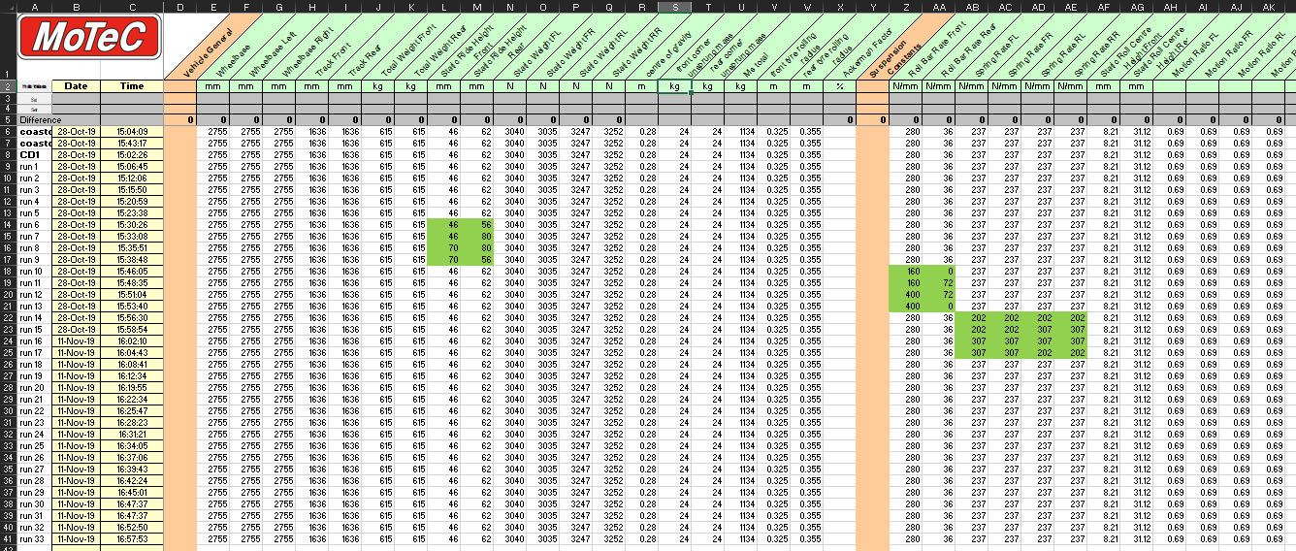
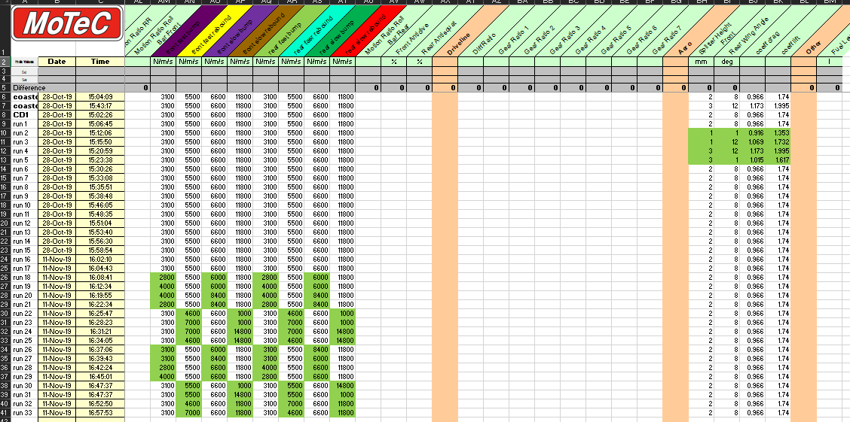

Appendix 2
Maths channels
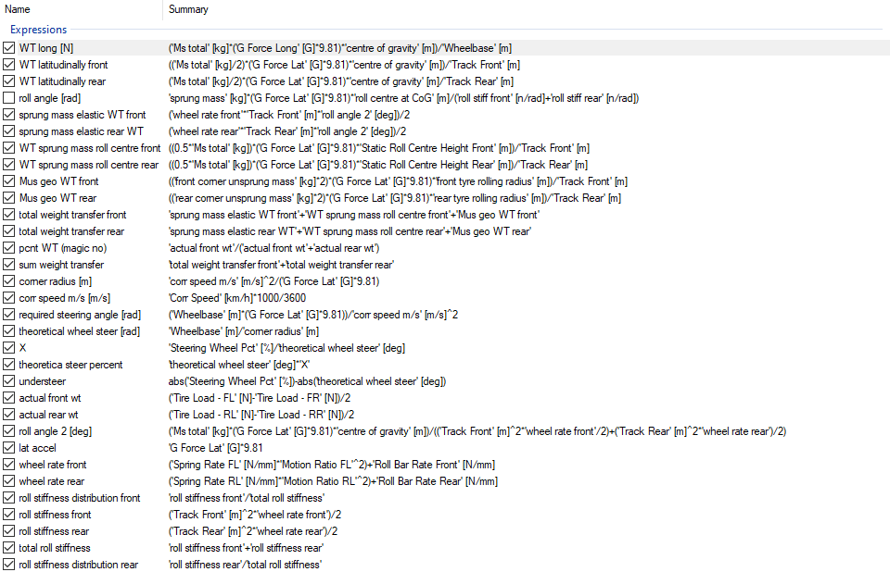
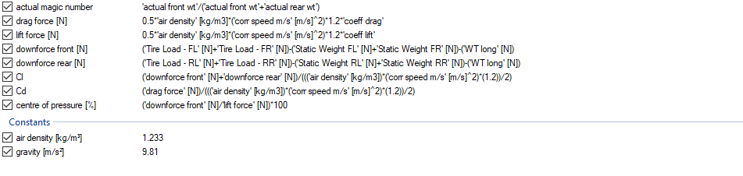

Appendix 3
Test plan


