Placement Research Project

Topic: Improving efficiency in the hospitality management services and employee satisfaction aspects at Travelodge

Student: Maricel-Avram Dobre
Student ID Number: 2108419
Email: 2108419@student.uwtsd.ac.uk
Module: Placement Project
Module code: BMIH6008
Lecturer: Maggie-Lan Zhang

Executive Summary
Employee efficiency and employee motivation have a direct impact on customer service as well as customer satisfaction. Organisations especially hotel and hospitality industry businesses need to consider employee motivation to improve organisational performance. The report has focused on preparing a case study on Travelodge and its relevant aspects to identify the issues the company had faced or might face. Travelodge is one of the largest hotel chains in the UK which mostly operates in the UK and Ireland markets. The report has demonstrated some internal issues such as challenges in hospitality management services and employee engagement of Travelodge. The aim and objectives of this paper have been elaborated here which will lead to the overall findings. The report has included an extended literature review by collecting information from different books and published sources. The importance of leadership and management in an organisation to support employee motivation has been demonstrated here. Therefore, it has also highlighted the required changes in Travelodge to increase customer satisfaction such as technical upgradation. A brief research methodology has also been highlighted here. Research philosophy, Research Design, research method, Data Collection, process, and ethical considerations have been elaborated here. A brief company description of Travelodge including financial information has been covered in the case study. The case study section has also covered a SWOT analysis of Travelodge to identify issues or challenges encountered by the company. In addition, the case study section has outlined the PESTLE analysis of Travelodge to identify external barriers to the company. Furthermore, a competitor analysis and ethnography analysis of Travelodge have been explained in this case study section. The findings section has analysed identified challenges, investigated areas of improvement and devised an action plan to improve these areas. The reflective part has demonstrated my placement experience while working at Travelodge using Gibbs’s reflective cycle. In this section, my personal experience and my feelings about my placement program have been highlighted.

Table of Contents
Introduction 5
Research Background 5
Research objectives 5
Rationale 6
Theme 6
Literature Review 7
Methodology 10
Case Study 13
Background details of Travelodge 13
SWOT analysis of Travelodge 14
PEST analysis of Travelodge 16
Competitor analysis (Price vs Quality) 21
Ethnography 23
Findings 24
Analysing challenges 24
Possible areas of improvement 28
Action plan 29
Conclusions and Recommendations 30
Reflective writing 32
References 36

Introduction

Research Background
Travelodge is a private hospitality brand that operates a chain of budget hotels. The headquarters of this company is located in the UK. Travelodge has nearly 600 hotels in the UK, Ireland and Spain in some specific holiday destinations as well as major cities. Currently, the company has over 13,000 employees including all locations. Employee engagement and staff management have become a key issue in this company. According to recent company reports, employee performance has reduced which is also affecting customer satisfaction. Some employees have reported they have poor work-life balance and they face challenges to maintain their productivity at the workplace. The overall hospitality management services also need to be improved to increase customer satisfaction. The study will analyse the problems at Travelodge and identify some key objectives based on the issue. An elaborated case study of the hotel brand will be evaluated here to offer some recommendations as well.

Research objectives
Aim
- To understand the ways of improving the organisational efficiency in the hospitality management services and employee satisfaction at Travelodge to enhance customer satisfaction.
Objectives
- To identify the issues related to employee management and hospitality management services at Travelodge.
- To develop better hospitality management services through different strategies at Travelodge.
- To evaluate the role of employee motivation in enhancing employee efficiency and workplace satisfaction at Travelodge.
- To analyse the role of leadership and management in improving employee satisfaction as well as hospitality management services.
- To demonstrate different strategies to improve customer satisfaction and organisational performance at Travelodge.

Rationale
The main purpose of this paper is to create different strategies for Travelodge to improve employee performance and hospitality management services. Investing in employee motivation will help the company attract more talented employees, improve their work-life balance and manage staff shortages. Analysing the role of leadership and management in this company is similarly important to evaluate the employee motivating factors. Leadership and management can guide employees to improve their performance by providing essential resources. The paper will highlight various related factors of employee performance and hospitality management services in a hotel brand in the light of Travelodge.

Theme
The main theme of this report is the role of employee motivation in improving organisational efficiency and customer satisfaction. The paper will highlight the issues in the hospitality management services of Travelodge and the cause of poor employee engagement. The role of leadership and management in employee motivation will also be discussed here. The paper will elaborate on how organisational leadership and management approaches can develop better employee engagement to lead to employee satisfaction.

Literature Review
As per the view of Setiyani et al., (2019), human resource management in an organisation is responsible for improving employee engagement. The HR department runs various programs such as employee training, development opportunities, seminars and conferences to motivate employees. According to the authors, flexible working hours, a positive work environment and other factors can motivate employees to improve their performance. The current workplace environment has evolved as millennial employees prefer to work with better technology and communication systems. Communicating through email and social media platforms can increase employee engagement as well as staff involvement. According to the hierarchy of Needs theory, there are five types of needs of employees such as physiological needs, security needs, social needs, esteem needs and self-actualisation. Employees can perform better whenever all of these needs are properly met in the workplace.
According to Mansaray (2019) employee motivation and employee performance are interconnected as employee motivating factors influence employees to improve their performance. Motivation is the influence to perform and performance is the execution of the tasks by maintaining their quality. Mansaray (2019) has stated that organisations can achieve new opportunities and better success through a motivated workforce. Understanding the ways to manage employee performance is important for human resource management. The author has demonstrated that the willing power of an employee influences his/her workplace performance. There are several theories that support the concept of employee motivation in an organisation. Alderfer’s ERG theory, McClelland’s theory of learned needs, Vroom’s expectancy theory, Herzberg’s two-factor theory and others have stated how organisations can increase employee motivation.
Puyri and Pasaribu (2019) have the importance of organisational leadership approaches on employee motivation and performance. According to these authors, leadership and motivation have a direct relationship as leadership creates a positive work culture and sets clear expectations for employees. There are various leadership styles but all of them create trust among employees. According to Puyri and Pasaribu (2019), leadership encourages innovation and also provides various growth opportunities for employees. Businesses have to maintain an appropriate leadership style where employees can make their own decisions and participate in the decision-making process.
As per the view of Khuong and Linh (2020), the global hotel and hospitality industry has high work pressure which increases work-related stress among hospitality employees. Workplace stress factors affect employee motivation, loyalty and job satisfaction. The authors collected primary data from nearly 600 hotel employees including low-level managers, general managers, front desk operators and directors. Studies have shown that low wages, poor working conditions, longer working hours and lack of performance feedback are key factors which increase work stress in the hospitality industry. Hotel and hospitality organisations need to focus on these issues otherwise it can decrease overall organisational performance. High work stress leads to demotivated employees which also increases employee turnover. Besides that, Employees with low or zero work satisfaction cannot offer bitter customer service which also affects the overall organisational productivity.
As stated by Kurdi et al., (2020), customer behaviour and preferences can change according to recent market trends, economic status, technical development as well as product development in the market. Employees need to understand consumer demand and adapt to the changes to maintain effective customer service. According to the paper, satisfied employees can offer better customer service as they can go the extra mile and make extra effort to resolve consumer queries. Besides that, satisfied employees are also willing to engage with the organisation and can have positive interactions with customers. They try to maintain effective communication which increases customer satisfaction as well as loyalty and increases business profit.
According to Riyanto et al., (2021), every company needs to consider technical development to gain a competitive advantage in the market and improve employee performance. Active employee engagement can improve overall customer service and increase consumer satisfaction. Organisations can consider different employee motivating factors for enhancing job satisfaction and creating a positive workplace culture. Riyanto et al., (2021) have identified that various workplace factors lead to job satisfaction in an organisation such as wage rate, the job itself, company culture, the behaviour of management and others. An organisation needs to update its human resource management policies to meet employee expectations and increase employee engagement.
As per the view of Kurniawan et al., (2021) leadership and management practices in an organisation create various employee motivation factors by considering the laws, morals as well as ethics. Leaders and managers are the success factors in an organisation where the quality of leadership denotes the employee engagement rate. Kurniawan et al., (2021) have evaluated that leadership is important in every industry including health, public sector, education, corporate and others. Apart from leadership, work motivation is another important factor which affects employee performance. Employees always see new opportunities and areas to improve their knowledge. Organisations need to provide enough resources to develop their skills and efficiency to increase staff satisfaction rates.
According to the view of Maddern et al., (2021), businesses need to consider employee satisfaction which can lead to better profitability and high organisational performance. Financial service providers in the UK use various strategies to maintain employee satisfaction, reward and compensation are one of them. Human resource managers offer better salary packages and performance-based bonuses to employees in financial service organisations. The organisations also conduct various career advancement programs to create new opportunities for employees. They can develop their existing skills and learn new skills. Apart from that, organisations also offer flexible timing, invest in employee training, and maintain employee transparency. According to reports, satisfied employees maintain daily contact with customers, resolve customer issues and create a loyal customer base.
As per the view of Yang et al., (2021), smart hotels have become very popular in the hospitality industry where hotels use advanced technology to enhance customer experience. Hotel businesses use the extended technology acceptance model (TAM) to implement technical upgrades according to consumer preference. The study has demonstrated the importance of Artificial Intelligence, cloud architecture, Information Technology, Big Data and the Internet of Things (IoT) in hospitality services. Using various smart technologies can enhance the overall communication between the organisation and customers. AI-generated sensors provide more personalised services to customers. Various global hotels have already implemented technologies such as Marriott International has made a partnership with Samsung and Legrand to implement IoT sensors in hotel rooms, Hilton Hotels has launched connected rooms and Henn-na Hotel has implemented a robot service for greeting visitors. The demand for smart hotel rooms is increasing and reports say their profit rates are higher than traditional hotels.
According to Buhalis and Moldavska (2022), hotel and hospitality industry businesses need to invest in smart technologies such as AI-enabled voice assistants and IoT. Using technology can improve the overall hospitality management services and increase customer satisfaction. Virtual assistant enabled systems of her more personalised services to hotel guests. IoT sensors and smart room controls can enhance the overall security system which will increase business profitability for a hotel chain.

Methodology
Research philosophy: The paper has used the positivism research philosophy where all the research topics and research objectives have been demonstrated by factual knowledge. Objectivity is one of the key characteristics of this research philosophy where the researcher focuses on the explanation of objectives which are free from any biases (Tamminen and Poucher, 2020). This research philosophy is mostly dependent on quantitative data hence this paper has elaborated clear discussions based on real-time statistics and scientific evidence (Khatri, 2020).
Research design: The paper has also used descriptive research design as a scientific method of analysing qualitative and quantitative data (Siedlecki, 2020). This research design has been adopted by the researcher to answer ‘wh’ questions rather than why and features a ‘where’, ‘what’, ‘when’, and ‘how’. This research design is equally resourceful in giving a framework that assists in solving and analysing the research topics with regard to the current and existing conditions. This research design has also helped the researcher to source data from the target market like the hospitality industry and make a genuine forecast regarding the research problem (Dovetail, 2023). The researcher has made guided decisions through this research design.
Research approach: The deductive research approach is a scientific research approach that systematically applies theories as well as hypotheses to expound the research objectives (Aransiola, 2021). The research has incorporated various theories and frameworks in an effort to explain the motivating factors in structuring the employee reward system. In turn, the choice of deductive research approach has assisted the researcher in illustrating the research themes and concerns as per the mentioned research objective the theories subsequently, form a general framework that helps to identify the issues of Travelodge with regard to the motivation of the employees. This research approach also has set some themes based on the relevant theories. Thus, according to the view of Abdukarimova and Zubaydova (2021), the deductive approach draws an inference that is based on evidence and can be used for research purposes in future.
Research method: To gather statistical as well as theoretical data in this paper, the researcher has implemented a qualitative research method. All information is collected from various published sources which helps the researcher to understand the real-world problems of the hospitality industry (Lester et al., 2020). This research method also helps to understand the why and how questions behind the issues. The qualitative research method is very flexible as the researcher can choose a small or large platform to collect insights and it also offers in-depth information (Girardin, 2023). This research method is more focused on arguments and real-world issues instead of statistics.
Data collection process: The secondary data collection method has been used in this paper. The writer has collected data from various books, journals, and articles and submitted research papers (Schuster et al., 2014). Most of the articles and journals are collected from Google Scholar. The secondary data collection process is a good approach to reduce costs and save time on data collection (Mazhar et al., 2021). Besides that, the researcher has also used company reports, several blogs and some other websites to collect secondary data on the current external environment of the UK as well as the existing business performance of Travelodge.
Ethical consideration: Ethical consideration is very important for every research paper as it ensures ethical research practice. The researcher has collected all data from secondary resources and properly referenced them with citations. The copyright rule and guidelines have been maintained in this paper while collecting secondary data from various published sources. A difference list has been included at the end of this paper to support all arguments and findings. All research confidentiality and beta security have also been maintained here.

Case Study

Background details of Travelodge
Established in 1985, Travelodge is among the major budget hotel groups in the UK (Travelodge, 2024). The British budget hotel chain is headquartered in Thame, UK (Gov.UK, 2024). The hotel chain started its journey by opening its first hospitality property at Barton under Needwood, England Barton under Needwood, England (Travelodge, 2023). Travelodge has a modernised and well-invested portfolio of more than 600 hotels including more than 46,000 bedrooms across the UK, Spain as well as Ireland (Travelodge, 2024). Travelodge welcomes more than 22 million customers annually (Travelodge, 2024). On TripAdvisor, Travelodge’s 90% of hotels are rated 4 stars or above as the company proudly offers a good value experience to its diverse customer base whether they travel for leisure or business purposes (Travelodge, 2024). Travelodge’s major hotels belong to holiday spots, key business hubs, airports, towns and major cities.
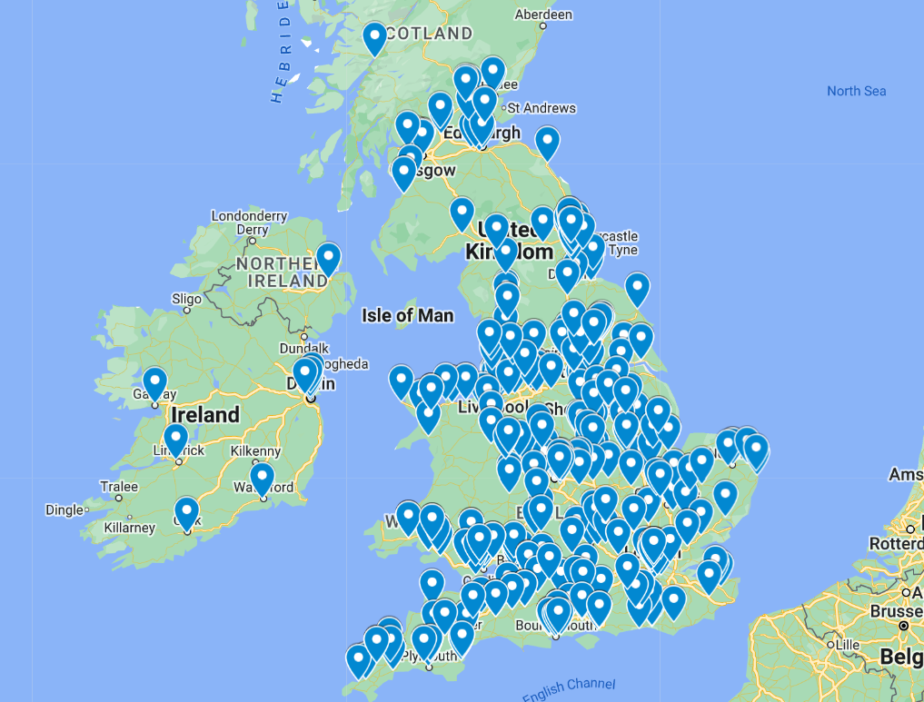
Figure 1: Travelodge hotel locations in the UK
(Source: Google Maps, 2024)
According to Statista (2023), the number of Travelodge hotels in the UK was estimated at 592 in 2021 compared to 586 in 2020. This case study will be demonstrated based on Travelodge Letchworth Garden City in the UK which has been shown below.
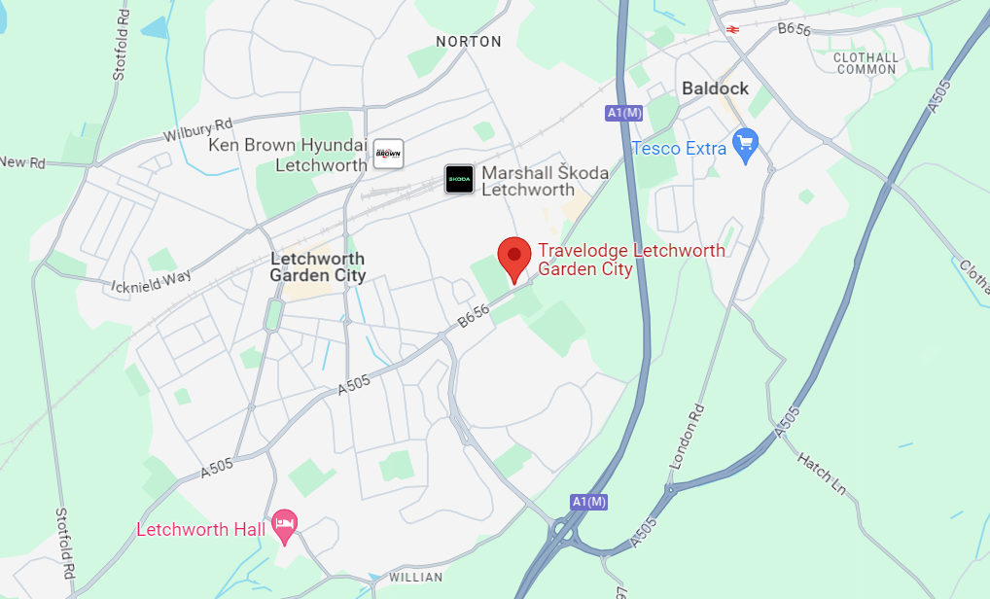
Figure 2: Travelodge Letchworth Garden City
(Source: Google Maps, 2023)
Financial performance: Travelodge annual turnover surpassed £1 billion for the first time in 2023 due to its record full-year performance (Travelodge, 2024). Travelodge’s total revenue increased to £1,035.2 million in 2023, compared to 13.7% higher than in 2022 (Travelodge, 2023). The adjusted EBITDA of Travelodge also increased by 14.6% to £243.9 million in 2023 (Travelodge, 2024). Travelodge employed more than 13,000 dedicated employees in 2023 to create better opportunities for earning, learning and belongingness (Travelodge, 2024).

SWOT analysis of Travelodge
Strengths | Weaknesses
Brand legacy: Travelodge has had higher brand value and recognition in the UK budget hotel segment since 1985. The hotel chain won the Best Budget Hotel Brand in 2019 at the Business Travel Awards (Travelodge, 2019).  Extensive hotel network: Travelodge has a large network of more than 600 hotels under its hotel group which has helped it become one of the biggest hotel chains in the UK. Travelodge’s major hospitality properties are located across city centres, airports, business hubs, and holiday destinations in the UK, Ireland or Spain (Travelodge, 2024).  Budget-friendly pricing strategy: Travelodge itself is a budget hotel chain in the UK which indicates the hotel group follows an affordable pricing strategy for business and leisure customers. Around 50% of Travelodge’s hotel rooms were sold at less costs than £60 in 2023 (Travelodge, 2024). | Staff shortage: As per Crippss (2023), the UK hospitality sector reported a shortage of 188,000 staff including chefs and house staff. Travelodge sought more than 3,000 university students as the company encountered staff shortages due to the new immigration policy of the UK government led by Brexit (Butler, 2019).  Poor work-life balance: As per Glassdoor reviews (2024), most Travelodge staff reported poor work-life conditions due to higher stress, poor management and low wages. Certain former employees claimed that there was no appreciation for hard work and they had to work for longer hours due to staff shortages in Travelodge (Indeed, 2024).  Poor customer service: As per TripAdvisor (2024), Travelodge Letchworth Garden City Hotel has received numerous negative customer reviews due to poor customer support service. Customers reported their worst hotel experience and unenthusiastic staff service while staying at Travelodge Letchworth Garden City Hotel.
Opportunities | Threats
Rising demand for budget hotels: Travelodge has numerous opportunities to extend the number of hotels in the UK due to the rising demand for budget hotels. The hotel chain has identified more than 300 locations across various cities in the UK to open 15.20 new hotels annually (Travelodge, 2024).  Globalisation: Travelodge’s international expansion strategy can strengthen its global market position as it plans to expand in the Asian market. In addition, low penetration of branded budget hotels could offer significant market growth opportunities for Travelodge in Spain.  Sustainable business opportunities: The rising demand for green and eco-friendly tourism has increased the number of budget-friendly responsible travellers. Therefore, Travelodge’s environmental sustainability programmes could attract more eco-friendly travellers. | Intensified competition: Other UK budget hotel chains offer more complementary services like breakfast and spa treatment at lower costs. The presence of competitive brands like Premier Inn, Holiday Inn, Hilton Hotel, Days Inn and Ibis has intensified market competition for Travelodge (Bell, 2023).  Fewer global markets: Travelodge has a limited expansion rate in the global markets. Travelodge is only present in Ireland and Spain across the European region. Therefore, a limited market expansion rate could restrict the hotel chain’s reach to global customers (Whitla et al., 2007).  Risk of losing staff and customers: Poor leadership from the upper management of Travelodge might increase the risk of losing staff due to poor working conditions (Lopez-Andreu et al., 2019). In addition, poor customer service and bad staff experience could increase the risk of losing customers for Travelodge.
Table 1: SWOT analysis of Travelodge
(Source: Author)

PEST analysis of Travelodge
Factors | Description | Impacts
Political | Government stability: Despite the geopolitical tension raised due to the Russia-Ukraine conflict, the political situation in the UK is stable. Therefore, reformed tax policy and lower corruption have reinforced the UK hospitality industry which might encourage the market growth opportunities for Travelodge (George, 2021).  Brexit situation: The Brexit situation has forced the UK government to impose new immigration policies and trade regulations in the hospitality sector. According to Dempsey (2023), the UK hospitality sector has been suffering seriously due to staff shortage with 48% higher job vacancies than in the pre-pandemic situation as reported by Trade Body UK Hospitality. Therefore, staff shortages due to Brexit might negatively affect Travelodge’s operation in the UK. | Positive and negative
Economic | Inflation rate: The inflation rate of the UK was estimated at 10.3% in May 2023 which might have increased hotel costs due to higher energy and food costs (Clark, 2023). This could limit the number of customers for budget hotel chains like Travelodge.  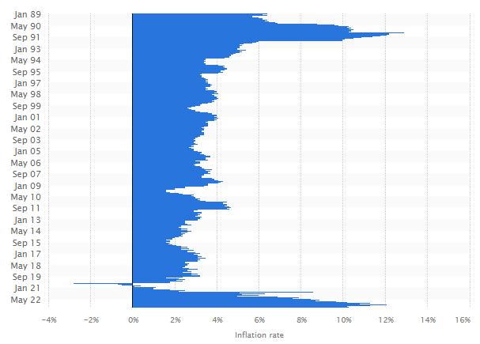  Figure 3: The UK inflation rate  (Source: Clark, 2023)  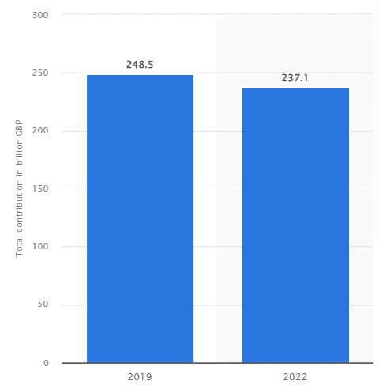  Figure 4: Travel and tourism contribution to the UK GDP  (Source: Statista, 2024)  GDP growth: After the COVID-19 pandemic, the contribution of the travel and tourism industry to GDP was estimated at £237.1 billion in 2022, 4.6% less than in 2019. This might have reduced the purchasing ability of consumers and the unemployment rate for Travelodge. | Negative
Social | UK population growth: As per Worldometers (2024), the current population of the UK was estimated at 67.93 million in 2024. Therefore, rising population growth could increase the number of potential customers for Travelodge in the UK.  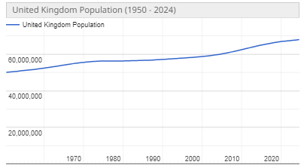  Figure 5: UK population growth  (Source: Worldometers, 2024)  Rising tourism demand: After the post-pandemic situation, the UK government’s tourism recovery plan has increased tourist numbers to 31 million due to rising demand for inbound tourism (Statista, 2023). This might have improved the financial performance of Travelodge in 2023 with a record sales revenue of £1 billion (Travelodge, 2024).  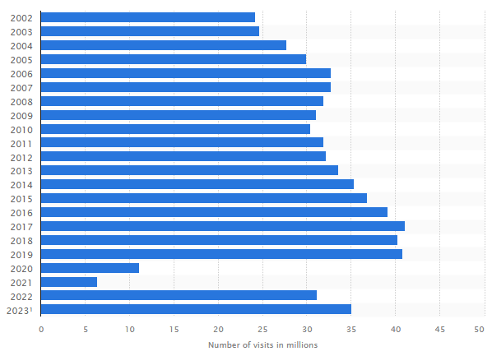  Figure 6: Growth of inbound tourists in the UK  (Source: Statista, 2023) | Positive
Technological | Rising demand for online booking: According to Phocuswright Research (2024), the UK travel and hospitality sector experienced a significant booking growth of 19% due to the rising demand for online bookings and mobile transactions after the pandemic situation. This might have enhanced the online booking trends of customers for Travelodge hotels in the UK.  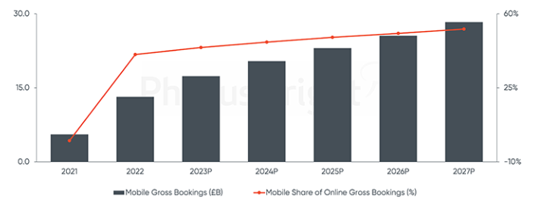  Figure 7: UK hospitality gross booking (£B)  (Source: Phocuswright Research, 2024)  Digital transformation: The UK hospitality sector has adopted disruptive technologies like virtual reality (VR), AI-powered chatbots, machine learning, 5G technology, IoT and Big Data to deliver better experiences to customers (Davronov, 2021). Travelodge has also introduced digital tools like Medallia to gain better customer insights (Business Wire, 2022). However, competitive brands like Premier Inn have been using more robust technologies to enhance customer experience which might have limited the market share of Travelodge in the UK (Gursoy et al., 2022). | Positive and negative
Table 2: PEST analysis of Travelodge
(Source: Author)

Competitor analysis (Price vs Quality)
A competitive analysis based on Porter’s Five Force Model can help Travelodge identify its potential ability to meet customers' expectations in terms of price and quality in the UK. Porter’s five forces for Travelodge are going to be demonstrated as follows;
Rivalry among existing market competitors: According to Bell (2023), in the UK budget hotel market segment, existing rival brands of Travelodge are Days Inn, Ibis, Premier Inn, Wetherspoon Hotels and Hilton Hotel. According to Bell (2023), Ibis Budget Hotel is the cheapest hotel chain in the UK with an average hotel price of £69 along with a 64% customer satisfaction score based on its quality. A close competitor brand, Days Inn also provides hotels at a similar average price to Travelodge with £79. However, Days Inn scored 65% in customer satisfaction rate in terms of quality and customer service compared to 56% of Travelodge. Another competitive brand Wetherspoon Hotels also provides budget hotels at an average cost of £84 while the customer satisfaction score was estimated at 73% in 2023 (Bell, 2023). The most recommended accommodation provider Premier Inn has scored the highest customer satisfaction rate of 75% with an average hotel price of £93 for its premium quality services (Bell, 2023).
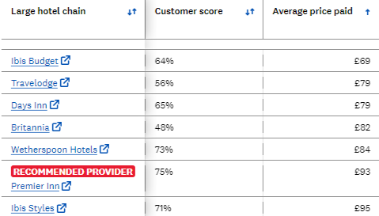
Figure 8: Rivalry among existing competitors in terms of price and quality
(Source: Bell, 2023)
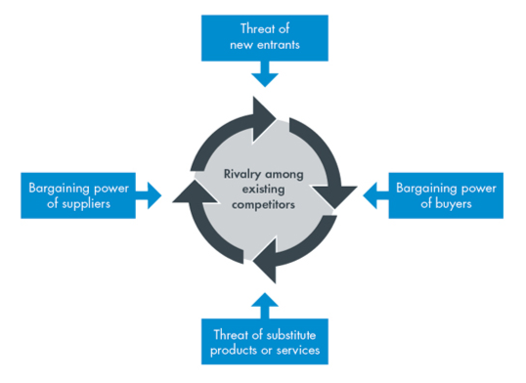
Figure 9: Porter’s Five-Force Model
(Source: Porter, 2008)
The threat of new entrants: The UK tourism and hospitality industry is expected to expand at a 1.58% compounded annual growth rate from 2023 to 2027 with 31 million international tourist arrivals in 2023 (Business Wire, 2021). Hence, the hospitality sector is also expanding by invading new emerging hotels in the market. New entrants in this industry are Jesmond Dene Hotel, Vermont Apart Hotel, Mollie’s, Treehouse Hotel and Raffles London. These new hotel businesses could greatly affect Travelodge’s ability to capture new market share by imposing a threat to its growth.
The threat of substitute services: Alternative accommodation services provided by Airbnb have disrupted the traditional hospitality industry in the UK based on its unique business model and innovative services (The Accommodation Club, 2023). According to Kommenda et al. (2020), the number of Airbnb listings has increased to 257,000 as of January 2020. Therefore, Airbnb’s budget accommodation services in the UK could impose a threat to Travelodge while attracting new customers.
The bargaining power of suppliers: In the UK hospitality industry, the bargaining power of suppliers is relatively low due to a high number of suppliers and low switching costs (Lopez-Jauregui et al., 2022). Therefore, the supplier's low bargaining power cannot induce risk for Travelodge. Alongside this, Travelodge maintains a great relationship with its 50 suppliers to control their bargaining power (Travelodge, 2023).
The bargaining power of customers: In the UK hospitality industry, the bargaining power of customers is high due to the presence of numerous hospitality service providers and low switching costs (Solakis et al., 2022). However, Travelodge provides hospitality services to more than 22 million customers every year (Travelodge, 2024). Therefore, the customers’ bargaining power for the hotel chain is moderate due to its loyal customer base (Okumus et al., 2019).

Ethnography
According to Urban and Koh (2013), corporate ethnography study involves qualitative research to understand the social practices and cultural aspects of a company. The ethnographic approaches of modern businesses are the inner workings of corporations as small-scale societies and the impacts of corporations on employees, consumers, communities as well as the broader environment (Urban and Koh, 2013). Travelodge promotes an inclusive and diverse culture for diverse groups of customers or communities. Travelodge has committed to developing an inclusive workplace to provide better opportunities for its 13,000 colleagues to earn more, learn efficiently and develop a sense of belongingness (Travelodge, 2023). Travelodge provides staff with equal opportunities regardless of ethnic background to help them progress in their careers (Travelodge, 2023). Travelodge’s Better Future Sustainability Plan aims to create a more sustainable future for its colleagues, customers and society (Travelodge, 2024). Besides this, Travelodge has created a healthy and caring environment for its customers as well as colleagues to ensure their effective well-being (Travelodge, 2023).

Findings

Analysing challenges
Poor work-life balance: The main challenge employees face while working in Travelodge is high stress due to poor work-life balance. Long working hours, low wages and poor management are responsible for Travelodge's poor work-life balance as staff claimed. According to Cooks-Cambell (2023), poor work-life balance can have negative outcomes for both employers and employees. Employees who work for long hours might face a higher risk for stress-related health issues, fatigue and burnout due to a lack of self-care practices (Cooks-Cambell, 2023). Furthermore, poor work-life balance can cause staff to be less productive while working longer hours. At Travelodge, working long hours might be beneficial to cover the tasks of other staff members while the industry has long been suffering due to staff shortages. In addition, despite poor work-life balance, Travelodge’s customers can receive uninterrupted hospitality services due to the long working hours of staff. However, certain Travelodge staff might have reported their demoralised conditions and dissatisfaction due to poor work-life balance. In addition, some employees might have reported their long-term negative health outcomes due to long working hours and poor work-life balance.
Staff shortage: Another challenge that Travelodge experienced was the shortage of staff following certain rules implemented by the UK government after Brexit. The recent Brexit immigration policy has affected the mobility of EU employees in the hospitality sector of the UK. Consequently, the hospitality industry has been straining with insufficient staffing for the Brexit scenario. Taking into account the definition of Roelen-Blasberg (2024), hospitality staff shortage means that there are not enough employees in a hotel chain to address the dynamic need for hospitality services. Therefore, Travelodge could possibly encounter some challenges that are associated with staff shortages and affect its customers and operations. Hospitality staff shortage sometimes can be useful for Travelodge to cut off its extra overhead expenses although the hotel chain may provide its current staff with extra incentives including free room and board to help maintain them effectively. Additionally, staff shortage might have helped Travelodge save its operating costs to invest in other segments. However, staff shortage might cause a loss of productivity and organisational efficiency at Travelodge which could increase the work pressure on existing employees. In addition, staff shortage could also result in dissatisfaction for existing staff and customers due to poor support service.
Poor customer service: Travelodge’s customers complained about poor staff services several times due to a lack of staff or poor staff training. According to Belevska (2023), customers are the main stakeholders of a business who are responsible for building its brand reputation. Therefore, poor customer service can damage the brand reputation of a company. As per Fowler (2023), bad customer service can impact the hospitality experience of customers which can result in their negative reviews on the company’s site and a decline in brand loyalty. As a result, Travelodge might lose its customers and ultimately sales revenue due to its bad support service. In addition, Travelodge’s credibility could be damaged due to poor customer support service. However, poor customer service can help Travelodge adjust its mistakes across its hospitality services to deliver improved customer support for retaining them and better satisfaction.
Market competition: The intensified market competition between hotel brands in the UK hospitality sector has become a significant challenge for Travelodge. The superior service quality and lower accommodation costs of competitive brands have provided them with greater competitive advantages than Travelodge (Tavitiyaman et al., 2011). A strong market competition in the UK hospitality sector can help Travelodge gather essential information from competitors. In addition, analysing the competitive market can also be beneficial for Travelodge to identify effective pricing strategies to gain a competitive advantage over competitors. However, market competition can negatively influence the customer base of Travelodge as they can easily switch to alternative companies that provide better customer satisfaction and superior hospitality services. In addition, market competition also could reduce Travelodge’s market share in the UK hospitality sector due to a lack of customer service while providing premium quality hotels at budget costs.
The threat of substitute services: According to Becker (2022), alternative accommodation services provided by Airbnb can impose a great market risk for Travelodge in the UK. Alternative hotel services can induce opportunities for tourists to meet locals which they can get with Travelodge. Besides this, alternative accommodation costs can be more affordable than Travelodge’s hotels. Therefore, customers can easily switch to these cost-effective alternative services who are on a tight budget during their vacation. Alternative accommodation can provide better leisure activities such as treehouses or glamping compared to the traditional hotel rooms of Travelodge (Becker, 2022). Alternative accommodations can provide more realistic experiences to customers which they might not get from the artificial hotels of Travelodge. However, checking in alternative accommodations could be a hassle for tourists, instead, they can choose Travelodge to check in more efficiently. In addition, alternative accommodations may not meet the required quality standards of tourists which Travelodge can. Apart from these, alternative accommodations are limited for tourists in peak seasons compared to room availability at Travelodge in the UK.
The threat of new entrants: The rising growth of new budget hotel accommodations in UK hospitality service providers can put significant pressure on Travelodge to retain its customers. New entrants in the UK like Raffles London, Jesmond Dene Hotel, Vermont Apart Hotel, Mollie’s, and Treehouse Hotel have been attracting inbound tourists to the UK. According to Lacalle (2022), in the UK hotel industry, independent hotels are built on unique services to attract more customers despite the standard quality offered by Travelodge. In addition, hotel chains like Travelodge might not offer a personal touch to customers as they focus on maintaining their brand standards while new hotel brands are mostly customer-centric to offer superior customer service. However, existing brand Travelodge have more market experience and availability which can provide better accessibility to tourists rather than new hotel brands in the UK. Besides this, Travelodge focuses on expanding its business to more than 300 locations in the UK to attract more customers which can restrict the market expansion opportunities for new hotels.
Economic crisis: There are several external environmental factors such as inflation, the Ukraine-Russia war, the pandemic and Brexit which have increased the economic crisis for Travelodge. Due to inflation, the cost of living, basic commodities and food products have increased in the UK. Due to the higher living cost, the local customer number has decreased by 13% in this hotel chain (Travelodge, 2024). On the other hand, due to the Russia-Ukraine war, the oil price and energy costs have also increased. According to recent reports, the operation cost of UK hotels can increase by 40% due to high fuel costs (Travelodge, 2024). Travelodge has to invest a lot otherwise it can face financial losses as well. Therefore, during the pandemic, the revenue of this hotel chain dropped by £284.4 million in 2020 (Travelodge, 2023). This is a current financial pressure on Travelodge, accordingly, the cost-of-living crisis is also increasing in the UK. The hotel chain has to increase its employee wage rate otherwise it will face a huge staff shortage in upcoming years.
Fewer global markets: The global market expansion of Travelodge is very limited as it only has 6 hotels in Spain. The business operations are mostly dependent on the UK and Ireland market which is creating limitations on its growth opportunities. Its competitors such as Premier Inn, Hilton Hotel, Ibis Hotels and others have a large global market. Due to the limited market, Travelodge is not able to attract more global customers and is losing competitive advantages as well. The company can increase its profit range and operational growth by expanding its global market (Travelodge, 2024). Similarly, it also offers only accommodation services which offer limited choices to customers.
Lack of disruptive technologies: Technical development is also Limited in Travelodge according to its competitors. The hotel brand has not adopted smart technologies in its rooms which is reducing its demand among millennials and Gen Z customers (Hollander, 2023). According to reports, nearly 70% of millennial customers prefer smart hotel rooms with advanced technology while booking their vacations. This is a global report which indicates that Travelodge can face poor customer growth in future if it does not implement advanced technologies in its customer service. Similarly, the UK hotel industry also uses Artificial Intelligence, Virtual Reality Machine Learning, Big Data Technology, chatbots, 5G technology and many other disruptive technologies to improve customer satisfaction (Hollander, 2023).

Possible areas of improvement
Human resource policies: Travelodge needs to update its current human resource policy to increase employee motivation, staff recruitment rate and employee engagement. The HRM is responsible for increasing employee motivation by providing them with flexible working hours and performance-based rewards. Besides that proper implied training is also required to improve the working efficiency of existing employees (Tuomi et al., 2021). The existing staff recruitment policy needs to be improved as well. The company can increase its staff recruitment and employee retention rate by providing them with better salary packages, employee benefits as well as attractive incentives.
Customer support service: The customer support service plays a vital role in customer satisfaction and creating a loyal customer base for Travelodge. The hotel brand can implement chatbots and AI-generated customer service systems to resolve consumer queries in a minute (Tuomi et al., 2021). Besides that, collecting customer feedback through online surveys and social media posts will also help Travelodge improve its service quality.
Technical development: Technical development is an important part of every hotel and hospitality business in the UK to get competitive advantages from the market. Travelodge can implement smart technologies in its hotels and change traditional rooms into smart rules to attract more customers (Chambers and Cifter, 2022). AI-generated room controls, facial recognition, automatic check-in and check-out programs, mobile key technology and others (MEWS, 2024). Besides that, using Big Data Analytics and the machine learning algorithm will help Travelodge to understand consumer preferences. Travelodge can implement Virtual Reality in its website to offer more customised customer service.
Operation improvement and market expansion: The overall improvement of its operations is important to gain competitive advantages and reduce the threats of substitutes (Tahiri et al., 2022). Travelodge can increase its product and service range by offering budget-friendly travel packages, air ticket booking, transportation and other services. Besides that, it can expand its market in Asian and European countries where the demand for budget-friendly hotels is very high.

Action plan
Objectives | Description | Responsible department | Timeline
To improve human resource policies | Travelodge will update its HRM policies, and recruitment policies as well as offer better pay packages to employees. It will also offer training and skill development programms for employees. | Human resource management | 6 months
To develop better customer service | Travelodge will implement chatbots and an AI-generated customer service system. The company will also provide technical training to its customer service employees. | Customer service | 6 months
To implement advanced technologies | Travelodge will launch smart hotels with advanced technologies to increase customer satisfaction. The overall leadership approach will also be improved as company leaders will use advanced technologies for better employee management. | IT department, accounting and operations. | 1 year
To expand market and operations | Travelodge will expand its operations in Italy, France and Malaysia by collaborating with local hotel chains. | Marketing, sales and operations. | 2 years
Table 3: Action Plan
(Source: Author)

Conclusions and Recommendations
The report has demonstrated various issues of Travelodge related to employee management and hospitality management services. The paper has identified that the hotel brand is currently facing staff shortage and lack of employee motivation which is affecting its organisational performance as well. Employees have reported they have a poor work-life balance due to longer working hours and a poor management system. On the other hand, poor customer service is another issue of Travelodge.
Travelodge can improve its performance by adopting various strategies which have been briefly demonstrated in this report. According to the findings, the company needs to identify the employee motivating factors and offer workplace flexibility to improve their performance. A SWOT framework of Travelodge has been discussed here to identify its operational weak areas. Hence, the report has found that due to poor employee management and lack of job satisfaction, the company is also facing issues with poor customer service.
Leadership and management play a vital role in every organisation to improve employee motivation. The report has discussed the importance of leadership approaches in staff management through various literature. The names of some specific employee motivation theories have also been identified here which have also considered the role of leadership and management for better employee performance.
The report has briefly evaluated the role of employee motivation on their productivity and job satisfaction. The report has considered findings from various books and journals to understand the importance of employee motivation in an organisation. The SWOT analysis has highlighted the strength areas of Travelodge as well. The company has a good brand reputation which motivates employees to improve customer service. On the other hand, the PESTLE analysis has shown that the demand for technology-based services is increasing in the UK but Travelodge has not implemented advanced technologies which affects employee motivation as well.
Along with this, the report has demonstrated some operational and organisational management issues of Travelodge. According to this paper, inflation, changing customer behaviour, a highly competitive market, Brexit and other external factors are increasing the risk of financial loss as well as other operational issues for the company. The report has highlighted some possible areas of improvement as well by analysing the current challenges of Travelodge.
Recommendations
Recommendation 1: Travelodge needs to invest in its employee training and employee motivation. Offering various training and growth opportunities will help employees to understand the market changes easily. They will be able to offer better quality customer services which will increase organisational performance as well. Updating the basic salary packages, offering incentives and providing other employee benefits will also improve the staff recruitment rate in this organisation.
Recommendation 2: Travelodge can expand its business in global countries, especially in European and Asian countries. The demand for budget-friendly accommodations is very high in these areas which will offer competitive benefits as well. The hotel brand can collaborate with local businesses such as airlines, transportation, car rentals and others to expand its service range as well.
Recommendation 3: Travelodge can implement smart technologies and launch smart hotels to attract more customers. Using artificial intelligence, robotics, IoT sensors, big data and other advanced technology will help the company to offer more personalised services. Besides that, using chatbots in customer service will increase customer satisfaction as well.

Reflective writing
I gathered a mixed experience during my placement at Travelodge Letchworth Garden City Hotel which will remain memorable for my career. In this section, I am going to demonstrate my overall placement experience based on Gibbs’s reflective cycle. According to Gibbs and Slevitch (2019), Gibbs’s reflective cycle includes six stages such as description, feeling, evaluation, analysis, conclusion and action plan to reflect an individual’s personal experience. As per the description stage, I started my job role as an intern with a lot of responsibilities regarding hospitality services from the moment I took over my dream job. There were several things I experienced during my working days. I met new people in my team including my manager whom I had not met before. According to Lawson (2018), the hotel industry consists of several services such as housekeeping, front office, concierge, food and beverage department, reception, etc. I was appointed as a housekeeper by the management of Travelodge. I was provided with complete freedom to express my own opinions and perform my tasks more efficiently. My colleagues are very supportive as they always supported me in finding out the best solutions during critical problems that occurred in the hotel rooms. During my placement period, I collaboratively worked with my colleagues to bring innovative ideas to solve problems and deliver great results to customers. I was very grateful to my company as Travelodge helped me with staff accommodations where I did my placement for two days each week. This has helped me prepare to return to my university as a graduate.
My personal experience at Travelodge Letchworth Garden City was great as I felt I learned so many things during this placement. I came to know about the ways to treat guests more carefully as they are the main stakeholders in the industry. I felt proud to be part of this industry as I served each customer with a warm smile to deliver better customer satisfaction. I realised my managers always motivated me to be enthusiastic while serving customers. I became excited during my journey at Travelodge when I came to know I might be given a permanent role after completing my graduation. This made me very happy and more inspired to perform my tasks more enthusiastically to increase my recognition among HR managers. However, I felt nervous and lacked confidence on my first day during my placement period as I was given a major role as an intern in such a great institution. My colleagues supported me a lot to boost my confidence level. I also struggled during my training period as I was given training at a fast pace, however, my manager supported me a lot in understanding certain parts I missed during training. According to Ali et al. (2020), staff working in a productive and respectful environment feel inclusive as well as supported by the management. This might increase their engagement in the workplace due to an increase in their confidence level (Ali et al., 2020).
As per the evaluation stage, I have evaluated that this placement program has helped me boost my skills and efficiency in the hospitality industry. I contributed to my company with new ideas and perspectives indicating my teamwork with my colleagues. I also evaluated that our managers allowed open communication which increased our flexibility with each other while providing services. As per Boyd et al. (2022), unequal participation of team members might limit the growth of other members in hospitality services. However, I also realised a lack of confidence, problem-solving skills and time management ability could impose poor customer service. My colleagues helped me increase these capabilities to perform my tasks efficiently during my placement work at Travelodge. As per the analysis stage, I analysed my overall placement program went very well based on reviews of customers at Travelodge. I was fully committed to the task as it matched my career profile and my capabilities. Rolfe and Freshwater (2020) identified that an entire placement could be chaotic and confusing if individuals fail to understand their roles efficiently. I analysed that I took more time to finish my tasks due to a lack of confidence level and experience. In addition, my inefficient problem-solving skills often prevent me from performing my service tasks more efficiently. However, sharing ideas with my managers was my best gain during this placement program which would be beneficial in my future career. During my placement period, I learned that working on a tight schedule can put more stress on team members. Therefore, effective collaboration with team members was essential to reduce pressure during the placement period.
I concluded that team members must communicate efficiently to share ideas and solve critical problems. I came to know that I need to improve my confidence level and problem-solving skills to perform tasks during critical situations. Additionally, I need to reduce my nervousness to prevent myself from getting stuck in critical tasks at Travelodge. Besides this, I need to enhance my time management capabilities to finish tasks timely for greater customer satisfaction. Furthermore, I would like to continue other projects with Travelodge by improving my development areas with an action plan that will provide me with extended opportunities in my future career. Therefore, I would like to seek help from industry experts to overcome such challenging situations during placement. I would like to take care of my communication skills and teamwork abilities to perform such tasks at hotels in the future. This can be beneficial to achieve great outcomes while working with a team. In addition, I would like to attend time management workshops to improve my time management skills. In addition, I will make a schedule for my tasks to prioritise my short-term goals to finish them more efficiently. In addition, I want to consult my senior mentor to learn about problem-solving skills while increasing my confidence level through grooming. Alongside this, I would like to learn customer service skills to support potential customers more effectively. This can increase my opportunities to get a full-time placement in the UK hospitality industry.

References
Abdukarimova, N.A. and Zubaydova, N.N., (2021). Deductive and inductive approaches to teaching grammar. JournalNX, pp.372-376.
Ali, A.A.A.M., Kee, D.M.H., Singh, A., Pandey, R., Alhamlan, H., Ahmad, K.M., Quttainah, M.A., Siw, M.Y., Ong, R.S. and Narayanan, Y., (2020). Does motivation improve employees job performance? A case of absolute hotel services. International Journal of Tourism and Hospitality in Asia Pasific (IJTHAP), 3(3), pp.9-21.
Aransiola, J., (2021). What is Deductive Research? Meaning, Stages & Examples. Available at: https://www.formpl.us/blog/what-is-deductive-research-meaning-stages-examples [Accessed 14 May 2024]
Becker, E. (2022). Airbnb vs. Hotel: What Are the Pros and Cons of Each? Available at: https://www.bemytravelmuse.com/airbnb-vs-hotel/ [Accessed 18 May 2024]
Belevska, T. (2023). Bad Customer Service: Benefits and Drawback Explained. Available at: https://help-desk-migration.com/bad-customer-service/ [Accessed 18 May 2024]
Bell, L. (2023). Best hotel chains in the UK – and the worst. Available at: https://www.which.co.uk/reviews/uk-hotel-chains/article/best-and-worst-uk-hotel-chains-aaVVF4u1jZpe [Accessed 18 May 2024]
Boyd, V.A., Woods, N.N., Kumagai, A.K., Kawamura, A.A., Orsino, A. and Ng, S.L., (2022). Examining the impact of dialogic learning on critically reflective practice. Academic Medicine, 97(11S), pp.S71-S79.
Buhalis, D. and Moldavska, I., (2022). Voice assistants in hospitality: using artificial intelligence for customer service. Journal of Hospitality and Tourism Technology, 13(3), pp.386-403.
Business Wire, (2022). Travelodge (UK) Selects Medallia to Power its New Voice of the Customer Programme. Available at: https://www.businesswire.com/news/home/20220616005140/en/Travelodge-UK-Selects-Medallia-to-Power-its-New-Voice-of-the-Customer-Programme [Accessed 12 May 2024]
Butler, S. (2019). Travelodge seeks 3,000 students as it faces Brexit staff shortage. Available at: https://www.theguardian.com/business/2019/may/07/travelodge-seeks-3000-students-as-it-faces-brexit-staff-shortage [Accessed 12 May 2024]
Chambers, N. and Cifter, A., (2022). Working capital management and firm performance in the hospitality and tourism industry. International Journal of Hospitality Management, 102, p.103144.
Clark, D., (2023). CPI inflation rate for restaurants and hotels in the United Kingdom from January 1989 to May 2023. Available at: https://www.statista.com/statistics/621993/cpi-restaurants-and-hotels-uk/#:~:text=CPI%20inflation%20rate%20for%20restaurants%20and%20hotels%20in%20the%20UK%201989%2D2023&text=The%20inflation%20rate%20for%20restaurants,percent%20in%20the%20previous%20month. [Accessed 18 May 2024]
Cooks-Campbell, A. (2023). How to have a good work-life balance. Available at: https://www.betterup.com/blog/how-to-have-good-work-life-balance [Accessed 19 May 2024]
Cripps, J. (2023). Two Solutions to Hospitality’s Staff Shortages. Available at: https://trailapp.com/blog/two-solutions-to-hospitalitys-brexit-staff-shortage [Accessed 12 May 2024]
Davronov, I.O., (2021). Economic Importance of Innovative Technologies for Improving Hotel Services. International Journal of Business, Technology and Organizational Behavior (IJBTOB), 1(3), pp.169-175.
Dempsey, J. (2023). Hospitality sector 'anxious' over summer staffing. Available at: https://www.bbc.com/news/business-66021588 [Accessed 15 May 2024]
Dovetail, (2023). What is descriptive research? Available at: https://dovetail.com/research/descriptive-research/#:~:text=What%20is%20descriptive%20research%20design,problem%20rather%20than%20the%20why. [Accessed 14 May 2024]
Fowler, D., (2023). Impact of poor service on hospitality industry organizations: A viewpoint. Tourism and Hospitality International Journal, 20(1), pp.95-102.
George, R., (2021). The Tourism and Hospitality Marketing Environment. In Marketing Tourism and Hospitality (pp. 183-219). Palgrave Macmillan, Cham.
Gibbs, L. and Slevitch, L., (2019). Beyond the classroom: student employability and intention to stay in the hospitality industry. Journal of teaching in travel & tourism, 19(4), pp.267-284.
Girardin, M., (2023). What is Qualitative Research? Methods and Examples. Available at: https://www.theforage.com/blog/skills/what-is-qualitative-research#h-qualitative-vs-quantitative-research [Accessed 11 May 2024]
Glassdoor, (2024). Travelodge Hotels (UK) Employee Reviews about "lack of training". Available at: https://www.glassdoor.co.in/Reviews/Travelodge-Hotels-UK-lack-of-training-Reviews-EI_IE39978.0,20_KH21,37.htm [Accessed 12 May 2024]
Google Maps, (2024). Travelodge Letchworth Garden City. Available at: https://www.google.com/maps/place/Travelodge+Letchworth+Garden+City/@51.9790063,-0.2059249,13z/data=!4m9!3m8!1s0x4876337b5d28556f:0x7c1307bc149d671!5m2!4m1!1i2!8m2!3d51.9781812!4d-0.2081991!16s%2Fg%2F11h6krk3jh?entry=ttu [Accessed 12 May 2024]
Google Maps, (2024). Travelodge UK & Ireland Hotel Map. Available at: https://www.google.com/maps/d/u/0/viewer?mid=1boFJ1gplrdWCCbxcF8p0TC5GhySCKYU&femb=1&ll=53.68926316197347%2C-2.552478313480675&z=6 [Accessed 15 May 2024]
Gov.UK, (2024). Travelodge Hotels Limited. Available at: https://find-and-update.company-information.service.gov.uk/company/00769170 [Accessed 15 May 2024]
Gursoy, D., Buttle, F. and Bowie, D., (2022). Hospitality Marketing: Principles and Practices. Routledge.
Hollander, J., (2023). Smart Hotels: What are Smart Hotels and What Technology do They Use? Available at: https://hoteltechreport.com/news/smart-hotels [Accessed 18 May 2024]
Indeed, (2024). Travelodge Hotels (UK) Employee Reviews. Available at: https://uk.indeed.com/cmp/Travelodge-Hotels-(uk)-1/reviews?ftext=hours [Accessed 18 May 2024]
Khatri, K. K. (2020). Research paradigm: A philosophy of educational research. International Journal of English Literature and Social Sciences, 5(5), 1435-1440.
Khuong, M. and Linh, U., (2020). Influence of work-related stress on employee motivation, job satisfaction and employee loyalty in hospitality industry. Management Science Letters, 10(14), pp.3279-3290.
Kommenda, N., Pidd, H., and Brooks, L. (2020). Revealed: the areas in the UK with one Airbnb for every four homes. Available at: https://www.theguardian.com/technology/2020/feb/20/revealed-the-areas-in-the-uk-with-one-airbnb-for-every-four-homes [Accessed 19 May 2024]
Kurdi, B., Alshurideh, M. and Alnaser, A., (2020). The impact of employee satisfaction on customer satisfaction: Theoretical and empirical underpinning. Management Science Letters, 10(15), pp.3561-3570.
Kurniawan, M.A., Qomariah, N. and Cahyono, D., (2021). The Role of Leadership and Competence in Improving Work Motivation and Performance of Cooperative Employees. Journal of Economics, Finance and Management Studies, 4(10), pp.1880-1892.
Lacalle, E. (2022). Pros and cons of independent hotels versus chains. Available at: https://www.mews.com/en/blog/independent-vs-chain-hotels [Accessed 22 May 2024]
Lawson, F., (2018). Hotels. In Metric Handbook (pp. 383-400). Routledge.
Lester, J.N., Cho, Y. and Lochmiller, C.R., (2020). Learning to do qualitative data analysis: A starting point. Human resource development review, 19(1), pp.94-106.
López-Andreu, M., Papadopolous, O. and Jamalian, M., (2019). How has the UK hotel sector been affected by the fissuring of the worker-employer relationship in the last 10 years?
Lopez-Jauregui, A., Martos-Partal, M. and Labeaga, J.M., (2022). Why do SMEs switch suppliers?. Journal of Business & Industrial Marketing, 37(7), pp.1463-1474.
Maddern, H., Maull, R., Smart, A. and Baker, P., (2021). Customer satisfaction and service quality in UK financial services. International Journal of Operations & Production Management, 27(9), pp.999-1019.
Mansaray, H.E., (2019). The role of human resource management in employee motivation and performance-An overview. Budapest International Research and Critics Institute (BIRCI) Journal, 2(3), pp.183-194.
Mazhar, S.A., Anjum, R., Anwar, A.I. and Khan, A.A., (2021). Methods of data collection: A fundamental tool of research. Journal of Integrated Community Health (ISSN 2319-9113), 10(1), pp.6-10.
MEWS, (2024). What technology is used in smart hotels? Available at: https://www.mews.com/en/blog/smart-hotel-technology [Accessed 11 May 2024]
Okumus, F., Altinay, L., Chathoth, P. and Köseoglu, M.A., (2019). Corporate-level strategies. In Strategic management for hospitality and tourism (pp. 135-151). Routledge.
Phocuswright, (2024). 5 things to know about the U.K. travel market in 2024 and beyond. Available at: https://www.phocuswright.com/Travel-Research/Research-Updates/2024/5-things-to-know-about-the-uk-travel-market-in-2024-and-beyond#:~:text=In%202023%2C%20the%20U.K.%20travel,like%20airlines%20and%20car%20rentals. [Accessed 12 May 2024]
Porter, M.E., (2008). The five competitive forces that shape strategy. Harvard business review, 86(1), p.78.
Puyri, L. and Pasaribu, H., (2019), November. The effect of leadership and motivation on employee performance. In Proceedings of the 1st International Conference on Economics, Management, Accounting and Business, ICEMAB 2018, 8-9 October 2018, Medan, North Sumatra, Indonesia.
Riyanto, S., Endri, E. and Herlisha, N., (2021). Effect of work motivation and job satisfaction on employee performance: Mediating role of employee engagement. Problems and Perspectives in Management, 19(3), p.162.
Roelen-Blasberg, T. (2024). Navigating the Staff Shortage Challenge in the Hospitality Industry. Available at: https://www.mara-solutions.com/post/staff-shortage-challenge-in-the-hospitality-industry#:~:text=Staff%20shortages%20in%20hospitality%20result,opportunities%20due%20to%20service%20limitations. [Accessed 14 May 2024]
Rolfe, G. and Freshwater, D., (2020). Critical reflection in practice: generating knowledge for care. Bloomsbury Publishing.
Schuster, C.P., Anderson, B. and Brodowsky, G., (2014). Secondary data: Collection and analysis-Classroom activities for learning.
Setiyani, A., Djumarno, D., Riyanto, S. and Nawangsari, L., (2019). The effect of work environment on flexible working hours, employee engagement and employee motivation. International Review of Management and Marketing, 9(3), pp.112-116.
Siedlecki, S. L. (2020). Understanding descriptive research designs and methods. Clinical Nurse Specialist, 34(1), 8-12.
Solakis, K., Pena-Vinces, J. and Lopez-Bonilla, J.M., (2022). Value co-creation and perceived value: A customer perspective in the hospitality context. European research on management and business economics, 28(1), p.100175.
Statista, (2023). Number of overseas resident visits to the United Kingdom (UK) from 2002 to 2022, with a forecast for 2023. Available at: https://www.statista.com/statistics/287133/annual-number-of-overseas-visits-to-the-united-kingdom-uk/ [Accessed 14 May 2024]
Statista, (2023). Number of Travelodge hotels in the United Kingdom (UK) from 2016 to 2021. Available at: https://www.statista.com/statistics/1118520/number-of-travelodge-hotels-uk/ [Accessed 15 May 2024]
Statista, (2024). Total contribution of travel and tourism to GDP in the United Kingdom (UK) in 2019 and 2022. Available at: https://www.statista.com/statistics/598093/travel-and-tourism-gdp-total-contribution-united-kingdom-uk/#:~:text=Travel%20and%20tourism's%20contribution%20to,the%20impact%20of%20COVID%2D19? [Accessed 15 May 2024]
Tahiri, A., Kovaci, I., Dimoska, T. and Meha, A., (2022). Impact of motivation on employee performance in the hospitality industry. QUALITY Access to Success, 23(187), pp.58-64.
Tamminen, K.A. and Poucher, Z.A., (2020). Research philosophies. In The Routledge international encyclopedia of sport and exercise psychology (pp. 535-549). Routledge.
Tavitiyaman, P., Qu, H. and Zhang, H.Q., (2011). The impact of industry force factors on resource competitive strategies and hotel performance. International journal of hospitality management, 30(3), pp.648-657.
The Accommodation Club, (2023). The impact of Airbnb on the UK travel and Hospitality industry. Available at: https://www.theaccommodation.club/blog/the-impact-of-airbnb-on-the-uk-travel-and-hospitality-industry/#:~:text=The%20rise%20of%20Airbnb%20has,alternative%20to%20traditional%20lodging%20options. [Accessed 19 May 2024]
Travelodge, (2019). Travelodge wins Best Budget Hotel Brand at Business Travel Awards 2019. Available at: https://www.travelodge.co.uk/blog/news/travelodge-wins-best-budget-hotel-brand-business-travel-awards-2019/ [Accessed 22 May 2024]
Travelodge, (2023). Annual Report And Financial Statements 2023. Available at: https://www.travelodge.co.uk/nw/sites/default/files/Thame_and_London_Limited_signed_FY23.pdf [Accessed 12 May 2024]
Travelodge, (2023). Financial Report Year Ended 31 December 2023. Available at: https://www.travelodge.co.uk/nw/sites/default/files/Thame_and_London_Quarterly_Report_to_Note_Holders_2023_Q4_FINAL.pdf [Accessed 12 May 2024]
Travelodge, (2023). Our Sustainability Plan 2023. Available at: https://www.travelodgesustainability.co.uk/wp-content/uploads/sites/2/2023/05/Better-Future-Report-2023.pdf [Accessed 19 May 2024]
Travelodge, (2023). Travelodge reports record results for 2022 and encouraging early 2023 trading. Available at: https://travelodge.co.uk/our-business/blog/2023/05/15/travelodge-reports-record-results-for-2022-and-encouraging-early-2023-trading/ [Accessed 18 May 2024]
Travelodge, (2024). Company Overview. Available at: https://travelodge.co.uk/our-business/about-us/company-overview/ [Accessed 19 May 2024]
Travelodge, (2024). How we’re responding to the hospitality staffing crisis. Available at: https://www.travelodge.co.uk/blog/news/responding-hospitality-staffing-crisis/ [Accessed 12 May 2024]
Travelodge, (2024). Record full-year performance with Travelodge well positioned for long-term growth. Available at: https://travelodge.co.uk/our-business/blog/press_release/record-full-year-performance-with-travelodge-well-positioned-for-long-term-growth/ [Accessed 11 May 2024]
Travelodge, (2024). Travelodge reports record results for 2022 and encouraging early 2023 trading. Available at: https://travelodge.co.uk/our-business/blog/2023/05/15/travelodge-reports-record-results-for-2022-and-encouraging-early-2023-trading/#:~:text=Travelodge's%20UK%20like%2Dfor%2Dlike,2021:%20%C2%A381.1m). [Accessed 11 May 2024]
TripAdvisor, (2024). Tired building and unenthusiastic staff - Letchworth Hall. Available at: https://www.tripadvisor.co.uk/ShowUserReviews-g503876-d248884-r797636676-Letchworth_Hall-Letchworth_Garden_City_Hertfordshire_England.html [Accessed 12 May 2024]
Tuomi, A., Tussyadiah, I.P. and Stienmetz, J., (2021). Applications and implications of service robots in hospitality. Cornell Hospitality Quarterly, 62(2), pp.232-247.
Urban, G. and Koh, K.N., (2013). Ethnographic research on modern business corporations. Annual Review of Anthropology, 42, pp.139-158.
Whitla, P., Walters, P.G. and Davies, H., (2007). Global strategies in the international hotel industry. International Journal of Hospitality Management, 26(4), pp.777-792.
Worldometers, (2024). U.K. Population (LIVE). Available at: https://www.worldometers.info/world-population/uk-population/#google_vignette [Accessed 12 May 2024]
Yang, H., Song, H., Cheung, C. and Guan, J., (2021). How to enhance hotel guests’ acceptance and experience of smart hotel technology: An examination of visiting intentions. International journal of hospitality management, 97, p.103000.

