TAguchi Catapult Experiment

John Hamilton

Contents
Table of Figures 1
Table of Tables 1
1 Objective 2
2 Method and Equipment 2
2.1 First Launch Experiment 2
2.2 Second Launch Experiment 3
2.3 Third Launch Experiment 3
3 Experimental Data and Interpretation of Results 4
3.1 First Launch Experimental Data and Results 4
3.2 Second Launch Experiment Data and Results 4
3.3 Third Launch Experiment Data and Results 5
4 Key Control Factors From this Experiment 5
4.1 Stop Position 5
4.2 Front Position 6
4.3 Pull Back 6
5 Conclusion and Reflection 7
References 8
AI Acknowledgement Statement 8

Table of Figures
Figure 1- Labelled Catapult System [3] 2
Figure 2- Stop Position Graph 6
Figure 3- Front Position Graph 6
Figure 4- Pull Back Graph 7

Table of Tables
Table 1-First Launch Experiment 3
Table 2- Second Launch Experiment 3
Table 3-Third Launch Experiment 3
Table 4-First launch Experiment Results 4
Table 5-Second Launch Experiment Results 5
Table 6-Third Launch Experiment Launches 5

1 Objective

The objective for the catapult Taguchi experiment is to undertake multiple launches of a catapult whilst also altering the positions of the variable launching positions to understand and analyse key control factors and noises which may affect the results of this test. Operators were also changed throughout the experiment to understand the potential human factors elements which could affect results. The benefit to conducting a Taguchi experiment model is that it improves a product or the process in which case would be the catapult system [1]. Taguchi analysis is used early in the product development stage as this allows for cost effective solutions to be met for quality and reliability [2]. Figure 1 demonstrates a labelled diagram of the catapult system used for this experiment.

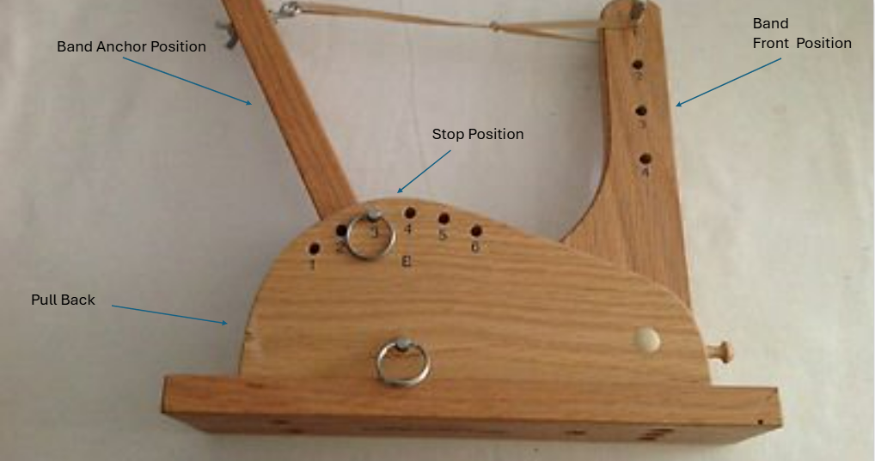
Figure 1- Labelled Catapult System [3]

2 Method and Equipment

2.1 First Launch Experiment
To start this experiment 8 experiment tests with variable launching methods and operators was undertaken to understand the best positions to assemble the catapult equipment to ensure successful test results as well as the most successful operator. For this procedure a catapult was used as the launching platform which was secured by a G-clamp. This enabled the launch to be conducted without the system moving during launch and affecting the credibility of the test results. 3 results would then be recorded, and an average was taken to get an accurate and consistent result from each firing. A ball was launched by the catapult and a measuring tape used to measure the range at which the ball travelled. The catapult positions are split into levels 1 and 2. Level 1 consisted of band front position 1 and a pullback of 140 whereas level 2 consisted of a band front position 3 with a pullback 170. This is demonstrated in table 1 below.
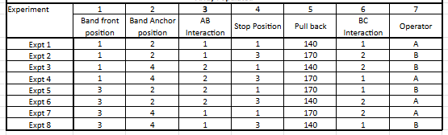
Table 1-First Launch Experiment

2.2 Second Launch Experiment
A further 12 tests were conducted using the same equipment as the previous launches, the most successful operator was used for these 12 launches. There were 4 experimental firings and completed 3 results for each experiment to get an average range which the ball travelled. The catapult positions are split into levels 1 and 2 like the first launch experiment, this can be seen below in table 2.

Table 2- Second Launch Experiment
Experiment | Band Front  Position | Pull Back | Anchor  Position | Stop Position |  | Result 1 | Result 2 | Result 3 | Average
Firing 1 | 1 | 140 | 2 | 3 | Range
Firing 2 | 3 | 140 | 2 | 3 | Range
Firing 3 | 1 | 170 | 2 | 3 | Range
Firing 4 | 3 | 170 | 2 | 3 | Range

2.3 Third Launch Experiment
There was one final launch experiment, and this was using the best test results gathered from the first 2 launch experiment tables and used the most successful operator. There was a target of 150 set for this experiment using averages from results from the second experiment. There were 3 launches completed to gather an average which was similarly completed to the previous launch experiments, for this firing a target for successful launch was projected prior to starting. The band front position and pull back was calculated from the second launch experiment averages for level 1 and level 2 firings. This can be viewed below in table 3.

Table 3-Third Launch Experiment
Experiment | Band Front  Position | Pull Back | Anchor  Position | Stop Position |  | Result 1 | Result 2 | Result 3 | Average
Firing 1 | 2 | 155 | 2 | 3 | Range

3 Experimental Data and Interpretation of Results

3.1 First Launch Experimental Data and Results
The data gathered from the first launch experiment gave a grounding for the second and third launch experiments conducted. Operator B demonstrated a greater consistency level to operator A which is demonstrated in table 4. It can also be determined from table 4 that band front position 1 and anchor position 2 provide the elastic band with greater strain and therefore this allows the arm of the catapult to propel the ball forward at a fast rate and a greater distance. The best result achieved was the second firing as this produced a range of 306.33cm as seen below in table 4.

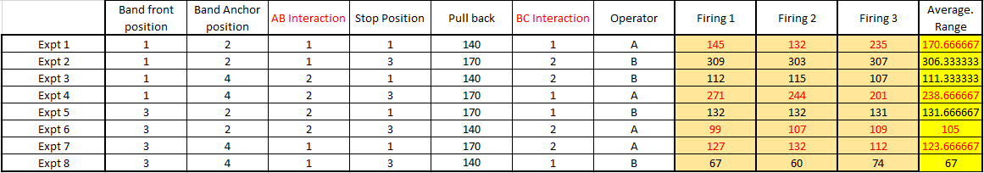
Table 4-First launch Experiment Results

3.2 Second Launch Experiment Data and Results

The second experiment consisted of taking the most successful results from the first experiment and using the same operator to ensure accurate and consistent results were achieved. This consisted of using the best variable launching positions that were achieved during the first launch experiment. For this experiment anchor position 2 and stop position 3 was set for all firings. The greatest average result as seen in table 5 was firing 3 as the ball travelled an average distance of 261.67cm across the three firings.

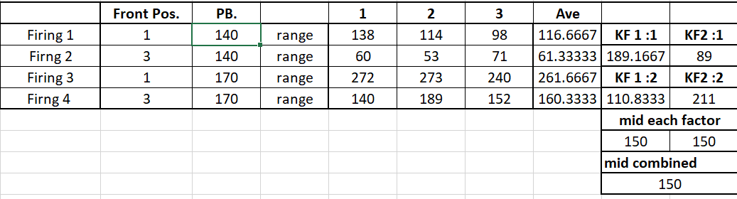
Table 5-Second Launch Experiment Results

The KF:1 figure was calculated using the averages from firings 1 and firing 3. The KF 2:1 was calculated using averages from firings 1 and 2. The K1:2 average was taken from firings 2 and 4. The KF 2:2 was calculated using averages from firings 3 and 4.

3.3 Third Launch Experiment Data and Results
The third and final launched consisted of taking the data captured from the second experimental catapult launch and using this to achieve an overall average that would meet the 150cm target set. For this experiment anchor position 2 and stop position 3 was set for all firings. The front position for this was set to position 2 and the pull back was set to 155 and the front position set to two as these results were both based off the last experiments averages to obtain accurate results. Table 6 demonstrates the results gained from the 3 firings and it can be viewed that the target was not met with an average of 132.33 cm the range achieved.
Table 6-Third Launch Experiment Launches

4 Key Control Factors From this Experiment

4.1 Stop Position
The stop position is a key control factor as significant performance was seen better in level 2 in comparison to level 1 results. Stop position 3 which was conducted as part of the level 2 firings allows the catapult arm to stop abruptly and provides energy which propels the ball. In level 1 however, the stop position was set to 1 which gives the catapult minimal capability to build sufficient velocity and hampering the potential for greater ranges to be achieved. This is demonstrated from the graph shown in figure 2.

Figure 2- Stop Position Graph

4.2 Front Position
The front position is another key control factor which should be managed during the firing process of the experiment. In the case of level 1, the front position was set to 1 and this enabled the rubber band component more strain and hence when the catapult arm was pulled back and released there was more tension provided, hence increasing the velocity. In contrast, level 2 demonstrated that the front position being set to 3 makes the rubber band component of the system has less tension and therefore less velocity enabling for an undesirable range being achieved. The importance of the key control factor of the front position in figure 3.

Figure 3- Front Position Graph

4.3 Pull Back
The pull back is another integral component for the catapult system firing to be performed correctly. The greater the pull back the greater the opportunity for the catapult arm to reach the capable velocity and propel the ball. For level 1 the pull back was set to 140 and this combined with the stop position being set at 1 the arm was restricted and therefore the arm would not reach its capable velocity. In terms of level 2 the pull back was set to 170 and this combined with stop position 3 allowed for a build up of velocity and enhanced range. This is demonstrated below in figure 4 pull back graph.

Figure 4- Pull Back Graph

5 Conclusion and Reflection
In conclusion the Taguchi catapult experiment was conducted unsuccessfully as the target distance was not achieved during the final launch average. This was due to a range of control factors but particularly the pull back sub-systems role in ensuring an acceptable velocity is achieved.
Should this experiment be to be repeated, the control factor mitigations would be implemented to analyse and conduct accurate experiment that achieves the specified target distance. The overall key control factor for this experiment would be the pull back and this can significantly increase the build up velocity during firings. The pull back should be set to 170 to achieve optimum performance from the pull back subsystem however, this should coincide with the correct stop position and front position.

References

[1] | C. S. Z. Z. H. W. a. Y. L. Ning Li, “A review on mixture design methods for geopolymer concrete,” Composites Part B: Engineering, vol. 178, 2019.
[2] | Quality Inspection.org, “How The Taguchi Method Leads To Consistently-Manufactured Products,” Quality Inspection.org, [Online]. Available: https://qualityinspection.org/taguchi-method-consistently-manufactured-products/#:~:text=The%20Taguchi%20method%20is%20a,into%20it%20in%20detail%20here.. [Accessed 16 April 2025].
[3] | Wordpoint Logo, Wordpoint Logo, [Online]. Available: https://www.worthpoint.com/worthopedia/ncmr-wooden-statapult-catapult-2003-411198554. [Accessed 16 April 2025].

AI Acknowledgement Statement
I can confirm that I have not used any AI tools as part of my research nor the creation of this assignment. I can confirm that I have evidence of notes, drafts and other resources used to create this assignment. I can confirm that I have not labelled any AI materials as my own work.

