Application Development
ACCA5012
Habib Muin
1650547
Application Development
Lecturer: Kemi Ademoye
Date: 04/05/2020

Contents
1. Introduction 3
2. Requirements 4
3. Design and Implementation Introduction 5
3.1 Main Design Features 5
3.2 Main Models 6
3.3 View Models 7
3.4 Controllers 8
3.5 Screenshots 8
3.5.1 Admin Screenshots 9
3.5.2 User Screenshots 11
3.5.3. Register Form 13
3.5.4. Forgot Password 14
4. Test Cases 14
4.1. Evaluation 15
4.2. Future Improvements 17
References 18

Introduction
This assignment required a construction and implementation a ASP.NET MVC web application. This report will underline and discuss the research that took place during the implementation of the application as well as the necessary documentation of the activities, followed by the requirements of the application and the design and implementation.
The chosen topic for the web application is a library application. The library web application integrates with a SQL Server Express LocalDB. This allow the data to be managed and stored promptly. In the database for the application, the data is normalised to 3NF (Third normal form). This is simply a part of a set of notions for database normalization. Database normalization also includes 1NF and 2NF (First Normal Form & Second Normal Form). The idea of database normalization tracks back to a data scientist named ‘Edgar Codd’ and his work in the 1970s with IBM. [1]
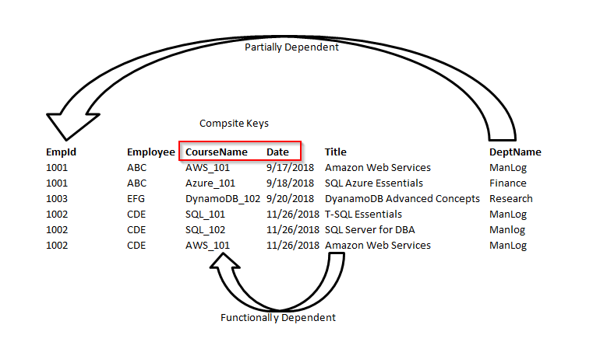

Figure 1: Business Employees Database [2]

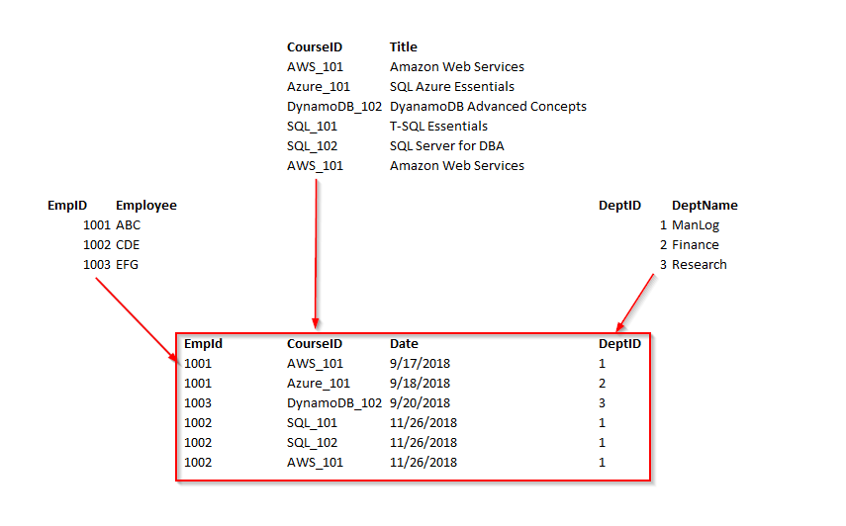

Figure 2: Business Employees 3NF [3]

Requirements
The web application created for this task is a library application. Growing up near a local library and spending many hours in, a development of a profound value and understanding of such an institution has embedded. Libraries allow individuals to expand their knowledge in a friendly and calm environment. Although there are approximately 4.1 thousand public libraries and 950 academic libraries in the UK alone. [4] Studies have shown that in 2015, the access of libraries is 1.39 billion visits, or 4.48 visits per person. [5] However, this figure is declining steadily due to online libraries applications such as ‘GoodReads, ‘LIBIB’, ‘RECO’ and many more. Having online access to a library allow individuals to read / download book from the comfort of their own home. In the next 50 years, public libraries will eventually become obsolete.
The purpose of developing a library application will benefit users that are in education, researchers or individuals who have a hobby with literature. The library application will allow users to access numerous books with a simple click. Thus, reducing the need to visit a public library. The users will have the ability to log in or sign up and create their individual user logins to access books from the application. For example, a student may create an account on the library application. After creating an account, the student will have access to many sources and books that will assist the student with their required work. Another example would be a researcher for English Literature, Physics or Computing may join the library application by creating an account, thus, having access to all the necessary books and sources to assist them in their research.
The library application will not only benefit students, it will also become greatly beneficial for individuals in the teaching industry. i.e. primary school teachers, comprehensive teachers, professors. Reason being, as technology makes drastic advancements, every household or educational ground contains up to date electronics such as projectors, computers tablets etc… Teachers can use the library application as a tool for students to use, especially in primary schools, in order for the students to have easy accessible reading material to use when not in school grounds. Allowing the younger KEYSTAGE students to be guided more towards books, as the younger generation have quick access or smart phones, tablets, and laptops.

Design and Implementation Introduction
This section will outline the main design features, as well as the main scripts, classes and methods that have been implemented in the application in order to provide the core functionality of the Library application.

Main Design Features
The main design features of the library application are the following:
- The login (Admin/User) (figure 11, figure 20)
The user or admin can input their login details and click ‘Login’, this will take them to their designated dashboard.
- Admin can add books to the book list (Figure 17)
The admin can insert the credentials of new books and add the books into the book list.
- Admin can update books in the book list
The admin can click on ‘Book List’. Beside the books there are two buttons. ‘Update’ and ‘Delete’. The admin can click on the update button. This will take the admin to a separate page. This page will allow the user to inset new books into the book list.
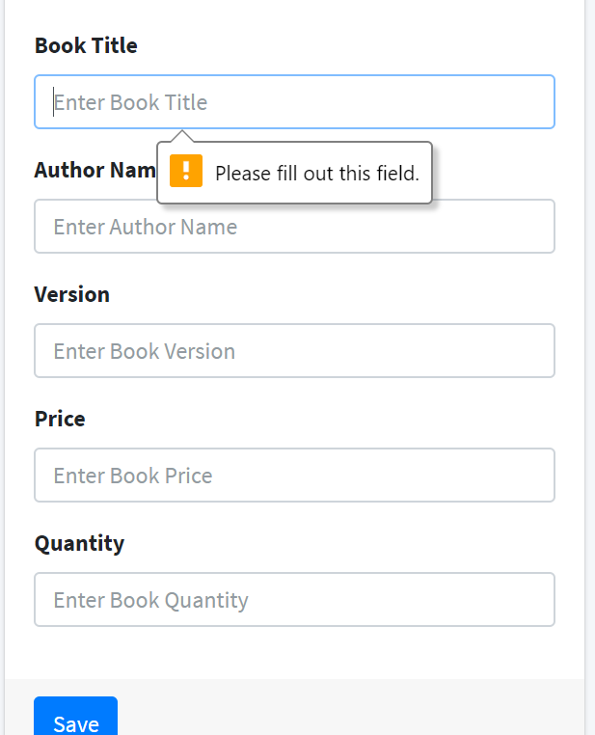
- Admin can view the student list (Figure 14)
One of the options is to view the student list, this allows the admin to view what the students have borrowed and the students credentials.
- Admin Delete Books
The admin can delete any book that are currently on the system and add in new books.
- User can retrieve and borrow books (Figure 22, Figure 23)
Once the user has logged in, they can view what books are available to borrow. By finding the right books, the user can borrow the books and add it to their list.

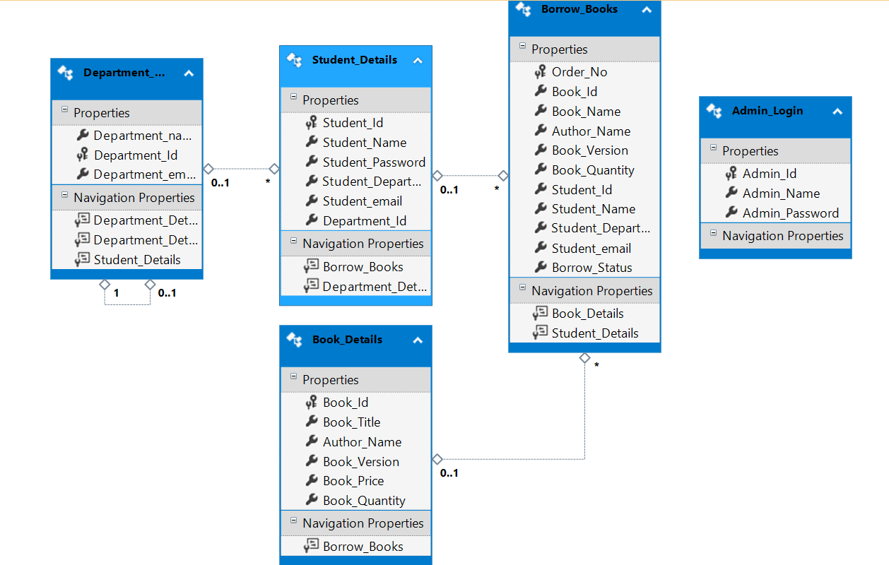
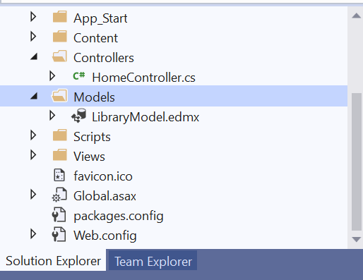
Main Models
Figure 4: Models
Figure 3: ERD

For the main models and Entity Relationship Diagram (ERD) has been created displaying the department linking to the student details, this is then linked with the borrowed books. The borrowed books are linked with book details. This is a 3NF (third normal form) database with all the primary and foreign keys implemented.

View Models
The view models contain the classes for each of the tables that are used as objects for storing and retrieving the data.
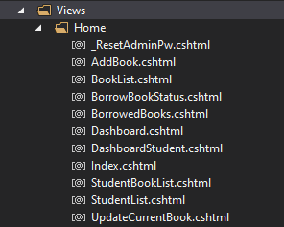
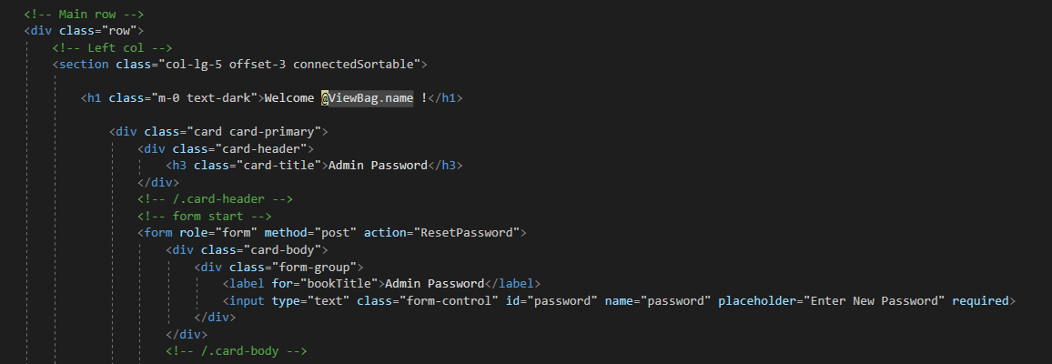
Below are screenshots of the completed webpages with a few partial views. These views are direct communication with the controller to preform CRUD operations. For example, “_Layout.cshtml” these are partial views and “Error.cshtml” are just views.
Figure 5: Views – “Reset Password”
Figure 6: Views (Home)

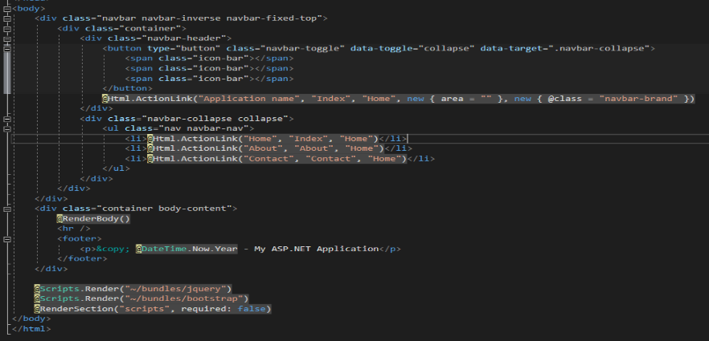

Figure 7: Views Layout
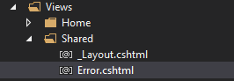
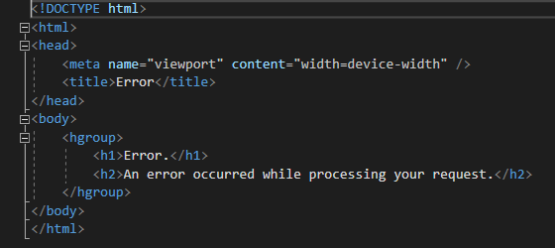
Figure 8: Views Error
Figure 9: Views (Shared)

Controllers
In the application, there is only one controller. This is the home controller; all of the core methods and scripts are written in the “HomeController”. The controller communicates with the views and uses models for performing interactions with the database.
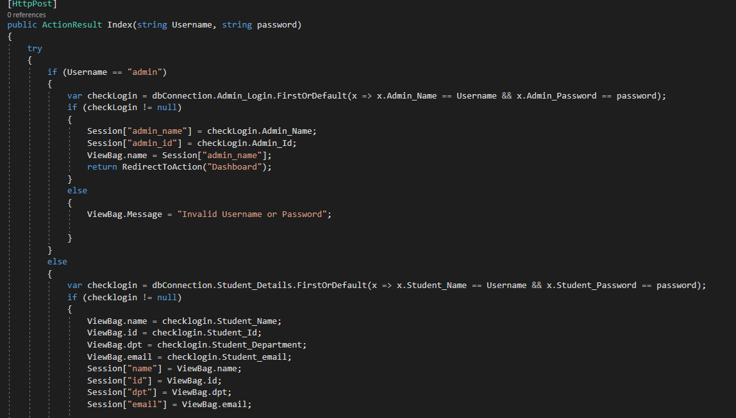

Figure 10: Controllers

Screenshots
This section of the report will provide screenshots of the completed library application pages from the Admin side and the user side.

Admin Screenshots
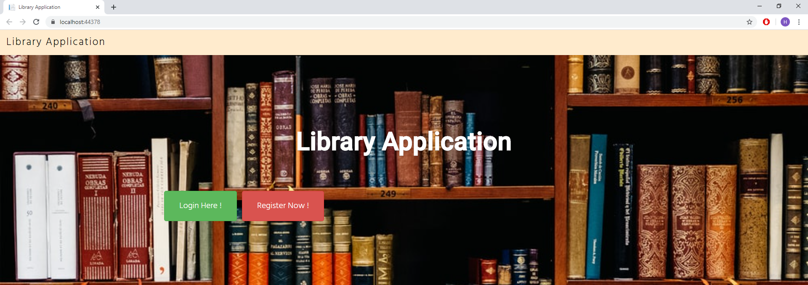
Figure 11: Login Page

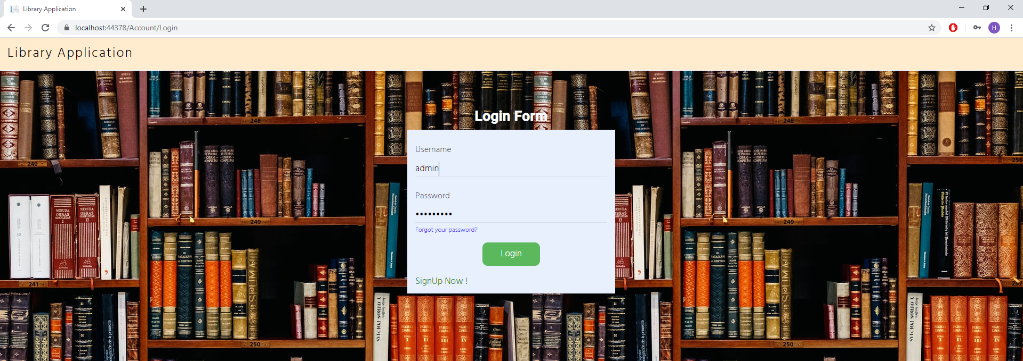
Login Details
Username: admin
Password: Admin@123
Figure 12: Login Form

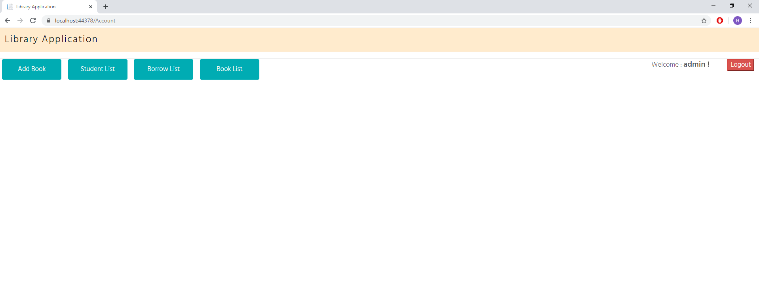
Figure 13: Admin Dashboard
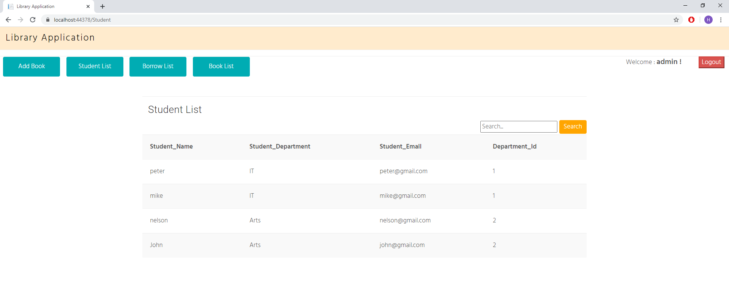
Figure 14: Student List

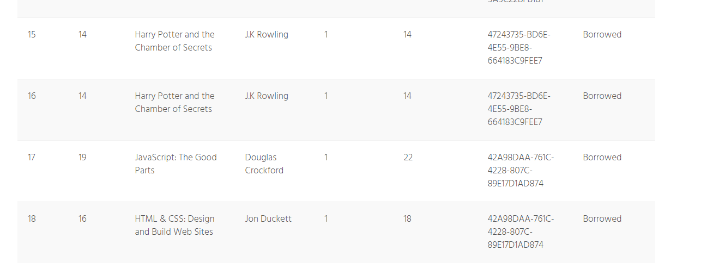
Figure 15: Borrow List
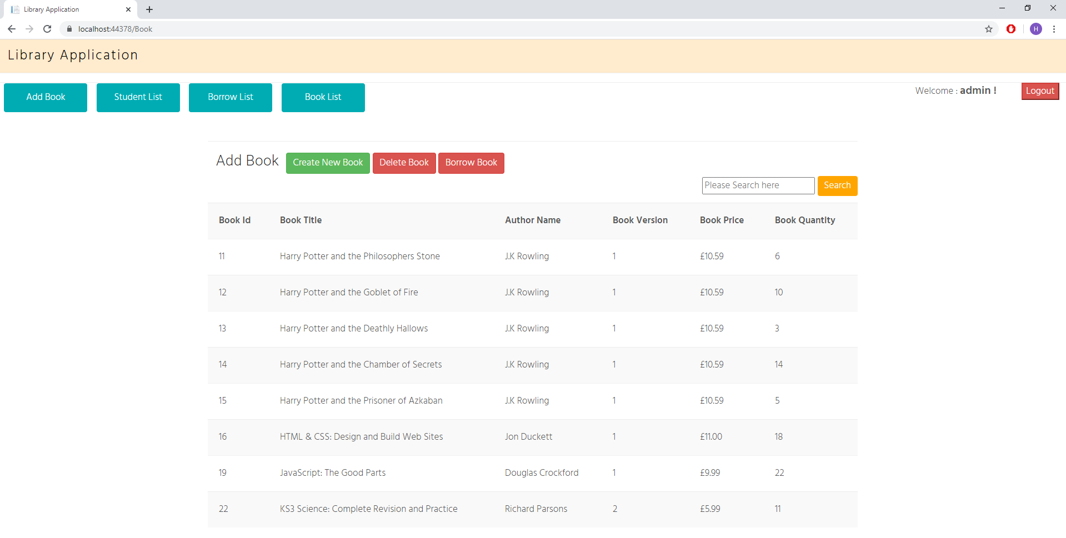
Figure 16: Book List
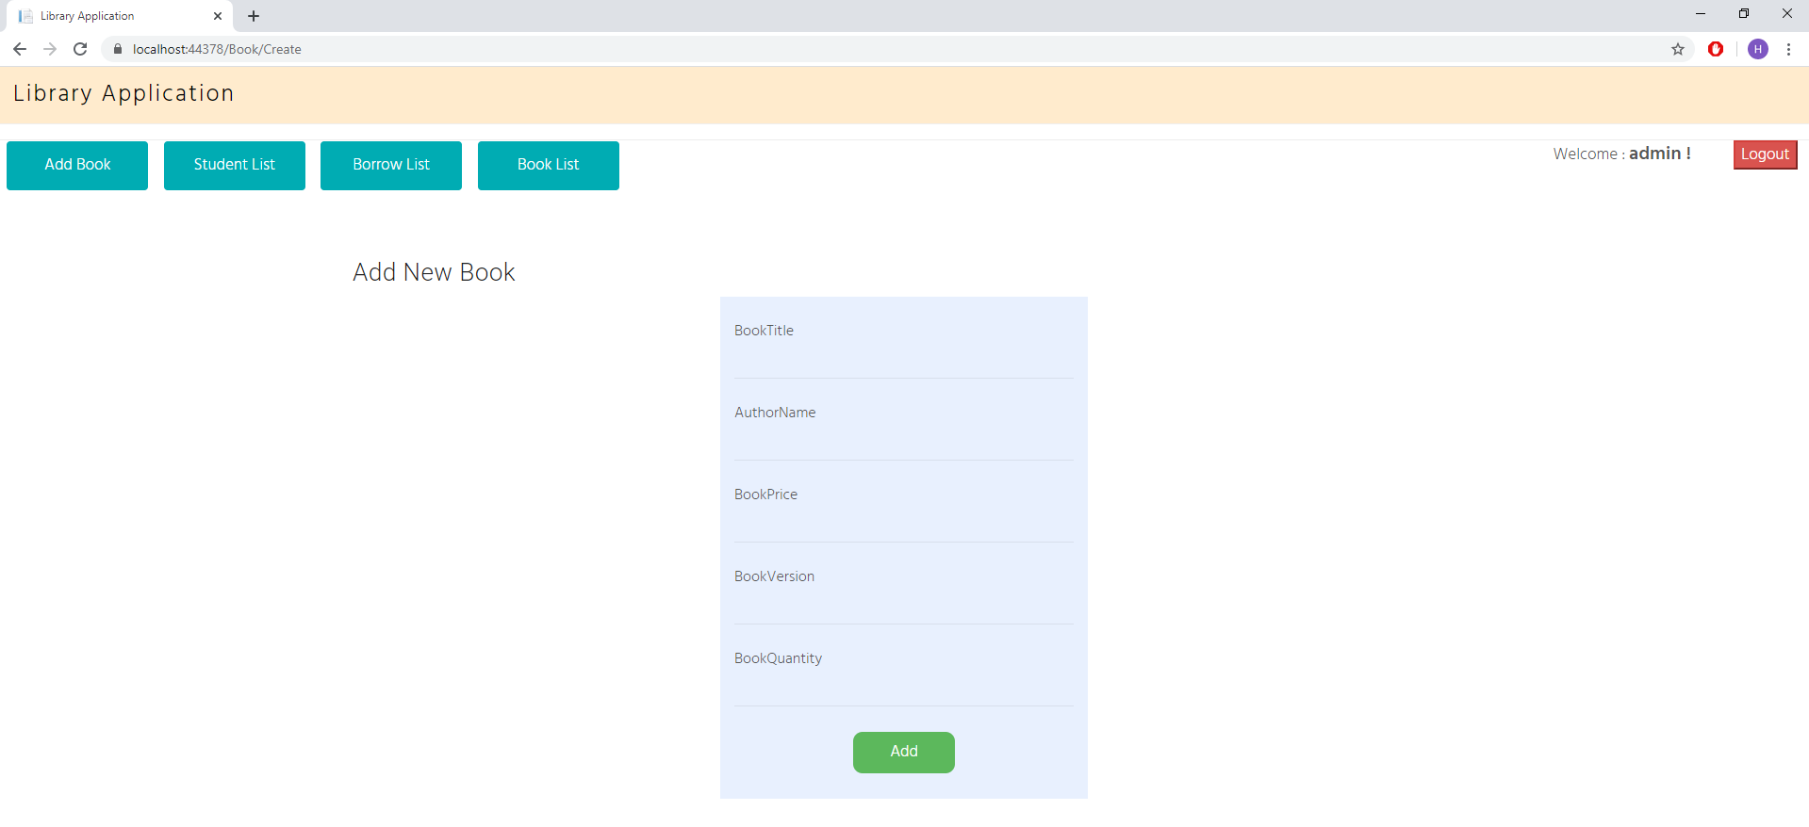
Figure 17: Add New Book

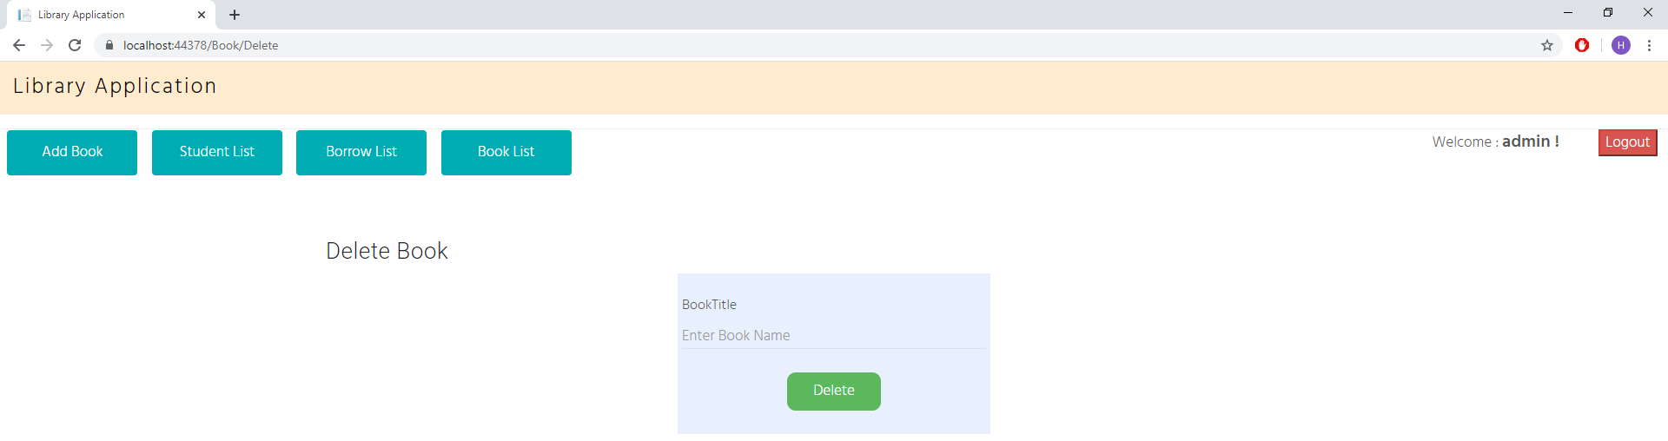
Figure 18: Delete Books

User Screenshots

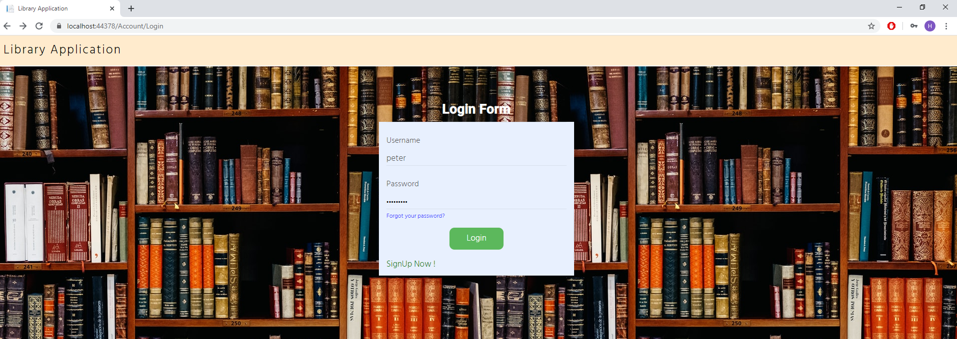
Login Details
Username: peter
Password: peter@123
Figure 20: User Login (Peter)

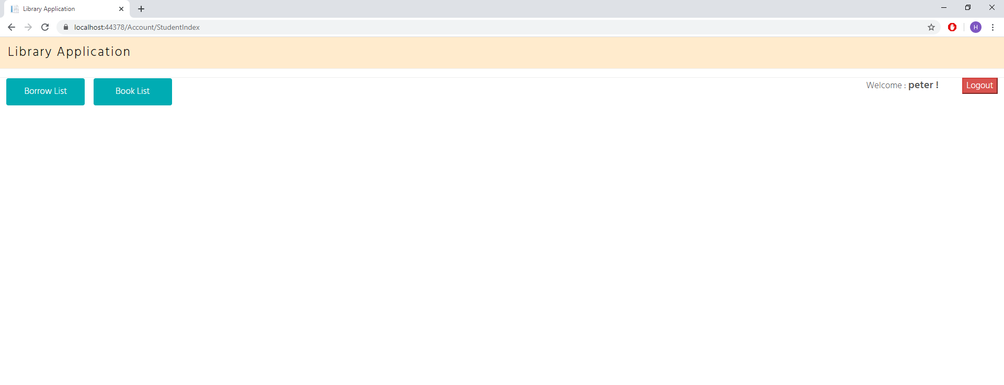
Figure 21: User Dashboard

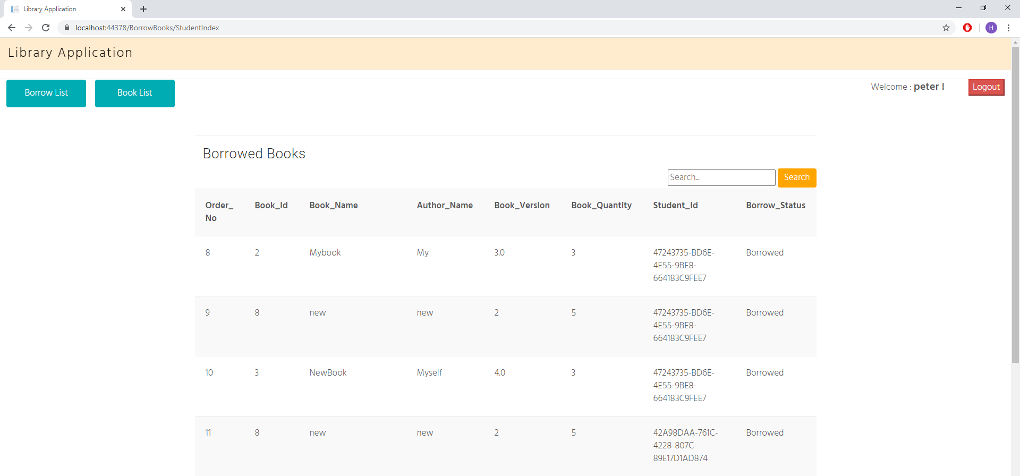
Figure 22: Borrowed Books (User)

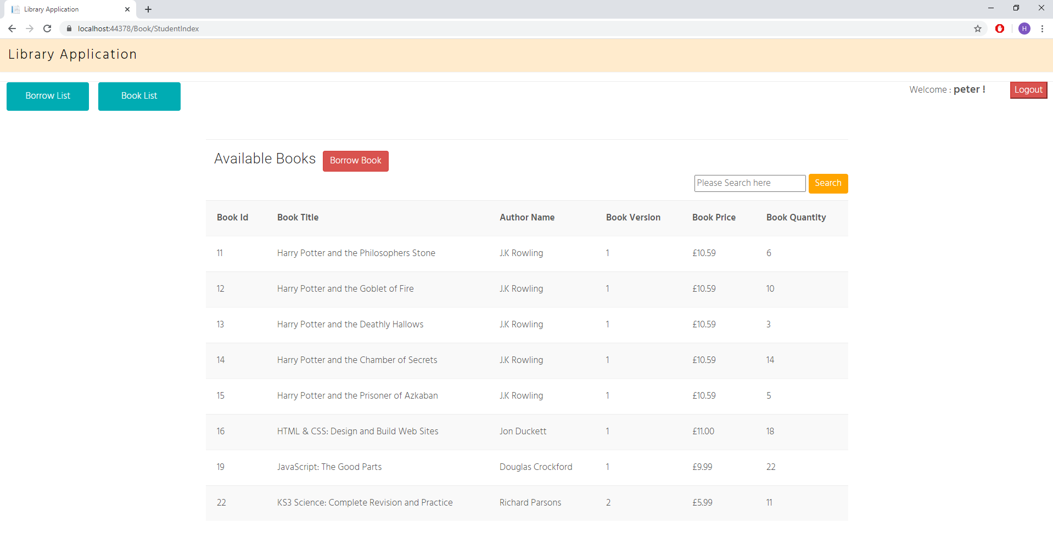
Figure 23: Book List (User)

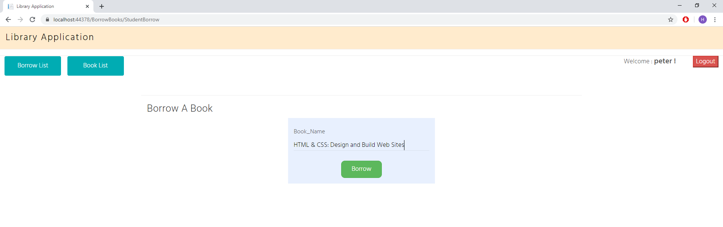
Figure 24: Books Borrowed (User)

Register Form
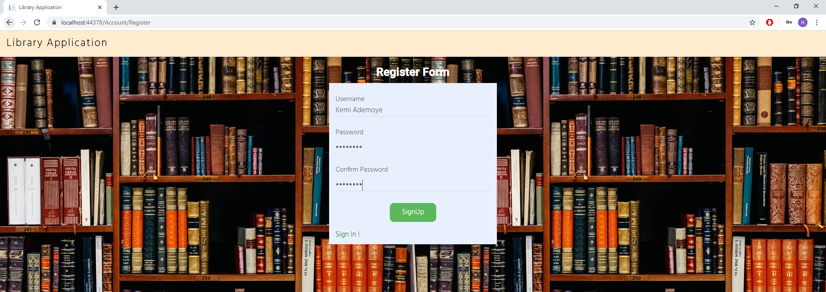
Login Details
Username: KemiAdeyome
Password: Kemi@123
Figure 25: Register Form (Kemi)
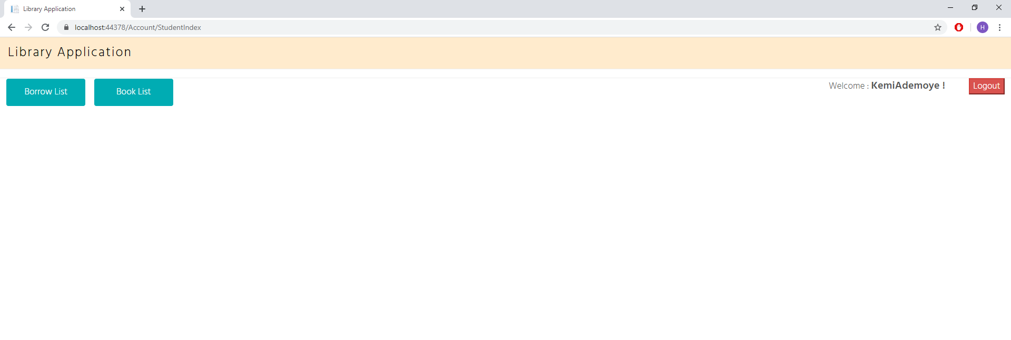
Figure 26: Kemi Dashboard

Forgot Password
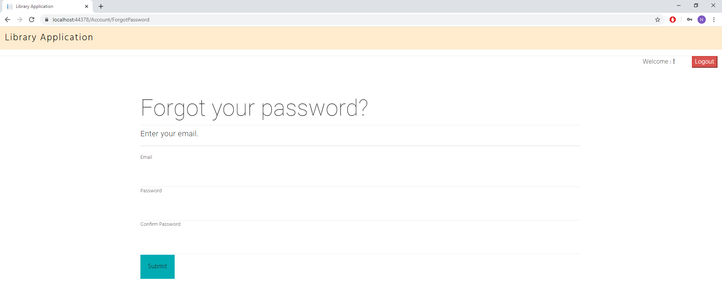
Figure 27: Forgot Password

Test Cases
After the development of an application it is important to do software validation and verifications. After the library application had been built, the student developed a set of test cases in order to validate and verify 7 of the functional requirements and features of the library application.
Here bellow in figure 28, a table is displayed showing the test cases that have been performed for the implemented library application:
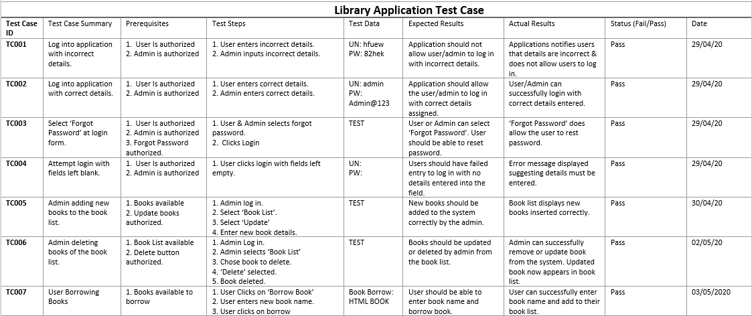
Figure 28: Test Case Table

Evaluation
The application created for this assignment is a library application. The purpose of this application is to allow users such as student, teachers, or any individuals to have access to books and online resources at any point and time. The applications functionality has been designed in a way to allow users to browse and borrow books with ease and simplicity minimising any confusion. The user can create an account and have their very own unique account to access the library application.
The overall design of the application is left simple, with two tone colours (Navy Blue & white). The button uses to borrow books and update books are in a bold red and blue colour. This allows the buttons to stand out to the users and become easier to navigate. The reasons why the colours of the application have been left to red, blue, and white because these are the colour pallets and colour-blind friendly, allowing users who suffer with colour-blind having a user-friendly experience. [6]
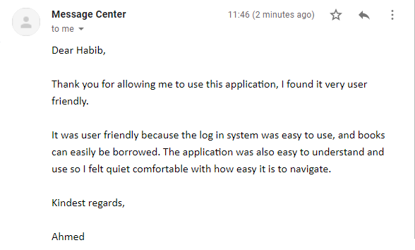
The library application was sent to 3 users to test out the application and give an unbiased feedback of the usability and design had been done. This allowed the student to have a better understanding of the overall implemented application, as well as any improvements that can be made in the future. Here bellow are 3 screenshots (figure 29, figure 30, figure 31) of users who have tested out the application from the admin account and user account:

Figure 29: User Feedback (1)
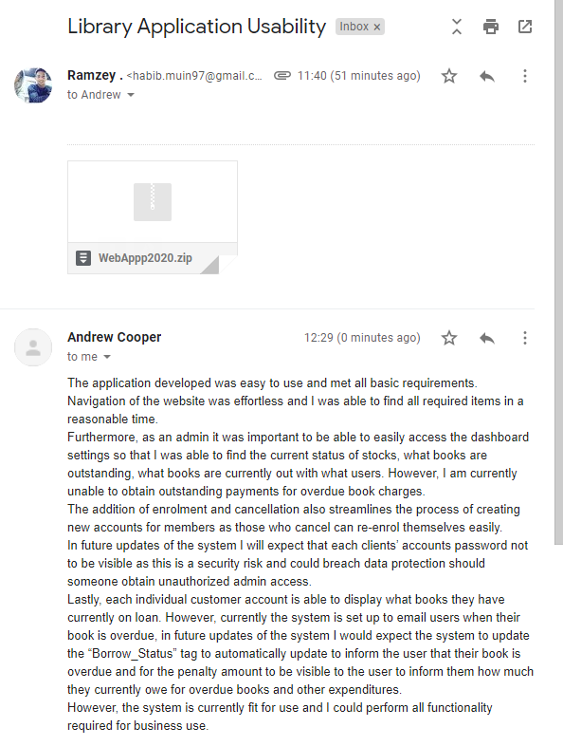
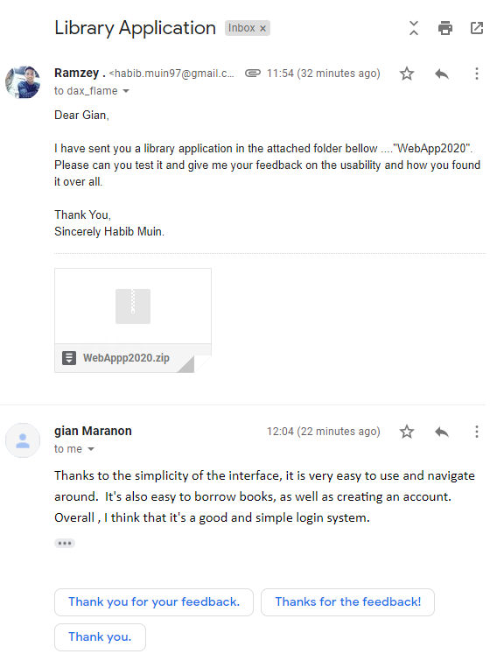
Figure 31: User Feedback (3)
Figure 30: User Feedback (2)

Future Improvements
After conducting test cases and receiving user feedback on the library application, there are a few improvements that can be made to the application which will benefit it. These improvements range from major improvements which can be done over time, to minor improvements which can be done right away. Here are the following improvements:
- Purchase of books
The current application does not allow the user to purchase any books. The application only has the feature of renting a book. In the future a payment system will be set up in order for users to purchase the books using a payment gateway api.
- Book Overdue
In the future, the system will have the feature to allow the admin, as well as the user, to review the duration of the user’s books that are borrowed. Currently, the application does not support this improvement.
- Adding Pictures
By adding pictures of the books would give the application a better aesthetic appearance, this way the users can have a look at the front page of the books.

- Book ID
The book ID is currently automatic generated; this currently causes the problem of the book ID of new book carrying on from the previous books that were entered. It auto increases every time a new book is added. In the future tables will be changed so that once the admin as new books in or deletes any books, the book ID will start in order.

- Deleting Books
When the admin currently deletes any books, he has to manually type in the title of the book exactly the way it is written. This can cause confusion. This can be improved in the future by allow the admin to view the books and manually click on the book titles in order to delete.

- Borrowing Books
Although the users can borrow books in the library application, they have to however insert the name of the book, word for word, if the book is misspelled it will not allow the user to borrow the book. This may lead to the user having to go back and forth from “Book List” and make sure the correct title of the book is inserted. This can be improved by adding a view of the current books from the Book List in the Borrow page. Once the user starts to type the book, it will auto suggest the book that they are looking for.

References

[1] - “Techopedia” Last Updated: April 24, 2020
Online Accessed: https://www.techopedia.com/definition/22561/third-normal-form-3nf
[2] – ‘Figure 1’, P. Jayaram, Nov 27, 2018, “SQLShack” 3NF Example
Image Source: https://www.sqlshack.com/what-is-database-normalization-in-sql-server/
[3] – ‘Figure 2’, P. Jayaram, Nov 27, 2018, “SQLShack” 3NF Example
Image Source: https://www.sqlshack.com/what-is-database-normalization-in-sql-server/
[4] – J. Johnson, Sep 16, 2019. “Statista”, “Libraries in the United Kingdom – Statistics & Facts”
Online Access: https://www.statista.com/topics/1838/libraries-in-the-uk/
[5] – E. Holtan, Aug 2, 2018. “Institute of Museum and Library Services”, “People visited public libraries more than a billion times in 2015”
Online Access: https://www.imls.gov/news/people-visited-public-libraries-more-billion-times-2015
[6] – J. Shaffer, Apr 20, 2016. “5 tips on designing colour-blind-friendly visualization”. ‘Tableau’
Online Access: https://www.tableau.com/about/blog/2016/4/examining-data-viz-rules-dont-use-red-green-together-53463

