Thomas Nica
2122261
Jaliya De Silva

BMIH5004
Management and Organisational Behaviour
Assessment Component 2 – Case Study of Hilton Hotels

Table of Contents
Introduction 3
Organization Structure, Culture, and Goals 3
Complex Organizational Structure 3
Indelible Organizational Culture 4
Overarching Organizational Goals 5
Recent Change Initiatives and Their Impact 6
Recent Transformative Change Initiatives 6
Multifaceted Implications of Change Initiatives 6
The Organization's Strategic Direction and Current Business Performance 7
Expansion and Augmentation of the Brand Portfolio 7
Technological Vigilance and Innovation 7
A Covenant of Sustainability and Corporate Responsibility 8
Current Business Performance 8
Critical Evaluation and Recommendations 9
Conclusion 10
References 11

Introduction
The report delves into a comprehensive examination and analysis of various aspects of the Hilton Hotel Group. It explores the complexities inherent in the organization's structure, the enduring cultural paradigms that have shaped its operations over time, the overarching goals that drive its corporate endeavours, the subtle yet significant effects of recent transformative change initiatives, and the current strategic trajectory and real-time business performance of the organisation. The present report encompasses the findings derived from the comprehensive audit and meticulous analysis that were undertaken. This comprehensive analysis delves into Hilton's performance, examining both its corporate and individual unit levels with meticulous attention. It employs intricate phrase structures, incorporating relevant theories and frameworks to provide a thorough understanding. The primary objective of this study is to offer profound insights aimed at enhancing the organization's overall efficacy, while concurrently providing an intricate analysis of its myriad strengths and challenges.

Organization Structure, Culture, and Goals

Complex Organizational Structure
In the contemporary expansive global economy, the hotel industry assumes a pivotal and indispensable role. The hospitality industry, being of utmost significance, attends to the demands of discerning tourists by offering them accommodations, dining options, and recreational activities. The Hilton Hotel Group, renowned for its contributions, has played a pivotal role in shaping the current state of the hospitality industry. It functions as the central governing body overseeing a vast network of hotels and resorts on a global scale. The Hilton Hotel Group undergoes a comprehensive audit and examination in this report, which is meticulously elucidated utilising intricate phrase constructions (Hiltonworldwide.com, 2013). The primary objective of this comprehensive analysis is to offer a deep understanding of the intricate organisational framework, deeply-rooted cultural principles, expansive corporate objectives, groundbreaking change endeavours, extensive ramifications, and the current state of the Hilton Hotel Group's strategic trajectory and financial performance (Geppert, 2013).
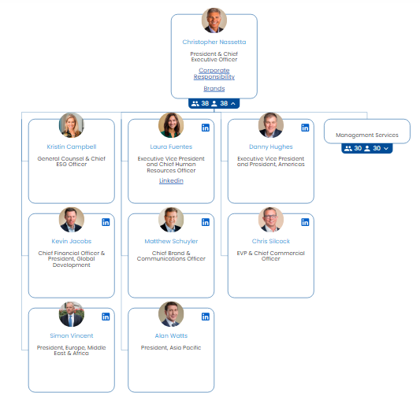
Figure 1 Organisational Structure of Hilton Hoels
Source: (Organimi, 2017)

Indelible Organizational Culture
At the core of the operational superstructure that the Hilton Hotel Group has established lies an intricately designed organisational framework, carefully constructed to effectively address the expansive worldwide presence of the Hilton Hotel Group. The corporate headquarters is situated at the pinnacle of this intricate multi-tiered organisation, assuming the role of overseeing a diverse range of global responsibilities (Gujar, 2004). Examples of such roles include the formulation of intricate strategies, the orchestration of complex financial operations, the application of astute marketing acumen, and the meticulous management of esteemed brands. McLean, Virginia serves as an exceptional locale for establishing the company's headquarters (Hiltonworldwide.com, 2013). Simultaneously, the regional offices situated in strategic hubs across Asia, Europe, and the Americas bear the responsibility of effectively coordinating operations within their respective geographical domains. Through this action, they have successfully bridged the divide between overarching corporate strategy and on-the-ground implementation at the local level (Robbins & Judge, 2011).
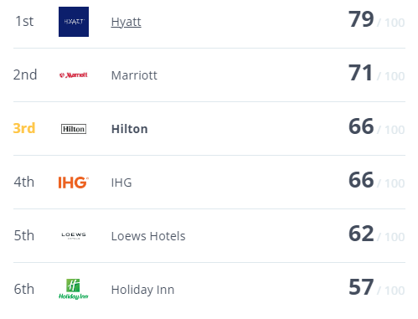
Figure 2 Hilton Ranks 3rd in Overall Culture Score
Source: (Hilton, 2023)

Overarching Organizational Goals
The recognised and enduring culture of Hilton serves as the cornerstone of the firm, establishing the fundamental principles that underpin its organisational dynamics. The foundation of this ethos lies in an unwavering dedication to the ongoing development of human capital, relentless pursuit of innovation, and unwavering commitment to providing exceptional service to customers. The company's mission statement encapsulates its grand vision with utmost eloquence, aiming to transcend all others in the realm of hospitality (Robbins & Judge, 2013). By meticulously crafting heartfelt experiences for Guests, providing meaningful opportunities for Team Members, delivering high value for Owners, and fostering a positive impact in our communities, the company strives to establish itself as the epitome of hospitality on a global scale (Applegate et al., 2008). Striving to create a positive impact within our communities, offering meaningful opportunities for our esteemed Team Members, delivering high value for our valued Owners, and ensuring heartfelt experiences for our esteemed Guests (Robbins & Judge, 2011).

Recent Change Initiatives and Their Impact

Recent Transformative Change Initiatives
The Hilton Hotel Group harbours ambitious aspirations that encompass a wide range of objectives, such as expanding its presence on a global scale, maintaining unparalleled levels of service excellence, maximising financial gains, and exemplifying corporate responsibility. At their core, these ambitious goals revolve around the continuous growth and meticulous maintenance of a diverse portfolio of hotel brands (Mullins, 2020). Every individual hotel chain within this comprehensive collection has undergone a meticulous process of adaptation, carefully tailored to effectively address the specific requirements of a diverse array of industries and cater to the unique preferences and characteristics of a wide-ranging clientele (Farzianpour et al., 2016).
The annals of Hilton's recent history are punctuated by a succession of audacious and groundbreaking endeavours. The demonstrated actions serve as a testament to the unwavering dedication of the company towards the perpetual enhancement and advancement of its operations. Of utmost significance among these initiatives is Hilton's unwavering dedication to sustainability, a core component that has now assumed a central role in the company's operational strategy. The Travel with Purpose initiative, which was formally introduced in the year 2018, functions as the guiding principle on this path towards achieving sustainability (Hilton, 2023).

Multifaceted Implications of Change Initiatives
Hilton's unwavering commitment to sustainability measures has left an indelible mark on the discerning community of environmentally conscious travellers, resulting in a noticeable enhancement of the company's positive reputation and affinity. Hilton's unwavering commitment to mitigating carbon emissions by an impressive 34% and its groundbreaking vow to eradicate all remnants of soap from contaminating landfills have left an indelible imprint on the ever-evolving sustainability realm (Stories From Hilton, 2022). Due to Hilton's robust alignment with the global paradigm shift towards sustainable tourism, the company is now poised to effectively appeal to a broader and more discerning clientele, encompassing a diverse range of individuals (Farzianpour et al., 2016).
Although Hilton's prompt response during the COVID-19 pandemic had a significant impact on financial indicators in the immediate period, owing to the simultaneous decline in travel and occupancy rates, it ultimately proved to be a successful strategy in reestablishing the company's reputation among its clientele. Hilton's remarkable capacity to swiftly adapt to the perpetually evolving travel landscape, coupled with the company's unwavering commitment to rigorous safety protocols, has not only reinstated the confidence of its clientele but also cemented the organization's enduring resilience (Gehani, 2016).

The Organization's Strategic Direction and Current Business Performance

Expansion and Augmentation of the Brand Portfolio
The expansion and augmentation of the brand portfolio entails the strategic diversification and enhancement of the range of brands owned and managed by a company (Mullins, 2016). The alignment of strategic objectives and the evaluation of ongoing business performance. In particular, Hilton's overarching strategic vision entails an unwavering focus on augmenting its global footprint through the establishment of novel hospitality establishments and astute acquisitions of pre-existing properties (Rollinson et al., 2008). The success of this endeavour is further enhanced by Hilton's expansive collection of prestigious brands, encompassing renowned names such as Hilton, Waldorf Astoria, Conrad, and Hampton. Every single one of these brands was meticulously designed with the intention of catering to a distinct array of target demographics and individual preferences.

Technological Vigilance and Innovation
The conscious allocation of resources towards technological innovation serves as a testament to Hilton's steadfast dedication to advancing technology and forms an integral component of their endeavour to substantially enhance the overall experience of their hotel patrons (Boddy, 2014).
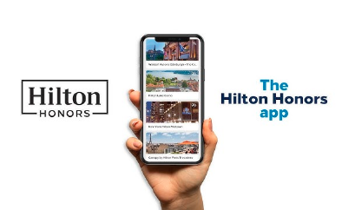
Figure 3 Hilton Honours App
Source: (Honors, 2022)
Pioneering initiatives such as the Hilton Honours app, which serves as a comprehensive guide for guests, offering convenience and personalised experiences, contribute significantly to the realisation of this ambitious objective (Honors, 2022). In a parallel trajectory, Hilton is embarking on a resolute expedition towards the unexplored realms of cutting-edge technologies such as artificial intelligence and data analytics (Mullins & Dosser, 2013). This audacious endeavour is driven by the aspiration to enhance its operational efficiency and elevate the quality of service bestowed upon its esteemed clientele.

A Covenant of Sustainability and Corporate Responsibility
Hilton's business strategy is firmly rooted in an unyielding commitment to sustainability, which permeates every aspect of the company's culture. Hilton demonstrates its unwavering commitment to fulfilling its broader responsibility as a conscientious corporate entity, which is evident through a multitude of avenues. These encompass the company's comprehensive waste management practises, meticulous selection of socially responsible suppliers, and unwavering dedication to actively engage and contribute to the betterment of local communities (Mullins & Dosser, 2013).

Current Business Performance
In spite of enduring rigorous examinations and challenges as a result of the catastrophic COVID-19 pandemic, Hilton's business performance has demonstrated remarkable resilience and adeptness in adapting to the circumstances. Hilton was compelled to confront the inescapable reality that the occupancy rates and income are destined to plummet in the year 2020 due to the unprecedented impact of the pandemic. The financial reports for the year 2021, on the other hand, reveal a modest rebound from the bleakness experienced in 2020, with a notable emphasis on the favourable expansion of global RevPAR (Revenue per Available Room) (Hilton.com, 2022). Hilton's steadfast commitment to ensuring safety and maintaining high hygiene standards, bolstered by the remarkable success of its loyalty programme, Hilton Honours, has been instrumental in not just attracting guests but also generating substantial revenue streams. This has laid a strong foundation for the organization's optimistic prospects in the foreseeable future, indicating a gradual resurgence of the hospitality sector.

Critical Evaluation and Recommendations
The organisational culture of Hilton, which is deeply rooted in the principles of hospitality, innovation, and sustainability, serves as a substantial asset that garners extensive appeal from both customers and employees alike. In addition, Hilton's extensive assortment of brand offerings serves as a conspicuous asset, enabling the company to meticulously accommodate diverse market segments and a vast array of customer preferences. Hilton's unwavering commitment to implementing environmental initiatives not only bolsters the company's reputation, but also resonates deeply with the increasingly discerning clientele actively seeking out conscientious vacation choices (Hofstede Insights, 2019). Hilton's remarkable ability to swiftly strategize and prioritise guest safety amidst the tumultuous earthquakes triggered by the unprecedented COVID-19 pandemic serves as a compelling illustration of their exceptional adaptive resilience.
Due to its strong interdependence with the tourism and hospitality sectors, Hilton is particularly vulnerable to financial turmoil, as these industries themselves are highly susceptible to the capricious nature of external factors, including pandemics and economic fluctuations. In the fiercely competitive landscape of the hospitality industry, numerous multinational corporations and small enterprises engage in a relentless battle, each vying for a share of the lucrative market. The aforementioned factor serves to exacerbate the competitive hurdles that Hilton is currently confronting. Despite the commendable sustainability initiatives undertaken by the hotel industry, it is undeniable that it still leaves a discernible environmental footprint (Applegate et al., 2008). Therefore, it becomes imperative to meticulously intensify the implementation of mitigation measures in order to effectively address this enduring issue.
Hilton may engage in a judicious exploration of prospects to broaden its revenue streams, transcending the boundaries of traditional hospitality paradigms, such as venturing into the burgeoning vacation rental sector or offering a diverse range of experiential activities, in order to mitigate its vulnerability to financial uncertainties (Farzianpour et al., 2016)
. In order to effectively address its environmental impact and uphold its steadfast commitment to sustainability, Hilton ought to significantly enhance and expand its existing sustainability initiatives. This is imperative, particularly in light of the ever-evolving consumer expectations and the pressing global environmental imperatives that demand immediate attention. In its relentless quest to enhance guest experiences and optimise operational efficiency, Hilton must steadfastly maintain its position at the vanguard of technological advancements, delving into nascent paradigms such as artificial intelligence and data analytics. This unwavering commitment is crucial for Hilton to sustain its competitive edge in the industry.

Conclusion
In light of the evidence presented, this audit and analysis have shed light on the intricate organisational structure, deeply ingrained cultural ethos, overarching corporate objectives, recent transformative change initiatives, and multifaceted consequences of the Hilton Hotel Group. Furthermore, it has provided a comprehensive understanding of the organization's strategic direction and business performance. Hilton boasts a formidable array of strengths, encompassing a robust and deeply ingrained company culture, an extensive portfolio of diverse brands catering to various consumer preferences, and an unwavering commitment to sustainability. However, amidst its triumphs, the company grapples with the formidable challenges of navigating through a landscape of financial uncertainty and contending with fierce competition within the fiercely competitive hospitality industry. The future prospects of Hilton hinge upon its adeptness in effectively manoeuvring through the intricate and perpetually evolving terrain of the hospitality industry. However, the company's exceptional flexibility and resolute dedication to pioneering advancements and ecological responsibility provide it with a distinct advantage.

References
Applegate, L.M., Piccoli, G., & Dev, C. (2008). Hilton Hotels: Brand Differentiation through Customer Relationship Management. Harvard Business School: Boston, Massachusetts.
Boddy, D. (2014) Management: An Introduction (6th Ed), Harlow, Pearson
Brown, D.R. (2011). An Experiential Approach to Organization Development. Saddle River, NJ: Prentice Hall.
Farzianpour, F., Abbasi, M., Foruoshani, A. R., & Pooyan, E. J. (2016). The relationship between hofstede organizational culture and employees job burnout in hospitals of tehran university of medical sciences 2014-2015. Materia socio-medica, 28(1), 26.
Gehani, R. R. (2016). Corporate brand value shifting from identity to innovation capability: From Coca-Cola to Apple. Journal of technology management & innovation, 11(3), 11-20.
Geppert, M. (2013). Politics and power within multinational corporations: Mainstream studies, emerging critical approaches and suggestions for future research. University of Surrey: Guildford, United Kingdom.
Gujar, P. (2004). Organizational Structure in the Hospitality Industry: A Comparative Analysis of Hotel Real Estate Investment Trust and Hotel Corporations. University of Pune: Pune, India.
Hilton (2023). Hilton Competitors. [online] Comparably. Available at: https://www.comparably.com/companies/hilton/competitors [Accessed 5 Oct. 2023].
Hilton.com. (2022). Annual Reports. [online] Available at: https://ir.hilton.com/financial-reporting/annual-reports [Accessed 5 Oct. 2023].
Hiltonworldwide.com. (2013). Hilton World Wide: History. Retrieved from www.hiltonworldwide.com.
Hofstede Insights (2019). Organizational Culture. Available at: https://www.hofstede-insights.com/models/organisational-culture/
Honors, H. (2022). Make Travel Easier & More Rewarding With the Hilton Honors Mobile App. YouTube. Available at: https://www.youtube.com/watch?v=UOCDlY8can0 [Accessed 5 Oct. 2023].
Mullins, L & Dosser, P. (2013) Hospitality Management and Organisational Behaviour (5th Ed) Harlow, Pearson.
Mullins, L (2020) Organisational Behaviour in the Workplace (12th edition) Harlow:Pearson
Mullins, L. (2016) Management and Organisational Behaviour (11th edition) Harlow: Pearson
Organimi. (2017). Hilton’s Organizational Structure [Interactive Chart] | Organimi. [online] Available at: https://www.organimi.com/organizational-structures/hilton/ [Accessed 5 Oct. 2023].
Robbins, S.P., & Judge, T.A. (2011). Essentials of Business Behavior. Saddle River, NJ: Prentice Hall.
Robbins, S.P., & Judge, T.A. (2013). Essentials of Organization Behavior. Saddle River, NJ: Prentice Hall.
Rollinson, D. et al (2008) Organisational Behaviour and Analysis (4 th edition) Harlow: Addison-Wesley Longman.
Stories From Hilton. (2022). Hilton 2022 Year in Review. [online] Available at: https://stories.hilton.com/2022-annual-report [Accessed 5 Oct. 2023].

