Evidence of using Welsh in class
Below are comments from both my mid and final review of PTE1 that show I have been using Welsh in lessons. Below my reviews is also more evidence from my learning journal that shows that I have used welsh in my lessons.
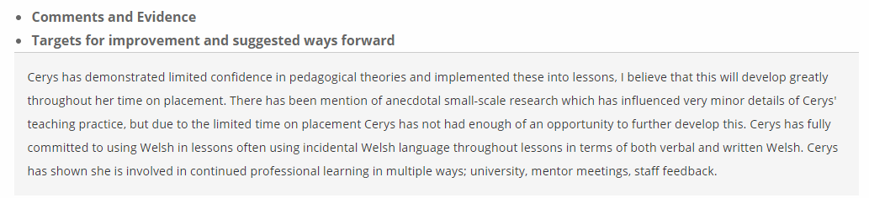
Mid Term Review
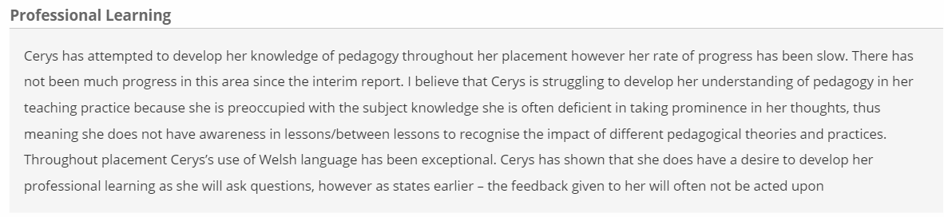
Final Review
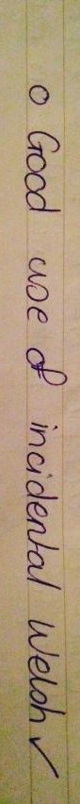
From the positive feedback I have received here I will continue to grow my Welsh vocabulary and my confidence in saying the common classroom phrases with the end goal of it feeling completely natural to use a wide variety of Welsh in the classroom. These phrases will be used regularly throughout all lessons.

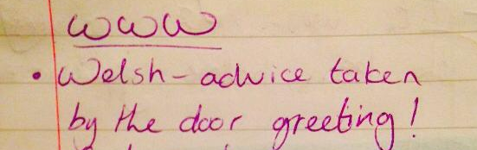
Teacher learning journal notes showing I used Welsh in class:

