Matthew Macpherson
Bsc Civil Engineering
1804910
Materials Engineering Assignment 2

Contents
- Analysis of Aggregates (Sieving)…………………………………………………3
  - Results…………………………………………………………………………………………….3
  - Fueller Graphs………………………………………………………………………………...4
  - Analysis……………………………………………………………………………………………5
  - Fineness Modulus Calculation………………………………………………………….6
- Aggregates Mix…………………………………………………………………………..7
  - Fineness Modulus……………………………………………………………………………7
  - Percentage of Aggregates……………………………………………………………….7
  - Analysis…………………………………………………………………………………………..8
  - Material Breakdown……………………………………………………………………….9
- Concrete Mix Quantities…………………………………………………………….9
  - Cubic Meters…………………………………………………………………………………..9
  - Tonnes…………………………………………………………………………………………..10
  - Kilograms……………………………………………………………………………………….10
  - Absolute Volume……………………………………………………………………………10
  - Quantities of Materials…………………………………………………………………..11
- Slump Test………………………………………………………………………………..12
  - Class and Effect on Hardened Concrete………………………………………….12
  - Use of Sample…………………………………………………………………………………12
  - Process for Incorrect Slump…………………………………………………………….12
- Compression Test………………………………………………………………………13
  - Compressive Strength……………………………………………………………………..13
  - Repeatability…………………………………………………………………………………..15
  - Analysis……………………………………………………………………………………………17
- References………………………………………………………………………………….18
- Appendix…………………………………………………………………………………….19

- Analysis of Aggregates (Sieving)
Sieve | Weight (g) | Retained (%) | Cumulative Retained (%) | Passed (%)
16mm | 2144.85 | 35.60 | 35.60 | 64.40
8mm | 3799.38 | 63.07 | 98.67 | 1.33
4mm | 45.77 | 0.76 | 99.43 | 0.57
2mm | 4.84 | 0.08 | 99.51 | 0.49
1mm | 0.68 | 0.01 | 99.52 | 0.48
500μm | 2.00 | 0.03 | 99.55 | 0.45
250μm | 3.88 | 0.06 | 99.61 | 0.39
125μm | 3.18 | 0.05 | 99.66 | 0.34
63μm | 0.66 | 0.01 | 99.67 | 0.33
Bottom | 19.9 | 0.33 | 100.00 | 0

20mm Results

Sieve | Weight (g) | Retained (%) | Cumulative Retained (%) | Passed (%)
8mm | 41.50 | 1.85 | 1.85 | 98.15
4mm | 1731.09 | 77.24 | 79.09 | 20.91
2mm | 402.30 | 17.95 | 97.04 | 2.96
1mm | 18.44 | 0.82 | 97.86 | 2.14
500μm | 6.55 | 0.29 | 98.15 | 1.85
250μm | 13.58 | 0.61 | 98.76 | 1.24
125μm | 9.60 | 0.43 | 99.19 | 0.81
63μm | 1.81 | 0.08 | 99.27 | 0.73
Bottom | 16.25 | 0.73 | 100.00 | 0
6mm Results

Sieve | Weight (g) | Retained (%) | Cumulative Retained (%) | Passed (%)
4mm | 8.65 | 1.146 | 1.146 | 98.854
2mm | 16.25 | 2.154 | 3.300 | 96.700
1mm | 21.76 | 2.885 | 6.185 | 93.815
500μm | 93.59 | 12.409 | 18.594 | 81.406
250μm | 534.76 | 70.906 | 89.500 | 10.500
125μm | 72.02 | 9.549 | 99.049 | 0.951
63μm | 0.25 | 0.033 | 99.082 | 0.918
Bottom | 6.9 | 0.914 | 99.996 | 0.004
Sand Results
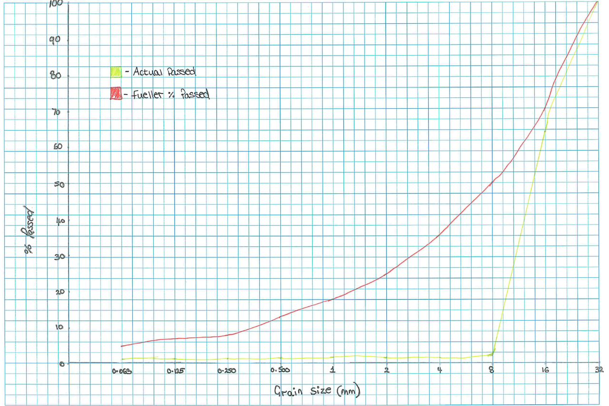
20mm Comparison between Fueller and Actual % Passed

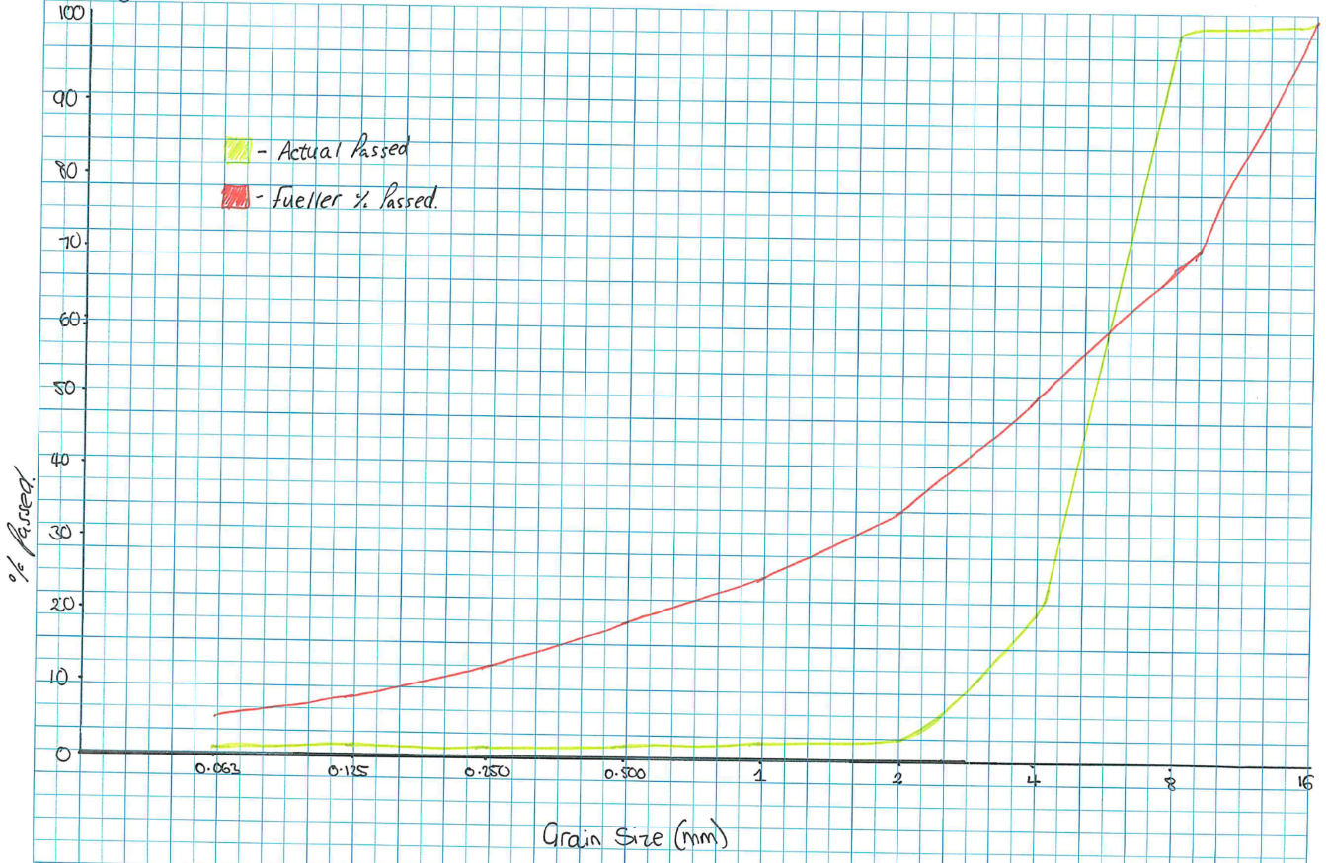
6mm Comparison between Fueller and Actual % Passed

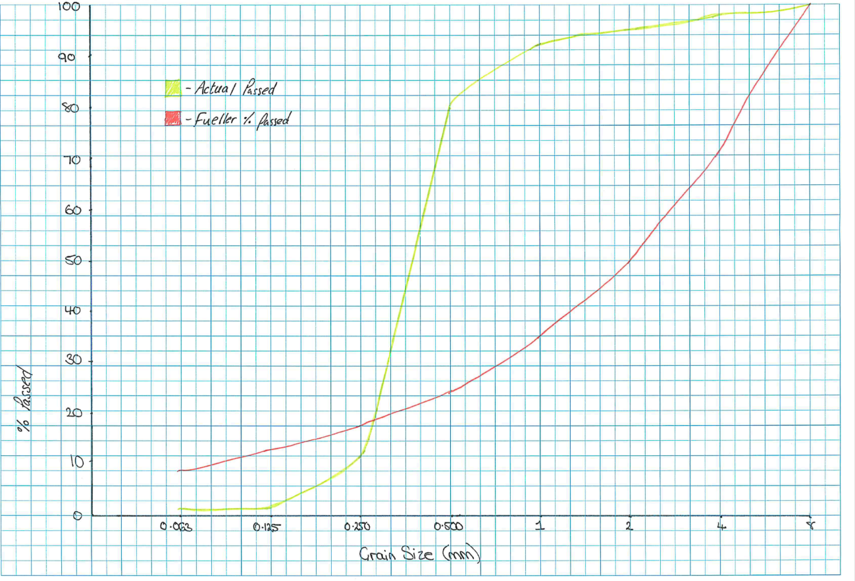
Sand Comparison between Fueller and Actual % Passed

Analysis

In an ideal situation the two lines would be as the same as the Fueller % passed is what is expected for that grain size. However, as seen above this often isn’t the case and from this you can identify what alterations need to be made in order to make the mix more balance and give it the characteristics that we desire for the sample. All aggregates to be used in compliance to the specifications and tolerance shown in BS EN 12620+A1:2008 (BSI, 2008).

From the 20mm graph you can see that there is a large discrepancy in the grain size causing a massive drop in the percentage passed meaning that there might be a need to alter the make up of the 20mm aggregate that would be used for the actual sample. To get the balance in the graph you’d have to increase the amounts of fine aggregates in the mix as that would bring up the flat part and make it more in line with Fueller, and overall have a much more balanced mix of aggregate sizes.

The 6mm graph shows a different pattern compared to the 20mm, with a much more varied grain size when completing the sieve test. To get the graphs to match there needs to be slight reduction in the coarser grains to make the curve even out at the top of the graph. However, there is still a need to even the graph out in terms of the fine aggregates also so like the 20mm above fine aggregates are to be added in to lift the graph and align it with Fuellers curve.

The sieve test for sand also shows an interesting pattern compared to the Fueller with a major spike in the coarse aggregates compared to fines and therefore would create an imbalance in the concrete and potentially negatively effect the properties of the concrete so a decrease of the coarser aggregates and replacing them with finer aggregates and making the curve more gradual and as a result make the sample more balanced throughout.

It’s also vital that during this process that the percentage passed ends up as zero so that the results are accurate to the amounts of aggregates stated, if the figure is more than zero then human error might be factor but it’s important for the integrity of the concrete that all aggregates weighed are accounted for in this process.

Fineness Modulus Calculations

20mm
$$=35.60+98.67+99.43+99.51+99.52+99.55+99.61+99.66+99.67+100$$
$=831$
$$\frac{831}{100}=8.31$$
6mm

=1.85+79.09+97.04+97.86+98.15+98.76+99.19+99.27+100
$=671$
$$\frac{671}{100}=6.71$$

Sand

$=1.1463+3.300+6.185+18.594+89.500+99.049+99.082+99.996$
$=316$

$$\frac{316}{100}=3.16$$

Compliance

As per BS EN 12620+A1:2008 (BSI, 2008) the grades chosen for the sample is compliant within the tolerances shown in the standards and it’s important that the percentage passed also is in the boundaries of the tolerances shown as per BS EN 12620+A1:2008 (BSI, 2008). If the aggregates are outside these boundaries, then the concrete may not have the characteristic strength that was intended and cannot be utilised for the purpose intended. All tables for the tolerances are shown in BS EN 12620+A1:2008 (BSI, 2008) section 4 for reference when completing the future steps of this process.

- Aggregates Mix (%)

    - Fineness Modulus
Sand | 6mm | 20mm | Fueller
3.16 | 6.71 | 8.31 | 8mm | 4.8
3.16 | 6.71 | 8.31 | 32mm | 6.69

    - Percentages of Aggregates

To find the percentages of the different aggregates in the mix use the following equation:
$F_{m}\left(1\right)\frac{x}{100}+F_{m}\left(2\right)\frac{y}{100}=Fm_{F}$ [Equation 1]
- For this equation it’s also important that $(x+y=100$)
Sand + 6mm
Using equation 1
$3.16\frac{x}{100}+6.71\frac{y}{100}=4.8$
$(x+y=100)$
$(x=100-y)$ (sub into equation)
$3.16\frac{(100-y)}{100}+6.71\frac{y}{100}=4.8$
$3.16(100-y)+6.71y=480$
$316-3.16y+6.71y=480$
$6.71y-3.16y=164$
$\frac{164}{3.55}=y$
$y=46.15\% (6mm)$
$x=53.8\% (Sand)$

20mm + 8mm Fueller
Using equation 1
$4.80\frac{x}{100}+8.31\frac{y}{100}=6.69$
$\left(x+y=100\right)$
$(x=100-y)$ (sub into equation)
$4.80\frac{(100-y)}{100}+8.31\frac{y}{100}=6.69$
$4.80(100-y)+8.31y=669$
$480-4.80y+8.31y=669$
$8.31y-4.80y=189$
$3.51y=189$
$\frac{189}{3.51}=y$
$y=53.8\% (20mm)$
$x=46.15\% (Sand+6mm)$

Percentage of Sand
$\frac{53.8×46.15}{100}=24.83\%$

Percentage of 6mm
$\frac{46.15×46.2}{100}=21.32\%$

Analysis and Results
To find the percentage of each material in the concrete sample you must ensure that the fineness modulus for each of the aggregate sizes is found as well as for the Fueller results for 8 and 32mm respectively (shown in i).
Once you have all the figures for the fineness modulus (calculations shown in part 1) use equation 1 to give you the percentages of the aggregates. Using the fine aggregates first in order to give you the ratio of sand compared to the 6mm. For the coarse aggregates use the 20mm and 8mm fueller since there were no grains higher than 20mm so the 32mm becomes redundant in this instance.
This then gives you the overall percentage of 20mm (y) and by using the ‘x value’ you can work out the exact percentage of 6mm and sand by substituting the previously calculated figures into the above equation to give you two percentages that accumulate the 46.15% answer that was figured out using equation 1.
From the calculated numbers it shows that there should be a larger percentage of sand compared to 6mm, below the final material breakdown shows the quantities of each aggregate is going to put into the mix.
Material Breakdown
20mm (%) | Sand (%) | 6mm (%)
53.8 | 24.83 | 21.32

- Concrete Mix Quantities

- 12 Cubic Samples
- 2 Flexual Samples

- 1L per Cube
  - Therefore 12 Litres in Total
- 5L per Flexual Sample
  - Therefore 10 Litres in Total
- 22 Litres of Concrete Overall

    - Cubic Meter
1 Litre = 1 Decimeter
Cubic Meter = $\frac{1 Decimeter}{1000}$ [Equation 2]
Using Equation 2
$\frac{22}{1000}=0.02{2m}^{3} of Concrete Needed$
However, for the purposes of this experiment 20% extra is to be made to compensate for any potential waste.
20% of 22 = 4.4
$\frac{4.4}{1000}=0.0044m^{3}$
$0.0044+0.02=0.0264m^{3}$
Therefore 0.027m³ of Concrete required

    - Tonnes
For the tonnage of concrete use, the following equation:
$m^{3}×Density of Concrete=Tonnes$ [Equation 3]
- Density of Concrete = 2.5
Using Equation 3
$0.027×2.5=0.0675 Tonnes$

    - Kilograms
$Tonnes×1000=Kg$ [Equation 4]
Using Equation 4
$0.0675×1000=67.5Kg$

    - Absolute Volume
Absolute Volume is calculated using the following equation:
$V_{c}=\frac{w}{1000}+\frac{c}{1000_{Sc}}+\frac{f}{1000_{Sf}}+\frac{Ca}{1000_{Sca}}$ [Equation 5]
Where:
$V_{c}=Absolute Volume$
$W=Water (Mass)$
$C=Mass of Cement$
$F=Mass of Fine Aggregates$
$C_{a}=Mass of Coarse Aggregates$
$S_{c},S_{f} and S_{ca}=Densities of Cement, fine and coarse aggregates respectively$

- Density of Cement = 3.8
= 3800 Kg/m³
- Density of Sand = 2.1
= 2100Kg/m³
- Density of Coarse Aggregates = 2.3
= 2300Kg/m³
- Density of Water = 1
= 1000Kg/m³

Minimum Cement = 300Kg/m³
Water/Cement Ratio = 0.55

- Minimum Cement for mix:
$300×0.027$
$=8.1Kg$
- Water/Cement Ratio
$8.1×0.55$
$=4.455$
$=4.5Kg$
Once all the above are calculated, the absolute volume can then be worked out using Equation 5 as follows:
$0.027=\frac{4.5}{1000}+\frac{8.1}{3800}+\frac{0.2487x}{2100}+\frac{0.2129x}{2300}+\frac{0.5384x}{2300}$
$0.027-\frac{4.5}{1000}-\frac{8.1}{3800}=\frac{0.2487x}{2100}+\frac{0.2129x}{2300}+\frac{0.5384x}{2300}$
$0.027-0.0045-0.0021=0.000118x+0.0000925x+0.000234x$
$0.0204=0.000445x$
$x=\frac{0.0204}{0.000445}$
$=45.84Kg of Aggregates$

Quantities of Materials
Material | Quantity
Sand | $$0.02487×45.84$$  $$=11.4Kg$$
6mm | $$0.2129×45.84$$  $$=9.76Kg$$
20mm | $$0.5384×45.84$$  =24.68Kg

Calculations made regarding the quantities of the aggregates follow the guidance given in BS 8500-2:2015+A1:2018 (BSI, 2015)

- Slump Test
  - Class and effect on hardened concrete
Given that the result of the slump test came out as 50mm, the concrete has a S2 slump as per BS EN 206:2013+A1:2016. Ultimately the slump of the concrete impacts the strength of the concrete so it alters the uses that different concrete types can have. The slump also refers to the consistency of the concrete which also effects the properties of the concrete as it has a different ratio of water, cement and aggregates and therefore would impact the strength of the concrete when it cures and hardens (The Concrete Society, 2016).
  - Use of sample?
    - Concrete has many different uses, and this mainly comes down to the slump as it gives the concrete different properties and ensure that they are fit for purpose. The sample we tested had a S2 slump meaning its consistence is lower so is ideal for things like floor slabs (MPA, N.D). Whereas a concrete that has a S3 slump would be more used for mass fill and foundations as it has a greater consistence which allows it to be a stronger material than its counterparts due to the water/cement ratio in this instance (Civilology, N.D).
    - The slump achieved would not be used in precast elements as it wouldn’t achieve the strength that would be required for such elements as typically precast elements are used in a structural sense and this sample doesn’t have the correct properties in order to make it suitable for this purpose. It is important that the specifications shown in BS EN 12350-2:2019 (BSI, 2019) is followed so that the correct concrete is used for the job in hand.

  - Process for incorrect slump
Having concrete that is at the desired slump is vital for the structural integrity of the build so you have to send it back if it isn’t at the desired consistency as it won’t have the characteristics that it is intended to have and therefore could alter the strength of the concrete. Before sending it back to the batching plant it could be worth finding any other suitable positions that the concrete could be utilised where the slump matters less.
It’s also important to understand that nothing should be added to the concrete when it enters the site as you wouldn’t know the ratios and therefore would likely make the concrete mix change it’s characteristics further and making it even less useable. Plasticisers, however, are an option that can be added if seen necessary, it must follow a set process to be able to be added this is as follows:
  - It can only be added by the delivery driver upon a manager’s permission
  - It will then be edited on the delivery ticket and signed by the manager to show that the alteration was verified.

Analysis
As per BS 8500‑2:2015+A2:2019 (BSI, 2015) the slump case for RC30/37 should be S3 this is different to the slump we have in our sample and this therefore could compromise the properties of the concrete that we desire and make it have different uses again potentially causing issues in the future.

- Compression Test

  - Compression Strength at 7 Days
    - Compressive Strength Calculations
For each calculation the following formula is to be used
$f_{c}=\frac{L_{max}}{S}$ [equation 6]
Where:
$f_{c}=Maximum Compressive Strength$
$L_{max}=Maximum Load (N)$
$S=Surface in Contact (mm^{2})$

Using Equation 6

Sample | Calculation
1 | $$f_{c}=\frac{(363.469×1000)}{1{00}^{2}}$$  $$=\frac{363,469}{10,000}$$  $$=36.3 MPa$$
2 | $$f_{c}=\frac{(352.772×1000)}{1{00}^{2}}$$  $$=\frac{352,772}{10,000}$$  $$=35.3 MPa$$
3 | $$f_{c}=\frac{(371.210×1000)}{1{00}^{2}}$$  $$=\frac{371,210}{10,000}$$  $$=37.1 MPa$$

    - Compressive Strength Breakdown

Sample Number | Breaking Load (kN) | Compressive Strength (MPa)
1 | 363.469 | 36.3
2 | 352.772 | 35.3
3 | 371.210 | 37.1

    - Average Compressive Strength of the Samples (1,2,3)

$$\frac{36.3+35.3+37.1}{3}$$

$$=36.2 MPa$$

  - Compression Strength at 28 Days
    - Compressive Strength Calculations
Sample | Calculation
4 | $$f_{c}=\frac{(402.729×1000)}{1{00}^{2}}$$  $$=\frac{402,729}{10,000}$$  $$=40.3 MPa$$
5 | $$f_{c}=\frac{(405.729×1000)}{1{00}^{2}}$$  $$=\frac{405,729}{10,000}$$  $$=40.6 MPa$$
6 | $$f_{c}=\frac{(397.150×1000)}{1{00}^{2}}$$  $$=\frac{397,150}{10,000}$$  $$=39.7 MPa$$
Using Equation 6

    - Compressive Strength Breakdown

Sample Number | Breaking Load (kN) | Compressive Strength (MPa)
4 | 402.729 | 40.3
5 | 405.305 | 40.6
6 | 397.150 | 39.7

    - Average Compressive Strength of Samples (4,5,6)

$$\frac{40.3+40.6+39.7}{3}$$

$=39.7 MPa$

  - Repeatability
As per BS EN 12390-3:2009 (BSI, 2009) if the results of this calculation are greater than 9% then the whole process must be completed again as the concrete isn’t compliant with the standards.
The following equation is used to get this percentage:

$$\frac{Difference in Sample}{Average of the Samples}×100 [Equation 7]$$

    - At 7 Days
Using Equation 7
Sample Compared | Calculation
1-2 | $$\frac{1}{36.2}×100$$  $$=2.7\%$$
2-3 | $$\frac{1.8}{36.2}×100$$  $$=5\%$$
1-3 | $$\frac{0.8}{36.2}×100$$  $$=2.2\%$$

Sample Compared | Difference (MPa) | %
1-2 | 1 | 2.7
2-3 | 1.8 | 5
1-3 | 0.8 | 2.2

Average
$$\frac{2.7+5+2.2}{3}=3.3\%$$

    - At 28 Days
Using Equation 7
Sample Compared | Calculation
4-5 | $$\frac{0.3}{40.2}×100$$  $$=0.7\%$$
5-6 | $$\frac{0.9}{40.2}×100$$  $$=2.2\%$$
4-6 | $$\frac{0.6}{40.2}×100$$  $$=1.5\%$$

Sample Compared | Difference (MPa) | %
4-5 | 0.3 | 0.7
5-6 | 0.9 | 2.2
4-6 | 0.6 | 1.5

Average
$$\frac{0.7+2.2+1.5}{3}=1.47\%$$

As mentioned above, 9% is the maximum figure when it comes to repeatability and as shown above the mean of the repeatability at 7 days is 3.3% which is below the tolerance, so the samples are acceptable as per BS EN 12390-3:2009 (BSI, 2009). In comparison to 28 days where the repeatability percentage is 1.47% which again is as expected and below the maximum 9%.

  - Analysis
As shown above there is a noticeable difference from compressive strength at 7 days and 28 days, the sample at 7 days however, reaches 90% of the 28 day concrete samples which shows that it is a high initial strength concrete as typically the 7 day result should be around 70% of the maximum strength. Concrete that has a high initial strength has more tri-calcium aluminate in the clinker, a reference to this can be found in BS EN 12390-4:2000 (BSI, 2000).
Concrete goes through a curing process which is a chemical reaction that activates the cement and gives the concrete its strength. As stated above at 7 days at least 70% of the maximum strength should be achieved and the curing process is a continuous one that slows after the 28-day mark hence why the samples are taken at 28 days. This is shown in the results with the average at 7 days being 3.5 MPa lower than that at 28 days showing how much impact the curing process has.
Although the concrete tests occur at 7 and 28 days the concrete continues to cure past this point so therefore the concrete would be stronger at both 90 days and then would continue to cure further to the 365-day mark, it is unknown at what point the maximum strength is but the process is a continuous one even if after the 28-day mark the curing process continues and makes the concrete stronger as time progresses, See figure 1 below for reference to this
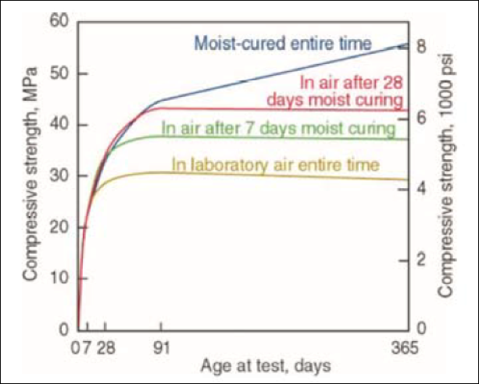

Figure 1 – Curve to show how curing over time effects compressive strength (SCP Tech Brief: Concrete Curing - Spray-Lock Concrete Protection, n.d.)

The RC30/37 refers to the breaking load of both the cylindrical samples and the cube samples. For the figures given above the focus is the 37 which refers to 37 Newtons. At 28 days the breaking load has to be above the given specifications to show that it complies with the specifications as shown in BS EN 206:2013+A1:2016 (BSI, 2013).The batch is as expected with regards to this with the breaking load being an average of 40.2 Newtons so it works as per the given concrete type we were aiming for.

- References
BSI, 2000. [online] Www-ihsti-com.ezproxy.uwtsd.ac.uk. Available at: <https://www-ihsti-com.ezproxy.uwtsd.ac.uk/tempimg/1AE5183-CIS888614800327644.pdf> [Accessed 22 April 2020].
BSI, 2008. [online] Www-ihsti-com.ezproxy.uwtsd.ac.uk. Available at: <https://www-ihsti-com.ezproxy.uwtsd.ac.uk/tempimg/4B723E1-CIS888614800286684.pdf> [Accessed 21 April 2020].
BSI, 2009. [online] Www-ihsti-com.ezproxy.uwtsd.ac.uk. Available at: <https://www-ihsti-com.ezproxy.uwtsd.ac.uk/tempimg/1AE5183-CIS888614800326874.pdf> [Accessed 21 April 2020].
BSI, 2013. [online] Www-ihsti-com.ezproxy.uwtsd.ac.uk. Available at: <https://www-ihsti-com.ezproxy.uwtsd.ac.uk/tempimg/1AE5183-CIS888614800315767.pdf> [Accessed 22 April 2020].
BSI, 2015. [online] Www-ihsti-com.ezproxy.uwtsd.ac.uk. Available at: <https://www-ihsti-com.ezproxy.uwtsd.ac.uk/tempimg/44F19F0-CIS888614800325082.pdf> [Accessed 21 April 2020].
BSI, 2015. [online] Www-ihsti-com.ezproxy.uwtsd.ac.uk. Available at: <https://www-ihsti-com.ezproxy.uwtsd.ac.uk/tempimg/1AE5183-CIS888614800325082.pdf> [Accessed 20 April 2020].
BSI, 2019. [online] Www-ihsti-com.ezproxy.uwtsd.ac.uk. Available at: <https://www-ihsti-com.ezproxy.uwtsd.ac.uk/tempimg/1AE5183-CIS888614800327128.pdf> [Accessed 22 April 2020].
Civilology. n.d. Cement Consistency Test - Standard Consistency Of Cement By Vicat Apparatus. [online] Available at: <http://www.civilology.com/consistency-test-of-cement/> [Accessed 20 April 2020].
MPA (N.D). Ready-Mixed Concrete – Practical guide for site personnel [Accessed 20 April 2020]
Spray-Lock Concrete Protection. n.d. SCP Tech Brief: Concrete Curing - Spray-Lock Concrete Protection. [online] Available at: <https://concreteprotection.com/tech-brief-concrete-curing/> [Accessed 20 April 2020].
The Concrete Society (2016). Good Concrete Guide 8, Concrete Practice Guidance on the practical aspects of concreting [Accessed 20 April 2020]

- Appendix
Standards Applicable for this piece
BS EN 932-1:1997
BS EN 12620+A1:2008.
BS EN 12350-2.2009.
BS 8500-2:2015+A1:2018
BS EN 206:2013+A1:2016
BS EN 12390-2:2009
BS 8500-2:2015+A1:2018

