Taslima begum
1713205
Taslima, Gosia, Kamil , Halima, steph
Tiny Tots
Kamil1712240@gmail.com Password: dob11.03.91
Our website was created as a team we all chose 2 questions each and on our website we all took a page each. Kamil did the home page, Gosia did the service page and contact page. I did the about page Halima did the staff page and Steph did the facilities page.
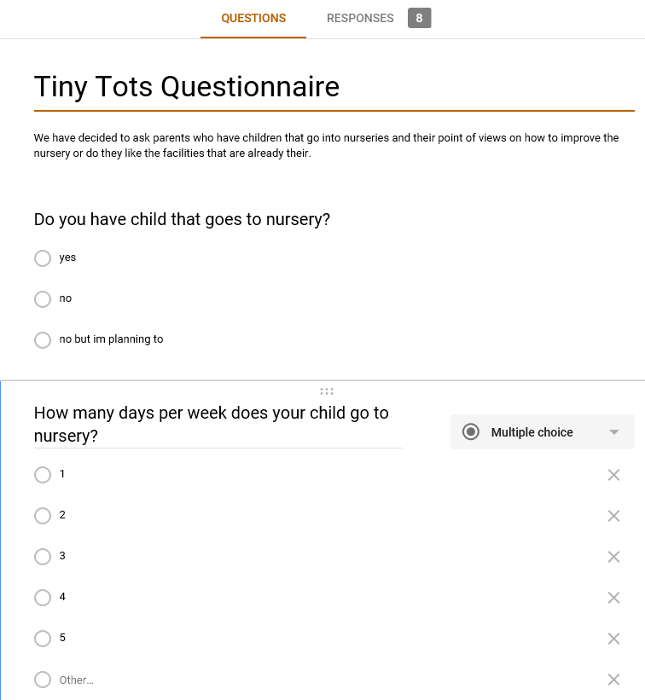
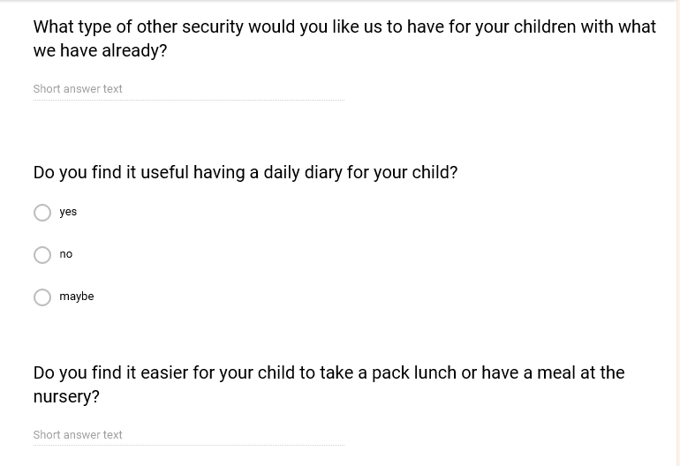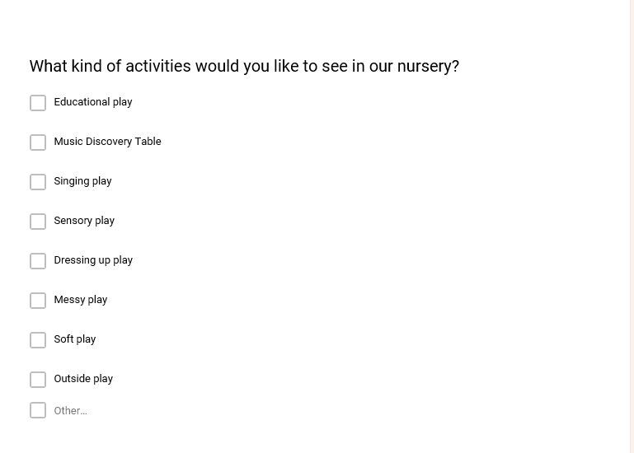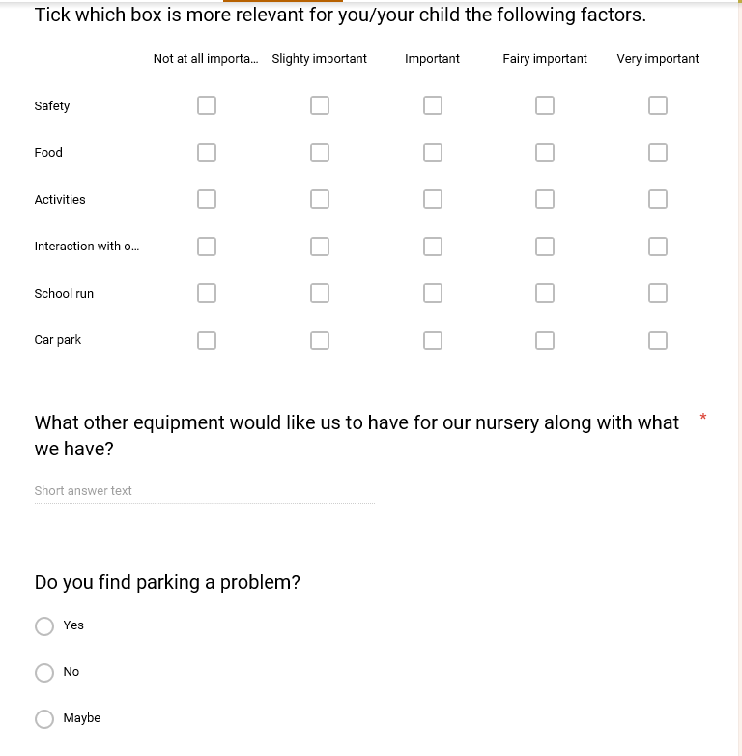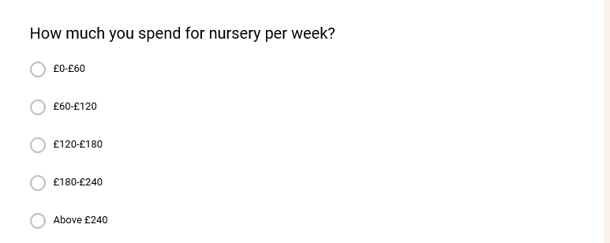

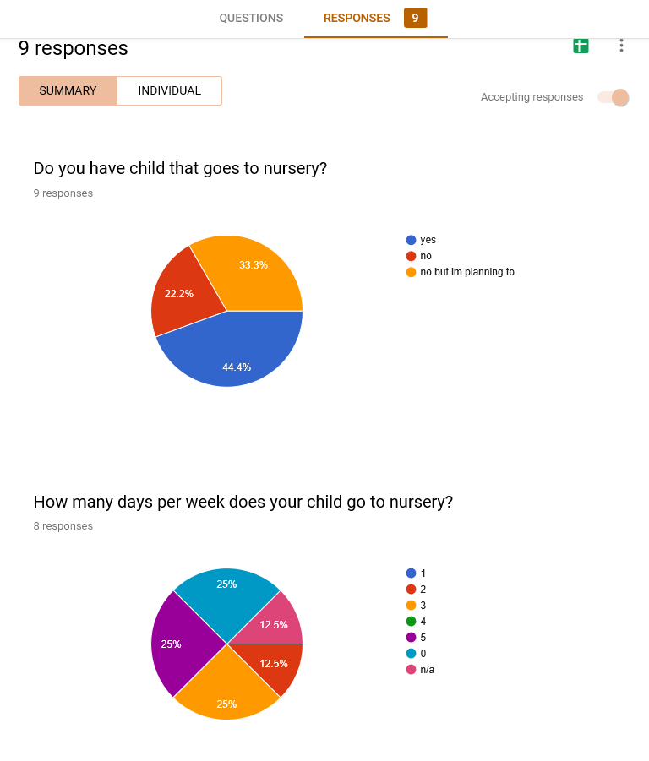
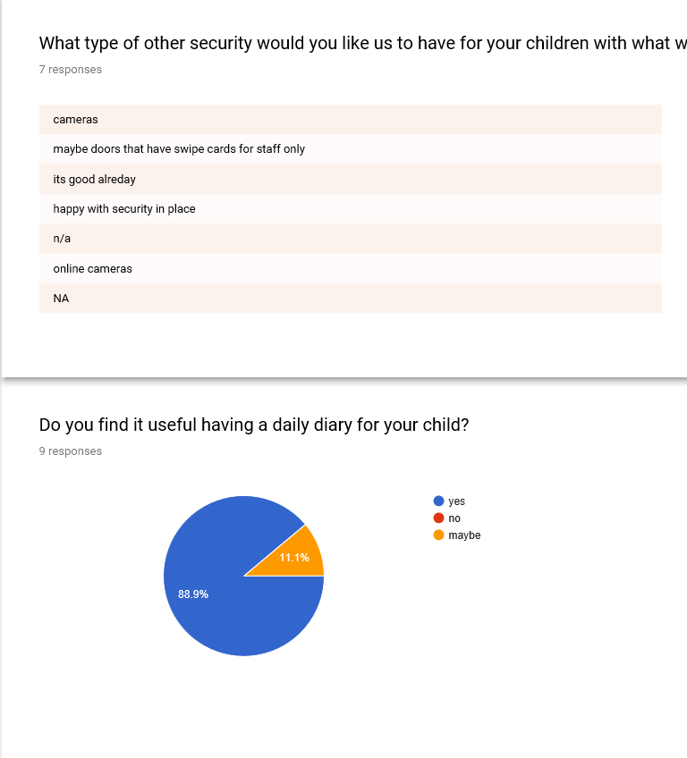
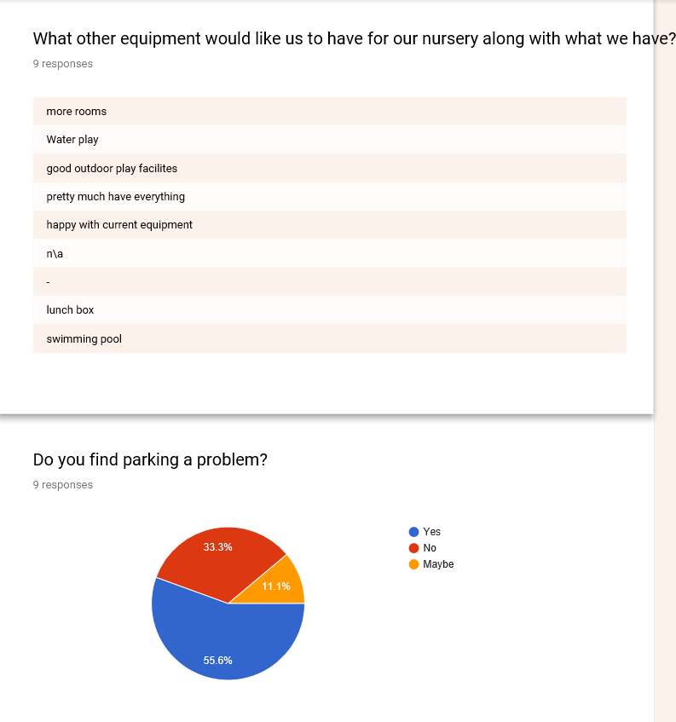

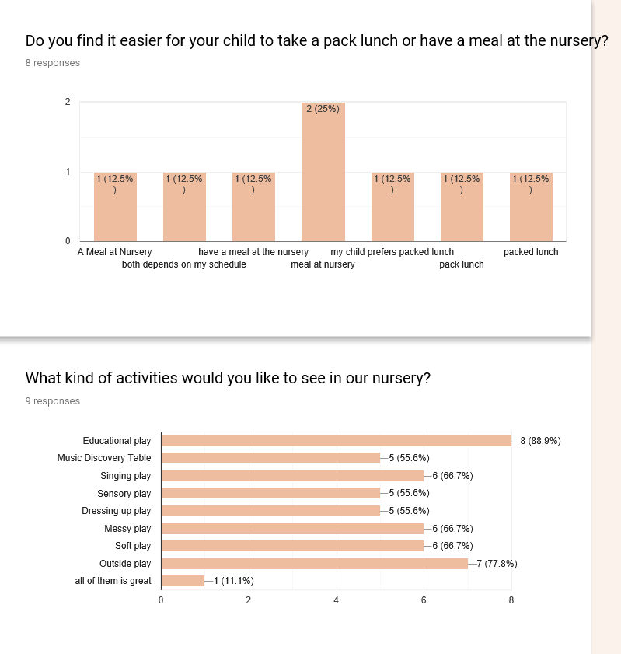

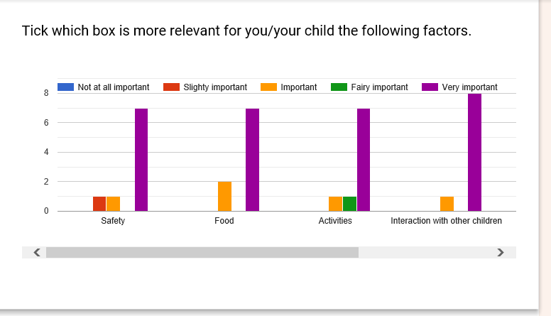
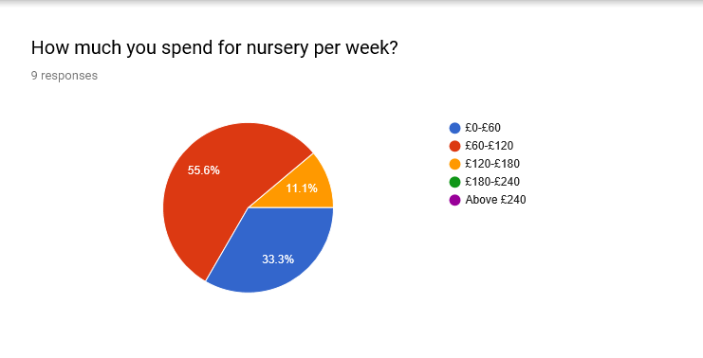
r

The two questions I have chosen for our questionnaire are:
I chose these questions because after doing my research on nursery settings most nurseries said they do dairies for children and they either make lunch or parents provide them with it some were because of dietary reasons.
I feel like having a diary will keep a good relation with parents as we are communicating with them about their child throughout the day which they can take away and read. Give feedback on what they want to see more and change in the nursery because sometimes parents pick up in a rush won’t be able to hear feedback of their child’s day so taking the diary back will give them a reflection on their day. . The results show a high percentage of parents wanting a daily diary for their child. Which is a positive result.
Second question I chose is if parents find it easier if they provide their child with a pack lunch or prefer a meal given in nursery. I felt like this is an important question to ask the parents because we as a nursery will need to know rough estimate on how much food we will need to order. Also the results are showing most parenst would like the nursery to prepare measls for their children and this will make their lifes eassier and not having to worry what to pack for lunch everyday.

Website:
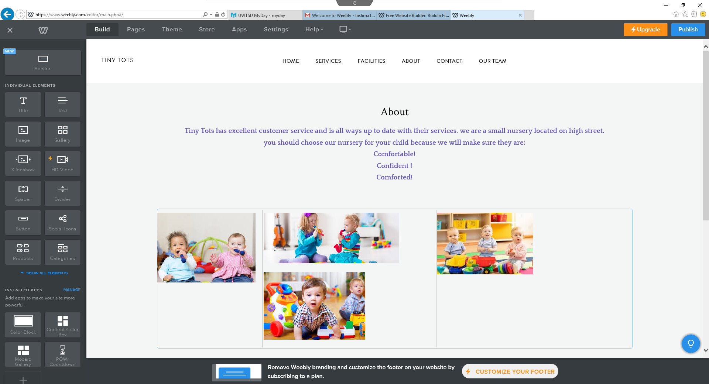

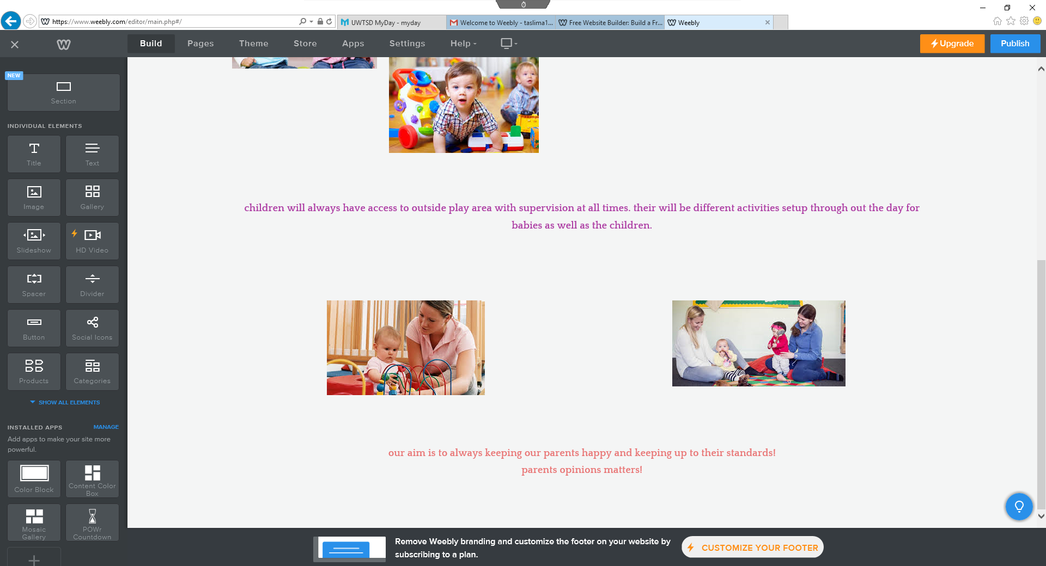

I have chosen to do the about page on our website because it is linked to product services. Which is my role in my business my page explains a little about what we do as a nursery how we make sure children are comfortable, confident and comforted at all times! Made the page eye catching for it to stand out to our customers when they are viewing. Also I added a little bit about children safety as they will be supervised at all times which is key to our customers. And how parents views matters. This is also important because they are giving their children to out nursery so what they say we have to take in account. And if they see this on our website it’s a good selling point. Made the writing different sections different colours as I am talking about three different points. Added pictures with staff and parents .To make the page look welcoming and parent friendly as well as child friendly. Adding catchy slogans like our aim is to keep our parents happy instead of the word customers, would want a parent to give their children to our nursery as it’s more comforting and personal than using the word customer. To come to a conclusion I would just like to say how I kept the page very simple with a few lines on each section and pictures to go with it, so it’s not too much information but just enough. And the page doesn’t look boring with loads of writing but has just what you need to know.

