Market analyzes and trends
The business which has purpose to satisfy the group of clients should develop excellent their terms and service. First key point to start a business have a nice look for client's eyes. The most important thing is to have a clear comprehension of what your business is trying to achieve, more than just bringing income. According Statista Research Department ( 2021) in 2020 the 7.7 million Britain customers use coffee shops. Following the new amendments for healthy habits we create menu with dairy free and sugar free menu, also our observations at our clients that some of them brought with them a book and therefore we develop our library with variety of books after two months of out opening.
Planning marketing strategy helps businesses set clear objectives based on the current state of their business. Those objectives are defined in the strategy, along with the target market and positioning of the company give more clarity. According to (Mccarthy 1960) and (Booms & Bitner 1982) to satisfy customer needs and position our offering clearly in the minds of customers, we use the seven steps of successful positioning.
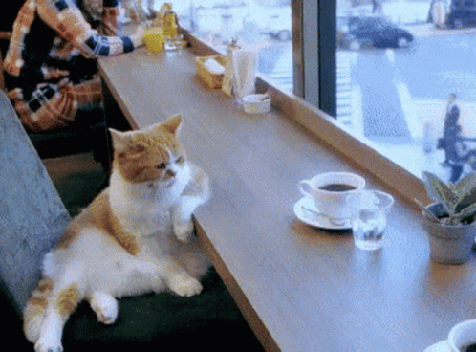photo link

- Product
The Kitty Kafé 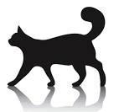 will provide coziness and excellent service for cat owners, that is mean the customers are able to come at the coffee with their cats, where we suggest the selection of variety hot drinks, healthy snacks, homemade ice cream and exotic drinks with healthy ingredients. These wonderful creatures will be able to enjoy a special dish, prepared in healthy and delicious way for them in the Kitty Kafé. For Kitty Kafé is not just our sales that make up our business, but also the service which we provide.
Menu of KITTY KAFE

 | Small | Medium | Decoff
Espresso | £2.90 | - | £ 2.50
Americano | £2.95 | - | -
Macchiato | £3.50 | - | 3.20
Capuchino | £3.60 | £ 4.20 | £3.10
Latte | £3.70 | £ 4.30 | £3.20
Matcha Late | £3.90 | £4.50 | -
Water | £1.99
San Pellegrino, Coca Cola, Sprite/ | £2.95
Fresh squeezed juice  Orange  Grapefruit  Carrot & Apple / Beetroot | £3.30  £3.30  £3.10

Tea drinks
 |  | + milk | + plant milk
English Breakfast tea | £1.90 | £2.30 | - £2.50
Herbal/ Fruit / /Green tea/ Peppermint | £1.60 | - | -
Specialty of KITTY KAFE
 | Small | medium
Iced tea  Raspberry & mint  Peach & mint  Mango & lime | £2.49 | £2.99
Flavors Capuchino - (coconut, hazelnut, vanilla, caramel, cocoa) with plant milk (oat, coconut, hazelnut, or rice milk) | £4.10 | £4.60 | Decoff- £3.70
DALGONA COFFE with ice  (Skimmed, oat, coconut, hazelnut, or rice milk) | - | £4.20 | Decoff- £3.80
Lemonade – SUGAR FREE  Elderflower lemonade  Strawberry & grapefruit lemonade  Raspberry mint lemonade  Peach & Mango lemonade | £3.85
Shakes  Brewed coffee  Chocolate  Toffee  Strawberry  Vanilla | £4.20  £3.20  £3.30  £3.10  £2.95
Smoothie  Matcha  Energy seeds boost  Berry delicious  Coconut banana  Green avocado boost | £4.20  £4.30  £3.50  £3.20  £3.80
Australian ice cream  Banana  Avocado & Chocolate  Coconut & Walnut | £2.55  £2.95  £2.75
Oatmeal bars  Oatmeal muffin | £2.50  £2.65
Toast with green salad  Energy toast with avocado and seeds  Salmon toast  Prosciutto toast  Croissants with ham & cheese  Butter croissant  Chocolate croissant | £5.69  £5.10  £4.95  £4.25  £2.65  £2.99
KITTY MENU🐱
Cooked Beef 80gr | £1.65
Cooked Turkey 100gr | £1.55
Cooked Chicken 100gr | £1.45
Lean delicacies 70gr | £1.19
Grass Salad | £0.79

The Kitty play area provide to favorable pets' safety and adventurous environment with climbing frames and tunnels to make new friendships, they also can have training to learn to be gentle, for hygiene training and for simple commands. After our observations of the first few months, we realized that the lovely creatures need relaxing care for them, and we discovered the planed Kitty beauty salon. The customers can enjoy for cat’s hygienic and cosmetic procedure in the Kitty salon, we know sometimes their bath, haircutting and nail cutting it turns out be terrible, but our professional end educated team make this process for them as SPA procedure while the owners enjoy their time at a Kafe or a Library.
The cat's pleasure can be continuous at the Kafe where we suggest delicious meals cooked with special and healthy technology for cats, in addition we are being keep on hygiene and therefore we serve their water and cat feeding in a bowls on a special mat.
The cat owners first shall make appointments for cat entrance because our capacity is limited, we are able to have fifteen cats at the same time in the play area, or also for grooming.
The Kitty Kafé created a particular nook with vintage style and massage chair to read a variety of books from famous authors in the field of popular science, personal development, medical books, or novel books library to distract themselves from the hectic lifestyle accompanied by calm purring kittens. It is a proven fact that cats release endorphins when purr and this can help the humans to manage their disease, low stress hormones and lowering blood pressure.
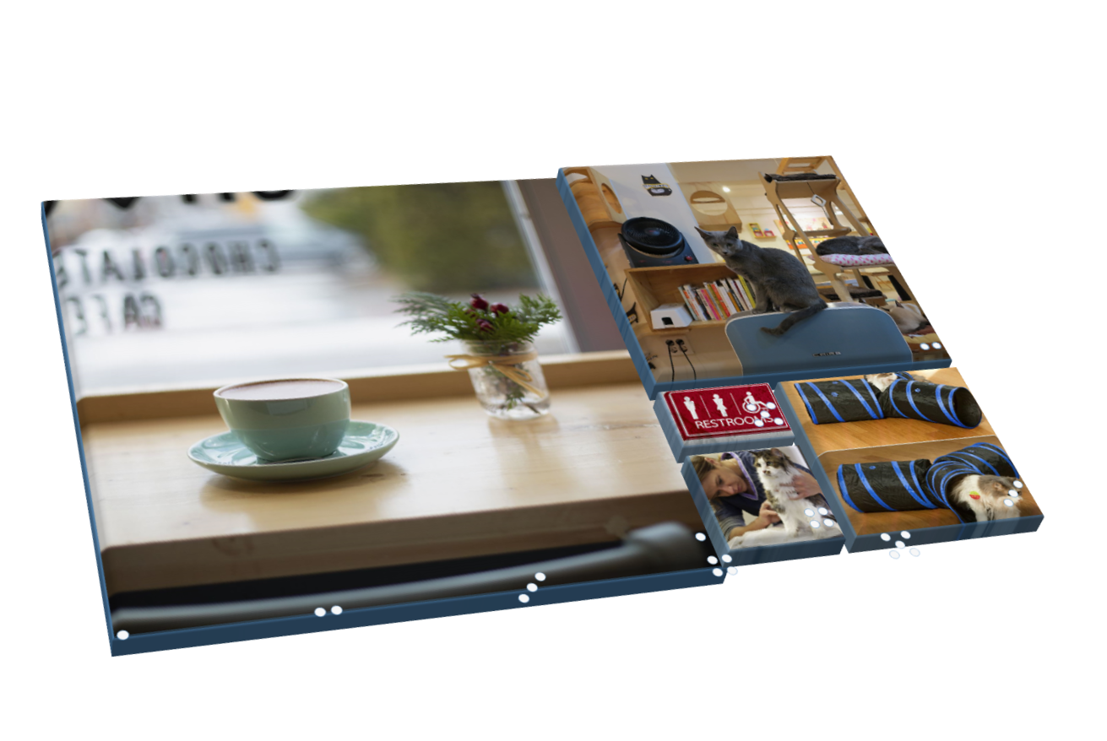The collages photo is from Microsoft stocks.
The management of the Kitty Kafe aimed people who love cats and reading books. In this case cat lovers but who do not have cats by visiting the library part will be able to enjoy the purring cats because they will also have a relaxation area there.

- Price
Good pricing is part of successful marketing strategy which present the company with excellent image and competitiveness. Determinant of prices is pricing in the competitors. Therefore, our pricing strategy in some field is cost plus pricing like specialty from the menu and cat entry. Like example cat entrance in another kafé is 14.99 for 1hour, in Kitty Kafé is £20.99 because the café stands out from the others cat kafé with his adventurous area and cat coach. Kitty salon pricing is relative to the market price because we do not provide different type of service. About usual part of menu our pricing is competitive according to central cafes, the specialty of menu is cost plus pricing, which are included at meal deal and promotion is developed at the Kitty Kafe conforming to new health standard and customer demand, which are not available elsewhere, they are company products. Penetration pricing strategy we use for customers, which wants to take or buy a book, reading at café is free, such as for customers using full pack, they can use massage chair free.
Price
Entrance cat – £ 20,99 (1hour)
Entrance + meal deal – £ 28.99
Entrance +meal deal + cat feeding - £ 29.99 (Full pack) (free massage chair)
Entrance + meal deal + cat feeding + cat care - £47.99 (1 free cat menu take away)
Cat care (grooming, nail cut) - £19.99 + washing (6.99)
Massage chair - £2
Take a book for 3 weeks -£1
Buy a book from a library -£2.49

- Place
Kitty Kafe is located on Central London between London Eye and Jubilee Gardens which is a magnificent view from Kitty Kafe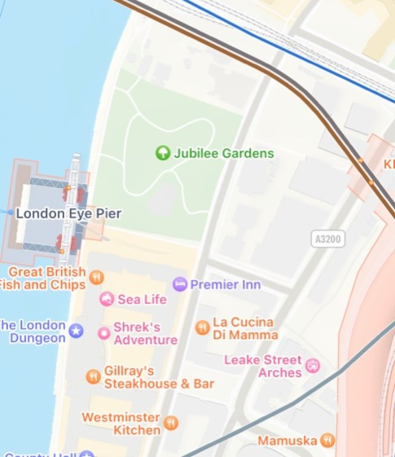 for Londoner’s and tourists.
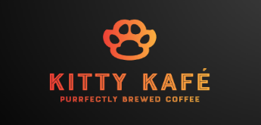Our logo with cat’s paw created by our behavior together with KITTY KAFÉ label to attract more attention for cat lovers who not heard for us, the comment about perfect coffee will amaze the client with our confidence at our working addition to inspire more the people, we use orange and yellow colors because they charge with a harmonious feeling. Our goal is to ensure that our customers with their cats have a wonderful and peaceful time at the café

We opted for a bright interior with hand painted walls and colorful booths.
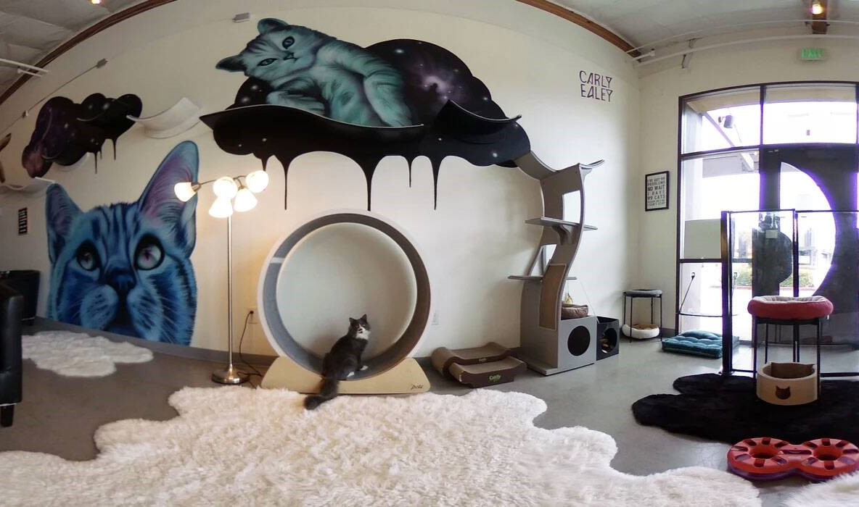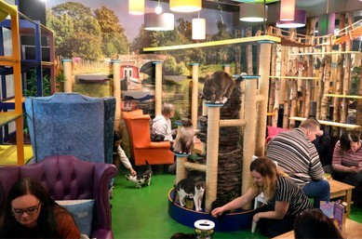
photo photo

Also, we are using delivery option, we join on Deliveroo platform for central London to satisfy customer’s needs.
Place suitable for pets and free Wi-Fi always invite the clients positively. We provide Wi-Fi connection at the Kafe, free reading a book and we accept the cats and provide to them a lot of service.
After initial observation we realize that our clients have more ability and free time to visit Kitty Kafe 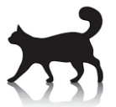at the weekend, therefore we have extended our opening time on Saturday and Sunday. Mid-week our customers are busy people worked around the area or tourist visited London, to meet their needs we offer hot drinks, healthy smoothies, homemade ice cream and healthy snacks take away with ecological plastic free cups and plates. Also, we sell from our healthy kitty pouch with a vacuum packing method with suitability one week, because they are without any preservatives. We are happy that the tourist when wants to take only coffee and when they see the library part, they decide to take a break there in our artistic and comfortable atmosphere to read a book, where they simultaneously enjoy a massage chair with purring cats sound. We renew our library every month with selected nominated books from charity shops with charitable purpose for donations about cancer.

- Promotions
Keep the clients active and satisfied.
- We provide all the clients loyalty card to encourage them to use the Kitty Café regularly with points saving system.
- We provide every week three type different meal deal.
Sales strategy
- Also, we use happy hour system on mid-week between 14:00-17:00 with 30% Specialty Kitty menu. To encourage more people for café when it is not pick time.
- We introduce every month some new product which on first week have 30% discount for members.
- Take 4 entrance get 1 free (in 1 month).
- Buy Full pack (Cat entrance +meal deal+ kat meal) + free massage chair token.
Public relations advertising and partnership.
- At the beginning first 3 months we gave to our clients, which using Kitty area or Kitty Salon 10% discounts for Cat’s Hotel and Pet Veterinary Clinic. Also, we continue to surprise with discount gift at selected time of the year our customers.
- We have partnership with Cat’s Hotel and Pet Veterinary Clinic, where they also promote our company with 50% entry discount.
- We have fun street board advertising on front of the door to make a smile and impress to come inside.
Social media advertising
- We are active in Google, Facebook, Instagram profile to share our new product or service.
- We create social advertising through customers who share and follow us, we give a discount to some of them that we choose through a raffle.
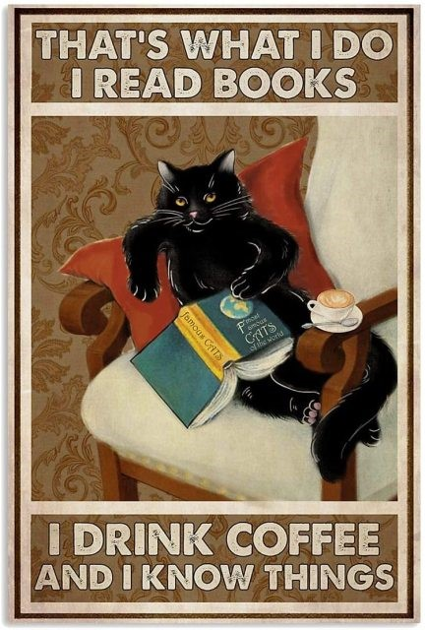photolink
- Process
The mission on Kitty Kafe is cat service for training the cat for proper behavior, play area specially and safety built for cat world, also car haircutting and nail cut, which turns out to be a difficult challenge at home. In the cafe is created pleasant and artistic atmosphere for connoisseurs of quality service. Also, high rate of hygiene at the café is another fact of which we care a lot. According to Gahan Packing strategy we use plastic free-take away cup and plate to environmental support for the planet with Kitty Kafe brand logo. Our marketing program will focus on customer service and make it a priority. Client approval and customers advertising each other are driven by delivering what they want, when and how they want it.
It is also important to consider product strategy when it comes to marketing, it is important how to introduce a new product. Unique style of coffee “Dalgona coffee,” whipped coffee prepared with espresso shots and ice, served with small cookie made at Kitty Kaffe, the start season for serving is May when it is hot to have great attention in the marketplace. We planning to introduce from Autunm Turmeric late and pumpkin pie with Halloween thematic style.
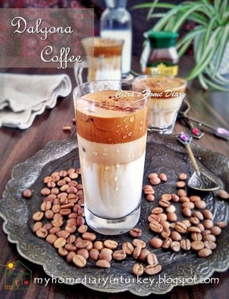This Photo by Unknown author is licensed under CC BY-NC-ND.
- People
The employee of company is leading role at the business when the staff is feeling confident and happy at work, they carry positive mood and excellent work, therefore we strive to make our staff feel lucky to be working at our company.
We are confident that provide high quality of service, the management of Kitty Kaffe take care of compliance with the rules as every inexperienced staff is trained and all staff has briefly introduction early morning where everyone is able to give their ideas or ask question to be more confident.
We have:
One professional educated manager
Three Baristas.
Two cashiers.
Two cook food prep staff.
Two dishwasher cleaning staff.
Two cat trainers.
One Cat hairdresser.

- Physical evidence
As we care about hygiene in our colorful and cozy designed cafe, we also care about representativeness and the appearance of our employee is important to show our responsibility and therefore for all the staff is insured uniform with black polo shirt with Kitty Kafe logo. Nowadays the social media takes big since for mostly of the people and we advertise the business on social media Facebook, Instagram, and Google profile to present our promotions and new products, or new activities, as well as to keep in touch with customers regarding their questions. We registered our company on TripAdvisor and Yelp, also Google to tracking the customers review, give information if they need or improve something in our service. We have mobile app for booking cat entrance or grooming, and ordering something from the menu. We provide card payment by app or contactless payment and cash in the cafe.

