

Student name: Boyd R Malcolm Student ID number: 2128536
Programme: BA (Hons) Leadership and Management Skills for the Workplace
Module: Coaching and Mentoring Skills for the Workplace (weekend)
Module code: BMSW6105 Lecturer: Dr. Denis Pepple
Assignment Title: A Reflective report on peer coaching and mentoring
Mentoring

Coaching
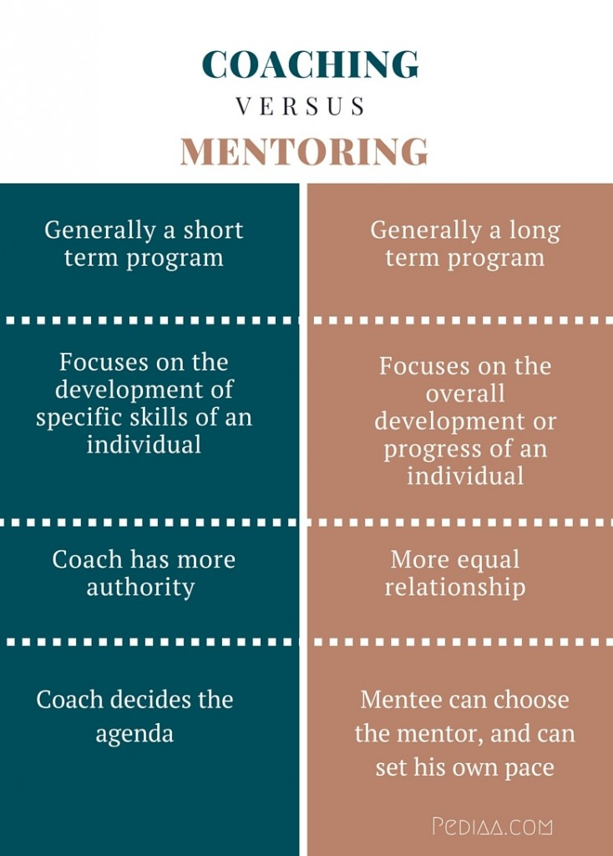
Contents
Introduction 4
Introducing coaching and mentoring 4
Coaching 4
Mentoring 4
The main purpose of coaching and mentoring in the workplace 4
Benefits of Coaching 4
Benefits of Mentoring 5
Challenges in Coaching and Mentoring 5
Coaching Challenges 5
Mentoring Challenges 5
Ways to mentor and coach people in organizations 6
Statistical Data on Coaching and Mentoring 6
Key Theories and Models 7
Models Used in-class presentation 9
Advantages of using the smart model. 9
Disadvantages Avoided. 10
Situations Where SMART is Useful 10
Johari’s Window 11
Advantages of using Johari’s 11
Situations Where Johari’s Window is Useful 11
My Reflections 11
Coaching Reflection 11
Mentoring Reflection 12
Conclusion 13
References 15

Introduction
In the workplace, a coach is a person who guides and supports employees to enhance their skills, performance, and career development. Workplace coaching involves a collaborative relationship where the coach helps individuals identify their strengths, set goals, and overcome challenges. Effective workplace coaches utilize techniques such as Communication, active listening, feedback, and questioning to promote self-awareness and encourage professional growth (Whitmore, 2009). Mentoring is defined as a learning relationship in which individuals share their skills, knowledge, and expertise via developmental talks and experience-sharing
for this paper, we will be Introducing coaching and mentoring, The main purpose of coaching and mentoring in the workplace, the Benefits of Coaching, the Benefits of Mentoring, Challenges in Coaching and Mentoring, Ways to mentor and coach people in organizations, Statistical Data on Coaching and Mentoring, Key Theories and Models, the Models Used in- my class presentation, Advantages of using the smart model. The Disadvantages Avoided. Situations Where SMART is Useful, Johari’s Window, the Advantages of using Johari’s, the Situations Where Johari’s Window is Useful, My Coaching Reflection, Mentoring Reflection Conclusion and References.

Introducing coaching and mentoring.
Coaching and mentoring are both developmental practices aimed at enhancing individuals' skills, knowledge, and performance, but they differ in their approaches, scope, and objectives.

Coaching
is a planned procedure that aims to improve an individual's performance in specific areas, usually relevant to their present profession or skill set. It is usually short-term and aims to achieve specified objectives. Coaches frequently use a variety of approaches and models to aid this process. While coaches may not be experts in the coachee's field, they are capable at supporting increased performance and assisting individuals in achieving their specific goals (Whitmore, 2009).

Mentoring
Mentoring is defined as a learning relationship in which individuals share their skills, knowledge, and expertise via developmental talks and experience sharing. It is an inclusive relationship that celebrates diversity and seeks mutual learning. The mentor often has more expertise in a certain field and may provide guidance and assistance to help the mentee reach their goals. Mentors often have extensive expertise and knowledge in the mentee's sector, providing useful insights gleaned from their own careers (Kram, 1985). It is a more casual and long-term partnership that frequently includes additional personal and professional growth. Mentoring often consists of a more knowledgeable individual (the mentor) offering direction, support, and advice to a less experienced one (the mentee).

The main purpose of coaching and mentoring in the workplace.
The main reason for mentoring and coaching in the business place and some negative effects of not being done properly. Both coaching and mentoring have evolved, influenced by various organizational needs and cultural shifts. Understanding their nuances can enhance how these practices are applied in professional settings.

For instance, workplace coaching can focus on skill development, where coaches assist employees in acquiring new competencies, or on performance improvement, where they provide constructive feedback to enhance job performance (Grant, 2010).
Ultimately, the aim of workplace coaching is to empower individuals, fostering a culture of continuous learning and improvement within organizations (Bachkirova, 2011).

Benefits of Coaching
Skill Development: Coaches help individuals identify and develop specific skills necessary for their roles, leading to improved performance (Whitmore, 2009).
Accountability: Coaching often includes regular check-ins, fostering accountability in achieving set goals (Whitmore, 2009).
Enhanced Self-Awareness: Coaches use feedback and questioning techniques to promote self-reflection, helping individuals understand their strengths and areas for improvement.

Benefits of Mentoring
Career Advancement: Mentoring relationships often lead to better career opportunities for mentees, including promotions and networking advantages (Kram, 1985).
Emotional Support: Mentors provide emotional and psychological support, which can be crucial in navigating workplace challenges (Kram, 1985).
Knowledge Transfer: Mentors share their experiences, insights, and industry knowledge, which can be invaluable for mentees’ professional growth.

Challenges in Coaching and Mentoring
While both practices offer significant benefits, they also face challenges that can impact their effectiveness.

Coaching Challenges

Resistance to Change: Individuals may be resistant to feedback or reluctant to change their behaviours, hindering the coaching process (Whitmore, 2009).
Limited Time: Coaching sessions may be constrained by time, limiting the depth of exploration possible (Whitmore, 2009).
Goal Misalignment: If the coach’s objectives do not align with the coachee’s personal goals, the effectiveness of coaching can diminish.

Mentoring Challenges

Mismatch: A poor fit between mentor and mentee can lead to ineffective relationships and missed opportunities for growth (Kram, 1985).
Time Commitment: Both mentors and mentees must invest time in the relationship, which can be challenging in busy work environments (Kram, 1985).
Dependency: Mentees may become overly reliant on their mentors, potentially stifling their independence and initiative.

Ways to mentor and coach people in organizations
There are several types of mentoring relationships, each serving different purposes:
One-on-one coaching or mentoring: A traditional format where a single mentor/ coach works with a mentee/coachee to provide personalized guidance.
Group Mentoring involves one mentor working with a small group of mentees. It is often used in educational settings or organizations to develop multiple individuals simultaneously.
Peer Mentoring: In this arrangement, individuals at similar levels support each other, sharing experiences and best practices.
Reverse Mentoring: A junior employee mentors a senior colleague, often providing insights into new technologies or perspectives.
Virtual Mentoring: Facilitated through digital platforms, allowing mentors and mentees to connect regardless of geographical barriers.
During my research, I came across some statistics and findings regarding the impact of coaching and mentoring in the workplace in the UK.

Statistical Data on Coaching and Mentoring
Increased Employee Performance: According to a study by the Association for Coaching (2020), organizations that implemented coaching reported a 70% improvement in individual performance and a 50% improvement in team performance. This data suggests that coaching significantly enhances productivity and collaboration in the workplace.
Employee Retention Rates: A report by the Chartered Institute of Personnel and Development (CIPD) indicated that organizations with mentoring programs experience a 20% higher retention rate among employees. This demonstrates the positive effect of mentoring on employee loyalty and satisfaction (CIPD, 2019).
Impact on Leadership Development: A study by the Institute of Leadership & Management (2021) found that 92% of individuals who received mentoring reported that it positively impacted their leadership skills. This highlights the crucial role of mentoring in developing future leaders.
Financial Return on Investment: Research conducted by the International Coach Federation (ICF) in 2016 found that businesses that invest in coaching can expect a return of £7.90 for every pound spent on coaching services. This data underscores the financial benefits of integrating coaching into organizational practices (ICF, 2016).

Key Theories and Models
These theories and models collectively provide a robust framework for understanding the dynamics of coaching and mentoring, emphasizing goal setting, relationship development, group dynamics, and cognitive processes. They support practitioners in enhancing their effectiveness and achieving better outcomes for their clients. theories and models relevant to coaching and mentoring, along with their explanations some notable ones are

GROW Model
Developed by Graham Alexander and popularized by Sir John Whitmore, the GROW model involves four stages: Goal, Reality, Options, and Will. It provides a structured framework for coaching conversations, helping individuals set goals and explore options (Whitmore, 2017).

Kolb’s Experiential Learning Theory
David Kolb’s model emphasizes learning as a process involving four stages: concrete experience, reflective observation, abstract conceptualization, and active experimentation. This theory supports the idea that effective coaching and mentoring involve experiential learning (Kolb, 1984).

Situational Leadership Theory
Developed by Hersey and Blanchard, this model suggests that effective leadership, including coaching and mentoring, should adapt to the individual’s development level. It emphasizes adjusting style based on the mentee’s competence and commitment (Hersey & Blanchard, 1982).

Transformational Leadership Theory
This theory posits that effective leaders inspire and motivate their followers to achieve more than they thought possible. In coaching and mentoring, this approach emphasizes building trust and fostering personal development (Bass, 1999).

SMART Goals
This framework emphasizes setting Specific, measurable, Achievable, Relevant, and Time-bound goals. The SMART criteria help coaches and mentors design clear and attainable objectives, enhancing focus and motivation (Doran, 1981).

The Mentoring Cycle
Developed by various scholars, this model outlines the stages of mentoring, including initiation, cultivation, separation, and redefinition. It highlights the dynamic relationship between mentor and mentee, emphasizing growth and development throughout the mentoring process (Kram, 1985).

Tuckman’s Stages of Group Development
Bruce Tuckman’s model identifies stages of group dynamics: Forming, Storming, Norming, and Performing. Understanding these stages helps coaches facilitate team development and address challenges within groups (Tuckman, 1965).
Cognitive Behavioral Coaching (CBC)
This approach integrates cognitive behavioural therapy principles into coaching. It focuses on changing negative thought patterns that can hinder personal and professional growth, promoting resilience and a positive mindset (Neenan & Dryden, 2002).
Kram’s Mentoring Model (1985)
This model outlines two primary functions of mentoring: career-related support (sponsorship, exposure, coaching) and psychosocial support (friendship, acceptance, and confirmation).
Johari’s window
Is a psychological tool that helps individuals understand their relationships with themselves and others, as it enhances personal development, self -awareness and communication. (Luft & Ingham, 1955).
I went through each model extensively and decided to use the following.

Models Used in-class presentation

The SMART model and Johari's Window are both essential tools for personal and professional growth, having different objectives and being effective in different situations. I'll go over their benefits and drawbacks, as well as scenarios in which they could be very useful.
It was most advantageous to employ these strategies since the situations being handled were of a more professional nature. And integrating these models in my choice provided me with the finest option for attaining the specific goal of assisting a client who was already a manager in getting in the appropriate place, mentally, emotionally, and spiritually, to apply for the position of senior management.

Advantages of using the smart model.
Clarity: By defining goals in a specific manner, the SMART model helps individuals and teams gain clarity on what they aim to achieve.
Measurability: The measurable aspect allows for tracking progress and outcomes, making it easier to assess success.
Focus: The model promotes focus on achievable goals, reducing the risk of overwhelming oneself with unrealistic expectations.
Time Management: By setting deadlines, the SMART model encourages timely completion of goals, which can enhance productivity.
These would work as the job at hand was on a time frame basis. However, by knowing the downside, I would set specific questions to steer the conversation in the direction of choice and keep the client engaged, so each question was chosen specifically to avoid theses downfall and keep the client engaged.

Disadvantages Avoided.
Rigidity: The structured nature of SMART goals can lead to inflexibility, as individuals may feel constrained by the parameters set.
Overemphasis on Measurability: Focusing too much on measurable outcomes can overshadow qualitative aspects of performance and personal growth.
Short-term Focus: The model may encourage a short-term perspective, potentially neglecting long-term aspirations and values.

Situations Where SMART is Useful
according to (Doran,1981) These are areas where this model would work best, hence my decision to apply it.
Project Management: When specific deliverables are required within a set timeframe.
Performance Reviews: Setting clear and measurable objectives for employee evaluation.
Skill Development: When individuals aim to acquire specific skills in a defined period.

For the mentoring part of the assessment, I have applied this tool and used or tried to used skills for these specific reasons,

Johari’s Window
Definition:- Johari’s Window is a model for understanding self-awareness and interpersonal relationships, consisting of four quadrants: Open, Hidden, Blind, and Unknown (Luft & Ingham, 1955). The

Advantages of using Johari’s
The model encourages individuals to explore their behaviours and how they are perceived by others, fostering personal growth. By promoting the sharing of feedback, Johari’s Window can help improve communication within teams, It also facilitates trust-building and collaboration by encouraging openness and vulnerability among team members. The model can help identify blind spots and facilitate discussions that resolve misunderstandings. As with the previous tool, each question was chosen specifically to avoid these downfalls and keep the client engaged.
Disadvantages of using Johari’s
Sharing personal information can be uncomfortable and risky for some individuals, potentially leading to resistance, Engaging in the self-disclosure process takes time and may not be feasible in fast-paced environments also the Feedback may be misinterpreted, leading to further confusion rather than clarity.

Situations Where Johari’s Window is Useful
According to (Luft & Ingham, 1955), these scenarios, are where it would be best to use this tool When fostering collaboration and trust among team members is a priority. To facilitate open dialogue about strengths and areas for improvement. And When misunderstandings need to be addressed and resolved constructively.

My Reflections

Coaching Reflection

Using Gibbs' Reflective Cycle has allowed me to systematically explore my coaching experiences. The SMART Model, which emphasizes Specific, Measurable, Achievable, Relevant, and Time-bound goals, was particularly beneficial. Clarity and focus are essential in coaching, as they help both the coach and client understand the objectives clearly, enhancing motivation (Doran, 1981). However, I recognized that if goals lack specificity, confusion can arise, leading to misalignment in our sessions. Thus, the more precise the goals, the better the outcomes.

The SMART Model also highlights the importance of setting achievable goals. Unrealistic goals can lead to frustration and feelings of failure, while realistic goals foster sustained effort (Schunk, 2003). For me, the most crucial aspect was ensuring that goals are relevant to the client’s personal or professional aspirations. When clients see how their efforts align with their broader objectives, they are more likely to engage fully in the coaching process. If the goals lack relevance, clients may disengage (Ryan & Deci, 2000).

While the SMART Model offers significant benefits when applied correctly, poor implementation can undermine the coaching experience. Therefore, careful consideration and customization of goals are vital for maximizing effectiveness.

In my first professional experience using these techniques, I observed my client closely, noting soft cues such as body language and demeanor. I chose to approach the session by intentionally jumbling my questions. Since my client was already a manager, I anticipated that this would trigger his instinct to fix things. This strategy helped build rapport and trust; he became less nervous and started responding more candidly. I utilized situational leadership theory to create a conducive environment for the SMART goals to take effect. However, I later realized that my tutor recognized my intentions and commented on the approach, highlighting the importance of self-awareness in practice.

Mentoring Reflection

For the mentoring session, I employed the Johari Window model, which emphasized the importance of preparation. I noticed that my own stress could potentially impact my client, which led me to recognize the need for greater flexibility and adaptability. My emotions, strengths, weaknesses, values, and cultural background can significantly affect others during the mentoring process.

I realized that I needed to focus more on perceiving others’ emotions and responding appropriately. Empathy is crucial for building strong relationships. I found myself superficially engaged, concentrating more on the exercises than on meaningful conversations, which resulted in a lack of genuine insight (Luft & Ingham, 1955).

Enhancing the client's self-awareness should have been a priority, as it would help them understand their behaviors, emotions, and motivations better, thereby increasing their self-awareness (Luft & Ingham, 1955).
A major flaw in my mentoring session was my oversight of cultural differences and norms regarding self-disclosure and feedback. This ignorance may have led to misunderstandings and ineffective communication (Hofstede, 2001). At one point, my client seemed uncertain about the direction of the session, which underscored the importance of being sensitive to cultural contexts in mentoring.
Both coaching and mentoring sessions have highlighted areas for personal growth and understanding. By reflecting on my experiences through structured models like Gibbs' Cycle, the SMART Model, and the Johari Window, I can better navigate future sessions. Moving forward, I aim to cultivate a more empathetic approach and remain cognizant of cultural differences to enhance my effectiveness as a coach and mentor.

Conclusion

Through the overall interviews, I gained deeper insights into myself rather than solely focusing on the clients. Recognizing my own flaws has highlighted areas for improvement, emphasizing the importance of preparation, mental and physical presence, and sustained focus for achieving better outcomes.
I discovered that various models and theories exist, each offering distinct approaches that are not universally applicable. This realization led me to understand the value of creating a hybrid approach, combining elements from different theories to effectively reach the overarching goal of client assistance.
Coaching and mentoring are pivotal in employee development and contribute significantly to organizational success. While both methods are essential, they serve different purposes: coaching is structured and performance-driven, whereas mentoring focuses on personal growth and long-term development.
Additionally, Johari’s Window provides a robust framework for enhancing communication and self-awareness during workplace mentoring sessions. Leveraging technology, such as virtual mentoring programs, can bridge geographical barriers, facilitating a wider exchange of knowledge and experiences (Duncan et al., 2020).
By effectively structuring programs, promoting diversity, implementing feedback mechanisms, and aligning mentoring with career development, organizations can significantly enhance their coaching and mentoring initiatives. This, in turn, fosters a more engaged, skilled, and productive workforce. It is crucial for organizations to cultivate inclusive environments where diverse perspectives are welcomed and valued.

References

Association for Coaching. (2020). Coaching at Work: The Association for Coaching 2020 Research Report. Available at: (https://www.associationforcoaching.com ) [Accessed 4 Mar. 2025].
Bachkirova, T. (2011) Developmental coaching: Working with the self. Maidenhead: Open University Press.
Bass, B.M. (1999) Two decades of research and development in transformational leadership. European Journal of Work and Organizational Psychology, 8(1), pp. 9-32.
Chartered Institute of Personnel and Development (CIPD). (2019). The role of mentoring in career development. Available at: (https://www.cipd.co.uk ) [Accessed 4 Mar. 2025].
Doran, G.T. (1981) There’s a S.M.A.R.T. way to write management’s goals and objectives. Management Review, 70(11), pp. 35-36.
Duncan, D., Brown, R., and O’Neill, M. (2020) Organizational behaviour: A critical perspective. London: Routledge.
Grant, A. M. (2010). *Coaching and responsibility: The role of the coach in the coaching process*. *International Journal of Evidence Based Coaching and Mentoring*, 8(1), 1-10.
Grant, A.M. (2010) *Coaching for greater effectiveness: The role of the coaching relationship*. *International Journal of Evidence Based Coaching and Mentoring*, 8(1), pp. 34-48.
Hersey, P. and Blanchard, K.H. (1982) Management of organizational behavior: Utilizing human resources. 4th edn. Englewood Cliffs, NJ: Prentice Hall.
Hofstede, G. (2001) Culture’s consequences: Comparing values, behaviors, institutions, and organizations across nations. 2nd edn. Thousand Oaks, CA: Sage Publications.
Institute of Leadership & Management. (2021). The Value of Mentoring: Insights from the UK Workforce. Available at: (https://www.institutelm.com ) [Accessed 4 Mar. 2025].
International Coach Federation (ICF). (2016). The Coaching Industry: Global Coaching Study. Available at: (https://coachfederation.org ) [Accessed 4 Mar. 2025].
Kolb, D.A. (1984) Experiential learning: Experience as the source of learning and development. Englewood Cliffs, NJ: Prentice Hall.
Kram, K.E. (1985). Mentoring at Work: Developmental Relationships in Organizational Life. Glenview, IL: Scott, Foresman.
Luft, J. and Ingham, H. (1955) *The Johari window: A graphic model of interpersonal awareness*. *Personnel Journal*, 53(7), pp. 441-446.
Neenan, M. and Dryden, W. (2002) Cognitive-behavioural coaching. In: Palmer, S. and McDowall, A. (eds.) The coaching relationship: Putting people first. London: Sage, pp. 15-30.
Ryan, R.M. and Deci, E.L. (2000) Self-determination theory and the facilitation of intrinsic motivation, social development, and well-being. *American Psychologist*, 55(1), pp. 68-78.
Schunk, D.H. (2003) Self-efficacy for reading and writing: Influence of modeling, goal setting, and self-evaluation. *Reading & Writing Quarterly*, 19(2), pp. 159-172.
Tuckman, B.W. (1965) Developmental sequence in small groups. *Psychological Bulletin*, 63(6), pp. 384-399.
Whitmore, J. (2009) Coaching for performance: GROWing human potential and purpose. 3rd edn. London: Nicholas Brealey Publishing.
Whitmore, J. (2009). Coaching for performance: GROWing human potential and purpose. 4th ed. London: Nicholas Brealey Publishing.
Whitmore, J. (2017) Coaching for performance: The principles and practice of coaching and leadership. 5th edn. London: Nicholas Brealey Publishing.

