
Assessment component 1: Marketing Environment Analysis

Programme Name: Master of Business Administration
Student Name: Delwar Hussen Raju
Student ID: 2506700
Module Name: Marketing Management Module
Code: LCMB7024
Lecturer’s Name: Dr. Jaya Gopalkrishnan
Work Count: 2620
Submission Date: 20 November 2025

Contents
1.0 Introduction 3
2.0 Task 1 Critical Analysis of the Macro Marketing Environment 4
2.1 Macro Marketing Environment Overview. 4
Technological Actor 4
Opportunities and Threats of the Technological Actor. 6
Natural/Environmental Actor. 6
Opportunities and Threats created by the Natural/Environmental Actor. 7
2.3 Critical Analysis of Each Actor 8
Table-Technological Actor: Tesla vs BYD 8
Table-Natural / Environmental Actor: Patagonia vs The North Face 9
3.Task 2 Strategic Responses of Pioneer and Follower Organisations. 10
3.1 Strategy Respondences of Pioneering Organisations. 10
Tesla (Technological Pioneer) 10
Patagonia (Natural Pioneer) 11
3.2 Strategic Responses of Follower Organisations. 12
BYD (Technological Follower) 12
The North Face (Natural Follower) 13
Comparative Table: Strategic Responses 14
Implications and Insights to the Strategy. 15
4.Conclusion 15
References 16

1.0 Introduction
The report examines the impacts of strategic decisions of pioneers and followers to the key changes in the macro marketing environment. Organisations are in a complex environment that is influenced by technological, ecological, economic, political, sociocultural and legal forces. The evaluation of these factors is crucial to the marketing success in the long-term perspective, enabling companies to take advantage of opportunities and cut down threats (OpenStax, 2019).
It involves two macro-environmental actors transforming industries, Technological actor and Natural / Environmental actor. The technological advances, such as the digital innovation, AI, and battery breakthroughs, change the production, customer experiences, and market structures. The environmental pressures, including climate changes, scarcity of resources, and sustainability requirements, are redefining consumer demands and corporate liabilities (Fibre2Fashion, n.d.; Chalmers University, 2017).
Example of these dynamics, two pairs of pioneers and followers are discussed Tesla (Pioneer) vs BYD (Follower) in EVs, where the response to technological disruption is observed, and Patagonia (Pioneer) vs The North Face (Follower) in outdoor apparel, where the response to sustainability pressures is observed.
The analysis has been divided into Task 1-measures macro-environmental actors, and Task 2-measures strategic responses based on the Porters Generic Strategies and Ansoff Growth Matrix (Nosratabadi et al., 2019).
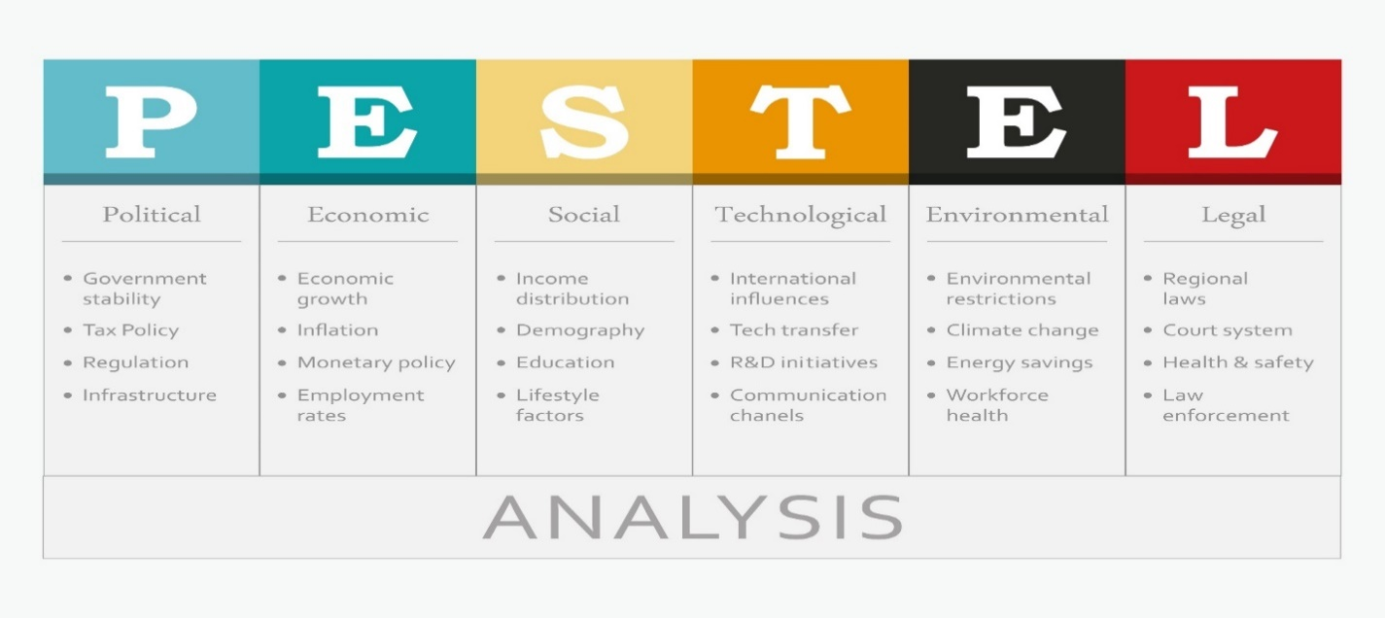

2.0 Task 1 Critical Analysis of the Macro Marketing Environment

2.1 Macro Marketing Environment Overview.
The macro marketing environment is the term used to describe the external factors which impact the capacity of a firm to operate yet a firm has little control over them (OpenStax, 2019). These forces influence opportunities and threats, influences strategic decision making, competitive positioning and customer satisfaction. To be competitive, firms should be able to keep up with these external factors by continually keeping an eye on them.
One of the commonly adopted models of the external forces is PESTEL: Political, Economic, Sociocultural, Technological, Environmental/Natural, and Legal (Raider Pressbooks, 2025). All these dimensions have the capacity to affect the marketing strategy to a great extent. Example as, sustainable production techniques might be demanded by regulatory modifications (Legal) which in turn influence prices and cost policies (Economic). Similarly, technological solutions may also form new product categories, such as in the EV industry (Bohnsack, Pinkse and Kolk, 2014).
The inability to trace these changes may lead to either strategic obsolescence, missed opportunities, or a competitive advantage (Nosratabadi et al., 2019). Thus, both pioneering and following firms have to have a systematic analysis of macro-environmental actors to predict trends and respond in advance.
In this report, Technological and Natural / Environmental forces are the two macro-environmental players chosen. These players are very powerful in the EV and outdoor apparel industries.

Technological Actor
The technological environment includes the digital platform, automation, AI, and energy storage innovations. Technology is the source of differentiation and competitive advantage in the EV industry:
- Tesla (Pioneer): Has software-defined cars, autonomous driving features, and battery technology (Automotive Manufacturing Solutions, 2025).
- BYD (Follower): uses vertical integration and AI-enabled manufacturing to scale effectively and save money, and uses successful technologies of the leaders (Collins, 2025).

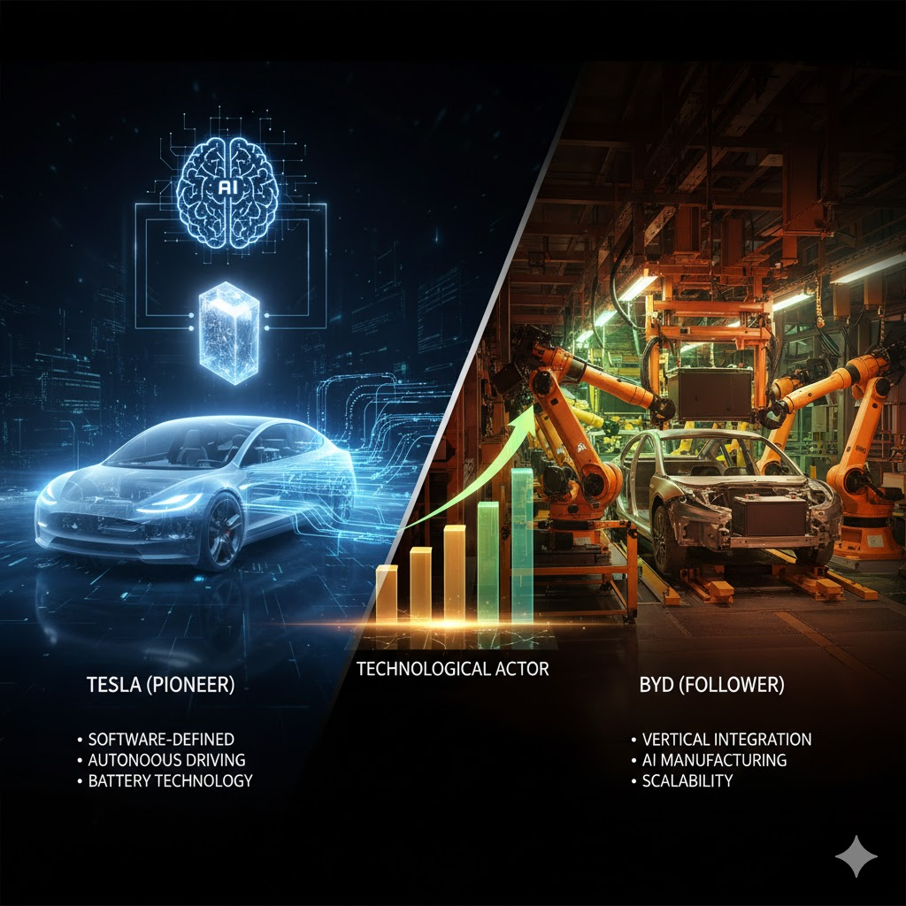
The technological changes influence the production processes, speed-to-market, and customer experience. Companies that possess the control over the core technologies are able to attain sustainable competitive advantage, whereas followers need to be keen to monitor and implement the innovations as a way of avoiding risk.

Opportunities and Threats of the Technological Actor.

Natural/Environmental Actor.
The forces in the environment have been of key strategic concern because of climate change, scarcity of resources and increasing regulatory demands (World Bank, 2011). Sustainability and ethical sourcing affect the operational decisions and brand image:
- Patagonia (Pioneer): Makes environmental activism a part of its business model. Circularity, durability, and customer loyalty are encouraged via programmes such as Worn Wear (Business of Fashion, n.d.).
- The North Face (Follower): This is the one that puts adaptive sustainability practises into play, recycling and using renewable resources and aligning environmental practises with the mainstream consumer interest (Chalmers University, 2017).
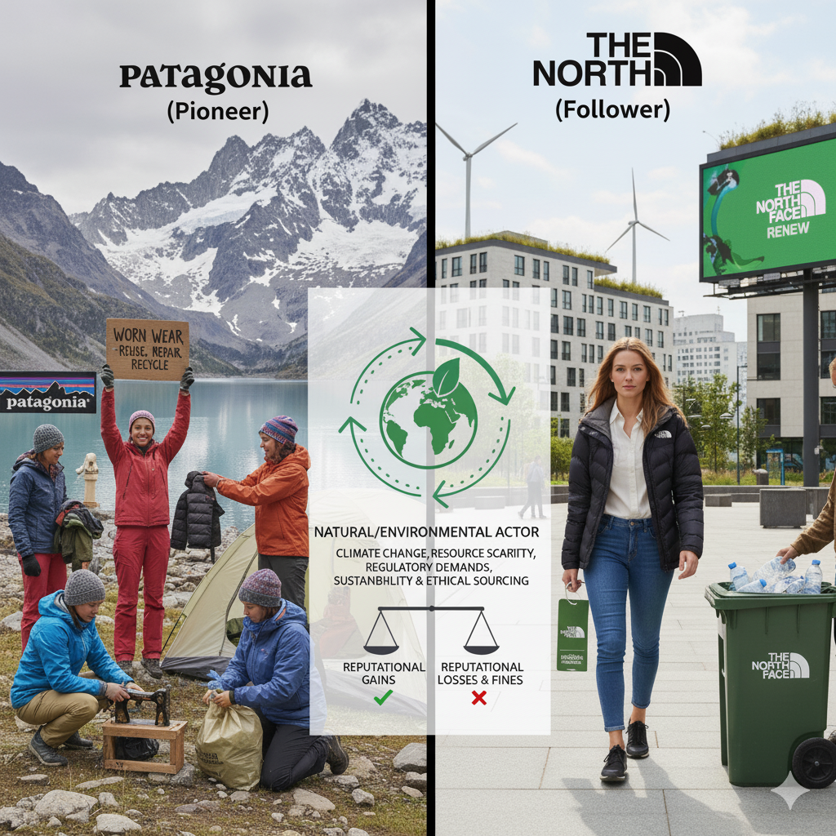
These forces have an impact on the supply chain, sourcing of materials, production process, and consumer expectations. Those companies that do not react face the threat of reputational losses and fines.

Opportunities and Threats created by the Natural/Environmental Actor.

2.3 Critical Analysis of Each Actor

Table-Technological Actor: Tesla vs BYD
Strategic Dimension | Tesla (Pioneer) | BYD (Follower)
Product Innovation | Radical, software-defined, autonomy-focused | Incremental, manufacturing-driven, battery-focused
Market Entry | Direct-to-consumer, global expansion via brand prestige | Domestic market dominance, affordable global models via platform standardization
Competitive Advantage | First-mover lead in software and brand prestige | Cost leadership via vertical integration, supply chain resilience
Customer Value Proposition (CVP) | Premium, high-performance, cutting-edge technology | Affordable, safe, accessible green mobility

Tesla Strategy: Tesla has the first-mover advantage because it has combined battery management systems and software into an ecosystem. Differentiation is enhanced by over-the-air updates and such innovations as Full Self-Driving Beta. The threat is great research and development and technological risk (Automotive Manufacturing Solutions, 2025).
BYD Strategy: BYD uses vertical integration, whereby it has control over battery, semiconductor and assembly. It relies on platform standardisation to create various types of vehicles in a cost-effective and large-volume manner. This follower approach is less risky and a broader market niche (Collins, 2025).

Table-Natural / Environmental Actor: Patagonia vs The North Face
Strategic Dimension | Patagonia (Pioneer – Purpose-Driven) | The North Face (Follower – Adaptive)
Sourcing & Production | Organic/recycled materials, high standards, premium pricing | Aggressive targets for recycled/renewable materials, integration with technical performance
Branding & Perception | Environmental activism, anti-consumerism | Innovation-focused, sustainability integrated to meet market expectations
Supply Chain Risks | Cost of premium materials | Risk of fast-moving supply chains failing to meet ESG reporting
Customer Engagement | Repair and reuse (Worn Wear) | Refurbishment/secondary market programs (Renewed)

Patagonia Strategy: Patagonia is a circular economy that implements repair and resale schemes that minimize the environmental footprint and enhance brand devotion. Its value proposition is sustainability-centred, and is made attractive to purpose-driven consumers (Business of Fashion, n.d.).
The North Face Strategy: TNF incorporates the use of sustainable materials, product refurbishment and environment standards in its lines. It is also balanced in terms of sustainability, performance, and affordability without being greenwashed but fulfilling the expectations of consumers (Chalmers University, 2017).
Macro-Actor Impact:
Both pioneers and followers have pressures created by technological and natural/environmental forces.
- The innovators have to risk and spend big to establish industry standards.
- Disciples become effective followers by scaling innovations that have been proven.
- All in all, differentiation, scalability and long-term competitive advantage require strategic alignment with macro-environmental forces.

3.Task 2 Strategic Responses of Pioneer and Follower Organisations.
The macro-environmental forces that were identified in Task 1 pose different strategic needs to pioneers and followers. Pioneers work in uncertain settings, and they need to invest heavily in new technology, venture into unexplored markets as well as influence the consumer expectations (Zahra, Nash and Bickford, 1995). This puts them at a disadvantage of incurring high costs in R&D, lack of certainty in market adoption and risk in regulation. The followers, in turn, have the advantage of seeing the pioneer results and can implement more efficient and scalable and cost-effective strategies based on already available market data and adaptive innovation. These opposite behaviours develop competitive advantage in dynamic industries (Green, Larsen and Kao, 2008). This part uses the Generic Strategies and the Ansoff Matrix to the EV and outdoor apparel companies.

3.1 Strategy Respondences of Pioneering Organisations.

Tesla (Technological Pioneer)
Tesla is a technology innovator, transforming the automotive industry with an unending stream of innovations, digitalization, and energy solution integration. Its strategic model is based on radical differentiation, first-mover advantages and aggressive international expansion (Daylan, Majid and Sandberg, 2023). The innovative approach adopted by Tesla needs to coordinate the development of technologies, supply chain issues, and the informational process in the market in order to make consumers accept EVs.
The Differentiation Leadership by Porter:
- Software-Defined Vehicles: Tesla cars have an embedded proprietary software that allows them to update over-the-air, have an autopilot mode, and be connected to the grid (Automotive Manufacturing Solutions, 2025). This strategy transforms vehicles into dynamic technological platforms increasing customer experience and establishing high switching costs.
- Ecosystem Integration: Tesla is no longer just a vehicle maker, and it aims to incorporate energy storage and renewable energy products (Powerwall, Solar Roof) that allow them to build a unified ecosystem. Tesla gives its customers a holistic sustainability experience, which sets it apart in comparison to traditional automotive rivals (Tesla, 2024).
Ansoff Growth Matrix Application Ansoff:
- Product Development: Tesla is also technologically progressive (4680 cell batteries) and diversified (Cybertruck, Semi) indicating a tendency towards technical progress and new customer experiences.
- The third strategy involves rapid market penetration: strategic pricing of Model 3 and Model Y, and scaling of production in global gigafactories, facilitates the adoption and increases the market presence.
- Market Development: Tesla has entered the emerging markets including India, Thailand and Latin America which indicates its dedication to expansion globally and adjusting to the local infrastructure limitations.
- Diversification: Tesla enters the robotics (Optimus) and grid-scale energy storage, which are new steps into completely different industries and introduces several sources of revenue (Tesla, 2024).
The innovative approach to Tesla includes heavy investment in research and development and the willingness to take technological risks but it makes the company to influence the industry standard, set the expectations of customers and gain the first mover advantage, which can hardly be followed by the followers.

Patagonia (Natural Pioneer)
Patagonia is a trendsetter in the natural/environmental sphere, as it has made sustainability a part of its business strategy and leveraged environmental responsibility as a competitive edge. The way it strategically differentiated is driven by purpose and has a balance between ethical leadership and performance in the market.
Differentiation Leadership of Porter:
- Repair and Longevity of the Products: The Worn Wear programme by Patagonia helps to increase the product durability and circularity, decreasing the environmental impact and establishing a high level of customer loyalty (Business of Fashion, n.d.).
- Activism as Branding: Don’t Buy This Jacket and donating 1 per cent of sales to environmental causes are two campaigns that support the brand ethically and show that the brand is authentic in sustainability leadership.
Growth Matrix Application developed by Ansoff:
- Product Development: The use of low-impact materials, such as organic cotton and recycled synthetics, is an innovation that does not impact the quality of products.
- Market Development: Patagonia enters new neighbouring markets, e.g., Patagonia Provisions, which provides environmentally sustainable food products to current consumers and extends the ethical footprint of the brand (Chalmers University, 2017).
The approach of Patagonia is an example of how leaders in the green movement can build a brand equity and brand differentiation in the long term without taking reputational risks through authentic alignment of operations with consumer values.

3.2 Strategic Responses of Follower Organisations.

BYD (Technological Follower)
BYD shows how the follower strategy can be applied in the EV industry, with the pioneering investments of Tesla to provide cost efficiency, market penetration, and scale. Disciples such as BYD are also in a position to see the trends in technology, adoption in the market and regulatory changes without having to invest in it on large scale.
Key Strategies:
- Vertical Integration: BYD has the battery (Blade Battery) production, semiconductor manufacturing, and vehicle assembly procedures, minimising supply chain risk and decreasing the cost of production (Collins, 2025).
Technology Adaptation: BYD does not work on developing high-energy batteries but instead concentrates on the lithium iron phosphate (LFP) technology that is safer, cheaper and can be adopted by the mass-market.
Ansoff Strategies:
- Market Penetration: BYD is able to expand into new markets quickly with the use of its cost leadership strategy and affordability to drive high uptake and become the leader in plug-in vehicle sales over Tesla.
- Product Development: With the e-Platform 3.0, it is possible to create multiple types of vehicles (sedans, SUVs, taxis, buses) in a standardised, scalable way, which allows adopting to market demand quickly and entering fleet markets (Automotive Manufacturing Solutions, 2025).
The strategy at BYD shows how the followers can reduce technology and market risks and at the same time capitalise on operational efficiency and use pioneer knowledge to successfully scale.

The North Face (Natural Follower)
The North Face (TNF) has follower approaches when it comes to sustainability where it employs adaptive differentiation as it incorporates environmental initiatives without affecting its mainstream performance and affordability (Brown, 2022). TNF monitors the activities of such pioneers as Patagonia and selectively applies such initiatives to attract eco-conscious customers and retain their interest at the same time as not to lose their relevance in the wider markets.
Strategic Actions:
- Differentiation Focus: TNF presents recycled and renewable materials and maintains the high level of performance like ThermoBall insulation (Chalmers University, 2017).
- Refurbishment Programmes: TNF can follow the example of Patagonia with its Worn Wear, and its Renewed programme can help to capture the value of the second-hand market, increase the concept of circularity, and strengthen the idea of sustainable consumption.
Ansoff Application:
- Product Development: TNF is gradually transforming product lines into sustainable materials (recycled synthetics, Climate Conscious Cotton), with little to no impact on technical performance, but meeting environmental expectations.
- Market Penetration: TNF enhances the availability of sustainable products to a broader demographic with a balance between the price, performance and ethical accountability.
- Greenwashing avoidance: TNF provides credibility through setting of measurable environmental goals (Scope 1 and 2 emissions reduction) and by following the certifications, like the Responsible Down Standard (RDS), to prove that it is green (Chalmers University, 2017).
TNF approach emphasises the strategic integration of followers, i.e. balancing between adaptation and operational scalability, reducing reputational and competitive risk and attracting environmentally conscious customers.

Comparative Table: Strategic Responses
Strategic Dimension | Tesla (Pioneer) | BYD (Follower) | Patagonia (Pioneer) | The North Face (Follower)
Porter’s Strategy | Differentiation Leadership | Cost Leadership | Differentiation Leadership (Focused) | Differentiation Focus (Adaptive)
Ansoff Focus | Diversification / Product Development | Market Penetration / Product Development | Product Development / Market Development | Product Development / Market Penetration
Core Value Chain Response | Vertical Integration (Software/Battery IP) | Vertical Integration (Cost & Supply Chain) | Circularity & Durability | Recycled Materials & Performance Integration
Risk Handling | High R&D / Tech Uncertainty | Mitigate Supply Chain & Market Risks | Ethical/Reputation Risk Mitigation | Greenwashing / Market Credibility Risk Mitigation

Implications and Insights to the Strategy.
Innovators influence industry landscapes by differentiating, enjoying first-mover advantage and having a purpose-driven innovation. Tesla and Patagonia make technology leadership, genuine sustainability, and integration with the ecosystem investments and embrace high uncertainty to establish standards in the market. The followers focus on efficiency, scalability, and minimised risks. Adaptive differentiation, cost leadership, and incremental innovation help BYD and TNF refine the existing practices and increase their cost-effectiveness and market reach. All in all, strategic reactions to the macro environment rely on the innovation status of a firm, i.e. pioneer or follower, steering sustainable competitive advantage in terms of differentiation, operational efficiency, and purpose-driven innovation.

4.Conclusion
The discussion shows that macro-environmental forces, especially technological and natural/environmental players, have a strong effect on the strategic decision of firms. The first movers, such as Tesla and Patagonia, have high-risk, proactive, differentiation, innovation, and purpose-driven efforts, establishing first-mover advantages by technology, sustainability, and ecosystem integration, but with high-risk and capital risk.
Strategically, followers like BYD and The North Face can monitor and change the innovations of pioneers to attain scale, operational effectiveness and infiltration. BYD employs the vertical integration and cost leadership strategy whereas TNF employs the adaptive sustainability and performance integration strategy to fulfil consumer expectations without interfering with brand identity.
Finally, companies need to match the internal strengths with external opportunities and threats, and constantly scan the macro environment, as well as adopt flexible marketing strategies to ensure long-term success and competitive advantage (Nosratabadi et al., 2019; OpenStax, 2019).

References
Automotive Manufacturing Solutions (2025) How China’s BYD surpassed Tesla with production and battery tech, reshaping the global EV market. Available at: https://www.automotivemanufacturingsolutions.com/electrification/how-chinas-byd-surpassed-tesla-with-production-and-battery-tech-reshaping-the-global-ev-market/304649 (Accessed: 19 November 2025).
Bohnsack, R., Pinkse, J. and Kolk, A. (2014) ‘Business models for sustainable technologies: Exploring business model evolution in the case of electric vehicles’, Research Policy, 43(2), pp. 284–300. doi: 10.1016/j.respol.2013.10.014.
Brown, C. (2022) The North Face and supply chain transparency. Available at: https://scholarworks.calstate.edu/concern/projects/12579z795 (Accessed: 19 November 2025).
Business of Fashion (n.d.) Patagonia: Sustainability as a strategic advantage. Available at: https://www.businessoffashion.com/articles/news-bites/patagonia-sustainability-strategy (Accessed: 19 November 2025).
Chalmers University of Technology (2017) Investigating the move towards circular business models in textile companies: The case of Patagonia. Available at: https://publications.lib.chalmers.se/records/fulltext/254960/254960.pdf (Accessed: 19 November 2025).
Collins, G. (2025) ‘BYD: How AI is driving EV manufacturing success’, EV Magazine. Available at: https://evmagazine.com/news/how-chinas-byd-is-using-ai-to-scale-global-ev-manufacturing-2025 (Accessed: 19 November 2025).
Daylan, A., Majid, D. and Sandberg, A. (2023) Examining the disruptive innovation theory by analysing Tesla, Inc. Available at: https://www.utupub.fi/bitstream/handle/10024/174431/Daylan_Arda_Thesis.pdf (Accessed: 19 November 2025).
Fibre2Fashion (n.d.) Eco innovation in fashion: Revolutionising the industry. Available at: https://www.fibre2fashion.com/industry-article/9788/eco-innovation-in-fashion-revolutionising-the-industry (Accessed: 19 November 2025).
Green, S.D., Larsen, G.D. and Kao, C. (2008) ‘Competitive strategy revisited: Contested concepts and dynamic capabilities’, Construction Management and Economics, 26(1), pp. 63–78. doi: 10.1080/01446190701656174.
Nosratabadi, S. et al. (2019) ‘Sustainable business models: A review’, arXiv. Available at: https://arxiv.org/abs/1907.10052 (Accessed: 19 November 2025).
OpenStax (2019) Principles of management: Section 8.3 — A firm’s external macro environment (PESTEL). Available at: https://openstax.org/books/principles-management/pages/8-3-a-firms-external-macro-environment-pestel (Accessed: 19 November 2025).
Raider Pressbooks (2025) The PESTEL environmental analysis. Available at: https://raider.pressbooks.pub/strategicmarketing/chapter/evaluating-the-general-environment/ (Accessed: 19 November 2025).
Tesla, Inc. (2024) Annual report 2023 (Form 10-K). Available at: https://ir.tesla.com/_fly/docs/2023-10k.pdf (Accessed: 19 November 2025).
World Bank (2011) World development report 2011: Conflict, security and development. doi: 10.1596/978-0-8213-8439-8.
Zahra, S.A., Nash, S. and Bickford, D.J. (1995) ‘Transforming technological pioneering into competitive advantage’, Academy of Management Perspectives, 9(1), pp. 17–31. doi: 10.5465/ame.1995.9503133481.

