Targets | How you have worked on this. | An example can be found.
- proofread your work to avoid written inaccuracies | I have given myself enough time to carefully proofread checking my spelling and punctuation. | Throughout the essay.
- ensure that all points made are supported by relevant literature | I have, where possible found literature that agrees and disagrees with the point I am making and have stated where I stand on the subject also. | In particular pages 10-11

ECAD6013: The learner, who am I teaching?

Supporting your discussion with theory, practice and evidence from literature, critically reflect on how you would support an individual learner whose progress is being affected by specific barriers to his/her learning during one particular transition period (horizontal or vertical).

Part 1 word count: 3250
Part 2 word count: 2057

Assignment title.

Supporting your discussion with theory, practice and evidence from literature, critically reflect on how you would support an individual learner whose progress is being affected by specific barriers to his/her learning during one particular transition period (horizontal or vertical). The response should include:

- A written reflection.
- A one-page profile of the pupil and a support plan that outlines the provision, the role of key stakeholders in the transition process and any evaluation strategies.

Part 1 – The written response.

According to UNICEF (2023) Article 3 states that when decisions are being made about an individual child, their best interests must be held at paramount importance. Similarly, the curriculum for Wales states that it aims to “set high expectations for all and promote individual and national well-being” (Welsh Government, 2021). With this in mind, when making decisions about learners it is essential that all stakeholders are ensuring that any intended support encourages better outcomes for the learner and ensures that provisions are meaningful and impactful.

Lowri Morris is a 10-year-old girl who has recently transitioned to Year 6 in her primary school located in Pembrokeshire. She has attended this primary school for her entire school career and has remained with the same group of peers throughout. Since early on in Lowri’s school years she has displayed signs of anxiety and has needed additional support with certain activities. Lowri struggled with the transition of starting school and particularly struggled with leaving her parents. This is not uncommon for children when starting school as it is considered a major transition and within a few sessions she had settled with her class peers and teacher.
Over the last few years Lowri has been experiencing household disruption. This is due to one of her parents being an alcoholic and abusing substances. As a result of the substance abuse and subsequent household/family disruption Lowri’s parents decided to separate. This was an extremely difficult period for Lowri who already displayed symptoms of anxiety which seemed to heighten as a consequence of her household disruption. Lowri’s attendance was affected due to this transition at home and when she did attend school she would often present as having a headache or tummy ache. As time went on, Lowri’s attendance continued to drop, and her anxiety intensified. It had escalated to the point that Lowri found it too difficult to separate from her mother on some school mornings and could become so distressed that she would become ill. This continued to magnify throughout the summer term of Year 5 with her generally missing at least one school day per week. During the school days where Lowri did attend she struggled with most small-scale transitions throughout the day. She would become overwhelmed when transitioning from lesson to lesson, from class to break and from break back into class. She also struggled with unexpected changes such as changes to the daily routine, staff absences and even not being able to sit in her usual seat in class. Lowri’s low attendance and anxiety around daily transitions have led to significant gaps in Lowri’s progression and development.

Lowri has a diagnosis of Generalised Anxiety Disorder (GAD) this can be described as “excessive worry and tension about everyday events that the child or adolescent cannot control and that is expressed on most days for an extended period of time” (Gale and Millichamp, 2016). Lowri received her diagnosis after her parents’ separation but has shown symptoms of anxiety throughout her whole school experience. Lowri displays many traits of anxiety some of which were present before her household disruption and some which have surfaced following her parents’ separation. Some of these traits include, Lowri is shy and withdrawn, she can come out of her shell with adults and peers who she feels safe and comfortable with. Lowri has low confidence, she is extremely self-critical and is often hesitant to give opinions, preferences and answers in class. Lowri has low school attendance/school avoidance and often states she has a tummy/headache. This has detrimentally affected Lowri and her experience of school. It has become clear to Lowri’s teacher, LSA and parents that her progress is being affected by her GAD and household disruption. Lowri has now transitioned into her first term of year 6. She has coped reasonably well with this transition due to her teacher and classmates remaining the same however, she is still avoiding school and making little progress both academically and in terms of her GAD being a barrier to her learning. It is clear that she will need specific support with coping with day-to-day transitions and coping strategies for her GAD.

Lowri’s main barrier to her development and progression is her GAD which has been worsened by her recent household disruption.
Household disruption/dysfunction can include family member incarceration, parental separation/divorce, witnessing/experiencing domestic violence and parental substance use. These are just some of the examples that are known as Adverse Childhood Experiences (ACEs). These experiences are documented to have detrimental effects on children and often cause high levels of stress (Negriff, 2020). It can be confirmed that Lowri has at least experienced parental separation and parental substance misuse as this has been disclosed previously.
Lowri’s GAD and ACEs are affecting her daily horizontal transitions. According to Dunlop and Fabian (2006) horizontal transitions refer to children’s daily lives, they can be transitions from educational settings to/from home or can be changes that happen in short time frames throughout the day. The horizontal changes that Lowri has been struggling with include but are not limited to, transitioning to/from school, changing lesson to lesson, transitioning from teaching to learning & play, changes to the daily routine and staff absences.

As part of starting year 6 and transitioning back to school after the summer, Lowri and her peers created their own one-page profiles (see page 11). Article 13 of the United Nations Convention on the Rights of the Child (UNCRC) states that all children have the right to express opinions, thoughts and feelings freely (UNICEF, 2023). The one-page profiles are created to uphold this right and ensure that the children have the freedom to express themselves and their preferences and have their voices heard. The one-page profiles also give the children the opportunity to express any aspects that they struggle with and anything they find helpful to overcome these barriers.
Due to Lowri needing extra support due to her GAD & ACEs and that Lowri is already suffering from barriers affecting her daily school experience it has been decided that Lowri would benefit from an individual support plan (see pages 12-13). It was of the highest importance that Lowri, her teacher/LSA and parents conducted a meeting to create her support plan collaboratively. According to Gray and Macblain (2015) Bronfenbrenner’s Ecological Model theory states that there are layers that surround and affect a child as they develop. These layers include individuals and stakeholders that have a direct or indirect impact on the child. It was important to include individuals from these layers when devising a support plan for Lowri. The immediate layer or system in this model includes the child and their immediate family. Moving out, the next layer describes places that the child is connected to for example their home, their school and classroom and the people present e.g., other family members and peers. If this theory is taken as correct in the matter of each system having an effect on the child’s development, then it would be illogical to have not included all individuals in the creation of her support plan.

During the support plan meeting, Lowri’s parents and teacher highlighted some specific aspects of the school day that Lowri needs extra support with. Lowri was also able to contribute aspects that she finds difficult using her one-page profile as a scaffold to the conversation. (please see page 11- what is important to me & how to support me section) It is important to highlight that many of Lowri’s barriers are directly linked to her GAD and concern horizontal daily changes. It was concluded that Lowri needs extra support with; moving from lesson to lesson/not knowing what topics are going to be taught, being overwhelmed in lessons, particularly moving from being taught to completing activities, regulating her emotions which are usually heightened during these transition periods and dealing with frustration when she is unsure of her work.
These barriers have been having a direct effect on Lowri’s progression and development. Due to these barriers, Lowri is not currently working at her expected progression steps holistically for her age due to her GAD and struggles surrounding transitions. It has been noted that in particular, Lowri’s health and well-being outcomes have been detrimentally affected as her GAD has a huge impact on her physical and mental health. It has been decided that in order to support Lowri to manage her GAD barriers during daily transitions the support plan will focus on health & well-being and English lessons this term.

Before outlining the support plan, it is beneficial to understand where Lowri is currently working on in regard to progression steps and how her barriers link to this.

Firstly, a year 6 pupil like Lowri should be working towards progression step 2 ‘I can understand how & why my thoughts, feelings & actions change in response to different experiences” (Welsh Government, 2020). Lowri is not currently working at this progression step as she becomes overwhelmed during most daily transitions and usually cannot verbalise how she is feeling or what has triggered it due to her GAD. Supporting Lowri to work towards this progression step would empower her to self-regulate during everyday scenarios. According to Shanker (2013) If Lowri could begin working at this progression step, regulating her thoughts and emotions she could begin taking on new information, retaining and recalling it, improving her outcomes and progression holistically. Similarly, Maslow’s Hierarchy of Needs theory suggests that before progress and learning can commence there is a system of basic needs that must be met first. The most basic needs including food, water and shelter and are closely followed by the need for safety and security (Research History, 2012). In Lowri’s case she is currently missing this feeling of safety and security which will inevitably prevent her from progressing and achieving.
It has also been noted that Lowri struggles with minor transitions in English lessons. Lowri displays symptoms of her GAD which become a barrier when beginning an English lesson but also when transitioning from receiving instructional teaching to completing the work independently. It has been identified that Lowri is expected to be working at Languages, Literacy and communication progression step 2 “I can use my imagination to create my own literature” (Welsh Government, 2019). Lowri is not currently working at this progression step. Lowri’s GAD becomes a particular barrier in this context due to her lack of confidence and severe self-criticality. According to McLeod (2023) the better a child’s confidence and self-worth the more likely they are to achieve both academically and personally. This could suggest that supporting Lowri to overcome her self-criticality and low confidence could improve her outcomes holistically.
It has also been noted that during English lessons, Lowri is often reluctant to contribute and severely struggles to transition from listening to speaking tasks. Lowri is expected to be working at progression step 2 languages, literacy and communication “I can adopt a range of roles & manage my contributions appropriately” (Welsh Government, 2019). Lowri is not currently working at this progression step, she will often avoid answering questions and becomes overwhelmed either during the transition to group discussion or immediately after which prohibits her from taking part. According to Nikolić et al. (2019) Children with anxiety fear the assumptions their peers will make about them and the subsequent judgements and consequences and as a result will avoid social situations and this could be seen as a sign of social anxiety. In contrast to this, Kleitman et al. (2012) suggest that self confidence in children develops at age 9-12 which could suggest that Lowri’s lack of confidence could be considered developmentally normal. In Lowri’s case it has been collaboratively agreed that given her GAD diagnosis and other barriers in regard to transitions it is unlikely that this could be considered normal development, and she could likely benefit from the extra support to allow her to be working at a similar level to peers of her age.

Whilst the support plan will be focussing on health & well-being and languages, literacy and communication outcomes the benefits will be seen holistically. The strategies of support which have been outlined in the plan will ultimately give Lowri the tools that she needs to cope through various transitions in a variety of contexts ultimately creating a whole child approach to development. According to Slade and Griffith (2013) this type of approach develops future citizens and creates the opportunity for each child to thrive and succeed. This affiliates with the vision of the Curriculum for Wales which states that it aims to set high standards for all learners promoting their individual well-being. (Welsh Government, 2021b).
When Lowri completed her one-page profile, she included details of what is important to her and how to support her. According to UNICEF (2023) It is important to include children in matters that affect them, this is why Lowri’s one-page profile was used as a starting point to develop Lowri’s support plan.

Lowri stated that she likes to bring fidget toys to class and break time. According to Biel (2017) when fidget toys are used correctly, they can enable pupils to self-regulate and be present in their learning by focussing their anxiety to an object. Meanwhile, Kriescher (2020) theorises that fidget toys could become distracting and even a barrier to learning. Whilst this is a potential outcome to using fidget toys, in Lowri’s case she is currently unable to focus & regulate in class on some occasions so allowing her to have fidget toys could be the first step to overcoming this barrier and in time she may not need them.

Lowri also mentioned that she benefits from having time in the cwtch which is a calm room connected to the classroom. She stated that having space away from everyone to let her feelings out helps her to cope with transitions throughout the day. According to Lantieri (2008) creating a calm space allows pupils to regulate and re balance themselves throughout the day. Similarly, Boekaerts and Corno (2005) suggest that pupils who have access to and successfully use regulation strategies are more likely to apply sustained effort to their learning and work. Broadly, research views giving pupils opportunities to self-regulate as a pivotal strategy to improving outcomes as suggested above. Lowri has found that having access to the cwtch has worked well for her previously, consequently, access to the cwtch in reasonable moderation has been added as a support strategy throughout Lowri’s action plan. A potential limitation to this strategy could be that due to Lowri’s GAD she may begin overusing the cwtch as an escape. Whilst the amount of time Lowri is spending in the cwtch will be monitored, if this becomes an issue a check in would be conducted with Lowri to understand the bigger picture of why Lowri is needing more time in the cwtch, and any new issues would be dealt with.

Lowri mentioned the importance of knowing her routine and the lessons she will receive as being key to alleviating unnecessary anxiety. According to Herrick and Redman-White (2018) having a reliable classroom routine that pupils are aware of and involved in extends the feeling of safety and security to pupils. Masten and Barnes (2018) discuss the importance of developing resilience in children but places detrimental importance on the exposure dose to resilience building, particularly in the case of children with ACEs, a group that Lowri falls into. Careful consideration was taken when determining how to develop Lowri’s resilience due to her barriers.

It was decided that week 1 on the support plan would have a back-to-school session which would outline a general daily routine and the overarching topics that would be covered this term. This was decided in light of the potential limitation that in school, timetables and routines are often subject to changes that can be last minute. To overcome this and limit anxiety a general overview was given.
Lowri stated on her one-page profile that she doesn’t always understand classwork when it is explained but often doesn’t want to ask for help. Lowri stated that she finds written steps and working with a friend helpful. According to Black and Wiliam (1998) giving pupils clear instructions for their learning allows them to understand why the work is being set and how to reach the intended learning outcome. This could suggest that giving written instructions could be beneficial to not only Lowri but also her class peers. According to Cohen et al. (2019) pupils with anxiety may struggle with pair work due to the social nature of it. Lowri stated that she finds working with a friend in pair work helpful, a limitation to this strategy could be Lowri’s anxiety however, she will be paired with a friend which should alleviate some anxiety. Another potential limitation could be if Lowri’s friend is absent. To mitigate this and build resilience Lowri could use a split of independent and pair work so in the event of her friend’s absence Lowri should have the resilience to work independently.

Lowri stated on her one-page profile that she finds spending time outdoors relaxing and regulating. This led to week 5 being a planned outdoor gardening/mindfulness session. Humberstone, Prince and Henderson (2015) suggest that when individuals spend time outdoors it allows them to connect to themselves and their peers. O’brien and Great Britain. Forestry Commission (2006) states that it is detrimental that pupils are given learning opportunities outside the classroom in order to build resilience. Moore, Morrissey and Robertson (2019) stress the important role the quality of the outdoor space plays. They state that a natural, open and spacious outdoor area promotes better outcomes whereas a poorly designed, overcrowded space can lead to learners becoming overwhelmed. Given that Lowri stated that being outdoors is beneficial to her self-regulation it was decided that week 5 would include a well-being mindful outdoors session. The outdoor area available is a spacious garden with a wild area for exploration and learning. As part of this session the class will also be planting flowers and bushes to further improve the area. If Lowri does find being outdoors with her peers overwhelming it has been planned that she can use her break card to access the cwtch if necessary.

To conclude, Lowri was not working at the expected progression steps and would become overwhelmed during daily transitions. This was largely due to her anxiety and ACEs. Lowri created a one-page profile detailing what worked well for her last term and any improvements she could suggest. From here, Lowri, her parents, support staff and teacher met to create a support plan to help overcome the barriers she was facing. Lowri stated that fidget toys, time out/the cwtch, knowing routines, steps to success and pair work are all strategies that support her through daily transitions. These strategies were then built into a support plan.

Throughout this essay and research, I feel as a student teacher I have gained new experience in thew QTS teaching standards strand-pedagogy-influencing and in particular I have researched and began to understand another aspect of listening to learners. I can see when creating support plans it is entirely beneficial to include the opinions and views of the child and how this can greatly improve the learning outcomes. I would like to continue improving my own practice by doing further research into Bronfenbrenner’s Ecological Model theory and more hands-on real-life contexts where the systems around the child work fluidly together to improve outcomes for all learners.

Part 2 word count – 2057

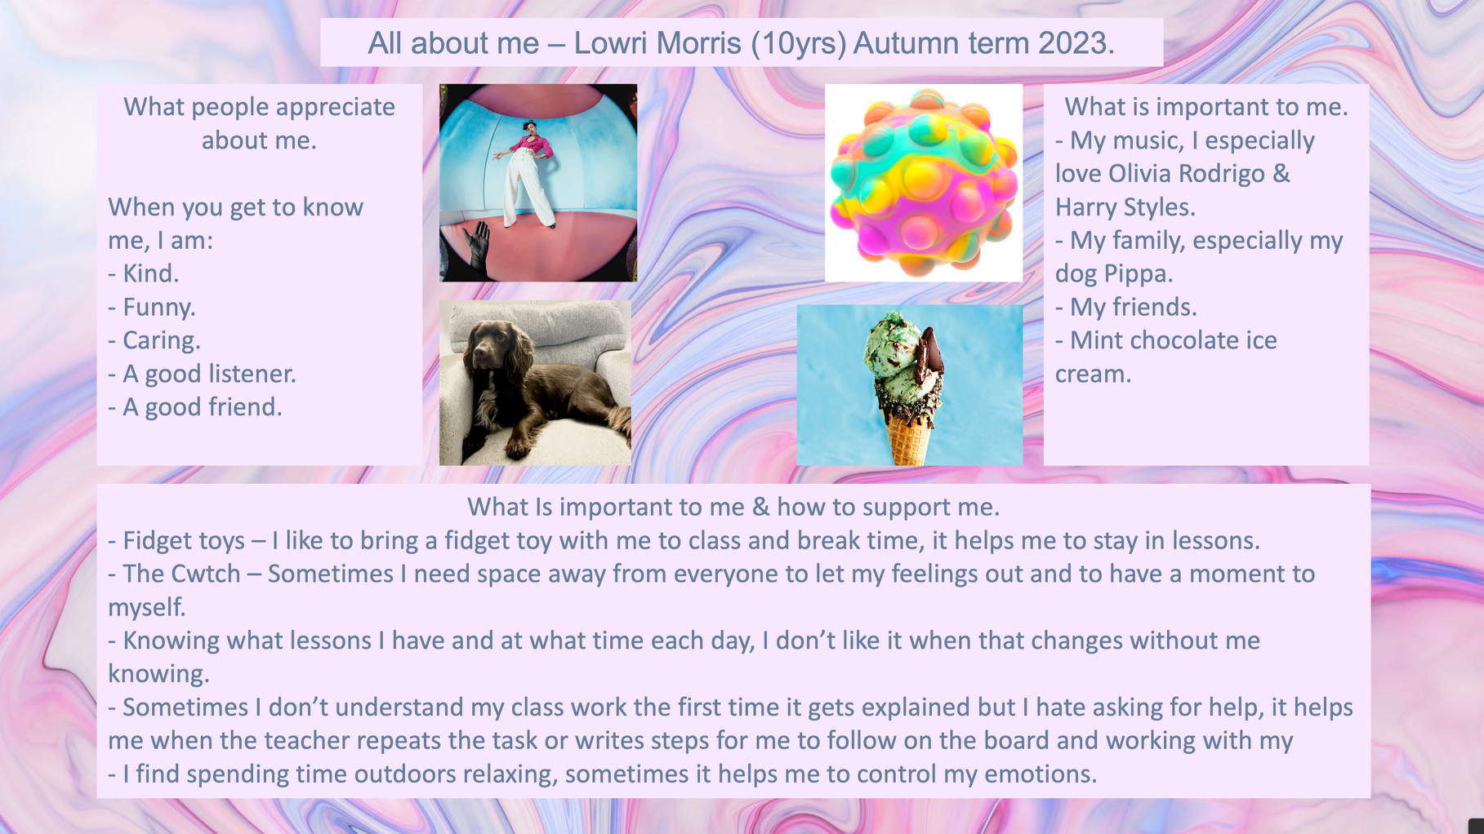
Part 2 - One-page profile.

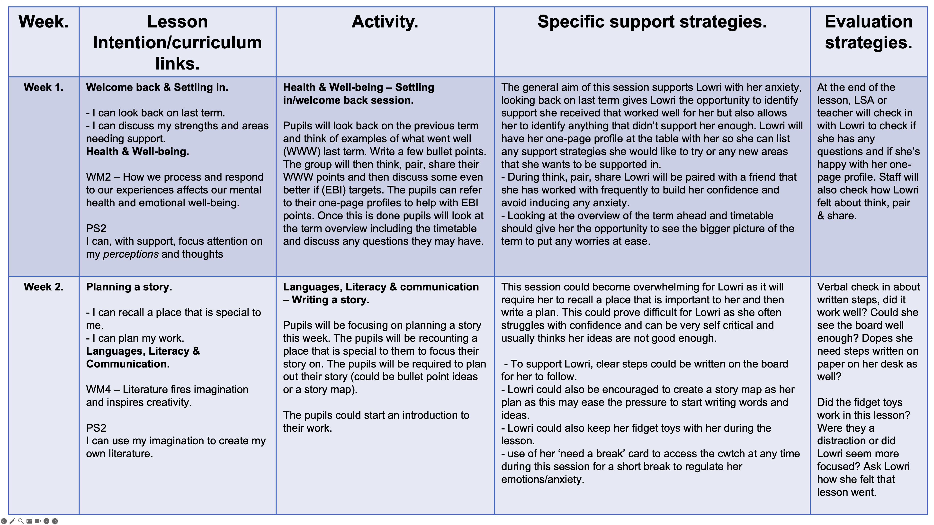
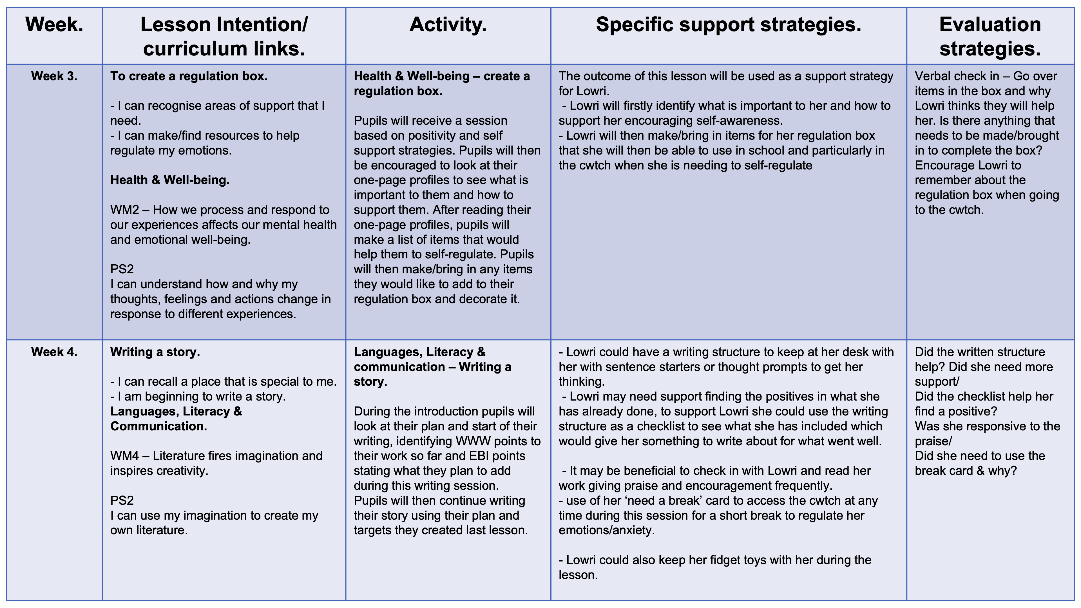
Part 2 – Lowri Morris Support plan.
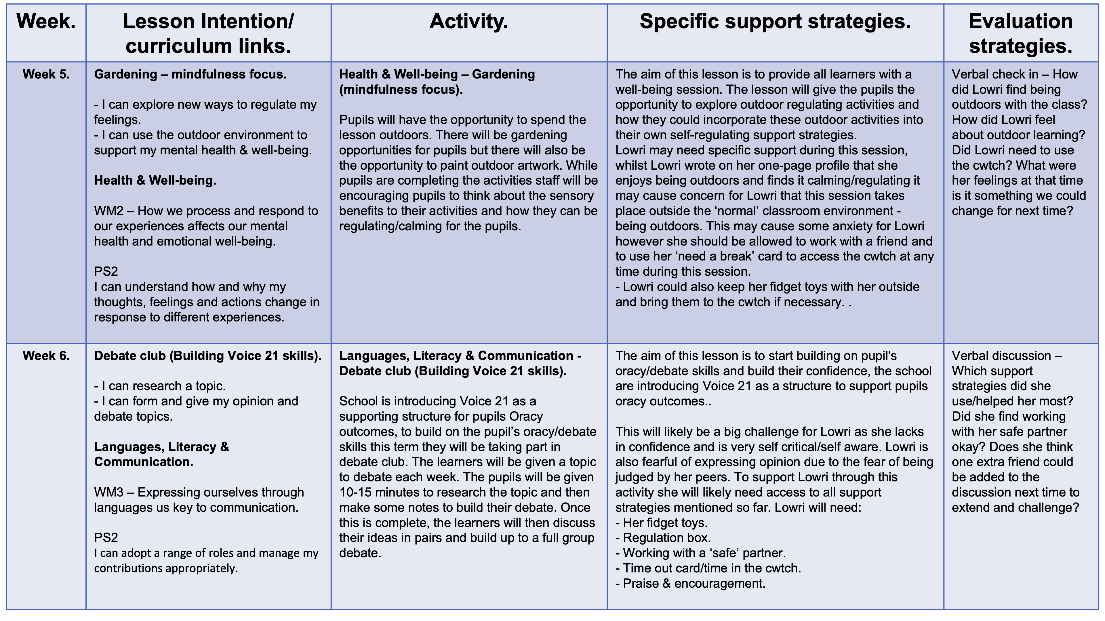

Reference list
Biel, L. (2017). 2 SENSORY SMARTSTM Fidget Toys or Focus Tools? Despite recent criticism, these handy gadgets benefit many students on the spectrum. [online] Available at: https://www.sensorysmarts.com/AADJun17.pdf [Accessed 31 Oct. 2023].
Black, P. and Wiliam, D. (1998). Inside the black box: raising standards through classroom assessment. [online] Google Books. Granada Learning. Available at: https://books.google.co.uk/books?hl=en&lr=&id=_hDy-5KOro8C&oi=fnd&pg=PA1&dq=black+%26+Wiliam+success+criteria&ots=smbanqrNAn&sig=DYe1MdJRjJN22xkCuVG35Au2dvQ&redir_esc=y#v=onepage&q=success%20criteria&f=false [Accessed 30 Oct. 2023].
Boekaerts, M. and Corno, L. (2005). Self-Regulation in the Classroom: A Perspective on Assessment and Intervention. Applied Psychology, [online] 54(2), pp.199–231. doi:https://doi.org/10.1111/j.1464-0597.2005.00205.x.
Cohen, M., Buzinski, S.G., Armstrong-Carter, E., Clark, J., Buck, B. and Reuman, L. (2019). Think, pair, freeze: The association between social anxiety and student discomfort in the active learning environment. Scholarship of Teaching and Learning in Psychology, [online] 5(4). doi:https://doi.org/10.1037/stl0000147.
Dunlop, A.-W. and Fabian, H. (2006). Informing Transitions in the Early Years. [online] Google Books. McGraw-Hill Education (UK). Available at: https://books.google.co.uk/books?hl=en&lr=&id=rkhEBgAAQBAJ&oi=fnd&pg=PA33&dq=what+is+a+horizontal+transitions&ots=sNELmEht8q&sig=kRCBO4xkXO1WYimlY6hzfxisZeY#v=onepage&q=what%20is%20a%20horizontal%20transitions&f=false [Accessed 30 Oct. 2023].
Gale, C.K. and Millichamp, J. (2016). Generalised anxiety disorder in children and adolescents. BMJ clinical evidence, [online] 2016, p.1002. Available at: https://www.ncbi.nlm.nih.gov/pmc/articles/PMC4711893/#:~:text=Generalised%20anxiety%20disorder%20(GAD)%20in [Accessed 30 Oct. 2023].
Gray, C. and Macblain, S. (2015). Learning theories in childhood. 2nd ed. London: Sage.
Herrick, E. and Redman-White, B. (2018). Supporting Children and Young People with Anxiety: A Practical Guide. [online] Google Books. Routledge. Available at: https://books.google.co.uk/books?hl=en&lr=&id=Xah8DwAAQBAJ&oi=fnd&pg=PT9&dq=supporting+anxious+children+my+creating+classroom+routines&ots=QVr-OrDIHs&sig=tWKQilpMXCBZyz_CUz3__dARdd4&redir_esc=y#v=onepage&q=creating%20routines&f=false [Accessed 31 Oct. 2023].
Humberstone, B., Prince, H. and Henderson, K.A. (2015). Routledge International Handbook of Outdoor Studies. [online] Google Books. Routledge. Available at: https://books.google.co.uk/books?hl=en&lr=&id=oJj4CgAAQBAJ&oi=fnd&pg=PA59&dq=the+benefits+of+being+outdoors+for+children&ots=zv-mCa2l_S&sig=3w54L76GlNjYSI1vu4S8mt9M1XU&redir_esc=y#v=onepage&q=the%20benefits%20of%20being%20outdoors%20for%20children&f=false [Accessed 31 Oct. 2023].
Kleitman, S., Stankov, L., Allwood, C.M., Young, S. and Mak, K.K.L. (2012). Metacognitive Self-Confidence in School-Aged Children. Self-directed Learning Oriented Assessments in the Asia-Pacific, [online] pp.139–153. doi:https://doi.org/10.1007/978-94-007-4507-0_8.
Kriescher, S. (2020). The Effects of Fidgets on Attention and Learning of College Students. Dissertations. [online] Available at: https://digscholarship.unco.edu/dissertations/666/#:~:text=This%20study%2C%20along%20with%20developing [Accessed 31 Oct. 2023].
Lantieri, L. (2008). Nurturing Inner Calm in Children. [online] Available at: https://citeseerx.ist.psu.edu/document?repid=rep1&type=pdf&doi=0898687a6c129a09f194aa3354d574bfa1842035#:~:text=They%20are%20teach%2D%20ing%20young [Accessed 31 Oct. 2023].
Masten, A. and Barnes, A. (2018). Resilience in Children: Developmental Perspectives. Children, [online] 5(7), p.98. doi:https://doi.org/10.3390/children5070098.
McLeod, S. (2023). Carl Rogers’ Humanistic Theory of Personality Development. [online] Simply Psychology. Available at: https://www.simplypsychology.org/carl-rogers.html [Accessed 30 Oct. 2023].
Moore, D., Morrissey, A.-M. and Robertson, N. (2019). ‘I feel like I’m getting sad there’: early childhood outdoor playspaces as places for children’s wellbeing. Early Child Development and Care, [online] 191(6), pp.1–19. doi:https://doi.org/10.1080/03004430.2019.1651306.
Negriff, S. (2020). ACEs are not equal: Examining the relative impact of household dysfunction versus childhood maltreatment on mental health in adolescence. Social Science & Medicine, [online] 245, p.112696. doi:https://doi.org/10.1016/j.socscimed.2019.112696.
Nikolić, M., Storm, L., Colonnesi, C., Brummelman, E., Kan, K.J. and Bögels, S. (2019). Are Socially Anxious Children Poor or Advanced Mindreaders? Child Development, [online] 90(4). doi:https://doi.org/10.1111/cdev.13248.
O’brien, L. and Great Britain. Forestry Commission (2006). A marvellous opportunity for children to learn : a participatory evaluation of forest school in England and Wales. Farnham, Surrey: Forest Research.
Research History (2012). Maslow’s Hierarchy of Needs – Research History. [online] Research History. Available at: https://www.researchhistory.org/2012/06/16/maslows-hierarchy-of-needs/?print=1 [Accessed 30 Oct. 2023].
Shanker, S. (2013). Calm, alert, and learning : classroom strategise for self-regulation. Don Mills, Ontario: Pearson.
Slade, S. and Griffith, D. (2013). (PDF) A whole child approach to student success. [online] ResearchGate. Available at: https://www.researchgate.net/publication/287320346_A_whole_child_approach_to_student_success [Accessed 30 Oct. 2023].
UNICEF (2023). UN Convention on the Rights of the Child (UNCRC). [online] Unicef. Available at: https://www.unicef.org.uk/what-we-do/un-convention-child-rights/ [Accessed 30 Oct. 2023].
Welsh Government (2019). Languages, Literacy and Communication: Introduction - Hwb. [online] hwb.gov.wales. Available at: https://hwb.gov.wales/curriculum-for-wales/languages-literacy-and-communication/ [Accessed 30 Oct. 2023].
Welsh Government (2020). Health and Well-being: Introduction - Hwb. [online] hwb.gov.wales. Available at: https://hwb.gov.wales/curriculum-for-wales/health-and-well-being/ [Accessed 30 Oct. 2023].
Welsh Government (2021a). Introduction - Hwb. [online] hwb.gov.wales. Available at: https://hwb.gov.wales/curriculum-for-wales/introduction/ [Accessed 30 Oct. 2023].
Welsh Government (2021b). Introduction - Hwb. [online] hwb.gov.wales. Available at: https://hwb.gov.wales/curriculum-for-wales/introduction/ [Accessed 30 Oct. 2023].

