AI acknowledgement statement
In the preparation of this assignment, generative artificial intelligence tools (ChatGPT, OpenAI) were used to support the drafting, editing, and refinement of written content, including improving clarity, structure, and academic style. The AI was also used to assist with reorganising sections of the report and checking coherence and language. All decisions regarding the study design, data collection, data analysis, interpretation of results, and final conclusions were made by the author. The author takes full responsibility for the accuracy, originality, and academic integrity of the work and has critically reviewed and edited all AI-assisted content in accordance with university assessment guidelines.

Kinematic Analysis of the Strict Overhead (Military) Press Across Multiple Loads: A Single-Subject Dartfish Case Study

1. Introduction
The strict overhead (military) press is a fundamental upper-body exercise used in strength training and many sports to develop shoulder and triceps strength while maintaining trunk stiffness and postural control. Although the movement is dominated by upper-limb action, successful execution requires coordinated whole-body stabilisation and efficient force transfer from the ground to the barbell (Escamilla et al., 2009; Haff and Triplett, 2016). From a biomechanical perspective, the press provides a useful model to examine kinematic features such as bar path, joint coordination, and time under tension, all of which influence mechanical efficiency, performance, and injury risk.
Biomechanics commonly distinguishes between kinematics, which describes motion, and kinetics, which concerns the forces that cause motion (Winter, 2009). In applied sport and coaching environments, access to laboratory-based measurement systems such as force plates or three-dimensional motion capture is often limited. However, two-dimensional video analysis can still provide meaningful insight into kinematic variables such as displacement, velocity, movement sequencing, and gross joint positioning (Lake and Lauder, 2012; Balsalobre-Fernández, Torres-Ronda and García-Ramos, 2017). These variables are closely linked to performance outcomes. The well-established force–velocity–power relationship indicates that as external load increases, movement velocity decreases, and power output typically peaks at moderate loads rather than at very light or very heavy intensities (Baker, 2001; Jidovtseff et al., 2011; Suchomel, Nimphius and Stone, 2018).
In pressing movements, technique-related changes in bar path and joint coordination are also associated with the so-called “sticking region”, a phase of the lift where mechanical disadvantage can transiently reduce bar velocity (Duffey and Challis, 2007; van den Tillaar and Ettema, 2010). Understanding how this region manifests across different loads is important for both performance optimisation and injury-risk management. From a safety perspective, overhead pressing places considerable demands on the glenohumeral joint and the lumbar spine, particularly when technique deteriorates or asymmetries emerge (Escamilla et al., 2009; McKean and Burkett, 2015). Video analysis can therefore help identify potentially harmful movement strategies, such as excessive trunk extension or side-to-side discrepancies at lockout, which may increase cumulative injury risk over time.
The aim of this report is to investigate the biomechanics of the strict overhead press across multiple relative loads (~60%, ~75% and ~90% 1RM) using Dartfish video analysis. Specifically, the report examines:
- kinematic indicators of performance, including concentric phase duration, bar displacement, and estimated velocity and power;
- movement characteristics related to mechanical efficiency, such as bar path consistency and movement coordination;
- potential safety considerations, including asymmetry and trunk positioning.
The report is structured into Methods, Results, Discussion, and Conclusion, and concludes with evidence-based recommendations for performance enhancement and injury-risk reduction.

2. Methods
Design
A single-subject, repeated-measures case study design was used to examine load-dependent changes in the strict overhead press under controlled conditions.
Participant
One trained adult male (age 26 years; height 188.5 cm; body mass 102 kg; approximately 12 years of resistance training experience) volunteered. Due to a lower-back strain, deadlift testing was avoided and the overhead press was selected as the primary movement. Injury status was checked before the warm-up and again before testing; no pain was reported during the session. The participant provided informed consent prior to data collection.
Equipment and set-up
Video was recorded using an iPhone 17 Pro Max at 60 frames·s⁻¹ mounted on a tripod, from side-on and posterior views, approximately 2 m from the lifter. Filming took place at JD Gym using a Hammer Strength platform, barbell, and plates. Dartfish software was used for frame-by-frame inspection and timing, using basic playback and frame stepping tools to identify key movement events and extract temporal data.
Warm-up and task
The warm-up comprised:
- 10 minutes of light jogging to raise heart rate,
- 1 minute of dead hang to reduce shoulder and latissimus dorsi tension,
- One set of 20 repetitions with the empty bar,
- Two sets of three speed repetitions at 40 kg.
Rest intervals were 2 minutes for warm-up sets and 3 minutes for working sets. The verified strict overhead press one-repetition maximum (1RM) was 75 kg. The participant performed 45 kg (3 repetitions), 55 kg (2 repetitions), and 67 kg (1 repetition), corresponding to approximately 60%, 75%, and 90% 1RM, respectively. Each repetition began from a rack at shoulder height, from a dead stop, with a slightly wider-than-shoulder grip, feet shoulder-width apart, no leg drive, no belt, straps, or chalk, and maximal concentric intent. A false grip was used; the head moved posteriorly to allow bar clearance and returned to a neutral position at lockout.
Event definitions and variables
Movement onset was defined as the first video frame showing upward bar displacement. The concentric phase ended at full elbow extension with the head aligned with the shoulders. Vertical displacement from start to lockout was measured as 0.712 m. Concentric time was obtained from frame counts (frames/60). Mean velocity (v̄ = s/t), mean acceleration (ā ≈ 2s/t²), estimated mean barbell force (F̄ = m(ā + g)), and estimated mean barbell power (P̄ = F̄·v̄) were calculated, noting that these represent barbell mechanical estimates rather than whole-body or joint-level kinetics (Winter, 2009). Bar path and joint positions were assessed qualitatively from both camera views.
Limitations of data collection
Two-dimensional (2D) video analysis was used rather than three-dimensional motion capture, which limits the precision of joint kinematic measurement when movement occurs outside a single plane. In addition, the absence of force plates, linear position transducers, or inertial measurement units prevented direct measurement of kinetic variables such as joint moments or whole-body power output. Due to the unavailability of specialist motion analysis software at the time of testing, joint angles could not be digitised frame-by-frame and were therefore assessed qualitatively across key phases of the lift. Although consistent camera positions were used to improve internal consistency, perspective and parallax error remain possible sources of measurement inaccuracy. Despite these limitations, the methods reflect realistic constraints in applied sport settings and still allow meaningful biomechanical interpretation of technique across increasing loads.

3. Results
Vertical bar displacement from the start position to lockout was 0.712 m for all repetitions. Figures 1a–2b illustrate the start and lockout positions from side and posterior views. The side-view images show a near-vertical bar path with posterior head displacement to allow bar clearance, followed by a return to a neutral head position at lockout. The posterior-view images show symmetrical grip and shoulder positioning at the start of the lift, with a small right–left asymmetry apparent at lockout, where the right side reached the terminal position marginally earlier before the bar levelled.
Concentric phase times obtained from Dartfish were: 45 kg—0.80 s, 0.76 s, and 0.90 s; 55 kg—0.92 s and 0.97 s; 67 kg—1.46 s. As load increased, concentric duration increased, indicating a reduction in movement velocity. Using the predefined equations, estimated mean velocities were highest at 45 kg (0.791–0.937 m·s⁻¹), lower at 55 kg (0.734–0.774 m·s⁻¹), and lowest at 67 kg (0.488 m·s⁻¹). Estimated mean accelerations followed a similar decreasing pattern with increasing load.
In contrast, estimated mean barbell force increased with load due primarily to the greater mass lifted, being lowest at 45 kg and highest at 67 kg. Estimated mean barbell power outputs were highest at the moderate loads (45–55 kg) and lowest at 67 kg. When summarised by condition, mean ± SD power was approximately 470 ± 54 W at 45 kg, approximately 473 ± 23 W at 55 kg, and 342 W for the single repetition at 67 kg. Thus, despite the highest estimated force occurring at 67 kg, the substantial reduction in velocity resulted in lower estimated power at the heaviest load.
Qualitative inspection of the side-view footage showed no obvious forward or backward bar path drift across loads, supporting a consistent and mechanically efficient bar trajectory. No distinct sticking point was observed; however, bar speed appeared lowest when the elbows passed approximately 90° of flexion. From the posterior view, the small asymmetry at lockout was more evident in the heavier conditions but resolved once the bar stabilised overhead.

4. Discussion
The purpose of this study was to examine how increasing relative load affects kinematic indicators of performance, movement characteristics related to mechanical efficiency, and potential safety considerations during the strict overhead press using video-based analysis. The primary findings were: (i) concentric phase duration increased and mean velocity decreased as load increased; (ii) estimated mean barbell power was highest at moderate loads (45–55 kg) and lower at the heaviest load (67 kg); (iii) bar path remained largely vertical with the slowest phase occurring around ~90° elbow flexion; and (iv) a small right–left asymmetry was evident at lockout.
Load–velocity–power relationship and performance
The inverse relationship between load and movement velocity observed here is consistent with strength-training and biomechanics literature (Baker, 2001; Jidovtseff et al., 2011; Suchomel, Nimphius and Stone, 2018). As external load increases, greater force production constrains muscle shortening velocity (Winter, 2009). This was reflected in the present data, with concentric time increasing from approximately 0.8 s at 45 kg to 1.46 s at 67 kg and corresponding reductions in estimated mean velocity.
Estimated mean barbell power peaked at moderate loads (45–55 kg) and declined at 67 kg, consistent with the force–velocity–power relationship (Baker, 2001; Suchomel, Nimphius and Stone, 2018). Although the heaviest load produced the greatest estimated force, the reduced velocity limited power output. This supports the use of moderate loads with maximal intent for power development, in agreement with velocity-based training research (Jidovtseff et al., 2011; Sánchez-Medina and González-Badillo, 2011; Weakley et al., 2021).
It should be noted that the force and power values reported here are barbell mechanical estimates derived from kinematics rather than direct measures of whole-body or joint kinetics (Winter, 2009). However, this approach remains appropriate for within-subject comparisons in applied settings where force plates or linear transducers are unavailable (Lake and Lauder, 2012; Balsalobre-Fernández, Torres-Ronda and García-Ramos, 2017).
Mechanical efficiency and movement strategy
Mechanical efficiency in lifting tasks is often inferred from bar path consistency and minimal unnecessary horizontal displacement (Haff and Triplett, 2016). In the present study, the bar path remained largely vertical across all loads, suggesting efficient force application and limited energy loss due to horizontal deviations. This is desirable in overhead pressing, as forward drift can increase shoulder moments and lumbar extension demands (Escamilla et al., 2009; McKean and Burkett, 2015).
The slowest phase of the lift occurred when the elbows passed approximately 90° of flexion, consistent with a mechanically disadvantageous region in multi-joint pressing tasks (Duffey and Challis, 2007; van den Tillaar and Ettema, 2010). Although no pronounced sticking point was observed, the visible deceleration indicates increased mechanical demand.
Methodological considerations and limitations
A key strength of this study is the use of accessible, video-based analysis to generate biomechanical insight under controlled conditions (Lake and Lauder, 2012; Balsalobre-Fernández, Torres-Ronda and García-Ramos, 2017). Standardisation of technique, loads, and rest intervals strengthened internal validity. However, limitations include the single-participant design, two-dimensional analysis, and the estimation of force and power rather than direct measurement (Winter, 2009). Qualitative assessment of bar path and joint positions also introduces some observer error.
Implications for training and rehabilitation
The findings reinforce the utility of moderate loads for power development in pressing movements and highlight the importance of maintaining a vertical bar path and strict technique for mechanical efficiency and safety. For individuals managing lower-back issues, rack starts and strict pressing may reduce unnecessary spinal loading while maintaining training stimulus (Escamilla et al., 2009; Haff and Triplett, 2016). Simple time- or velocity-based monitoring using video may also help track performance and fatigue (Sánchez-Medina and González-Badillo, 2011; Weakley et al., 2021).
5. Conclusion & Recommendations
This video-based case study examined load-dependent kinematic changes in the strict overhead press. As load increased from approximately 60% to 90% 1RM, concentric phase duration increased and estimated mean velocity decreased, while estimated mean barbell power was highest at moderate loads (45–55 kg) and lowest at the heaviest load (67 kg). Bar path remained largely vertical, with the slowest region occurring around ~90° elbow flexion, and a small right–left asymmetry was observed at lockout.
Recommendations:
- Performance: Prioritise moderate loads (~60–75% 1RM) with maximal concentric intent to target power development, and monitor concentric time or velocity to maintain movement quality (Baker, 2001; Suchomel et al., 2018).
- Mechanical efficiency: Coach a consistent, near-vertical bar path and effective head “back-and-through” strategy to minimise horizontal deviation and shoulder moments (Escamilla et al., 2009).
- Injury-risk reduction: Monitor trunk position and side-to-side symmetry, particularly at lockout, and incorporate unilateral pressing and scapular stabilisation exercises if asymmetry persists.
- Rehabilitation/return-to-load management: For individuals with lumbar issues, use rack starts and strict technique, and progress loads using time/velocity thresholds to avoid compensatory strategies (Haff and Triplett, 2016).
Overall, Dartfish-based video analysis provided actionable insight into performance, efficiency, and safety, despite not being implemented to it’s full capabilities, demonstrating a practical framework for applied biomechanics when laboratory instrumentation is unavailable.

6. References (UWTSD Harvard)
Baker, D. (2001) ‘A series of studies on the training of high-intensity muscle power in rugby league football players’, Journal of Strength and Conditioning Research, 15(2), pp. 198–209.
Balsalobre-Fernández, C., Torres-Ronda, L. and García-Ramos, A. (2017) ‘Validity and reliability of a smartphone app for measuring barbell velocity’, Journal of Strength and Conditioning Research, 31(5), pp. 1254–1262.
Duffey, M.J. and Challis, J.H. (2007) ‘Vertical and lateral forces applied to the bar during the bench press in novice lifters’, Journal of Strength and Conditioning Research, 21(4), pp. 1350–1356.
Escamilla, R.F., Yamashiro, K., Paulos, L. and Andrews, J.R. (2009) ‘Shoulder muscle activity and function in common shoulder rehabilitation exercises’, Sports Medicine, 39(8), pp. 663–685.
Haff, G.G. and Triplett, N.T. (2016) Essentials of Strength Training and Conditioning. 4th edn. Champaign, IL: Human Kinetics.
Jidovtseff, B., Harris, N.K., Crielaard, J.-M. and Cronin, J.B. (2011) ‘Using the load–velocity relationship for 1RM prediction’, Journal of Strength and Conditioning Research, 25(1), pp. 267–270.
Lake, J.P. and Lauder, M.A. (2012) ‘Kinematic and kinetic comparison of the kettlebell swing and the explosive deadlift’, Journal of Strength and Conditioning Research, 26(7), pp. 2002–2011.
McKean, M.R. and Burkett, B.J. (2015) ‘The influence of trunk motion on performance in the overhead press’, Journal of Sports Sciences, 33(3), pp. 230–238.
Sánchez-Medina, L. and González-Badillo, J.J. (2011) ‘Velocity loss as an indicator of neuromuscular fatigue during resistance training’, Medicine & Science in Sports & Exercise, 43(9), pp. 1725–1734.
Suchomel, T.J., Nimphius, S. and Stone, M.H. (2018) ‘The importance of muscular strength in athletic performance’, Sports Medicine, 48(4), pp. 765–785.
van den Tillaar, R. and Ettema, G. (2010) ‘A comparison of muscle activity in concentric and counter movement maximal bench press’, Journal of Human Kinetics, 24, pp. 63–71.
Weakley, J., Mann, B., Banyard, H., McLaren, S., Scott, T. and Garcia-Ramos, A. (2021) ‘Velocity-based training: From theory to application’, Strength and Conditioning Journal, 43(2), pp. 31–49.
Winter, D.A. (2009) Biomechanics and Motor Control of Human Movement. 4th edn. Hoboken, NJ: Wiley.

Appendix A. Testing Log
- Time of day: Between 14:30 and 15:00
- Sleep and fatigue status: Well rested and feeling fresh
- Warm-up protocol used: 10 min light jog; 1 min dead hang; empty bar ×20; 40 kg ×3 ×2 sets
- Loads tested: 45 kg (3 reps), 55 kg (2 reps), 67 kg (1 rep)
- Rest intervals: 2 min (warm-up sets); 3 min (working sets and 1RM verification)
- Camera setup: iPhone 17 Pro Max; side-on and posterior; 60 fps; tripod; ~2 m distance
- Venue/equipment: JD Gym Llansamlet; Hammer Strength barbell and plates; wooden platform
- Belt/straps/chalk: None used
- Injury status: Lower back strain; no pain reported during pressing
- Notes on technique or anomalies: No sticking point observed; slowest region when elbows passed ~90°; slight right-arm lead at lockout before levelling

Figures
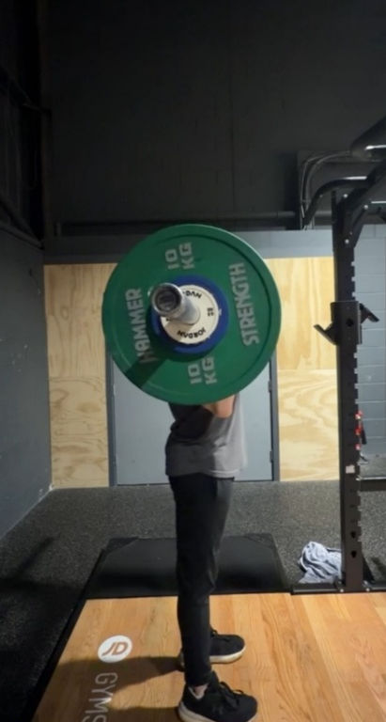
Figure 1a. Side view of the strict overhead press at the start position (bar at shoulders, dead stop).

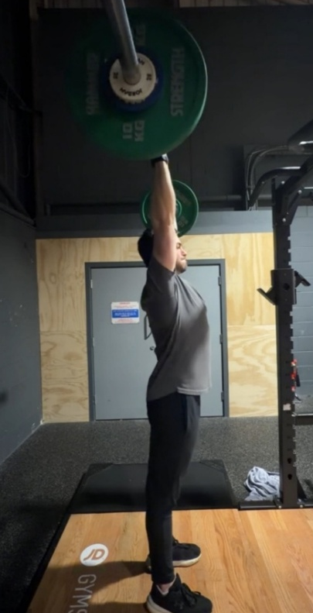
Figure 1b. Side view of the strict overhead press at lockout (full elbow extension, head aligned with shoulders).

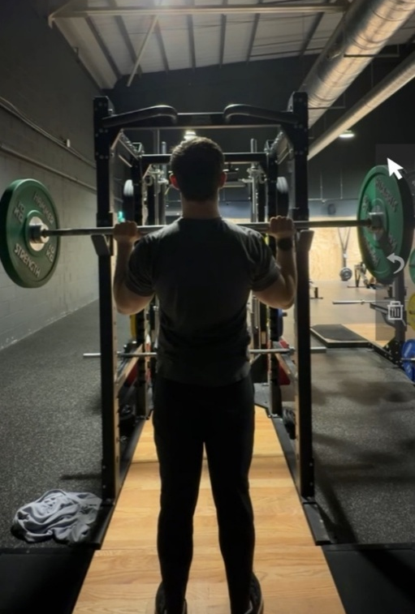
Figure 2a. Rear view of the strict overhead press at the start position.

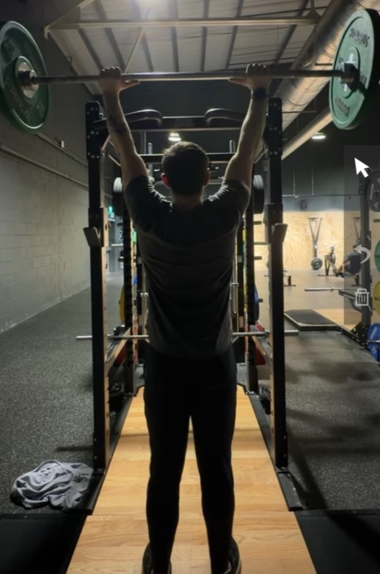
Figure 2b. Rear view of the strict overhead press at lockout.
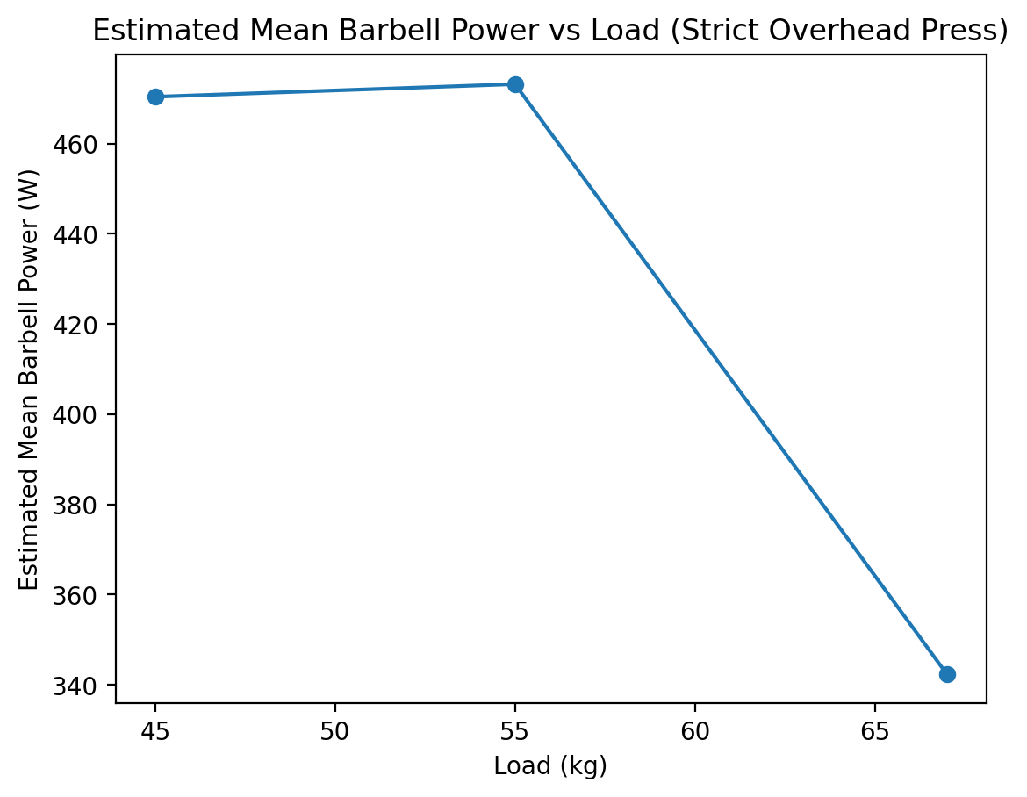
Figure 3. Estimated mean barbell power as a function of load (45, 55, 67 kg) during the strict overhead press.
Table 1. Kinematic summary
Load (kg) | %1RM | Rep | Time (s) | Disp. (m) | Mean v (m·s⁻¹) | Mean a (m·s⁻²) | Est. Force (N) | Est. Power (W) | Bar path | Symmetry | Figure ref.
45 | ~60% | 1 | 0.8 | 0.712 | 0.89 | 2.225 | 541.6 | 482.0 | Near-vertical | Symmetrical | Fig. 1a/1b
45 | ~60% | 2 | 0.76 | 0.712 | 0.937 | 2.465 | 552.4 | 517.5 | Near-vertical | Symmetrical | Fig. 1a/1b
45 | ~60% | 3 | 0.9 | 0.712 | 0.791 | 1.758 | 520.6 | 411.8 | Near-vertical | Symmetrical | Fig. 1a/1b
55 | ~75% | 1 | 0.92 | 0.712 | 0.774 | 1.682 | 632.1 | 489.2 | Near-vertical | Slight R>L | Fig. 2a/2b
55 | ~75% | 2 | 0.97 | 0.712 | 0.734 | 1.513 | 622.8 | 457.1 | Near-vertical | Slight R>L | Fig. 2a/2b
67 | ~90% | 1 | 1.46 | 0.712 | 0.488 | 0.668 | 702.0 | 342.4 | Near-vertical | Slight R>L | Fig. 2a/2b

