University of Wales Trinity Saint David (UWTSD)
ACBA4026 – Procurement Process
Assignment: Procurement & Contract Selection

Student Name: Charlie Tee
Student ID: 2517370
Submission Deadline: 08 May 2025

Module Code: ACBA4026
Title: Procurement Process

Contents
Contents 2
1. Introduction 3
2. Procurement route Analysis 3
2.1 Design and build (D&B) 3
2.2 Traditional (Design, Bid and build) 4
2.3 Management contracting 5
3. Analysis for the best suited procurement route 6
4. Tendering Process 6
4.1 Selective tendering 7
4.2 One and two stage Tendering 7
5. Conclusions 7
6. References 7

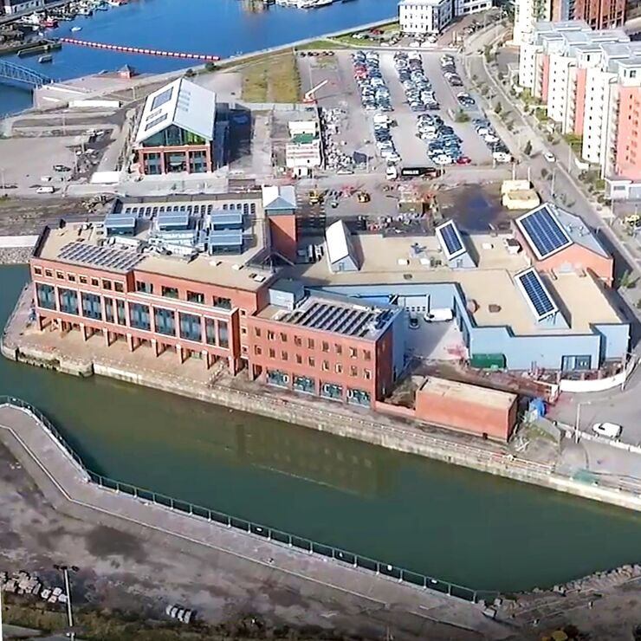
1. Introduction

Within this report I will be assessing the feasibility and best procurement route for the construction of a new Centre of excellence for construction training. I will be giving my advice on the top three procurement routes best suited for the work identifying both strengths and weaknesses, I will then apply this to the Centre of excellence for the construction training. Due to the focus being delivering the project within the budget, this is what I will base my judgement on for the best procurement route.
Furthermore, I will advise on the best tendering process that should be used in line with the given procurement route with justification.

2. Procurement route Analysis

2.1 Design and build (D&B)

The design and build (D&B) procurement route is a delivery method mostly for projects. This is where a single contractor is responsible for both the design and construction of the project. In a traditional scenario the client would be hiring designers and then a contractor separately whereas in this case they are hiring a contractor to take on both responsibilities.
‘It is the most commonly used procurement method in the UK, accounting for over 50% of projects.’ (CIOB, 2022)
The advantages of using design and build are that the contractor who undertakes the work takes responsibility, which reduces risk for the client. However, there is an element of risk if the contractor is to use subcontractors, but the client still uses the main contractor for liability. Another benefit of using design is that the cost is almost certain despite the element of variations not included in the original scope of works these could be requested by the client or submitted by the contractor with reason for the variation.
The downside for the client using design and build is that there is reduced design control for the client as once the contractor takes over the design the client has less influence on decisions. Another risk for the client is that the contractor decides to use cheaper materials to drive their cost base down to protect the profit.

2.2 Traditional (Design, Bid and build)

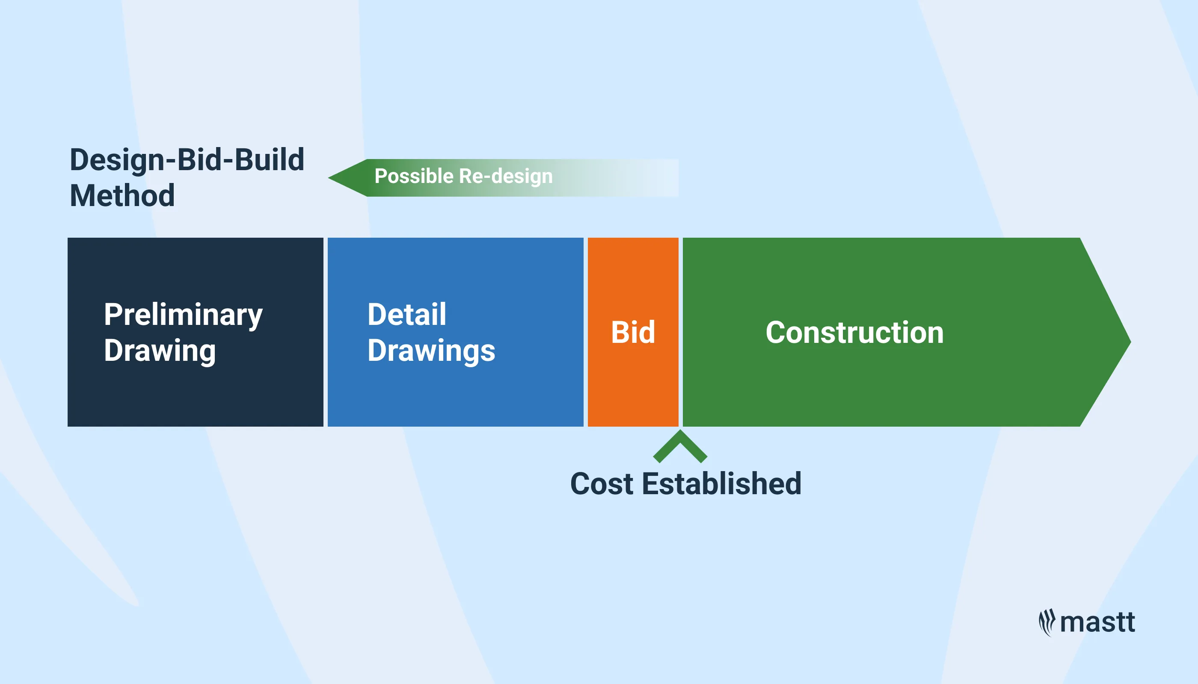
The traditional procurement route is the oldest method of procurement but the most established in the UK construction industry. When using the traditional procurement this is how it works. Client will appoint consultants (Architect, Engineers, Mechanical and electrical Consultant, Quantity Surveyor) who will work as the design team, the architect will produce the drawings, the engineer designs the building structure to make sure the building can withstand certain loads and forces, the M&E side will design the building services for the building and finally the Quantity Surveyor which in our case will be the most important role for the project will prepare cost estimations and a budget, A bill of quantities, advise on the best procurement and type of contract then finally once the work is awarded to a contractor the Quantity surveyor will manage costs, variations and manage any financial risk throughout the construction.
The pros to using a traditional procurement route are that as a client you have strong control over the design of the project this may allow the project to have a higher quality design as the architect specialises in this area, this is great for where aesthetics and performance of a building matter. Next the traditional procurement route is worthy as the tendering element is competitive between the contractors bidding for the work. This is because all contractors are pricing the same information therefore it’s much easier to compare the bids. In our scenario I think overall this Is a strong method because certain contractors who are looking to win the work may reduce their costs and sacrifice their profit for the bigger picture of working on a project like this, for the larger scale contractors this makes the tender more competitive. ‘Since all contractors are given the same specific brief in the tender pack, traditional procurement leads to a greater level of competitive equity during the tendering process’ (Builtinteriors.com, 2023)
On the other hand, the setbacks of the traditional procurement method are that firstly the overall delivery is lower which can affect projects that are time critical. In addition to this there is a risk associated due to the contractor not being involved during the design stage. Meaning as the designs could be expensive or difficult to build once the contractor gets to site there are increased risk of variations due to buildability and suitable value engineering to make sure the quality is up to standard as well as the design. But contractors can price on the rates or schedule provided but if they have not been to site and seen the conditions it is almost certain there will be costs/variations not allowed for in the bid.
‘This also means the contractor is not able to help improve the buildability of the design, or to input into the packaging of the works as they develop.’ (www.designingbuildings.co.uk, 2023) as seen in this statement above the contractor is not involved until the design is finished.

2.3 Management contracting

Management contracting is a route where the client firstly appoints a design team in stage 1 (Architect, Engineers, Mechanical and electrical Consultant, Quantity Surveyor). The management contractor usually comes in around stage 2 or 3. The management contractor is brought in to use their experience and identify ways to improve costs and buildability, note that the management contractor will not deliver any of the works on site only managing, advising, and coordinating. Then instead of the contractor delivering all works the management contractor will tender out packages of the project then works contractors are contracted to the management contractor. This way as discussed, the management contractor can effectively manage the site.
The benefits for the client using Management contracting are that the work delivery on site can start early due to part of the design complete this means packages of work can go out to tender and a works contractor can be appointed for the element of work which can lead to a saving on the programme overall. Additionally, the management contractor can provide information to ensure better risk awareness and reduce design problems. For example, if the management contractor will have the knowledge of site conditions that might affect the overall cost, identifying this makes sure that a cost is captured and when the works contractor reaches site there are minimal variations.
Management contracting can also be an unsuitable method of procurement because the client can hold of a financial risk. As the Management contractor only manages the work this means and changes in subcontract price, design changes or mistakes found later the client will still pay. This method is not suitable for an inexperienced client because of the financial risk and being able to manage and make informative decisions.

3. Analysis for the best suited procurement route

The design and build method is the most suitable procurement route for the client because it gives the client a budget cost instantly. The reason I say this is because the clients main concern was ‘delivering the project within budget’ I think this would give an early indication for costings and allow the project to be delivered with minimal change in costs. Furthermore, the contractor must manage both design and build liabilities for the project even if they were to subcontract packages back out. Lastly In line with the liabilities the developer stated that this project is larger than previous projects that they have dealt with, as this project involves specialist works this will put the client at ease.

4. Tendering Process
The tendering process is a structured method used by organisations to determine who the works are awarded to by evaluating different sections the tender, this may involve; Preparation of the tender documentation, Invitation to tender, Pre-qualification (Suitability of suppliers and subcontractors if needed), Submission of bids and finally the contract award.

4.1 Selective tendering
Selective tendering is a method which uses an approach that only allows a limited amount of contractors to be shortlisted by using the pre-qualification approach as discussed. This will include all company information, a section on financials, an important section on Technical and professional ability to deliver the project (Similar projects, SKEB, Compliance with the standards of work) and finally legal and compliance requirements.
Annex-A-Core-PQQ-questions.pdf (Example Pre-qualification questionnaire from GOV.UK)

4.2 One and two stage Tendering
One stage tendering is a process whereby the tender is released and there are no limits as to who can submit a bid if they can provide the documents required. The contractors must submit their technical and commercial response in a whole submission. In two stages tendering the difference is that in stage 1 it allows the contractor to submit details under a pre-construction agreement including things like overheads, method statements, and preliminaries. After this the second stage is using what was agreed in the first stage in the scenario of the project. This is a risk as there may have been items that have not been considered for.

5. Conclusions
Overall, I have decided that that one and two stage tendering is best suited for this project. Firstly, the use of selective tendering for this project would not be suitable for the clients needs because we are restricting the variety of bidders by using the pre-qualification. Although this method allows the client to shortlist the most competent contractors, it also disregards the smaller contractors who may not have the relevant certificates because they operate as a smaller workforce. Which in theory leaves you with larger contractors who are more costly and in our scenario the focus is delivering the project within a budget. Therefore, I believe that the one and two stage allows all contractors to competitively tender and gives more options for the client to choose from by gathering all information commercially and technically.

6. References

CIOB (2022). Design and build procurement route. [online] www.designingbuildings.co.uk. Available at: https://www.designingbuildings.co.uk/Design_and_build_procurement_route. Accessed on: (11/04/2026)
Martins, A. (2025). The Evolution of the Procurement Function from 1850 to Today: From Administrative Necessity to Strategic Advantage. [online] 18(3), pp.245–278. Available at: https://www.researchgate.net/publication/392325368_The_Evolution_of_the_Procurement_Function_from_1850_to_Today_From_Administrative_Necessity_to_Strategic_Advantage. Accessed on (11/04/2026)
www.designingbuildings.co.uk. (2023). Traditional contract - pros and cons. [online] Available at: https://www.designingbuildings.co.uk/Traditional_contract_-_pros_and_cons. Accessed on (11/04/2026)
Builtinteriors.com. (2023). The Pros and Cons of Traditional Procurement Explained. [online] Available at: https://www.builtinteriors.com/blog-posts/the-pros-and-cons-of-traditional-procurement-explained Accessed on (11/04/2026)
www.designingbuildings.co.uk. (n.d.). Management contractor. [online] Available at: https://www.designingbuildings.co.uk/Management_contractor. Accessed on (11/04/2026)
www.designingbuildings.co.uk. (2023). Management contracting - pros and cons. [online] Available at: https://www.designingbuildings.co.uk/Management_contracting_-_pros_and_cons. Accessed on (11/04/2026)
Tender Consultants. (2023). Tendering: definition and how it works. [online] Available at: https://www.tenderconsultants.co.uk/tendering-definition-and-how-it-works/. Accessed on (19/04/2026)
SCAPE (2021). Single Stage Vs Two Stage Tendering - Procurement Process. [online] SCAPE. Available at: https://scape.co.uk/news/single-stage-vs-two-stage-tendering. Accessed on (19/04/2026)
www.designingbuildings.co.uk. (2023). Management contracting - pros and cons. [online] Available at: https://www.designingbuildings.co.uk/Management_contracting_-_pros_and_cons. Accessed on 20/04/2026

‌

‌

‌

‌

.
‌

‌

‌

‌

