Table of Contents
Database 1
Queries 5
Bibliography 13

In this report I will show the created database for the task ,queries related to it and how they interact with each other. We will have a look in reports, forms and some diagrams.

Database
What is the database ? (Microsoft corporation , 2020)
This is a tool for organizing ,storing and collecting information. It may be used for different varieties of tasks. It may hold information related to people ,items ,prices and etc.
Here I will provide a screenshot for my database and then will break down the information.
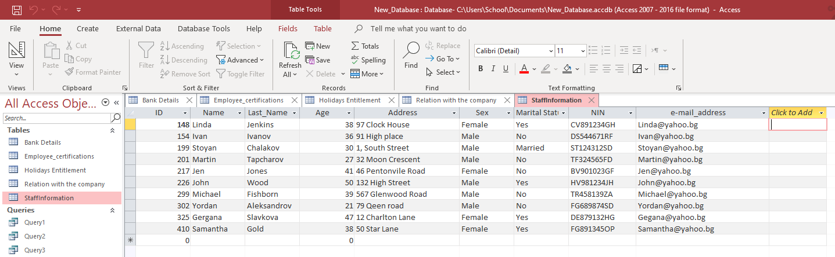
My database is variety of tables. Here we hold all the information regarded with the company staff. On the next topic will show what tables are and how they display the necessary information.
Tables
What are the tables in Microsoft access ? (Microsoft corporation , 2020)
This is a spreadsheet which holds the data in rows and columns. That is more easy and efficiency way to categorize the information validated.
I have made 5 different tables with different varieties of information.
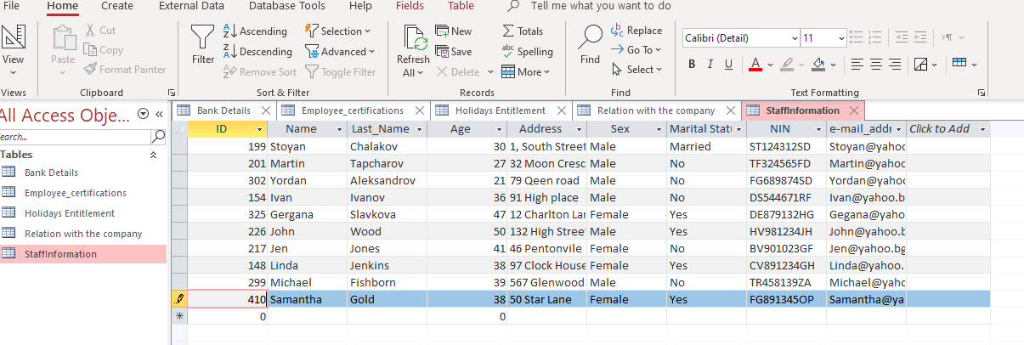
My first table holds the staff information for all people in the company.
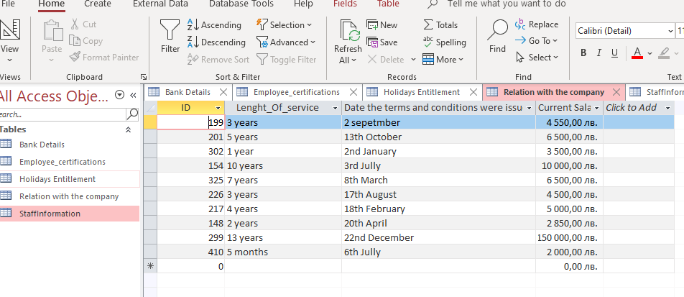
The second table held information for all employees and their relations with the company.
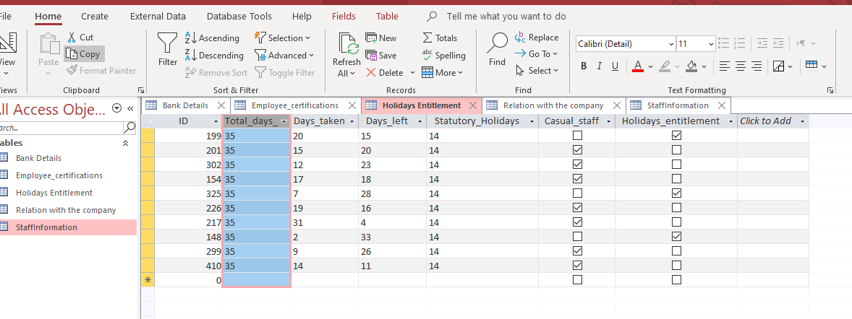
The third table held the information about all holidays and entitlements for employees and also which of them are eligible for it.
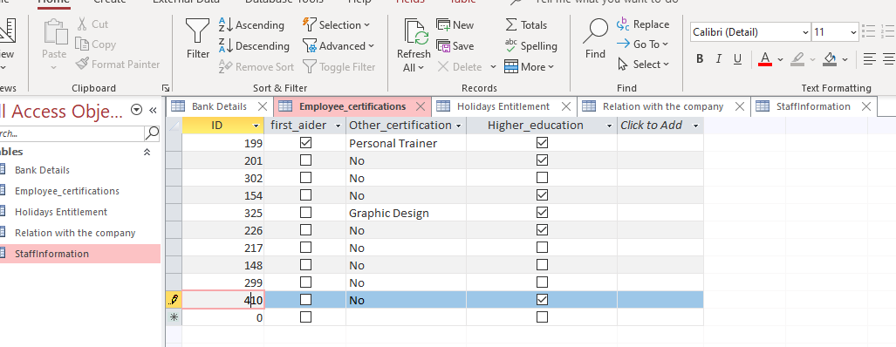
The forth table held the information about any of our employees have or not having any certifications ,not related with their current position.
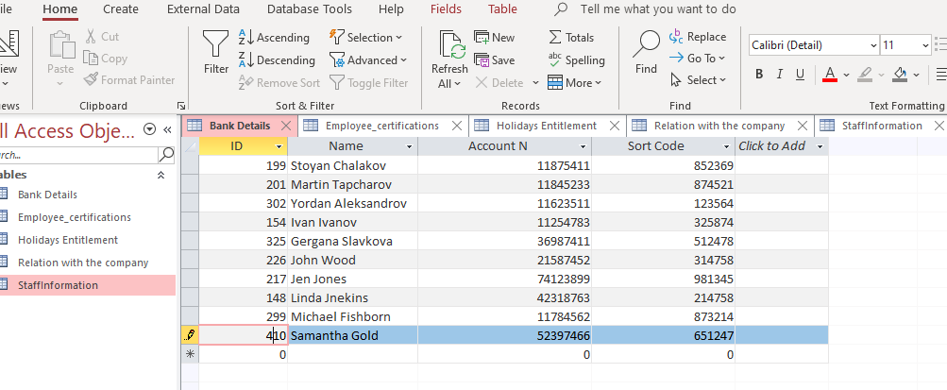
And finally the fifth table held the information about bank details for all employees.
Queries
What are the queries in Microsoft access ? (Microsoft corporation , 2020)
Queries allows us to retrieve different information from two or more tables and implement them in another table with specific categorized information.
I will upload several screenshots to show relations between two tables using queries.
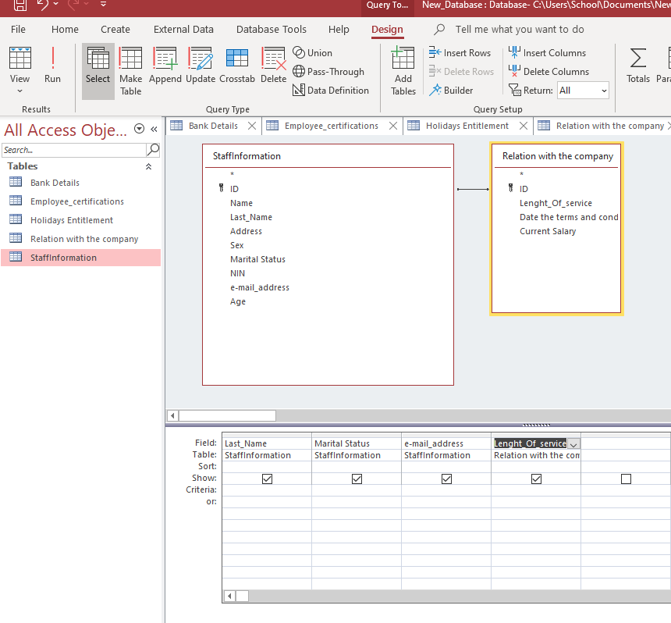
This is the raw image of creating a query between two tables. We can choose all or just few fields to filter information. In this case we using “staff information” table and “relation with a company” table . As you may see we do not use all rows ,but just the one needed to display the information.
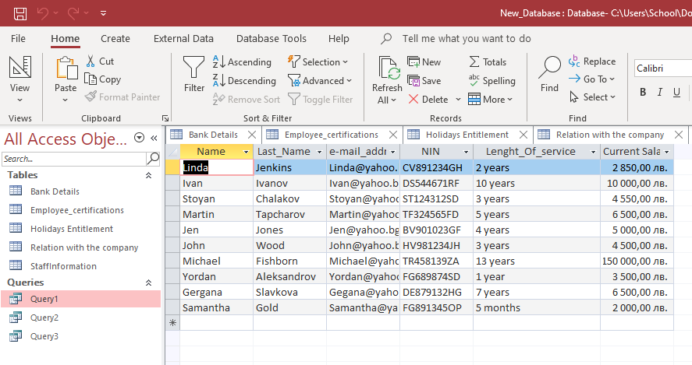
And this is how it is looking already created query between the two tables we were using.
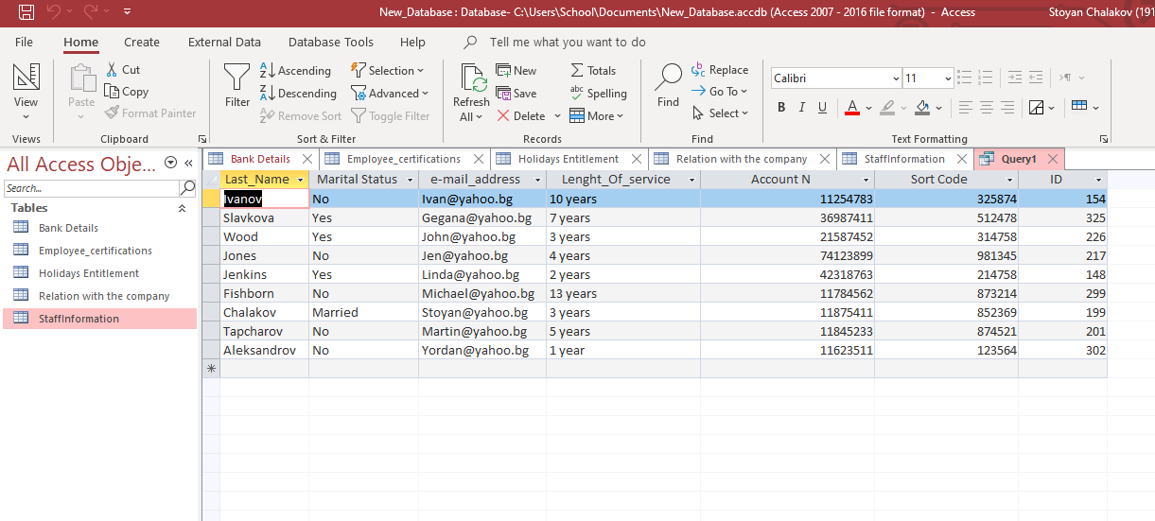Here is a query which show us information from three tables. Queries are very useful ,because with their help we can retrieve any information we like from all tables created.
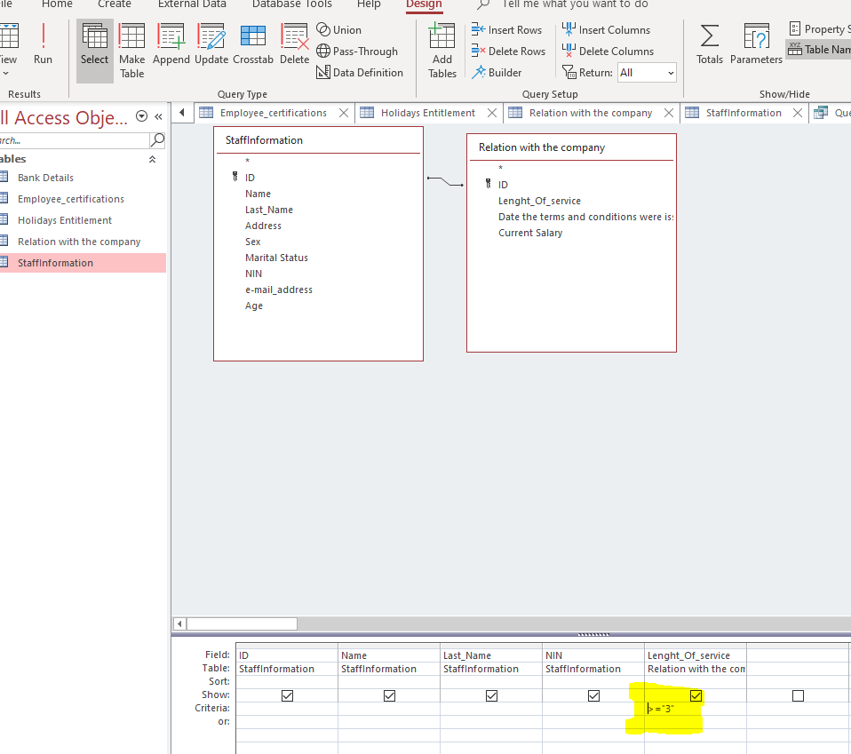
Here we show also the foreign key tool ,which can allow us to made different changes in our query. For example to display no more than one employee information or based on they years of experience ,will show people who are working in the company from 3 or more years. It is very helpful to use if you have to deal with big corporation and you have to find a single person etc.
Reports
Reports
What are reports in Microsoft access? (Microsoft corporation , 2020)
Reports are been using for summarize and formatting specific data. They always reflect the current data in the database. Also this the format which can be printed if necessary, sent by email and etc.
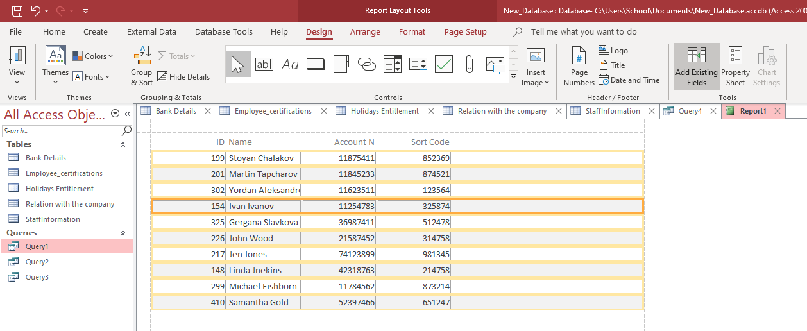
This is how the reports looks like after the table are created and queries have been made in.
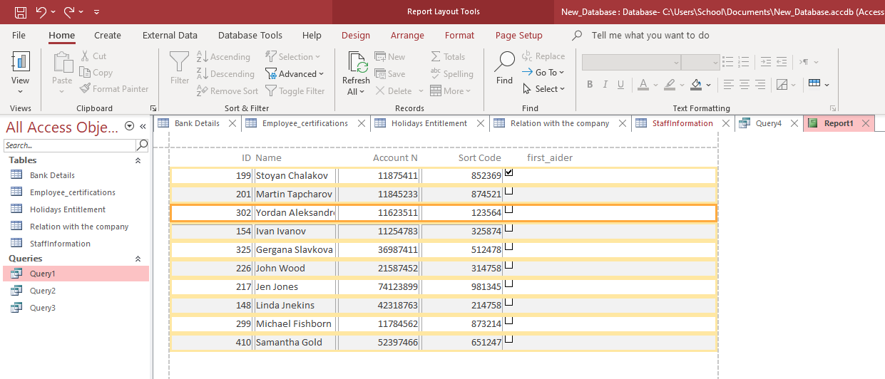
Here we show the relation between two tables in the report.
Forms
What are forms represent in Microsoft access?
They allow us to created UI ,in which we are able to create and edit data. Forms allowed to control users interact with the database.
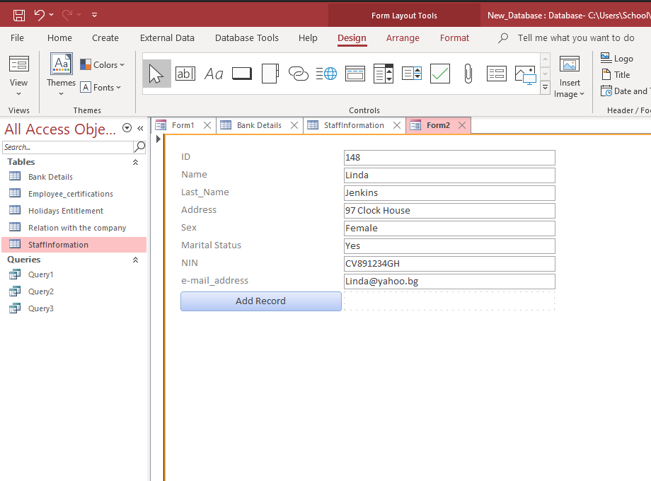
This is how form looks like, by creating it after you created the tables and fill the information.
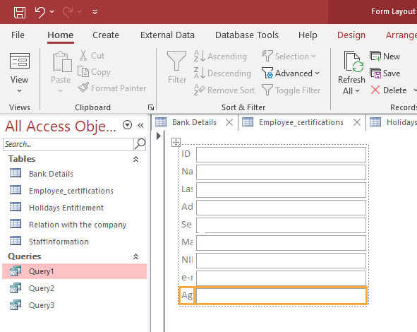
And here is a blank form .
Diagram
For the next task will make a ERD or entity relationship diagram.
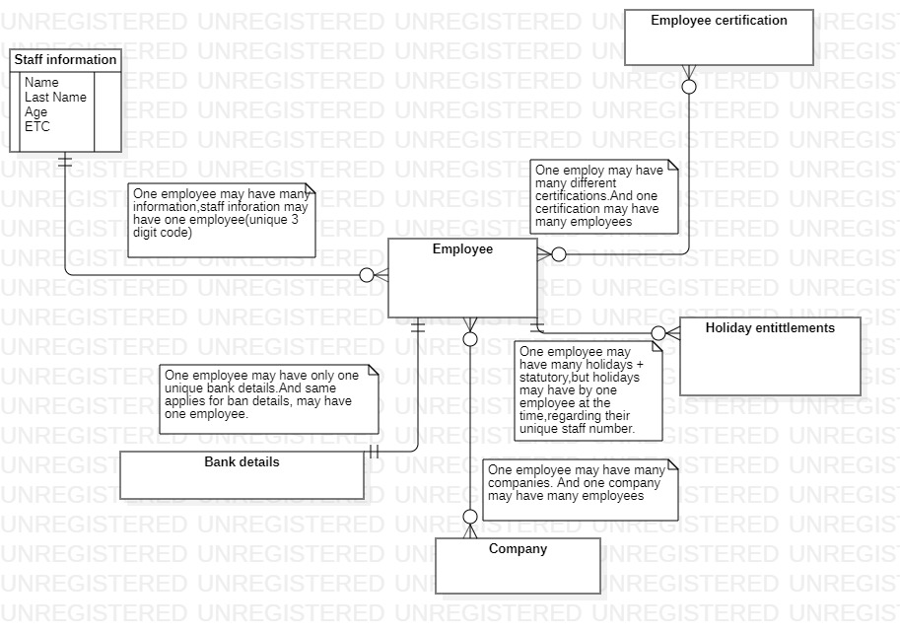
I just would like to add that, I have some issues with my Word program and it is not displaying the pages correctly. I will work on this these days to see if I am able to sort it out. Thanks for understanding.

Bibliography
Microsoft corporation . (2020, 12 15). www.support.microsoft.com. Retrieved from www.microsoft.com: https://support.microsoft.com/en-us/office/database-basics-a849ac16-07c7-4a31-9948-3c8c94a7c204#__toc257378512

