ANDREEA OLIVIA STAICU (2021165)
University of wales trinity saint david
Skills for the workplace (health and social care)
Lecturer john malagila
bmsw 4003
DIGITAL SKILLS AND RESEARCH METHODS
rESEARCH METHODS IN hEALTHCARE

Contents
- Introduction to Research Methods
- Concept of Research Methods
- Difference between data, information, and knowledge
- Quantitative and qualitative research methods
- Primary and secondary research methods
- Secondary Research on the use of technology in the modern healthcare workplaces
- Conclusion
- References



1.Introduction to Research Methods

The following report is an example of research methods used in Healthcare. This essay will focus on the definition, content of Research Methods and usage of Secondary Research in Healthcare.
Research has been described as the development, in a new and creative manner, of new knowledge and of existing knowledge to generate new concepts. This may involve synthesis and analysis of previous research so that creative and original performance can be obtained.
Research in Healthcare is essential to provide support for the improvement of services and findings in developing new models of treatment, the redesign of emergency care, the advancement of primary care and the transformation of psychiatric and cancer services.

2.Concept of Research Methods

Research is an attempt to acquire new information systematically. Research is an original contribution to the information available and helps to further advance it. Research is the exploration for knowledge which uses objective methods to solve a problem.

Characteristics of Research:

- Effective analysis is based on a systemic approach to correct data collection. For findings or conclusions to be extracted, researchers must practise ethical and code of conduct.
- The analysis is logically focused and includes inductive as well as deductive approaches.
- The actual observations of natural settings are the source of data and information in real time.
- All the data collected was carefully examined so that it does not contain any irregularities.
- It provides a way to develop new issues. Existing evidence allows to provide more resources for study.
- It is analytical and uses all the data available to avoid any misunderstanding.
- Precise analysis is one of the most important aspects. The data must be right and precise. Laboratories, for example, offer a managed data collection environment. Accuracy is calculated in the used samples, instrument or tool calibrations and the outcome of the experiment.

The Objective of Research:

- Exploratory: As the title indicates, exploratory studies are conducted by researchers to investigate a set of questions. The answers and analytics may not have a solution to the perceived problem. It is undertaken to address previously unexplored problem areas. This exploratory method establishes the basis for more conclusive data collection and analysis.
- Descriptive: The aim is to expand information about relevant problems by means of a data collection method. Explanatory research examines the conduct of a representative population. To carry out the analysis, only one variable is required. The three main goals of descriptive research are to describe, clarify, and validate the results.
- Explanatory: The effect of improvements in current routine procedures is understood because of causal or explanatory analysis. The most common method is performing experiments.

Methods of research are basic methods of data collection and analysis. The development of your research methods is an essential part of your layout.
The data is the information that you receive to answer your questions about your research. The data collection techniques you implement are determined by the type of information you need.
Data collection has the following purposes: to collect and archive databases, to share information with others on relevant topics.
Research methods can be divided into different types of methods:

- Quantitative and Qualitative research methods
- Primary and Secondary research methods

3.Difference between data, information, and knowledge
Data is words, numbers, dates, images, sounds, without context. To assign them sense, data items must be part of a structure, such as a sentence. Examples of data:
- 42
- rabbits
- 16:00
- 76
- apples
- 09743245530
- £40
- seaside


Information is a set, that means to give it significance to words, numbers, dates, pictures, sounds.
They acquire meaning when used to be part of a sentence:
- there are 42 apples in that box and each one of them has been nibbled by rabbits
- the fare to the seaside is £40 and the journey takes 76 minutes by rail
- my telephone number is 09743245530, call me at 16:00
There is information - details presented in context.
Knowledge is the ability to understand information and to make judgments based on it, presumptions, opinions, predictions and decisions.

Example:
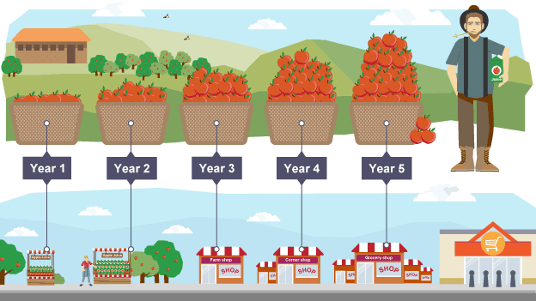
“The apple crop in Somerset has grown by 10 percent last year, over the past five years. This year's growth is expected to be similar, so we'll need to find markets for an additional 10% of apples.”

Over the past five years, data obtained annually have become information and a rate of the apple crop growth has been reported - 10 percent per year. This information is used to forecast the same growth level this year and highlights the need to increase markets. The knowledge is estimation and implementation.

Muller and Maasdorp (2011) highlight the DIK (Data- Information- Knowledge) model's dominance in information science. The first is about the foundation of knowledge theory, the second is about simplicity, and the third is based on worldview accumulation. The diagram below depicts knowledge being extracted from data.

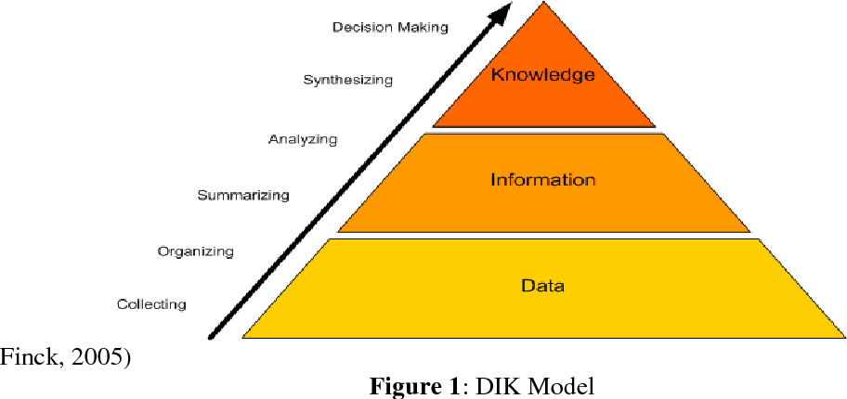

4.Quantitative and qualitative research methods

Qualitative method is about ideas, perceptions and meanings or studies that cannot be numerically identified. This technique is adaptable; you can frequently change your approaches when you gain new knowledge. Can be performed on small samples. However, it cannot be statistically analysed or applicable to larger populations. It is difficult to standardise studies.
Quantitative method is intended to build a more mechanistic interpretation or to evaluate conclusions to gather quantitative data in the study.
This technique can be used to classify massive groups of objects in a systematic manner. Produces replicable information.

5.Primary and secondary research methods

Primary research is any unique information that you obtain to address your study query (e.g., through surveys, observations and experiments). Primary data would most likely be used to investigate a novel study topic.
This technique can be collected to address a particular study query. The sampling and measurement methods are under your control. Besides this, collecting is more expensive and time consuming. Training in methods of data collection is necessary.

Formats of Primary Sources:
- audio: music, interviews, oral stories
- images: photos, videos, visual art
- objects: clothing, tools
- statistics: data, records
- text: letters, documents, maps

Techniques of Collecting Primary Data:
- Experiments
- Telephone surveys
- Written questionnaires and surveys
- Observation
- Personal interviews
- Surveys

Secondary research is knowledge which other researchers have already obtained (e.g., in a government census or previous scientific studies). Secondary data could be a safer option for synthesising current information, analysing historical trends, or identifying patterns on a wide scale.
This process is faster and easier to be using. You may collect information that covers longer time frames and geographic regions. There is no control about how the data is generated. Extra processing is needed to ensure that it fits with the research.

Techniques of Collecting Secondary Data:
- Published sources:
- International
- Government
- Municipal corporation
- Institutional/ Commercial
- Unpublished sources

6.Secondary Research on the use of technology in the modern healthcare workplaces

Secondary sources collect, analyse and evaluate primary information and studies to draw conclusions or to present existing knowledge in a particular discipline or topic. A bibliography can be included in the sources, which will bring you back to the primary research listed in the article.
A summary or description of a research study written by someone other than the analysis investigators is referred to as a secondary source. Determine if the author of the article did not analyse the study mentioned in the article and is instead reporting research conducted by others to find a secondary source.

Examples of secondary sources are:

- reviews, systematic reviews, and meta-analyses
- newsletters and health news sources
- treatment recommendations and standards
- clinical care notes
- patient education information
- government and legal information
- monographs
- entries in nursing or medical encyclopaedias

Dr. Antonio Espingardeiro, Member of the Institute of Electrical and Electronics Engineers, discusses the need for adaptable infrastructure to deal with health problems and how technology is tackling healthcare issues in this post.
Last year, health secretary Matt Hancock warned that if the NHS is to succeed, it would embrace emerging healthcare technologies, such as IoT computers, robotics, and artificial intelligence.
Today's world trends have pressured the healthcare sector to change. As NHSX is used to track and manage the development of Covid-19 in real-time, we have seen the dramatic surge of telehealth platforms, the use of artificial intelligence in diagnosis, and the importance of secure, reliable, and timely data enabled by modern telecommunications.
In general, health-tech innovations are crucial, but their full potential and abilities still must be realised. If this pandemic has shown, there is an urgent need for adaptable technology to deal with such health emergencies now and in the future.
We must recognize a problem that has existed for many countries for many years prior to the recession: an aging population that is growing exponentially before it expands. Before we explore this further. Scalability and consistency of healthcare have always been necessary. With the world's population living longer with more individuals living with non-communicable diseases (alone over 400 million citizens worldwide) requiring routine medical inspections, we need to use technology to make healthcare completely democracy.
The use of machine learning is now in use for artificial intelligence. These medical practitioners to understand certain health conditions better. For example, scientists may investigate the huge amounts of data in the blood of patients with cancer through artificial intelligence programmes. This allows them to diagnose new mutations that can potentially be used to determine those that are more at risk or to recognise those that may need more testing.
Artificial intelligence has the potential to provide patients with more efficient and scaled screening, as well as to assist doctors in the treatment process through pattern recognition. Consequently, they will improve or better coordinate long-term recovery health policies.

7. Conclusion

In conclusion, health care research methods are a key subject for all health workers who want to develop their knowledge in this field. The study offers a concise coverage of key research methodologies and guidance on how research techniques can be understood and applied. Examples are used to demonstrate theoretical and practical research methods.

8.References

- Google.com/Images/University of Wales Trinity Saint David, Available at: https://images.shiksha.com/mediadata/images/1541152532phpaMbjD5.jpeg (Accessed: 01 May 2021)
- Research NHS Available at: https://www.england.nhs.uk/commissioning/supporting-commissioners/research/ (Accessed: 01 May 2021)
- Definition of Research, Western Sydney University (2020), Available at: https://www.westernsydney.edu.au/research/researchers/preparing_a_grant_application/dest_definition_of_research (Accessed: 01 May 2021)
- What is Research? Available at: https://www.questionpro.com/blog/what-is-research/ (Accessed: 01 May 2021)
- John Malagila (2021), DSR Week 5, Topic 1, Lecture notes- Digital Skills and Research Methods- Introduction to Research Methods (18.03.2021), University of Wales Trinity Saint David (Accessed: 02 May 2021)
- Dr. Chipo Mutongi (2016) Revisiting Data , Information , Knowledge and Wisdom ( DIKW ) Model and Introducing the Green Leaf Model, Available at: https://www.semanticscholar.org/paper/Revisiting-Data-%2C-Information-%2C-Knowledge-and-(-)-Mutongi/14b904f0e28b26eaa214fe086f0df90ce502ae53 (Accessed: 02 May 2021)
- Dr. Chipo Mutongi (2016) Revisiting Data , Information , Knowledge and Wisdom ( DIKW ) Model and Introducing the Green Leaf Model, Available at: http://www.iosrjournals.org/iosr-jbm/papers/Vol18-issue7/Version-2/J1807026671.pdf (Accesssed: 02 May 2021)
- Research Methods | Definitions, Types, Examples – Scribbr.com, An introduction to research methods, Available at: https://www.scribbr.com/category/methodology/ (Accessed: 03 May 2021)
- John Malagila (2021), DSR Week 5, Topic 2, Lecture notes- Digital Skills and Research Methods- Data Collection Methods (18.03.2021), University of Wales Trinity Saint David (Accessed: 03 May 2021)
- Data, information and knowledge, Available at: https://www.bbc.co.uk/bitesize/guides/zkfbkqt/revision/1 (Accessed: 03 May 2021)
- Image of data, Available at: https://bam.files.bbci.co.uk/bam/live/content/z8nb87h/large (Accessed: 03 May 2021)
- Image of knowledge, Available at: https://bam.files.bbci.co.uk/bam/live/content/zt4jtfr/large (Accessed :03 May 2021)
- Nursing Resources at the MSU Libraries. (2021), Nursing Resources: Primary and Secondary Sources in Nursing, Available at: https://libguides.lib.msu.edu/nursing/primaryandsecondary (Accessed: 03 May 2021)
- Dr Antonio Espingardeiro, Health Europa,How technology is addressing modern healthcare challenges (2020) Available at: https://www.healtheuropa.eu/how-technology-is-addressing-modern-healthcare-challenges/99553/ (Accessed: 04 May 2021)

