
Leadership and Management - Skills for the Workplace
Module Assignment Submission
Student Name: | Mahbub Ur Rashid
Student Number: | 1815292
Module No: | BMSK6001
Module Title: | Emergent Leadership Skills for the Workplace

Statement of Confirmation of Authenticity
By the act of making this submission, the student declares that this is the work of the student named above. The work has not, in whole or in part, been knowingly presented elsewhere for assessment, or where assessment has been built on a previous assessment, this has been identified. Where materials have been used from other sources it has been properly acknowledged. If this statement is untrue, the student acknowledges that an assessment offence has been committed.
Attention is drawn to the plagiarism and unfair practice policies of both the University and of ILM.
Permission for ILM to use this script
ILM uses learners’ submissions – on an anonymous basis – for assessment standardisation. By submitting, both the centre and the learner agree that ILM may use this script on condition that identifying information is removed. However, if you are unwilling to allow ILM use this script, please refuse by ticking the box: □

Table of Contents
Introduction: 2
Discussion: 3
Model the way: 3
Challenge the process: 3
Inspire a shared vision: 4
Encourage the heart: 4
Enable others to act : 4
Challenges and Advantages of leadership : 5
1. Critically assess a recognised leadership model or theory in relation to its ability to impact on individual’s workplace performance 5
1a. Leadership Models or Theory: 6
2. Evaluate own ability to use a range of leadership styles, in different situations and with different types of people, to fulfil the leadership role 12
2a. Leadership Styles: 12
Autocratic Style: 13
Pros and Cons of Autocratic Leadership: 15
Democratic Leadership: 15
Prons and Cons of Democratic Leadership Style: 17
Laissezz-Fire Leadership: 17
Pros and Cons of Laissezz-fire leadership: 19
3. Assess your own ability to set direction, motivate, delegate and empower others to bring about a workplace change 24
Conclusion: 28
References: 30
APPENDIX A: 35
APPENDIX B: 35

Introduction:

Leadership is the encouraging art for work together by a team of individuals towards the same goal. The contents of able to motivate others and being ready are encapsulated can be called leadership. Leadership on effectiveness is founded on an adapted and unique idea, which are communicated effectively in such a track, in which others get engaged enough to perform as the leader expects. Performance in business is tied in this, it has to consider by every definition. Individuals who are considered as good leaders in the business process are those, who help grow the company's bottom line (Ward, 2020), while profit is not inherently by leadership. Several persons think of leadership as a set of attributes or behaviors. Some believe it is made up of specific talents and information. Numerous people, like the report writer, consider leadership to be a procedure. The approach to leadership as a process emphasizes connection building and social interaction. It represents the concept that leadership is a form of connection, which entails persuading others in a particular way.
Planning, organizing, leading, and controlling/coordinating are the four key functions associated with management in traditional viewpoints. Many educators, practitioners, and writers, on the other hand, disagree with this conventional viewpoint. They distinguish between leading and managing. Others, on the other hand, continue to regard the four functions as intertwined (Malik and Azmat, 2019). Leading is just not to lead the organization it is the hope of employees, trust and respect as well as a willingness to accomplish his/her task dutifully. To lead the organization the leader has too many qualities like mostly concerned with the advancement of everyone else, foster strategic thought, action, and innovation, self-awareness and a desire to improve oneself, Exercising excellent cross-cultural communication, and civic-minded & ethical, etc (Eastwood, 2019). Therefore according to Dwight D. Eisenhower “Leadership is the art of getting someone else to do something you want to be done because he wants to do it.” As one takes ideas of impacts a step farther, this involves engaging others, motivating and encouraging others to accomplish activities they enjoy. Whenever this happens, you know you've succeeded as a leader (Mighty Raising, 2012).

Discussion:

This report demonstrates the meaning of leadership, how can a leader motivate his/her employee so that the target goal can be achieved within a fixed time. What the qualities of the leaders. Various styles of leadership, methods, Advantages of leadership, and challenges as well. The Kouzes and Posner leadership Style, Comparison between Transformational Leadership styles and other Autocratic leadership, Democratic, Transaction, Laissezz-fire leadership styles also demonstrate in this. what kind of situation leaders have to adopt which leadership methods, or styles and what is the main theme of the leadership also shown in this. Goleman's Six Leadership Styles and Managerial Grid leadership styles are also provided.
In 1983, Kouzes and Posner created their first leadership surveys. Leaders were asked what they did when they were at their best in these surveys. They've questioned over 75,000 people so far to document the behaviors of excellent leadership. In 1987 their book the Leadership Challenge was published. in this book, they mentioned Exemplary Leadership's Five Practices and they are :

Model the way:

Show the Path Leaders construct a series of standards for how others shall be treated and adhere to them. They provide guidelines for how things should be done and set an example for others to follow. They understand how regulation can stifle progress and work to remove unnecessary roadblocks to genuine growth. They demonstrate what they expect of others and provide an opportunity for them to succeed.

Challenge the process:

According to this, the status quo does not satisfy leaders. They are always on the lookout for innovative methods to better their company. This necessitates trial and error as well as taking calculated risks. Leaders are also forgiving of failures and mistakes because they understand the nature of risk-taking.

Inspire a shared vision:

Leaders are confident in their ability to influence others. They develop a vision for their organization's future that they utilize to motivate their followers. They persuade via charm, gravity, and subtle persuading at their finest. leaders are conscious, however, of the need for practical initiatives and hence encourage action.

Encourage the heart:

Changes that great leaders attempt to create are difficult to achieve and generally challenging. As a result, they employ strong degrees of psychological intelligence to retain motivation as well as resiliency and perseverance by value hard work and applaud accomplishments.

Enable others to act :

To inspire collaboration and establish productive teams, leaders actively involve others. leaders understand the importance of mutual respect to develop outstanding efforts (Clayton, 2017). As a result, they foster a climate of trust and confidence. They encourage and grow their employees so that they believe competent as well as trustworthy.

Challenges and Advantages of leadership :

CHALLENGES:  • generating motivation.  • Taking charge of change.  • Team management.  • Others' development.  • Managing several viewpoints. (CHIRIMBU, 2014) | ADVANTAGES:  • Making quick decisions.  • Job satisfaction improved.  • Boost overall productivity.  • Enhance the quality of an organization.  • Group motivation high. (Khan1, Khan2, and Quresh, 2015)

1. Critically assess a recognised leadership model or theory in relation to its ability to impact on individual’s workplace performance

1a. Leadership Models or Theory:

There are a variety of leadership models or theory, which would be applied in the organization as well as the leadership style. Some of the organizations applied Autocratic Leadership, some of the Democratic, some Transformational Leadership, and some of others leadership.
In the organization, leadership models and theories can assist employees to become more productive in the workplace, especially whether they work with or manage others regularly. There are a variety of theories and models of leadership likes the Trait Theory, The theory of Great man, The theory of Behavioural, Theory of Transactional, and The Theory of Transformational, etc. Among these, the Theories or Models of Transformational Theory seem quite different. The relationship theory also can be defined as a transformational leadership theory, which demonstrates leadership on effectiveness outcome the relationships positive among team members and leaders. Leaders of Transformational inspire and motivate team members by their passion and skills. Leaders remain in the same high standards, which they put team members, therefore, Leaders can be called role models for their teams. (Indeed Editorial Team, 2021a). It affects followers favorably and beneficially by the ultimate turning goal to them. while exercised in form of purest, amend team members' motivation, morals, and performance via a variety of processes is also called Transformational leadership.
At first, the Transformational leadership concept was developed in 1973 by James V Downton, Afterward in 1978 by James MacGregor Burns expanded it on political leader's descriptive research, but in the psychology of organizational, it is now utilized. Leadership on Transformational, according to Burns, is a process in which "leaders and followers assist each other in achieving a greater level of morale and motivation." (George, 2006)
Transformational leadership has four elements are Inspirational motivation, Idealized Influence, Intellectual Stimulation, and Individualized Consideration.

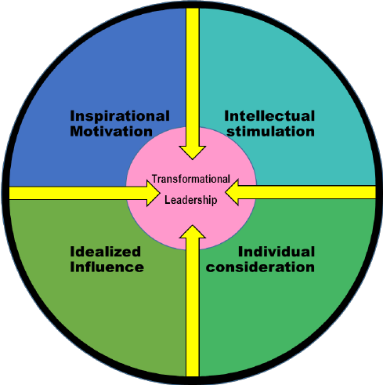
Figure (i): Transformational Leadership

- Motivational Inspirational :

Transformational leaders can communicate to team members by their strong vision. They might drive in objectives achieve by retaining their team member the enthusiasm of same.

- Intellectual Stimulation:

In this, Transformational can push team members to be creative and also question the current quo. To take advantage of fresh learning possibilities and try new things the leader encourages his/her team members.

- Idealized Influence :

In this, transformational leaders can be regarded as role models by the team members. Followers want to internalize leaders' values and want to emulate leaders because of the trust and respect towards their leader by team members.

- Individualized Consideration:

As part of transformational leadership, Individual team members have to be encouraged and supported. Transformational leaders maintain lines of communication open so that followers feel free to express ideas and leaders may directly acknowledge each follower's unique contributions to develop supportive connections lines of communication openness by Transformational leaders maintain-ness (Cherry and Gans, 2020).

Because of these reasons the Transformational leadership(TL) is unique. This style of leadership is a necessary precondition for a group's collective confidence or strength to be effective when confronted with challenging situations. TL can bring about major organizational transformation by acting as change agents, increasing followers' intrinsic desire and devotion, and introducing a new image or picture of the future. Because of these reasons the Transformational leadership is unique and different from other theories and models. In Trait Theory, good leaders share a combination of characteristics of personality, which support the other's arrangements around a goal of commonality. Motivations and personality traits, abilities and skills, and social conduct are included characteristics (Graduate Studies, no date). But, Transformational theory leaders would be a focus on Employee and how to maintain relationship and encourage them because employee plays a very important role in achieving the organization goals. In the theory of great man leadership, with the required characteristics some people are born, from others that distinguish them, and for their ascending to positions of power and authority these characteristics are responsible. Despite all circumstances for or his people, a hero is someone who achieves goals. According to the belief, due to a unique set of abilities, in positions of authority persons are deserving of their position. It implies that almost all good leaders possess these characteristics, despite where and when he or she lived or what role they played in history (Madanchian et al., 2016). But, In Transformational Theory, it is not included that the leader has to born not made, according to the Research of millions of university leaders are 30% genetic and 70% are learning (Di Giulio and Giulio, 2014). In the Great man theory, A leader is only appealing if his or her supporters recognize him or her for what he or she is; followers must identify with the leader's goal (Halaychik, 2016). In the theory of behavioral leadership, rather than their intrinsic characteristics a leader's success is determined by their actions and behaviors in response to a specific scenario,is central to theory of behavioral leadership evaluating as well as observing a leader's actions and behaviors. According to this belief, leaders are created rather than born. According to philosophy proponents anybody could develop and specific characteristics implement to become an excellent leader (Indeed Editorial Team, 2021b). Employee performance is typically boosted by this leadership approach. However, little or no employee-centered leadership is evident, which has a detrimental impact on performance (Ezenwa, 2017). And, TL theory emphasizes leaders who are primarily concerned with their relationships with others. They frequently serve as mentors to employees, setting aside time to speak with them and assisting them in achieving their goals (Ahmed Khan, Nawaz, and Khan, 2016).

Managerial leadership can be also called Transactional leadership , it is a management style where rewards and penalties to motivate his or her employees the executive uses for best perform. Employees will accomplish their duties as the transactional leader expects them to in exchange for the leader providing something the workers want, like pay, according to the notion (Pratt, 2021). It may encourage adherence to practice norms by applicable in various of situation transactional leadership style but not innovation necessary. A transformational leadership method establishes a vision and motivates subordinates to go above and beyond what is expected, whereas transactional leadership emphasizes extrinsic incentives for job performance. Transformative leadership influences perceptions by encouraging the embrace of innovation via the creation of excitement, trust, and transparency, while transactional leadership influences perceptions by reinforcing and rewarding innovation (Farahnak et al., 2020).

For development as well as survival, environmental knowledge and awareness have to expand by organization, as well as broad organizational changes implement. In the scenario of this, the responsibility of leader in moving the forward business ,recognizing the environmental change need, and facilitating the changes that is necessary becomes more apparent. Transformational leaders are those who can change things for better. In the organization Transformational leaders can improve the quality of work-life by increasing fairness and awareness of the employee . Transformational leadership has gotten a lot of publicity in the last few decades. The transformational leadership style is credited with encouraging teamwork, developing new ideas, sharing opinions, and effectively dealing with emergencies. Transformational leadership is more adaptable, motivating, and believes in the opinions of employees than pragmatic leadership. So, in today's environment, while the entire world is dealing with the Covid-19 global healthcare issue, numerous people see transformational leadership as a beneficial tool for continuing company functions by assisting employees and maintaining strategies of the business (Korejan and Shahbazi, 2016).

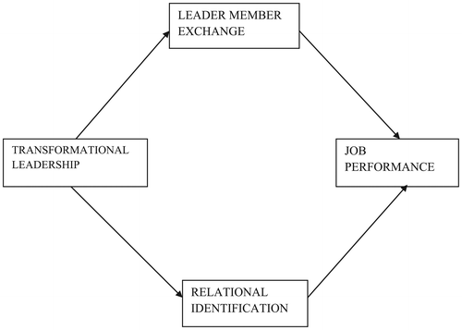
Figure (ii): Transformational Leadership theory
This figure (i)shows the bound among transformational leadership(TL) & other factors at the workplace like the Job Performance of the employee. Many organizations concluded that after applying this leadership method the job performance of the employee has been increased (Jyoti and Bhau, 2015).
The variables' Mean, Standard Deviation, and Correlation are displayed in a flowing table (i), which shows Job performance has a positive link with transformational leadership (r = 0.380, P 0.01).

Variables Mean Standard Deviation TL JP
Transformational Leadership 3.322 0.805 1
Job Performance 3.657 0.585 0.380** 1
Table (i) { note: At the level of 0.001, significant correlation (2-tailed), JP ( job Performance), TL ( Transformational Leadership)}

As the report writer’s organization primarily adopted the other leadership model or theory, the result of job performance by the employee does not seem to increased or not overly fruitful, but after applying the transformational leadership model, the job performance of the colleagues has increased dramatically (CHAND, 2015). The relationship between leader and subordinates maintains beautifully and the leader understands the rule of managing the organization. Individualized consideration, Idealized influence, inspirational motivation and intellectual stimulation are the leadership characteristics that impact the commitment of fewer experience followers in the same manner as they influence the commitment of more experienced followers in the Organization (Yücel and Richard, 2013). The report writer’s company's employees are empowered to participating in decision-making by transformational leaders, which leads to increased commitment to the organization. It contributes toward more empowered and engaged employees to participate in decision-making to them (Yasir et al., 2016).

2. Evaluate own ability to use a range of leadership styles, in different situations and with different types of people, to fulfil the leadership role

2a. Leadership Styles:

A leadership style demonstrates how leaders motivates, guides, directs and manages people. To inspire change in political and social and also to work hard inspire people, new things development, and innovate (Dinibutun, 2020) the great leaders plays a vital role. It is how individuals are directed, plans are implemented, and people are motivated. It covers the whole pattern of explicitly and implicitly behaviors taken by the leader, as seen by the workforce. By changing the environment of the world, business’s style of doing business also has changed (Kleefstra, 2019). There are many leadership styles like Leadership Style of Lewin, The Blake Mountain Managerial Grid, Path-Goal Theory, Six Emotional Leadership Style, Etc (Burton, Kane and Borland, 2020).
Here the report writer would choose Lewin’s Leadership style to fulfill the leadership role in different kind of situation to different type of people. In 1939 a group of academics led by psychologist Kurt Lewin set out to uncover various styles of leadership. This early study was extremely helpful in establishing three basic leadership styles. more unique varieties of leadership reveled subsequent research which have work as a springboard for more defined leadership theories and they are Autocratic Leadership, Democratic, and Laissezz-Fire Leadership.
(See Appendix A and B for the report writer’s Leadership style and skill’s).
Leaders have to adopt different leadership styles in different kinds of situations, while the report writer would apply Autocratic , Democratic, and other styles.

Autocratic Style:
Leaders set clear requirements in autocratic, authoritarian how it have to be done and what have to be done when it must be done. It emphasizes the authority of leader and control of followers. The leader and the employees are likewise clearly separated. Without communicating the members, Authoritarian leaders make choices and with little or no influence from them. For group decision-making, when there is minimal time or the leader the most knowledgeable period to group of member, best option is leadership of authoritarian, therefore I would like to choose in this type of situation. Whenever the necessitates circumstance choices in quick and decisivible measures, the style of autocratic is beneficial. On the other hand, even hostile workplaces, frequently creates dysfunctional and pitting followers against the overbearing boss (Burnes, 2020). The authoritarian leadership style is best suited to situations requiring tight control and limited room for error. Rigid rules can keep individuals out of harmful path when situations are unsafe (Dyczkowska and Dyczkowski, 2018).
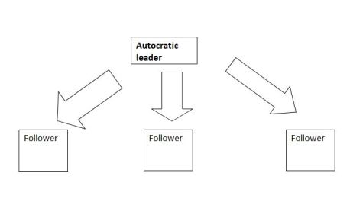
Figure (iii): Autocratic Leadership Style

Pros and Cons of Autocratic Leadership:

PROS-  • leadership chain clear .  • workplace expectations clear.  • quick decision-making.  • effective leadership of inexperienced employees. | CONS-  • May Generate Worker Resentment.  • May Put Pressure on the Leader.  • Flexibility is limited or non-existent.  • Could Lead to Employee Dissatisfaction. (Al Khajeh, 2018)

Democratic Leadership:

Shared leadership or Participative leadership can be also called as a Democratic leadership, it is a leadership style, The report writer would like to choose to fulfill the role, which members of team participate decision-making activity. Including private organizations, government, and schools, It could found in a variety of settings . When members of the group are knowledgeable and enspire to their knowledge share, leadership of democratic works the best. To participate, devise a strategy, and then select the right action path of (Sharma and Singh, 2013) it also gives a lot times in a crucial manner role. For working democratically as a company Google is known . In crucial company decisions employees will be participate in lengthy talks and sessions of brainstorming (Akparep, Jengre and Mogre, 2019). Democratic Leadership style Better in a circumstance in which the organization employs highly qualified and experienced individuals who can provide valuable feedback and contributions (Udovita, 2020). Steve Jobs the Co-founder of the Apple Company known as a Democratic Leader.


Figure (iii): Democratic Leadership Style

Prons and Cons of Democratic Leadership Style:

PROS-  • More perspectives are brought to the forefront.  • Strengthens group bonds  • It stimulates higher levels of stimulates  • higher levels of engagement  • participation in practically any workplace. (Solomon and Steyn, 2017) | CONS-  • Procrastination can happen.  • can make feel uncomfortable  • would not imply that the optimal solution is always available.  • Many times, the definition is ambiguous.  • Team members may begin to doubt the leadership's skills. (Bucata and Rizescu, 2016)

Laissezz-Fire Leadership:

The precise antithesis of authoritarian leadership The report writer would choose Laissezz-fire leadership. Rather all of the decisions for an organization made by a leader in single, limited number of decisions and allow employees to select acceptable solutions in the workplace by laissez-faire leaders. For example, a Chief executive officer or executive director who exhibits laissez-faire leadership tends to employ or appoint top executives and department heads with extensive experience in their industries. Such people must be capable of running respective divisions. They've been given very little oversight to do so. This style mainly suitable for Construction, Military, and Manufacture (Tayfur Ekmekci and Tosunoglu, 2016). When the group's members are more knowledgeable, its role is especially well than the group's leader. To demonstrate their extensive knowledge and expertise on the subject at hand the uninhibited approach allows to employees. For example, Leaders and supervisors at work will be step back and allow their employees make their own decisions as well as setting deadlines. They don't give much in the way of feedback (Jarc, 2015).
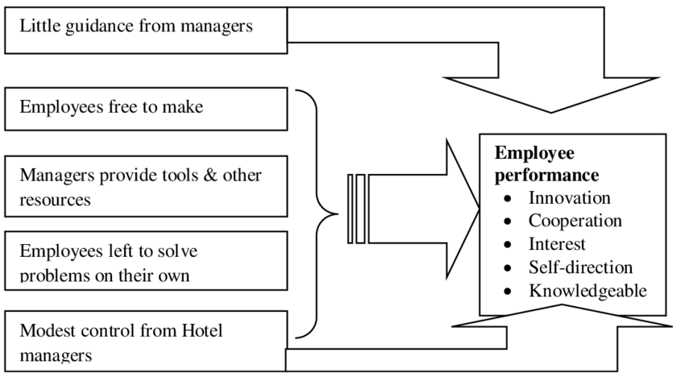
Figure (iv) : Laissez-faire Leadership Style

Pros and Cons of Laissezz-fire leadership:

PROS:  1. Build-up Networking.  2.Decision-Making Freedom.  3. Creativity is attracted to this item. | CONS:  1. Employee apathy.  2. Lacking understanding of their roles.  3. Weak levels of accountability.

We often use the democratic leadership model because in the report writer’s workplace, most of the employees are qualified and creative, they occasionally help the report writer to clear situations and take any decisions. This style of leadership helps in various ways like employee high productivity, less need for management and formalized rules and procedures, development of skilled employees eager to perform their all, who think for themselves and seek responsibility to develop subordinates tendency development (Cherry, 2021). The performance of the employee can decide the future of the organization, so the leader should always have to give priorities to employees.
Here is given how the style of Democratic leadership impacts the employee performance.
Table(ii): The Impact of Democratic Leadership Style on Subordinates' Job Performance (N=74)
SN |  | Statement of items |  | Categories |  |  |  | Total  Score  xxx | Mean  $\overline{(x}$)  (Total Score÷74) | Remarks
 |  |  |  | SA  (4) | A  (3) | D  (2) | SD  (1) | Total  Score  xxx | Mean  $\overline{(x}$)  (Total Score÷74) | Remarks
1  2  3  4  5 | Results in high employees’  productivity |  | Freq. | 17 | 24 | 15 | 18 | 188 | 2.54 | Positive
1  2  3  4  5 |  |  | Score | 68 | 72 | 30 | 18 | 188 | 2.54 | Positive
1  2  3  4  5 | the need for control and formal rules, and procedures reduce. |  | Freq. | 16 | 23 | 19 | 16 | 187 | 2.53 | Positive
1  2  3  4  5 |  |  | Score | 64 | 69 | 38 | 16 | 187 | 2.53 | Positive
1  2  3  4  5 | low employees turnover and absenteeism results. |  | Freq. | 15 | 18 | 25 | 16 | 180 | 2.43 | Negative
1  2  3  4  5 |  |  | Score | 60 | 54 | 50 | 16 | 180 | 2.43 | Negative
1  2  3  4  5 | who are willing to give their best development of the competent people. |  | Freq. | 23 | 19 | 15 | 17 | 196 | 2.65 | Positive
1  2  3  4  5 |  |  | Score | 92 | 57 | 30 | 17 | 196 | 2.65 | Positive
1  2  3  4  5 | who seek responsibility and think for themselves, tents to develop subordinates. |  | Freq. | 28 | 20 | 14 | 12 | 212 | 2.86 | Negative
1  2  3  4  5 |  |  | Score | 112 | 60 | 28 | 12 | 212 | 2.86 | Negative
Note: Fieldwork by researchers in 2017; criterion score = 2.50. (Dolly C and Nonyelum P., 2018a)

In The reort writer’s experience, this democratic leadership style is very useful. Subordinates' performance improves when a democratic leadership style is used. As a result, leaders are urged to use a style of democratic leadership and team in decision-making process allow to participate members of team because it has been proven that this type of leadership improves employee performance.
But sometimes The report writer have to use an autocratic leadership style because sometimes employee who does not have skills and hope for the leader to order then, autocratic leadership have to use. For example, to comply with the rules and regulations organizations have to apply autocratic leadership because the rules and regulations are most and very important to apply by everybody, there is no compromise in it. The report writer’s real-life experience has some in it, once the report writer’s company had made policy for the employee but some of the employees do not want to comply it, therefore, The report writer have to apply autocratic leadership style for them.

Here are given How the Automatic leadership style and performance of the subordinates in the below table.

Table(iii)Style of Autocratic leadership affects on job performance of employee (N=74).
SN | Items Statement |  | Categories |  |  |  | Total  Score  xxx | Mean  $\overline{(x}$)  (Total Score÷74) | Remarks
SN |  |  | SA  (4) | A  (3) | D  (2) | SD  (1) | Total  Score  xxx | Mean  $\overline{(x}$)  (Total Score÷74) | Remarks
1  2  3  4  5 | It fosters animosity and production stifling counter-forces. | Frequency | 10 | 11 | 34 | 19 | 160 | 2.16 | Negative
1  2  3  4  5 | It fosters animosity and production stifling counter-forces. | Scores | 40 | 33 | 68 | 19 | 160 | 2.16 | Negative
1  2  3  4  5 | frequently contributes to unfavorable attitudes toward work. | Frequency | 11 | 16 | 28 | 19 | 167 | 2.26 | Negative
1  2  3  4  5 | frequently contributes to unfavorable attitudes toward work. | Scores | 44 | 48 | 56 | 19 | 167 | 2.26 | Negative
1  2  3  4  5 | Employees who are reliant and uncreative are more likely to be developed, who are hesitant to look for responsibilities. | Frequency | 22 | 15 | 20 | 17 | 190 | 2.57 | Positive
1  2  3  4  5 |  | Scores | 88 | 45 | 40 | 17 | 190 | 2.57 | Positive
1  2  3  4  5 | As a result, communication is guarded and distorted. | Frequency | 10 | 12 | 26 | 26 | 158 | 2.14 | Negative
1  2  3  4  5 | As a result, communication is guarded and distorted. | Scores | 44 | 36 | 52 | 26 | 158 | 2.14 | Negative
1  2  3  4  5 | Rules and procedures occupy the minds of subordinates. | Frequency | 21 | 24 | 17 | 12 | 202 | 2.73 | Positive
1  2  3  4  5 | Rules and procedures occupy the minds of subordinates. | Scores | 84 | 72 | 34 | 12 | 202 | 2.73 | Positive
Note: Fieldwork by researchers in 2017; criterion score = 2.50. (Dolly C and Nonyelum P., 2018b)

3. Assess your own ability to set direction, motivate, delegate and empower others to bring about a workplace change

There are various famous theorists, who describe the leadership to delegate, direct, encourage, and empower others to effect change in the workplace. Leaders are the bonemarrow of the company, their style of leadership decides the future of the organization, therefore before applying leadership style in the company, the leader has to study and think carefully about which style would be best for the situation.
one of the theorists who describe leadership is Daniel Goleman. The six styles of leadership introduced by Daniel Goleman's, which is based on Emotional Intelligence and are the most useful styles of leadership the report writer come across. To some level, Goleman's all of styles of leadership can be be applied beautifully. The situation, depending on the circumstances, and the involved persons , they should be used in varying degrees. The report writer effectively used this framework to help improve leadership tactics and talents. According to Goleman, the Six styles of leadership are Visionary styles of Leadership, Commanding styles of Leadership, Coaching styles of Leadership, Democratic styles of Leadership, Pacesetting styles of Leadership, and Affiliative styles of Leadership.

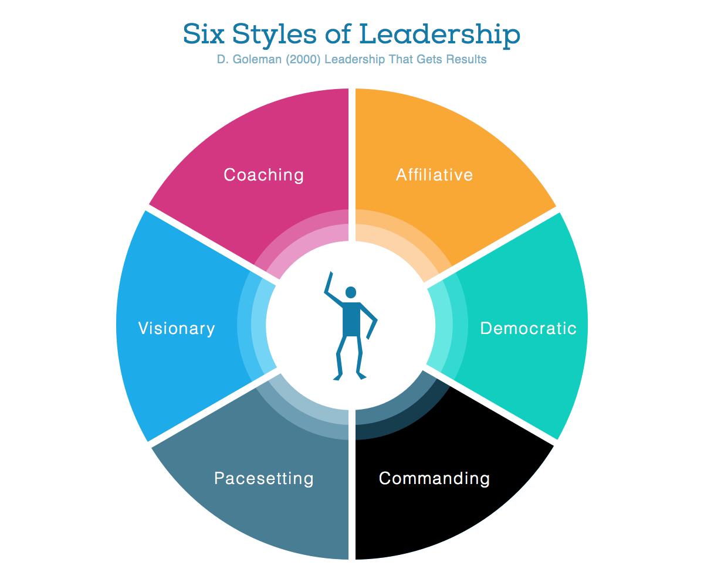
Figure(V): Goleman Six Style of leadership

- Visionary styles of Leadership :

The visionary style of leadership is also known as authoritative style of leadership. It includes a component of implementation and fixing things. Visionary leadership that is truly excellent takes a lot of Emotional Intelligence on the part of the leaders. Such an approach, more than any other, necessitates strong communication abilities. It creates reverberation by drawing others along and assisting them in achieving a common objective. Clarity, dedication, rewards, Flexibility, and pretty much all other components of a group culture have been shown to have a strong association in research. In the report writer’s current position, the report writer frequently employ visionary leadership. This could extend from offering a strategic vision to creating an image for workplace change on a more short-term basis.

- Commanding Leadership Style:

Such type of leadership is sometimes referred to be directive or coercive. All of the decisions are made by the leader, their squad is given commands with no justification. The dominating leadership style emphasizes strong and strict control and follow-up, as well as great clarity in roles, rules, and expectations. Because of its high clarity and implementation pace, this style generates resonance through reducing worries and anxiety in stressful situations.

- Coaching Leadership Style:

Leaders can get the team to commit, engage, and be loyal if they use this leadership style. Members of the team will be nurtured to become coaching leaders in the future if they are properly developed. In the workplace, coaching style of leadership often in possible times the report writer try to employ,but like with the styles of other , we should try combination of them rather than just one.

- Democratic style of Leadership :

The Democratic style of leadership is a component to various other styles of leadership theories, including the Kurt Lewin Leadership Styles. By appreciating everyone's opinion, the democratic leadership style develops resonance. This level of participation usually results in a high level of dedication and engagement among the team members. According to Goleman et al research's democratic leadership and all dimensions of team climate are positively related.

- Pacesetting Leadership Style:

The pacesetter is completely focused on results and performance. The leaders want nothing less than the best from their staff members. It helps to the group's resonance by allowing them to work together to overcome problems and achieve goals, giving them a sense of achievement and competence.

- Affiliative Leadership Style:

Affiliative leadership is much highly concerned with individuals & connections. The affiliative leader establishes deep bonds and relationships with the members of the team and among them while concentrating on making everyone satisfied. It fosters group faith and unity, elevating group work to new heights. This leadership style includes a lot of feedback, acknowledgment, and incentives that help to foster group spirit and togetherness (Lindberg, 2021).

Another theorist who describes leadership is Managerial Grid of Blake and Mouton. The managerial grid, which was first conceived in the 1960s, has gone through several revisions (Blake & Mouton, 1964, 1978, 1985, 1994). It is well-known. Considered a serious and significant examination of the behavior of a leader. There are 5 components of the Managerial Grid leadership style. This instrument is used by organizations to analyze individual managers and determine their management styles to assist them in developing leadership excellence. Individuals can analyze themselves using questionnaires that ask questions such as how important completing a task is to them, as well as how much they love challenges and coaching employees. It could assist leaders to know their managerial weaknesses and strengths, allowing managers, their supervisors, and HR partners to suggest training and support that will assist them to develop (Lindberg, 2021).

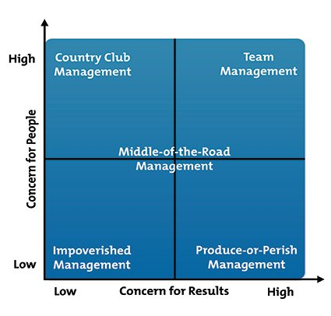
Figure(Vi): Managerial Grid Leadership Style
1.1—Impoverished Management: Emphasizes a situation where both results and persons are of little importance. This leader's apathy causes him to be distant from their subordinates and unconcerned about his achievement.
1.2—Country Club Management: This mix of low care for results and great care towards individuals produces a leader who is more concerned with fair trading even than completing duties. The leader makes an effort to establish a welcoming and friendly workplace.
1.3—Authority-Compliance Management: It reflects a high level of interest for outcomes but a low level of care for people. The commanding leadership style is defined by dictating orders to subordinates without showing care or empathy.
1.4—Middle of the Road Management: Leaders who strike a balance between concern for results and satisfying relationships exhibit this style of compromise. The team consists of, Even so, there is the possibility for more achievement.
1.5—Team Management: Production and people are given a lot of attention in this. The most satisfying work environment is achieved by striking the right balance between developing human relationships and achieving effective results (Seidel et al., 2019).
These two theories of theorists are very famous in many organizations. Safra the CEO of oracle corporation has been applied the Goldman leadership style. Some other famous company also has been applying the managerial grid leadership style. Sometimes the report writer at his workplace applies Goleman's six leadership styles and sometimes the managerial grid leadership style and other leadership styles according to the situation because one leadership style does not always work in every kind of situation. So, according to the situation leaders always tried their best to manage the organization. In the process of workplace change, the leader has to motivate, provide direction, empower and delegate others, for that leader has to adopt the correct leadership method. leadership is about opening the heart not so much about methods and techniques as inspiration of others and oneself. Leadership is not processes but a experiences of human. Leadership is a human activitivities not a program or a formula, which comes from considers the hearts of others. It is not a routine but an attitudes. (Rogers, 2021)

Conclusion:

Lastly, Leadership is the key to every organization's success and future, without proper leadership the organization is like without root, the organization has the fear of not able to run or vanish in the business world. The Autocratic, Democratic, Transaction, Transformational, Managerial Grid, Goleman Six Leadership Style, Laissezz-fire leadership style have its unique style, so the from the businessman to the other sector leaders also has been applying various methods to lead to the organization. Leadership widely held to be societal functioning and success and to be essential for efficient organizational . It may say to guide a set of persons toward a purpose of single leadership is the power . Individuals utilize unique qualities of leadership for accomplish goals of organization. To be committed and enthusiastic leadership inspires people for achieving objectives. Among the leader interplay , the environment and the followers is how to achieved leadership . While being still like that the leadership roles can operate in various ways whenever it comes to the company’s development. When it can not provide a proper of framework organization and managing will be beyond backing if leadership did not serve as the backbone of ideas, leadership is meaningless.

References:

Ahmed Khan, Z., Nawaz, A. and Khan, I. (2016) ‘Leadership Theories and Styles: A Literature Review’, Journal of Resources Development and Management, 16(1), pp. 1–7. [ Accessed 18th July 18, 2021]
Akparep, J., Jengre, E. and Mogre, A. (2019) ‘The Influence of Leadership Style on Organizational Performance at TumaKavi Development Association, Tamale, Northern Region of Ghana’, Open Journal of Leadership, 08(January), pp. 1–22. doi: 10.4236/ojl.2019.81001. [ Accessed 18th July 18, 2021]
Bucata, G. and Rizescu, A. M. (2016) ‘Management Style as a Triggering Factor for Organization Effectiveness and Efficiency’, Journal of Defense Resources Management (JoDRM), 7(2), pp. 159–164. [ Accessed 18th July 18, 2021]
Burnes, B. (2020) ‘The Origins of Lewin’s Three-Step Model of Change’, Journal of Applied Behavioral Science, 56(1), pp. 32–59. doi: 10.1177/0021886319892685.
[ Accessed 18th July 18, 2021]
Burton, L. J., Kane, G. M. and Borland, J. F. (2020) ‘Sport leadership in the 21st century (2nd edition)’, Journal of Sport Management, 34(5), pp. 502–503. doi: 10.1123/JSM.2020-0108. [ Accessed 18th July 18, 2021]
CHAND, T. (2015) ALTERNATIVE ENERGY AND EFFECTIVE IMPLEMENTATION OF ENVIRONMENTAL. Daayitwa. [ Accessed 18th July 18, 2021]
Cherry, K. (2021) What Is Laissez-Faire Leadership?, Very Well Mind. Available at: https://www.verywellmind.com/what-is-laissez-faire-leadership-2795316. [ Accessed 18th July 18, 2021]
Cherry, K. and Gans, S. (2020) Transformational Leadership, Very Well Mind. Available at: https://www.verywellmind.com/what-is-transformational-leadership-2795313. [ Accessed 18th July 18, 2021]
CHIRIMBU, S. (2014) ‘Challenges of leadership in modern organizations: knowledge, vision, values’, Annals of Spiru Haret University Economic Series, 14(9), p. 39. doi: 10.26458/1434. [ Accessed 18th July 18, 2021]
Clayton, M. (2017) JAMES KOUZES AND BARRY POSNER: LEADERSHIP CHALLENGE, Pocket Book. Available at: https://www.pocketbook.co.uk/blog/2017/08/08/james-kouzes-and-barry-posner-leadership-challenge/.[ Accessed 18th July 18, 2021]
Dinibutun, S. (2020) ‘Leadership: A Comprehensive Review of Literature, Research and Theoretical Framework’, Journal of Economics and Business, 3(1), pp. 44–64. doi: 10.31014/aior.1992.03.01.177. [ Accessed 18th July 18, 2021]
Dolly C, K. and Nonyelum P., O. (2018a) ‘Impact of Democratic Leadership Style on Job Performance of Subordinates in Academic Libraries in Port Harcourt, Rivers State, Nigeria’, International Journal of Research -GRANTHAALAYAH, 6(10), pp. 232–239. doi: 10.29121/granthaalayah.v6.i10.2018.1190. [ Accessed 18th July 18, 2021]
Dolly C, K. and Nonyelum P., O. (2018b) ‘Impact of Democratic Leadership Style on Job Performance of Subordinates in Academic Libraries in Port Harcourt, Rivers State, Nigeria’, International Journal of Research -GRANTHAALAYAH, 6(10), pp. 232–239. doi: 10.29121/granthaalayah.v6.i10.2018.1190. [ Accessed 18th July 18, 2021]
Dyczkowska, J. and Dyczkowski, T. (2018) ‘Democratic or Autocratic Leadership Style? Participative Management and its Links to rewarding Strategies and Job Satisfaction in SMEs’, Athens Journal of Business & Economics, 4(4). doi: 10.30958/ajbe.4.2.5. [ Accessed 18th July 18, 2021]
Eastwood, B. (2019) The 5 Qualities All Successful Leaders Have in Common, Northern University Blog. Available at: https://www.northeastern.edu/graduate/blog/top-5-leadership-qualities/.[ Accessed 18th July 18, 2021]
Ezenwa, J. (2017) ‘Effect of Leader Behaviour on Employee Performance’. Academia, pp. 1–27. [ Accessed 18th July 18, 2021]
Farahnak, L. R. et al. (2020) ‘The Influence of Transformational Leadership and Leader Attitudes on Subordinate Attitudes and Implementation Success’, Journal of Leadership and Organizational Studies, 27(1), pp. 98–111. doi: 10.1177/1548051818824529. [ Accessed 18th July 18, 2021]
George, W. (2006) ‘Transformational Leadership’, Enterprise Transformation: Understanding and Enabling Fundamental Change, pp. 69–77. doi: 10.1002/0470007826.ch4. [ Accessed 18th July 18, 2021]
Di Giulio, J. and Giulio, D. (2014) ‘Are leaders born or made?’, Leadership and Business Acumen, (1), pp. 1–6. [ Accessed 18th July 18, 2021]
Graduate Studies, G. S. C. (no date) ‘Trait, contingency, behavioral, and full-range theories’, in Cultivating Your Leadership Capabilities. Granite State College.
[ Accessed 18th July 18, 2021]
Halaychik, C. S. (2016) ‘Chapter 1 - Leadership Theories’, in Halaychik, C. S. B. T.-L. in L. L. (ed.) Lessons in Library Leadership. Chandos Publishing, pp. 1–56. doi: https://doi.org/10.1016/B978-0-08-100565-1.00001-7. [ Accessed 18th July 18, 2021]
Indeed Editorial Team (2021a) ‘6 Leadership Theories for Career Growth’, Indeed.
[ Accessed 18th July 18, 2021]
Indeed Editorial Team (2021b) ‘What is Behavioral Leadership Theory? Definition and Types of Behavioral Leadership’, Indeed. [ Accessed 18th July 18, 2021]
Jarc, J. (2015) Laissez-Faire Leadership. [ Accessed 18th July 18, 2021]
Jyoti, J. and Bhau, S. (2015) ‘Impact of Transformational Leadership on Job Performance: Mediating Role of Leader–Member Exchange and Relational Identification’, SAGE Open, 5(4), pp. 1–13. doi: 10.1177/2158244015612518. [ Accessed 18th July 18, 2021]
Al Khajeh, E. H. (2018) ‘Leadership styles on organizational performance’, Journal of Human Reseources Management Research, 2018, pp. 1–10. doi: 10.5171/2018.687849. [ Accessed 18th July 18, 2021]
Khan1, M. S., Khan2, I. and Quresh, Q. A. (2015) ‘The Styles of Leadership: A Critical Review’, Public Policy and Administration Research, 05(3), pp. 1–7. doi: 10.2307/2372326. [ Accessed 18th July 18, 2021]
Kleefstra, A. (2019) ‘A Literature Review into Leadership Styles Discussed in the Past Five Years’, Open Journal of Social Sciences, 07(1), pp. 180–190. doi: 10.4236/jss.2019.76015. [ Accessed 18th July 18, 2021]
Korejan, M. and Shahbazi, H. (2016) ‘An analysis of the transformational leadership theory’, Journal of Fundamental and Applied Sciences, 8(August), p. 452. doi: 10.4314/jfas.v8i3s.192. [ Accessed 18th July 18, 2021]
Lindberg, C. (2021) The Six Leadership Styles by Daniel Goleman, Leadership Ahoy. Available at: https://www.leadershipahoy.com/the-six-leadership-styles-by-daniel-goleman/.[ Accessed 18th July 18, 2021]
Madanchian, M. et al. (2016) ‘Leadership Theories; an Overview of Early Stages’, Recent Advances in Energy, Environment and Financial Science, (2), pp. 198–201.
[ Accessed 18th July 18, 2021]
Malik, M. and Azmat, S. (2019) ‘LEADER AND LEADERSHIP: HISTORICAL DEVELOPMENT OF THE TERMS AND CRITICAL REVIEW OF LITERATURE’, LEADER AND LEADERSHIP, 5(12), pp. 16–32. [ Accessed 18th July 18, 2021]
Mighty Raising (2012) What is Leadership: 18 Definition of Leadership from the Experts, Mighty Raising. Available at: http://mightyrasing.com/what-is-leadership-18-definition-of-leadership/.[ Accessed 18th July 18, 2021]
Mohammed, R. et al. (2018) ‘Leadership in the organization: A Conceptual Review’, Leadership in the organization: A Conceptual Review, 2(Octobe), pp. 52–59. [ Accessed 18th July 18, 2021]
Pratt, M. K. (2021) ‘Transactional leadership’. [ Accessed 18th July 18, 2021]
Rogers, M. G. (2021) Monday’s Leadership Quotes, Teamwork Leadership. Available at: https://www.teamworkandleadership.com/2009/06/mondays-leadership-quotes.html. [ Accessed 18th July 18, 2021]
Seidel, A. et al. (2019) ‘How can general leadership theories help to expand the knowledge of lean leadership?’, Production Planning and Control, (5), p. 25. doi: 10.1080/09537287.2019.1612112. [ Accessed 18th July 18, 2021]
Sharma, D. and Singh, D. (2013) ‘A Study on the Democratic Style of Leadership’, INTERNATIONAL JOURNAL OF MANAGEMENT & INFORMATION TECHNOLOGY, 3(1), pp. 54–57. doi: 10.24297/ijmit.v3i2.1367. [ Accessed 18th July 18, 2021]
Solomon, A. and Steyn, R. (2017) ‘Leadership style and leadership effectiveness: Does cultural intelligence moderate the relationship?’, Acta Commercii, 17(1), pp. 1–13. doi: 10.4102/ac.v17i1.453. [ Accessed 18th July 18, 2021]
Tayfur Ekmekci, O. and Tosunoglu, H. (2016) ‘Laissez-Faire leaders and organizations: how does Laissez-Faire leader erode the trust in organizations’, Journal of Economics Finance and Accounting, 3(March), pp. 89–99. doi: 10.17261/Pressacademia.2016116538. [ Accessed 18th July 18, 2021]
Udovita, V. (2020) ‘Conceptual Review on Impact of Leadership Style on Employee Performance’, Journal of Business and Management Invention, 9(September), pp. 16–23. doi: 10.35629/8028-0909011623. [ Accessed 18th July 18, 2021]
Ward, S. (2020) Definition & Examples of Leadership, The Balance Small Business. Available at: https://www.thebalancesmb.com/leadership-definition-2948275. [ Accessed 18th July 18, 2021]
Yasir, M. et al. (2016) ‘Leadership Styles in Relation to Employees’ Trust and Organizational Change Capacity: Evidence From Non-Profit Organizations’, SAGE Open, 6(4), pp. 1–12. doi: 10.1177/2158244016675396. [ Accessed 18th July 18, 2021]

Yücel, I. and Richard, O. (2013) ‘Transformational Leadership, Subordinate Experience, and Subordinate Organizational Commitment: Different Leadership Strokes for Different Folks’, Bogazici Journal, 27(1), pp. 19–51. doi: 10.21773/boun.27.1.2. [ Accessed 18th July 18, 2021]

APPENDIX A:

APPENDIX B:

MAHBUB UR RASHID(1815292)
6.2 Leadership Skills Questionnaire

Purpose
1. To identify your leadership skills
2. To provide a profile of your leadership skills showing your strengths and weaknesses
Directions
1. Place yourself in the role of a leader when responding to this questionnaire.
2. For each of the statements below, circle the number that indicates the degree to which you feel the statement is true.
Statements | Not true | Seldom  true | Occasionally  true | Somewhat  true | Very  true
1. I am effective with the detailed aspects of my work. | 1 | 2 | 3 | 4 | 5
2. I usually know ahead of time how people will respond to a new idea or proposal. | 1 | 2 | 3 | 4 | 5
3. I am effective at problem solving. | 1 | 2 | 3 | 4 | 5
4. Filling out forms and working with details come easily for me. | 1 | 2 | 3 | 4 | 5
5. Understanding the social fabric of the organization is important to me. | 1 | 2 | 3 | 4 | 5
6. When problems arise, I immediately address them. | 1 | 2 | 3 | 4 | 5
7. Managing people and resources is one of my strengths. | 1 | 2 | 3 | 4 | 5
8. I am able to sense the emotional undercurrents in my group. | 1 | 2 | 3 | 4 | 5
9. Seeing the big picture comes easily for me. | 1 | 2 | 3 | 4 | 5
10. In my work, I enjoy responding to people’s requests and concerns. | 1 | 2 | 3 | 4 | 5
11. I use my emotional energy to motivate others. | 1 | 2 | 3 | 4 | 5
12. Making strategic plans for my company appeals to me. | 1 | 2 | 3 | 4 | 5
13. Obtaining and allocating resources is a challenging aspect of my job. | 1 | 2 | 3 | 4 | 5
14. The key to successful conflict resolution is respecting my opponent. | 1 | 2 | 3 | 4 | 5
15. I enjoy discussing organizational values and philosophy | 1 | 2 | 3 | 4 | 5
 | Not true | Seldom  true | Occasionally  true | Somewhat  true | Very  true
  Statements | Not true | Seldom  true | Occasionally  true | Somewhat  true | Very  true
16. I am effective at obtaining resources to support our programs. | 1 | 2 | 3 | 4 | 5
17. I work hard to find consensus in conflict situations | 1 | 2 | 3 | 4 | 5
18. I am flexible about making changes in our organization. | 1 | 2 | 3 | 4 | 5

Scoring
1. Sum the responses on items 1, 4, 7, 10, 13, and 16 (administrative skill score).
2. Sum the responses on items 2, 5, 8, 11, 14, and 17 (interpersonal skill score).
3. Sum the responses on items 3, 6, 9, 12, 15, and 18 (conceptual skill score).
Total Scores
Administrative skill: ___23________________
Interpersonal skill: ____20________________
Conceptual skill: _____20________________

Scoring Interpretation
The Leadership Skills Questionnaire is designed to measure three broad types of leadership skills: administrative, interpersonal, and conceptual. By comparing your scores, you can determine where you have leadership strengths and where you have leadership weaknesses.

If your score is 26–30, you are in the very high range.
If your score is 21–25, you are in the high range.
If your score is 16–20, you are in the moderate range.
If your score is 11–15, you are in the low range.
If your score is 6–10, you are in the very low range.

Building Your Leadership Profile
If you have the interactive eBook version of this text, log in to access the Leadership Profile Tool. After completing this chapter’s questionnaire, you will receive individualized feedback and practical suggestions for further strengthening your leadership based on your responses in this questionnaire.

