


INVESTIGATION INTO THE QUALITY OF OPEN-SOURCE CYBER THREAT INTELLIGENCE FEEDS
by
Lee C Canning (2116295)
Supervisor: Carlene E-A Campbell

Project submitted as part of the requirements for the award of BSc (Hons) Computing (Computer Networks and Cybersecurity)

July 2025

Declaration of Originality
I, Lee Christian Canning declare that I am the sole author of this Project; that all references cited have been consulted; that I have conducted all work of which this is a record, and that the finished work lies within the prescribed word limits.
This work has not previously been accepted as part of any other degree submission.

Signed : L C Canning
Date : 23/07/2025

Form of Consent
I, Lee Christian Canning hereby consent that my Project, submitted in candidature for the BSc (Hons) Computing (Computer Networks and Cybersecurity) degree, if successful, may be made available for inter-library loan or photocopying (subject to the law of copyright), and that the title and abstract may be made available to outside organisations.

Signed : L C Canning
Date : 23/07/2025

Copyright Acknowledgement
I acknowledge that the copyright of this project report, and any product developed as part of the project, belong to University of Wales Trinity Saint David, Swansea.

Acknowledgements
The past four years at UWTSD have taught me a lot about myself as a student, and as a person.
I would like to thank the university tutors for their knowledge and support. In particular I would like to thank my student liaison officer Stephen Hole for his motivational sessions, and for putting situations in perspective when things became difficult.
Most of all, I would like to thank my friends and peers, particularly James, Joe, Ryan, and Stephen for the camaraderie, general banter, and the copious amount of chips that we ate at lunchtime.
I wish you all the best for the future.

Table of Contents
Declaration of Originality 2
Form of Consent 2
Copyright Acknowledgement 2
Acknowledgements 3
Table of Contents 4
Abstract 8
1 Introduction 11
1.1 Background to Proposed Research 11
1.2 Aim 12
1.3 Objectives 12
1.4 Project Structure 12
2 Literature Review 13
2.1 Introduction and Background 13
2.1.1 Types of Threat Intelligence 13
2.2 CSINT vs OSINT 14
2.3 Intelligence Model and Information 15
2.4 OSCTI Sources and Data Collection 16
2.4.1 Social Media Platforms 16
2.4.2 Technical Data Sources 16
2.4.3 The Dark Web 18
2.4.4 Indicators of Compromise 19
2.5 Sharing Standards and Formats 19
2.5.1 STIX 19
2.5.2 TAXII 19
2.5.3 MISP JSON 20
2.6 Strengths and Limitations of Intelligence Sharing 20
2.7 Legal and Ethical Implications 21
2.8 Emerging Trends 21
2.9 Conclusion 22
3 Methodology 23
3.1 Research Methodology 23
3.1.1 Philosophy 23
3.1.2 Approach 23
3.1.3 Research Strategy 24
3.1.4 Risks and Limitations 24
3.1.5 Validity, Reliability, and Generalisability 25
3.1.6 Data Evaluation Methods 25
3.1.7 Experimental Methodology 26
3.2 Resources 26
3.2.1 Hardware Resources 26
3.2.2 Software Resources 27
3.3 Time Horizon 27
3.4 Conclusion 28
4 Design and Implementation 29
4.1 Introduction and Problem Formulation 29
4.2 Design 29
4.2.1 Intelligence Feeds 31
4.3 Implementation 33
4.3.1 Host PC and Azure 33
4.3.2 Connecting and Configuring Virtual Machines 36
4.3.3 Installing Docker and MISP 37
4.3.4 Adding Intelligence Feeds 39
4.3.5 MISP API, Python, and PyMISP 42
4.4 Conclusion 43
5 Testing and Evaluation 44
5.1 Introduction 44
5.2 Testing 44
5.2.1 Pulling TI Feeds and Extracting Data from MISP API 44
5.2.2 Statistical Analysis in MS Excel 48
5.3 Evaluation 52
5.3.1 Key Findings 52
5.3.2 Unexpected Findings 52
5.3.3 Research Hypothesis: Validate or Reject? 52
6 Conclusions and Recommendations 54
6.1 Summary 54
6.2 Conclusions 54
6.3 Recommendations for Further Research 55
7 Reflections 56
7.1 Reflecting on Project Aim and Objectives 56
7.1.1 Project Aim 56
7.1.2 Project Objectives 56
7.2 General and Personal Reflections 57

List of Figures
Figure 1: Cyber Threat Intelligence Model [18]. 18
Figure 2: Example of a CVE Record from cve.org 20
Figure 3: A reported IP address from abuseipdb.com 21
Figure 4: The MITRE ATT&CK Matrix 22
Figure 5: Overview of Threat Intelligence Ingestion in an Azure Environment. Microsoft.com 24
Figure 6: Block Diagram of Design Overview. 37
Figure 7: Key variables; The MISP IP addresses and API keys. 38
Figure 8: Data flow diagram showing experiment process. 39
Figure 9: Host PC specifications. 41
Figure 10: UWTSD Azure portal. 42
Figure 11: Deploying an Ubuntu VM in Azure. 42
Figure 12: Azure VM for experimental group 1. 43
Figure 13: Azure VM for experimental group 2. 43
Figure 14: Putty terminal. 44
Figure 15: Ubuntu system properties. 45
Figure 16: CLI installation of Docker on Ubuntu. 46
Figure 17: misp_docker's .env file. 46
Figure 18: MISP initialising via Putty 47
Figure 19: Accessing the MISP web interface for the first time. 48
Figure 20: High number of attributes from a single MISP "fixed event". 49
Figure 21: List of feeds from the Low Diversity group. 50
Figure 22: List of feeds from the High Diversity group. 50
Figure 23: MISP overlapping feeds matrix. 51
Figure 24: Importing the PyMISP library and experimental group variables. 52
Figure 25: Login screen for Low Diversity MISP instance. 54
Figure 26: Feeds page for Low Diversity group. 54
Figure 27: ThreatFox event page. 55
Figure 28: Configuring Python script for Low Diversity group. 55
Figure 29: Setting experiment date for Low Diversity Group 55
Figure 30: Sample output from Python script. 56
Figure 31: Partial capture of experimental data. 58
Figure 32: Standard Deviation of Daily IoC Totals. 59
Figure 33: Outcome of T-Test for both groups. 60
Figure 34: Selected IoC ratios for LD and HD groups. 61

List of Tables
Table 1: Comparison of OSCTI and CSCTI Features. 14
Table 2: MISP Intelligence Feeds. 32
Table 3: Low Diversity Group data for 15th July 2025, in Excel. 47
Table 4: Average daily IoCs, Attributes, and difference between groups. 48
Table 5: Percentage of Unique IoCs vs Attributes. 49

Table of Acronyms

Abstract
The ever-evolving cyber threat landscape requires efficient and timely threat intelligence capabilities for organisational cyber defence. Open-Source Cyber Threat Intelligence (OSCTI) offers vital capabilities for ingesting, correlating, and aggregating community-driven insights. However, optimal curation and configuration of intelligence feeds and how it affects quality remains a critical area of study.
This assignment addresses this essential aspect with the aim “To conduct an experiment on an OSCTI platform that could be deployed within DHCW’s current security portfolio and integrate with systems such as MS Sentinel, to ensure cyber threats are efficiently identified, analysed, and mitigated.”
Extensive research has been conducted on OSCTI literature, trends, and its comparison to Closed Source Cyber Threat Intelligence (CSCTI). Key strengths, limitations, and challenges are identified and discussed.
A core experimental methodology is developed, involving the configuration of two distinct Malware Information Sharing Platform (MISP) instances representing a low and high diversity threat intelligence environments. A Python script is developed to extract intelligence from the MISP interfaces and export the raw data to Microsoft Excel for statistical analysis.
Key findings reveal that increasing threat intelligence feed diversity leads to a statistically significant increase in the volume of unique Indicators of Compromise (IoCs), attributes, and types over a defined experimental period. However, this increase is accompanied by an increase in daily variability, which suggests a trade-off between the amount of intelligence, and the predictability of its volume. Potentially, this could pose operational considerations for integration into Security Information and Event Management (SIEM) systems such as MS Sentinel.
The main conclusions drawn suggest the need for further research into the quality of OSCTI feeds, to include official feeds exclusively available to organisations such as DHCW. OSCTI is undeniably valuable, however the volume of data, along with its inherent redundancies needs to be curated and managed effectively to avoid security analyst fatigue.

Introduction

Background to Proposed Research
Security is a data problem. A data-centric approach arming organisations with the correct information in a timely manner, providing a complete overview of an environment and threat landscapes, is vital to a robust cyber security defence [1].
Digital Health and Care Wales (DHCW) are a Special Health Authority that provide critical digital services for the delivery of health and social care in Wales [2]. Amongst its key responsibilities is the protection of organisational and patient data, alongside critical medical organisational infrastructure. The digitisation of the healthcare sector has enabled rapid growth and operational efficiency, whilst improving patient care. This means that it is important to consider that cyber and information security enables DHCW to meet business and care objectives, mitigating risks to the organisation [3].
The sensitive nature of patient data means that the healthcare industry is a prime target for cybercriminals, therefore a robust and proactive cyber security posture is of paramount concern.
CTI helps security professionals detect, triage, and investigate threats, and is increasingly seen as a crucial security tool [4]. It provides crucial intelligence about the tactics, motivations and techniques of threat actors. The ability to anticipate attacks allows defences to be strengthened more efficiently and improves response time and effectiveness. However, CTI platforms can be prohibitively expensive and not always optimised to the specific threat landscape faced by organisations such as DHCW.
Utilizing publicly available information is a potential solution to this, which is where OSCTI can be useful. This is done by monitoring many sources of publicly available information, which can include the dark web, deep web, and utilizing many other threat intelligence feeds.
The research will focus on simulating an OSCTI dashboard targeted to DHCW’s cyber resilience strategy and requirements, with the ability to integrate with their current security portfolio.

Aim
The aim of the independent project is to conduct an experiment on an OSCTI platform that could be deployed within DHCW’s current security portfolio and integrate with systems such as SIEM, to ensure cyber threats are efficiently identified, analysed, and mitigated.

Objectives
- Conduct extensive research and literature reviews of OSCTI.
- Analyse and identify key strengths and weaknesses of current systems.
- Curate and configure OS intelligence feeds.
- Conduct an experiment to measure the quality of the intelligence feeds.
- Offer a conclusion and suggest future work.

Project Structure
Chapter 1 provides a background to the proposed research and an overview of the project’s aims and objectives.
Chapter 2 focuses on in depth research and literature reviews surrounding CTI and OSCTI. It will analyse key trends, strengths, weaknesses of current solutions as well as the requirements of the target organisation, DHCW.
Chapter 3 will describe the developmental methodology used and why and will consider any advantages and disadvantages. It will also consider the software and hardware required.
Chapter 4 constitutes a major section of the project concerned with the design and implementation of the solution. It is important to consider which design choices were made and why, so that the reader can understand how these decisions contribute to meeting the project aims and objectives, based on the specified requirements that will be detailed.
The tools and techniques employed to implement the solution will be reviewed along with any difficulties or issues, and whether these were overcome.
Ideally, the simulation would be evaluated by potential end users (DHCW Cyber Security employees) who could then provide feedback.
Chapter 5 provides an evaluation of the simulation, comparing the simulation with the initial objectives. It is important to know if these were met, and if not, why. What conclusions can be deducted from the testing and data provided, and how can these be useful for end users? In hindsight, would a different approach be beneficial?
Chapter 6 concludes the project and provides future recommendations. The project will be summarised and once analysed further avenues and recommendations will be considered.
Chapter 7 is a personal reflection on how the author feels about the work done, lessons learnt, and whether they feel that the overall aim of the independent project has been met.

Literature Review

Introduction and Background
Threat intelligence empowers organisations to proactively combat cyber-attacks by collecting and processing data to help understand the threat landscape, threat actors and their TTPs. It is a predictive capability that organisations can configure to their requirements and integrate within their current security suite (such as SIEM). This valuable information aids in building effective defence mechanisms and mitigating potential catastrophic attacks [5].
CTI analyses data from a variety of sources, using automation and machine learning techniques to provide context to tactics, techniques, procedures (TTPs) of threat actors and indicators of compromise (IoCs) [6]. Specific tools and methods generate focused information about emerging and existing threats. CTI plays a key role in reducing the time it takes to detect and react to suspicious or malicious activities, known as Mean time to detect (MTTD) and Mean time to react (MTTR) [7].
OSCTI platforms gathers intelligence feeds from open-source intelligence (OSINT) resources. OSINT can include government agencies such as the National Cyber Security Centre, and other organisations and individuals that share threat information publicly. This intelligence can include anything from social media feeds and web releases, forums and marketplaces on the dark web [8].

Types of Threat Intelligence

Strategic Threat Intelligence
A high-level overview of the threat landscape aimed primarily at senior management to inform business decisions and develop long-term strategies. This includes insight of geopolitical factors and overall risk assessments, and understanding the capabilities, motivations and emerging trends of threat actors, with the aim of anticipating future attacks [9].

Tactical Threat Intelligence
Specific analysis of threat actors, TTPs and IOCs with the aim of identifying vulnerabilities in an organisation’s systems that could lead to network breaches and providing actionable insights. Examples of tactical threat intelligence are reported IP addresses or domains associated with a particular threat actor, or malware samples and contents of phishing emails. This intelligence empowers the security team with the information to build a defence strategy and strengthen existing security protocols and procedures.

Operational Threat Intelligence
Focuses on active and emerging threats that require immediate attention. The main challenge here is gathering the information, as it needs to be gained from private online chat rooms, the dark web, or other secure channels.
It aims to provide context around the who, what, when, where, and why of a threat. It provides structural and actionable information so analysts can prioritise the most relevant threats and take swift and effective action [10].
Although all types are equally important, this project will focus primarily on tactical threat intelligence.

CSINT vs OSINT
Closed-Source Intelligence (CSINT) can include government reports and confidential law-enforcement data which is not publicly available. It primarily includes TI feeds from organisations such as Microsoft, ThreatConnect, and Crowdstrike. Although these provide a potentially wider range of intelligence and improved accuracy, the feeds can be prohibitively expensive. There is a valid argument that the data is more reliable, having been curated and vetted, often alongside additional context and a comprehensive analysis [11].
OSCTI, extracted from publicly available resources such as community forums, the dark web, and cybersecurity reports are flexible and allow for easier adaption to system architectures and integration into a variety of cybersecurity infrastructures [12].
Utilising OSTI feeds and OSCTI platforms could provide an economical focused solution that remains effective in predicting cyber-attacks. However, it is important to consider and analyse if open-source intelligence provides enough reliability, especially considering the high-fidelity threat data available from CSINTs.
Using a hybrid model combining both OSCTI and CSCTI would provide a more comprehensive understanding of the threat landscape, taking full advantage of the broad access to data provided by OSCTI and the sheer depth of insight of CSCTI.
Therefore, the motivation behind this project is to be able to provide DHCW with a cost-effective CTI solution that integrates with the current security suite (Sentinel), without compromising on the quality or suitability of intelligence feeds.

Feature | OSCTI | CSCTI
Cost and Accessibility | Available from various sources such as vulnerability databases, security blogs, reports [13]. Attractive to many organizations and significantly lowers required budget [14]. | Usually proprietary with tiered subscription pricing. High licensing fees can be inhibitive to smaller organizations [15].
Integration and Interoperability | Varies. Can require additional configuration to integrate into existing frameworks. | Solutions include tools and support for seamless integration into existing frameworks.
Timeliness | Real-time insights: Information is aggregated from a dynamic array of sources. | Often slower due to validation and aggregation processes.
Quality and Reliability | Quality varies. Susceptible to misinformation and possible lack of validation [16]. | Curated, validated intelligence. Higher reliability due to the controlled information dissemination processes [17].
Collaboration | Promotes collaboration among the intelligence community. | Confidential nature of intelligence limits what can be shared.
Type of Intelligence Provided | Primarily overt information, including broad observations from public sources. | Includes classified or sensitive data. Provides deeper insights into the threat landscape.
Table 1: Comparison of OSCTI and CSCTI Features.

Intelligence Model and Information
The figure below, developed by Mavroedis and Bromander in 2017, demonstrates the various types of information that can be ingested into a TI system from multiple sources.
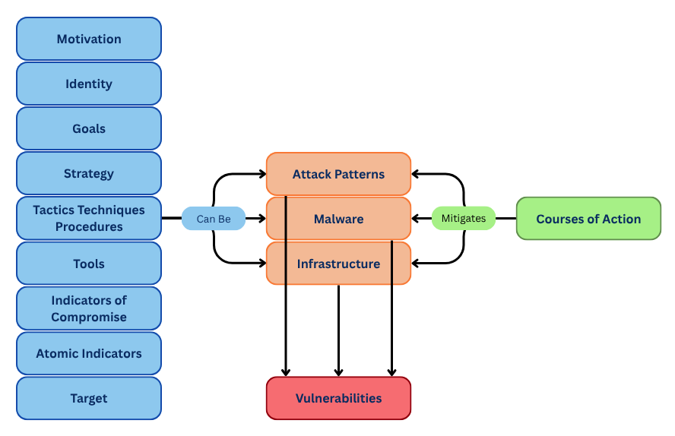
Figure 1: Cyber Threat Intelligence Model [18].

When collecting this information, the aim is to identify the goals and motivation of the threat actor, as well as identifying the threat actor themselves. This could be a person, organisation, or even a nation state [18]. This also aids in identifying a strategy, as without a strategy, there cannot be goal.
TTPs underpin a threat actors’ methods, technical knowledge and the tactics that they employ to attack a system. Once identified they can assist in describing an attacker’s behavioural patterns, essentially explaining the “why”, “what, and “how”. Understanding an adversary’s TTPs enable an organisation to proactively strengthen their cyber defences.
IOCs are constructed by combining a variety of information. Some examples of IOCs are malicious URLs, Domain Names, or IP addresses, file hashes, registry key changes, or unusual user activity.
This information is combined to describe malicious or suspicious behaviour that directly detects TTPs, attack patterns, malware, threat actors and tools [19].

OSCTI Sources and Data Collection
Threat intelligence sources collect their data in a variety of ways. Some collect via their own honeypots and analysing malware, and others such as Facebook Threat Exchange collect from intelligence supplied by users or organisations [20].
Intelligence sources for OSCTI include, but are not limited to the following:

Social Media Platforms
Social media platforms such as Twitter serve as real-time data aggregation points for threat intelligence [21], and combined with appropriately developed frameworks it’s possible to extract, analyse and classify into meaningful intelligence. Some examples of this are discussions and behaviour that can reveal possible emerging threats, or opinions on cyber-attacks. It’s possible to monitor specific keywords or hashtags that relate to malware, revealing the motivations or techniques that threat actors employ. Geo-tagged content can reveal physical locations related to incidents.

Technical Data Sources

Vulnerability databases
Vulnerability databases are a crucial source of information. CVEs (Common Vulnerability and Exposures) are assigned to a publicly known vulnerability, which are then added to the database and used in security advisories. They provide accurate and detailed information on known vulnerabilities, which aid in understanding the flaws within software platforms. Intelligence such as vulnerability type, affected product, impact, and root cause [22].
Organisations and Governmental entities such as CIS (Center for Internet Security), CISA (Cybersecurity and Infrastructure Security Agency), and NCSC (National Cyber Security Centre) are just some of the many sources for up-to-date intelligence advisories. However, the Mitre Corporation maintains the CVE database at cve.org. These can be accessed in JSON format for easy ingestion into TI platforms. CVEs are assigned a CVSS (Common Vulnerability Scoring System) score, which represents the severity of a vulnerability in a qualitative representation; Low, Medium, High, or Critical [23].
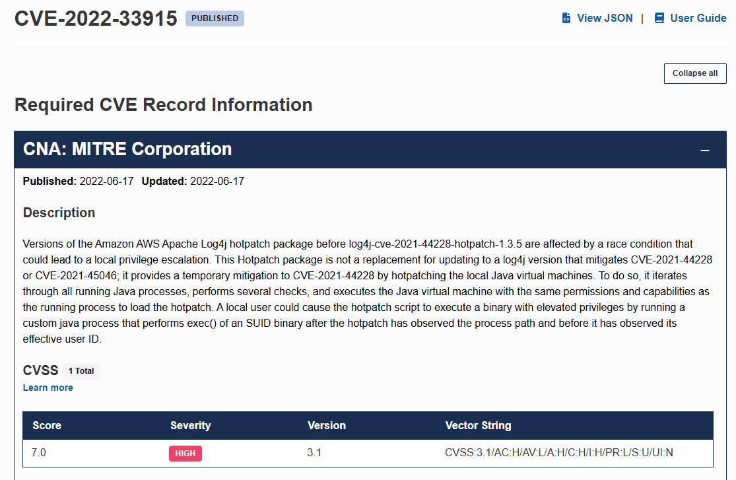
Figure 2: Example of a CVE Record from cve.org

Public Threat Intelligence Feeds
Open-source IOC feeds are generally curated by the TI community or security researchers. They list actionable intelligence such as malicious domains, IP addresses, registry changes, and hashes, indicating attempted or successful attacks.
As with the example below, form abuseipdb.com, this intelligence can be as simple as a list of reported and investigated IP addresses.
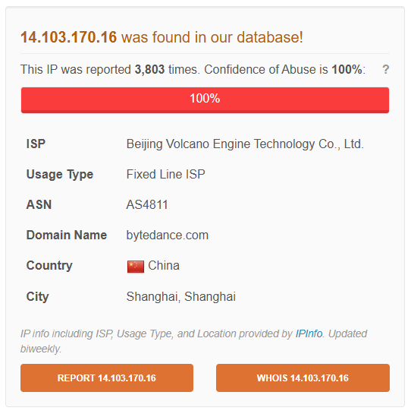
Figure 3: A reported IP address from abuseipdb.com

It is of concern that the quality of information received can vary significantly, as highlighted by Schaberreiter et al, and that it is necessary to continuously monitor the intelligence feeds in order to determine if the information is of sufficient quality, and that the source can be considered trustworthy [24].

Malware Analysis Repositories
Purpose built databases or file archives that can safely store malware samples. VirusTotal and Any.Run are two of the leading providers. These repositories allow users to analyse suspicious files, IPs and URLs, with the results automatically shared with the security community via APIs.

Cybersecurity Frameworks
MITRE ATT&CK (Adversarial Tactics, Techniques and Common Knowledge) is a leading knowledge base that maps threat actors TTPs, which in turn allows OSCTI platforms to provide organisations with structured and categorized behaviours. These behaviours and actions are presented in a matrix format, which allows security professionals gain a deeper understanding of the underlying methodologies used in attacks and incidents [25].

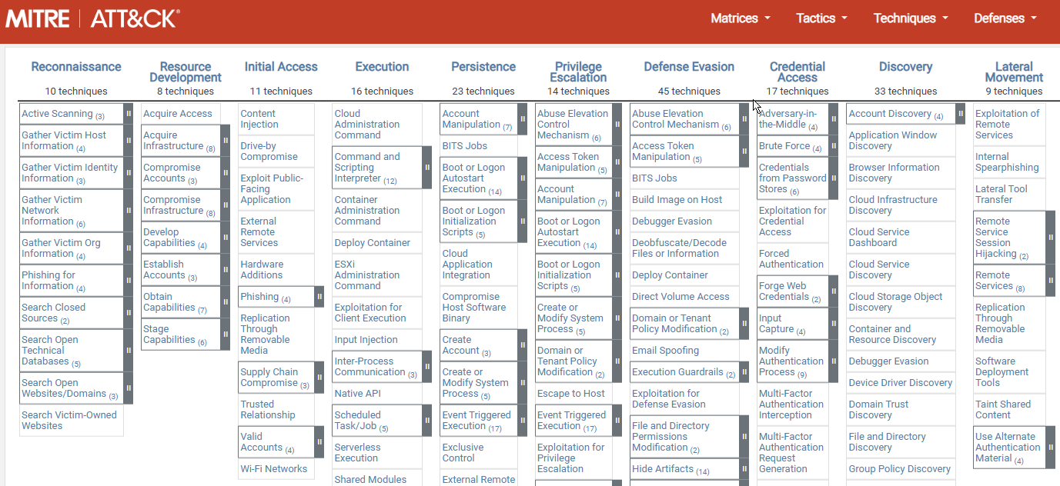
Figure 4: The MITRE ATT&CK Matrix
Despite the numerous benefits of the framework, namely mapping vulnerabilities and IOCs to techniques, there are still documented challenges to its practical application. Principally, an organisation attempting to align their cyber defence can be overwhelmed by the sheer volume of data. Therefore, it is the organisation’s responsibility to prioritise actions based on suitable risk profiles.

The Dark Web
The obscurity and anonymized nature of the dark web naturally attracts illicit activities. Because of this, a key aspect of its functionality is marketplaces and forums. Criminal actors exchange illicit and illegal items, including data and intelligence, and for the most part remain untraceable [27].
There are concerns surrounding the quality of data obtained from the dark web, particularly mentioning intelligence and feed poisoning, where threat actors deliberately post false information with the aim of deceiving the intelligence community and giving themselves more time or opportunity to launch attacks and campaigns.

Indicators of Compromise
IoCs play a vital role in threat intelligence, as they suggest a potential breach or compromise has occurred. Statis IoCs such as file hashes, or dynamic IoCs such as malware behaviour can all reveal an attacker’s techniques and methodologies.
Static IoCs are important for the rapid identification of malware and can be compared against established databases of currently known threats. This emphasises the importance of intelligence sharing and collaboration in improving response times during incidents. XX
As stated by Li et al., there is a significant overlap in threat intelligence data from public sources, which can affect the coverage and accuracy of IoCs [20]. Varying response times from days to months can make a significant difference to a community or organisation’s ability to mitigate threats.

Sharing Standards and Formats
TI sharing formats standardize how cyber threat information is represented and exchanged to ensure interoperability between the various tools and platforms. A key feature is automated ingestion, processing and analysis of data.
The major formats are STIX (Structured Threat Information eXpression) and TAXII (Trusted Automated eXchange of Intelligence Information), with STIX considered the “what”, and TAXII the “how”.

STIX
Provides a common language to describe threats, vulnerabilities and attack patterns, allowing organisations to exchange intelligence seamlessly. Using JSON, a machine-readable format, security tools can automatically interpret threat information, which reduces the need more manual configuration and increases automated intelligence exchange [28].

TAXII
TAXII is a transport protocol that provides the mechanism to share STIX insights over HTTPS, ensuring that CTI is transported over secure channels. It also supports automated sharing topologies based on risk-levels [29], assisting organisations in disseminating and receiving real-time intelligence and the ability to adapt to emerging threats quickly.
Although STIX and TAXII are regarded as industry standards, research has shown that practical implementations can vary in their complexity [30], and the diverse systems and tools that they use can hinder seamless interoperability and hinder TI sharing and timely threat response.

MISP JSON
Like STIX, MISP uses the JSON format as its primary format for representing and sharing intelligence. This allows for seamless ingestion, from automated feeds or API integrations. The platform can also ingest csv and free text formats, with the intelligence being translated into JSON format, which simplifies integration and dissemination to SIEM or SOAR platforms.
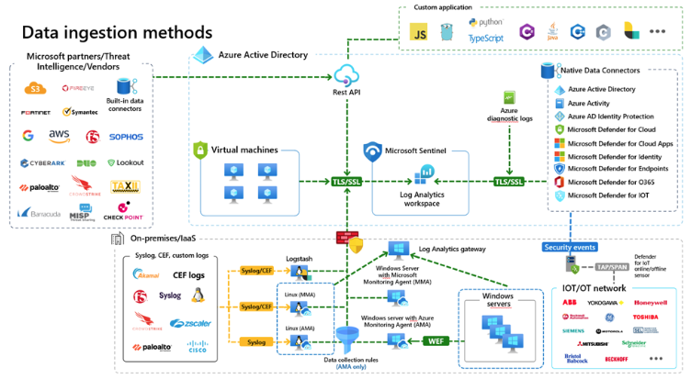
Figure 5: Overview of Threat Intelligence Ingestion in an Azure Environment. Microsoft.com
Figure 5 illustrates how threat intelligence is ingested into an Azure environment; Via a Rest API and into Sentinel, where analytics and automation can take place with information on IoCs and potential threats being dispersed throughout the network.

Strengths and Limitations of Intelligence Sharing
It is widely accepted that through the advanced identification of potential risks, OSCTI can strengthen an organisation’s cyber resilience [31]. Another advantage is that OSCTI’s timely processing and sharing of information can enhance threat detection and an organisation’s response capabilities across multiple sectors [19]. This highlights the importance of collaborative sharing standards within OSCTI in establishing robust and effective sharing strategies [19].
Trust is a major part of intelligence sharing, and there is concern within the industry that members are utilising intelligence without further contributing. This undermines the collective effort, and is known as “free riding”, and can distort threat perceptions, leading to the misallocation of resources [32].
Naturally, OSCTI can often rely on unverified data. Therefore, it can be considered that the challenge in OSCTI information sharing is to maximise the efficient processing and sharing of data, whilst minimising “free loading” and ensuring that the collective effort is maintained so that other organisations can utilise it effectively. Elastic Labs’ Global Threat Report agrees with this, and states that there is a lack of discussion around the mechanisms used to share and distribute threat intelligence [33], and that a more proactive strategy would increase protection.
On a personnel level, there is an ongoing debate as to whether security teams can transform the raw data into actionable, insightful intelligence [34], as this largely depends on their knowledge, experience, and expertise. As cyber security analysts largely have to deal with huge amounts of information, as well as several false positives, and with the additional concern of “feed poisoning”, it is a credible worry that genuine threats and IOCs can be missed. In short, despite the significant promise for cybersecurity, OSCTI is accompanied by numerous criticisms concerned with the reliability of data and the challenges of collective intelligence. It’s also worth noting that organisations need to be aware of the threat of how thoughtful they need to be when integrating OCSTI into their cybersecurity posture.

Legal and Ethical Implications
From a legal and ethical perspective, TI feeds may contain personally identifiable information (PII). It is an organisation’s responsibility to adhere to regulations such as General Data Protection Regulation (GDPR) in the European Union (EU) when handling this data. This is a particular concern when accessing data from social media or the dark web.
Another concern is the reliability and credibility of information. The nature of OSCTI means that risk of inaccurate information is present, whilst it is challenging to differentiate between misinformation and genuine information. The potential of processing false CTI is a growing concern [35], and needs to be treated as such. Fake CTI can be generated, collected by CTI platforms and then ingested by cyber defence systems such as Sentinel. Additionally, this provides another challenge for analysts who rely on accurate information to stay informed about attack vectors.
Fake CTI often provides misinformation on vulnerabilities that are exploited during an attack, which then require additional verification from an analyst, and complicates the mitigation process [36]. A lack of a suitable platform that addresses legal boundaries was mentioned by Serrano, et al. who have highlighted the concerns around the legal implications of sharing CTI across borders, given the variety of data protection and regulation protocols internationally, such as Europe’s GDPR.

Emerging Trends
The scale and sophistication of attacks on critical infrastructure is constantly increasing, therefore an approach that considers contextual information and leverages CTI could provide a more comprehensive and integrated solution [37].
TIPs like MISP already automate much of the process by using scripts to automatically scan and analyse publicly available information.
They also provide data processing enrichment by normalising and correlating threat data from various sources. This can include enriched IOCs including valuable contextual information from services such as virus total and alien vault, aiding in the prioritization of threats.
Integrating AI (Artificial Intelligence) and automation, with AI models expected to improve data quality and standardization, and having the potential to enhance information sharing and analysis across organisations. AI and automation may also provide a solution to the issue of CTI analysis being resource intensive, freeing up valuable time and resources for security analysts.
Advancements in Neuro Linguistic Programming (NLP ) and AI have impacted how OSCTI platforms collect and process threat feeds, playing a crucial role in source selection. By automating the extraction of TI from largely unstructured data, intelligence generation is faster and more efficient [38].

Conclusion
This literature review set out to explore and critique existing literature based on the evolving process of Threat Intelligence, specifically looking at OSCTI as a viable solution to enable an organisation to establish a robust cyber security posture.
Although an established resource, there are concerns about the quality and reliability of open-source intelligence provided when comparing it to CSCTI. CSCTI intelligence is curated and vetted, however it is prohibitively expensive for many organisations. Therefore, improving the quality of OSCTI is of high importance, as it has the potential provide reliable intelligence without the associated costs. Pelofske et al. comment that the sheer volume of OSCTI data can make it difficult to discern actionable intelligence from noise [39].
There are trust issues around sharing, with concerns largely focused on organisations utilising intelligence, but not sharing with the wider community. This defeats the entire purpose of OSCTI and complicates attempts to identify threat actors and mitigate attacks.
The analysis revealed that a lack of expertise and knowledge of analysts can be a hinderance to providing actionable data, especially considering there is a lack of analysts, and many are overwhelmed by alert overload.
Despite numerous advancements, there remains a notable gap for studies measuring the impact of curated open-source intelligence, and whether it can provide reliable, quality data that can compete with closed-source intelligence.
Ultimately, well-structured and curated open-source intelligence has the potential to provide organisations with the information required to improve their security posture despite an ever-evolving threat landscape.

Methodology

Research Methodology
This chapter outlines the methodological framework and research design approach that underpins this body of work and justifies the methods by relating them to the project aims and objectives stated in Chapter 1. The aim is to provide the reader with a clear explanation of how the research has been conducted, and the reasoning behind it.

Philosophy
A positivistic philosophy requires knowledge based on the observation or experience of real phenomena in an objective and real world. It focuses on empirical evidence, objectivity, and the scientific method. Variables are required to be measurable, allowing for statistical analysis of the results [40]. From a positivistic point of view, something can only be true, false, or meaningless.
Positivism advocates for quantitative data and statistical analysis, which is achievable given the numerical data provided by TIPs.
A TIP gathers a large amount of quantitative and qualitative information. IOCs are the core quantitative data type processed in a TIP. Information such as IP addresses, file hashes, domain names, filenames, and URLs, alongside numerical data such as port numbers and file sizes are included, along with timestamps.
A TIP provides contextual data such as comments and descriptions, threat actor information, and executive summaries and reports. These are considered qualitative. However, for the purposes of this report, the focus will be on quantitative data.

Advantages and Disadvantages
A positivistic approach tends to produce quantitative data, whereas it is likely that qualitative data will also be required in this project. Therefore, a mixed-method approach will be considered. The main advantage to this is that both reliability and validity can be kept high, and the full range of intelligence generated by a TIP can be analysed.

Approach
A deductive approach is the best option given that the research is based on something that already exists; OSCTI. There is a pre-existing, large body of research relating to it and several platforms available.
This approach will begin with a hypothesis, which will be tested through research.
Quantitative data will be disseminated from the TIP, and will be analysed for its quality, reliability and usefulness. Large sample sizes will be taken, allowing a generalisation of the data and testing of the research hypothesis.
Conversely, an inductive approach would emphasise the meanings humans attach to events. This is relevant given threat actors’ motives and TTPs. It is also more flexible, and research emphasis can change as the project progresses.

Advantages and Disadvantages

While the deductive approach largely focuses on numerical data, it is important to recognise that OSCTI platforms also generate visual and textual data. Careful consideration will be given whether to include this in the research, as this would result in the approach not being purely deductive.

Research Strategy
Research strategies are for an accurate comparison of results. An in-depth literature review has been conducted in Chapter 2, and the main body of work for this project will be an experiment.

Literature Review
An in-depth literature review has been conducted to understand the trends, advantages, challenges, and limitations of OSCTI. It has discussed the background to threat intelligence, compared OSCTI and CSCTI, and investigated the type of data provided by intelligence feeds and their importance.

Experiment
Experimental research aligns with the positivist philosophy and is deductive in nature. The experiment phase will examine the relationship between two variables, known as the Independent Variable (IV) and the Dependent Variable (DV)
In this instance, creating changes to the IVs will directly cause a change(s) to the DV – the outcomes of which will wither prove or disprove a research hypothesis.

Risks and Limitations
The submission deadlines are strict, so it is imperative that the researcher is organised and manages time effectively. Although this does not necessarily affect the outcome, additional time to design and implement the experiment would likely yield more accurate and conclusive results.
A primary concern are the rigid organisational structures imposed by DHCW. Conducting this experiment within the organisational environment may result in intelligence that needs to be kept in house, which would severely restrict any demonstration required. Access to the organisational cloud environment would need to be granted initially, and if this access is denied then an alternative plan is required.
UWTSD possess and Azure student subscription, and it is possible to conduct the experiment within this environment without privacy or organisational concerns. The disadvantage of this approach is that the researcher would not be able to utilize DHCW’s SIEM instance, and the additional open-source feeds that are only available to qualifying organisations.

Validity, Reliability, and Generalisability

Validity
TI data sources can be noisy and unstructured, so to provide accurate measurements and ensure sound conclusions the metrics and causal variables need to be considered carefully.

Reliability
Reliability will depend on the measurements and procedures remaining stable. The challenge is whether the experiment could be repeated under identical conditions, given the interpretative nature of TI.
If another researcher were to conduct the same experiment, provided they conducted it over the same predefined period, they would obtain identical results as the data held in the TIP is cached once ingested.

Generalisability
The results could apply to a wide range of situations, because the intelligence analysed is open source and publicly available.

Data Evaluation Methods

Data Collection
MISP API and MISP web interface will be used to collect experimental data.
To query MISP’s API endpoints, it will be necessary to use Python and the PyMISP library.

Initial data collection
Once experimental group 1’s feeds have been fully ingested and cached; a script will query the first TIP and return the initial set of data.

Experimental data collection
On the second TIP, experimental group 2 feeds are ingested and cached. The same script will query the second API and return the required data.

Data Evaluation
Using descriptive statistics such as mean and SD (standard deviation), it will be possible to analyse and compare the unique IOCs for the initial and experimental data collection phases.
Once completed, inferential statistics using a paired-samples test (known as a t-test) will be utilised and a comparative analysis performed.
The expected outcome is that there will be a “statistically significant” increase in the discovery of unique IOCs once experimental group 2 is introduced.

Experimental Methodology
The purpose of experimental methodology is to establish relationships by manipulating variables. It falls under the wider scope of quantitative research.
A research hypothesis is required. This is necessary to narrow the research focus and provide a clear and testable relationship between variables.

Research Hypothesis
Increasing the number and variety of OSCTI feeds ingested into a TIP will result in a statistically significant increase in the number of unique IOCs detected.

Independent Variables
Two distinct experimental groups will be created, based on the number and type of intelligence feeds. The purpose of an IV is to cause a change in the DV.
- Experimental group 1 – Low Diversity.
The first group will include a small number of popular/commonly available TI feeds. They will be well known in the TI community and readily available to configure.
- Experimental group 2 – High Diversity.
The second group will include a larger, more diverse set of TI feeds. These feeds should specialise in detecting a specific variety of threats and techniques.

Dependent Variable
- The number of unique IOCs that are ingested by the TIP.
This metric directly addresses the diversity and quantity of the raw threat intelligence ingested and quantifies how much new intelligence is added by increasing the diversity of the intelligence feeds.

Control Group
- Consistent timeframe.
The experiment will be conducted over 7-day period so that there is reliable baseline for comparison. In addition, two TIP instances will be running concurrently. One will host the low diversity group, and the other will host the high diversity group.
This provides causality, and the researcher can directly attribute any observed changes to the effect of each IV.

Resources

Hardware Resources
The only hardware required is a laptop running Windows 10, Intel Core i5-6300u processor with 16GB RAM and a 500GB SSD.

Software Resources

Microsoft Azure
An on demand, software-defined cloud computing environment that runs on physical hardware in Microsoft’s Azure data centres. Includes the ability to choose and amend the VM’s configurations to fit requirements [41].

Azure VM specifications
Intel(R) Xeon(R) Platinum 8171M CPU @ 2.60GHz
8GB RAM
128GB SSD

Ubuntu 22.04.6 LTS
Open-source, Linux based OS with long term support. Lightweight and easy to use. A popular option in cloud environments such as Azure as it runs on azure-optimised kernels and is available with enhanced security [42].

Docker engine 28.2.2 and Docker Compose
An open-source application for the building and deployment of containerized applications. Containerization has transformed software development and deployment. It decentralizes applications into independently deployable services which can be updated or modified without impacting the system as a whole [43]. Docker Compose Simplifies control by storing configuration of services in a single YAML file [44].

MISP 2.5 OSCTI platform:
Another open-source resource, MISP enhances proactive collaborative cybersecurity efforts by collecting, storing, and sharing threat intelligence [45]. GitHub hosts a production ready docker image for simplified installation.

PyCharm/Python
A python IDE and the latest version of the Python language. This is required to query MISPS API endpoints to extract data and will make use of the PyMISP library.

Time Horizon
The approach towards time horizon will be longitudinal. The intelligence feeds ingested into the TIP will contain data collected over a long period, depending on the intelligence source; In the case of some feeds this period can be years old. A longitudinal approach is critical to understand the content of intelligence feeds over time, providing an insight into the freshness of the feeds, as well as any persistent threat actors and the emergence of new threat patterns.
By collecting and analysing data over an extended period, the study can identify trends and patterns, specifically focused on IOCs such as malicious IP addresses, domain names, URLs and file hashes, to determine if increasing the amount of intelligence feeds reliably increases the number of unique IOCs identified.

Conclusion
This chapter has outlined the research approaches necessary to investigate the impact of intelligence feed diversity on the volume and composition of IoCs. The experimental design utilises two MISP instances that are configured to represent low diversity and high diversity intelligence environments.
Data collection is performed using a Python script, which queries each MISP instance for it’s daily metrics, extracting the amount of unique IoCs and total attributes.
The resulting dataset underpins the statistical analysis to be undertaken, which will identify temporal trends and enact quantitative comparisons between the groups. Once the analysis has been completed, and adhering to the aforementioned methodology, a reliable foundation for drawing conclusions regarding the diversity of OSCTI feeds will be drawn.

Design and Implementation

Introduction and Problem Formulation
Organisations globally rely on CTI for informed decision making. It allows them to proactively adapt to the threat landscape and improve their cyber security posture. An assumption when integrating a TIP is that the more intelligence provided the more insightful an organisation will become.
However, cost is a major issue for many organisations and the subscription fees and layered models of CSCTI can be inhibitive, especially as it is curated and considered more reliable than OSCTI.
There is a lack of understanding surrounding the impact of increasing the number and variety of OSCTI feeds in terms of the number of unique IOCs and correlations. Increasing this understanding will allow security analysts to optimise configurations and potentially improve threat visibility and identify an improved number of threat correlations.

Design
The crux of this experimental research requires a TIP instance for each of the experimental groups that can intelligence feeds, and a mechanism to query their endpoints to provide quantitative data for analysis.
MISP is the preferred TIP, not only because it is open sourced, but because it is community driven. The codebase is openly available and auditable. It provides extensive modules and integrations for the import and export of data and can be integrated with other security tools such as Microsoft’s Sentinel. Although the modules and integrations are beyond the scope of this project, it is important to consider the benefits these could provide to DHCW.
To create the MISP instances, the following is required.
A standard commercially available laptop running Windows 10, which will become the host machine.
Through UWTSD’s subscription, Microsoft Azure will provide the virtual environment in which two VMs will be configured. On these VMs, the Ubuntu LTE OS will be installed. Ubuntu is a lightweight but powerful Linux based OS and can be accessed via terminal using an SSH client such as Putty. The Ubuntu GUI is not necessary for this experiment, as use of the OS will be minimal.
Using the terminal, Docker will be installed for its ability to improve resource allocation in containerised environments, which simplify the way that applications are deployed and run. Docker provides a production ready MISP instance, which can be cloned from MISPs GitHub repository - https://github.com/MISP/misp-docker.
A MISP instance will be created within Docker, which will then allow the host laptop to interact with its web interface using it’s IP address via Google Chrome. The IP addresses will be determined by the Azure VMs and require http ports 80 and https port 443 to be open.
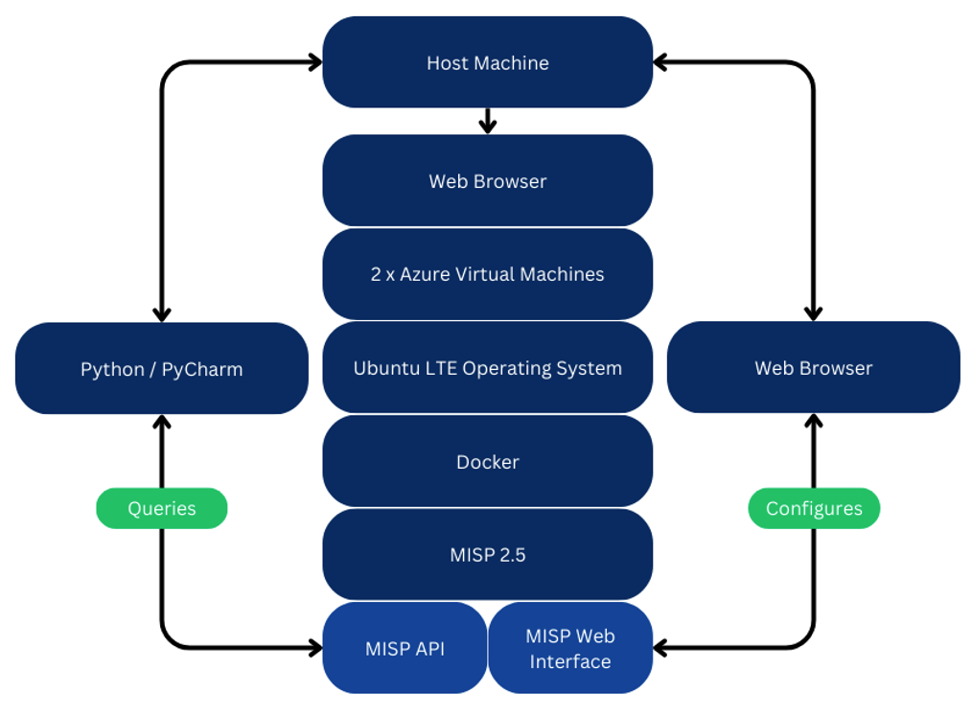
Figure 6: Block Diagram of Design Overview.
Figure 6 outlines the applications and services that are required, and the communication that occurs between them in order to configure and query the web application and API.
To query MISPs API endpoints, Python/PyCharm will be installed on the host machine. Python is known for being a lightweight, resource friendly language, and the researcher has selected the PyCharm IDE (Integrated Development Environment) for its usability and simplicity. PyMISP is a python library that can query MISPs API and fetch events, attributes, and IOCs. This is crucial to the experiment.
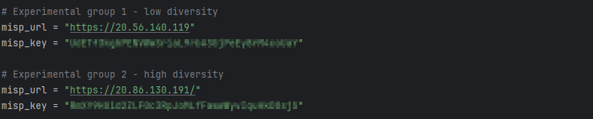
Figure 7: Key variables; The MISP IP addresses and API keys.

Initially, the intention was to run MISP from a locally hosted VM (Virtual Machine) using VirtualBox 7.1.8, however given the problematic performance of VirtualBox in previous modules, it has been decided the Azure cloud platform, and its vast array of resources and configuration options will be more suitable.
This approach overcomes the limitations of running a hypervisor and VM from the host machine and will allow for the allocation of extra computing resources on demand should they be required.
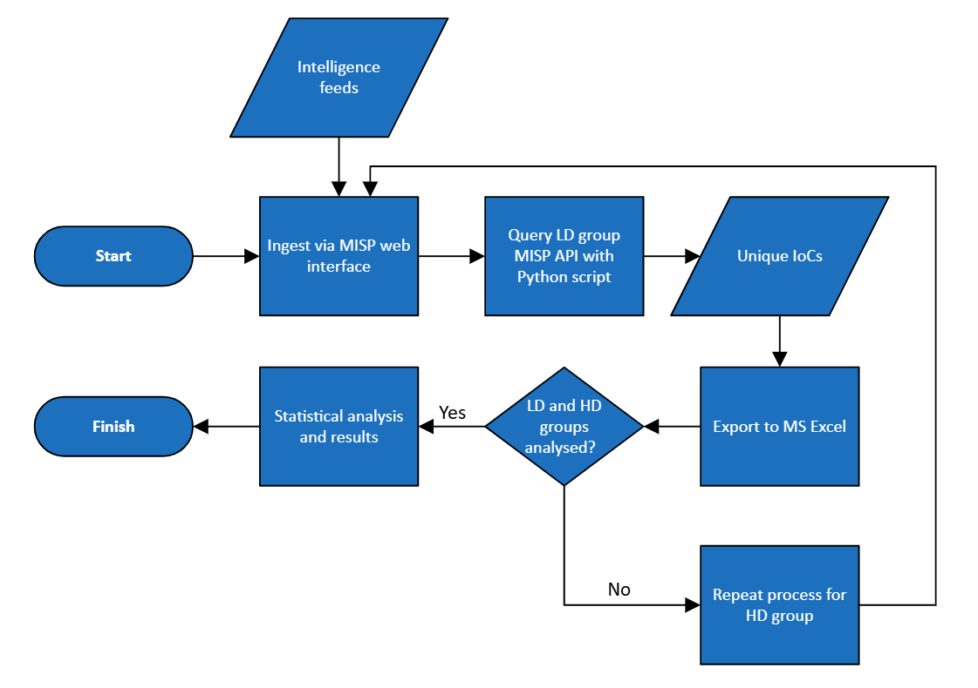
Figure 8: Data flow diagram showing experiment process.
Figure 8 shows the testing environment and the steps taken in the experiment process. It accounts for both experimental groups needing to be actioned before the statistical analysis and results can be calculated.

Intelligence Feeds
The following table shows the feeds that will be ingested into MISP. While there are numerous additional feeds to choose from, the researcher feels at this point it would be prudent no to enable all that are available as there are over 50, and this may prove to be too much data for this experiment.
Table 2: MISP Intelligence Feeds.
The low diversity feeds (experimental group 1) will be ingested into one MISP instance, and both the low and high diversity feeds (experimental group 2) ingested into the second MISP instance. These are the independent variables.

Implementation
This section details the implementation process of the testing environment, based on the design considerations. It will include the installation of all software required, alongside any additional configuration.
Importantly, the experimental steps will be documented, and either the raw data or selected datasets shown.

Host PC and Azure
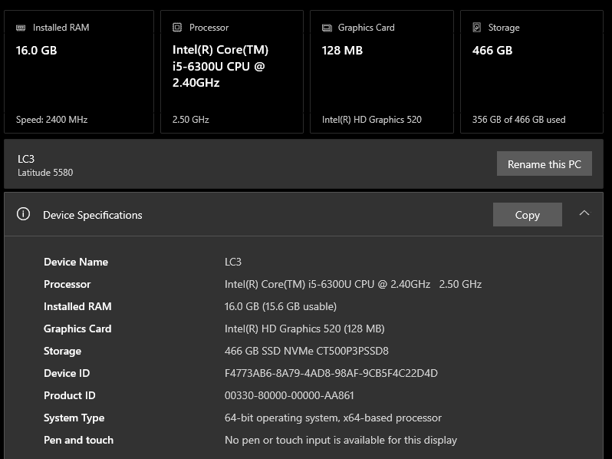
Figure 9: Host PC specifications.
Although the host PC has ample RAM, it’s dated i5 processor makes running a hypervisor challenging, particularly if more than one VMs are running simultaneously.

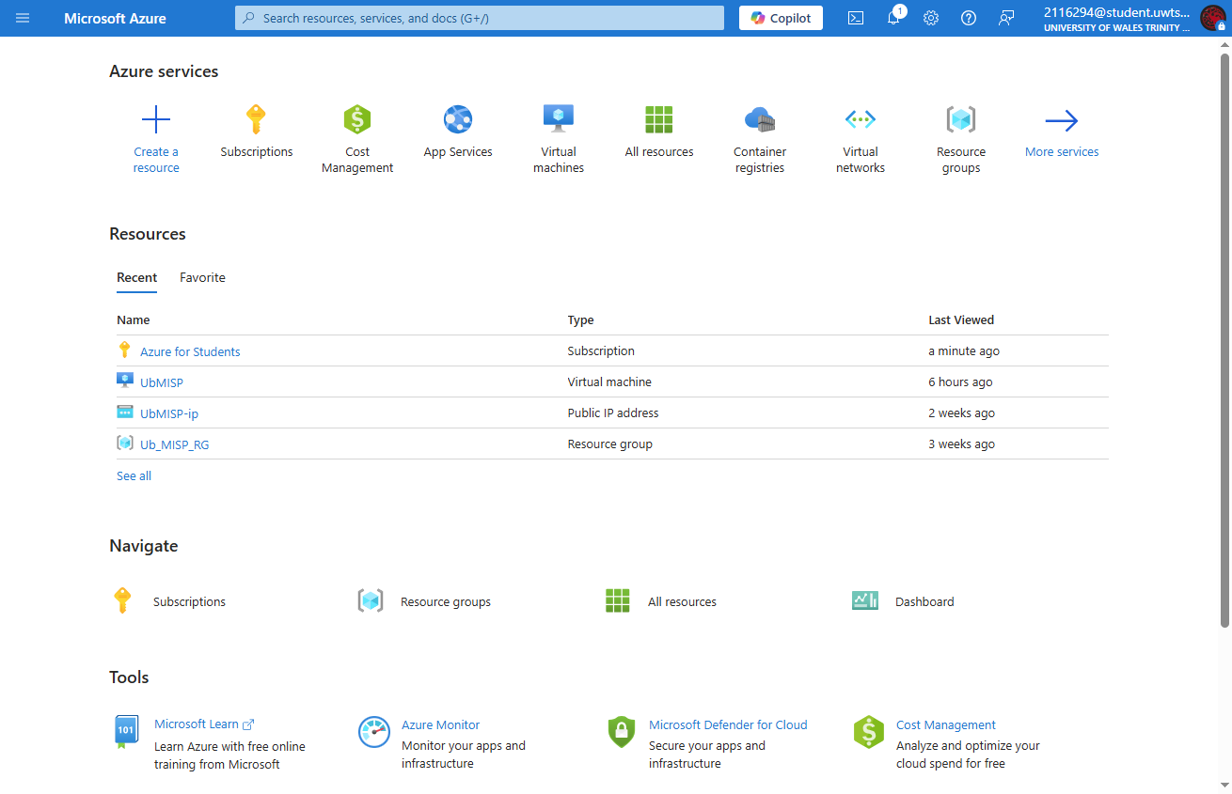
Figure 10: UWTSD Azure portal.
UWTSD students have an Azure subscription, which allows the use of £100 credit to use against any available resources. More credit can be purchased if required, however with only two VMs running, this should not be necessary.
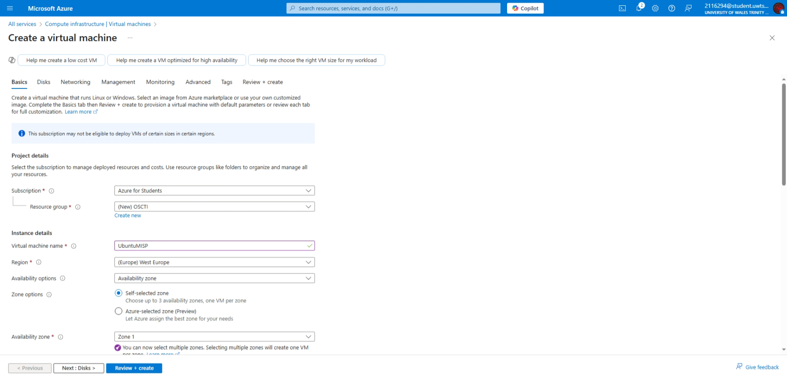
Figure 11: Deploying an Ubuntu VM in Azure.
Setting up a VM is straightforward; All that is required is for the virtual hardware and OS to be selected. Deployment occurs within a few minutes of selection.

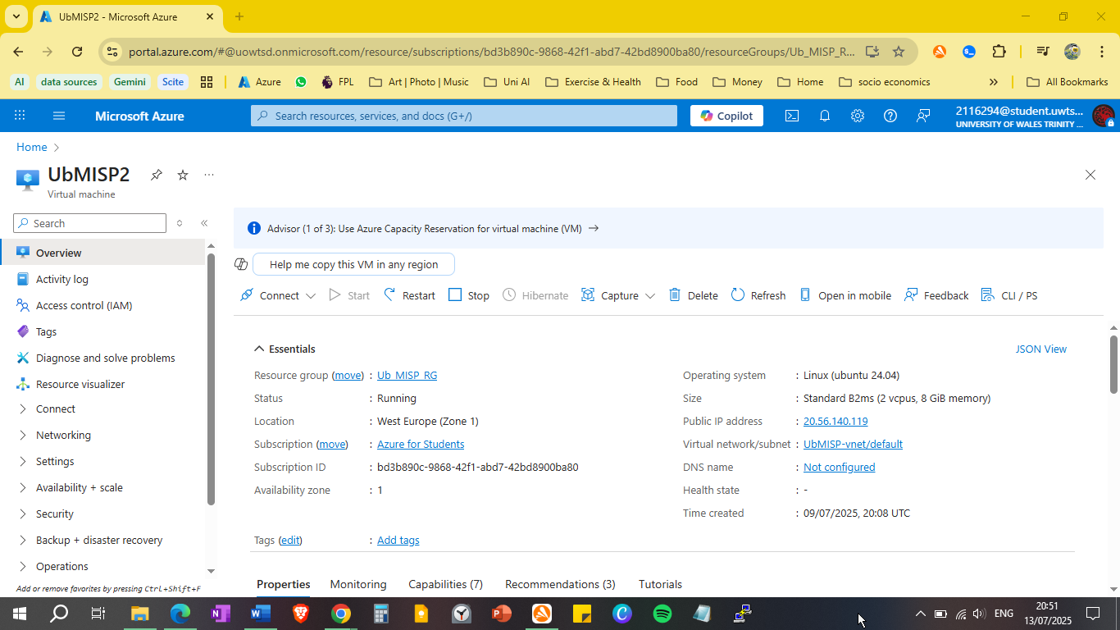
Figure 12: Azure VM for experimental group 1.
The above screenshot shows the successful deployment of an Ubuntu VM, and an assigned public IP address.

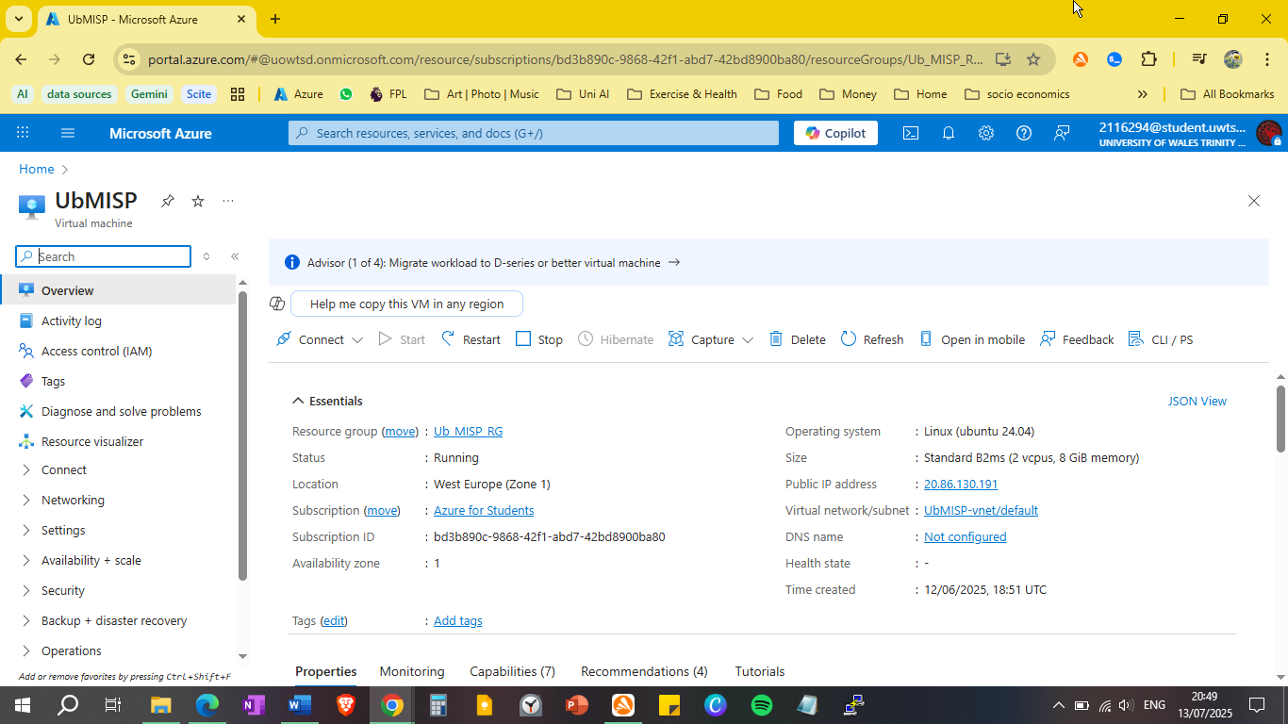
Figure 13: Azure VM for experimental group 2.
The second Ubuntu VM is deployed in the exact manner as the first, with the only difference being the assigned public and private IP addresses. In this instance, a virtual network was not required, however both VMs are within the 10.0.0.0/16 network, so could communicate with each other if necessary.
VM UbMISP has a public IP of 20.86.130.191, with UbMISP2 accessible via IP 20.56.140.119.

Connecting and Configuring Virtual Machines
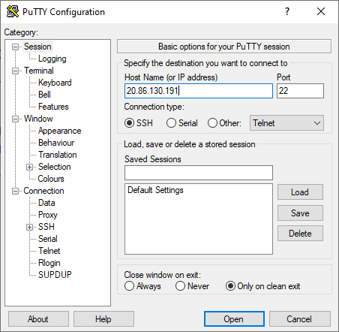
Figure 14: Putty terminal.
Putty is a widely used terminal emulator for Windows, that can connect using SSH. As the Ubuntu LTE version is CL (command line ) only, this is a resource friendly method of connecting to the machine. During deployment, port 22 was opened on both the Ubuntu VMs to enable an SSH connection.
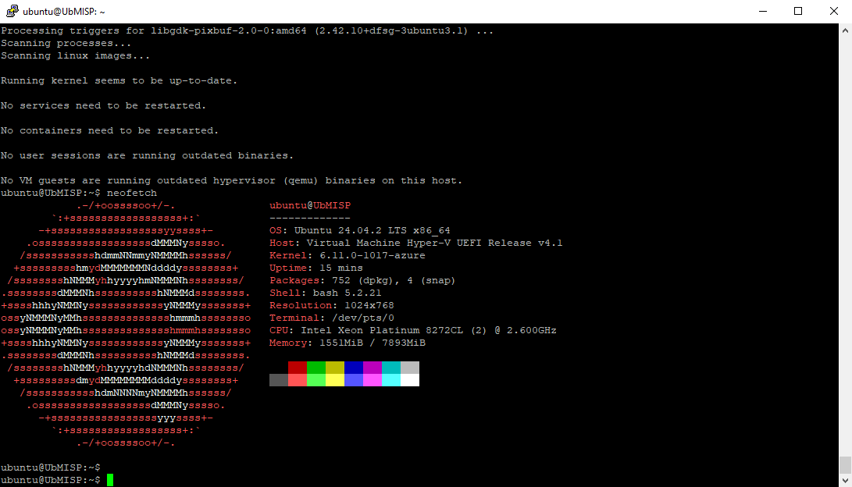
Figure 15: Ubuntu system properties.
Using Putty, an SSH connection was established to UbMISP. Although it is possible to install a GUI for Ubuntu, this has been deemed unnecessary, as once Docker and MISP have been installed, access to Ubuntu is only required to start and stop them or update the OS. This would need to be done via a bash terminal regardless; therefore, a GUI would prove to be resource hungry.

Installing Docker and MISP
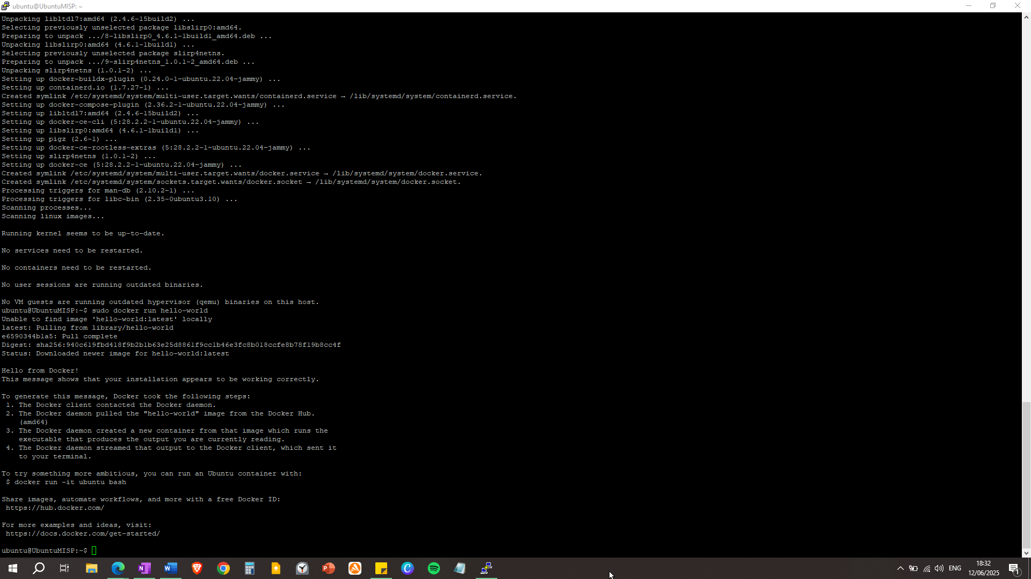
Figure 16: CLI installation of Docker on Ubuntu.
A production ready Docker MISP image is available from https://github.com/MISP/misp-docker , which significantly simplifies the installation process. All that was required was to install Docker and Docker Compose by using the commands sudo apt install docker-ce docker-ce-cli containerd.io and sudo apt install docker-compose-plugin.
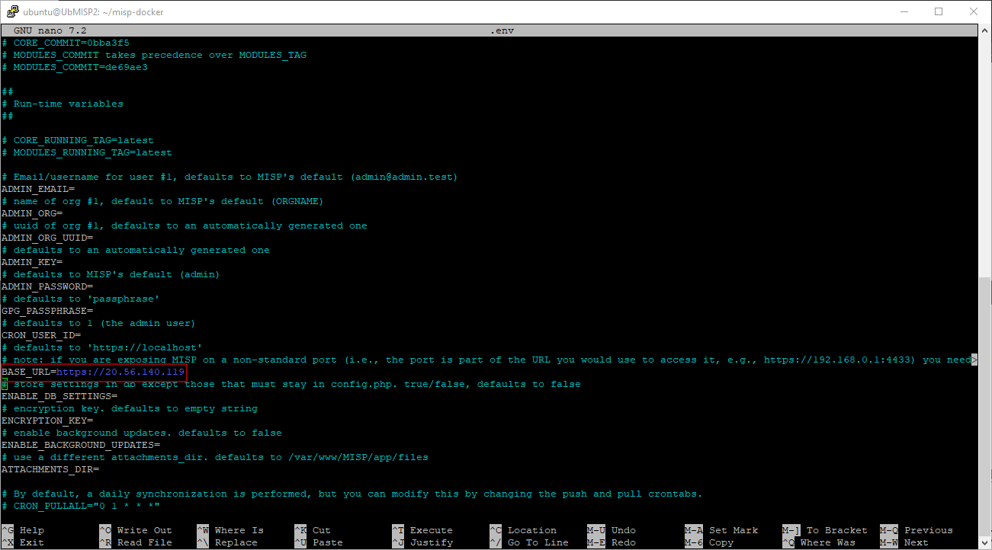
Figure 17: misp_docker's .env file.
Once completed, all that was necessary to do was to clone the MISP Docker repository, configure the environment, and start the MISP containers. The above figure highlight’s a key component in the configuration step – the BASE_URL variable must be set to the public IP address for each Ubuntu VM.
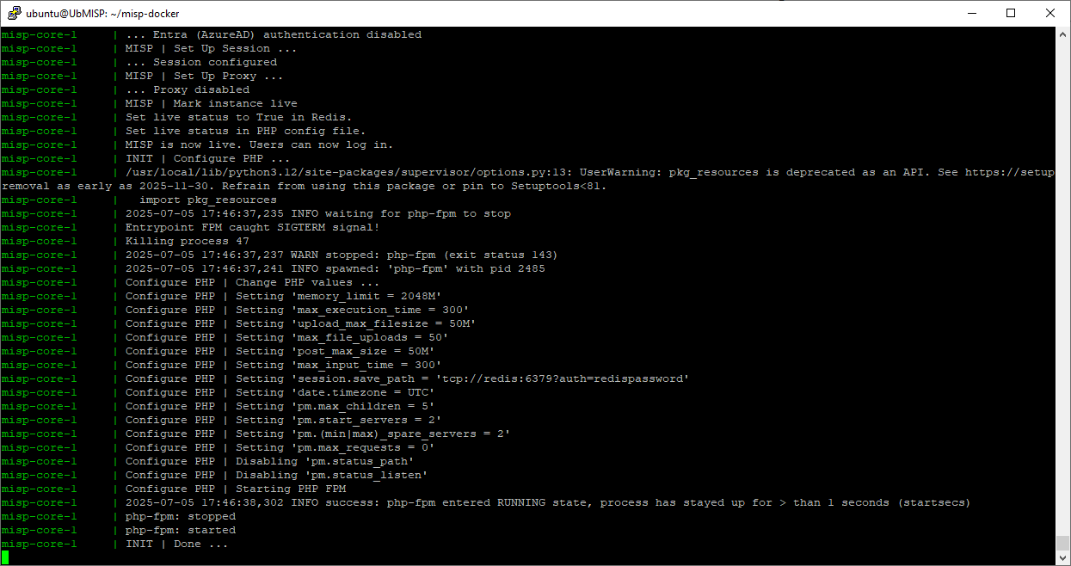
Figure 18: MISP initialising via Putty
As soon as the Docker MISP container has loaded, navigate to the public IP address via a web browser, and login with the default MISP credentials.

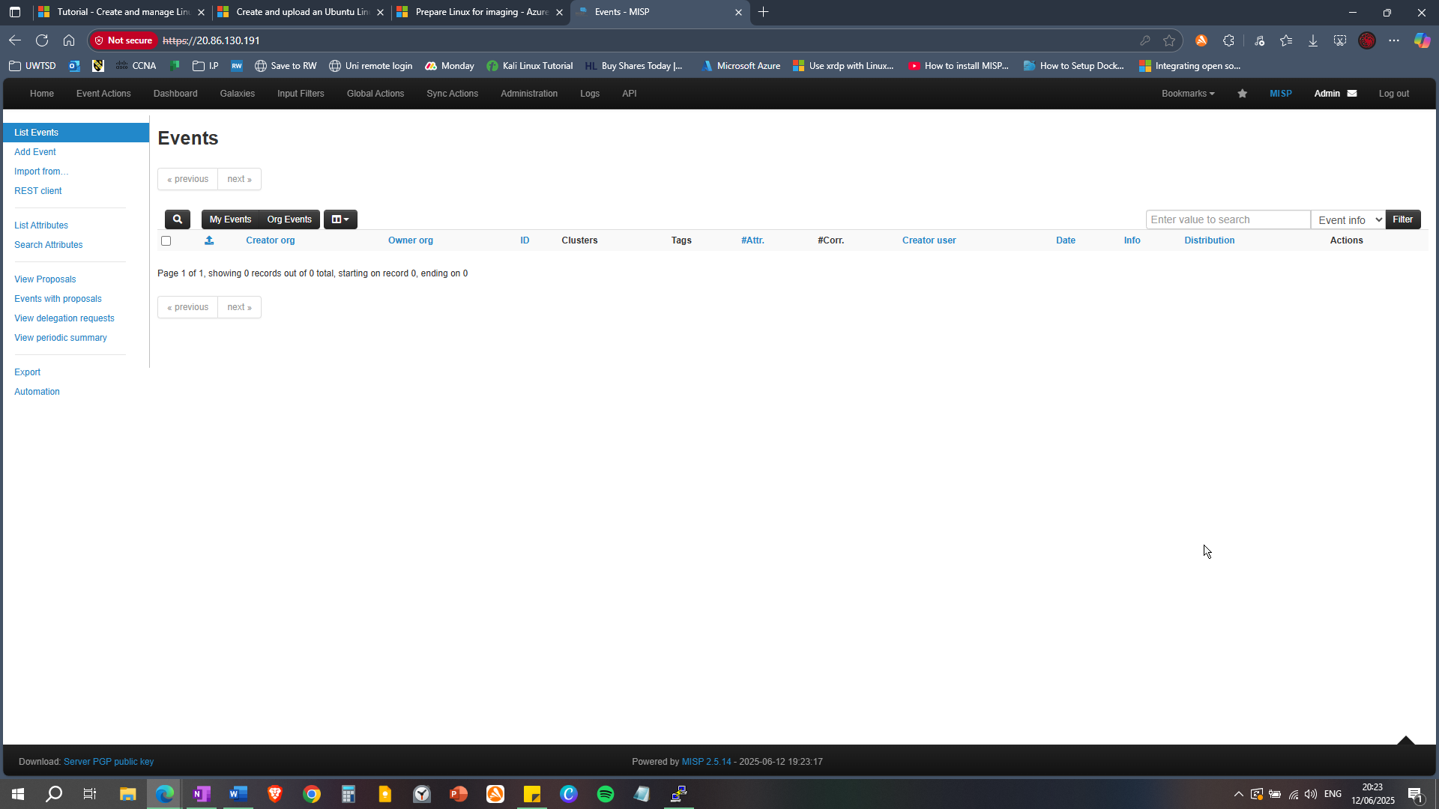
Figure 19: Accessing the MISP web interface for the first time.
As is evident by the above figure, there are no events showing. This is because MISP does not have any currently enabled feeds, so no intelligence is being ingested.

Adding Intelligence Feeds
As stated previously, the experiment requires 2 – 3 broad coverage feeds, and 10/15 feeds that are more specific towards certain IOCs.
While locating suitable feeds, it’s important to consider the following characteristics:
- Credible: From reputable communities or organisations.
- Structured: MISP can ingest JSON, CSV, plain text or STIX/TAXII formats.
- Timely: Feeds must be updated regularly.
- Community-driven: From broad community contributions and validation.
The unexpected challenge in acquiring feeds, were that several of them formed a “fixed event” when pulled. In this scenario, all IOCs/attributes are timestamped with the date the feed was pulled, which drastically skewed the statistics for that specific day.

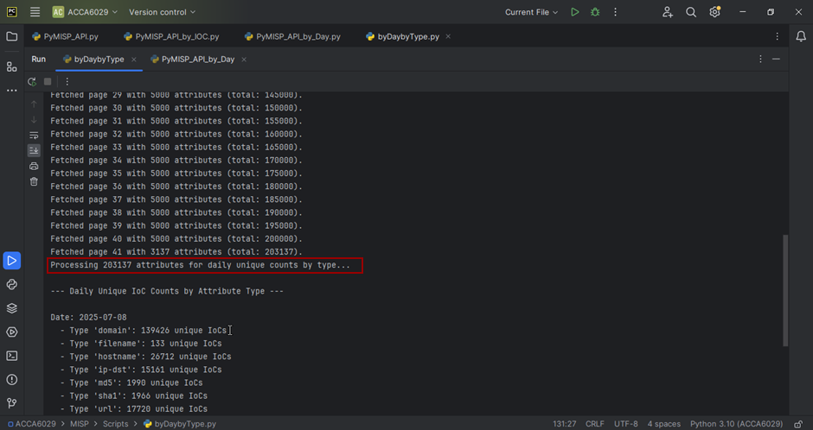
Figure 20: High number of attributes from a single MISP "fixed event".

On further investigation, the fixed events issue can be mitigated by either manually pulling the feeds daily or creating a scheduled task. Because the attributes are timestamped when they are pulled, if we pull daily then we will get each day’s new attributes.
The above image shows 203,000 attributes ingested as the feeds from experimental group 2 have been pulled and cached. When pulling a fixed feed in the first instance, all the events are timestamped with that date. The issue here is that the feed data for the initial pull dates is vastly skewed. Henceforth those dates cannot be used in the experiment.
However. Now that all the feeds have been gone through an initial pull, this should not prove an issue going forward.

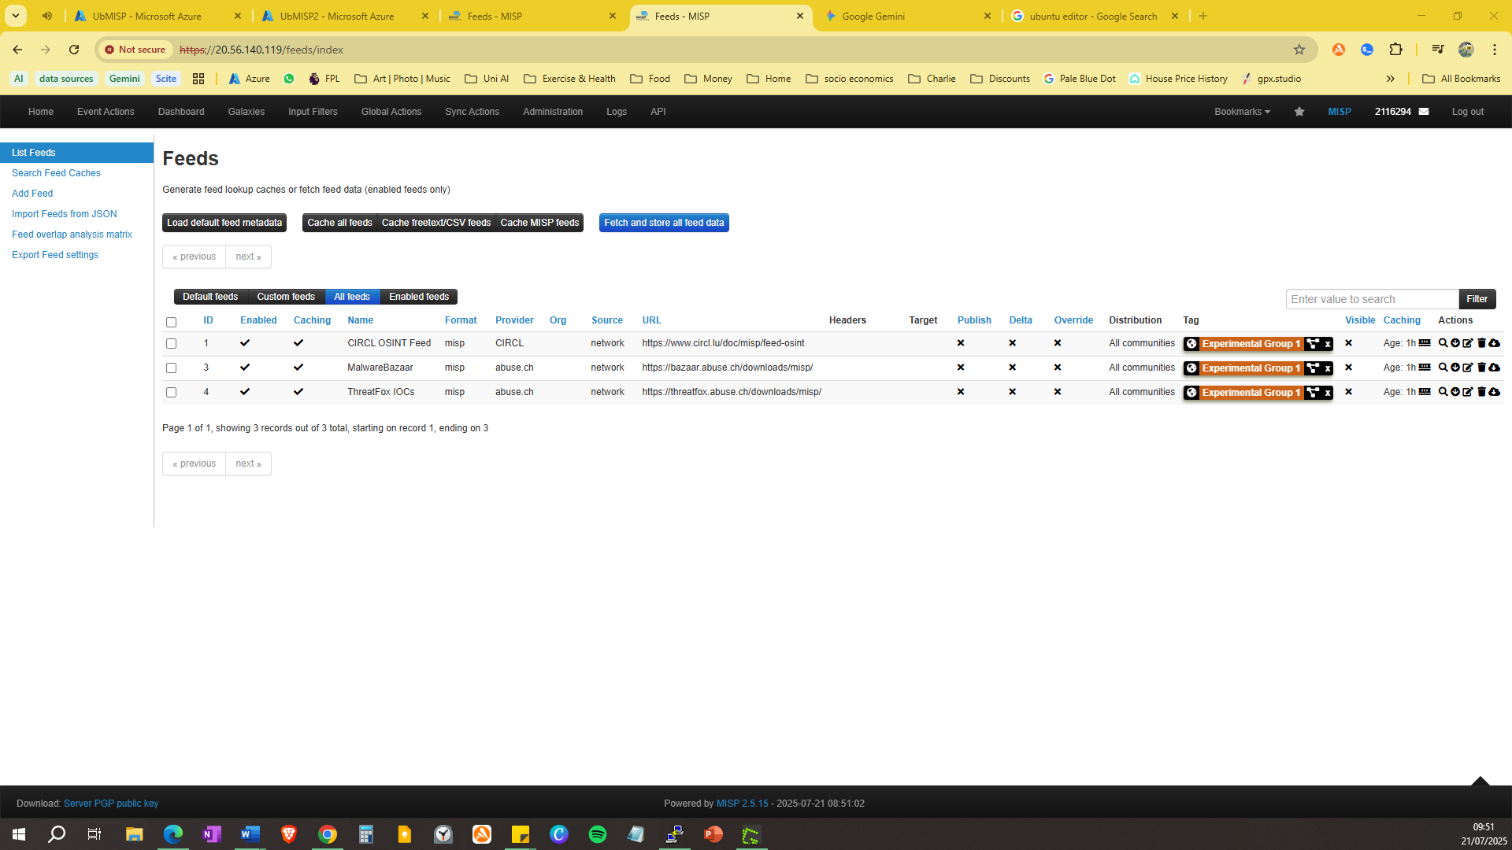
Figure 21: List of feeds from the Low Diversity group.
Figure 21 shows the three selected feeds for the Low Diversity group, which should provide a general overview of attributes, compared to the more specialised feeds.

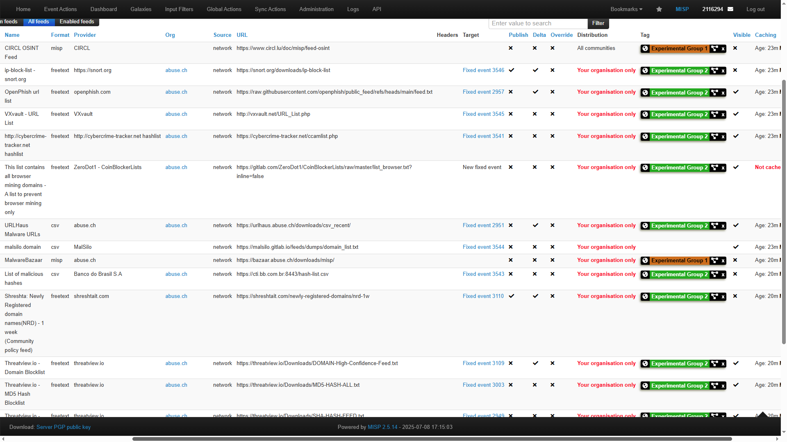
Figure 22: List of feeds from the High Diversity group.
Figure 22 displays a full list of curated feeds, tagged with experimental groups 1 (low diversity) and 2 (high diversity). The intention of the high diversity group is to include as many attributes as possible when feeds are pulled and cached.

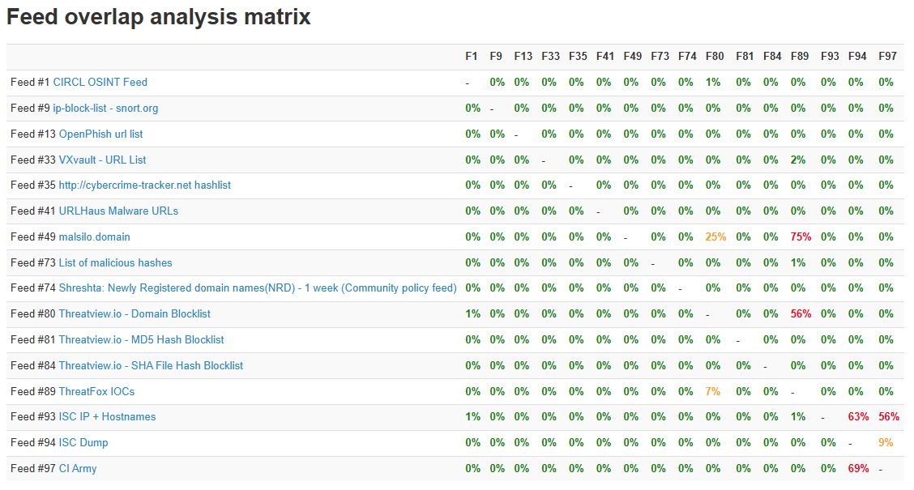
Figure 23: MISP overlapping feeds matrix.
Figure 23 shows that most of the selected feeds do not overlap, showing a diverse range of IoCs and attributes. This should provide a wide range of intelligence to work with. When conducting the experiment and analysis, it should be remembered that there may be some overlap.

MISP API, Python, and PyMISP
The MISP API will be accessed through the PyMISP library, created to simplify direct http requests and JSON parsing.
PyCharm Community 2023.2 and Python 3.13.5 are already installed on the host machine, from work completed in previous university modules.
The script will connect to each MISP instance, and target the retrieval of unique IoCs and attributes, which will also be filtered to a specific day. The full python script is submitted separately and included in an appendix; however, some key code snippets are included below.
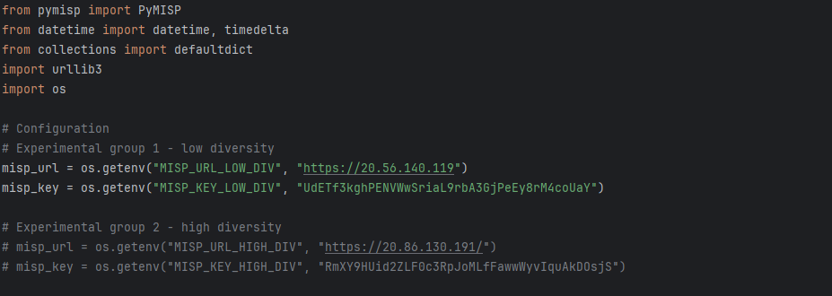
Figure 24: Importing the PyMISP library and experimental group variables.
The PyMISP library is essential to allow connection and querying of MISPs API endpoints.
There are two sets of misp_url and misp_key variables depending on which experimental group will be queried. For simplicity the one not in use will be commented out. misp_url is the IP address, and misp_key an API key generated from the admin section of the MISP web interface.

Conclusion
The careful setup of the testing environment, consisting of two MISP instances configured for low diversity and high diversity ingestion of intelligence feeds that form the bedrock of this research. After the initial difficulties of “fixed event” feeds was overcome, there is now a controlled and isolated environment that allows for the manually operated pulling and cashing of feeds. This will enable a direct, comparative analysis of how the variety of feed diversity impacts the number of unique IoCs ingested, as well as individual attributes.
The python script serves as a data extraction tool and will provide the raw data necessary to move to the next stage, which is to conduct testing and analysis.

Testing and Evaluation

Introduction
Having established a research methodology and prepared the experimental environment, this chapter focuses on the execution and evaluation phase of the study. The primary aim here is to systematically collect, process, and analyse the data generated from our low diversity and high diversity intelligence feeds.
Through this chapter, the aim is to uncover key insights into the impacts of feed diversity on IoC volume, composition, and uniqueness.

Testing
The following steps form the basis of the experiment. They are repeated daily, across the experimental timeframe of 7 (consecutive) days.
Once complete, there will be 14 sets of raw data to analyse: days 1-7 for the Low Diversity group, and days 1-7 for the High Diversity group.

Pulling TI Feeds and Extracting Data from MISP API
- Connect and login to MISP instance for the Low Diversity group.

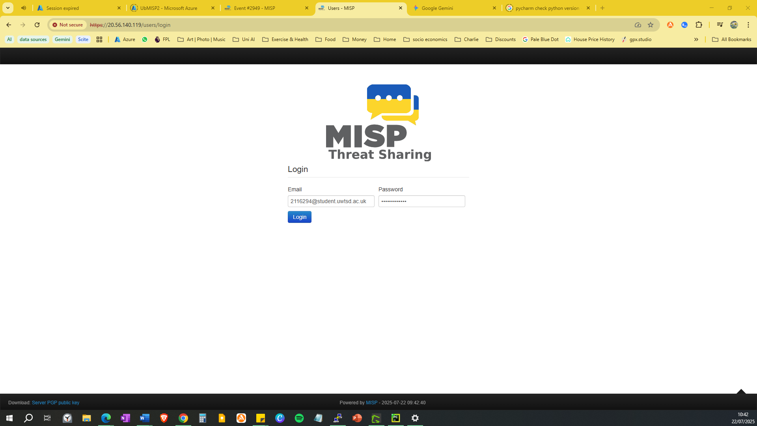
Figure 25: Login screen for Low Diversity MISP instance.
- Pull and cache all feed data.
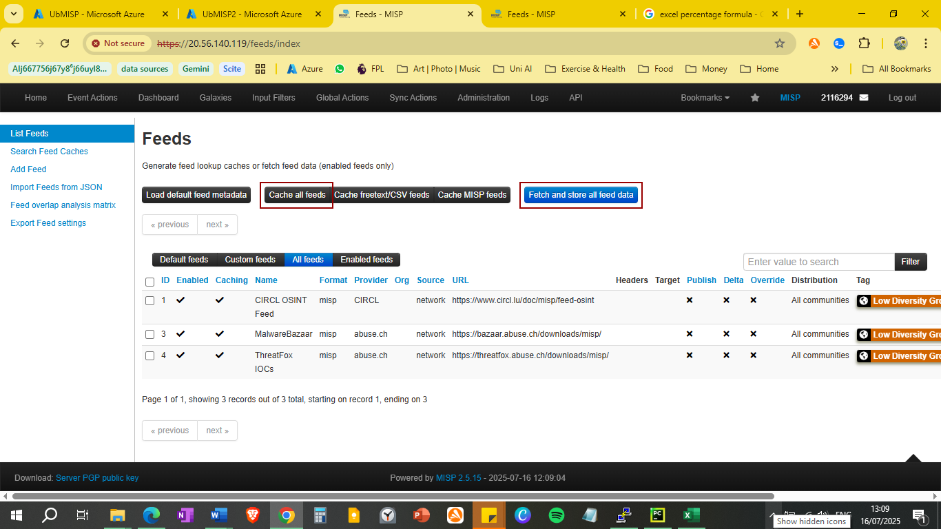
Figure 26: Feeds page for Low Diversity group.

As shown in figure 26, only the low diversity group feeds are displayed. Once the highlighted buttons are selected, the MISP instance will start to process new events. The purpose of this action is to process the new events which include the attributes and unique IoCs, which are also timestamped.

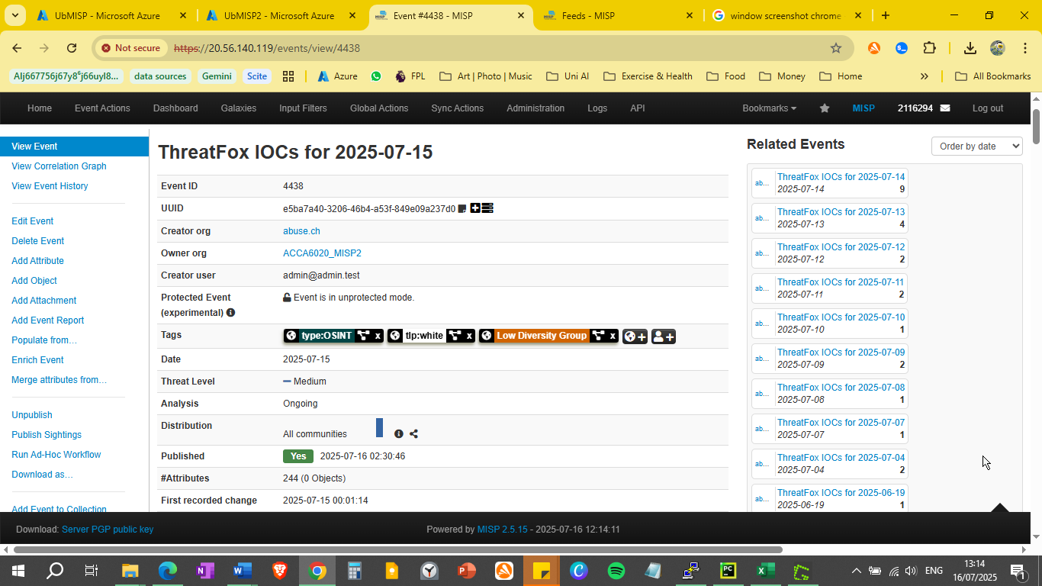
Figure 27: ThreatFox event page.
Figure 27 shows the ThreatFox fixed event page for 15th July. Related events are shown on the right hand side, which is how MISP builds its correlation database.

- Configure Python script to pointing towards the correct MISP instance and date.
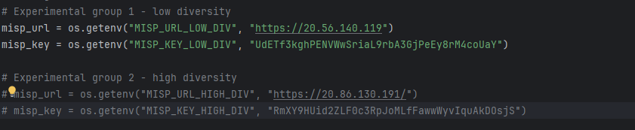
Figure 28: Configuring Python script for Low Diversity group.
Figure 29: Setting experiment date for Low Diversity Group
Once the three variables in figures 28 and 29 have been set, the script can connect to the Low Diversity group instance using an API key and run the relevant code for the date specified.

- Run Python script.
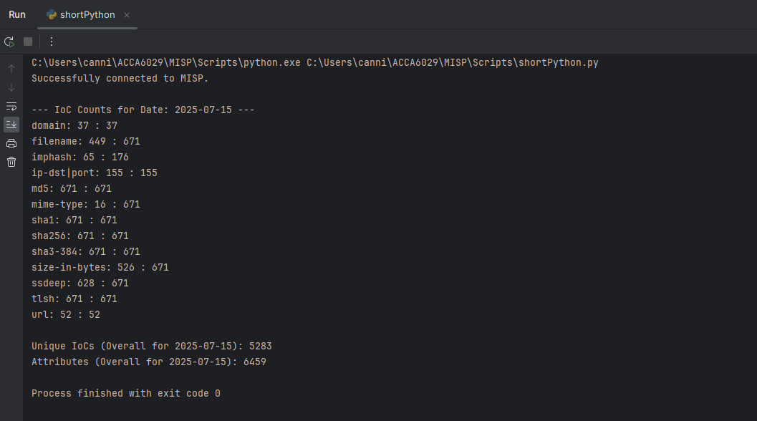
Figure 30: Sample output from Python script.
The above output in figure 30 shows the types, counts, and total unique IoCs from the Low Diversity group on the selected date, as well as the total attributes. This is the raw data required to perform statistical analysis.

- Copy and paste output into Excel spreadsheet.
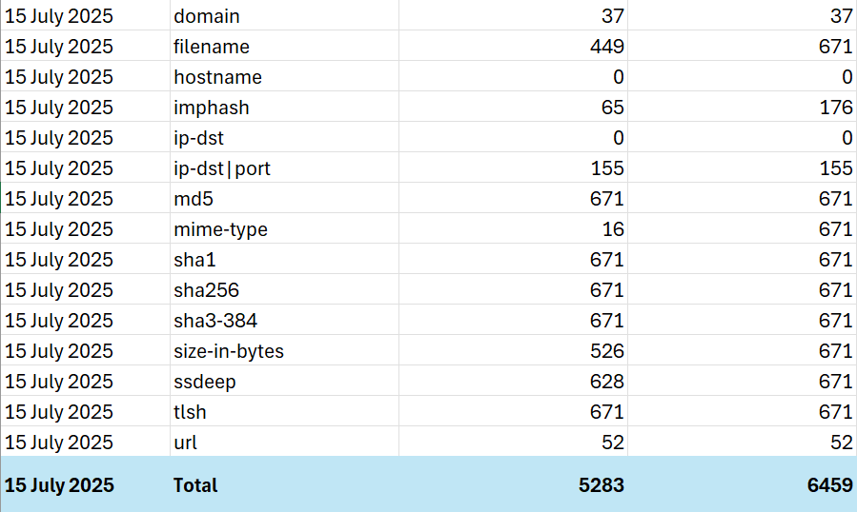
Table 3: Low Diversity Group data for 15th July 2025, in Excel.
The above table shows the data after pasting into Excel with slight formatting. This will form the basis of our statistical analysis.

- Repeat steps 1 – 5 for High Diversity Group
Now that the data has been collected for the Low Diversity Group, the process is repeated for the High Diversity group.

Statistical Analysis in MS Excel
Now that all the raw data has been acquired, statistical analysis is performed. A copy of the raw data Excel file is included in the appendices and has been submitted separately.
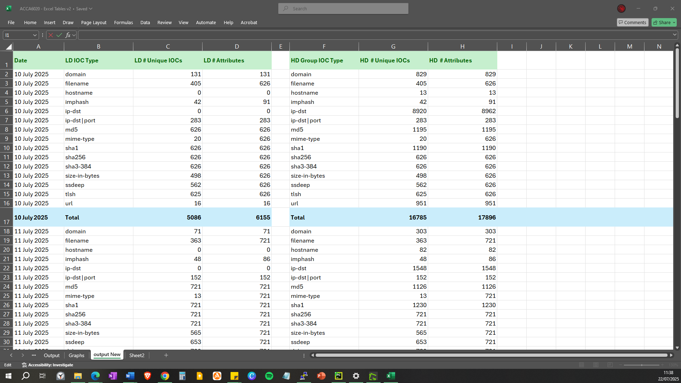
Figure 31: Partial capture of experimental data.
Figure 31 shows the format/structure of the initial data captured from MISPs API via the Python script. The Attribute and IOC types, and count for each group are listed, along with a daily total.
The raw data provided for the 7-day experimental period will now be analysed and to evaluate how the independent variables (Low Diversity and High Diversity Group) have affected the dependent variable (The number of unique IOCs that are ingested by MISP).

Overall Averages
Table 4: Average daily IoCs, Attributes, and difference between groups.
Average daily unique IoCs and attributes for each group to give a simple summary of the volume difference. This table also shows that the average difference in the amount of IoCs was 8642.14, and attributes 8667.14. This clearly demonstrates that there are both more IoCs and attributes ingested by the High Diversity Group.

Table 5: Percentage of Unique IoCs vs Attributes.
Table X evidently shows that the percentage of unique IoCs in the HD group is higher than the LD group, with the average being 9.95%. Such a large percentage shows improvement in the quality of intelligence introduced by the extra feeds.

Variability
The aim here is to compute Standard Deviation for the daily totals to show fluctuation, and if one group is more consistent than the other.
Figure 32: Standard Deviation of Daily IoC Totals.

Figure X compares the standard deviation of total IoCs for each group. The High Diversity group displays considerably more standard variation than the Low Diversity group, suggesting that there is a more inconsistent influx of intelligence ingested daily. The IoC volume is less stable on a day-to-day basis, which does make it less predictable **need to find a way of seeing if this makes any difference at all.****

Samples T-Test
The purpose of this test is to if the differences in IoCs and attributes between the groups is down to random chance, or if there is a statistically significant difference.
Taking the daily totals for IoCs and attributes for each group, and using Excel’s T-Test formula, the following results were obtained.
Figure 33: Outcome of T-Test for both groups.
Null Hypothesis: There is no significant difference between the means of the two groups.
Alternative Hypothesis: There is a significant difference between the means of the two groups.
Significance level = 0.05
As both outcomes are far smaller than the significance level, it has to be concluded that there is a significant difference in the average daily IoCs and attributes between the low diversity and high diversity groups. This difference is highly unlikely to be due to random chance.
** KEY FINDING*** There is strong evidence that the observed difference in IoCs and atts is due to feed diversity genuinely showing a higher average volume of IoCs*** YES!

Duplication and redundancy analysis
Figure 34: Selected IoC ratios for LD and HD groups.
The aim of calculating ratios per type for unique IoCs versus attributes is to ascertain an indication of duplication and redundancy within the data set. A ratio towards 1.00 indicates that every attribute of that type collected is unique, as is evidenced by the domain, sha 256 and URL attribute types. The implication of this is that the intelligence is novel, and that each piece of information is a new observation.
A lower ratio, as observed in filename and imp shows that information is repeated. Although this could suggest that there are a certain number of already known threats.

Proportional Analysis
% contribution for each IoC type to total unique IoCs, to see if higher diversity introduce more types of IoCs.

Trend Analysis
Here there will be line and bar charts. Looking at time series plots, average distribution of IoC types, etc.

Figure 35: Graph of overall LD vs HD daily totals

The Low Diversity Group doesn’t show a clear trend in either direction, only a slight oscillation. On the other hand, the High Diversity group shows more oscillation, and the linear trend line clearly shows an incline over the experimental period. This analysis confirms that the High Diversity group provides a far greater volume of intelligence, but that comes with a greater unpredictability.

Evaluation

Key Findings
Larger Volume in HD
The results clearly demonstrate that the High Diversity group yields a statistically higher average daily volume of unique IoCs and attributes compared to the Lower Diversity group. The t-tests with extremely low p-values confirm that the differences indicate a substantial increase in intelligence based on higher feed diversity.

Increased variability for HD feeds
While the High Diversity group excels in volume, it exhibits a significantly higher standard deviation in daily IoC and attribute totals. This signifies an unmistakable daily fluctuation and reduced consistency in the volume of intelligence ingested. In contrast, the Low Diversity group maintains a stable and predictable data flow.
This suggests that there is a trade-off between a wider range of intelligence, and the predictability of daily loads.

IoC Duplication Patterns
A consistently high uniqueness ratio (1.00) for several IoC types such as domain, sha256, URL and more suggest that the average unique to total ratio approached 1.00 in both groups. This indicates that for those attribute types, every piece of intelligence was unique, regardless of the diversity level.
For those types that were showing under the duplication ratio such as filename, the ratio remained consistent across both groups. Filename ratios were 0.63 in LD and 0.64 in HD, which suggests the level of redundancy is mostly independent of the volume of feeds.

Unexpected Findings
Overall, the experiment performed as intended, however some results were unexpected. The ratio of all hash related IoCs (sha1, sha256, etc) to attributes was a consistent 1.00 across both groups. This indicated that the intelligence was novel, however a concern is that the data was inaccurate. Upon investigation, a single file can have multiple hash types which allays any previous concerns but could indicate that hashes are not a reliable indicator of the IoC to attribute ratio.
Another unexpected finding was the lack of variety in IoCs and attributes. The Low Diversity group numbered 13, with the High Diversity group at 15. This was expected to be higher, and include information such as email addresses, registry keys, threat actor information and more. The researcher must take responsibility for this as it is likely that this is intelligence available to MISP, but the feeds selected did not contain that information.
It has not affected the hypothesis, aims, or objectives, however any further research should look to address this as a priority.

Research Hypothesis: Validate or Reject?
The research hypothesis was defined in chapter 3:
“Increasing the number and variety of OSCTI feeds ingested into a TIP will result in a statistically significant increase in the number of unique IOCs detected.”
Considering the testing and evaluation undertaken in this chapter, particularly in the statistical analysis performed on the raw data from MISPs API, the hypothesis can be confidently validated. All evidence provided indicates a statistically significant increase in the number of unique IoCs detected.

Conclusions and Recommendations

Summary
This report has discussed and analysed the critical role that OSCTI plays in enhancing an organisation’s cyber posture and their ability to react to the ever-evolving threat landscape. Research has focussed on the effectiveness of OSCTI compared to CSCTI and discussed emerging trends and concerns surrounding this type of threat intelligence.
Research methodology was based on a positivist philosophy, underpinned by a deductive approach. A hypothesis was formulated to conduct an experiment on quantitative data, with independent and dependent variables a key part of the experiment. This experiment was conducted on the MISP TIP, with a Python script extracting the data from MISPs API, and finally the data exported into MS Excel for statistical analysis.
The statistical analysis confirmed that a higher diversity of intelligence feeds resulted in a higher amount of unique IoCs, and the experimental hypothesis was validated.

Conclusions
This research has demonstrated that OSCTI can play a crucial role within an organisation such as DHCW and should be considered a viable alternative to CSCTI or deployed alongside it for the maximum amount of available intelligence.
The literature review concluded that there is a lack of research into OSCTI and whether it can provide reliable quality data, but highlighting it’s potential benefits if the intelligence is well-structured and curated. One concern that this project cannot address is the lack of expertise and analysts to process this data, which is why automation is an emerging trend.
Whilst constructing a solid, reliable research methodology it was necessary to outline the adequate approaches to investigate the impact of feed diversity and develop an experimental design that would enable a rigid and constructive testing environment to do this.
Once design and implementation had taken place, the controlled and isolated testing environment (two separate MISP instances) would allow for the extraction of data ready for analysis. There were issues with certain feeds and how they timestamped “fixed events” when first ingested, however these were overcome.
Testing and evaluation resulted in key findings which underpin and validate the experimental hypothesis. In short, increasing the diversity of feeds directly increases the amount of unique IoCs. In addition to this, the majority of IoCs had a high uniqueness pattern when compared to the total attributes.
Considering all the above, the experiment has been successful, and the study supports the value of OSCTI as an essential component which could be utilised within DHCW’s cybersecurity portfolio.

Recommendations for Further Research
There are several areas that would benefit from further research. Primarily, access to DHCW’s MS Azure environment could have provided several key benefits and advantages.
A MISP instance could be created and connected to MS Sentinel, which is DHCW’s SIEM application. Once created KQL (Kusto Query Language) could be used to query MISP and provide statistics and reports. Integrating with Sentinel would also require further research into the STIX and TAXI data formats, which were mentioned in chapter 2.
In addition, there are several open-source feeds that are available to governmental organisations only, such as TISP, the NCSC’s intelligence feed. This is an example of an open-source feed that is highly curated and well-structured and would provide intelligence more akin to the CSCTI feeds commercially available. Unfortunately, this feed is only available to participating organisations which would need to request access, so it was not possible to include it in this research.
Another feed which would have been of benefit, is Microsoft’s Free Threat Intelligence Feeds, which again are curated, but not as comprehensive as the paid versions. Research for both above would likely yield a wide range of IoCs and attributes that could be ingested into Sentinel.
As mentioned in the literature review, automation is a current trend in the TI community. Configuring MISP to automate tasks such as pulling feeds, correlating, and exporting data would save security analysts valuable time and resources.
Another key benefit of combining with DHCW and Sentinel is that it also ingests data from Defender XDR. This would provide instant updates on vulnerabilities, threats, and attacks which could be correlated with TI data to enrich the intelligence, then shared amongst the community.
The ability to harness MISPs full repertoire of intelligence should also be further explored. For this assignment, the experiment may have been overly simple, but future research could include more in-depth details about the intelligence itself and MISPs correlation engine. Exploration into taxonomy and galaxies, the wealth of modules which provide key benefits such as data enrichment could well yield a more comprehensive assignment more aligned with the quality of intelligence, rather than its volume.

Could run experiments comparing numbers of OSCTI vs CSCTI….
Collect data over longer period of time.

Reflections
What did I learn doing this project?
How did it develop me as a person?
Make sense of what I did.
soft skills: time management, people skills, overcoming obstacles.
Could it have been better? How?

The journey undertaken during this project has provided me with several reflections on the benefits, complexities, and challenges of OSCTI. It has also given me ample opportunity to reflect on the personal challenges of developing a large body of work, and the lessons learnt along the way.

Reflecting on Project Aim and Objectives
Overall, I feel the aim and objectives have been met.

Project Aim
“To conduct an experiment on an OSCTI platform that could be deployed within DHCW’s current security portfolio and integrate with systems such as MS Sentinel, to ensure cyber threats are efficiently identified, analysed, and mitigated.”
I feel that this project has provided a crucial step in considering the feasibility and operational considerations of a potential deployment. Understanding the configuration and sheer volume, while considering quality too, is paramount for DHCW to plan for the necessary infrastructure and analytical capacity required to integrate OSCTI into their security architecture.

Project Objectives

Conduct extensive research and literature reviews of OSCTI
The theoretical understanding of the role that OSCTI plays in cybersecurity, through the extensive literature review, helped me to better understand the vast landscape of intelligence available alongside the significant challenges posed by varying intelligence quality and the way it is shared throughout the intelligence community. Research and literature reviews have always been the most challenging part of any assignments during my time at UWTSD, however in hindsight, the review undertaken for this project is probably my best effort.

Analyse and identify key strengths and weaknesses of current systems
The analysis and identification of key strengths and weaknesses of existing systems became tangible through my introduction to MISP. Of note is my firsthand experience of configuring and managing intelligence feeds, which proved extremely problematic at first. However, these problems were overcome, and this phase certainly highlighted the importance of meticulous planning and monitoring required.

Conduct an experiment to measure the quality of OS intelligence feeds
Conducting an experiment to measure the quality of OS intelligence feeds was the core component of this work and provided significant learning opportunities. My chosen metrics and the data analysis proved instrumental in allowing me to quantify the quality of the feeds, rather than merely observing them. Whilst higher feed diversity does lead to a statistically significant increase in the volume of IoCs, it also introduced an unpredictable variability in the volume ingested. The duplication ratios of certain IoC types highlighted the fact that redundancy is a prevalent characteristic of threat intelligence, and that more data doesn’t always equate to more unique insights.

Offer a conclusion and suggest future work
Offering a conclusion and suggesting future work was an excellent tool to synthesise the project as a whole and I was able to critically assess how well I met my aim and objectives. There are without doubt, several improvements that were recommended; The majority of which were discovered or learnt across the entire scope of the project.
I feel that the connections made between the documented theory and in practice were mostly successful and to a degree I am satisfied with the process. However, I do have a lingering regret that the project could have been more in depth, particularly the experimental process. If it were possible to gain access to DHCW’s Azure environment, and their portfolio of threat defence and intelligence applications, a far more comprehensive experiment would have taken place.

General and Personal Reflections
Something I have become particularly aware of over the last few months, are the skills and knowledge gained from modules across the entire degree course and their application in this project. Modules of note were Data Analysis and Visualisation, Software Development, Learning in the Digital Era, Changemakers, and Network Programmability. Of course, the many modules that covered cybersecurity were invaluable too, however I was pleasantly surprised at the amount of information that I needed to go back through to achieve my goals. It truly shows that this assignment has been the culmination of four years of learning and development.
On a personal note, I feel have developed both as a student and a person during this project. As always, time management is an important skill to possess, particularly whilst working full time. Using various techniques and methods to rest and remotivate was critical, especially as I spend the entire working day in front of a monitor. There needed to be a balance between studying effectively whilst not burning out. I feel I mostly achieved that and have developed meditation techniques alongside an excellent exercise and sleep routine to keep myself sharp and focused.
The entire objective of enrolling on this degree was to gain a position within DHCW’s Cyber Security team. This has already been achieved, and I started in June. I wholeheartedly feel that the topics covered during the degree, and the research conducted into threat intelligence assisted me in the interview, and it has already been extremely useful in practice at work.
In conclusion, I am extremely happy that I enrolled on this degree course. The first year was particularly challenging, having not been in education for nearly twenty years, and the face that all lectures were online. Over time, my confidence improved, and I settled back in to the educational system, improved my time management, organisation, and most importantly consistently performed above my expectations in assignments and exams. The degree has improved my knowledge and confidence, and I sincerely hope that everything I have learnt and experienced at UWTSD is demonstrated in my final body of work.

