
Skills for the Workplace
Module Assignment Submission
Student Name: | Caroline Smitham
Student Number: | 2011711
Module No: | BMSK4006
Module Title: | Part 1 Business Plan

Statement of Confirmation of Authenticity
By the act of making this submission, the student declares that this is the work of the student named above. The work has not, in whole or in part, been knowingly presented elsewhere for assessment, or where assessment has been built on a previous assessment, this has been identified. Where materials have been used from other sources it has been properly acknowledged. If this statement is untrue, the student acknowledges that an assessment offence has been committed.
Attention is drawn to the plagiarism and unfair practice policies of both the University and of ILM.

Table of Contents
Title Page 3
Business/Industry Overview 3
Market Analysis and Competition 4
Sales and Marketing Plan 6
Pricing Strategy 7
Sales and Distribution 8
Ownership and Management Plan 8
Operating Plan 8
Financial Plan 8
Appendices 9
References 12

Title Page

Business Plan for Made by Caroline
06/07/2022
104 Salem Road, Morriston, Swansea, SA6 8NN
07772311644

Executive Summary

Made by Caroline is a business that has just started up in Swansea, the business will be owned and managed by myself. The company is a custom printed items business for all ranges of people of all ages. Caroline aims to target young children and adults with the personalised printed T-shirts to start off her business and then expand to a wider range of items such a hoody, stationary, bags etc.
I have decided to start this business has it during covid when I was not working due to furlough, I started printing t-shirts as a hobby. I then had family and friends purchase of me through word of mouth. It was not until I returned back to my full-time role that I realised that I had a passion for printing personalised t-shirts and wanted to commit my life to it as a career.
I feel like the business will be a success as there is high demand for custom print clothing and materials being a reasonable cost to purchase.

Business/Industry Overview

Made by Caroline is a personalised item company targeting towards male and females of all ages. The items will include personalised logos of the person’s choice for example small business logos or a personalized birthday t-shirt. The company will mainly be aimed at parents of school age children to provide them with affordable products with a quick turnaround especially when events with schools crop up e.g., number day or birthday parties.
Caroline has been making personalised items for over 3 years as a hobby and for friends and family for non-profit. It was not until Caroline returned to her full-time role after the pandemic that she realised personalizing items was her passion and she would like to dedicate her life making her personalized items permanent.
Caroline has decided to start up Made by Caroline on a part time basis whilst working her current administrator role as The University until she can earn enough money to become a full-time sole trader.
The following products will be available to purchase from Made by Caroline to personalise of the persons choice –

T-shirts
Jumpers / Hoodies
Shirts
Dresses
Skirts
Jackets
Stationary

I will sell to private individuals but will also consider selling to other small businesses that are just starting out. I will offer collection from my home address but will also deliver either with a postal service or deliver myself using my own vehicle if local to the Swansea area.

Market Analysis and Competition

Made by Caroline aims to target people locally in Swansea and surrounding areas to provide a faster turnaround service. Caroline already has a small number of customers who are mainly close friends and family that have purchased of her recently and will purchase in the future. With word of mouth and advertising on social media platforms such as Facebook and Instagram, Caroline is confident that she will gain a lot more customers as she progresses.
Made by Caroline has identified two competitors within the personalised items industry one are internet based only company, and the other one is another local company.
YOUR DESIGN (Appendix A)
This internet-based company offers the same products as what Made by Caroline has to offer. Please see SWOT analysis for Your design company.

Strengths  Turbo machines for faster printing  Can offer bulk orders of 50 units or more  Courier delivery service  High Product quality | Weaknesses  Does not offer a time frame for delivery  Operating cost  Do not have shop
Opportunities  Rising demand  Increased internet sales every year  Internet more easily available | Threats  Competitors  Cost of living crisis  High prices
Little rascals (appendix b) is a local company offering the same products as my business, they have over 2000 people following their business page on Facebook, Little Rascals are not offering competitive prices so I am confident I can gain my customers with the prices that I have to offer. Please see SWOT analysis for Little Rascals Below

Strengths  - Locally made T-shirts meaning faster turnaround on orders.  - Repeat customers promoting business | Weaknesses  - Pricing is not competitive
Opportunities  - Custom made clothing in the new trend | Threats  - Competitors undercutting prices.  - Rising operations cost

Sales and Marketing Plan
With the global custom t-shirt printing market valued at USD 3.9 billion in 2021 and is expected to increase at a compound annual growth rate (CAGR) of 9.9% from 2022 to 2030 (appendix B). The entertainment industry is contributing to the market growth with many people purchasing t-shirt with logos or slogans relating to their favourite tv show/movie
Caroline will advertise her products on social media platforms such as Facebook, Instagram, tik tok and twitter. Caroline will also advertise her business with leaflets and business cards advertised in local shops, community centres and local schools.

To start of my business, I will be advertising the following discounts to customers

- By three t-shirts, get 1 free
- Free delivery over £25
- Free gift over £50
- Set up a rewards club

POLITICAL | ECONOMIC
Tax Policy  Government Policy  Wars & Conflicts  Brexit | Interest Costs  Labour Costs  Inflation  Energy Costs
SOCIAL | TECHNOLOGICAL
Population Growth  Job Opportunities  Health  Lifestyle Choices | Advancing Technology  Changes in Technology  Research & Development

Pricing Strategy

I have priced the cost of all materials to custom t-shirts, and I have also considered my time to make the items and the energy costs I will use.
Item | Price
T-shirts | £3.00
Sublimation sheets | £1.50
Heat transfer sheets | £0.10
Ink | £0.50
Packaging | £0.20
Energy costs | £1.00
Hoodies | £7.00

My current price list is
£12.00 T-shirt.
£20.00 Hoodie

Sales and Distribution
Caroline will advertise her business mainly on social media platforms, Caroline will have plain sample t-shirts if people wish to try for sizes. People will be able to purchase items via phone calls, messages or emails, Caroline will prefer to have a contactless payment method such as PayPal or bank transfer but is open to take cash payments. I will offer a collection service, postal service, and a delivery service if in the local surrounding area.

Ownership and Management Plan
I will be the sole proprietor of the business, I will be responsible for taking orders via emails phone calls or direct messages, ordering stock, and managing my accounts. I will use government recognised apps to use for my own records.

Operating Plan
Made by Caroline plans to operate from her spare room at her home address that she currently owns and plans to stay there for the near future. The advantages of running the company from her own home is the ability to work at own pace and have increased focus, working from her property will save on expenses such as commuting and extra fees so will benefit in being able to offer a delivery service of products for a small fee. Caroline has also identified disadvantaged of running her business from her property, as mentioned as an advantage there is also a risk to productivity, with the freedom to work at own pace and take breaks it can also be difficult to stay focused, this can lead to slower productivity. Caroline will use her own equipment to produce her products, but it would be cost efficient at the to use a printing service if needed to bulk print.

Financial Plan

Made by Caroline will incur the following expenses to start up: -
A laptop which will be at the higher end module containing the following software – Microsoft office, adobe photoshop and Illustrator - £800
HP laser printer - £350
Broadband internet connection - £35pcm
Desk, Chair, and office supplies set - £200
Heat press to make the sublimation transfer - £100.
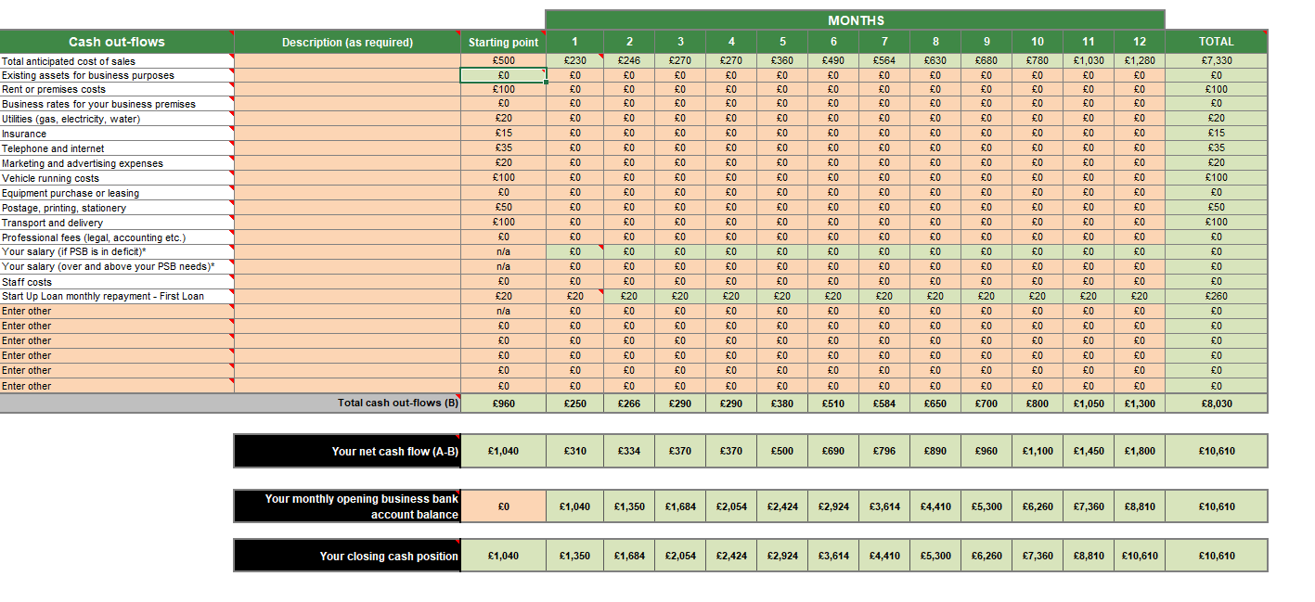
I have created a cash flow spreadsheet of my current earnings, my outgoings and what I aim to earn

Appendices

Appendix A

Appendix B
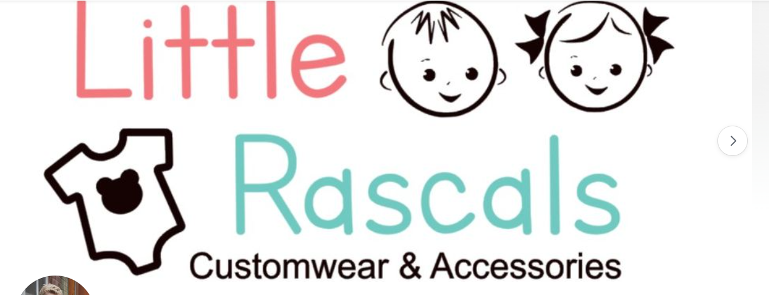

Appendix
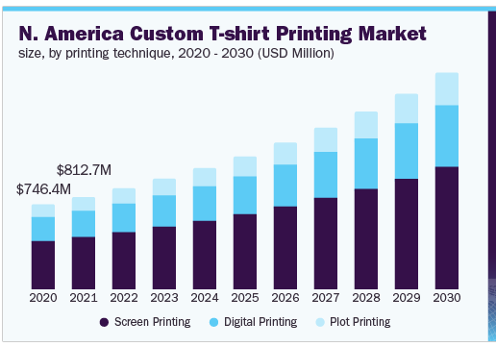

Appendix

Appendix
Caroline Louise Smitham
104 Salem Road
Morriston
Swansea
SA6 8NN
07772311644
Caroline84thomas@live.co.uk
Profile
Well presented with exceptional customer service skills, and the ability to provide an effective reception and switchboard service. Experienced in working under pressure in a quick paced fast-moving environment and able to receive guests on arrival in a friendly, helpful, and approachable manner. Able to be an integral member of an administrative and clerical team and can follow instructions and have a willingness to learn.
Career Progression
University of Wales Trinity Saint David Technium 2011 – Present (Operations Administrator)
Working within a reception environment providing a telephone answering, admin and reception service as well as organising the post, welcoming visitors, and providing hospitality towards guests and clients.
Duties:
Answering all incoming calls / emails and re-routing them to relevant parties.
Meeting and greeting visitors and students ensuring they are signed in and inducted.
Opening, distributing, collecting, and taking the post.
General administration duties, photocopying, filing etc.
Dealing with any enquiries at the reception. Reporting any problems to the building manager.
Dealing with car park requests and hospitality requirements.
Ensuring that the reception area is tidy and clutter free.
Operating a computer system and switchboard.
Wolseley UK 2004 - 2011
Collaborating with customers to come to an agreement to clear debt via telephone, letters or email, create spreadsheets through excel managing the day-to-day daily duties in the office and organising office and filing systems.

Office Angels 2003 – 2004 (Recruitment agency)
Magistrates Court sorting out all post court files.
Renault Garage on the Switch Board directing calls to the relevant department.
Courage Brewery inputting details of returned stock back into the system
Diamond Holidays 2000 - 2003
Working in busy office, managing over 100 calls daily and dealing publicly with customers. Sending out travel tickets, taking customer payment over the phone and cash handling and also other general office duties etc keeping up to date with paperwork, photocopying, filing.

Education/Qualifications
1995 – 2000 Pentrehafod Comprehensive School
English GCSE
Maths GCSE
Science GCSE
I.T GCSE
Food Technology GCSE
Child Development GCSE

Training
2003 Gained NVQ level 2 & 3 in customer service, through an open college while I was working as an apprentice in Diamond Holidays.
January 2013 NVQ IT
May 2013 Fire Marshal Training
March 2015 Fire Alarm training
October 2020 Skills for the workplace – Certificate of higher education

Referees
Available on Request

References
, Custom T-shirt Printing Market Size Report, 2022-2030. Available: https://www.grandviewresearch.com/industry-analysis/custom-t-shirt-printing-market [Jul 14, 2022].

, Competitor Analysis: Examples & Ultimate Guide-11-18T08:09:36+00:00, 2021-last update. Available: https://sixads.net/blog/competitor-analysis-example/ [Jul 6, 2022].
How to become a sole trader. 2021.
, How to Write the Competitive Analysis for Your Business Plan [2022]-01-02T20:38:09+00:00, 2019-last update. Available: https://www.growthink.com/businessplan/help-center/business-planning-competition-good [Jun 23, 2022].
The 30 Best Ways to Promote Your Business at Any Budget.
, ElizabethBeeDesign | Etsy UK. Available: https://www.etsy.com/uk/shop/ElizabethBeeDesign [Jun 23, 2022].
, How to Determine the Legal Structure of Your Business | Edward Lowe Foundation. Available: http://edwardlowe.org/how-to-determine-the-legal-structure-of-your-business/ [Jun 17, 2022].
, Personalised T Shirt | Etsy UK. Available: http://www.etsy.com/uk/market/personalised_t_shirt [Jun 23, 2022].
, UK Press Package No1 - Printing Business Start Up. Available: https://www.start2print.co.uk/product-page/work-from-home-print-business [Jun 23, 2022].
, What’s Included in a Small Business Operating Budget?. Available: https://www.thebalancesmb.com/preparing-operating-budget-for-small-business-393026 [Jul 12, 2022].
CHEN, J., -08-05T14:56:37+00:00, 2020-last update, 12 Clever social media promotion ideas you’re not using. Available: https://sproutsocial.com/insights/social-media-promotion/ [Jul 14, 2022].
LTD, Y.C.U., , Print on Demand | Custom Clothing. Available: https://www.yourdesign.co.uk/ [Jul 6, 2022].
PANEL, E., , Council Post: Eight Effective Strategies For Identifying Your Target Customers. Available: https://www.forbes.com/sites/theyec/2021/10/04/eight-effective-strategies-for-identifying-your-target-customers/ [Jun 23, 2022].

