Tensile Test

Snasloy D Silva

2321317

Engineering Science

ACHA4002

Introduction
The aim of this assignment is to conduct a tensile test for various materials. This is done to find the breaking point of each material and figure out their durability. Tensile testing is done by majority of engineers over the world who work in industries. It is also done by engineers in research institutions. Force is exerted onto a specimen to determine how it responds to the stress put on it. A material’s quality allows the user to choose when, where and how to use depending on the design on the product as this testing offers the information required for whichever field of use. (INSTRON, 2024)
In this experimental procedure, a Tensile Tester Kit ES6 is used. The four different specimens that have been tested are: Steel, Aluminium, Duralumin and PVC.
The ES6 tensile tester is used to determine material strength and how it reacts to load that is applied. It allows you to calculate the yield strength, tensile strength and elongation of materials (AYVA Educational Solutions | Canadian Educational Partner for Many Top Brands, 2017). The tester consists of a load nut with a load nut scale that depicts the number of rotations made. The dial indicator identifies the amount moved/stretched or the deflection of the spring at the bottom. The top and bottom chuck hold the materials in place.
The measured original length of each specimen material are as follows:
Steel | 31mm
Aluminium | 31mm
Duralumin | 31mm
PVC | 31.2mm

With the data recorded while conducting the experiment, the required fields to be calculated are, force (N), Extension (mm), Stress (n/m^2) and nominal strain.
Experimental Procedure
Step 1 – The steel specimen is placed onto the tensile tester and screwed onto the surface of the kit with two screws to make sure the material is rigidly in place. This is done by using an allen-key.
Step 2 – Once the material is places securely, the protective plastic guard is places over the tester to avoid any injuries. The dial indicator is then zeroed out and now the experiment is ready to commence.
Figure 1 shows how the material is placed before the experiment is started by twisting the load nut.

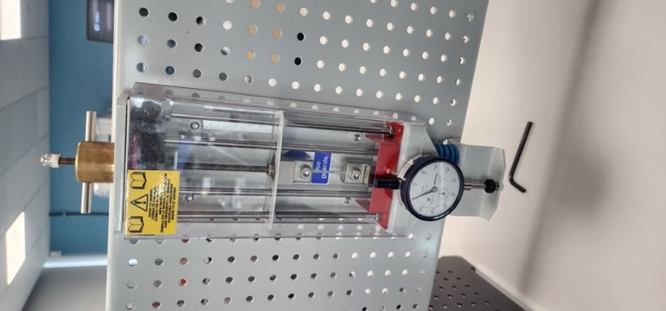
Figure 1
Step 3 – The load nut has 10 dials and is rotated clockwise every 0.2 millimetres. Which is also recorded as every two dials on the load nut scale. Once the load nut is rotated to match 5 millimetres it then takes full rotations (1 millimetre = 1 full rotation) until the material snaps.
Step 4 – After every rotation the reading on the dial indicator is noted down as this helps in determining the extension till breaking point.
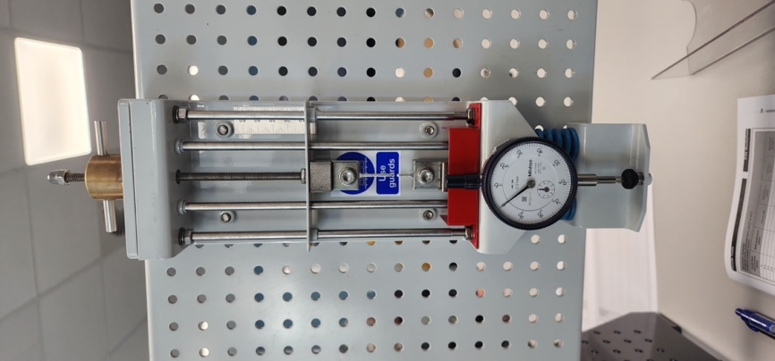
Figure 2
Figure 2 is a picture of the material once it has snapped.
Step 5 – Once the material breaks, remove the safety guard so that the material is taken off the tester by using the allen-key on the top and bottom chuck. The material is then measured to determine the final length of the material.
Step 6 – The procedures above are repeated for the next three materials in the following order: Aluminium, Duralumin & PVC
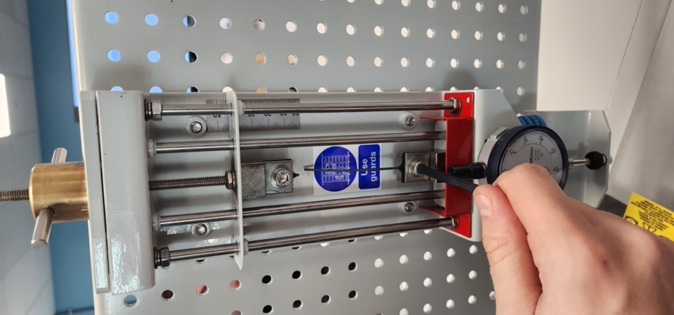
Figure 3
Figure 3 is the final product of the PVC, and it shows the difference in its elasticity as compared to the previous three materials.

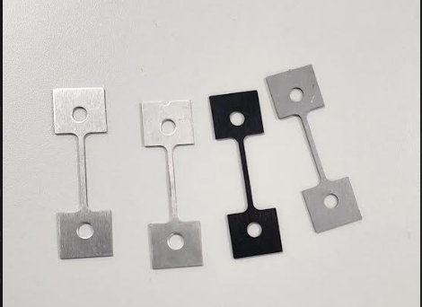
Figure 4
In figure 4, one can see the 4 materials besides each other before the experiment was started. The material on the furthest left is duralumin, the material in the middle to the left is the aluminium specimen, the material on furthest left is the steel material and the one on the right in the middle is the PVC specimen.
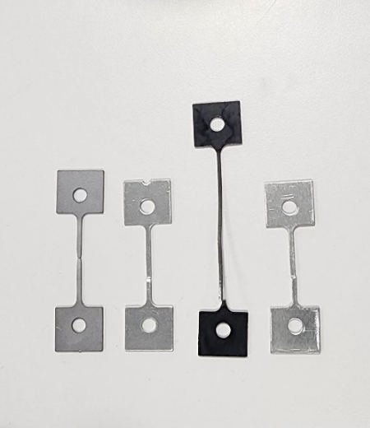
Figure 5
Figure 5 shows the materials after the experiment is conducted. The one on the left is the steel specimen, the one on the right of it is the aluminium specimen, the one on the furthest right is the duralumin specimen and the one to the left of the duralumin specimen is the PVC specimen.
Results
The final length after conducting the tensile test of each material is specified below:
Steel | 39.1 mm
Aluminium | 33.95 mm
Duralumin | 33.5 mm
PVC | 69.51 mm

The recorded data and its required calculations are listed below:
Steel
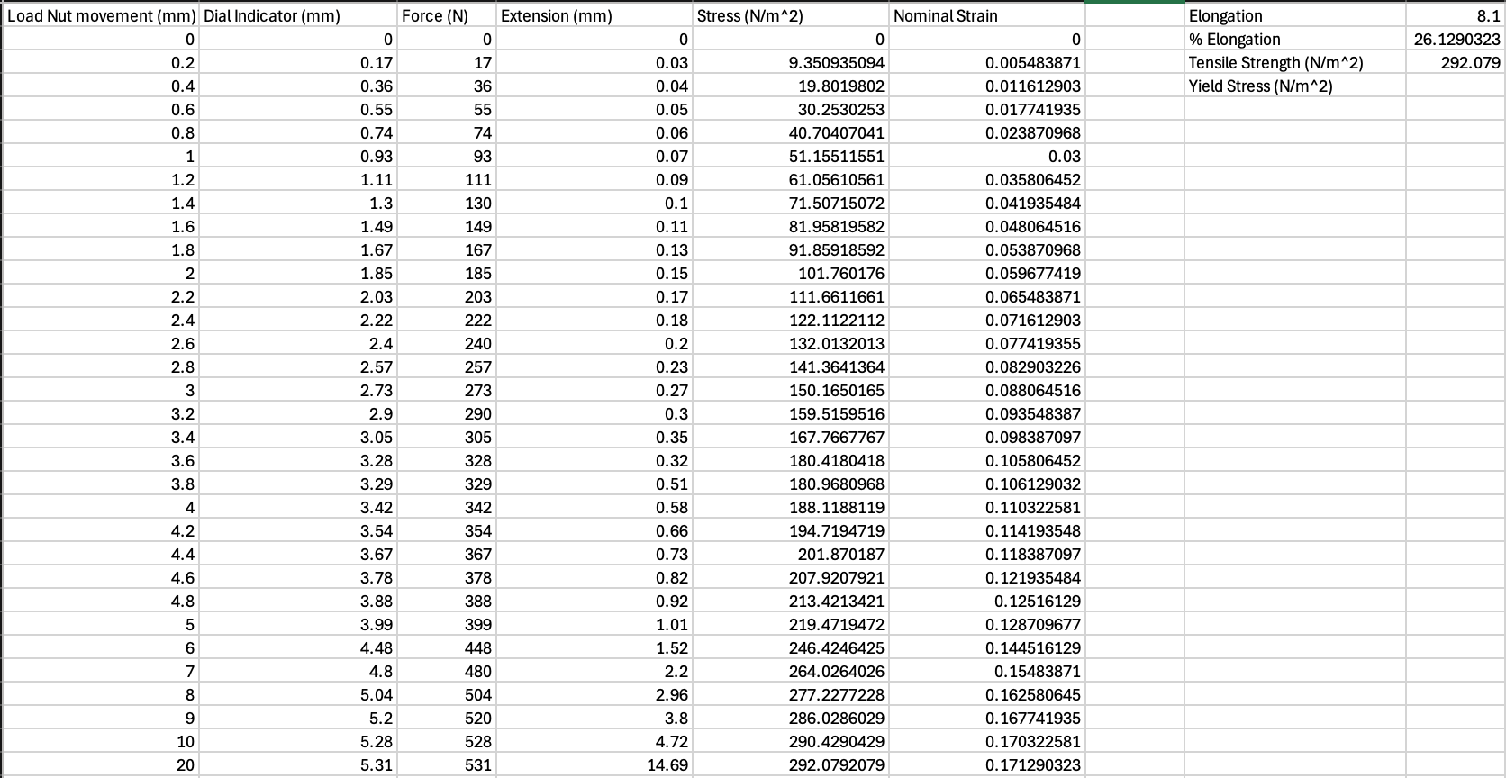

Aluminium
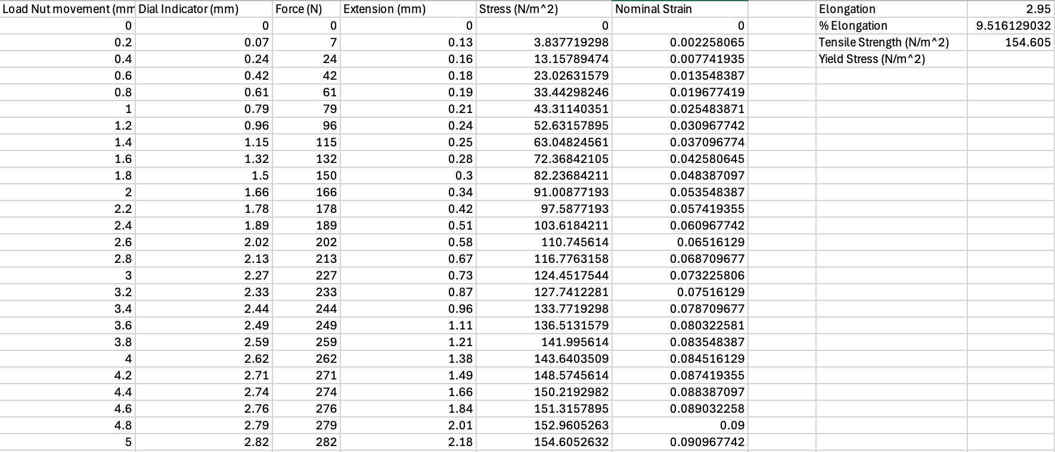

Duralumin
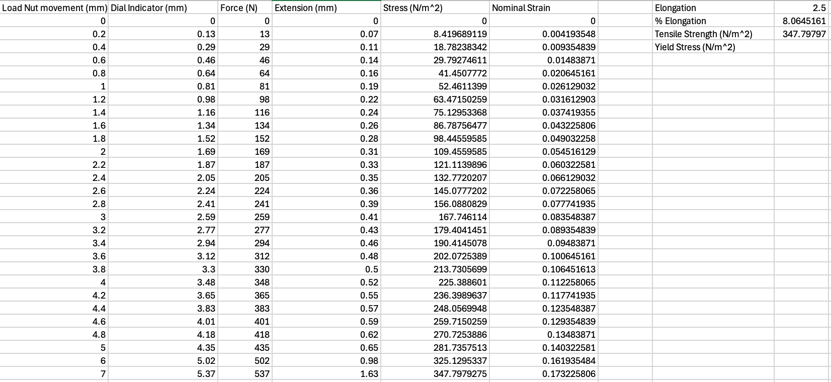

PVC
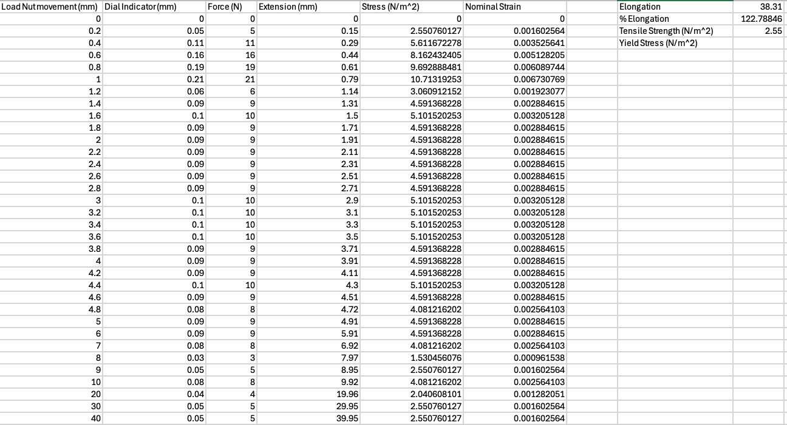

Analysis

Above, are the stress & strain graphs that help determine the yield stress. Stress is indicated on the x-axis and strain is indicated on the y-axis. The yield stress is the moment or point at which the gradient of the line on the graph starts bending. This shows the elasticity of each material as well. The yield stress has no S.I. unit. The end point on each graph is the point at which the material breaks or snaps. The tensile strength of each element is listed in ascending order: PVC, aluminium, steel and duralumin. The aluminium alloy, duralumin, is the strongest amongst the four tested specimens.
Conclusion
With the data presented, one can verify that different materials have different durability. Some materials are stronger than others, and this is very important when Engineering is related. It is clearly proved that PVC has more elasticity as compared to aluminium, duralumin and steel. Duralumin has similar properties as aluminium since it is an aluminium alloy. Steel has more elasticity than aluminium or duralumin. One can say that duralumin is the least elastic material amongst the four specimens tested. One important factor that plays on the elasticity of PVC is temperature, the hotter the room temperature is the more the elasticity. Whereas the cooler the room temperature the easier it is to snap the PVC specimen. The graph of steel and aluminium seems to have the same gradient as they have similar properties. Duralumin is an alloy of aluminium, so it tends to be stronger than aluminium. The constant force application rate and temperature are key in terms of PVC as they can vary from cold temperatures to warm temperatures, and if constant force is not applied the material can stretch for longer producing errors in the calculations.
Evaluation
In this experiment, some factors to prevent errors or eliminate errors is to make sure the specimens are securely installed onto the testing kit. This is done by tightly screwing the chucks on by using the allen key. Make sure the plastic guard is fitted on, so no injuries are caused. One must also make sure that the dial indicator pin is at zero before the experiment is taken place. To get accurate data one must make sure they are working in teams as the data collected while turning the load nut needs to be accurate. This is because the dial indicator can fluctuate due to different elements having different flexibility (elasticity). The point at which the material breaks is also known as the fracture point. The point on the graph where it starts bending is known as the yield point whereas the area after it is known as the plastic region. PVC is more ductile, and duralumin is more brittle.
Further work
This experimented can be better in various ways. Different materials can be tested other than the four specimens used. Carbon fibre could be an interesting material to test as they are light and durable materials that are frequently used in the Motorsport or Mechanical industry. Some materials that could have interesting results are copper, gold or brass. Using a tensile tester machine rather than a kit can help determine yield strength, tensile strength and elongation of bigger materials for example steel material for a roll cage tube to determine how safe the roll cage of a motorsport car can be.

Bibliography

AYVA Educational Solutions | Canadian Educational Partner for Many Top Brands. (2017). TecQuipment Tensile Tester Kit – ES6 | AYVA Educational Solutions. [online] Available at: https://www.probeware.ca/product/tensile-tester-kit/ [Accessed 8 Dec. 2024].
‌ INSTRON (2024). Tensile Testing Machines | an Introduction. [online] Instron.com. Available at: https://www.instron.com/en/resources/test-types/tensile-test.
‌

