Name: Lacramioara Ionesi
Student ID: 1813706
Module code: BMSK4002_LON
Assignment Name: Effective Team Working and Communication
Lecturer’s Name: Richard Small

Table of Contents
❖ Introduction 2
❖ What is communication? 2
❖ Definition of Effective Communication 3
❖ 4
❖ What are the models of communication? 4
❖ Shannon and Weaver’s Informational Theory Model: 4
❖ Berlo’s S-M-C-R Model: 5
❖ Types of communication 5
• Five Types of Communication 5
❖ Theories of communication 6
✓ Structural and Functional theories: 7
✓ Cognitive and behavioural theories: 7
✓ Interactionist theories: 7
✓ Interpretive theories and critical theories: 7
❖ Types of communication skills at the workplace 8
✓ Verbal communication: 8
✓ Non-verbal communication: 8
✓ Written communication: 8
✓ Visual communication: 8
Managing conflict through effective communication at the workplace 8
❖ Communication styles 9
✓ Passive 9
✓ Aggressive 9
✓ Passive-Aggressive 9
✓ Assertive 9
❖ Communication styles to be used within the workplace 10
❖ Recommendations for improvement 10
❖ Conclusion 10
❖ References 11
Bibliography 11

Introduction

- In this task, I will be talking and describing what communication means, what effective communication is, the importance of effective communication at the workplace, the theories and models of communication, how to solve problems and conflicts at the workplace through effective communication.

What is communication?

- Communication is a modest process yet showing complexity in some aspects. Different ways of communication and the spaces over which one is required to transfer the information make the process complicated. Communication is a Latin word which means ‘to share’. It is the sharing of data between diverse persons. It contains the sharing of ideas, concepts, visions, activities and written content. Communication is simply defined as the transmission of information from one place to another. This transmission of information can be managed in different ways (Team, 2019).

Definition of Effective Communication

- Definition of Effective Communication is a communication between two or more persons wherein the intended message is successfully delivered, received and understood. In additional words, the communication is supposed to be effective when all the gatherings (sender and receiver) in the communication, allocate similar values to the message and listen carefully to what all have been said and make the sender feel heard and understood. In the business background, communication is effective if the information shared between the business employees supplies regarding the organization’s commercial success. The effective communication contains not just the method you use the words but also protections several other skills such as, non-verbal communication, skill to understand your own feelings as well as of the other person with whom you are communicating, engaged listening, ability to speak energetically.

- There are numerous barriers to effective communication which are listed below:

- Semantic Barriers
- Organizational Barriers
- Psychological and Emotional Barriers
- Personal Barriers
- Effective communication in the company, allows the employees to develop their connection with others and increase teamwork, decision-making, and problem-solving capacity. The communication is an ability which is academic, and an individual can achieve spontaneity in it by positioning in his extra strengths and sharing in more public conversations (Jargons, n.d.).

What are the models of communication?

- Over the centuries, the experts discovered a lot of models of communication within the business environment. There isn’t a model of communication that contains of all the elements needed in a communication situation. Two of the models of communication that are well known are:

Shannon and Weaver’s Informational Theory Model:

- In 1948, Shannon was an American mathematician, Electronic engineer and Weaver was an American scientist both of them join together to write an article in “Bell System Technical Journal” called “A Mathematical Theory of Communication” and also called as “Shannon-Weaver model of communication”. This model is particularly designed to improve the effective communication between sender and receiver. They find factors which affecting the communication process called “Noise”. At first the model was developed to improve the Technical communication. Later it’s widely applied in the field of Communication (Theory, n.d.).
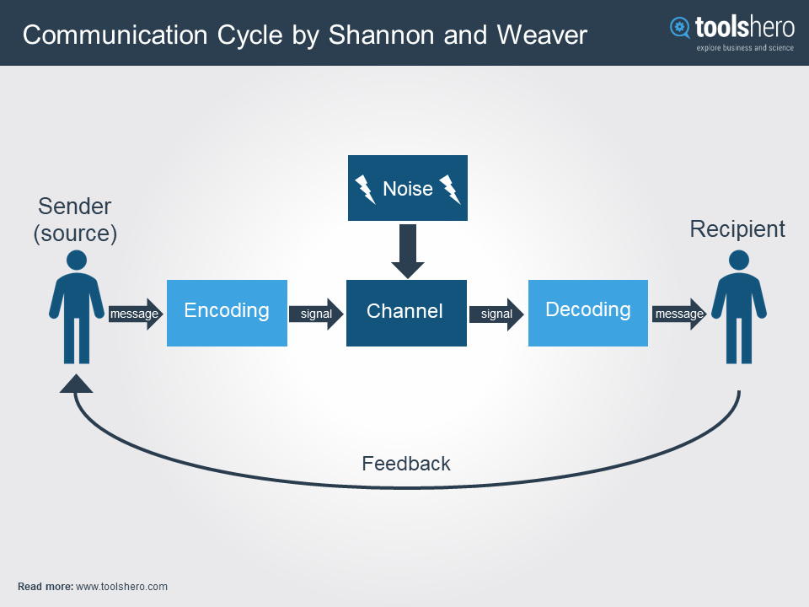

Berlo’s S-M-C-R Model:

- In 1960, David Berlo postulated Berlo’s Sender-Message-Channel-Receiver (SMCR) model of communication from Shannon Weaver ‘s Model of Communication (1949). He defined factors affecting the individual factors in the communication making the communication more effective (Communication, 2018).

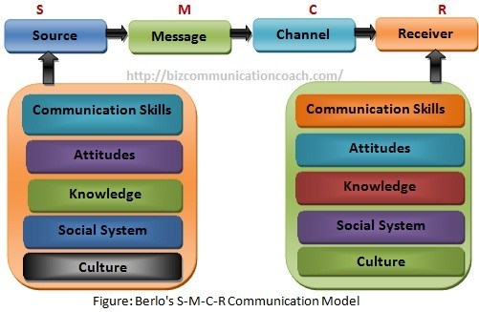

Types of communication

Five Types of Communication

  - Research deep into the five types of communication detected between the group of people or an official team.

- Verbal Communication:
- Verbal communication can similarly be called as Oral communication. In very simple terms, any communication that occurs orally between people is recognised as verbal communication.

- Non-verbal / Interpersonal communication:

- The beyond were certain examples of Non-verbal communications or interpersonal communications. One of the HR supplies for new joiners in a business is for them to have good interactive skills. This fundamentally means that the employees should meet up on their non-verbal skills.

- Written Communications:

- All different methods of written communication can be official or unofficial. If currently, we visit a court of law, you will find that even WhatsApp messages are considered to be legal in nature. Statistic, there have been so numerous cases of celebrities carried under the scanner because of wrong written communications on their social media account.

- Formal &Informal:

- There are two categories of communication when reflecting the procedure of the communication. One is the formal and official type of communication which can be emails, letterheads, memos, reports and other such kinds of written material.
Informal communication is one where there is nothing official about the communication that is scheduled. It can be recognised as Grapevine communication.

- Visual Communication:

- These informative brochures have all the information about the medicine so that doctors can feel self-confident in suggesting the medicine to their patients. Similarly, many different industries are using visual communication to help interaction with their customers so that they can communicate their ideas better. Explainer videos as a concept is rising and is becoming as one of the best types of communication observed on websites (Bhasin, n.d.).

Theories of communication

- The research of communication and mass media has guided to the formulation of many theories: structural and functional theories consider that social structures are valid and function in ways that can be detected accurately. Cognitive and behavioural theories manage to focus on psychology of
Individuals. Interactionist theories view social life as a development of communication. Interpretive theories expose the ways people actually understand their individual experience, and critical theories are concerned with the engagement of interests in society and the way communication perpetuates authority of one group over another (Suresh, 2003).

Structural and Functional theories:

  - The structural-functional method is a theoretical method that understands society as a complex and interconnected system, whose individual shares work in concert to promote stability and agreement in the system as an entire. Again, let's return to the metaphor of our forms to assist make this clear. Each structure in our forms has a function to promote the overall well-being of our health. You can't take away one organ and expect to still be healthy. The heart needs to pump the blood. Your brain needs to do the thinking. Your liver and kidneys do the purifying, things like that. If one of them goes away, the whole system fails (Lamb, n.d.).

Cognitive and behavioural theories:

  - Social cognitive theory is a knowledge theory developed by the celebrated Stanford psychology professor Albert Bandura. The theory delivers a framework for understanding how people dynamically shape and are shaped by their environment. In particular, the theory details the processes of observational learning and modelling, and the influence of self-efficacy on the production of behaviour (Vinney, 2019).

Interactionist theories:

  - Social interactionist theory is a description of language development highlighting the role of social interaction between the developing child and linguistically knowledgeable adults. It is based principally on the socio-cultural theories of Soviet psychologist (Vygotsky, n.d.).

Interpretive theories and critical theories:
  - Critical theory and interpretive theory operate from within what can be characterised the transitive epistemological measurement and tends to emphasize the importance of ontological matters (Anon., 2013).

Types of communication skills at the workplace

- There are different kinds of information. The four major types are:

Verbal communication:
  - Verbal communication is an essential component when it appears to the overall success of a business. Verbal means that certain sounds, specific languages, and the spoken word may be used. In today's world, there is a large diversity of individuals that make up the standard workforce.

Non-verbal communication:
  - When it approaches communication in the workplace, it is important to understand the significance of non-verbal communication four types of communication. When this occurs, it means that a physical manner of communication is being used to share ideas and meanings among others.

Written communication:
  - Written communication is also completely important when it comes to the workplace. This form of communication involves either writing or typing out information, facts, figures, and other types necessary information in order to express ideas among those in a business.

Visual communication:
  - In the workplace, it is common to incorporate visual communication in order to share ideas that relate to the business, provide information to those that work in the company, and to outline specific points that need to be emphasized for the success of the business (R, 2018).

Managing conflict through effective communication at the workplace

- One of effective communication skill for effectively resolving conflicts is to address only one subject at a time and avoid introducing other subjects, even if they are connected. Clearly specify what you are concerned about, even if it takes some time to isolate the primary issue at hand. Also, avoid attacking the other person or making accusations, which will only lead to distrust and defensiveness. To listen effectively, take care to make sure you understand what the other person is trying to say, restating that person’s thoughts and feelings as needed. Strong verbal and nonverbal communication involve making appropriate eye contact, not using threatening physical actions, and verbally expressing how the situation makes you feel, instead of attacking or accusing the other person (SWITZER, n.d.).

Communication styles

- Each person has a unique communication style, a method in which they interact and share information with others. There are four basic communication styles:
- Passive
- Aggressive
- Passive-Aggressive
- Assertive
- It’s important to recognise each communication style, and why persons use them. For example, the assertive communication style has been found to be highest effective, because it includes the best features of all the other styles. When we analysis these four styles, we’ll better recognise the characteristics of each style, normal expressions and what makes them unique (Communication, 2018).

Passive
  - Passive communication is a style in which you avoid directly speaking what you think or want and that often involves uncomfortable body language. Many people with social anxiety end up using passive communication (Cuncic, 2019).

Aggressive
  - Aggressive communication is a method of expressing requests and desires that does not take in to account the benefit of others (Cuncic, 2018).

Passive-Aggressive
  - Passive-aggressive communicators will repeatedly use irony as a method of covering their true feelings and opinions while also being involuntarily negative. Passive-aggressive communication also trusts upon the subtle use of facial expressions and body language like pouting or smiling when in fact they are angry inside (Watson, 2017).

Assertive
  - Assertive communication is born of high confidence. It is the strongest and most effective style of communication. The fragrant spot between being too aggressive and too passive. When we are assertive, we have the certainty to communicate without resorting to games or influence. We understand our bounds and don't permit ourselves to be pressed beyond them just because someone else wants or requests something from us. Unexpectedly, however, Assertive is the style most people use least (Newton, n.d.).

Communication styles to be used within the workplace

- A person's communication style is heavily influenced by their personality and the way they learn. Learning what style, you lean toward can be an insightful tool to improve your performance at work. There are four common communication styles: analytical, intuitive, functional and personal1. Each communication style exhibits strengths and weaknesses, and there are certain communication styles that conflict with one another. When looking to fill a critical department position, it’s important to reflect on the current communication dynamics within your workplace and to evaluate who would work well together and what pieces are missing to create a more well-rounded team.

Recommendations for improvement

- Possibly the one personal skill that has the supreme impact on your job satisfaction, promotion potential, and career success is your ability to communicate effectively with others. By improving your communications skills at work, you increase your skill to achieve success, have your achievements noted, and get yourself those promotions you earn. For example, things you can do to improve your communications skills at work is:
- to get your point across
- listen to what people are not saying
- Learn to Speak in Public to a Group
- Get Your Boss to Agree
- Give Positive Feedback
- Give Negative Feedback Properly
- Disagree Without Being Disagreeable
- Manage Older Workers Effectively
- Improve Your Written Communication Too
- Write Better Emails
- Network Better
- These stages will assist you to put your improving communications skills to good use to develop in your management career (REH, 2018).

Conclusion

- Effective communication and teamwork will support a business to maintain a confident work environment. Effective communication also permeates throughout all areas of business processes, because a confident workplace means happier workers are cooperating with the public and with customers. Effective communication between business teams begins with management that sets clear methods and standards (Leonard & Thompson, 2019).

References

Bibliography
Anon., 2013. Critical and interpretive social science theory. [Online]
Available at: https://www.researchgate.net/publication/260122265_Critical_and_interpretive_social_science_theory_A_case_study_approach
[Accessed 12 05 2019].
Bhasin, H., n.d. Five Types of Communication. [Online]
Available at: https://www.marketing91.com/five-types-of-communication/
[Accessed 11 05 2019].
Communication, 2018. 4 Types of Communication Styles. [Online]
Available at: https://online.alvernia.edu/articles/4-types-communication-styles/
[Accessed 12 05 2019].
Communication, B. i., 2018. Berlo’s SMCR Model of Communication. [Online]
Available at: https://www.businesstopia.net/communication/berlo-model-communication
[Accessed 11 05 2019].
Cuncic, A., 2018. Aggressive Communication and Social Anxiety Disorder. [Online]
Available at: https://www.verywellmind.com/what-is-aggressive-communication-3024507
[Accessed 12 05 2019].
Cuncic, A., 2019. Passive Communication and Social Anxiety. [Online]
Available at: https://www.verywellmind.com/what-is-passive-communication-3024630
[Accessed 12 05 2019].
Jargons, B., n.d. Effective Communication. [Online]
Available at: https://businessjargons.com/effective-communication.html
[Accessed 11 05 2019].
Lamb, Z., n.d. Identify the key ideas and basic components of the structural-functional approach.. [Online]
Available at: https://www.sophia.org/tutorials/structural-functional-theory
[Accessed 12 05 2019].
Leonard, K. & Thompson, J., 2019. Effective Communication & Team Work. [Online]
Available at: https://smallbusiness.chron.com/effective-communication-team-work-3167.html
[Accessed 12 05 2019].
Newton, C., n.d. The Five Communication Styles. [Online]
Available at: http://www.clairenewton.co.za/my-articles/the-five-communication-styles.html
[Accessed 12 05 2019].
R, A., 2018. Four Types of Communication. [Online]
Available at: https://socialmettle.com/four-types-of-communication
[Accessed 12 05 2019].
REH, F. J., 2018. Ways to Improve Your Communication Skills at Work. [Online]
Available at: https://www.thebalancecareers.com/improving-your-communication-skills-at-work-2275766
[Accessed 12 05 2019].
Suresh, K., 2003. Theories of Communication. [Online]
Available at: https://www.peoi.org/Courses/Coursesen/mass/mass2.html
[Accessed 12 05 2019].
SWITZER, C., n.d. Effective Communication for Resolving Conflict Successfully. [Online]
Available at: https://www.livestrong.com/article/146140-effective-communication-for-resolving-conflict-successfully/
[Accessed 12 05 2019].
Team, E., 2019. What is communication?. [Online]
Available at: https://entrepreneurhandbook.co.uk/what-is-communication/
[Accessed 11 05 2019].
Theory, C., n.d. Shannon and Weaver Model of Communication. [Online]
Available at: https://www.communicationtheory.org/shannon-and-weaver-model-of-communication/
[Accessed 11 05 2019].
Vinney, C., 2019. Social Cognitive Theory: How We Learn From the Behavior of Others. [Online]
Available at: https://www.thoughtco.com/social-cognitive-theory-4174567
[Accessed 12 05 2019].
Vygotsky, L., n.d. Social interactionist theory. [Online]
Available at: https://en.wikipedia.org/wiki/Social_interactionist_theory
[Accessed 12 05 2019].
Watson, E., 2017. What Is Passive-Aggressive Communication?. [Online]
Available at: https://classroom.synonym.com/what-is-passive-aggressive-communication-12084252.html
[Accessed 12 05 2019].

