Assessment 1
Human Resource Management

Table of Content
(a) The current state of the labour market in the UK 2
Introduction 2
There are still a lot more people unemployed than usual. 2
Unemployment has gotten better faster for men than women. 2
Remote working during covid has become more widespread and permanent, but not universal. 3
Action Taken by the UK government to increase employment. 3
Conclusion 4
(b) The emerging changes in Human Resourcing Strategies in the post-Covid, post-Brexit external environment. 5
Introduction 5
The emerging changes in the external environment 5
The impacts of the departure of Britain from the European Union 5
The impact of technological disruption on the global economic order 6
Challenges for recruiting and retaining international talent 7
Retaining older workers 7
Changing priorities of employees in a post-Covid, post-Brexit environment 8
Key things to think about with HR strategies 8
Conclusion 8
References 9

(a) The current state of the labour market in the UK

Introduction
The United Kingdom's labour market has changed a lot since the advent of covid. Unsurprisingly, this has had an impact on unemployment rates and wage growth. However, because these two factors are so interconnected, it can be hard to tell exactly how much each one contributes to the overall picture of how well or poorly Britain's economy is doing (Ellison et al. 2022).

The labour market is still in a recession. The number of people working is still lower than before the recession, not just because fewer people are in the country. It's also lower than it should be, given that more jobs are available. The number of people unemployed has been increasing since 2007 (Duval et al. 2022). Section (a) of the report has mainly focused on the current state of the labour market in the UK, along with various aspects that affect employability.

There are still a lot more people unemployed than usual.
The number of people who are unemployed in the UK is still high. The unemployment rate was 4.1% in February 2019 (figure 1.0), which is higher than it was before covid and higher than it was before the recession began in 2008. It's also higher than before the financial crisis began in 2007 and even higher than during the pandemic of 2006-2007 (Azar et al. 2022).

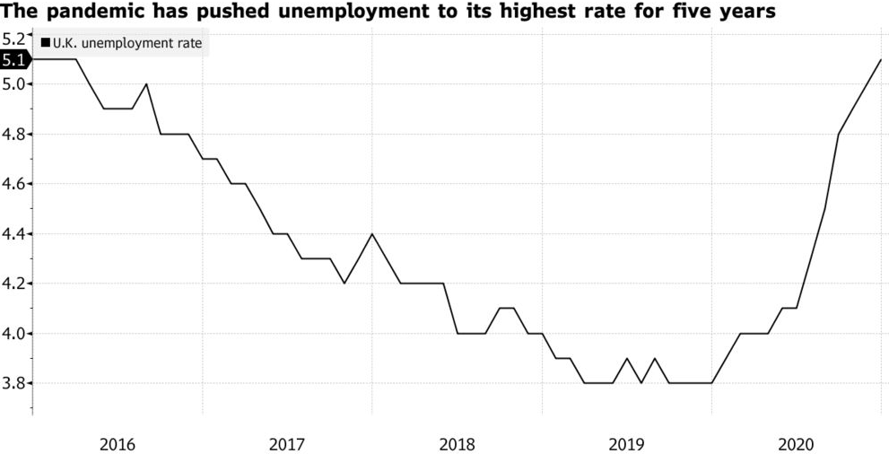
Figure 1.0: UK Unemployment Rate (Source: Bloomberg, Atkinson, 2021)

However, more people are working from home (or teleworking). According to data released by ONS this month, there were 2 million more workers collocated with their employers last year—a 10% increase since 2018.

Unemployment has gotten better faster for men than women.
The UK labour market has been improving since Covid. Unemployment has decreased, but it's been slower for women than men. The most recent data shows that 5% of people out of work are women, while only 4% are men—a major improvement over before Covid (when 8% of women and 7% of men were unemployed) (Rees, 2022). However, these figures still represent thousands upon thousands of people who have lost their jobs and may struggle to get back on their feet.

Remote working during covid has become more widespread and permanent, but not universal.

It has been found that remote working during covid has become more widespread and permanent, but not universal. Remote working is more common than it used to be: around 1 in 5 people work remotely at least once a week, while only 1 in 10 did so just two years ago. Remote working is not universal: 55% of full-time employees work outside the office on a daily basis, and 49% do so at least once per week; however, many workers still don't have the option of working remotely at all (Murphy et al. 2021). Remote working is more common in some places than others: although every region has seen an increase in those who work from home (except Wales), Northern Ireland leads with 62%, followed by Scotland with 57%, and then England with 50%. The work from home trends in the UK have been shown from the following graph:

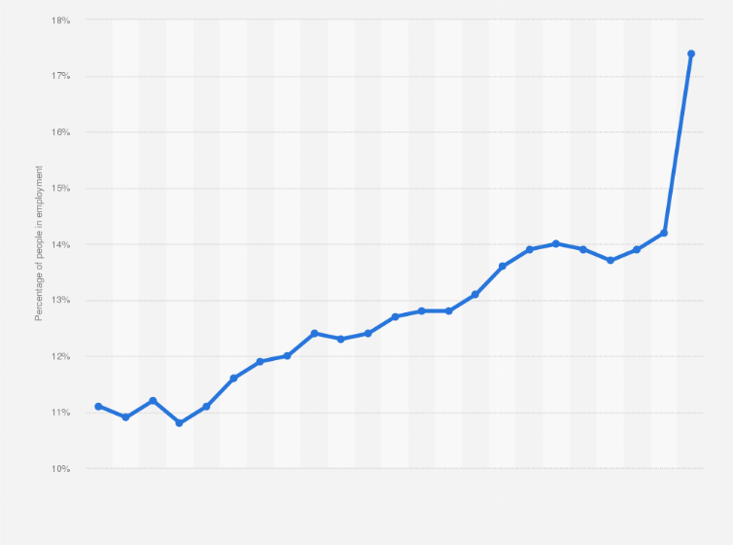
Figure 2.0: Working from Home trends in the UK (Statista, 2020)

Remote working has also become more common across different industries: today, 43% of employees are able to telecommute for their jobs, yet this number was only 32% just four years ago (Felstead and Reuschke, 2021).

The government's unemployment rate is still high in many regions, but it appears that the labour market has been improving for some time now. Unemployment rates are generally lower for men than women and higher in certain places compared to others. There are also gaps between the unemployment rates of different groups of people, such as those with disabilities or ethnic minorities.

Action Taken by the UK government to increase employment.
The UK government has taken various steps to increase employment. The government has increased the number of apprenticeships available, and it has encouraged more people to retrain by providing funding for training. The government also supports women in joining the workforce by offering affordable childcare and maternity leave.

The UK government has taken measures to increase the employment of disabled people as well as people living in rural areas, who often face greater challenges finding jobs than their city-dwelling counterparts. The government offers financial support to businesses that employ people with disabilities, and it has taken steps to ensure that these individuals are provided with the training they need to succeed in the workplace. The government has also created programs aimed at helping rural communities find jobs for their residents. The UK government has taken a number of steps to ensure that its workforce is diverse. For example, it recently announced plans to increase the number of women in senior positions by requiring companies with more than 250 employees to report their diversity statistics annually (Anand, 2020).

The government is taking action to reduce youth unemployment. In 2017-18, the number of young people in apprenticeships increased by 72% compared with 2016-17. The number of specialist "youth hubs" offering support and advice has increased from 141 to 158 since 2017. The UK government has also invested £35 million in a new program to help small businesses get off the ground (Davies et al. 2020). The program will provide funding to entrepreneurs and small companies so they can hire apprentices, giving young people an opportunity to gain experience while gaining valuable skills. The government is working on increasing employment levels overall by ensuring enough jobs are available for everyone.

Conclusion
The UK economy is recovering from a period of sluggish growth, high unemployment, and low productivity growth. The government has boosted demand and incentivised companies to invest in new technology. These efforts have helped improve wage growth but more needs to be done in order for the labour market to return back to full employment levels. The government has taken action to boost demand and incentivise companies to invest in new technology. The UK labour market is slowly improving, but it still has a long way to go. Job creation is increasing, but wage growth remains weak. The government is looking to reduce the number of people receiving benefits and increase the number of people at work. The government needs to continue investing in education so that more people can get jobs with better pay. The labour market will continue to improve as long as there are enough jobs available for people who want them. There is a long way to go before the UK economy reaches full employment levels, but it is clear that the government has taken steps to improve conditions for workers.

(b) The emerging changes in Human Resourcing Strategies in the post-Covid, post-Brexit external environment.

Introduction
In the post-Covid, post-Brexit external environment, companies face increasing challenges with their human resourcing strategies. The emerging changes in the external environment have contributed to these challenges by impacting recruitment and retention processes, changing the priorities of employees, and creating new priorities. These issues have led to significant changes in how companies recruit international talent as well as retain older workers and change the way they approach employee benefits packages.

The impact of Brexit was significant. There was a reduction in immigrant workers after Brexit, which can be attributed to changing technology and improved infrastructure such as better transportation systems, which allow companies to hire more local workers instead of internationals who were previously needed due to geographical restrictions (Bratton et al. 2021). The section (b) of the report thoroughly covers the emerging changes in HR strategies in the post-Covid and post-Brexit external environment.

The emerging changes in the external environment
Recruiting and retaining the right talent is a major challenge for organisations in any external environment. Amongst other factors, recruitment and retention have been impacted by the Covid 19 pandemic, which disrupted the flow of people across borders, and Brexit, which has created uncertainty over international mobility for British employees (and their families) working overseas (Amankwah-Amoah et al. 2021).

A growing number of employers are also facing pressure to retain older workers as part of their workforce mix due to skills shortages. The post-Covid, the post-Brexit external environment is presenting new challenges for recruiting and retaining international talent, as well as retaining older workers who may be less inclined to relocate or relocate with their families following Brexit.

The impacts of the departure of Britain from the European Union
The impacts on the global economic order (Adam, 2022).
- The number of EU nationals working in the UK has fallen since mid-2016, although there were small increases in 2016 and 2017.
- The impact on the labour market:
- Inflows from Europe have been declining since 2016 and are now at their lowest level since 2012. This is partly due to tighter controls on EU migration but also reflects a fall in net migration overall, resulting from Brexit-related restrictions and demographic factors such as an ageing population. However, recent data show that EU nationals who want to work in Britain can still do so - with over 128 000 arriving last year – albeit at lower levels than before 2016 (when it was around 188 000). There has been no appreciable change since then despite a series of policy changes intended to reduce overall immigration numbers by government ministers trying hard not only to gain control over our borders again but also to keep them open enough so that businesses can continue recruiting staff when needed without any further hindrance whatsoever while simultaneously avoiding other potential problems such as unemployment rising too quickly due largely increased demand being met by reduced supply due reduced availability - something which would leave insufficient time available for workers themselves if they wish to maintain high output levels per hour worked ratio ratios rather than simply reduces output per person employed instead which could lead many job seekers away completely disillusioned with other forms career progression opportunities altogether.

The impact of technological disruption on the global economic order
In addition to being a global economic order, the technology industry is also a major employer. The impact of technological disruption on the global economic order is therefore also an important factor in the development of human resources strategies. This section will explore how businesses are likely to change their human resources strategies as they respond to technological disruption (Hepburn et al. 2020).

The impact of technological disruption on businesses has been significant in recent years. Many businesses have had their core business model disrupted by new technologies, such as Uber disrupting taxis and Airbnb disrupting hotels. In some cases, these new technologies have created significant barriers to entry into industries where there were previously few barriers, leading to monopolistic pricing structures (e.g., Amazon). Other times it has led to lower margins due to higher competition (e.g., Airbnb versus hotels) (Hitt et al. 2021). Regardless of which outcome occurs when a new technology disrupts an industry, most companies find themselves having difficulty competing against companies who were able to adapt more quickly or at least maintain their market share during these changes.

In addition to business models being disrupted by new technologies or increased competition from other companies using those same technologies, another way that people's jobs could be affected by technological advancements is if they become replaced with automation software programs or robots taking over tasks once done by people themselves econometrics and quantitative analysis methods represent two examples where this type of replacement seems possible.

Challenges for recruiting and retaining international talent
Recruiting and retaining international talent is an important part of any organisation. With the increased global competition for these individuals, organisations will find it increasingly difficult to attract and retain this category of employees. Several challenges must be overcome in order for organisations to maximise their ability to recruit and retain international human resources.

Many different factors affect the attractiveness of an employer's environment. Some companies have a more comfortable or attractive environment than others depending on their financial status and size as well as their policies towards employee benefits such as health insurance or vacation time, among other things. For example, one company may offer free lunches while another does not; one may provide private rooms while another does not—the list goes on forever! The point here is that some employers offer better overall packages than others so they can attract more skilled workers who want good working conditions along with enough money coming in every month without having to worry about bills piling up at home because everything has been taken care off by the company itself (i.e., paying rent/mortgage payments).

Retaining older workers
It becomes important for various organisations to retain their old employees. First of all, they need to ensure that they feel that they are contributing to the team and that they feel valued within it. It can be done by ensuring that there is a clear link between the work they do and their performance in it.
Second, companies need to ensure that their employees get regular feedback on how well they are doing as individuals to know where improvements can be made. Thirdly, these workers need to have opportunities for training and development. These things will help them remain motivated at work even if their jobs become more routine over time. Fourthly, it is also important for companies who employ older workers not just for cash flow but also because their skills may be needed on short notice due to changes in technology or processes within an organisation (Walwei and Deller, 2021).

Changing priorities of employees in a post-Covid, post-Brexit environment
As the world becomes more and more interconnected, people want to work for companies that they can be proud of. That's why companies need to have a purpose beyond profit-making - like helping communities or being innovative in their industry. Employees want to work for companies with good community standing that treat all employees well and offer opportunities for learning and professional development (Wild and Szczepura, 2021).

Key things to think about with HR strategies
There are a number of key things to think about with HR strategies (Stuart et al. 2021). These include:
- Changing priorities of employees in a post-Covid, post-Brexit environment.
- Retaining older workers.
- How to deal with the impact of Covid 19 pandemic
A new report out today shows that the coronavirus crisis has had a significant impact on UK businesses. The Federation of Small Businesses (FSB) found that while most employees will be back at work by next March, around one-fifth still expect to be working remotely (Moradlou et al. 2020). This is going to have serious knock-on effects for HR managers as they prepare their teams for the future.

Conclusion
It is clear that there are many challenges facing those in human resources. These challenges require the companies to rethink their traditional ways of thinking about HR and the ways they recruit, train and retain employees. It will be important for businesses to adapt their HR strategies as they face these changes so that they can continue to provide high-quality service through good recruitment practices and effective training methods.

References
Adam, C., (2022). The emerging contours of a post-Brexit Britain. Oxford Review of Economic Policy, 38(1), pp.1-10.
Amankwah-Amoah, J., Khan, Z. and Wood, G., (2021). COVID-19 and business failures: The paradoxes of experience, scale, and scope for theory and practice. European Management Journal, 39(2), pp.179-184.
Anand, P., (2020). Economic policies for COVID-19 (No. 156). IZA Policy Paper.
Atkinson, A., (2021). U.K. Unemployment Rate Rises to Highest in Almost Five Years. [online] Bloomberg.com. Available at: <https://www.bloomberg.com/news/articles/2021-02-23/u-k-unemployment-rate-rises-to-highest-in-almost-five-years> [Accessed 1 September 2022].
Azar, J., Marinescu, I. and Steinbaum, M., (2022). Labor market concentration. Journal of Human Resources, 57(S), pp.S167-S199.
Bratton, J., Gold, J., Bratton, A. and Steele, L., (2021). Human resource management. Bloomsbury Publishing.
Davies, E., McConn-Palfreyman, W., Williams, J.M. and Lovell, G.P., (2020). The impact of COVID-19 on staff working practices in UK horseracing. Animals, 10(11), p.2003.
Duval, R.A., Ji, Y., Li, L., Oikonomou, M., Pizzinelli, C., Shibata, I., Sozzi, A. and Tavares, M.M., (2022). Labor Market Tightness in Advanced Economies. Staff Discussion Notes, 2022(001).
Ellison, N., Blomqvist, P. and Fleckenstein, T., (2022). Covid (In) equalities: labor market protection, health, and residential care in Germany, Sweden, and the UK. Policy and Society.
Felstead, A. and Reuschke, D., (2021). A flash in the pan or a permanent change? The growth of homeworking during the pandemic and its effect on employee productivity in the UK. Information Technology & People.
Hepburn, C., O’Callaghan, B., Stern, N., Stiglitz, J. and Zenghelis, D., (2020). Will COVID-19 fiscal recovery packages accelerate or retard progress on climate change?. Oxford Review of Economic Policy, 36(Supplement_1), pp.S359-S381.
Hitt, M.A., Holmes Jr, R.M. and Arregle, J.L., (2021). The (COVID-19) pandemic and the new world (dis) order. Journal of World Business, 56(4), p.101210.
Moradlou, H., Fratocchi, L., Skipworth, H. and Ghadge, A., (2020). Post-Brexit back-shoring strategies: what UK manufacturing companies could learn from the past?. Production Planning & Control, pp.1-18.
Murphy, M., Scott, L.J., Salisbury, C., Turner, A., Scott, A., Denholm, R., Lewis, R., Iyer, G., Macleod, J. and Horwood, J., (2021). Implementation of remote consulting in UK primary care following the COVID-19 pandemic: a mixed-methods longitudinal study. British Journal of General Practice, 71(704), pp.e166-e177.
Rees, T., (2022). Women and the labour market. Taylor & Francis.
Statista. 2022. Working from home rate UK 2020 | Statista. [online] Available at: <https://www.statista.com/statistics/303589/working-from-home-in-the-united-kingdom-uk-y-on-y/> [Accessed 1 September 2022].
Stuart, M., Spencer, D.A., McLachlan, C.J. and Forde, C., (2021). COVID‐19 and the uncertain future of HRM: Furlough, job retention and reform. Human Resource Management Journal, 31(4), pp.904-917.
Walwei, U. and Deller, J., (2021). Labor market participation of older workers in international comparison (No. 16/2021). IAB-Discussion Paper.
Wild, D.J. and Szczepura, A., (2021). Reimagining care homes: can the COVID-19 pandemic act as a catalyst for enhancing staff status and education?. Nursing older people, 33(5).

