University of Wales Trinity Saint Davids
Assignment 1 : Logistics operations in Transports Intervilles Express Frigo
Operations Analysis
Alexis Seité
13/12/2018

Introduction
This assignment is going to be about a company in which i spent 5 weeks from May 2017 to June 2017 for an internship. That company is called Transports Intervilles Express Frigo (Transports Inter-city express refrigerated). Along this assignment i am going to first describe to you their activity and from there i will try to analyze their activity, how do they improve their company every day and i am going to talk about my opinion on how they balance the five performance objectives mentionned in Slack et. al, (2016) 8th edition

What is Transports Intervilles Express Frigo ?

The company
TIEF was created in 1993 by the father of the two current directors, Robert TALAGAS, and his sons, Arnaud TALAGAS and Philippe TALAGAS now lead the company that he created as he retired some years ago.
TIEF is a small to medium company with a total of 12 full time permanent employees that can also go to up to 14 employees depending on the activity of the company throughout the year. It’s headquarters are located in the small city of Plobannalec in south of brittany at Philippe TALAGAS’ house.
The company is equipped with a fleet of 8 vehicles of various sizes to adapt to the demand which is fluctuating a lot throughout the year.
The fleet is composed of :
- 3 trucks of a Gross Combination Weight Rating (GCWR) of 44 tons
- 1 medium truck with a GCWR of 19 tons
- 2 small trucks with a GCWR of 12 tons
- 2 vans with a GCWR of 3.5 tons with trailers
Here is a small organization chart :

The annual turnover of this company is approx 800 000 to 900 000 EUR

2.2 Their activity
The company is specialized in the transport of seafood products in my home region in France which is Brittany. They transport various products from the fishing harbour to supermarkets all around the area (radius of approx 150km-90mi), from small fishmarkets to big supermarkets. When the fish is loaded on the trucks it is put in pilable fish tanks with ice and those tanks are the property of the harbour so TIEF also takes care of returning all those tanks from the customer back to the harbour each week.
TIEF is a company that is active 24h/24 all the week except the weekend and on Friday night. It’s activities are planned with different rotations that complete the 24h cycle each day. During my Internship i was able to participate to 3 out of 4 of these rotations.
The first one is the morning rotation (it begins at approx 5 :45am). 3 drivers start driving their truck from Morlaix (my home town) and drive north to a city called Roscoff where there is a fish sell (auction) beginning at 6 :15 am. The personnel of the harbour then begins sorting the fish tanks by customer/buyer. Then the drivers from TIEF come and begin palettizing the different fish tanks of their customers like so :
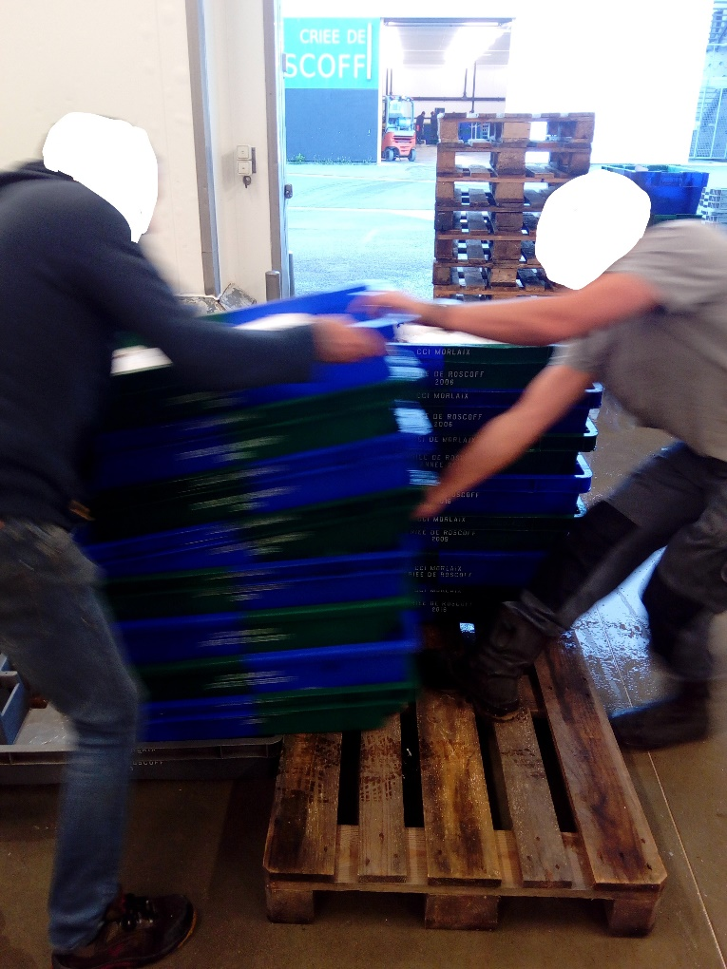
Then usually at 8 :00 to 8 :20, all the merchandise is loaded and papers are ready, each driver takes a different road to supply 3 different cities at the south of Brittany which are Le Guilvinec, Concarneau and Lorient. They then finish their day by directly driving back to Morlaix at approx 3 :00 PM
The second leader of the company, Philippe TALAGAS, lives in south Brittany and he does the same things as the drivers from the north but he begins his day by going to the harbour in Le Guilvinec to load his truck and then deliver the merchandise to the same places as the others.
The second one is the « Ramasse » or Picking rotation that begins in the early afternoon, it’s a rotation that consists in picking some fish tanks and also packages of conditionned fish to respectively Douarnenez if there is something to pick (not always), then to Audierne where another fish tank sale takes place and finally to Le Guilvinec where there will be a lot of packaged/conditionned fish and langoustines to load. Then when this is done, and after a 45 min break, the driver comes back to Morlaix where he will let the truck to the person that will do the next rotation.
The final rotation that takes place between midnight and the middle of the morning is the delivery rotation. It is divided between two drivers, one is transfering the merchandise of the truck that the picking rotation left to put in his truck and delivers them to clients all along the north coast of Brittany to the last client in Paimpol. Then he returns back to Morlaix. The other person begins at approx 4 am and delivers a few clients respectively in Landivisiau (20 km west of Morlaix), and then to Cléder (North from Landivisiau along the coast) and then the driver joins 2 other in Roscoff to participate to the morning rotation with the others. As this driver did begin at 4 am, he will do the shortest delivery of the three because they have a work span of 10 hours max.

How do they measure their performance ?
As i mentioned before, the activity varies a lot throughout the year, there are some periods in which fishmen bring a lot of fish to the harbour like summer because the weather is good which favorizes fishing and there is a lot of demand for fish because people tend to eat more fish in summer and therefore there is a lot of fish captured and then to transport. There is also a peak of activity in December espacially for crustaceans / shellfish because of Christmas.
Supermarkets also play a big role in the activity of TIEF because sometimes some of them decide to do big special offers and because of that spend without counting and buy tons of fish to supply their stores.
There are also some periods when the weather is bad and the fish migrates which makes it harder for the fishmen to reach high volumes and the activity of TIEF follows the activity of the fishmen. January and February are two months of very low activity for TIEF and May / June as well.
The data to which TIEF has access are each time they go to the harbour they know how many tons of fish are for sale that day, it can go from 7-10 tons of fish at the lowest days of low activity periods to something like 60+ tons on high activity periods.
TIEF also represents a big part of what will be transported from that harbour as a lot of the customers that buy from this harbour are TIEF’s customers so on average the amount of fish that TIEF’s customers buy from that harbour is approx 75% of the total amount.
With those two figures in hand they can deduce (approximately, these informations are not extremely accurate) the amount of fish that they can hope to have a certain day and then adapt by sending lighter trucks in case of low amounts or heavier trucks in case of high amounts of fish.
They also implemented IN the harbour where they load their trucks a paper, a list of the different customers that they have. This list is exposed in the harbour and it is made in such a way that it divides clients by city and they are listed in loading order from top to bottom, the first customer being at the very top of the list and the last one to load is at the very bottom. This helps gaining time as the pallets have to be loaded on the trucks by the harbour’s forklift operators. It is even more useful when knowing that the harbour regularly employs temporary workers and it’s a very easy, intuitive and fast way for them to know what to do. It is worth noting that in rare cases if the truck driver wants to load in a different order, he only has to tell the forklift operator.
As i mentionned in part 2 of this assignment, the company takes care of returning the empty fish tanks from the customers they deliver back to the harbour. This operation is generally made once or twice a week depending on the activity or, in case of low activity, when there is enough tanks to fill a certain part of the truck. This service is free for the harbour and the customer as it is included in the price that the customer pays for the transport. This is part of TIEF’s strategy to maintain customer loyalty as it is a free service that the company does for something very important for the harbour. Why are these plastic tanks so important ? They are important because in the first place, it fills a certain amount of space at the customer’s workshop but the biggest reason why it is so important is that it costs a lot of money. One plastic tank costs 10 EUR and each week, a lot of customers will buy enough fish so that there are thousands of fish tanks which could potentially represent a cost of minimum 10 000 EUR worth of tanks a week for the harbour.
This system is a win-win for the harbour and the customer, and a way for TIEF to maintain their customer, but they represent a potential risk for TIEF. Some of the customers that TIEF delivers are very professionnal and clean all of the tanks after using them and before they return to the harbour, but some of them are quite neglecting and take the fish from the tank and leave all the liquids that the fish lets behind in the tank before piling all of the tanks outside in the sun. This results after a week in tanks that have mold and in summer some maggots crawling in them. Fortunately, the drivers know that this happens and make sure that they deliver everything they have before picking the empty tanks because if they do pick the tanks before going to another customer and this customer sees maggots crawling in the trailer of the truck, it could be dramatic for the reputation of the company.
As i mentionned before, TIEF’s strategy is to have loyal customers that buy regularly instead of customers that are unpredictable and buy huge amounts of fish. That is why they don’t count on big supermarkets for their activity. These companies like E.LECLERC (French equivalent of Tesco or Sainsbury’s) are obsessed with prices and only pick the cheapest transport company for their operations which makes them unpredictable and not trust worthy. What TIEF does, is that they always say yes when they have the occasion to transport products for them but they never will rely on them to make a big part of their turnover. And as TIEF is a small company, they are more communicative and friendly with their customers which big supermarkets don’t do and that doesn’t really fit the company’s value.

How does TIEF balance the 5 performance objectives ?

Objective N°1 : The quality
In my opinion, this objective is 100% complete with TIEF. The inside of the trailers are very well maintained, their trailers are washed at least 2 times a week which guarantees that the fish that is transported is well preserved when arriving at the client’s workshop/warehouse. Also, incidents such as piles of fish falling in the trucks are very rare (In a 5 week internship, it happened only once)

Objective N°2 : The speed
Every truck that is loaded at the harbour arrives at it’s destination only a few hours after so TIEF’s operations are pretty much made for it’s payload to be delivered as soon as possible to the customer so the fish is still fresh and the customers can begin working on it as soon as possible as well.

Objective N°3 : The dependability
This objective doesn’t really apply to TIEF as they don’t really have to be on time but they are expected to be fast because once the customers buy their fish at the morning auction, they want to have it as soon as possible.

Objective N°4 : The flexibility
TIEF constantly adapts the means that it deploys to the demand to reduce the costs as much as possible and it is also as flexible as possible when there is a last minute transport to do but the fact that it is a small company makes it hard for them to adapt to all situations because if there is a need of one driver to do a delivery and the only drivers that could be available have to stay home because they didn’t complete the 11h rest time that the legislation says they must do, they are not able to adapt.

Objective N°5 : The cost
Unfortunately, TIEF can’t have that much of an impact on their costs ; their costs are mainly composed of fuel and workforce, and some other costs like changing the tires of the trucks etc… But what they can do and that they do is managing the trucks that the company has as much as possible. When they want to invest in a new 44t truck for instance and they can spend less on the truck itself but keeping the costs per km/mile the same or they can invest a little more on a new better truck that will consume 1L/100km less. Considering that trucks are driven 100 000 km a year, it makes a cost difference that will surely be more profitable on the long run.

Conclusion
Transports Intervilles Express Frigo is a small company that is cumfortable in it’s business and that has all cards in hand to prosper. Their strategy allows them to have a lot of very loyal clients which drastically reduces the risk of having a big drop in activity from a day to another only because they aren’t the cheapest transport company available. We also saw that they complete the majority of the 5 performance objectives as they ensure a good quality of service to their customers, they also deliver the merchandises quickly a few hours after the customers ordered their fish, their business is well established so there isn’t a great need of flexibility but when it is required they can adapt, and they don’t have a big impact on their costs as they don’t depend on them.
I really liked working with them for 5 weeks a year ago and i wish i had a longer period with them (A. TALAGAS is a neighbour and a friend of mine and my parents so it facilitated the contact). In my opinion, the two brothers gave their father’s company a real evolution but are the grandsons going to continue running their grandfather’s company when Philippe and Arnaud are going to retire ?

